**CRCCP Quarterly Program Update**

**Example/Draft Data Entry Screens**

**August 21, 2020**

**Welcome Page and Section 1. Respondent Information**

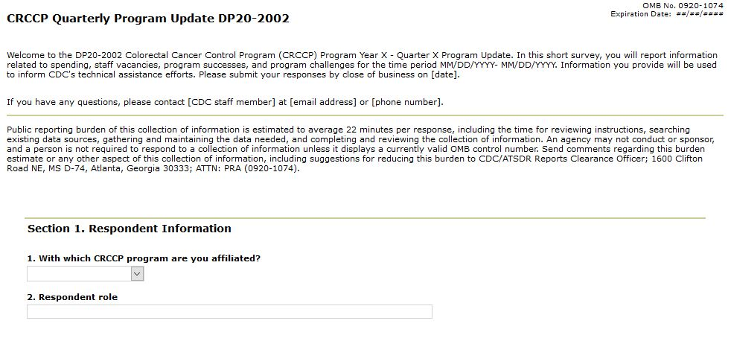

**Section 2. Award Spending**

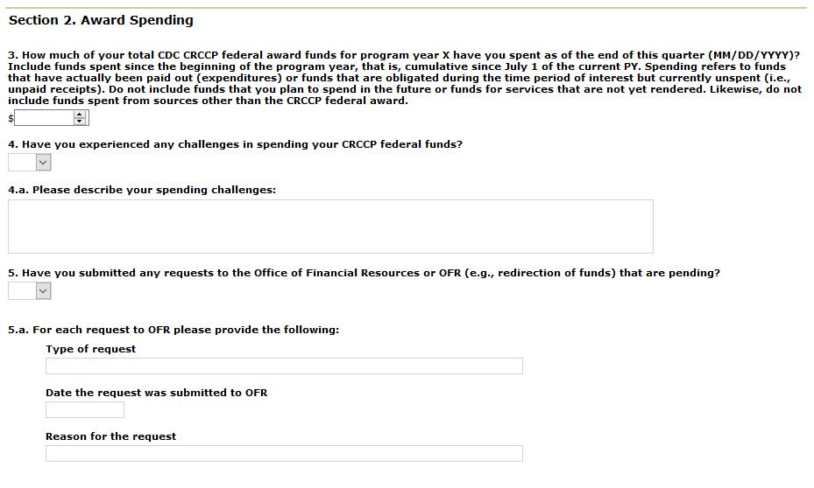

**Section 3. Staff Vacancies**

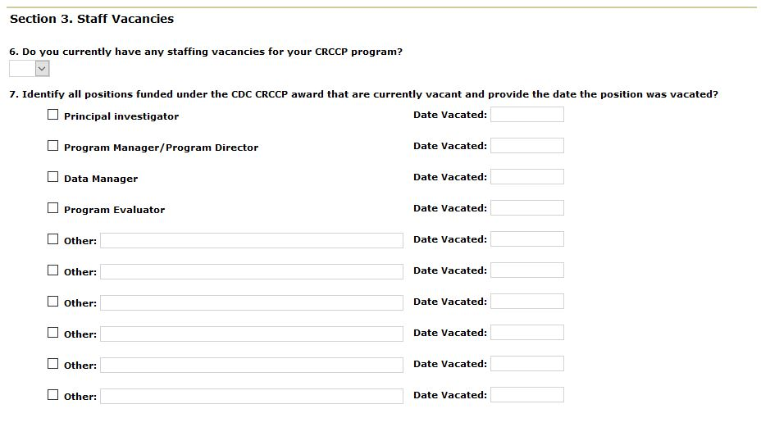

**Sections 4-6:**

**Section 4. Program Success and Challenges**

**Section 5. Technical Assistances Needs**

**Section 6. COVID-19**

