January, 2020

Dear Administrator:
I am writing to address any concerns you may have about your facility’s participation in the Medicare Current Beneficiary Survey (MCBS) as it relates to the Health Insurance Portability and Accountability Act (HIPAA) regulations. Please be assured that the standards of privacy of protected individually identifiable health information implemented under the HIPAA privacy regulation do not affect the data being collected for MCBS. Specifically, your cooperation with the MCBS will not violate the HIPAA privacy regulations. Nor will it require any additional privacy disclosure record keeping.
Under the HIPAA regulations, your facility does not need an individual’s authorization to disclose their protected health information to a health plan, such as the Medicare program, when the information is being disclosed for receiving organization’s health care operations activities. This holds if both your facility and the Medicare program has or had a relationship with the individual whose protected health information is being requested, and the protected information pertains to such relationship. See 45 CFR § 164.506(c) (4). Furthermore, participating in the MCBS will not impose additional disclosure record keeping burdens on your facility. Disclosures under 45 CFR § are explicitly exempt from the HIPAA disclosure accounting provisions. See 45 CFR § 164.528 (a) (1) (i).
I hope this information addresses any questions you had. If you have further questions or concerns about the study, please call me at (410) 786-5525. You may also contact our data collection agent, NORC at the University of Chicago, toll-free at 1-877-389-3429, or email NORC at mcbs@norc.org. You can visit the new MCBS website at www.mcbs.norc.org to learn more. We sincerely hope you will participate in this very important study.

Sincerely,
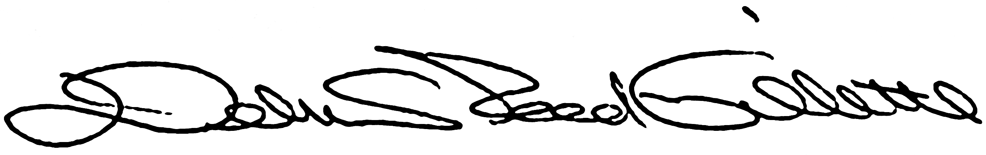
Debra Reed-Gillette

Director, Medicare Current Beneficiary Survey
Centers for Medicare and Medicaid Services

