[Month], [Year]
Dear [Administrator]:

I am writing to request your assistance in helping us conduct an important study called the Medicare Current Beneficiary Survey (MCBS). A resident in your facility, [R First] [R Last], has been selected to participate in this study.

Since 1991, the Centers for Medicare and Medicaid Services (CMS), part of the U.S. Department of Health and Human Services, have conducted the MCBS in order to better understand the needs of Americans enrolled in Medicare. It is the nation’s primary source of information about how Medicare affects the people it serves, and we intend to use the information collected to improve the Medicare program. Because we cannot interview everyone on Medicare, a sample of 16,000 Medicare beneficiaries was selected to represent all of those on Medicare.

A portion of the selected Medicare beneficiaries reside in long-term care facilities. These beneficiaries are extremely important to the study because long-term care issues are at the forefront of the national health policy agenda. We need your help to collect information about a resident in your facility. The interview focuses on the utilization and costs of the health care being received by [R First] [R Last], along with a small section describing the characteristics of your facility. Much of the information can be abstracted directly from the resident’s chart and will only require about an hour of your staff’s time.

No residents of your facility will be contacted directly. All of the information your organization provides will be kept private to the extent permitted by law, as prescribed by The Federal Privacy Act of 1974. Your participation is voluntary, and your relationship with programs administered by CMS will not be affected in any way by whether or not you participate. Furthermore, your residents’ Medicare benefits cannot be affected by the answers that you provide, or by whether or not you choose to participate.

NORC at the University of Chicago, a respected social science research organization, has been contracted to conduct the MCBS. Normally, our representatives visit in-person to conduct the interview. However, due to the coronavirus (COVID-19) outbreak, a professional interviewer will instead contact you by phone within the next few weeks to schedule an appointment and conduct the survey. Your facility’s safety and privacy is our greatest priority, so we are taking these necessary precautions.

If you have any questions about the survey or would like to schedule an appointment, please call NORC toll-free at 1-877-389-3429, or email NORC at mcbs@norc.org. Enclosed is a brochure that provides you with more information about the survey. You can also visit the MCBS respondent website at mcbs.norc.org to learn more. Please help us in this national effort to improve the Medicare program.

Sincerely,
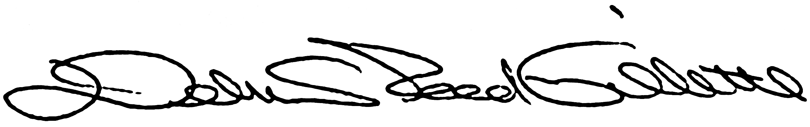
Debra Reed-Gillette
Director, Medicare Current Beneficiary Survey
Centers for Medicare and Medicaid Services

