[Month] [Day], [Year]

Dear [R First] [R Last]:

Recently an interviewer from our contractor, NORC at the University of Chicago, tried to contact you about your participation in the Medicare Current Beneficiary Survey (MCBS). Unfortunately, we have been unable to reach you! Because your participation is so valuable, we hope that you will reach out to us by calling the toll-free number listed at the end of this letter.

The MCBS is an important survey sponsored by the Centers for Medicare & Medicaid Services (CMS) of the U.S. Department of Health & Human Services. To learn more about the MCBS, please see the enclosed brochure or check out our website: www.mcbs.norc.org.

Your participation makes a difference! You cannot be replaced in this project because you, and others like you, represent all of the nation’s more than 49 million Medicare beneficiaries. Without you, we will have an incomplete picture of health care needs in America. We ask for your participation so that policymakers and researchers will be fully informed about important health care issues such as:
- The rising cost of health care,
- Access to quality care,
- Satisfaction with services, and
- Out-of-pocket expenses.

We know that your time is valuable, and we will do everything we can to make being involved as easy as possible. We will accommodate your schedule and your needs in order to complete interviews. You may always skip questions or sections of the survey if they make you feel uncomfortable.

Your information is always kept private and confidential. CMS and NORC follow all rules and regulations created by the Privacy Act of 1974, the NORC Institutional Review Board, and the U.S. Office of Management and Budget.

Again, your participation is crucial to the success of this study. Would you please contact us by telephone toll free ([FM 800 Number]) or by e-mail (mcbs@norc.org) so we can answer any questions you may have and schedule an interview with you? We will make every possible effort to conduct the interview at your convenience—day or night. Thank you for your time and attention.

Sincerely,
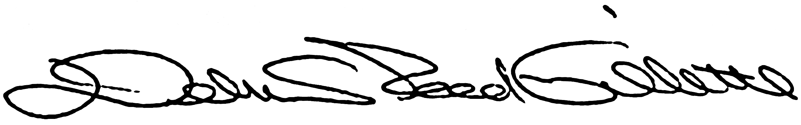
Debra Reed-Gillette
Director, Medicare Current Beneficiary Survey
Centers for Medicare and Medicaid Services

