Instrument 2. Identifying and contact information - revised

The purpose of this information collection is to evaluate innovative programs serving individuals facing challenges to employment and economic independence to expand the evidence base. Public reporting burden for this collection of information is estimated to average 25 minutes per response, including the time for reviewing instructions, gathering and maintaining the data needed, and reviewing the collection of information. This is a voluntary collection of information. An agency may not conduct or sponsor, and a person is not required to respond to, a collection of information subject to the requirements of the Paperwork Reduction Act of 1995, unless it displays a currently valid OMB control number. The OMB # is 0970-0545 and the expiration date is 04/30/2023. If you have any comments on this collection of information, please contact Mathematica at NextGenProject@mathematica-mpr.com.
Identifying and Contact Information Data Collection - Screens in the Random Assignment, Participant Tracking Enrollment, and Reporting, or RAPTER®, system
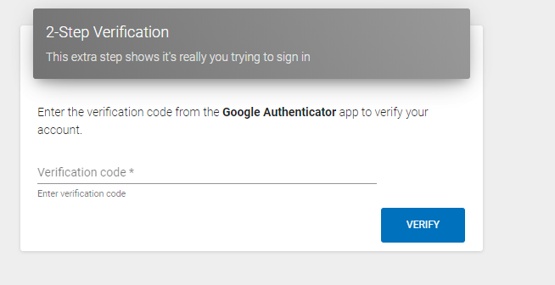
A1. Login screens

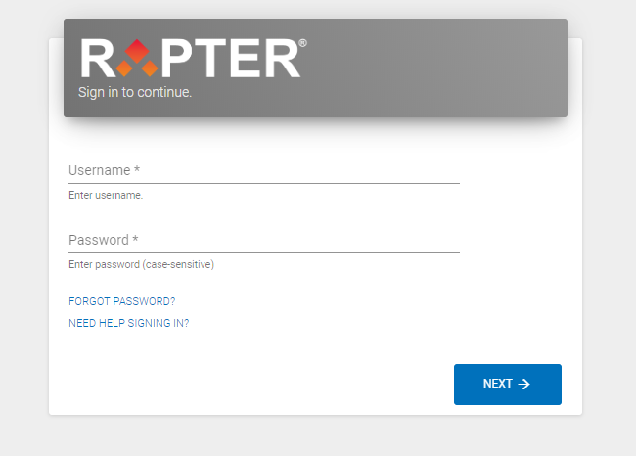

Intake Screens
B1. Study Eligibility
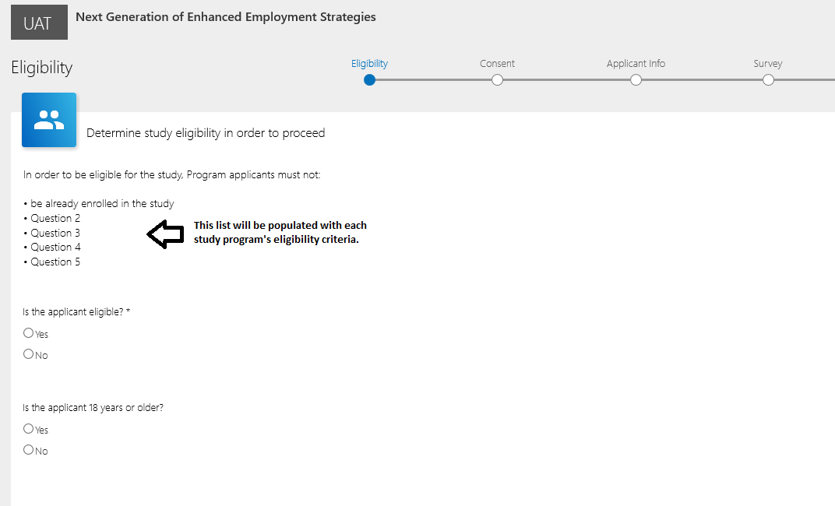

B2. Center for Epidemiologic Studies Depression Scale Revised (CESD-R) Eligibility (only for programs that use the CESD-R as part of programmatic eligibility screening)
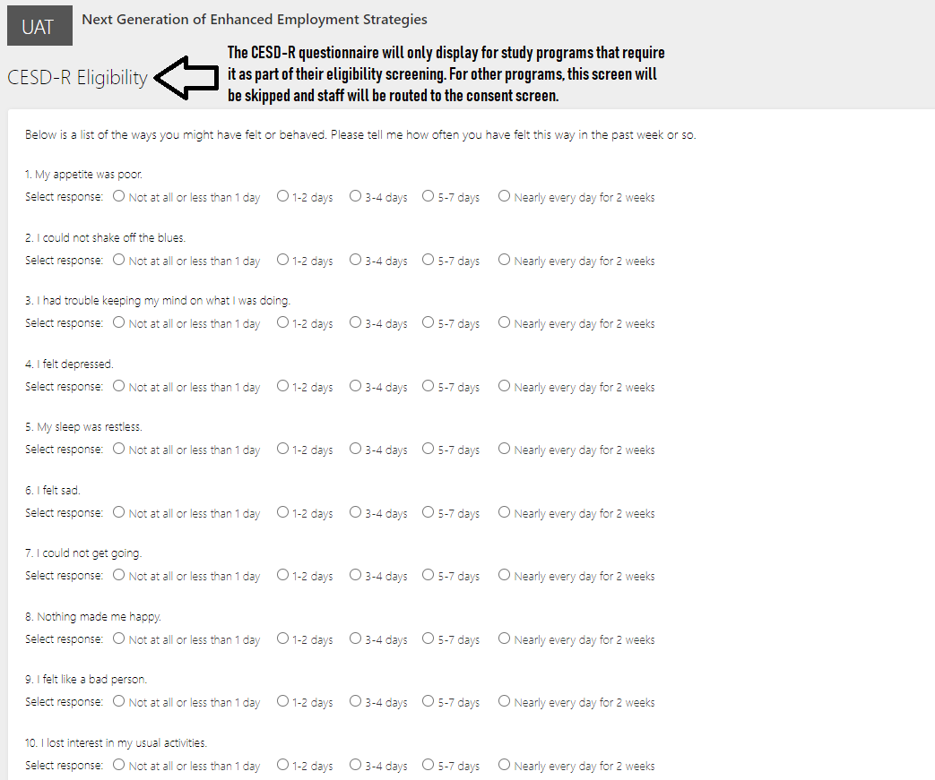
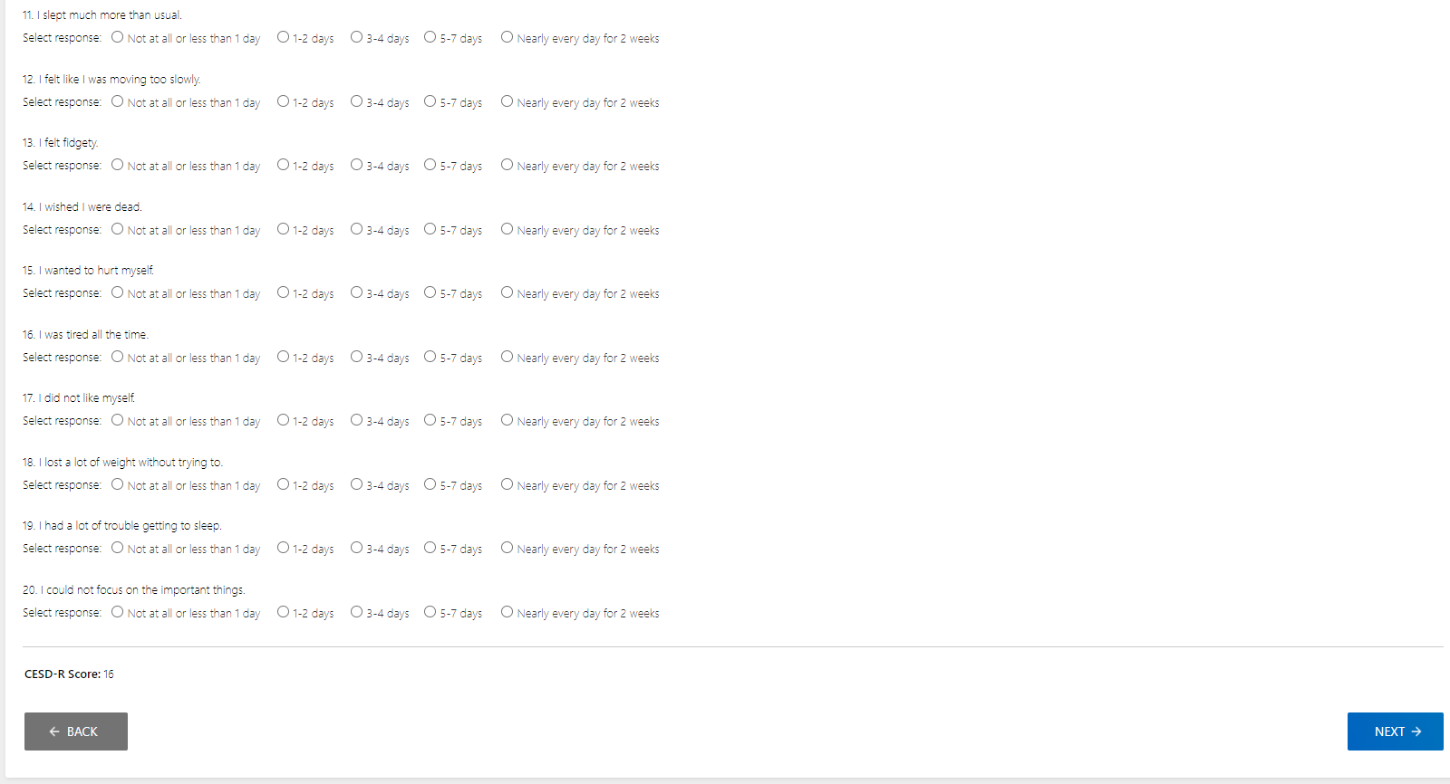

B3. Consent by Sample Member- if sample member is 18 and older

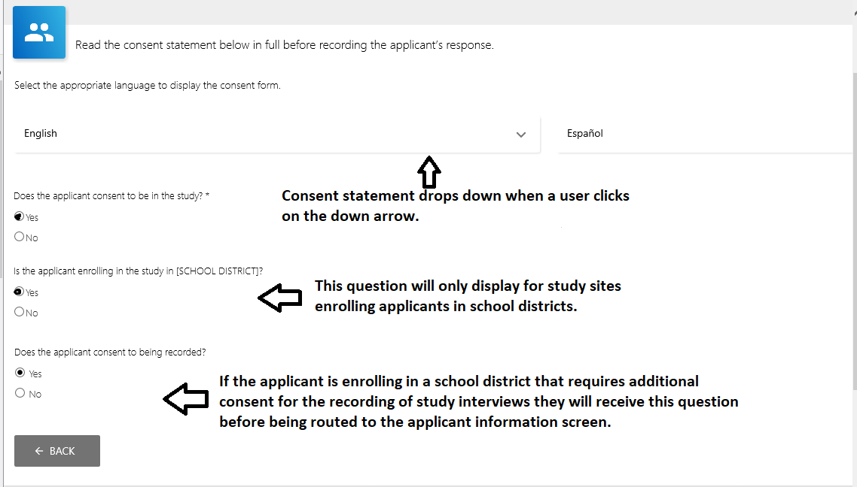

B4. Consent by parent/guardian and assent by sample member - if sample member is younger than 18
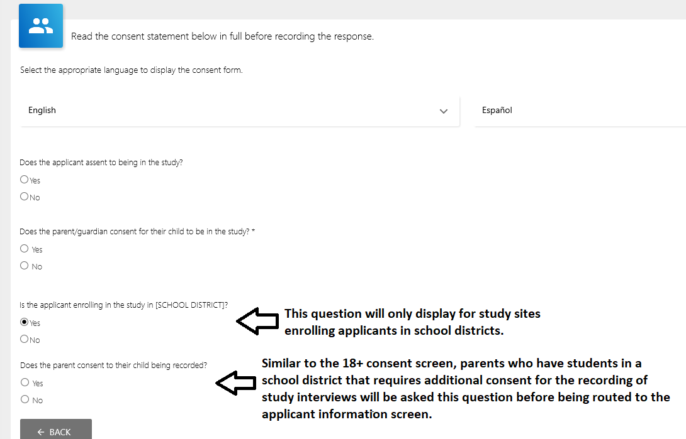

B5. Applicant information
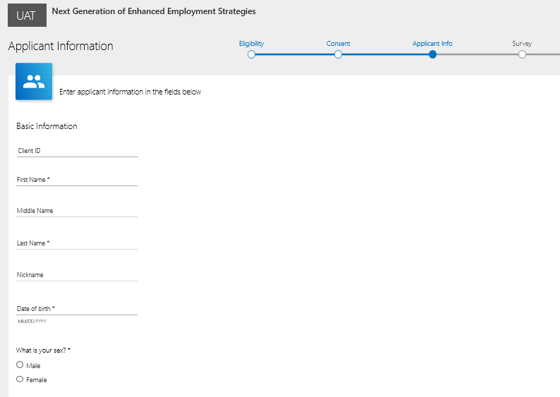

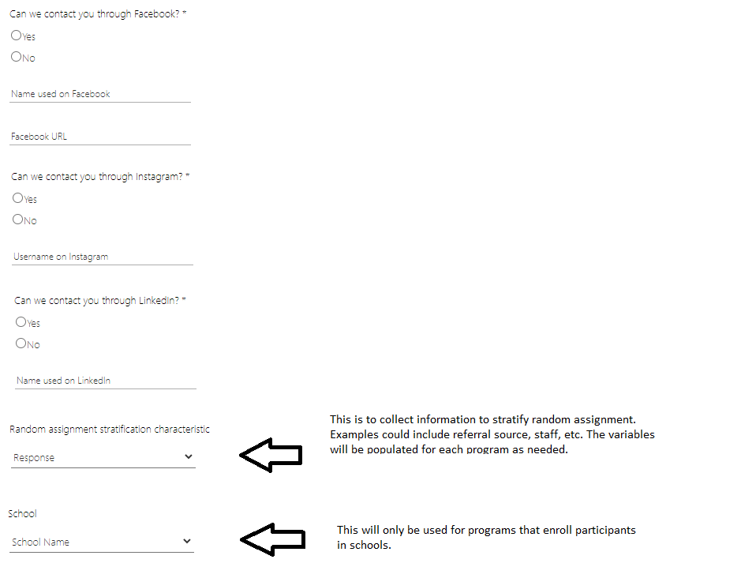

B6. Duplicate check
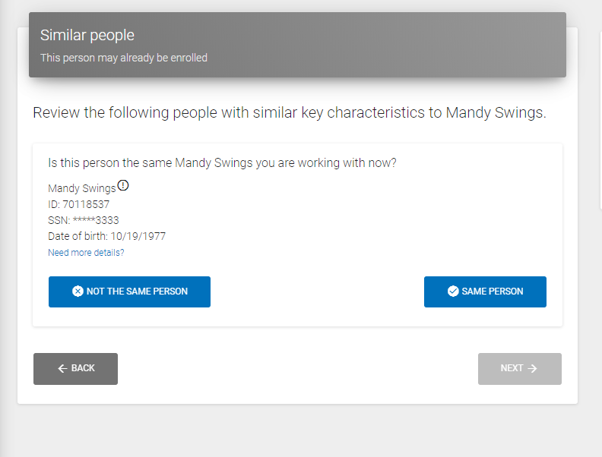

B7. Baseline
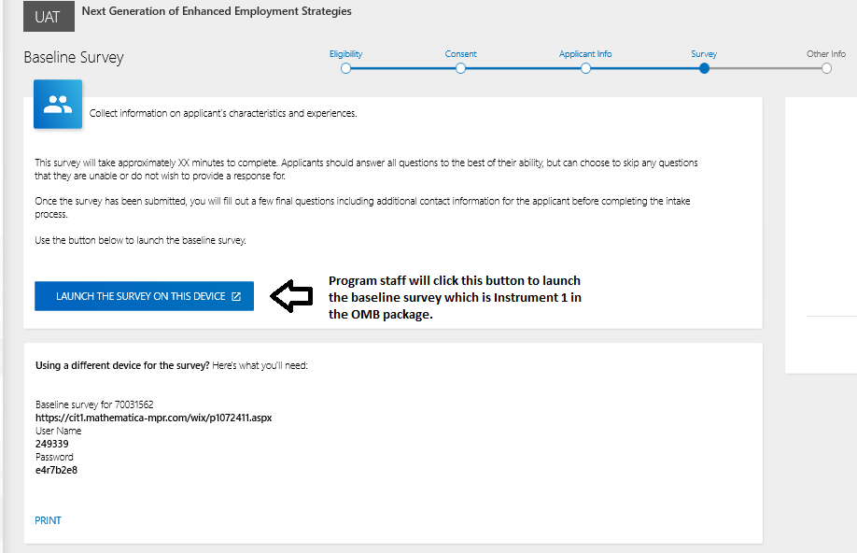

B8. Additional contacts screen
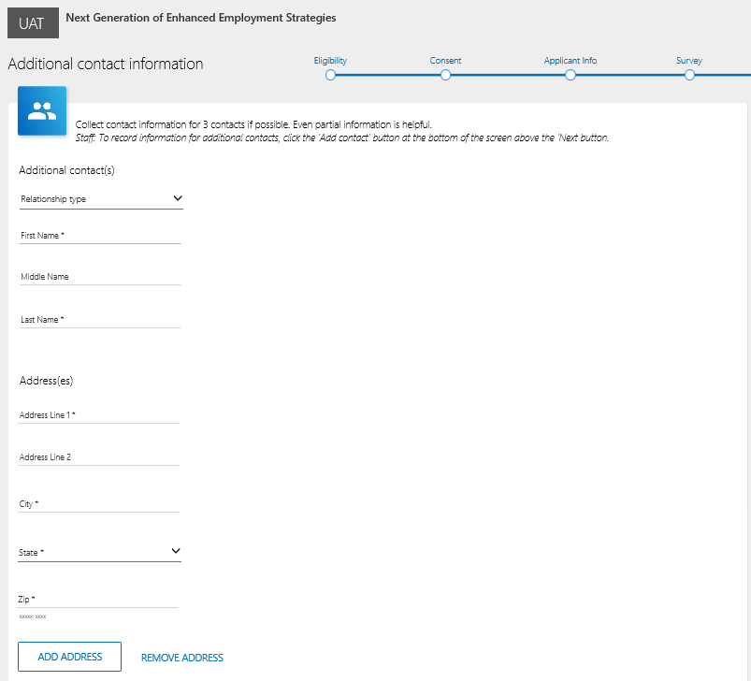

B9. Future Engagement (only for programs that use career navigators)
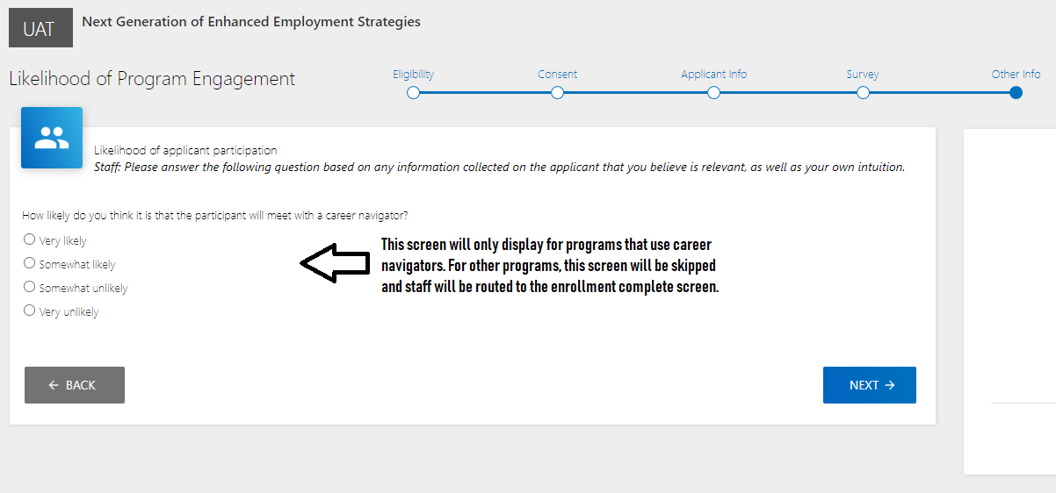

B10. Enrollment complete
