Appendix I. Instrument 5 Service receipt tracking

According to the Paperwork Reduction Act of 1995, no persons are required to respond to a collection of information unless it displays a valid OMB control number. The valid OMB control number for this information collection is XXXX-XXXX. The time required to complete this information collection is estimated to average 5 minutes per response, including the time to review instructions, search existing data resources, gather the data needed, and complete and review the information collection. Send comments regarding this burden estimate to XXX. OMB expiration date xx/xx/xxxx.

Service Receipt Tracking – Screens in the Random Assignment, Participant Tracking Enrollment, and Reporting, or RAPTER®, system
(this data is only collected for participants assigned to the treatment group)
C1. Participant summary
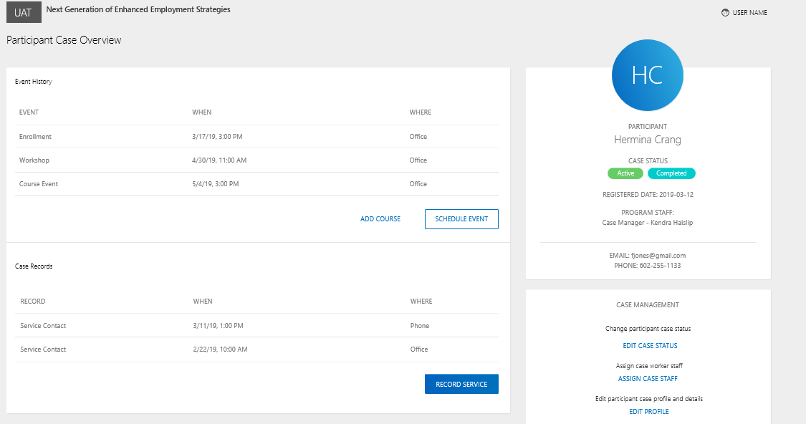
C2. Assign program staff to participant case
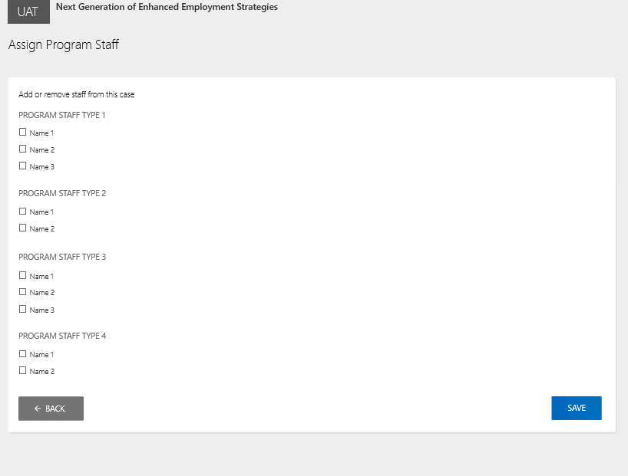
C3. Add service contact
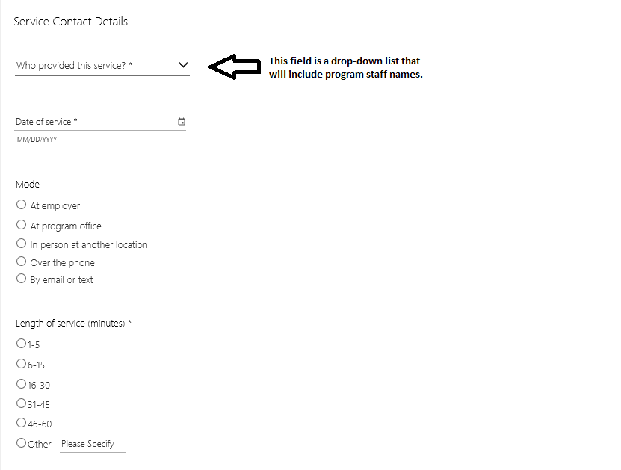
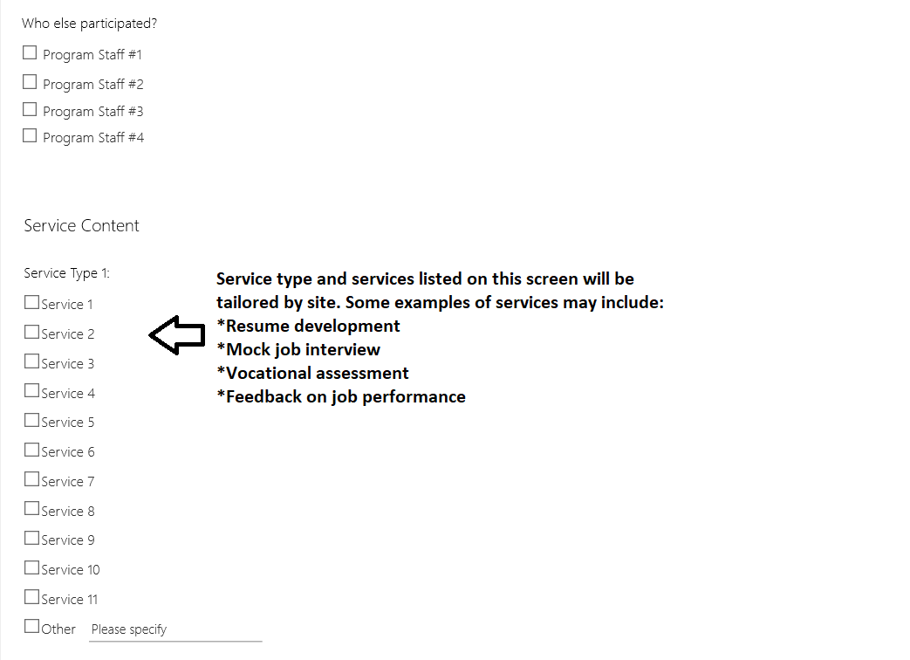
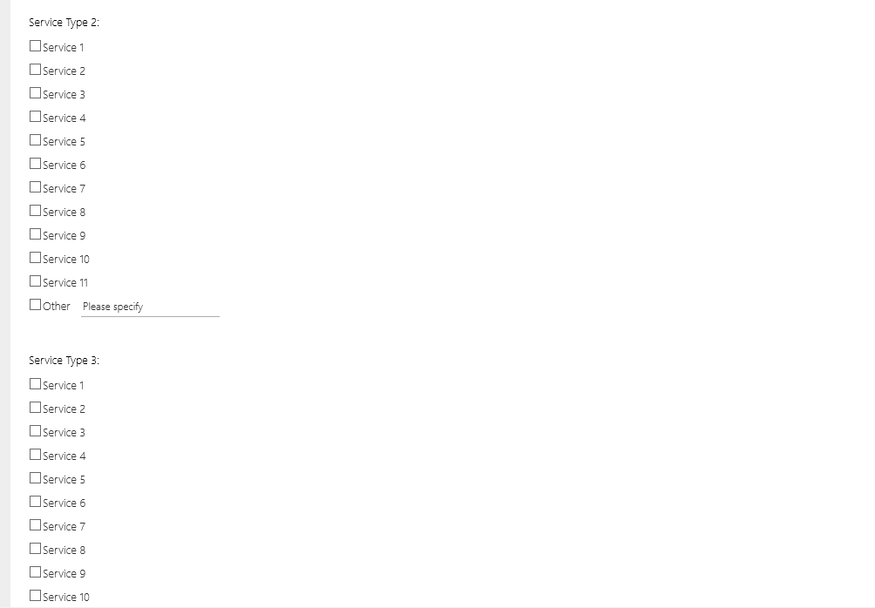
C4. Record collaboration with employer and other partners
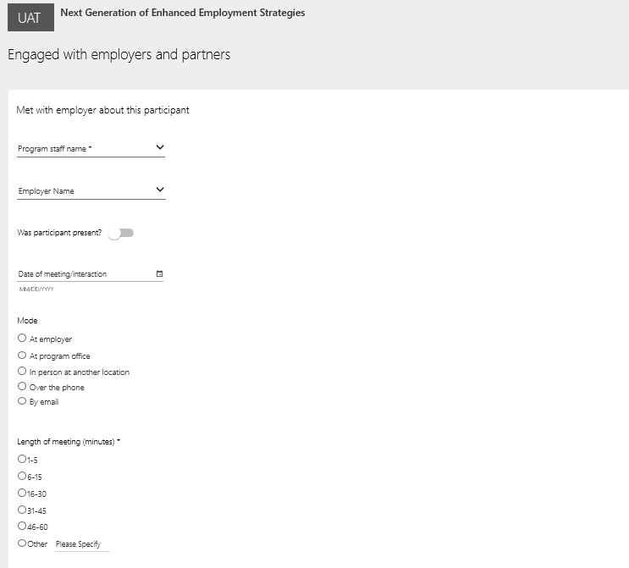
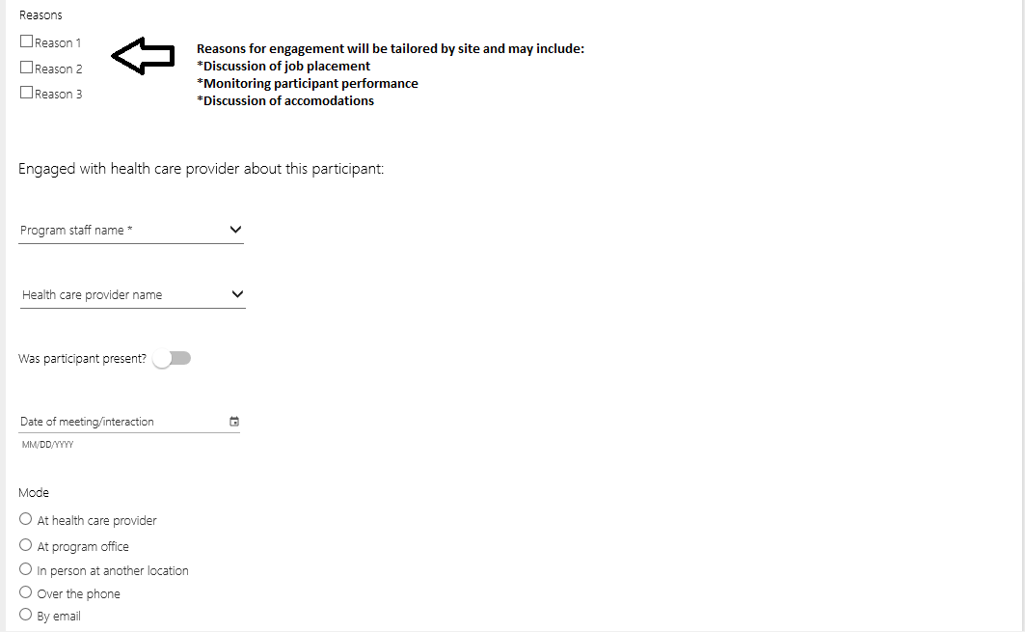
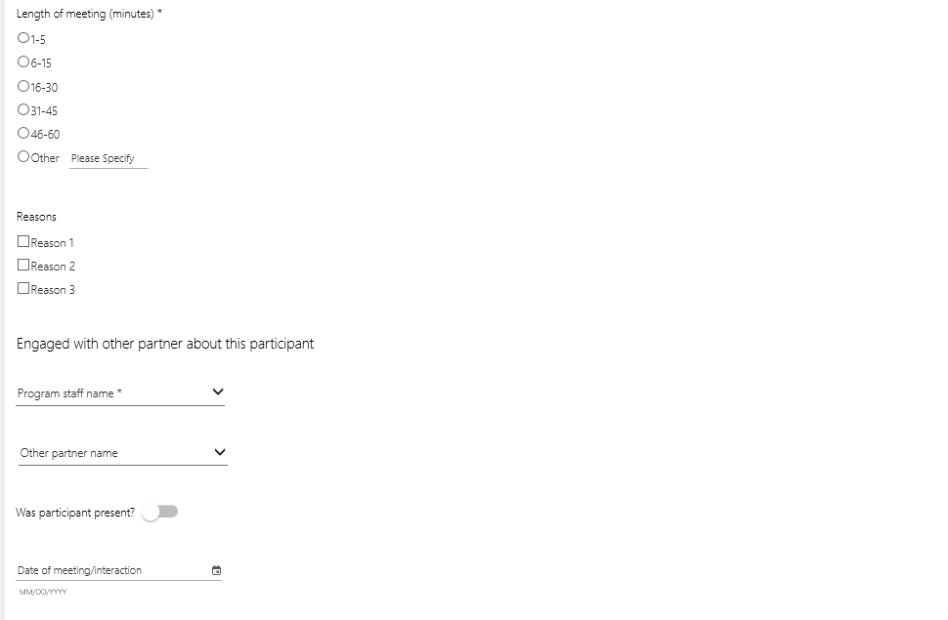

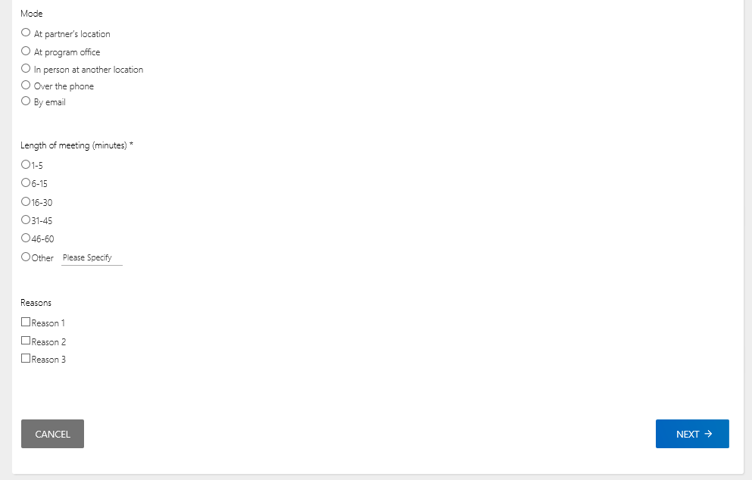

C5. Record work-based experiences and wage subsidies
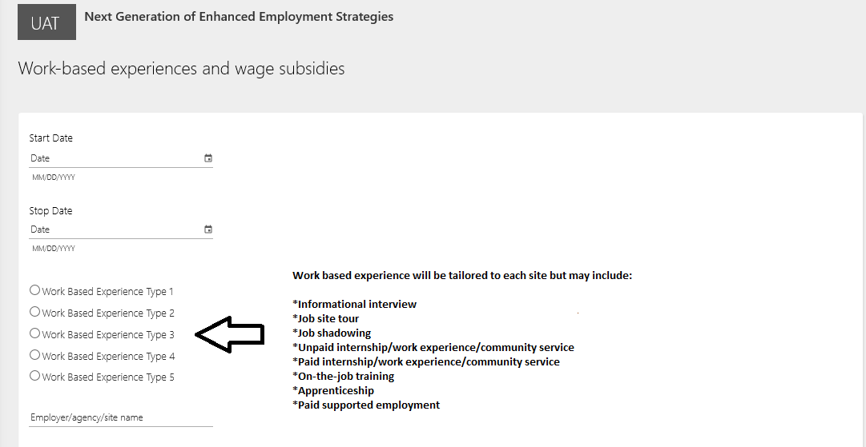

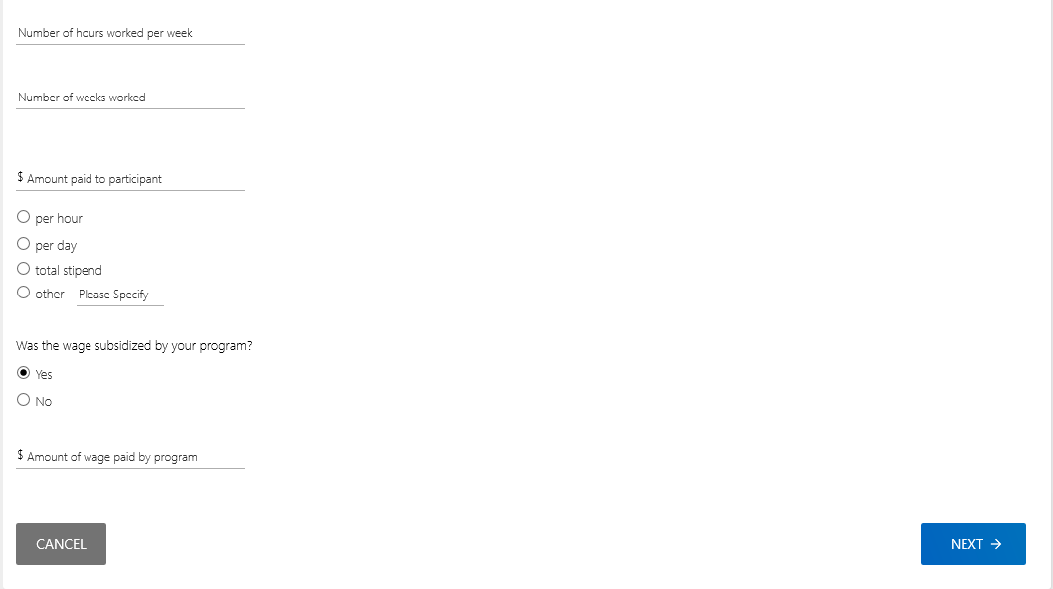

C6. Record education or training programs
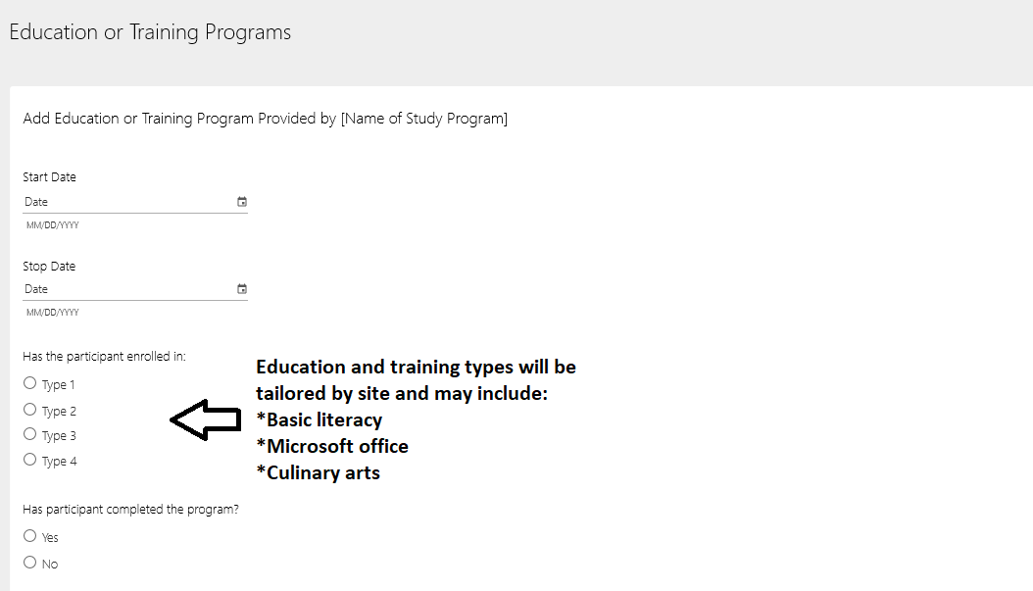––

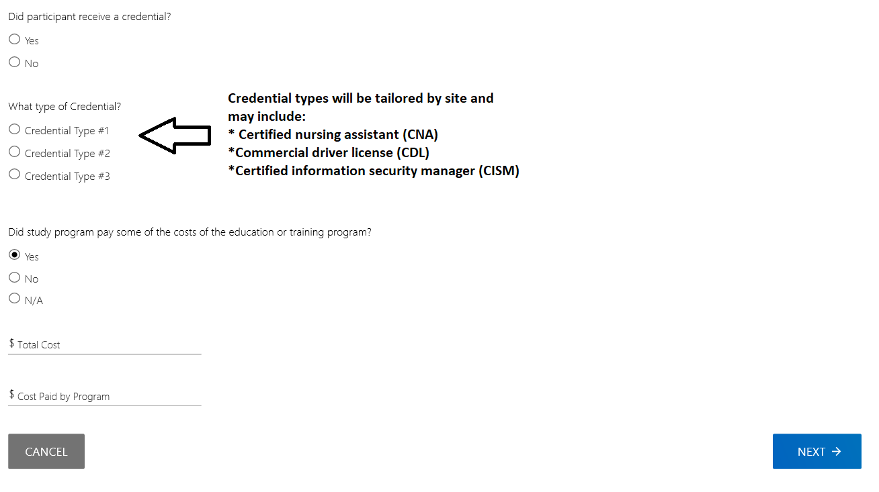

C7. Add financial or in-kind support
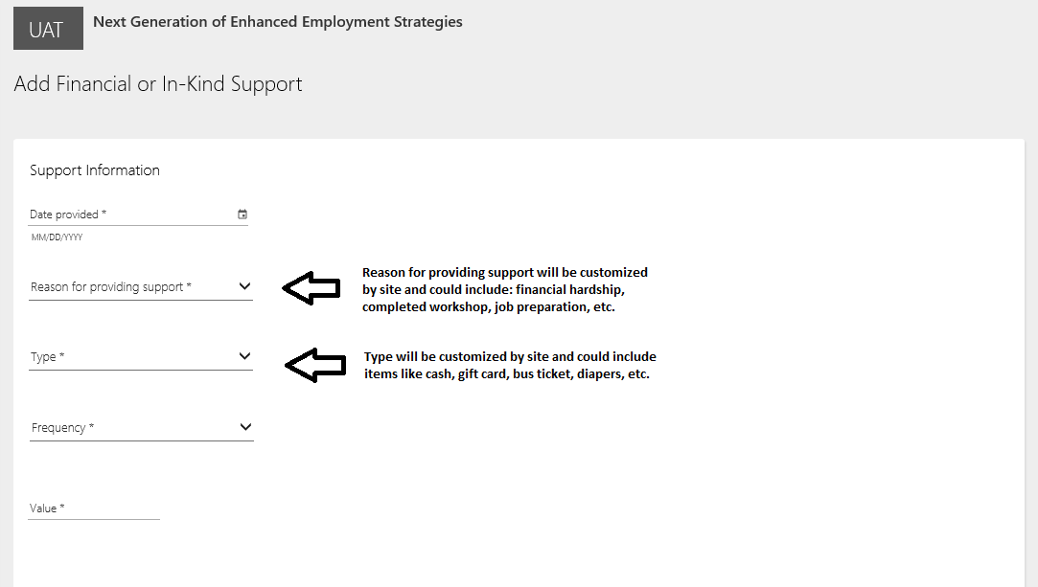

C8. Add referral
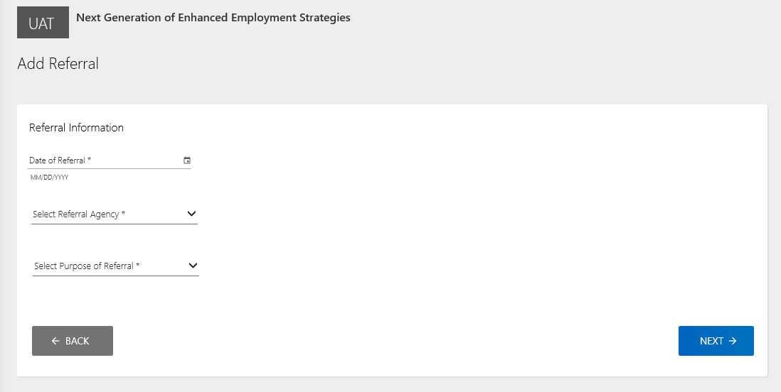

C9. Update participant case status
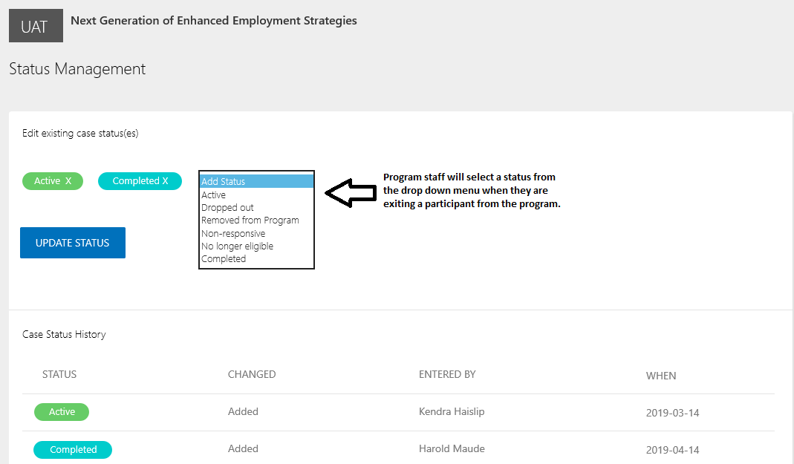
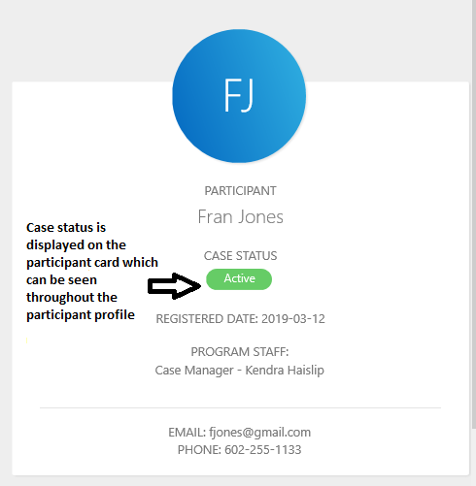

Group Events Screens
D1. Group event summary screen
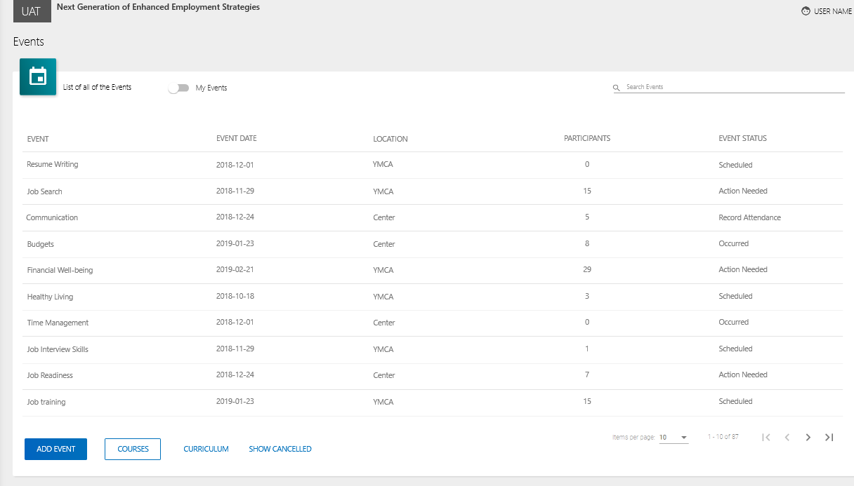

D2. Schedule event screen
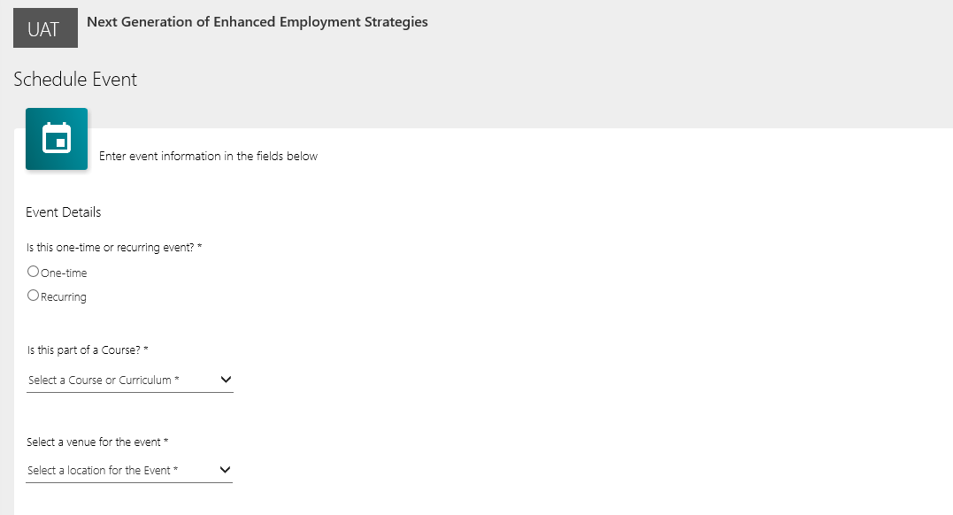

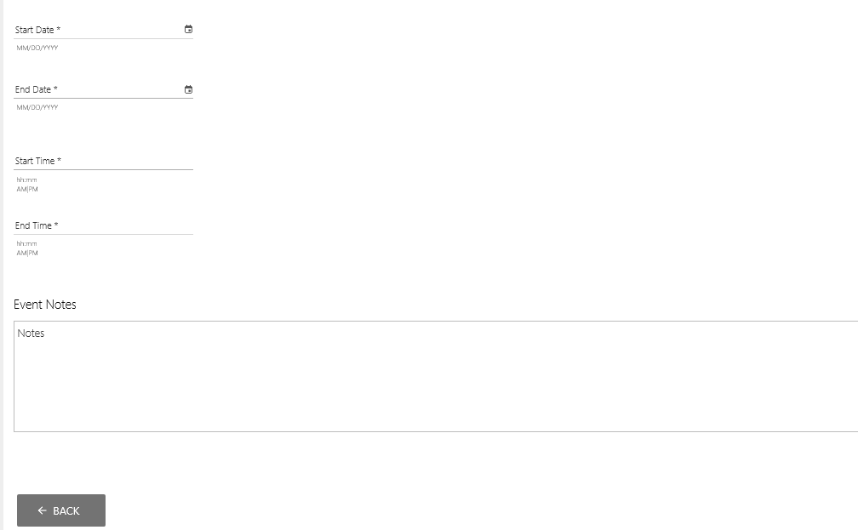

D3. Manage group event roster
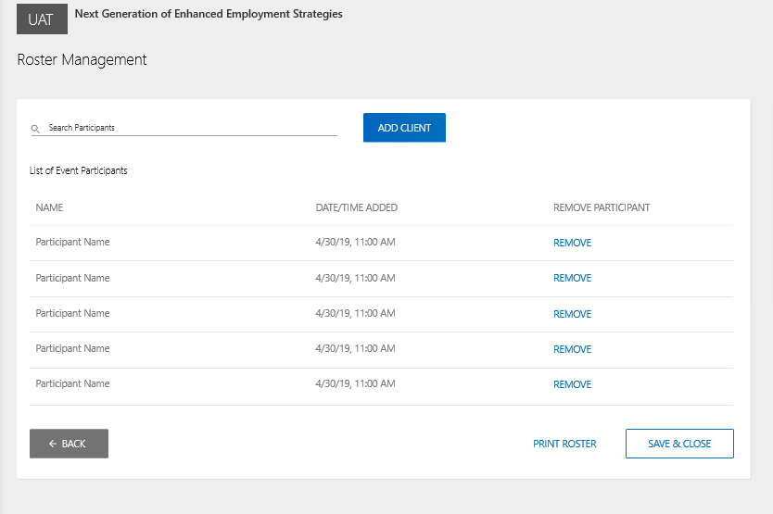

D4. Record group event attendance
