Attachment E: Performance Progress Reports (PPRs) Data List and Mockup
Below is the complete list of the proposed data items from HPOG Next Gen Participant Accomplishment and Grant Evaluation System (PAGES) that will feed into the Performance Progress Reports (PPRs). The PPR will consist of two sections within the PAGES system—a narrative portion that grantees will fill out in PAGES each six-month period, and a quantitative portion that will include metrics automatically generated from data that has been entered elsewhere in PAGES. The narrative portion will be taken directly from the first four pages of ACF-OGM-SF-PPR (a standard ACF form already approved by OMB under number 0970-0406; included in this attachment) and embedded in PAGES. The quantitative section will use the data items listed below. We also present a mockup of the quantitative section of the PPR.
Proposed Data Items from PAGES Used to Create Quantitative Section of PPRs:
- Healthcare training begin date
- Healthcare training end date
- Prerequisites begin date
- Basic Skills training begin date
- Basic Skills training end date
- Basic Skills training type
- Milestone training indicator
- Completed half of required course of training
- Second or higher healthcare trainings
- Occupational code of training
- Employment start date
- Employment in healthcare occupation
- Occupation of employment
- Average hourly wage of employment
- Average hourly wage of employment at intake
- Introduction to Healthcare Career Workshop start date
- College readiness start date
- Work Readiness start date
- Digital Literacy start date
- CPR start date
- Mandatory work readiness with peer support start date
- Other skill development activity start date
- Tuition / Training payment in last six months
- Tutoring in last six months
- Mentoring in last six months
- Peer Support in last six months
- Post-Eligibility Assessments in last six months
- Training-Related Costs in last six months
- Academic Advising in last six months
- Laptop for participant in blended training in last six months
- Internet access for participant in blended training in last six months
- Emergency Assistance in last six months
- Non-SNAP Food Assistance in last six months
- Child / Dependent Care Assistance in last six months
- Transportation Assistance in last six months
- Housing Support / Assistance in last six months
- Other Personal / Logistical Support in last six months
- Job Search Assistance in last six months
- Job Retention Services in last six months
- Job Placement Assistance in last six months
- On-the-Job Training
- Work Experience (as part of training)
- Job Shadowing
- Unpaid Internship or Externship
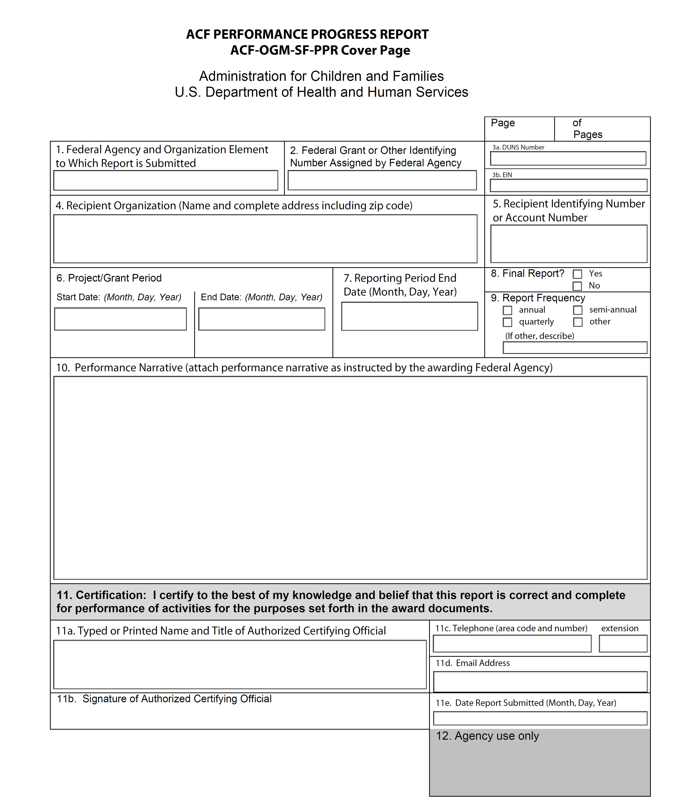

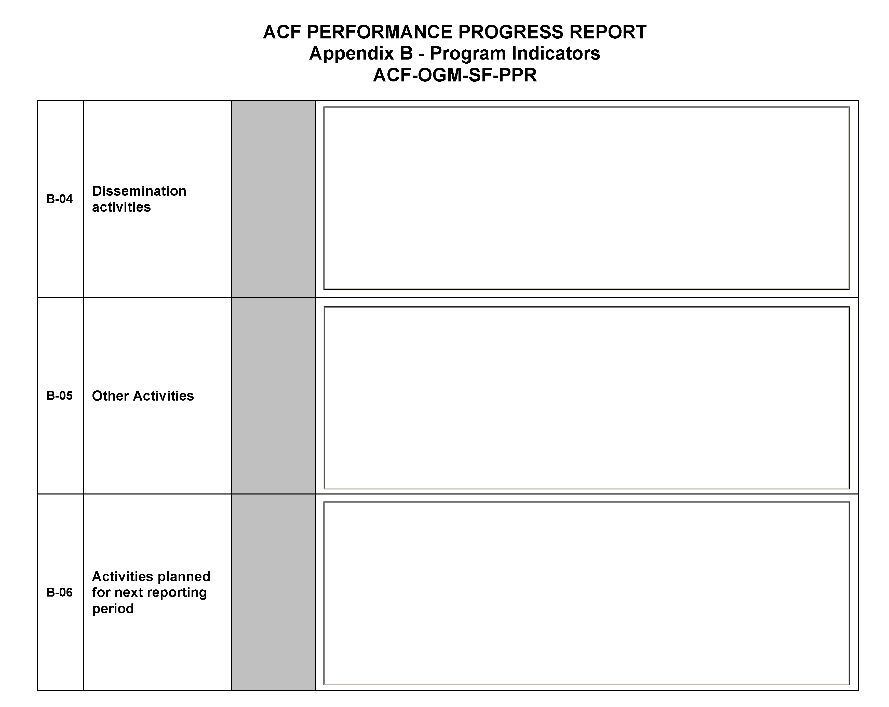

THE PAPERWORK REDUCTION ACT OF 1995 (Pub. L. 104-13)
Public reporting burden for this collection of information is estimated to average 1 hour per response, including the time for reviewing instructions, gathering and maintaining the data needed, and reviewing the collection of information.
An agency may not conduct or sponsor, and a person is not required to respond to, a collection of information unless it displays a currently valid OMB control number.

