Appendix A-2. Notification Letter for Parents of Students in Grades K-3
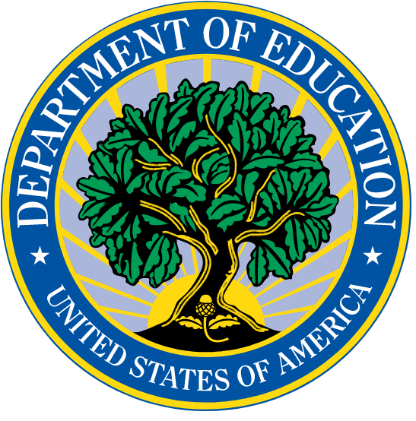When you applied for a DC Opportunity Scholarship, how was your experience?
We want to hear from YOU

Dear Parent of [CHILD_FNAME CHILD_LNAME],
We are doing a study of the DC Opportunity Scholarship Program (OSP). When you applied for a private school scholarship through this program, you agreed to complete annual surveys and release your child’s school records to the U.S. Department of Education and its study team.
We’ve included a $5 gift card to thank you for reading this letter.
- We would like you to complete a 15 minute parent survey. We’ll email you a link to complete it online.
- After you complete the survey, we’ll give you another $20 gift card.
The parent survey will ask about what you looked for when choosing a school for your child and about your experiences with the OSP.

Deciding not to complete the parent survey will not affect your child’s OSP scholarship or eligibility to re-apply.

The study will not identify you, your child, or your child’s school in any public reports. The Department may keep information collected for this study in case other researchers want to use it in the future. The Department and any researchers they hire must follow all federal laws regarding privacy and confidentiality. There is very low risk of any breach of privacy.

Questions about the study? Call XXX-XXX-XXXX (toll-free), or email XXXX@abtassociates.com.
Questions about study participants’ rights? Please call Abt’s IRB Administrator at (877) 520-6835 (toll-free).
Questions about the OSP? Please call Serving Our Children toll-free at 1-888-DC-YOUTH (329-6884).

