Progress in International Reading Literacy Study
(PIRLS 2021) Main study DATA collection

OMB# 1850-0645 v.15

AppendiX A2:
PIRLS 2021 Main Study Materials for Data Collection Activities

National Center for Education Statistics
U.S. Department of Education
Institute of Education Sciences
Washington, DC

November 2020

Appendix A2
PIRLS 2021 Main Study Materials for Data Collection Activities

Table of Contents
PIRLS 2021 Main Study Email to School Coordinator (SC) 3
PIRLS 2021 Main Study School Questionnaire Letter – for Hardcopy Mailings 5
PIRLS 2021 Main Study Teacher Questionnaire Letter – for Hardcopy Mailings 6
MyPIRLS Registration and Provide School Information (PSI) Guide 7
MyPIRLS Registration Page 9
MyPIRLS Provide School Information (PSI) Page 10
Automated Email for all MyPIRLS registrants 11
Automated Email for MyPIRLS School Coordinator registrant 12
MyPIRLS Login Page 13
MyPIRLS Home Page 15
Email to School Coordinator (SC) to Submit Class and Student Lists 16
Email to School Coordinator (SC) to Submit Class and Student Lists—No PSI 17
Email to School Coordinator (SC) with Selected Classes – No Student List 18
Email to School Coordinator (SC) with Selected Classes – Student List Submitted 19
Instructions for Submitting Class and Student Lists- Grade 5 20
Submit Class List Page 30
Submit Student List Page 32
MyPIRLS Prepare for Assessment Page 33
Student Tracking Form (STF) Email 34
Student Tracking Form (STF) Memo 36
Instructions for Reviewing the Student Tracking Form (STF) 37
Participation Status + Newly-enrolled or no-longer-enrolled students 37
Updates and Questions 37
Student Tracking Form (STF) Template 38
MyPIRLS Resources Page 40
MyPIRLS Important Websites and Contact Us Pages 41
School Principal Questionnaire Selection Email 42
Teacher Questionnaire Selection Email 44
School Principal Questionnaire Reminder Email 46
Teacher Questionnaire Reminder Email 48
Amazon Gift Card Code Email 50
Online Questionnaire Login Screen Text 51
Student Login Page 52
Student Login Form 53
Student Certificate of Completion 54
School Certificate of Appreciation 55
School Coordinator Incentive Template 56
School Incentive Template 57
Postcard 58
Accommodations Guide 59
Quality Control Check – CC Template 65
Quality Control Check – GE & CC Template 2 66
Quality Control Check – GE & CC Template 3 68
Quality Control Check – GE Template 70
Quality Control Check – SL Template 71

PIRLS 2021 Main Study Email to School Coordinator (SC)
(yellow highlight for mail merge; red for customization)
[DATE]

[School Name]
[School Address]
[School City], [State] [Zip Code]

Dear [School Cordinator],

We are looking forward to working with you and your school this year on the Progress in International Reading Literacy Study (PIRLS). The data collected will be used by researchers and policymakers to chart national progress against international standards and other countries around the world, informing national discussions about international competitiveness. As the designated school coordinator for PIRLS you play a critical role in assisting us with study preparations. We appreciate your assistance, particularly given the many demands on your time, and you will receive a $100 check for your efforts.

Next Steps
The first step is to register on the PIRLS website (www.MyPIRLS.com), complete the provide school information form, and provide a list of the 5th grade classes in your school so that we may randomly select the classes and students who will be invited to participate. Your registration ID is [PIRLS school registration ID]. This step is critically important, and we would appreciate your help in completing this task by [date].

You can refer to the attached MyPIRLS Registration and Provide School Information (PSI) Guide and Instructions for Submitting Class and Student Lists to assist you through the immediate next steps, and please call us if you have any questions or need additional assistance. We can be reached at [PIRLS E-File phone number] or by email at [PIRLS E-File email]. We have also attached a PIRLS Brochure and Summary of School Activities, which will provide you with an overview of PIRLS, as well as a list of upcoming tasks and a timeline for their completion.

Assessment Day
Your assessment date is [Assessment Date]. The PIRLS representative who is assigned to administer the assessment at your school will contact you in September to begin discussing assessment day logistics, including student accommodations and parental notification.

Students will be asked to complete a reading assessment and background questionnaire. For the first time, PIRLS will be completely digital, and administered on a tablet with a keyboard that we provide. Some students will take a paper and pencil assessment in order to bridge the new digital version of PIRLS to the previous paper and pencil version. A school administrator and the teachers of selected classes will also be asked to complete a questionnaire. They will be contacted separately, and their responses will be collected through a web-based application or hard-copy survey. Please prompt the administrator and teachers to complete the questionnaire as soon as they receive it.

Thank You
Each school’s participation is critical to the success of the study, and reports will not identify participating districts, schools, students, or individual staff. We sincerely appreciate your help in preparing for the session at [School Name] and in ensuring that PIRLS is a success.

Again, if you have any questions, please contact us at [PIRLS E-File phone number] or by email at [PIRLS E-File email]. Thank you for your support of education through participating in PIRLS.

Sincerely,

[NAEP State Coordinator]

Attachments:
MyPIRLS Registration and Provide School Information (PSI) Guide
Instructions for Submitting Class and Student Lists
PIRLS Brochure and Summary of School Activities

The National Center for Education Statistics (NCES) is authorized to conduct this study under the Education Sciences Reform Act of 2002 (ESRA 2002, 20 U.S.C. §9543), and to collect students’ education records from educational agencies or institutions for the purpose of evaluating federally supported education programs under the Family Educational Rights and Privacy Act (FERPA, 34 CFR §§ 99.31(a)(3)(iii) and 99.35). All of the information you provide may be used only for statistical purposes and may not be disclosed, or used, in identifiable form for any other purpose except as required by law (20 U.S.C. §9573 and 6 U.S.C. §151). In the United States, PIRLS is conducted by NCES, part of the U.S. Department of Education, and the data are being collected by Westat. The U.S. Office of Management and Budget has approved the data collection under OMB # 1850-0645.

PIRLS 2021 Main Study School Questionnaire Letter – for Hardcopy Mailings
(yellow highlight for mail merge; red for customization)

[Date]

[Title] [Name First] [Name Last] Web Address: https://portal.mypirls.com
[School] Your Study ID: [Study ID]
[Address 1] Your Password: [Password]
[City], [State] [Zip code]

Dear [Title] [Name Last]:

The United States is participating in an important international study in 2021: the Progress in International Reading Literacy Study (PIRLS). Since 2001, PIRLS has measured trends in reading achievement for students in countries around the world, including the United States. Results from PIRLS are used by researchers and policymakers to chart national progress against international standards and other countries around the world, informing national discussions about international competitiveness. [School name] is participating in this study in the fall of 2021.

We are asking you to complete a 35-minute questionnaire to provide insight into the practices and resources at your school. The survey is designed to be completed by you or a staff person you designate who can provide information about the characteristics of the school, its enrollment, resources, policies, and learning environment. The questionnaire may be completed by hardcopy or online using a secure website. To access the questionnaire online, please use the web address and unique study ID and password provided in this letter. If completing the questionnaire by hardcopy, please use the enclosed business reply envelope to return the completed questionnaire to us. You may also give the completed hard copy questionnaire to the PIRLS school coordinator at your school.

For information on the confidentiality of the data collected, please see the enclosed FAQ. While participation in this questionnaire is voluntary, your participation is invaluable.

If you have any questions, please do not hesitate to call the PIRLS Help Desk at 1-855-951-1215 or send an email to PIRLS@westat.com. You may also get more information about this study by visiting the PIRLS website at http://nces.ed.gov/surveys/PIRLS. If you have questions about your rights as a study participant, you may contact Laura Egan at (919) 474-0248 or email PIRLS@westat.com.

Your participation in the administrator questionnaire for PIRLS 2021 is very important to its success. Thank you for your time and for supporting this important international study.

Sincerely,

Peggy G. Carr, Ph.D.
Associate Commissioner, NCES

Enclosures

The National Center for Education Statistics (NCES) is authorized to conduct this study under the Education Sciences Reform Act of 2002 (ESRA 2002, 20 U.S.C. §9543), and to collect students’ education records from educational agencies or institutions for the purpose of evaluating federally supported education programs under the Family Educational Rights and Privacy Act (FERPA, 34 CFR §§ 99.31(a)(3)(iii) and 99.35). All of the information you provide may be used only for statistical purposes and may not be disclosed, or used, in identifiable form for any other purpose except as required by law (20 U.S.C. §9573 and 6 U.S.C. §151). In the United States, PIRLS is conducted by NCES, part of the U.S. Department of Education, and the data are being collected by Westat. The U.S. Office of Management and Budget has approved the data collection under OMB # 1850-0645.

PIRLS 2021 Main Study Teacher Questionnaire Letter – for Hardcopy Mailings
(yellow highlight for mail merge; red for customization)
[Date]
[Title] [Name First] [Name Last] Web Address: https://portal.mypirls.com
[School] Your Study ID: [Study ID]
[Address 1] Your Password: [Password]
[City], [State] [Zip code]

Dear [Title] [Name Last]:

The United States is participating in an important international study in 2021: the Progress in International Reading Literacy Study (PIRLS). Since 2001, PIRLS has measured trends in reading achievement at grade 5 in countries around the world, including the United States. Results from PIRLS are used by researchers and policymakers to chart national progress against international standards and other countries around the world, informing national discussions about international competitiveness. [School name] is participating in this study in fall of 2021.

We are asking you to complete a 30-minute questionnaire to provide insight into your teaching experience and available resources and instructional practices at your school. You may complete the questionnaire by hardcopy or online using a secure website. To access the questionnaire online, please use the web address and unique study ID and password provided on this letter. If completing the questionnaire by hardcopy, please use the enclosed business reply envelope to return the completed questionnaire to us. You may also give the completed hard copy questionnaire to the PIRLS school coordinator at your school.

You will receive a $20 Amazon gift card within a few weeks of completing the questionnaire as a token of our appreciation.

For information on the confidentiality of the data collected, please see the enclosed FAQ. While participation in this questionnaire is voluntary, your participation is invaluable.

If you have any questions, please do not hesitate to call the PIRLS Help Desk at 1-855-951-1215 or send an email to PIRLS@westat.com. You may also get more information about this study by visiting the PIRLS website at http://nces.ed.gov/surveys/PIRLS. If you have questions about your rights as a study participant, you may contact Laura Egan at (919) 474-0248 or email PIRLS@westat.com.

Your participation in the teacher questionnaire for PIRLS 2021 is very important to its success. Thank you for your time and for supporting this important international study.

Sincerely,
Peggy G. Carr, Ph.D.
Associate Commissioner, NCES

Enclosures

The National Center for Education Statistics (NCES) is authorized to conduct this study under the Education Sciences Reform Act of 2002 (ESRA 2002, 20 U.S.C. §9543), and to collect students’ education records from educational agencies or institutions for the purpose of evaluating federally supported education programs under the Family Educational Rights and Privacy Act (FERPA, 34 CFR §§ 99.31(a)(3)(iii) and 99.35). All of the information you provide may be used only for statistical purposes and may not be disclosed, or used, in identifiable form for any other purpose except as required by law (20 U.S.C. §9573 and 6 U.S.C. §151). In the United States, PIRLS is conducted by NCES, part of the U.S. Department of Education, and the data are being collected by Westat. The U.S. Office of Management and Budget has approved the data collection under OMB # 1850-0645.

MyPIRLS Registration and Provide School Information (PSI) Guide
Register
In order to prepare for the Progress in International Reading Literacy Study (PIRLS) in the fall of 2021, you must log in to the PIRLS website (www.MyPIRLS.com). If you have never logged in to the website for the PIRLS and cannot find the registration ID number provided to you by email, please contact the PIRLS Help desk at [PIRLS E-File phone number] or by email at [PIRLS E-File email].
- Once you have your registration ID number, go to the www.MyPIRLS.com website and click “Please register.”
- Enter your registration ID, and click “Continue.”
- Make sure to confirm the district and school name shown at the top of the page are correct. Then follow the instructions to enter your name and other contact info. If you will be handling most of the PIRLS tasks at your school, make sure to click the checkbox “Are you the school coordinator for?” to indicate that you are the school coordinator.
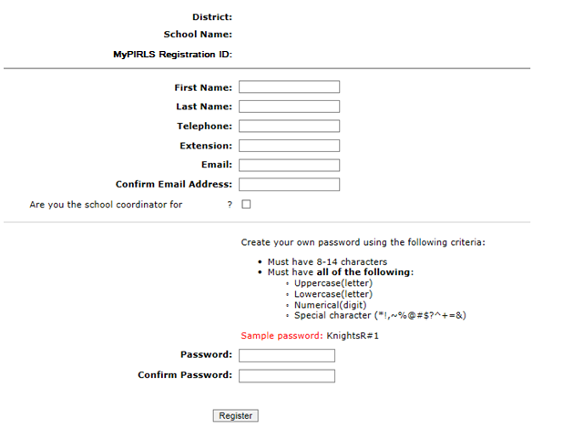
- Then, create a password that meets the password criteria and click Register.
- Once created, your username will be emailed to you. Your username is not your email address.
If you check the “Are you the school coordinator for?” box, you will get an additional email with a summary of upcoming activities.

Provide School Information (PSI)
The first step in MyPIRLS is to complete the Provide School Information page. Click the Provide School Information link at the left-hand menu to access this page.
On the PSI page, the information on the left is the current information available for your school. Please make updates in the fields on the right if the current information on the left is blank or incorrect. Make sure to complete both the “School Contact Information” and “School Characteristics” sections. Then click Save.
Note: You will see this red text banner below until all required fields are filled out completely:
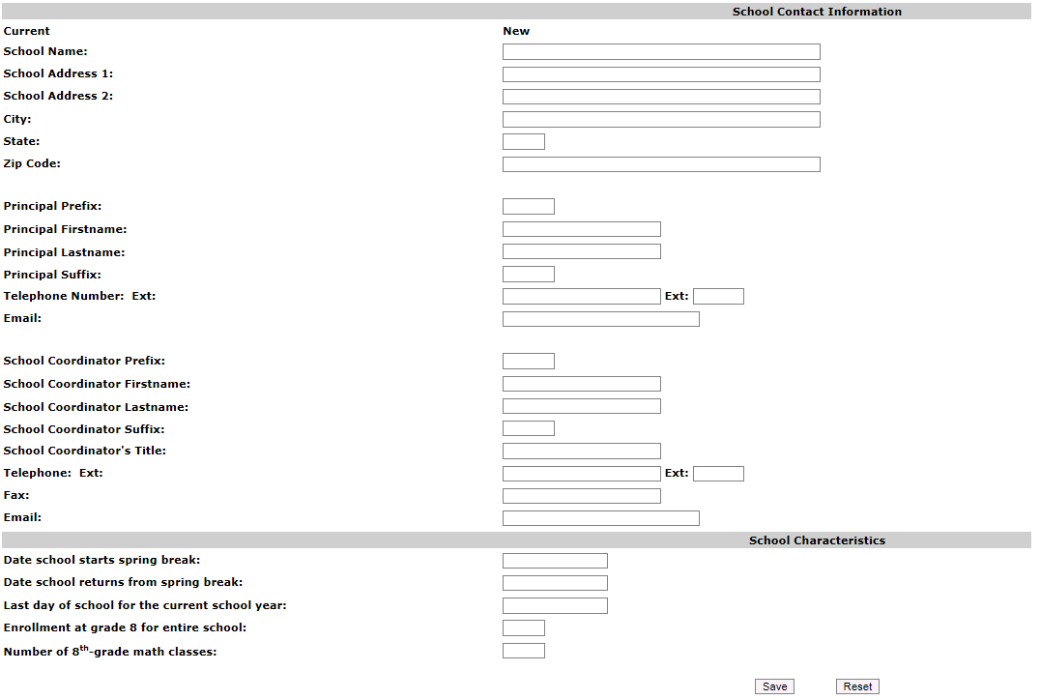
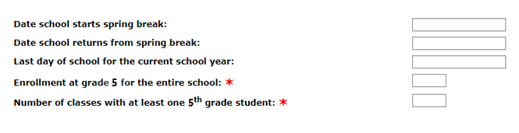
Once complete, you will see this blue text bar shown below at the top of the page.

MyPIRLS Registration Page

MyPIRLS Provide School Information (PSI) Page
IES Logo
Provide School Information
School Name: District:
State: Submitted by:
Please review and complete the form below to ensure that PIRLS has the most up-to-date information about your school. Some fields are filled in already. Please edit these if they are incorrect.
*This section is incomplete, please review the 10 missing fields below. (✶)

Automated Email for all MyPIRLS registrants
(Yellow highlight for merge data fields)
Greetings,
Thank you for creating a MyPIRLS account for the Progress in International Reading Literacy Study (PIRLS). To access MyPIRLS, go to www.MyPIRLS.com and enter your username and password.
Username: [username]
Password information: You created your own password upon registering. Use the "Forgot Password" links on the MyPIRLS login page if needed. You will be prompted to change your password after 90 days.
MyPIRLS is a secure site that contains confidential information, so it is important to remember your username and password. If you choose to write down this information, store it in a secure place.
The PIRLS Help Desk is open Monday through Friday between 9 a.m. and 5:00 p.m. ET. If you have questions or need help accessing the website, please contact the PIRLS Help Desk at [PIRLS E-File phone number] or by email at [PIRLS E-File email].
Sincerely,
The PIRLS Team
The National Center for Education Statistics (NCES) is authorized to conduct this study under the Education Sciences Reform Act of 2002 (ESRA 2002, 20 U.S.C. §9543), and to collect students’ education records from educational agencies or institutions for the purpose of evaluating federally supported education programs under the Family Educational Rights and Privacy Act (FERPA, 34 CFR §§ 99.31(a)(3)(iii) and 99.35). All of the information provided by school staff and students may be used only for statistical purposes and may not be disclosed, or used, in identifiable form for any other purpose except as required by law (20 U.S.C. §9573 and 6 U.S.C. §151). In the United States, PIRLS is conducted by NCES, part of the U.S. Department of Education, and the data are being collected by Westat. The U.S. Office of Management and Budget has approved the data collection under OMB # 1850-0645.

Automated Email for MyPIRLS School Coordinator registrant
(Yellow highlight for merge data fields; red font for customization)
Dear [school coordinator],
Thank you for creating a MyPIRLS account for the Progress in International Reading Literacy Study (PIRLS) on www.MyPIRLS.com. MyPIRLS is a secure website for sharing information and files related to your school’s participation in PIRLS 2021. The website’s "What You Need to Do" menu will guide you through the upcoming PIRLS activities.
The first step is to complete the Provide School Information page. If you have not already done so, please go to https://www.MyPIRLS.com/ProvideSchoolInformation.aspx.
In September, you will need to provide a complete and current list of all of your school’s fifth-grade classes for the PIRLS team to randomly select two classes to participate in PIRLS. You will then be asked to submit lists of all students in the selected reading classes. We will email you in early September with instructions about how to submit the class list, student list, and teacher list through www.MyPIRLS.com.
Please see the attached PIRLS Brochure and Summary of School Activities for a complete list of activities associated with your school’s participation in PIRLS.
Thank you very much for participating in PIRLS and for playing a key role in making the assessment a success in [school name]!
Sincerely,
The PIRLS Team
Attachment: PIRLS Brochure and Summary of School Activities
The National Center for Education Statistics (NCES) is authorized to conduct this study under the Education Sciences Reform Act of 2002 (ESRA 2002, 20 U.S.C. §9543), and to collect students’ education records from educational agencies or institutions for the purpose of evaluating federally supported education programs under the Family Educational Rights and Privacy Act (FERPA, 34 CFR §§ 99.31(a)(3)(iii) and 99.35). All of the information provided by school staff and students may be used only for statistical purposes and may not be disclosed, or used, in identifiable form for any other purpose except as required by law (20 U.S.C. §9573 and 6 U.S.C. §151). In the United States, PIRLS is conducted by NCES, part of the U.S. Department of Education, and the data are being collected by Westat. The U.S. Office of Management and Budget has approved the data collection under OMB # 1850-0645.

MyPIRLS Login Page
IES Logo
MyPIRLS 2021
Login

MyPIRLS is a restricted-use website that contains information on the Progress in International Reading Literacy Study (PIRLS).

Existing User Login First time visiting the site?
Schools can register now!
User Name: Please register
Password:
Forgot Password | Having trouble logging in?
Log In

The National Center for Education Statistics (NCES) is authorized to conduct this study under the Education Sciences Reform Act of 2002 (ESRA 2002, 20 U.S.C. §9543), and to collect students’ education records from educational agencies or institutions for the purpose of evaluating federally supported education programs under the Family Educational Rights and Privacy Act (FERPA, 34 CFR §§ 99.31(a)(3)(iii) and 99.35). All of the information you provide may be used only for statistical purposes and may not be disclosed, or used, in identifiable form for any other purpose except as required by law (20 U.S.C. §9573 and 6 U.S.C. §151). The U.S. Office of Management and Budget has approved the data collection under OMB # 1850-0645.
According to the Paperwork Reduction Act of 1995, no persons are required to respond to a collection of information unless such collection displays a valid OMB control number. The valid OMB control number for this voluntary information collection is 1850-0645. The time required to complete this information collection and participate in study activities is estimated to average 240 minutes per school coordinator, including the time to review instructions, search existing data resources, gather the data needed, and complete and review the information collection. If you have any comments or concerns regarding the accuracy of the time estimate(s), suggestions for improving the form, or questions about the status of your individual submission of this form, write directly to: Progress in International Reading Literacy Study (PIRLS), National Center for Education Statistics, Potomac Center Plaza (PCP), 550 12th St., SW, 4th floor, Washington, DC 20202.
OMB No. 1850-0645, Approval Expires 5/31/2023.

Notice: You are accessing a U.S. Government information system.
This warning banner provides privacy and security notices consistent with applicable federal laws, directives, and other federal guidance for accessing this Government system, which includes all devices/storage media attached to this system. This system is provided for Government-authorized use only. Unauthorized or improper use of this system is prohibited and may result in disciplinary action and/or civil and criminal penalties.

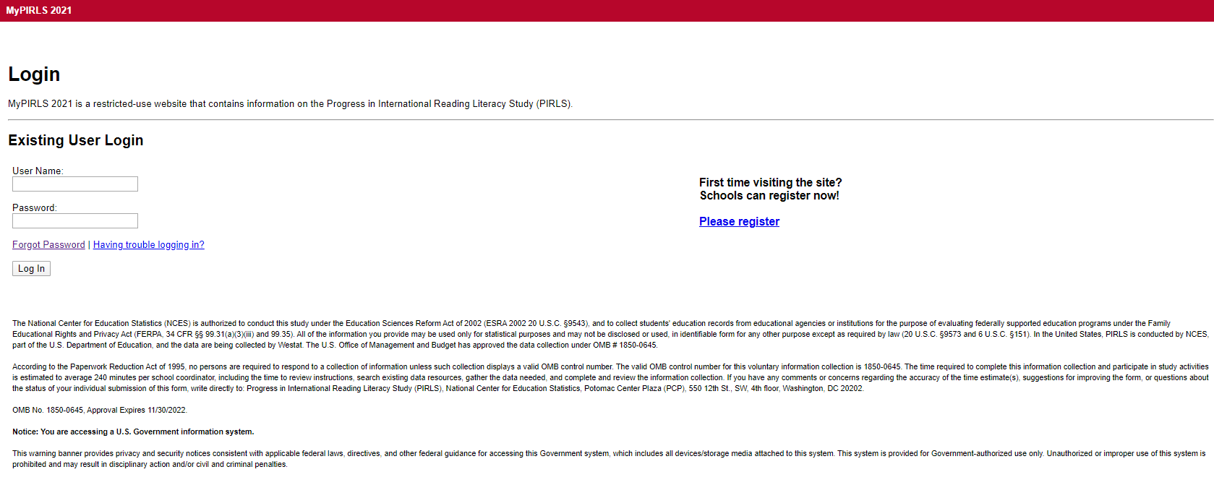

MyPIRLS Home Page
IES Logo
Welcome to PIRLS 2021!
Your school is participating the Progress in International Reading Literacy Study (PIRLS) to be conducted in 2021 in grade 5. Selected fifth grade classes will take a paper-and-pencil or digitally-based assessment of reading.
This website will help school coordinators prepare for the upcoming PIRLS assessment. Each assessment will be administered by trained PIRLS representatives. Thank you for helping your school participate in this important assessment.
The "What You Need to Do" menu on the left will guide you through the preparation activities. You will need to visit this website several times throughout the next few months, so remember your MyPIRLS username and password. You will be asked to update your password every 90 days. Use the left-hand menu to complete the tasks listed below.
- Provide School Information—Fall 2020
- Submit Class List—September 2021
- Submit Student List—September 2021
- Prepare for Assessment—September 2021
The following tutorial videos are designed to explain each step of the process:
- Register and Provide School Information
- Submit Class List
- Submit Student List

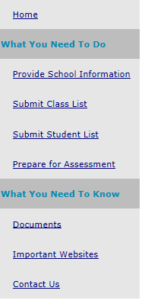

Email to School Coordinator (SC) to Submit Class and Student Lists
(yellow highlight for mail merge; red for customization)
IES Logo

Dear [SC First Name] [SC Last Name],

The PIRLS team needs a complete and current list of all of your school’s fifth-grade classes in order to randomly select classes to participate in the 2021 Progress in International Reading Literacy Study (PIRLS).
Please go to www.MyPIRLS.com. After logging in, select Submit Class List from the left hand panel to provide information about your fifth-grade reading classes. Instructions for submitting class and student lists and a guide for student accommodations are attached. These documents can also be found in the Resources section of the MyPIRLS website.

Once you have provided information about all fifth-grade reading classes, the PIRLS team will email you the names of the selected classes within 5-7 days. Then, PIRLS will need a complete and current list of all students in the selected classes only. Select Submit Student List to provide an electronic list of currently enrolled fifth-grade students in your school for the selected classes.

If you have any questions about submitting your lists or if you have forgotten your MyPIRLS login ID, please email or call the PIRLS Help Desk at [PIRLS E-File phone number] or by email at [PIRLS E-File email]. If you have forgotten your password, you can request a new password on the MyPIRLS login page.

Be sure to submit your class list by [date]. Thank you very much for participating in PIRLS and for submitting your school's class and student lists!

Sincerely,
The PIRLS Team
Attachments: Instructions for Submitting Class and Student Lists; Accommodations Guide

The National Center for Education Statistics (NCES) is authorized to conduct this study under the Education Sciences Reform Act of 2002 (ESRA 2002, 20 U.S.C. §9543), and to collect students’ education records from educational agencies or institutions for the purpose of evaluating federally supported education programs under the Family Educational Rights and Privacy Act (FERPA, 34 CFR §§ 99.31(a)(3)(iii) and 99.35). All of the information provided by school staff and students may be used only for statistical purposes and may not be disclosed, or used, in identifiable form for any other purpose except as required by law (20 U.S.C. §9573 and 6 U.S.C. §151). In the United States, PIRLS is conducted by NCES, part of the U.S. Department of Education, and the data are being collected by Westat. The U.S. Office of Management and Budget has approved the data collection under OMB # 1850-0645.

Email to School Coordinator (SC) to Submit Class and Student Lists—No PSI
(yellow highlight for mail merge; red for customization)

IES Logo

Dear [SC First Name] [SC Last Name],

The PIRLS team needs a complete and current list of all of your school’s fifth-grade classes in order to randomly select classes to participate in the 2021 Progress in International Reading Literacy Study (PIRLS).
Please go to www.MyPIRLS.com. After logging in, select Provide School Information from the left hand panel, and complete the bottom portion of the form with accurate fifth-grade enrollment and fifth-grade reading class counts. Then, select Submit Class List from the left hand panel to provide information about your fifth-grade reading classes. Instructions for submitting class and student lists and a guide for student accommodations are attached. These documents can also be found in the Resources section of the MyPIRLS website.

Once you have provided information about all fifth-grade reading classes, the PIRLS team will email you the names of the selected classes within 5-7 days. Then, PIRLS will need a complete and current list of all students in the selected classes only. Select Submit Student List to provide an electronic list of currently enrolled fifth-grade students in your school for the selected classes.

If you have any questions about submitting your lists or if you have forgotten your MyPIRLS login ID, please email or call the PIRLS Help Desk at [PIRLS E-File phone number] or by email at [PIRLS E-File email]. If you have forgotten your password, you can request a new password on the MyPIRLS login page.

Be sure to submit your class list by [date]. Thank you very much for participating in PIRLS and for submitting your school's class list and student lists.

Sincerely,
The PIRLS Team
Attachments: Instructions for Submitting Class and Student Lists; Accommodations Guide

The National Center for Education Statistics (NCES) is authorized to conduct this study under the Education Sciences Reform Act of 2002 (ESRA 2002, 20 U.S.C. §9543), and to collect students’ education records from educational agencies or institutions for the purpose of evaluating federally supported education programs under the Family Educational Rights and Privacy Act (FERPA, 34 CFR §§ 99.31(a)(3)(iii) and 99.35). All of the information provided by school staff and students may be used only for statistical purposes and may not be disclosed, or used, in identifiable form for any other purpose except as required by law (20 U.S.C. §9573 and 6 U.S.C. §151). In the United States, PIRLS is conducted by NCES, part of the U.S. Department of Education, and the data are being collected by Westat. The U.S. Office of Management and Budget has approved the data collection under OMB # 1850-0645.

Email to School Coordinator (SC) with Selected Classes – No Student List
(yellow highlight for mail merge; red for customization)
IES Logo

Greetings,

Thank you for providing a list of your 5th-grade reading classes! PIRLS now needs a complete and current list of all 5th-grade students in the classes that have been randomly selected to participate in the study.

The selected classes are as follows:

Class 1
Class 2

Please go to https://www.mypirls.com to submit your student lists. In case you have forgotten, your user id is usually your last name + the first initial of your first name (e.g., JohnsonB for Britney Johnson). You can also contact the PIRLS Help Desk at [PIRLS E-File phone number] or by email at [PIRLS E-File email] to request your username. If you have forgotten your password, you can request a new password by clicking the ‘forgot password’ link on the MyPIRLS login page.
After logging in, select Submit Student List from the left hand panel to provide information about the selected classes. Instructions for how to submit the student list and Excel templates are attached to this email. Please create your list using the Excel template that works best for you.
Student lists need to be submitted by [date]. PIRLS will then process your submission, and you will receive parent notification materials in the mail.

If you have any questions about submitting your lists, please email or call the PIRLS Help Desk at [PIRLS E-File phone number] or by email at [PIRLS E-File email] between 9-5pm ET, Monday through Friday.

Thank you very much for participating in PIRLS and for submitting your school's student lists!

Sincerely,

The PIRLS Team

Attachments: Instructions for Submitting Class and Student Lists
PIRLS FT Submit Student List Template 1
PIRLS FT Submit Student List Template 2

The National Center for Education Statistics (NCES) is authorized to conduct this study under the Education Sciences Reform Act of 2002 (ESRA 2002, 20 U.S.C. §9543), and to collect students’ education records from educational agencies or institutions for the purpose of evaluating federally supported education programs under the Family Educational Rights and Privacy Act (FERPA, 34 CFR §§ 99.31(a)(3)(iii) and 99.35). All of the information provided by school staff and students may be used only for statistical purposes and may not be disclosed, or used, in identifiable form for any other purpose except as required by law (20 U.S.C. §9573 and 6 U.S.C. §151). In the United States, PIRLS is conducted by NCES, part of the U.S. Department of Education, and the data are being collected by Westat. The U.S. Office of Management and Budget has approved the data collection under OMB # 1850-0645.

Email to School Coordinator (SC) with Selected Classes – Student List Submitted
(yellow highlight for mail merge; red text for customization)
IES Logo

Greetings,

Thank you for providing a list of your 5th-grade reading classes and submitting your school’s student list! The following classes have been randomly selected to participate in the study:

Class 1
Class 2

We will be in touch soon if we have any questions about what you have submitted. Otherwise, we will contact you by [Date] with next steps. As always, don’t hesitate to reach out to us with any questions you may have.

Sincerely,

The PIRLS Team

The National Center for Education Statistics (NCES) is authorized to conduct this study under the Education Sciences Reform Act of 2002 (ESRA 2002, 20 U.S.C. §9543), and to collect students’ education records from educational agencies or institutions for the purpose of evaluating federally supported education programs under the Family Educational Rights and Privacy Act (FERPA, 34 CFR §§ 99.31(a)(3)(iii) and 99.35). All of the information provided by school staff and students may be used only for statistical purposes and may not be disclosed, or used, in identifiable form for any other purpose except as required by law (20 U.S.C. §9573 and 6 U.S.C. §151). In the United States, PIRLS is conducted by NCES, part of the U.S. Department of Education, and the data are being collected by Westat. The U.S. Office of Management and Budget has approved the data collection under OMB # 1850-0645.

Instructions for Submitting Class and Student Lists- Grade 5

IES Logo

Submit Class List and Student List Instructions
Instructions for preparing and submitting Class and student lists through MyPIRLS.com

Table of Contents

Instructions for Submitting the Class List 2
1. Navigate to the Submit Class List page and form. 2
2. Enter class information. 2
3. Save each row. 3
4. Check the data. 3
5. Submit the Class List. 3
Table of Class List Field Descriptions 4
Class List Form 5
Instructions for Submitting the Student List 6
1. Prepare the Excel file. 6
2. Upload the Excel file. 7
3. Identify column headings. 7
4. Match values to PIRLS codes. 9
5. Verify Student List data. 9

Instructions for Submitting the Class List

The PIRLS team needs a complete and current list of all of your school’s fifth-grade reading classes in order to randomly select reading classes to be assessed. Typically, two classes are sampled in each school, and all students in the selected classes are assessed. Submit your class list; then, the PIRLS team will email you the list of selected classes. After you receive the list of selected classes, you will be asked to submit a student list naming all students in the selected classes only.

  - Navigate to the Submit Class List page and form.

Go to www.MyPIRLS.com and log in. On www.MyPIRLS.com, select Submit Class List from the navigation menu on the left. The table on the page provides a description of all information that is needed. Scroll down to enter information for each fifth-grade class in the form at the bottom of the page.

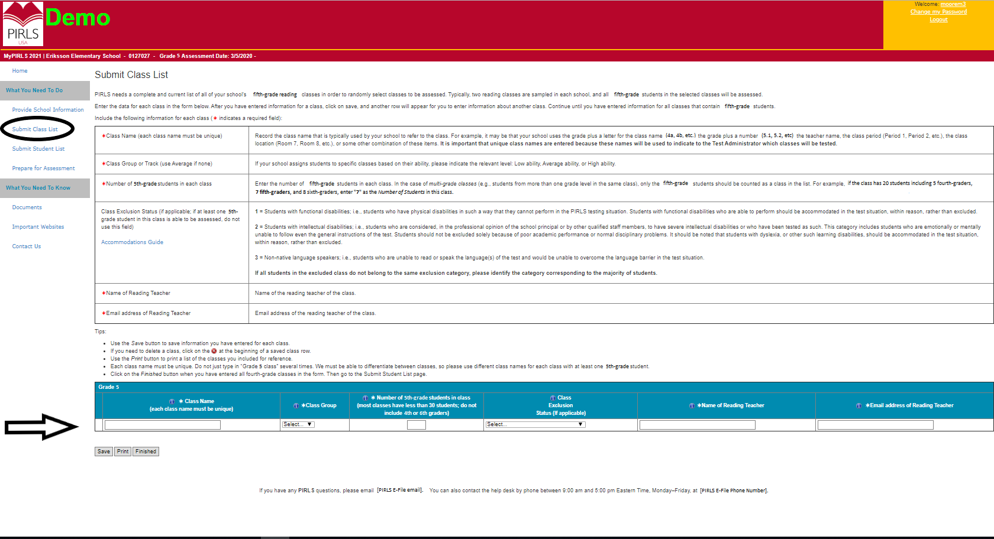

  - Enter class information.

- Class Name: Each class name must be unique and descriptive, e.g. “Mrs. Johnson’s 5th grade class”. Again, each row must have a different class name.
- Number of 5th grade students in the class: Use current and accurate counts. Do not include students in other grade levels.
- Class Exclusion Status: Include all classes in the list, even if the students in those classes are typically excluded from your state testing program or take alternate assessments. If all students in a class should be excluded because no students in the class would be able to take the assessment with or without the allowed accommodations, you can indicate this by selecting the appropriate Class Exclusion Status code. Only use this field if every student in a class cannot take the PIRLS assessment with or without the allowed accommodations.
- Name of Reading Teacher: Include the name of the reading teacher.
- Email address of Reading Teacher: Include the email address for the reading teacher. We will use this information to send a questionnaire to the teacher of the selected class(es).

  - Save each row.

After you have entered information for one class, click the Save button, and another row will appear for you to enter information about the next class. If you have not completely filled out a row, you may get a warning message at the top of the screen that the data must be fixed and resaved. Continue until you have entered information for all reading classes that contain fifth-grade students.

  - Check the data.

The total number of students listed on the class list form should match the fifth-grade enrollment count in your school, which was entered on the Provide School Information (PSI) page, unless the enrollment has changed since the PSI page was submitted. If your counts do not match, check to ensure that all classes and their correct enrollment counts have been listed. Make updates to the class list form and/or PSI page as needed.

- Submit the Class List.

Once you have entered information for all fifth-grade classes in your school, click Save and then click Finished.

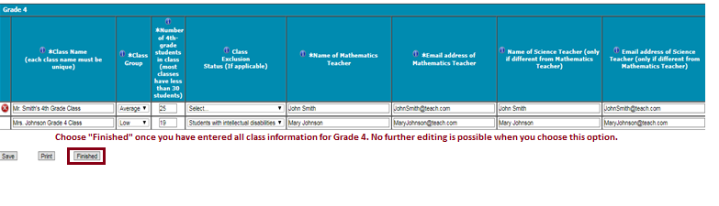
Once finished, the PIRLS team will email you the list of grade 5 reading classes that are selected to participate within 5-7 business days. Then, you can submit a student list for the selected classes only.

Table of Class List Field Descriptions

The table on the submit class list page provides a description of the information that is needed.

✶Class Name (each class name must be unique) | Record the class name that is typically used by your school to refer to the class. For example, it may be that your school uses the grade plus a letter for the class name (5a, 5b, etc.), the grade plus a number (5.1, 5.2, etc.), the teacher name, the class period (Period 1, Period 2, etc.), the class location (Room 7, Room 8, etc.), or some other combination of these items. It is important that unique class names are entered because these names will be used to inform the Test Administrator of which classes will be tested.
✶Number of 5th-grade students in each class | Enter the number of fifth-grade students in each class. In the case of multi-grade classes (e.g., students from more than one grade level in the same class), only the fifth-grade students should be counted as a class in the list. For example, if the class has 20 students including 5 fourth-graders, 7 fifth-graders, and 8 sixth-graders, enter “7” as the Number of Students in this class.
Class Exclusion Status (if applicable; if at least one 5th-grade student in this class is able to be assessed, do not use this field)  Accommodations Guide | 1 = Students with functional disabilities; i.e., students who have physical disabilities in such a way that they cannot perform in the PIRLS testing situation. Students with functional disabilities who are able to perform should be accommodated in the test situation, within reason, rather than excluded.  2 = Students with intellectual disabilities; i.e., students who are considered, in the professional opinion of the school principal or by other qualified staff members, to have severe intellectual disabilities or who have been tested as such. This category includes students who are emotionally or mentally unable to follow even the general instructions of the test. Students should not be excluded solely because of poor academic performance or normal disciplinary problems. It should be noted that students with dyslexia, or other such learning disabilities, should be accommodated in the test situation, within reason, rather than excluded.  3 = Non-native language speakers; i.e., students who are unable to read or speak the language(s) of the test and would be unable to overcome the language barrier in the test situation.  If all students in the excluded class do not belong to the same exclusion category, please identify the category corresponding to the majority of students.
✶Name of Reading Teacher | Name of the reading teacher for the class.
✶Email address of Reading Teacher | Email address of the reading teacher for the class.

Class List Form

Enter information for each fifth-grade class in the form at the bottom of the submit class list page. You can hover your mouse cursor over the Information symbol  to get more information about each field and its requirements. The white asterisks indicate which fields are required. Enter class details; then, click Save after each row. The row will not save if an error occurs. If you see an error message, please correct the text in that row, and save it again to activate a new row. Continue to click Save and make sure to click Save after you enter the last class. Do not click Finished until after you click Save one last time and there are no error messages.

Tips:
- Use the Save button to save information you have entered for each class.
- If you need to delete a class, click the  at the beginning of a saved class row.
- Use the Print button to print a list of the classes you included for reference.
- Each class name must be unique. Do not just type in “Grade 5 class” several times. We must be able to differentiate between classes, so please use different class names for each reading class with at least one 5th-grade student.
- Click the Finished button when you have entered and saved all fifth-grade reading classes in the form.
- Go to the Submit Student List page and submit the student list if you have less than 50 fifth-grade students enrolled in your school. If you have more than 50 fifth-grade students, wait until you receive an email from us with the list of randomly selected classes.

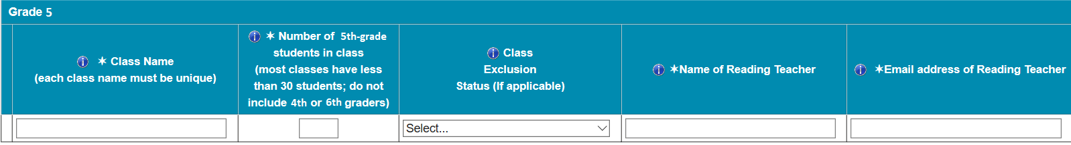

If you need assistance, call [PIRLS E-File phone number] or email [PIRLS E-File email].

Instructions for Submitting the Student List

Along with the list of classes, PIRLS needs a complete and current list of all students in the classes that are randomly selected to participate. You can only submit the student list after you have submitted the class list.

  - Prepare the Excel file.
Your student list must be submitted as a Microsoft Excel file. Click the Submit Student List link to get started. You may use the student list Excel Template we provide on the Submit Student List page and the Documents page on https://www.MyPIRLS.com, or you may provide an Excel file with the same information. Include the following information for each student:
- Student Name: The preferred format is First Name, Middle Name (or Initial), and Last Name in separate columns; however, MyPIRLS will accept student names in one column.
- Sex: Codes for Male/Female.
- Date of Birth: The preferred format is Month of Birth and Year of Birth in separate columns; however, MyPIRLS will accept Date of Birth in one column.
- Student with a Disability Status: Use 1=Yes, student has disability and/or IEP; 2=No, student does not have disability or IEP.
- English Language Learner Status: Use 1=Yes, student is ELL; 2=No, student is formerly ELL; 3=No, student is not ELL.
- Class Name: Please use the same unique class names for reading classes that you used on the Submit Class List page. You can copy and paste the class names from the class list form so that the text matches exactly. We will only assess students in the selected reading classes that were emailed to you. You do not need to list students in the other reading classes.
- Teacher Name: Reading teacher of the named class.
- Teacher Email: Reading teacher’s work email address.
- Student Current Grade Level: Please indicate the students’ current grade levels. We will only assess the 5th grade students in the selected reading classes. You do not need to list students in other grade levels.
It is preferred that you include column headers as the first row in your student list (see templates for examples in the Documents section on https://www.MyPIRLS.com). However, student lists without column headers will be accepted. If you cannot submit your student data with this information in an Excel file, please call or email the PIRLS Help Desk at [PIRLS E-File phone number] or [PIRLS E-File email]. Please save this file with your school name and district in the file name.

The following tips will help to ensure that the student list submission process goes smoothly:
- Use the template or provide column headers. Student information should begin on the second row. There should be no empty rows within the student data. Do not provide any other student information.
- Be sure to give your file a unique, descriptive name. Within Excel, click on File, then Save As, and give your file a name such as “Your School Name Grade 5 PIRLS.xls.” Save this file in a secure location.
- The first row of data in your file will be read as the column header unless you indicate otherwise on the Submit Student List page. Each succeeding row will be considered a student record.
- There should be only one worksheet with data in the Excel file. If there are other worksheets, they should not contain any data.
  - Upload the Excel file.

Once you have finished creating your student list, scroll towards the bottom of the page, and click Yes or No to indicate whether or not you have included column headers in your Excel file (first row in file says, “student name, sex, date of birth,” etc.).
Then, click Browse to locate the Excel file on your computer. Once, the Excel file is selected, click Upload.

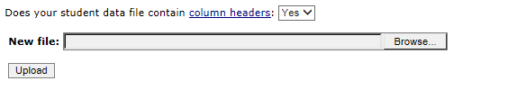

  - Identify Column Headings

The PIRLS team needs to know what information is in each column of your student list. If you provided column headers in your student list (preferred), they are displayed in the Column Heading Is column in the table. If you did not provide column headers, the Column Heading Is column will contain numbers for each column in your submitted student list. Click on the down arrows in the Your Column Contains column to select descriptions for each column header. If there is no appropriate description in the drop-down list, please select N/A.
Once finished, click Next.

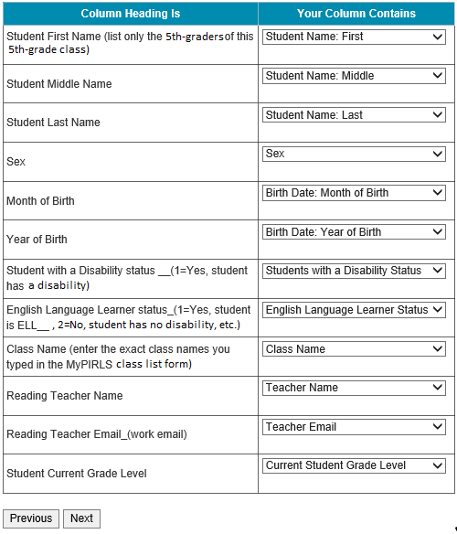

You can always come back to the Identify Columns page by clicking on the file name link on the Submit Student List page:
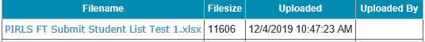

  - Match values to PIRLS codes.
The PIRLS team needs to know the meaning of the values for the data in each of the columns in your student list. The tables on the next few web pages contain the following information for each column with values that must match PIRLS codes:
- Your Values - the values in your student list,
- Codes - the PIRLS Codes that best match Your Values,
- Number - the number of students in your student list with that value, and
- Percentage - the percentage of students in your student list with that value.
Begin with the gender column, and use the Previous and Next buttons to navigate from column to column.
If there is an error in your data file, exit the student list, correct the problem in your Excel file, and upload the corrected file.
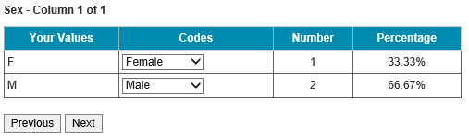
  - Verify Student List data.
After matching your values to PIRLS codes, you can review the percentages on the Verify your E-File page to ensure your file is correct. The table on this page summarizes the information you have provided on your student list. Please review this summary and verify that the number and percentage of students in the student list with the given values are correct. Also, the total enrollment at the bottom of the table should match the number of students entered in your student list.
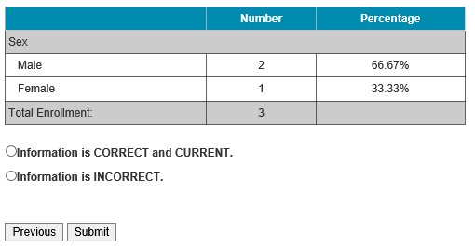
Record whether the information is correct or incorrect by selecting the appropriate button at the bottom of the page. Then, click the Submit button. If you select incorrect, you will need to correct your student list and resubmit it.
Once you click submit, you will see a message that says, “Thank you for submitting your student list! A PIRLS representative will contact you to make arrangements for the assessment.”

Submit Class List Page

Submit Class List
PIRLS needs a complete and current list of all of your school’s fifth-grade reading classes in order to randomly select classes to be assessed. Typically, two reading classes are sampled in each school, and all fifth-grade students in the selected classes will be assessed.
Enter the data for each class in the form below. After you have entered information for a class, click on save, and another row will appear for you to enter information about another class. Continue until you have entered information for all classes that contain fifth-grade students.
Include the following information for each class (✶ indicates a required field):
✶Class Name (each class name must be unique) | Record the class name that is typically used by your school to refer to the class. For example, it may be that your school uses the grade plus a letter for the class name (5a, 5b, etc.), the grade plus a number (5.1, 5.2, etc.), the teacher name, the class period (Period 1, Period 2, etc.), the class location (Room 7, Room 8, etc.), or some other combination of these items. It is important that unique class names are entered because these names will be used to indicate to the Test Administrator which classes will be tested.
✶Number of 5th-grade students in each class | Enter the number of fifth-grade students in each class. In the case of multi-grade classes (e.g., students from more than one grade level in the same class), only the fifth-grade students should be counted as a class in the list. For example, if the class has 20 students including 5 fourth-graders, 7 fifth-graders, and 8 sixth-graders, enter “7” as the Number of Students in this class.
Class Exclusion Status (if applicable; if at least one 5th-grade student in this class is able to be assessed, do not use this field)  Accommodations Guide | 1 = Students with functional disabilities; i.e., students who have physical disabilities in such a way that they cannot perform in the PIRLS testing situation. Students with functional disabilities who are able to perform should be accommodated in the test situation, within reason, rather than excluded.  2 = Students with intellectual disabilities; i.e., students who are considered, in the professional opinion of the school principal or by other qualified staff members, to have severe intellectual disabilities or who have been tested as such. This category includes students who are emotionally or mentally unable to follow even the general instructions of the test. Students should not be excluded solely because of poor academic performance or normal disciplinary problems. It should be noted that students with dyslexia, or other such learning disabilities, should be accommodated in the test situation, within reason, rather than excluded.  3 = Non-native language speakers; i.e., students who are unable to read or speak the language(s) of the test and would be unable to overcome the language barrier in the test situation.  If all students in the excluded class do not belong to the same exclusion category, please identify the category corresponding to the majority of students.
✶Name of Reading Teacher | Name of the reading teacher of the class
✶Email address of Reading Teacher | Email address of the reading teacher of the class

Tips:
- Use the Save button to save information you have entered for each class.
- If you need to delete a class, click on the at the beginning of a saved class row.
- Use the Print button to print a list of the classes you included for reference.
- Each class name must be unique. Do not just type in “Grade 5 class” several times. We must be able to differentiate between classes, so please use different class names for each class with at least one 5th-grade student.
- Click on the Finished button when you have entered all fifth-grade classes in the form. Then go to the Submit Student List page.

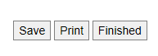

Submit Student List Page

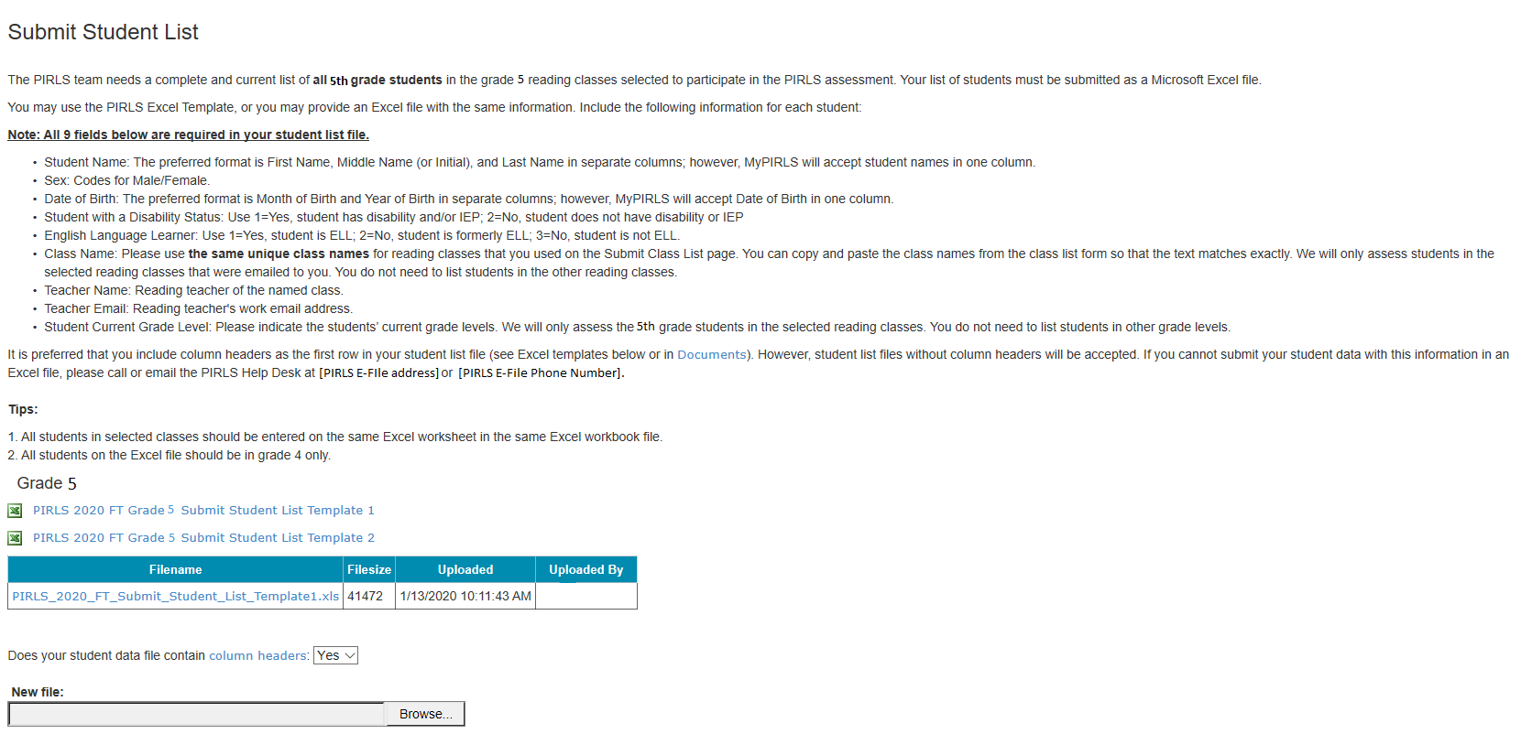

MyPIRLS Prepare for Assessment Page
(yellow highlight for merge field)

Prepare For Assessment
Thank you for providing information about all students in the classes selected to participate in the PIRLS assessment. Return to this webpage when you receive the email from PIRLS@westat.com stating that the Student Tracking Forms (STFs) are available on the MyPIRLS site.
Please note below:
Each STF has the list of students in the selected class and their teachers.
Schools with small classes or multi-grade classes may have more than two classes selected, so please check to see if there is more than two pages in the STF PDF file.
----------------------------------------------------------------
Student Tracking Form (download all if more than one link is shown)
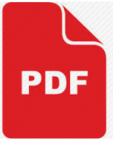 Click here to download the STF
- Student Tracking Form (STF) – The forms list the students who have been selected to participate in the assessment at your school. Instructions on how to access and review the forms are in the Resources section on this website.
- FedEx Package – You will receive a packet of PIRLS materials in the mail including a sample parent/guardian notification letter, a PIRLS Facts for Parents document, a copy of the Accommodations Guide, and a red storage envelope. Please review it prior to speaking with the Test Administrator.
A sample parent/guardian notification letter is in the Resources section for you to customize and print on your school letterhead. Please distribute the parent notification letter and the Facts for Parents about PIRLS to the parents of the selected students prior to the assessment. A Spanish version of the letter and Facts for Parents are also available in the Resources page.
As your assessment date approaches, your Test Administrator will be contacting you to finalize the assessment day activities.

Questionnaire Completion Statuses
Please review the completion status for each questionnaire, and prompt the administrator and teachers to complete the questionnaires as needed.
Recipient | Questionniare Type | Status
[Principal Name] | School | [OSS Status]
[Teacher Name] | Teacher | [OSS Status]
[Teacher Name] | Teacher | [OSS Status]

Student Tracking Form (STF) Email

IES Logo

Dear School Coordinator,
Thank you for providing information about all the fifth-grade classes in your school! The list of students selected to participate in PIRLS is now available in the Student Tracking Form (STF) available on the MyPIRLS website. Please see below for more details about the forms and parent notification.
- Student Tracking Form (STF) –The forms list the students who have been selected to participate in the assessment at your school. Instructions on how to access and review the forms were emailed to you. There may be multiple pages in each PDF file.
- Sample Parent Notification Letter and Facts for Parents about PIRLS – A sample parent/guardian notification letter is attached to this email for you to customize and print on your school letterhead. Please distribute the parent notification letter and the Facts for Parents about PIRLS to the parents of the selected students prior to the assessment. A Spanish version of the letter is available on the MyPIRLS site in Documents.
- Questionnaire Statuses – Please review the completion status for each questionnaire, and prompt the administrator and teachers to complete the questionnaires as needed.
- FedEx Shipment – Within a week, you will receive a FedEx shipment containing the following:
  - Hard-copies of the Facts for Parents document and a sample parent notification letter – Alternatively, you can distribute them electronically. The document is available to be downloaded from this site: https://www.mypirls.com/Documents.aspx.
  - A red storage snvelope – Please use this envelope to store the Student Tracking Forms, if you choose to print them, and any other materials containing the sampled student names. Your PIRLS test administrator will ask to have access to this envelope on assessment day so that he or she can add additional materials after the assessment.
  - Accommodations Guide – Please review this document to prepare for students needing accommodations that are allowed by PIRLS. Have a list of necessary student accommodations ready when the PIRLS representative calls to discuss assessment day logistics.
As your assessment date approaches, your Test Administrator will be contacting you to finalize the assessment day activities and discuss accommodations, if necessary.
If you have any questions, please do not hesitate to call 1-855-951-1215 or send an email to PIRLS@westat.com. You may also get more information about this study by visiting the PIRLS website at https://nces.ed.gov/surveys/pirls/.
Thank you for your assistance with this study.
Sincerely,
The PIRLS Team
Attachments:
Sample Parent Notification Letter
Facts for Parents about PIRLS
Accommodations Guide

The National Center for Education Statistics (NCES) is authorized to conduct this study under the Education Sciences Reform Act of 2002 (ESRA 2002, 20 U.S.C. §9543), and to collect students’ education records from educational agencies or institutions for the purpose of evaluating federally supported education programs under the Family Educational Rights and Privacy Act (FERPA, 34 CFR §§ 99.31(a)(3)(iii) and 99.35). All of the information provided by school staff and students may be used only for statistical purposes and may not be disclosed, or used, in identifiable form for any other purpose except as required by law (20 U.S.C. §9573 and 6 U.S.C. §151). In the United States, PIRLS is conducted by NCES, part of the U.S. Department of Education, and the data are being collected by Westat. The U.S. Office of Management and Budget has approved the data collection under OMB # 1850-0645.

Student Tracking Form (STF) Memo

Dear School Coordinator,
Thank you for providing information about all the fifth-grade classes in your school! The list of students selected to participate in PIRLS is now available in the Student Tracking Form (STF) available on the MyPIRLS website. Please see below for more details about the forms and parent notification.
- Student Tracking Form (STF) –The forms list the students who have been selected to participate in the assessment at your school. Instructions on how to access and review the forms were emailed to you. There may be multiple pages in each PDF file.
- Sample Parent Notification Letter and Facts for Parents about PIRLS – A sample parent/guardian notification letter was attached to the email you received for you to customize and print on your school letterhead. Please distribute the parent notification letter and the Facts for Parents about PIRLS to the parents of the selected students prior to the assessment. A Spanish version of the letter is available on the MyPIRLS site in Documents.
- FedEx Shipment – Within a week, you will receive a FedEx shipment containing the following:
  - Hard-copies of the Facts for Parents document and a sample parent notification letter – Alternatively, you can distribute them electronically. The document is available to be downloaded from this site: https://www.mypirls.com/Documents.aspx.
  - A red storage snvelope – Please use this envelope to store the Student Tracking Forms, if you choose to print them, and any other materials containing the sampled student names. Your PIRLS test administrator will ask to have access to this envelope on assessment day so that he or she can add additional materials after the assessment.
  - Accommodations Guide – Please review this document to prepare for students needing accommodations that are allowed by PIRLS. Have a list of necessary student accommodations ready when the PIRLS representative calls to discuss assessment day logistics.
As your assessment date approaches, your Test Administrator will be contacting you to finalize the assessment day activities and discuss accommodations, if necessary.
If you have any questions, please do not hesitate to call 1-855-951-1215 or send an email to PIRLS@westat.com. You may also get more information about this study by visiting the PIRLS website at https://nces.ed.gov/surveys/pirls/.
Thank you for your assistance with this study.
Sincerely,
The PIRLS Team
Enclosures:
Sample Parent Notification Letter
Facts for Parents about PIRLS
Red Storage Envelope

The National Center for Education Statistics (NCES) is authorized to conduct this study under the Education Sciences Reform Act of 2002 (ESRA 2002, 20 U.S.C. §9543), and to collect students’ education records from educational agencies or institutions for the purpose of evaluating federally supported education programs under the Family Educational Rights and Privacy Act (FERPA, 34 CFR §§ 99.31(a)(3)(iii) and 99.35). All of the information provided by school staff and students may be used only for statistical purposes and may not be disclosed, or used, in identifiable form for any other purpose except as required by law (20 U.S.C. §9573 and 6 U.S.C. §151). In the United States, PIRLS is conducted by NCES, part of the U.S. Department of Education, and the data are being collected by Westat. The U.S. Office of Management and Budget has approved the data collection under OMB # 1850-0645.

Instructions for Reviewing the Student Tracking Form (STF)

Reviewing the Student Tracking Form (STF)

The Student Tracking Forms (STFs) list the students who have been selected to participate in the PIRLS assessment at your school. This list is based on the student information you submitted on the student list and is available as a PDF file. Please review all classes in the PDF file as there may be more than one class and multiple pages in the file. You can write notes on this form to prepare for the pre-assessment call at which time your PIRLS representative will ask you to provide information about any updated or corrected data. To access the STF, please login at www.MyPIRLS.com; then, go to Prepare for Assessment and select “Click here to download the STF”.

As the first step in reviewing the Student Tracking Form, please verify that the school name is correct. Next, review the student information below for accuracy:

- Students’ names are listed in Column 1.
- Dates of birth are listed in Column 4.
- Genders (using codes—1 for female and 2 for male) are listed in Column 5.
Student Exclusions and Accommodations
Your PIRLS representative will discuss selected students’ accommodation needs and possible exclusions in your pre-assessment call. Review the Accommodations Guide found in the MyPIRLS site Documents page for more information on the accommodations allowed by PIRLS.

Participation Status + Newly-enrolled or no-longer-enrolled students
If 4 or more of the students listed in the STF are not enrolled in the school, please contact PIRLS@westat.com as soon as possible. You do not need to contact PIRLS@westat.com if only 1 to 3 students are no longer enrolled or are newly enrolled. These new or no-longer-enrolled students can be discussed with your PIRLS representative when they call you for the pre-assessment call. You can make a note on the form regarding these students in the first column of section 7 using the status codes shown at the bottom of the STF.

Updates and Questions
If you have made updates to the STF, please have the form ready for the pre-assessment call with your PIRLS representative. Please do not send the STF back to us. You can, however, keep it in the red storage envelope and give it to the PIRLS representative when they come to your school on the assessment day. If you have any questions about completing this form, please address them with your PIRLS representative when they contact you. For urgent questions about the STF, you can also contact the PIRLS Help Desk (PIRLS@westat.com or 1-855-951-1215).

Student Tracking Form (STF) Template

digitalPIRLS STF
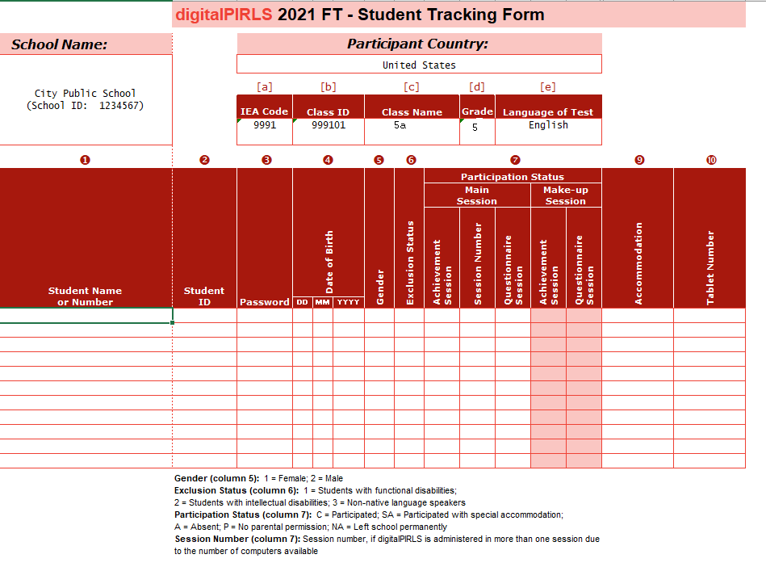

PIRLS (paper version) STF
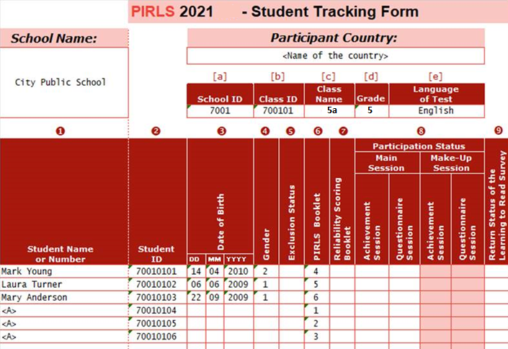

MyPIRLS Resources Page

Resources
General Information
- Brochure
- Frequently Asked Questions (FAQ)

Guides
- MyPIRLS Registration and Provide School Information (PSI) Guide
- Accommodations Guide
- Instructions for Submitting Class and Student Lists
- Submit Student List Template 1 (choose one template)
- Submit Student List Template 2 (choose one template)
- Instructions for Reviewing the Student Tracking Form (STF)

Parent Materials
- Facts for Parents about PIRLS
- Facts for Parents about PIRLS (Spanish)
- Multi-translation notice for Parents
- Sample Parent/Guardian Notification Letter
- Sample Parent/Guardian Notification Letter (Spanish)

MyPIRLS Important Websites and Contact Us Pages

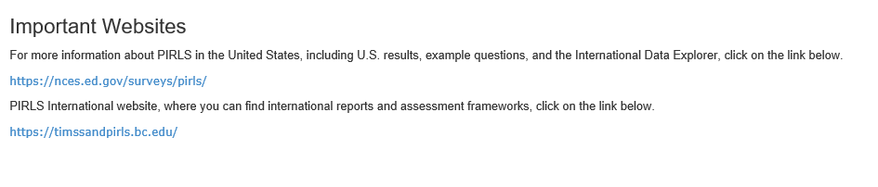
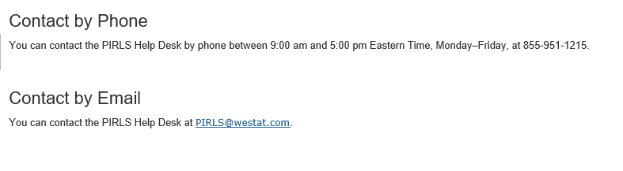

School Principal Questionnaire Selection Email
(yellow highlight for mail merge; red for customization)

Subject: Progress in International Reading Literacy Study: School Questionnaire
Welcome to PIRLS!

Your school is participating in the 2021 Progress in International Reading Literacy Study (PIRLS), an educational research project sponsored by the IEA (International Association for the Evaluation of Educational Achievement) through the National Center for Education Statistics (NCES) in the United States. PIRLS measures trends in student achievement in reading and studies differences in national education systems in more than 60 countries in order to help improve teaching and learning worldwide.

This online questionnaire seeks information about schools and provides important context to understanding the achievement of students taking the assessment. [School coordinator] has been assisting with PIRLS tasks at your school and can help you if you have questions. Please complete this questionnaire as soon as possible, and no later than [date].

Please go to the web address (URL) given below and log in to the online questionnaire with your “School User ID” and “Password”, which are shown below. Please contact the PIRLS Help Desk (PIRLS@westat.com) if you have problems logging on.

Website: https://portal.mypirls.com
School User ID: [ID]
Password: [Password]

Responses are saved automatically as you go from question to question. The “Table of Contents” link on the bottom of each page provides an overview of all questions and whether you have completed them. You may leave the questionnaire at any time and log in again later. You must click “Finish” on the last page for us to receive your submission. See notes at the bottom of this email below for more information.

Thank you for the thought, time, and effort you have put into completing the questionnaire!

Sincerely,
The PIRLS Team
NOTES
- Please use the Previous and Next buttons to navigate backward and forward.
- You may exit the questionnaire at any time and log in again later—all of your responses will be saved automatically.
- The Table of Contents provides an overview of all questions and shows whether you have completed each question.
- To exit the Table of Contents, click on any question link or section header.
- If you would like a printed copy of the online questionnaire, click on the “Prepare printer Version” link on the Table of Contents page.
- It is estimated that it will take approximately 35 minutes to complete the questionnaire.
- You must click “Finish” on the last page for us to receive your submission.
- If you are unable to access this questionnaire, please try using another browser instead. If your school is blocking this website, please try accessing the questionnaire from an off-site location.
- If you have problems accessing the online questionnaire or need assistance, please contact the PIRLS Help Desk at PIRLS@westat.com or 1-855-951-1215.
- If you would prefer to complete a paper questionnaire, please contact your PIRLS School Coordinator.

The National Center for Education Statistics (NCES) is authorized to conduct this study under the Education Sciences Reform Act of 2002 (ESRA 2002, 20 U.S.C. §9543), and to collect students’ education records from educational agencies or institutions for the purpose of evaluating federally supported education programs under the Family Educational Rights and Privacy Act (FERPA, 34 CFR §§ 99.31(a)(3)(iii) and 99.35). All of the information you provide may be used only for statistical purposes and may not be disclosed, or used, in identifiable form for any other purpose except as required by law (20 U.S.C. §9573 and 6 U.S.C. §151). In the United States, PIRLS is conducted by NCES, part of the U.S. Department of Education, and the data are being collected by Westat. The U.S. Office of Management and Budget has approved the data collection under OMB # 1850-0645.
Approval Expires 05/31/2023.

Teacher Questionnaire Selection Email
(yellow highlight for mail merge; red for customization)

Subject: Progress in International Reading Literacy Study: Teacher Questionnaire
Welcome to PIRLS!

Your school is participating in the 2021 Progress in International Reading Literacy Study (PIRLS), an educational research project sponsored by the IEA (International Association for the Evaluation of Educational Achievement) through the National Center for Education Statistics (NCES) in the United States. PIRLS measures trends in student achievement in reading and studies differences in national education systems in more than 60 countries in order to help improve teaching and learning worldwide.

This online questionnaire seeks information about teachers’ academic and professional backgrounds, classroom resources, instructional practices, and attitudes toward teaching. [School coordinator] has been assisting with PIRLS tasks at your school and can help you if you have questions. Please complete this questionnaire as soon as possible, and no later than [date].

If you are the reading teacher for more than one 5th grade class that is participating in PIRLS, you may be asked to complete more than one questionnaire. Please complete all of them. These additional questionnaires will contain a unique user ID. You will receive a $20 Amazon gift card code for each unique questionnaire that you finish. The user ID provided in this email is linked to student responses for [class name]. Please keep this particular class in mind when answering questions about your instructional practices.

Go to the web address (URL) given below and log in to the online questionnaire with your “User ID” and “Password,” which are shown below. Please contact the PIRLS Help Desk (PIRLS@westat.com) if you have problems logging on.

Website: https://portal.mypirls.com
User ID: [User ID]
Password: [Password]
Subject code: [Subject code]
Class to keep in mind when completing questionnaire: [Class name]

Responses are saved automatically as you go from question to question. The “Table of Contents” link on the bottom of each page provides an overview of all questions and whether you have completed them. You may leave the questionnaire at any time and log in again later. You must click “Finish” on the last page for us to receive your submission. See notes at the bottom of this email below for more information.

Thank you for the thought, time, and effort you have put into completing the questionnaire!

Sincerely,
The PIRLS Team

NOTES
- Please use the Previous and Next buttons to navigate backward and forward.
- You may exit the questionnaire at any time and log in again later—all of your responses will be saved automatically.
- The Table of Contents provides an overview of all questions and shows whether you have completed each question.
- To exit the Table of Contents, click on any question link or section header.
- If you would like a printed copy of the online questionnaire, click on the “Prepare printer Version” link on the Table of Contents page.
- It is estimated that it will take approximately 30 minutes to complete the questionnaire.
- You must click “Finish” on the last page for us to receive your submission.
- If you are unable to access this questionnaire, please try using another browser instead. If your school is blocking this website, please try accessing the questionnaire from an off-site location.
- If you have problems accessing the online questionnaire or need assistance, please contact the PIRLS help desk at PIRLS@westat.com or 1-855-951-1215.
- If you would prefer to complete a paper questionnaire, please contact your PIRLS School Coordinator.
- Within a few days of completing the questionnaire, you will receive a $20 Amazon gift card code from this email address as a token of appreciation for your participation.

The National Center for Education Statistics (NCES) is authorized to conduct this study under the Education Sciences Reform Act of 2002 (ESRA 2002, 20 U.S.C. §9543), and to collect students’ education records from educational agencies or institutions for the purpose of evaluating federally supported education programs under the Family Educational Rights and Privacy Act (FERPA, 34 CFR §§ 99.31(a)(3)(iii) and 99.35). All of the information you provide may be used only for statistical purposes and may not be disclosed, or used, in identifiable form for any other purpose except as required by law (20 U.S.C. §9573 and 6 U.S.C. §151). In the United States, PIRLS is conducted by NCES, part of the U.S. Department of Education, and the data are being collected by Westat. The U.S. Office of Management and Budget has approved the data collection under OMB # 1850-0645.
Approval Expires 05/31/2023.

School Principal Questionnaire Reminder Email
(yellow highlight for mail merge; red for customization)

Subject: Progress in International Reading Literacy Study: School Questionnaire - Reminder
Welcome to PIRLS!

We recently contacted you regarding an online questionnaire for the 2021 Progress in International Reading Literacy Study (PIRLS). Please take a few minutes to complete this important questionnaire that will provide context to the responses we receive from your students. [School coordinator] has been assisting with PIRLS tasks at your school and can assist you if you have questions. Please complete this questionnaire as soon as possible, and no later than [date].

Please go to the web address (URL) given below and log in to the online questionnaire with your “School User ID” and “Password”, which are shown below. Please contact the PIRLS Help Desk (PIRLS@westat.com) if you have problems logging on.

Website: https://portal.mypirls.com
School User ID: [ID]
Password: [Password]

Responses are saved automatically as you go from question to question. The “Table of Contents” link on the bottom of each page provides an overview of all questions and whether you have completed them. You may leave the questionnaire at any time and log in again later. You must click “Finish” on the last page for us to receive your submission. See notes at the bottom of this email below for more information.

Thank you for the thought, time, and effort you have put into completing the questionnaire!

Sincerely,
The PIRLS Team

NOTES
- Please use the Previous and Next buttons to navigate backward and forward.
- You may exit the questionnaire at any time and log in again later—all of your responses will be saved automatically.
- The Table of Contents provides an overview of all questions and shows whether you have completed each question.
- To exit the Table of Contents, click on any question link or section header.
- If you would like a printed copy of the online questionnaire, click on the “Prepare printer Version” link on the Table of Contents page.
- It is estimated that it will take approximately 35 minutes to complete the questionnaire.
- You must click “Finish” on the last page for us to receive your submission.
- If you are unable to access this questionnaire, please try using another browser instead. If your school is blocking this website, please try accessing the questionnaire from an off-site location.
- If you have problems accessing the online questionnaire or need assistance, please contact the PIRLS Help Desk at PIRLS@westat.com or 1-855-951-1215.
- If you would prefer to complete a paper questionnaire, please contact your PIRLS School Coordinator.

The National Center for Education Statistics (NCES) is authorized to conduct this study under the Education Sciences Reform Act of 2002 (ESRA 2002, 20 U.S.C. §9543), and to collect students’ education records from educational agencies or institutions for the purpose of evaluating federally supported education programs under the Family Educational Rights and Privacy Act (FERPA, 34 CFR §§ 99.31(a)(3)(iii) and 99.35). All of the information you provide may be used only for statistical purposes and may not be disclosed, or used, in identifiable form for any other purpose except as required by law (20 U.S.C. §9573 and 6 U.S.C. §151). In the United States, PIRLS is conducted by NCES, part of the U.S. Department of Education, and the data are being collected by Westat. The U.S. Office of Management and Budget has approved the data collection under OMB # 1850-0645.
Approval Expires 05/31/2023.

Teacher Questionnaire Reminder Email
(yellow highlight for mail merge; red for customization)

Subject: Progress in International Reading Literacy Study: Teacher Questionnaire - Reminder
Welcome to PIRLS!

This is a gentle reminder to please complete the 2021 Progress in Reading Literacy Study (PIRLS) online teacher questionnaire. This online questionnaire seeks information about teachers’ academic and professional backgrounds, classroom resources, instructional practices, and attitudes toward teaching. [School coordinator] has been assisting with PIRLS tasks at your school and can assist you if you have questions. Please complete this questionnaire as soon as possible, and no later than [date].

If you are the reading teacher for more than one 5th grade class that is participating in PIRLS, you may be asked to complete more than one questionnaire. Please complete all of them. These additional questionnaires will contain a unique user ID. You will receive a $20 Amazon gift card code for each unique questionnaire that you finish. The user ID provided in this email is linked to student responses for [class name]. Please keep this particular class in mind when answering questions about your instructional practices.

Go to the web address (URL) given below and log in to the online questionnaire with your “User ID” and “Password,” which are shown below. Please contact the PIRLS Help Desk (PIRLS@westat.com) if you have problems logging on.

Website: https://portal.mypirls.com
User ID: [User ID]
Password: [Password]
Subject code: [Subject code]
Class to keep in mind when completing questionnaire: [Class name]

Responses are saved automatically as you go from question to question. The “Table of Contents” link on the bottom of each page provides an overview of all questions and whether you have completed them. You may leave the questionnaire at any time and log in again later. You must click “Finish” on the last page for us to receive your submission. See notes at the bottom of this email below for more information.

Thank you for the thought, time, and effort you have put into completing the questionnaire!

Sincerely,
The PIRLS Team

NOTES
- Please use the Previous and Next buttons to navigate backward and forward.
- You may exit the questionnaire at any time and log in again later—all of your responses will be saved automatically.
- The Table of Contents provides an overview of all questions and shows whether you have completed each question.
- To exit the Table of Contents, click on any question link or section header.
- If you would like a printed copy of the online questionnaire, click on the “Prepare printer Version” link on the Table of Contents page.
- It is estimated that it will take approximately 30 minutes to complete the questionnaire.
- You must click “Finish” on the last page for us to receive your submission.
- If you are unable to access this questionnaire, please try using another browser instead. If your school is blocking this website, please try accessing the questionnaire from an off-site location.
- If you have problems accessing the online questionnaire or need assistance, please contact the PIRLS help desk at PIRLS@westat.com or 1-855-951-1215.
- If you would prefer to complete a paper questionnaire, please contact your PIRLS School Coordinator.
- Within a few days of completing the questionnaire, you will receive a $20 Amazon gift card code from this email address as a token of appreciation for your participation.

The National Center for Education Statistics (NCES) is authorized to conduct this study under the Education Sciences Reform Act of 2002 (ESRA 2002, 20 U.S.C. §9543), and to collect students’ education records from educational agencies or institutions for the purpose of evaluating federally supported education programs under the Family Educational Rights and Privacy Act (FERPA, 34 CFR §§ 99.31(a)(3)(iii) and 99.35). All of the information you provide may be used only for statistical purposes and may not be disclosed, or used, in identifiable form for any other purpose except as required by law (20 U.S.C. §9573 and 6 U.S.C. §151). In the United States, PIRLS is conducted by NCES, part of the U.S. Department of Education, and the data are being collected by Westat. The U.S. Office of Management and Budget has approved the data collection under OMB # 1850-0645.
Approval Expires 05/31/2023.

Amazon Gift Card Code Email
Subject: Progress in International Reading Literacy Study: Amazon Gift Code
IES Logo
Greetings,
Thank you for completing the Progress in International Reading Literacy Study (PIRLS) Teacher Questionnaire! We appreciate your time and effort to complete the survey. Your participation in PIRLS is very important to its success.
Here is your $20 Amazon gift card code: [code].
To redeem this gift card go to www.Amazon.com/redeem
If you have any questions about the research study, please email or call the PIRLS Help Desk at PIRLS@westat.com or 1-855-951-1215. Thank you again for participating in PIRLS!
Sincerely,
The PIRLS Team
The National Center for Education Statistics (NCES) is authorized to conduct this study under the Education Sciences Reform Act of 2002 (ESRA 2002, 20 U.S.C. §9543), and to collect students’ education records from educational agencies or institutions for the purpose of evaluating federally supported education programs under the Family Educational Rights and Privacy Act (FERPA, 34 CFR §§ 99.31(a)(3)(iii) and 99.35). All of the information you provide may be used only for statistical purposes and may not be disclosed, or used, in identifiable form for any other purpose except as required by law (20 U.S.C. §9573 and 6 U.S.C. §151). In the United States, PIRLS is conducted by NCES, part of the U.S. Department of Education, and the data are being collected by Westat. The U.S. Office of Management and Budget has approved the data collection under OMB # 1850-0645. Approval Expires 05/31/2023.

Online Questionnaire Login Screen Text
(for the Principal and Teachers)

PIRLS - English (United States)
You are not logged in.

Welcome to the IEA PIRLS 2021 SurveySystem
Online Questionnaires
Grade 5

Please enter your user ID and password.
User ID:
Password:

The National Center for Education Statistics (NCES) is authorized to conduct this study under the Education Sciences Reform Act of 2002 (ESRA 2002, 20 U.S.C. §9543), and to collect students’ education records from educational agencies or institutions for the purpose of evaluating federally supported education programs under the Family Educational Rights and Privacy Act (FERPA, 34 CFR §§ 99.31(a)(3)(iii) and 99.35). All of the information you provide may be used only for statistical purposes and may not be disclosed, or used, in identifiable form for any other purpose except as required by law (20 U.S.C. §9573 and 6 U.S.C. §151). In the United States, PIRLS is conducted by NCES, part of the U.S. Department of Education, and the data are being collected by Westat. The U.S. Office of Management and Budget has approved the data collection under OMB # 1850-0645.
According to the Paperwork Reduction Act of 1995, no persons are required to respond to a collection of information unless such collection displays a valid OMB control number. The valid OMB control number for this voluntary information collection is 1850-0645. The time required to complete this information collection is estimated to average 35 minutes per principal and 30 minutes per teacher, including the time to review instructions, search existing data resources, gather the data needed, and complete and review the information collection. If you have any comments or concerns regarding the accuracy of the time estimate(s), suggestions for improving the form, or questions about the status of your individual submission of this form, write directly to: the Progress in International Reading Literacy Study (PIRLS), National Center for Education Statistics, Potomac Center Plaza (PCP), 550 12th St., SW, 4th floor, Washington, DC 20202.
OMB No. 1850-0645, Approval Expires 5/31/2023.
This warning banner provides privacy and security notices consistent with applicable federal laws, directives, and other federal guidance for accessing this Government system, which includes all devices/storage media attached to this system. This system is provided for Government-authorized use only. Unauthorized or improper use of this system is prohibited and may result in disciplinary action and/or civil and criminal penalties.

© IEA Online SurveySystem - Help

Student Login Page
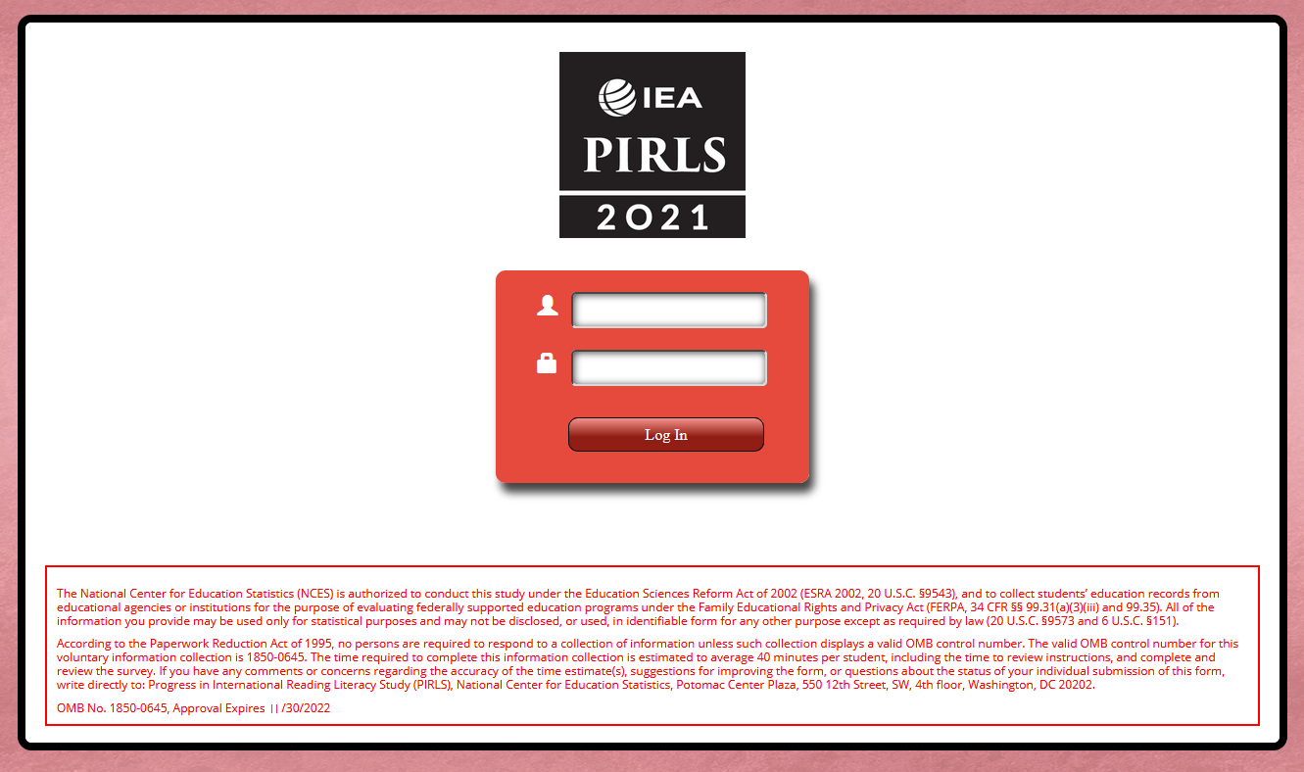
[IEA PIRLS 2021 Logo]
Student ID field
Password field
Log In
The National Center for Education Statistics (NCES) is authorized to conduct this study under the Education Sciences Reform Act of 2002 (ESRA 2002, 20 U.S.C. §9543), and to collect students’ education records from educational agencies or institutions for the purpose of evaluating federally supported education programs under the Family Educational Rights and Privacy Act (FERPA, 34 CFR §§ 99.31(a)(3)(iii) and 99.35). All of the information you provide may be used only for statistical purposes and may not be disclosed, or used, in identifiable form for any other purpose except as required by law (20 U.S.C. §9573 and 6 U.S.C. §151).
According to the Paperwork Reduction Act of 1995, no persons are required to respond to a collection of information unless such collection displays a valid OMB control number. The valid OMB control number for this voluntary information collection is 1850-0645. The time required to complete this information collection is estimated to average 35 minutes per student, including the time to review instructions, and complete and review the survey. If you have any comments or concerns regarding the accuracy of the time estimate(s), suggestions for improving the form, or questions about the status of your individual submission of this form, write directly to: Progress in International Reading Literacy Study (PIRLS), National Center for Education Statistics, Potomac Center Plaza, 550 12th Street, SW, 4th floor, Washington, DC 20202.
OMB No. 1850-0645, Approval Expires 5/31/2023

Student Login Form
(student login information will be merged onto the form before printing)
PIRLS 2021 – STUDENT LOGiN FORM

Student Name:
School Name:
Student ID:
Password:

Student Certificate of Completion

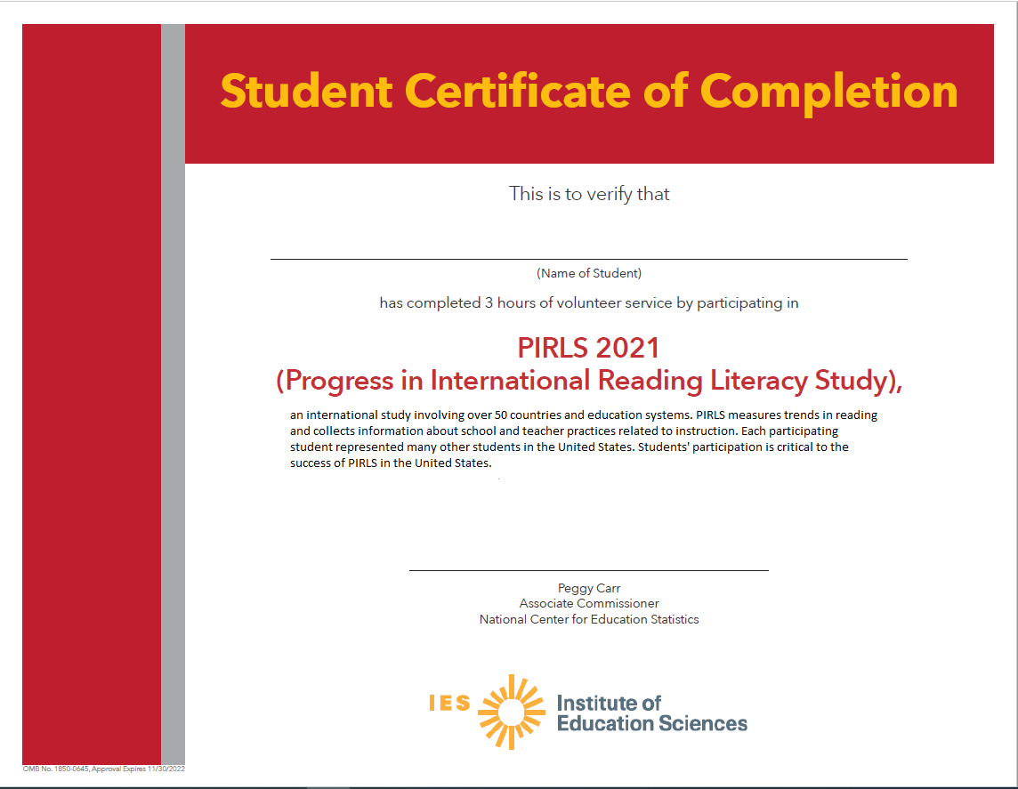

School Certificate of Appreciation

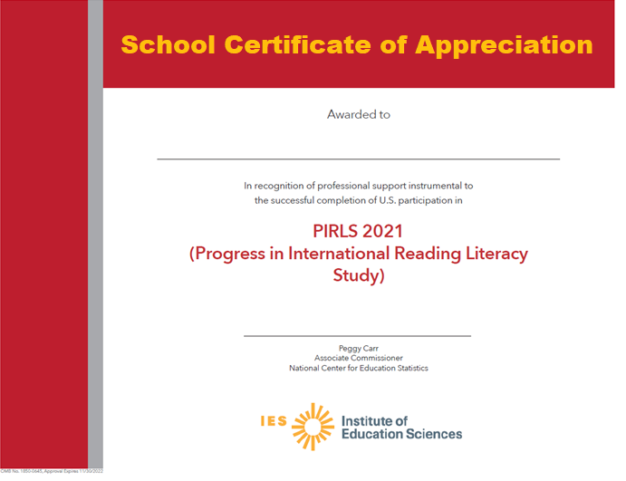

School Coordinator Incentive Template

IES Logo

Dear School Coordinator,
Thank you for serving as the School Coordinator for the Progress in International Reading Literacy Study (PIRLS) for your school. Your participation is vital to the success of this important study. As a token of our appreciation for your help with coordinating the assessment day logistics in your school, we have enclosed a check for $100.
If you have any questions, please feel free to call the PIRLS Help Desk at 1-855-951-1215, or send an email to PIRLS@westat.com. We appreciate your involvement.

Sincerely,
The PIRLS Team
The National Center for Education Statistics (NCES) is authorized to conduct this study under the Education Sciences Reform Act of 2002 (ESRA 2002, 20 U.S.C. §9543), and to collect students’ education records from educational agencies or institutions for the purpose of evaluating federally supported education programs under the Family Educational Rights and Privacy Act (FERPA, 34 CFR §§ 99.31(a)(3)(iii) and 99.35). All of the information you provide may be used only for statistical purposes and may not be disclosed, or used, in identifiable form for any other purpose except as required by law (20 U.S.C. §9573 and 6 U.S.C. §151). In the United States, PIRLS is conducted by NCES, part of the U.S. Department of Education, and the data are being collected by Westat. The U.S. Office of Management and Budget has approved the data collection under OMB # 1850-0645.

School Incentive Template

IES Logo

Dear Principal,
Thank you for participating in the Progress in International Reading Literacy Study (PIRLS). Enclosed is a gift to express our appreciation for your school’s participation in this important study.
The study has been very successful because of the cooperation and participation of the children and schools. You can find further information and results from the study at the government’s website at https://nces.ed.gov/surveys/pirls/.
Thank you for your support of PIRLS. If you have any questions, please call the PIRLS Help Desk at 1-855-951-1215, or send an email to PIRLS@westat.com. Again, we appreciate your involvement.

Sincerely,
The PIRLS Team
The National Center for Education Statistics (NCES) is authorized to conduct this study under the Education Sciences Reform Act of 2002 (ESRA 2002, 20 U.S.C. §9543), and to collect students’ education records from educational agencies or institutions for the purpose of evaluating federally supported education programs under the Family Educational Rights and Privacy Act (FERPA, 34 CFR §§ 99.31(a)(3)(iii) and 99.35). All of the information you provide may be used only for statistical purposes and may not be disclosed, or used, in identifiable form for any other purpose except as required by law (20 U.S.C. §9573 and 6 U.S.C. §151). In the United States, PIRLS is conducted by NCES, part of the U.S. Department of Education, and the data are being collected by Westat. The U.S. Office of Management and Budget has approved the data collection under OMB # 1850-0645.

Postcard

Front of Card:

Background/Right Side: Map of world

Left Side:
Join Team USA

Participate in the next Progress in International Reading Literacy (PIRLS) Study:

- Compares the reading of U.S. students with that of their peers in countries around the world;
- Involves students from more than 50 countries; and
- Provides valuable benchmark data for educators and policymakers to examine other education systems.

Your school was randomly selected to represent similar schools in the U.S. so that the results are representative of the overall U.S. school population.

OMB# 1850-0645 (expires 5/31/2023).

Back of Card:

Key findings from PIRLS 2016:

- The overall reading average scale score for U.S. students (549) was higher than the PIRLS scale centerpoint, which is 500.
- The United States average was higher than 30 education systems and not measurable different from 15 others. Twelve education systems had higher averages.
- The average score for girls was higher than the average score for boys in the United States (553 vs 545).
- In the new 2016 ePIRLS online assessment the U.S. average score was 557, which was lower than the averages for 3 education systems, higher than the average for 10 education systems, and not measurably different from the averages for 2 education systems.

https://nces.ed.gov/surveys/PIRLS
Call 1-855-951-1215 for more information.
IES logo
The National Center for Education Statistics (NCES) is authorized to conduct this study under the Education Sciences Reform Act of 2002 (ESRA 2002, 20 U.S.C. §9543), and to collect students’ education records from educational agencies or institutions for the purpose of evaluating federally supported education programs under the Family Educational Rights and Privacy Act (FERPA, 34 CFR §§ 99.31(a)(3)(iii) and 99.35). All of the information you provide may be used only for statistical purposes and may not be disclosed, or used, in identifiable form for any other purpose except as required by law (20 U.S.C. §9573 and 6 U.S.C. §151). In the United States, PIRLS is conducted by NCES, part of the U.S. Department of Education, and the data are being collected by Westat. The U.S. Office of Management and Budget has approved the data collection under OMB # 1850-0645.

Accommodations Guide

Accommodating Students on PIRLS
General Accommodation Guidelines
PIRLS in the United States strives to include as many students as possible. However, the specific adaptations of the testing environment that PIRLS can support is limited by the capabilities of the internationally developed testing software, as well as equipment and staffing capacity in the United States. For any accommodations not available due to these technological and logistical constraints, it is the school’s responsibility to decide how to include students based on their IEPs or 504 plans, protocols for state testing, and other considerations. In some cases, it may be possible to use an alternate method of providing an accommodation. It is recommended that you communicate your plans for testing students in these cases to the students’ parents or guardians so they are aware of the arrangements and can grant their permission, if necessary.
Planning Accommodations with the PIRLS Test Administrator
Prior to your assessment date, you will finalize assessment logistics with a PIRLS test administrator. The test administrator will contact you to schedule a brief phone conversation. Having a list of accommodated students available to you during this call will help you to make the necessary arrangements with the test administrator. The planning can also proceed more efficiently if you review the following information regarding accommodations prior to the phone call with the test administrator.
Accommodations Related to Time and Location
Separate Locations, Small Groups, and Preferential seating
Based on the number of PIRLS staff comprising an assessment team at the school, administering assessments in more than two locations simultaneously may not be feasible. Therefore, the following accommodations typically are not offered on PIRLS:
- Testing individual students in a separate location (one-on-one)
- Testing small groups of students in a separate location
If the testing location allows the setup of a separated or more enclosed space within the larger area (e.g. a more distinct corner or adjoining room in a library), these needs may be more easily met. Furthermore, the PIRLS assessment team will be able to set up the assessment location to satisfy any preferential seating needs, including specific seating arrangements to accommodate students who typically receive one-on-one or small group testing. In addition, PIRLS supports the use of school-provided study carrels to eliminate distractions.
Extended time, breaks, and the assessment schedule
A PIRLS assessment session may last up to 2.5 hours. The structure of the test is as follows:
Directions | 10 minutes
Part 1 | 40 minutes
Break | 5 minutes
Part 2 | 40 minutes
Break | 5 minutes
Questionnaire | 35 minutes

Up to two times the normal length of the assessment is allowed for extended time students, and the extra time is added on to each section individually. The following considerations apply to extended time on PIRLS:
- The ability of the PIRLS team to administer extended time depends, in part, on the parameters of the school schedule (most particularly the lunch period and dismissal).
- Typically, based on limitations to the number of simultaneous testing sessions that PIRLS can support, extended time students are assessed together with the other students. However, because the extra time is added on to each section, extended time students may be starting sections and taking breaks at different times than the other students (and each other). Consequently, arrangements should be made to minimize distractions caused by differing section timing.
Because each section is timed individually, with students moving through the assessment as a group, students who require breaks during testing may receive a break during the designated times in the assessment schedule.
Accommodations Related to Reading
Because PIRLS is an assessment of reading comprehension, any accommodations that might compromise the accuracy of measurements of reading skills are not available for PIRLS. These accommodations include:
- Text-to-speech
- Occasional words or phrases read aloud
- Read aloud for the entire test
- Presentation of the test in Sign Language
- Bilingual dictionary
- Testing in a language other than English
Note: the PIRLS staff will read the directions aloud as part of the normal administration of the assessment.
Accommodations Requiring Support Staff
PIRLS allows the use of school-provided support staff to assist students during the assessment. The following accommodations can be provided so long as the school arranges to have the support staff available for the assessment:
- Use of an aide or familiar school support staff
- Cueing to stay on task
- Directions presented in Sign Language
Accommodations Requiring Special Equipment or Materials
PIRLS allows the use of school-provided equipment or materials to accommodate students. The following accommodations can be provided so long as the school arranges to have the necessary items available for the assessment:
- Magnification device
- Special equipment
- Straightedge/ruler, overlay, or template
- Auditory amplification (e.g. microphone) for test administrator
Accommodations Related to the Testing System
PIRLS in the United States is administered via an internationally developed testing system, designed for use in a variety of testing environments around the world. The testing software includes the ability to zoom in and out. However, the following system capabilities are not available for PIRLS:
- A high-contrast view
- Text-to-speech
- A low-mobility version of the test
- A Braille version of the test
Other accommodations
Other accommodations, such as directions explained or clarified and read aloud to self, can be arranged with the PIRLS test administrator and are typically available so long as they do not require specific testing system functionality, do not distract other students, and can be provided with the PIRLS staff and equipment available. Snacks during the test are allowed if the snacks are eaten during the designated breaks and food is kept away from the tablets.

Summary of Accommodations
Accommodations That Are Always Available
Preferential seating
Study carrel
Read aloud – directions only
Directions explained or clarified
Read aloud to self
Familiar school support staff or aide
Cueing to stay on task
Directions in Sign Language
Magnification device
Special equipment
Straightedge/ruler, overlay, or template

Accommodations That Are Available with Limitations
Accommodation | Note
Extended time | Can be offered if there is time available in the school schedule; students are assessed with the whole group if possible
Breaks during test | Two 5-minute breaks are built into the structure of the test
Snacks during test | Allowed during designated breaks, away from the tablets
Zooming

Accommodations That Are Not Available
Accommodation | Alternative
Testing individuals in a separate location (one-on-one) | Preferential seating or study carrels
Testing small groups in a separate location | Preferential seating or study carrels
Text-to-speech | Read aloud for directions only
Read aloud – occasional or entire test | Read aloud for directions only
Presentation in Sign Language
Directions in Spanish
Bilingual dictionary
Versions of the test in other languages
Scribe
High-contrast
Low mobility version of the test
Braille version of the test

Quality Control Check – CC Template
(yellow highlight for mail merge)
IES Logo

Greetings,
Thank you for everything you have done thus far to ensure that your school is ready to participate in the Progress in International Reading Literacy Study (PIRLS). Upon reviewing your submissions, we have found an error that must be addressed in order to maintain the integrity of the reported data.
The following system-generated error requires your immediate attention:
Error | Action Steps
Class Count  Number of classes on class list differs from PSI.  Provide School Information: XX classes  Class List: XX classes | Please review your Provide School Information (PSI) and Class List pages on MyPIRLS.com. The number of classes entered on the PSI page should match the number of classes listed on the Class List page. You may edit the PSI page at any time if the number of classes entered was an estimate or error. Please reply to this email if the number of classes listed on the PSI page is correct, and you need to edit your class list. We will unlock your class list for editing. It is important that all reading classes containing 5th grade students are listed on the class list.

We greatly appreciate your assistance in resolving the noted issues. As soon as they are resolved, we will be able to provide you with next steps. As always, if you have any questions or concerns, please reply to this email, or call us at [PIRLS E-File phone number].
Thank you again for your efforts and participation.
Best,
The PIRLS Team
[School ID]
The National Center for Education Statistics (NCES) is authorized to conduct this study under the Education Sciences Reform Act of 2002 (ESRA 2002, 20 U.S.C. §9543), and to collect students’ education records from educational agencies or institutions for the purpose of evaluating federally supported education programs under the Family Educational Rights and Privacy Act (FERPA, 34 CFR §§ 99.31(a)(3)(iii) and 99.35). All of the information you provide may be used only for statistical purposes and may not be disclosed, or used, in identifiable form for any other purpose except as required by law (20 U.S.C. §9573 and 6 U.S.C. §151). In the United States, PIRLS is conducted by NCES, part of the U.S. Department of Education, and the data are being collected by Westat. The U.S. Office of Management and Budget has approved the data collection under OMB # 1850-0645.

Quality Control Check – GE & CC Template 2
(yellow highlight for mail merge)
IES Logo
Greetings,
Thank you for everything you have done thus far to ensure that your school is ready to participate in the Progress in International Reading Literacy Study (PIRLS). Upon reviewing your submissions, we have found errors that must be addressed in order to maintain the integrity of the reported data.
Our system checks the enrollment counts that you submit on MyPIRLS.com against a national data source generated by the Department of Education’s Common Core of Data (CCD). We have found that the CCD 5th grade enrollment count for your school differs from both the Provide School Information (PSI) and class list counts that you submitted. Additionally, the number of 5th grade reading classes listed on the class list differs from the number of 5th grade reading classes that was entered on the PSI page.
The following system-generated errors require your immediate attention:
Errors | Action Steps
Grade Enrollment  National data source, PSI, and class list grade enrollment counts all differ.  National Data Source: XX students  Provide School Information: XX students  Class List: XX students | Please review your PSI and Class List pages on MyPIRLS.com. Confirm that you entered the correct number of students in the 5th grade by replying to this email with the 5th grade enrollment count and any reasons you have that could help to explain the discrepancy (i.e. recent boundary changes, transient population, etc.). If you recorded an incorrect number of students, please update the PSI and class list pages accordingly. If you need to edit the number of students in each class or add classes on the class list page, please reply to this email so that your class list can be unlocked.
Class Count  Number of classes on class list differs from PSI.  Provide School Information: XX classes  Class List: XX classes | Please review your PSI and Class List pages on MyPIRLS.com. The number of classes entered on the PSI page should match the number of classes listed on the Class List page. You may edit the PSI page at any time if the number of classes entered was an estimate or error. Please reply to this email if the number of classes listed on the PSI page is correct, and you need to edit your class list. We will unlock your class list for editing.

We greatly appreciate your assistance in resolving the noted issues. As soon as they are resolved, we will be able to provide you with next steps. As always, if you have any questions or concerns, please reply to this email, or call us at [PIRLS E-File phone number].
Thank you again for your efforts and participation.
Best,
The PIRLS Team
[School ID]
The National Center for Education Statistics (NCES) is authorized to conduct this study under the Education Sciences Reform Act of 2002 (ESRA 2002, 20 U.S.C. §9543), and to collect students’ education records from educational agencies or institutions for the purpose of evaluating federally supported education programs under the Family Educational Rights and Privacy Act (FERPA, 34 CFR §§ 99.31(a)(3)(iii) and 99.35). All of the information you provide may be used only for statistical purposes and may not be disclosed, or used, in identifiable form for any other purpose except as required by law (20 U.S.C. §9573 and 6 U.S.C. §151). In the United States, PIRLS is conducted by NCES, part of the U.S. Department of Education, and the data are being collected by Westat. The U.S. Office of Management and Budget has approved the data collection under OMB # 1850-0645.

Quality Control Check – GE & CC Template 3
(yellow highlight for mail merge)
IES Logo

Greetings,
Thank you for everything you have done thus far to ensure that your school is ready to participate in the Progress in International Reading Literacy Study (PIRLS). Upon reviewing your submissions, we found discrepancies that must be addressed in order to maintain the integrity of the reported data.
Our system checks the enrollment counts that you submit on MyPIRLS.com against a national data source generated by the Department of Education’s Common Core of Data (CCD). We have found that the CCD 5th grade enrollment count for your school differs from both the Provide School Information (PSI) and class list counts. Additionally, the number of 5th grade reading classes listed on the class list differs from the number of 5th grade reading classes that was entered on the PSI page.
The following system-generated errors require your immediate attention:
Errors | Action Steps
Grade Enrollment  National enrollment data grade enrollment count differs from both PSI and class list.  National Data Source: XX students  Provide School Information: XX students  Class List: XX students | Please review your PSI and Class List pages on MyPIRLS.com. Confirm that you entered the correct number of students in the 5th grade by replying to this email with the 5th grade enrollment count and any reasons you have that could help to explain the discrepancy (i.e. recent boundary changes, transient population, etc.). If you recorded an incorrect number of students, please update the PSI and class list pages accordingly. If you need to edit the number of students in each class or add classes on the class list page, please reply to this email so that your class list can be unlocked.
Grade Enrollment  Grade enrollment count on PSI differs from total number of students listed on class list  Provide School Information: XX students  Class List: XX students | Please review your PSI and Class List pages on MyPIRLS.com. Confirm that you entered the correct number of students in the 5th grade, and update the PSI and/or class list page(s) accordingly. If you must edit the number of students in each class or add classes on the class list page, please reply to this email so that your class list can be unlocked.
Class Count  Number of classes on class list differs from PSI  Provide School Information: XX classes  Class List: XX classes | Please review your PSI and Class List pages on MyPIRLS.com, andconfirm that you entered the correct number of 5th grade reading classes. The number of classes entered on the PSI page should match the number of classes listed on the Class List page. You may edit the PSI page at any time. Please reply to this email if you need your class list to be unlocked for editing.

We greatly appreciate your assistance in resolving the noted issues. As soon as they are resolved, we will be able to provide you with next steps. As always, if you have any questions or concerns, please reply to this email, or call us at [PIRLS E-File phone number].
Thank you again for your efforts and participation.
Best,
The PIRLS Team
[School ID]
The National Center for Education Statistics (NCES) is authorized to conduct this study under the Education Sciences Reform Act of 2002 (ESRA 2002, 20 U.S.C. §9543), and to collect students’ education records from educational agencies or institutions for the purpose of evaluating federally supported education programs under the Family Educational Rights and Privacy Act (FERPA, 34 CFR §§ 99.31(a)(3)(iii) and 99.35). All of the information you provide may be used only for statistical purposes and may not be disclosed, or used, in identifiable form for any other purpose except as required by law (20 U.S.C. §9573 and 6 U.S.C. §151). In the United States, PIRLS is conducted by NCES, part of the U.S. Department of Education, and the data are being collected by Westat. The U.S. Office of Management and Budget has approved the data collection under OMB # 1850-0645.

Quality Control Check – GE Template
(yellow highlight for mail merge)
IES Logo

Greetings,
Thank you for everything you have done thus far to ensure that your school is ready to participate in the Progress in International Reading Literacy Study (PIRLS). Upon reviewing your submissions, we found a discrepancy that must be addressed in order to maintain the integrity of the reported data.
Our system checks the enrollment counts that you submit on MyPIRLS.com against a national data source generated by the Department of Education’s Common Core of Data (CCD). We have found that the CCD 5th grade enrollment count for your school differs from both the Provide School Information (PSI) and class list counts.
The following system-generated errors require your immediate attention:
Grade Enrollment Counts | Action Steps
National data source grade enrollment count differs from both PSI and class list.  National Data Source: XX students  Provide School Information: XX students  Class List: XX students | Please review your PSI and Class List pages on MyPIRLS.com. Confirm that you entered the correct number of students in the 5th grade by replying to this email with the 5th grade enrollment count and any reasons you have that could help to explain the discrepancy (i.e. recent boundary changes, transient population, etc.). If you recorded an incorrect number of students, please update the PSI and class list pages accordingly. If you need to edit the number of students in each class or add classes on the class list page, please reply to this email so that your class list can be unlocked.

We greatly appreciate your assistance in addressing the noted questions. As soon as they are resolved, we will be able to provide you with next steps. As always, if you have any questions or concerns, please reply to this email, or call us at [PIRLS E-File phone number].
Thank you again for your efforts and participation.
Best,
The PIRLS Team
[School ID]
The National Center for Education Statistics (NCES) is authorized to conduct this study under the Education Sciences Reform Act of 2002 (ESRA 2002, 20 U.S.C. §9543), and to collect students’ education records from educational agencies or institutions for the purpose of evaluating federally supported education programs under the Family Educational Rights and Privacy Act (FERPA, 34 CFR §§ 99.31(a)(3)(iii) and 99.35). All of the information you provide may be used only for statistical purposes and may not be disclosed, or used, in identifiable form for any other purpose except as required by law (20 U.S.C. §9573 and 6 U.S.C. §151). In the United States, PIRLS is conducted by NCES, part of the U.S. Department of Education, and the data are being collected by Westat. The U.S. Office of Management and Budget has approved the data collection under OMB # 1850-0645.

Quality Control Check – SL Template
(yellow highlight for mail merge)
IES Logo

Greetings,
I hope that all is well with you!
You are receiving this email because the number of students listed on your class list does not match the number of students entered on your student list for the following class(es):
[Class Name]
Class List: XX students
Student List: XX students
Please review the student list submitted on MyPIRLS.com, and ensure that all students in this class are listed. If you have omitted some students, please submit another student list that includes those students. If this discrepancy is due to student transfers, please reply to this email indicating the number of students that have transferred in or out of the class and the current class count. Please note that you will not need to complete this step for every additional student transfer prior to testing.
Thank you in advance for your attention to this matter, and please do not hesitate to reach out to us with additional questions. This is the final step of the list submission process, and we look forward to talking with you soon.
Best,
The PIRLS Team
[School ID]
The National Center for Education Statistics (NCES) is authorized to conduct this study under the Education Sciences Reform Act of 2002 (ESRA 2002, 20 U.S.C. §9543), and to collect students’ education records from educational agencies or institutions for the purpose of evaluating federally supported education programs under the Family Educational Rights and Privacy Act (FERPA, 34 CFR §§ 99.31(a)(3)(iii) and 99.35). All of the information you provide may be used only for statistical purposes and may not be disclosed, or used, in identifiable form for any other purpose except as required by law (20 U.S.C. §9573 and 6 U.S.C. §151). In the United States, PIRLS is conducted by NCES, part of the U.S. Department of Education, and the data are being collected by Westat. The U.S. Office of Management and Budget has approved the data collection under OMB # 1850-0645.

