WRR Portal Screenshots (DRAFT)
Login Screen
Profile Page
Relief Request submission
Rich Text Elements
Attachments
Preview
List of submissions
Administrator page

- Login Screen:
Users will get a credential issued by the NRC ICAM team which will be used to access the portal.
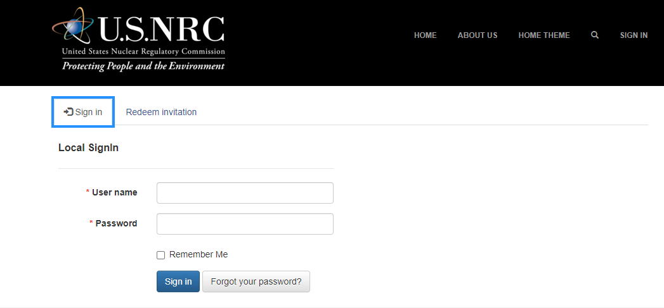

- Profile Page:

Each logged in user will have the ability to update their profile.

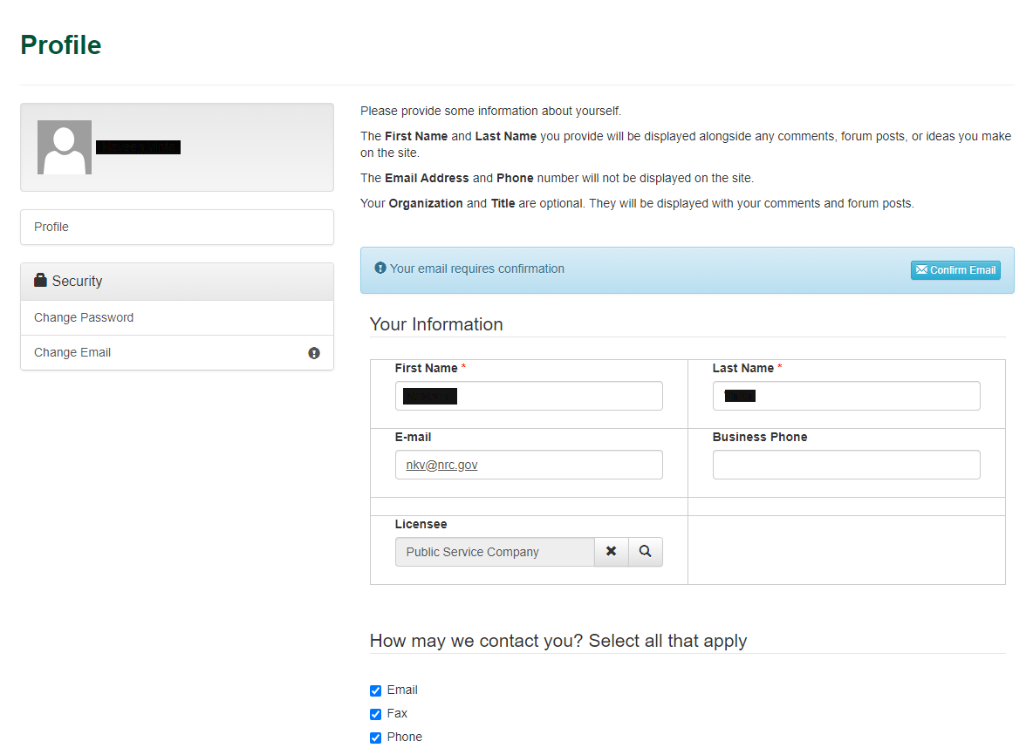

- Relief Request submission.
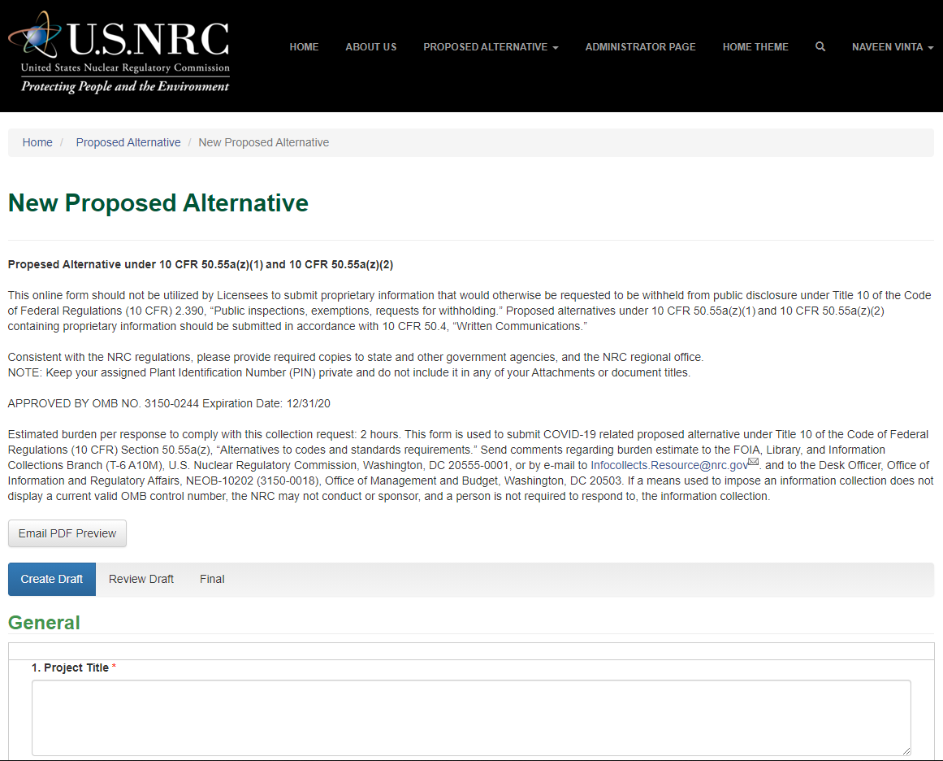
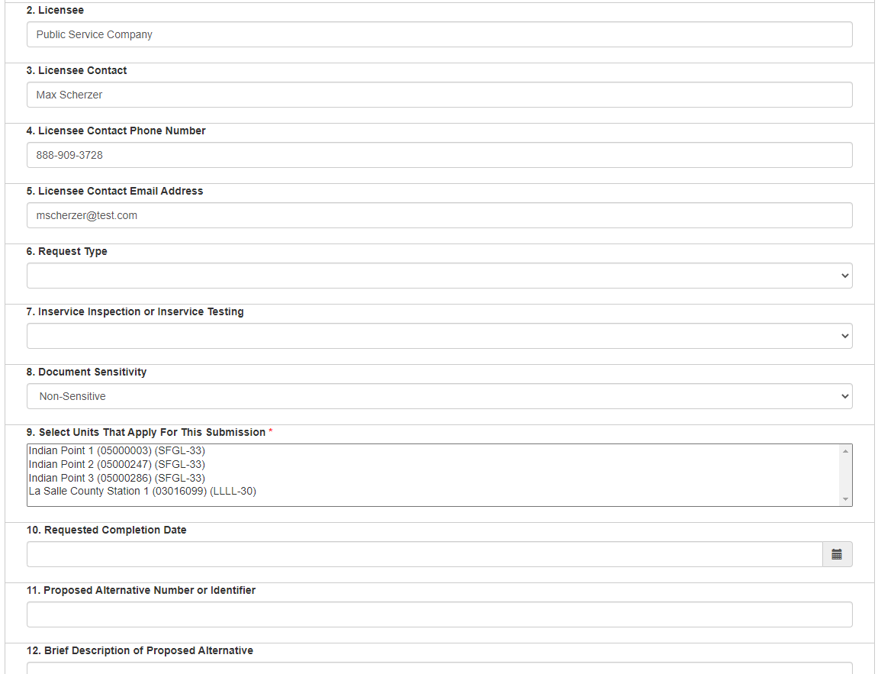

  - Rich Text Elements
Relief request form can insert rich text.
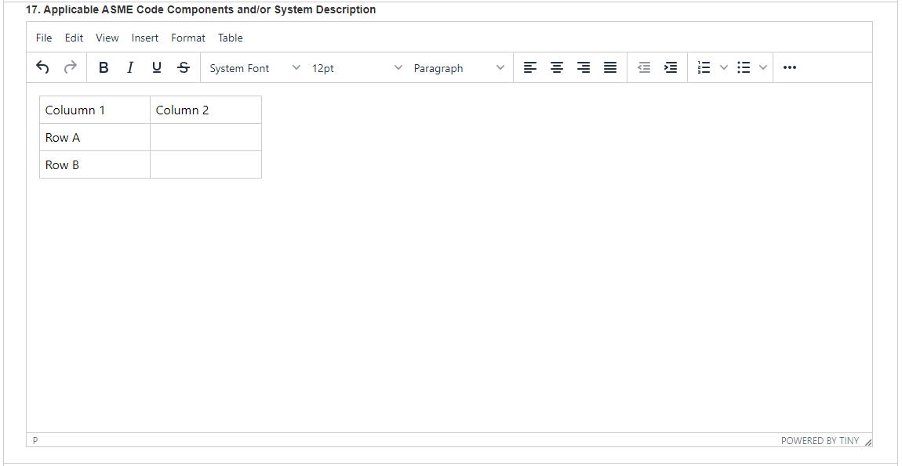

  - Attachments

Portal will have the ability to add attachments to a relief request.
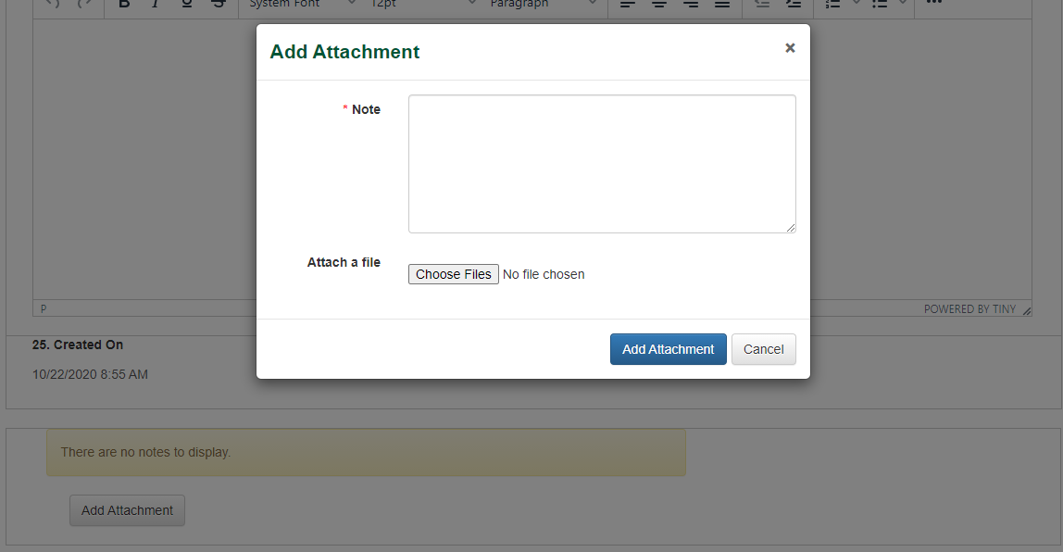

  - Preview

Users can get a PDF attachment of their submission emailed to them before they finalize their submission to verify the accuracy of their relief request.
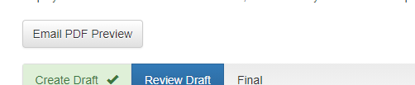

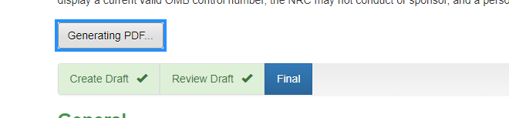

- List of submissions
Users will have a list of submissions that have initiated/submitted can be used to check for status or for reference purposes.
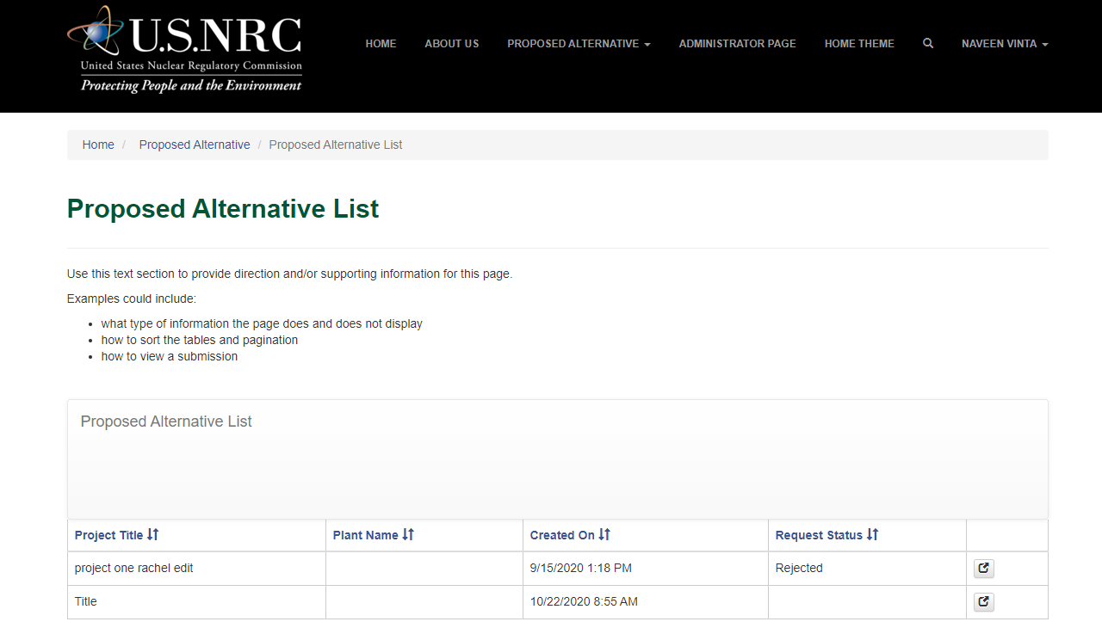

- Administrator page
Employees for a licensee can be designated as an administrator and they will have the ability to administer permissions for their employees on a plant by plant basis to ‘View’, ‘Edit’ or ‘Submit’.
