**United States Department of Agriculture**

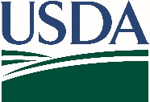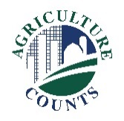

National Agricultural Statistics Service

May 24, 2020

Please complete the enclosed June Area survey to help USDA determine comprehensive estimates of U.S. land uses and agricultural activities.

To protect the health of producers, partners, and employees, the National Agricultural Statistics Service (NASS) is unable to complete this survey with you in person. Instead, a NASS representative will call you to arrange a telephone interview. The interview,estimated to take up to an hour, and can be done all at once or in multiple appointments.

A questionnaire, respondent booklet, aerial photo, and county section map of your property are enclosed.

* Please review the map to determine any agricultural land uses within the red boundary. Please keep the map as a reference for the survey interview.
* Read the questionnaire to prepare for the the phone interview. The survey includes questions about land uses and your operation within the boundaries on the map. The questionnaire is for reference purposes only, and your data will be collected by phone.

**How will the survey results be used?**

The results from this survey are used to develop comprehensive estimates of land uses and agricultural activities across the United States. Data from this survey are a critical foundation for other NASS reports.

The information you provide will be used for statistical purposes only. In accordance with federal law, your responses will be kept confidential, and the results will be available in aggregate form only to ensure that no individual producer or operation can be identified.

Thank you for your support of U.S. agriculture. For more information about this and other NASS surveys, visit nass.usda.gov/Surveys. If you have any questions, please contact us at 888-424-7828.

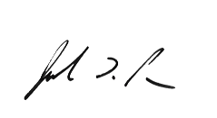

Sincerely,

Joseph L. Parsons

Chairperson, Agricultural Statistics Board

U.S. Department of Agriculture  
National Agricultural Statistics Service