**United States Department of Agriculture**

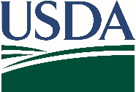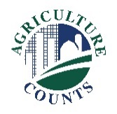

National Agricultural Statistics Service

March 8, 2021

[Farm Operation]

[Farmer Name]

[123 Example St]

[Example, MO 63132]

You have been selected to participate in an interview for the June Area Survey. The results from this survey are used to develop comprehensive estimates of land uses and agricultural activities across the United States. Data from this survey are a critical foundation for other USDA reports.

Please retain the enclosed aerial photo and county map. In a telephone interview, a NASS representative will call you and ask you to confirm whether the land you operate lies within the red segment boundaries on the map, as well as questions about agricultural land use on your operation. The interview is estimated to take up to 20 minutes.

The information you provide will be used for statistical purposes only. In accordance with federal law, your responses will be kept confidential, and the survey results will be available in aggregate form only to ensure that no individual producer or operation can be identified.

Thank you for your help and for your support of U.S. agriculture. For more information about NASS surveys, please visit nass.usda.gov/Surveys. If you have any questions, please contact us at 888-424-7828.

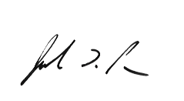

Sincerely,

Joseph L. Parsons

Chairperson, Agricultural Statistics Board

U.S. Department of Agriculture  
National Agricultural Statistics Service