General Sales Manager GSM

U. S. Financial Institution and U. S. Exporter Access

0051-0004

Table of Contents

Form Title Index 3
Form 1 – Create Application for Guarantee Coverage 4
Form 2 – Modify Application 16
Form 3 – Modify Registration 28
Form 4 – Assign Notice of Assignment 42
Form 5 – Withdraw Notice of Assignment 44
Form 6 – Accept Notice of Assignment 46
Form 7 – Reject Notice of Assignment 48
Form 8 – Reassign Notice of Assignment 50
Form 9 – Modify Organization (Exporter) 52
Form 10 – Modify Organization (US Bank) 55
Form 11 – Create Point of Contact 57
Form 12 – Modify Point of Contact 58
Form 13 – Create Delivery 59
Form 14 – Withdraw Delivery 65
Form 20 - Modify Delivery 67
Form 21 - Register as an Internal Control Administrator 73
Form 22 – Apply for Participation in GSM System (US Bank) 75
Form 23 – Apply for Participation in GSM System (Exporter) 80
Form 24 – Copy a Submitted Application 86
Form 25 – Assign Access 88
Form 26 – Submit Organization Information 90
Form 27 – Submit Delivery 91
Form 30 – Submit Application(s) 92
Form 31 – Submit Registration(s) 93
Form 33 – Request Web Access on Behalf of a Current Organization 94
Form 34 – Edit Web User Associations 95
Form 35 – Review Web Access Request 96

Form Title Index

Form No. | Form Title | Form Starts with Screen No. | Form Contains Screens
1 | Create Application for Guarantee Coverage | 2 | 2, 3, 4, 5, 8, 9, 10,11, 12, 13
2 | Modify Application | 16 | 16, 17, 18, 19, 20, 21, 22, 23, 24
3 | Modify Registration | 28 | 28, 17, 18, 19, 8, 20, 21, 22, 23, 24, 80
4 | Assign Notice of Assignment | 30
5 | Withdraw Notice of Assignment | 30
6 | Accept Notice of Assignment | 30
7 | Reject Notice of Assignment | 30
8 | Reassign Notice of Assignment | 30
9 | Modify Organization (Exporter) | 31
10 | Modify Organization (US Bank) | 32
11 | Create Point of Contact | 33
12 | Modify Point of Contact | 33
13 | Create Delivery | 34 | 34, 35, 36
14 | Withdraw Delivery | 40
20 | Modify Delivery | 52 | 52, 38, 36
21 | Register as an Internal Control Administrator | 53
22 | Apply for participation in GSM System (US Bank) | 55 | 55, 56, 57
23 | Apply for participation in GSM System (Exporter) | 55 | 55, 56, 57
24 | Copy Submitted Application | 60
25 | Assign Access | 61
26 | Submit Organization Information | 64
27 | Submit Delivery(s) | 65
30 | Submit Application(s) | 70
31 | Submit Registration(s) | 71
33 | Request Web Access on Behalf of a Current Organization | 74
34 | Edit Web User Associations | 75
35 | Review Web Access Request | 75

Form 1 – Create Application for Guarantee Coverage
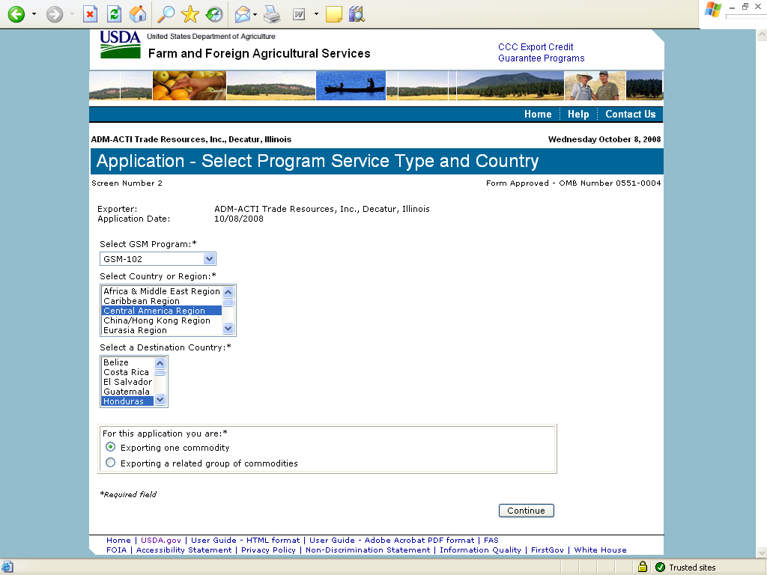
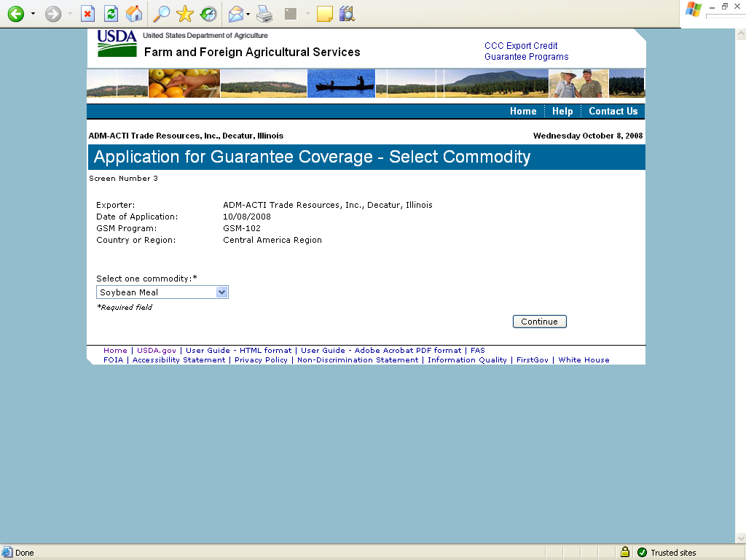
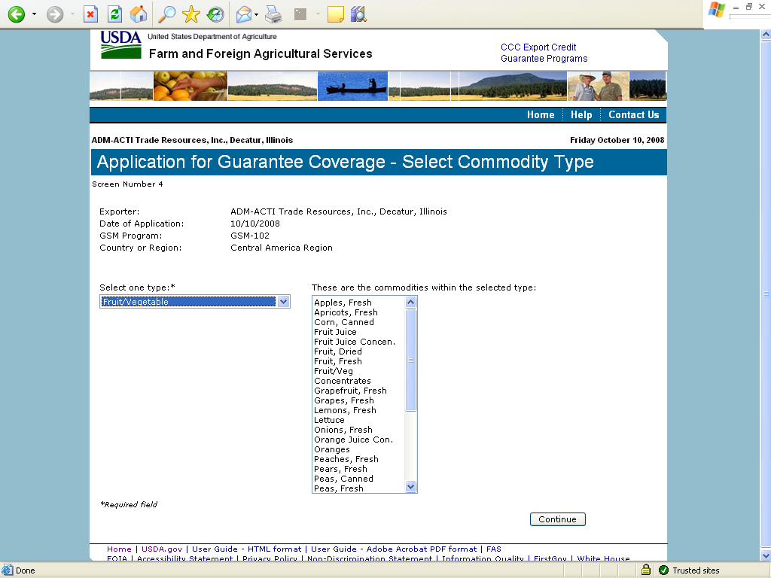
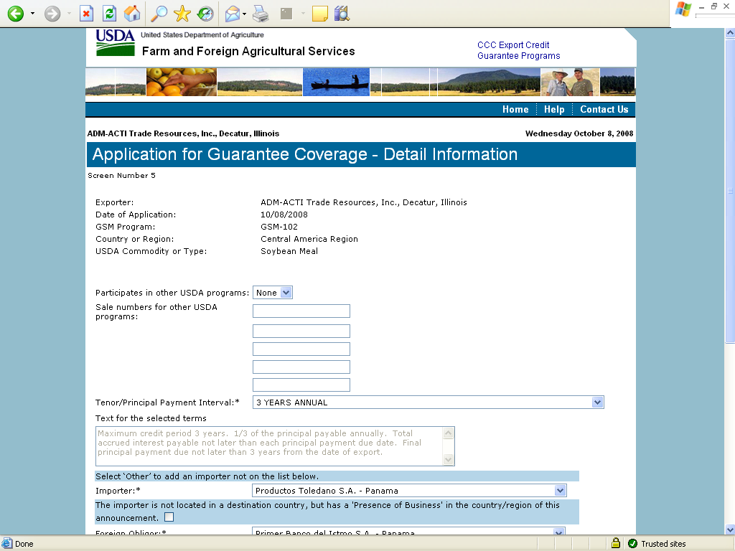
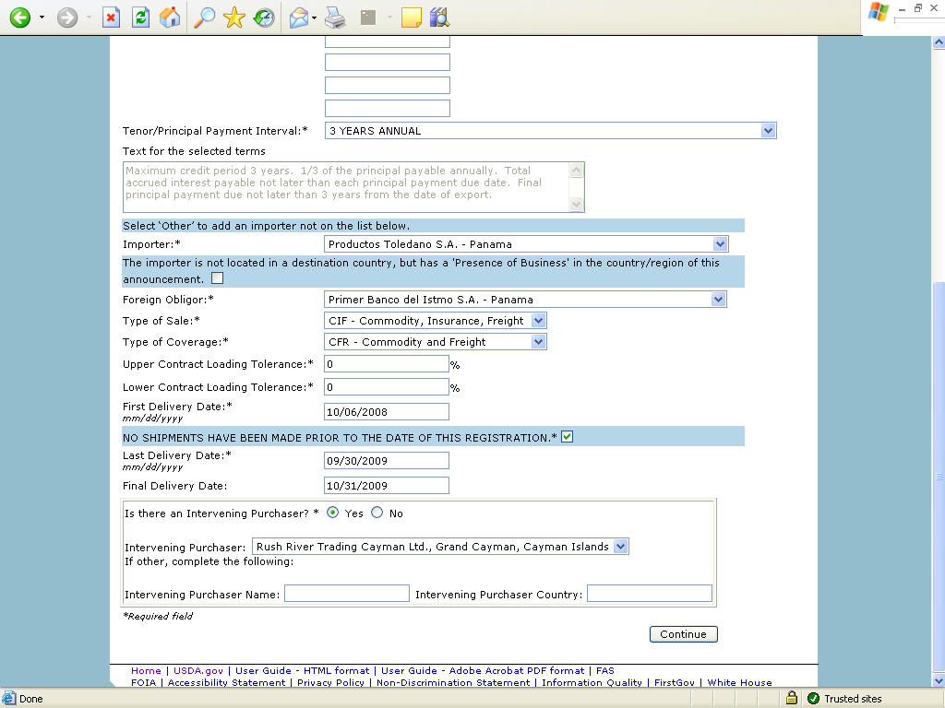
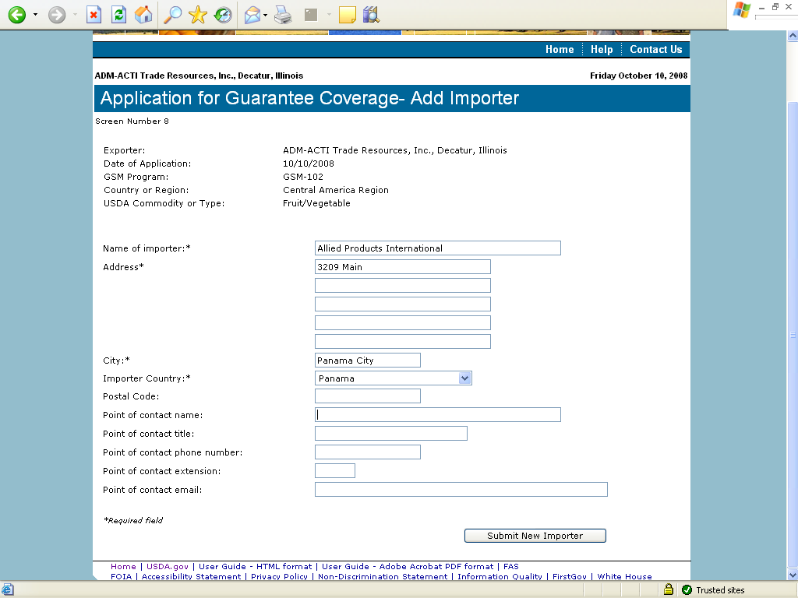
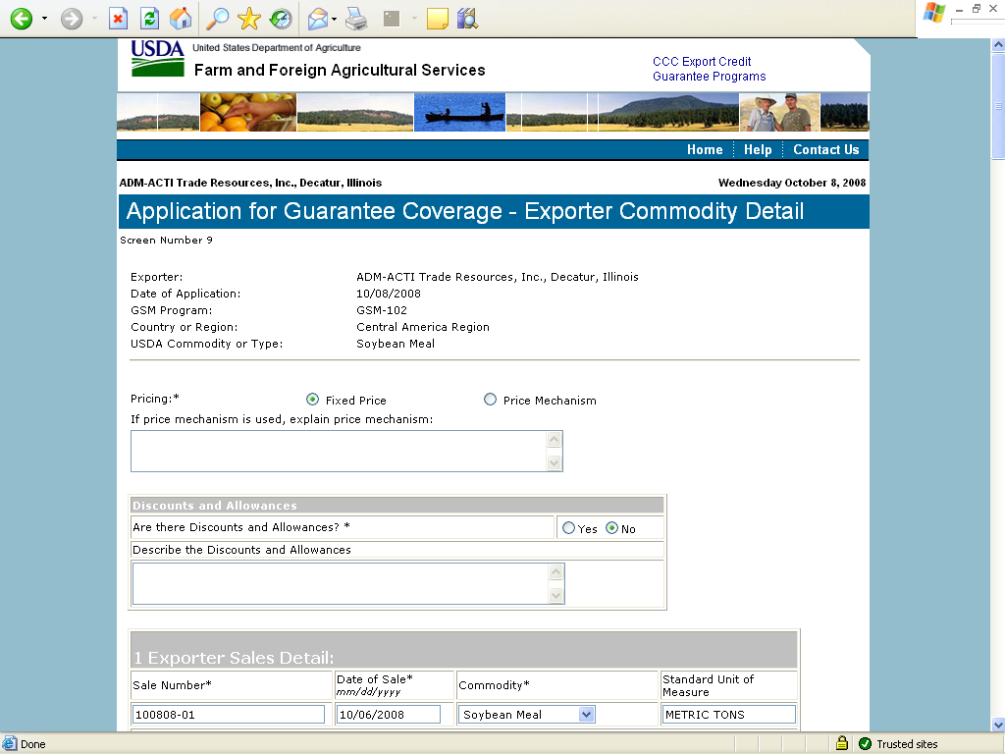
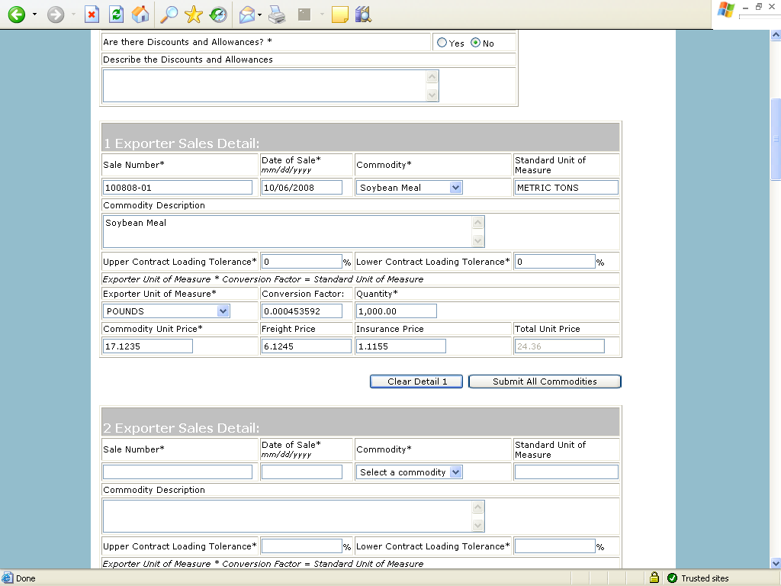
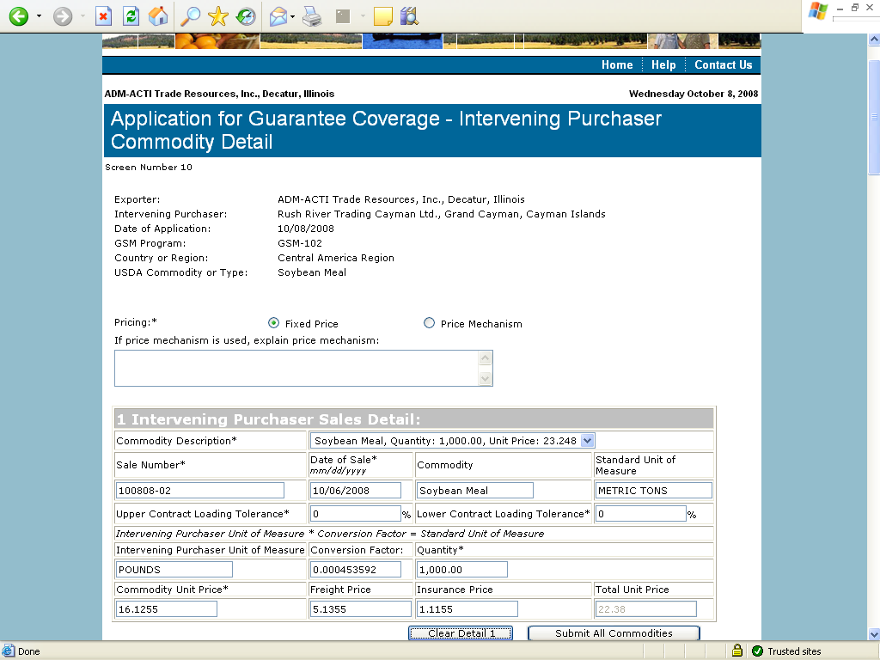
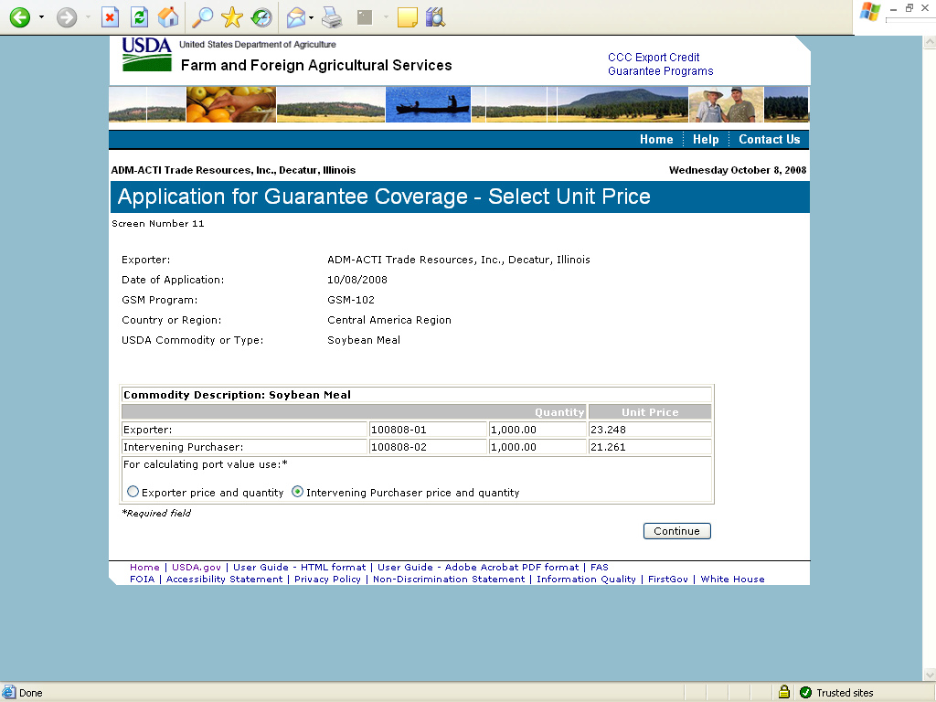
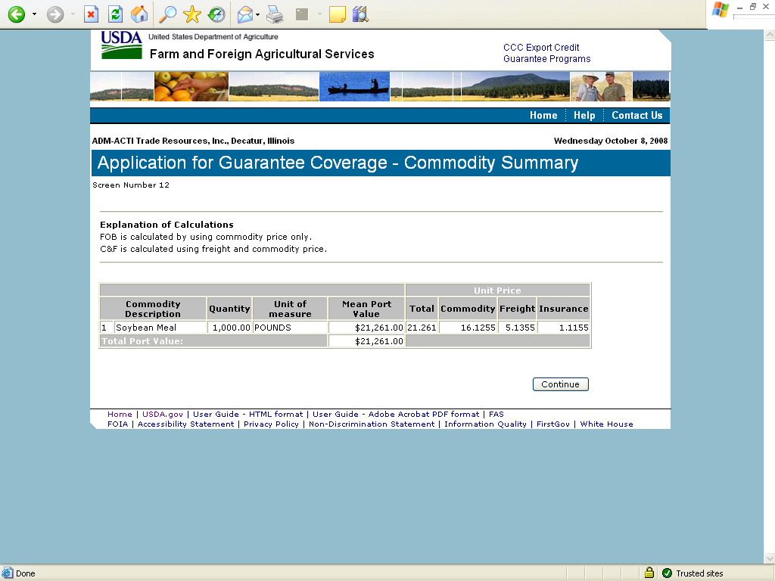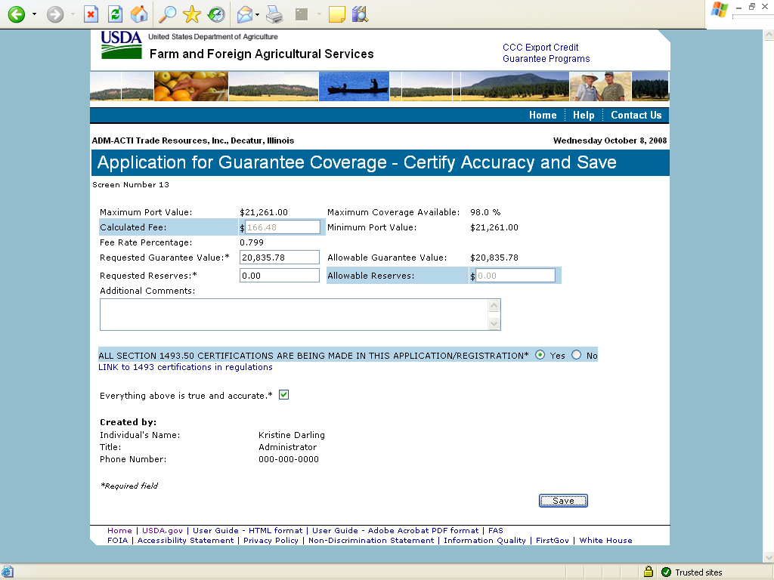

Form 2 – Modify Application
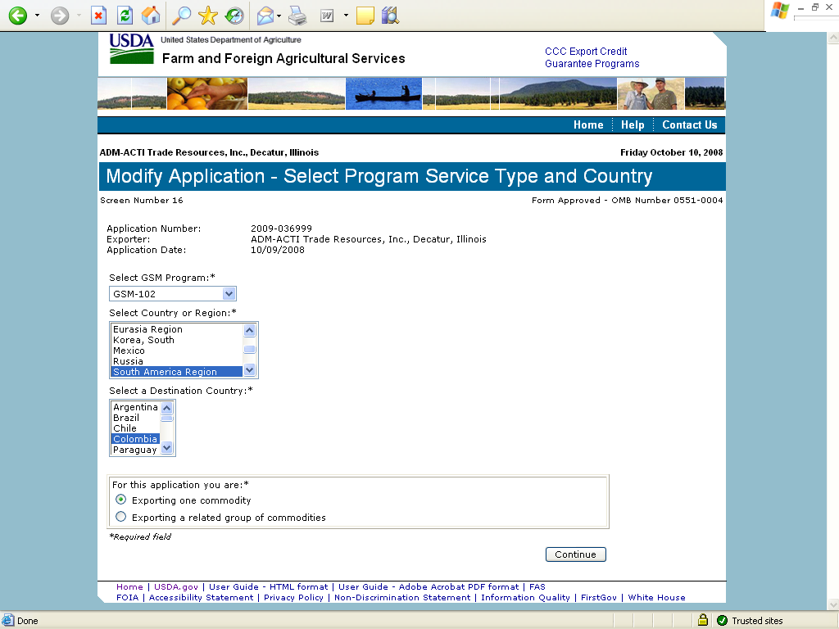
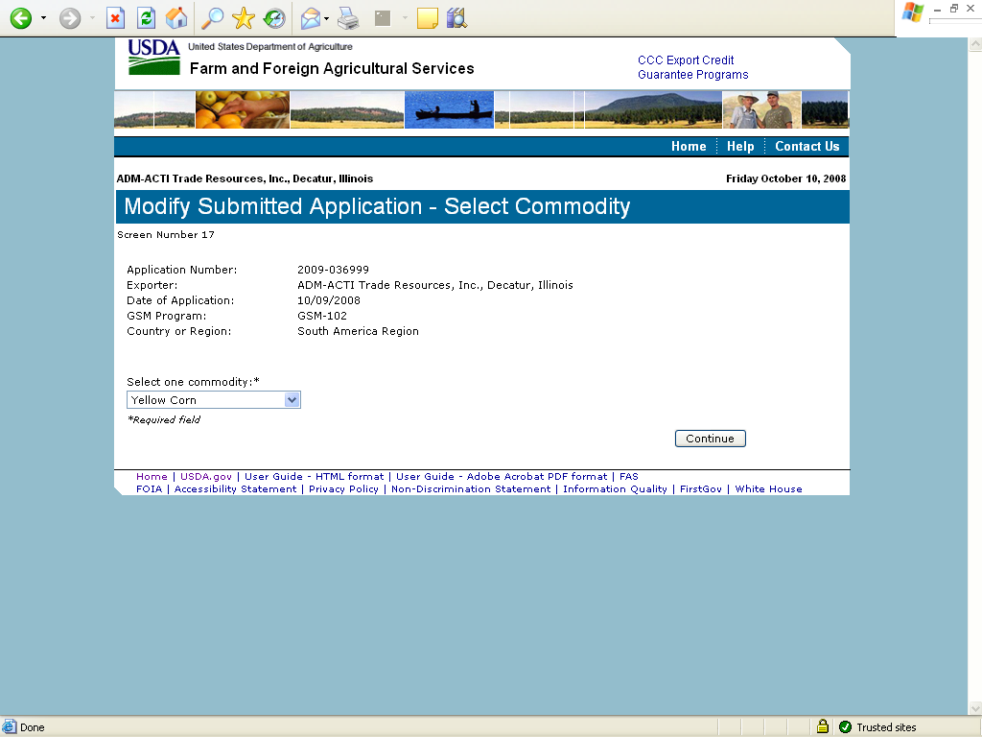
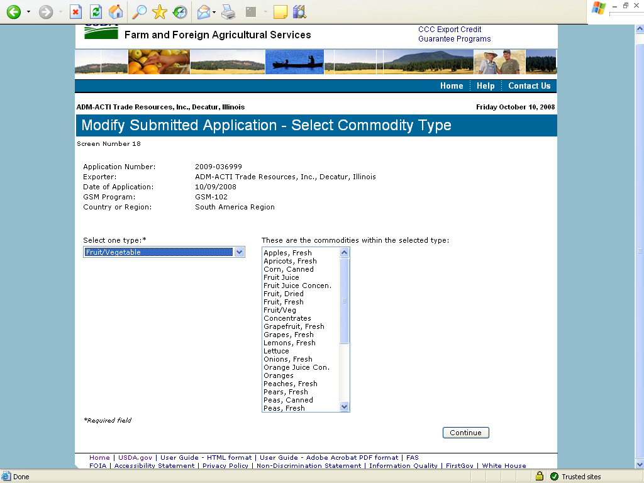
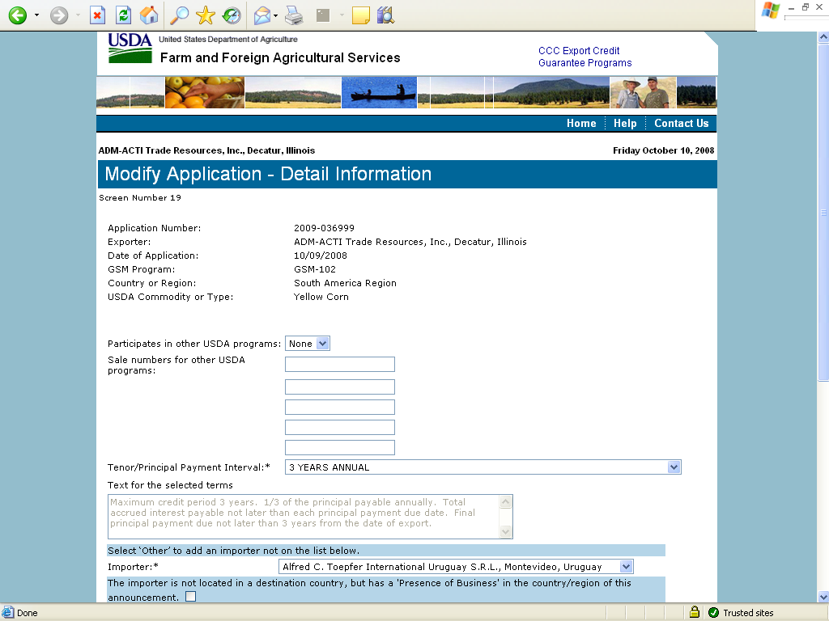
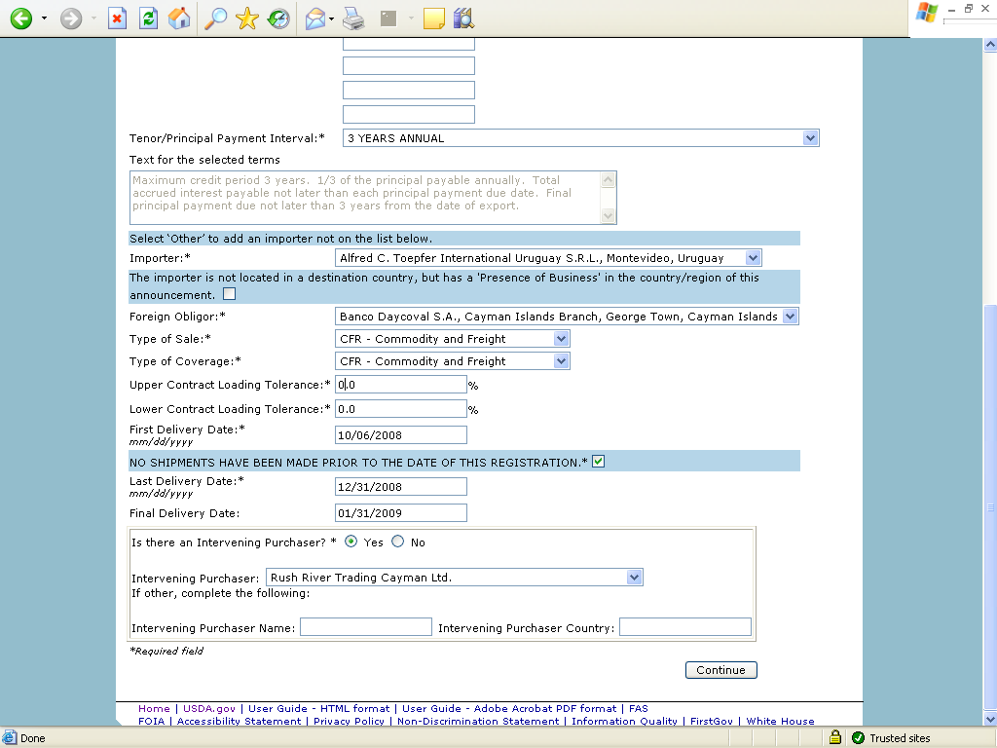
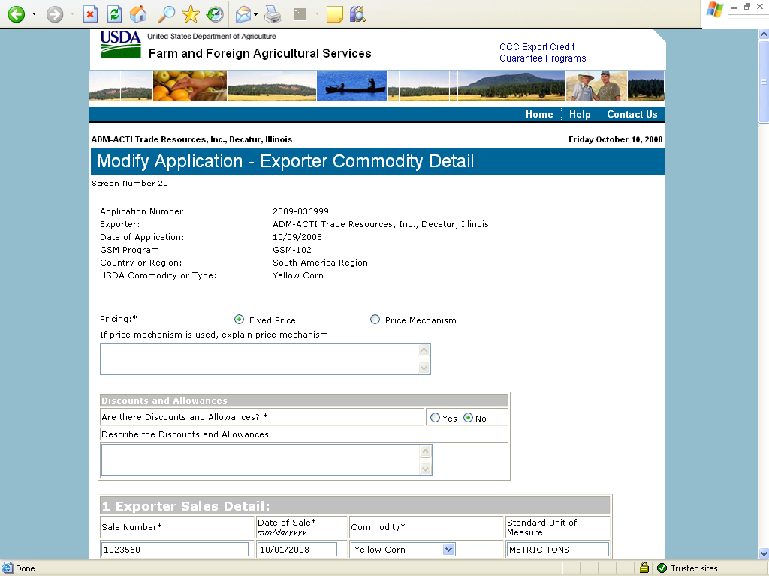
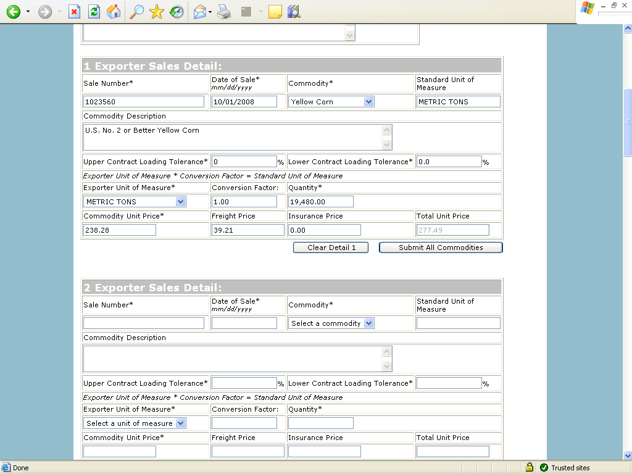
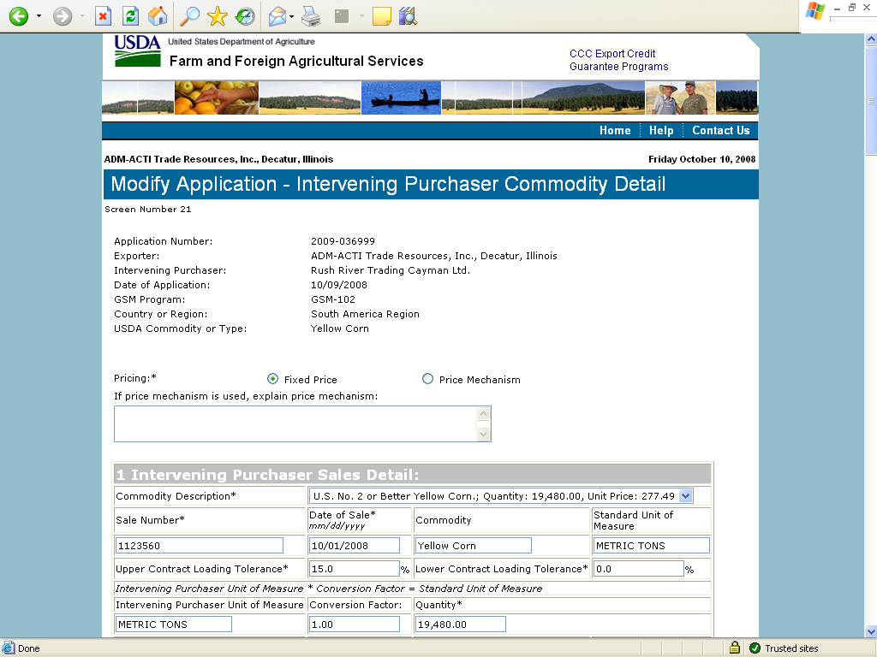
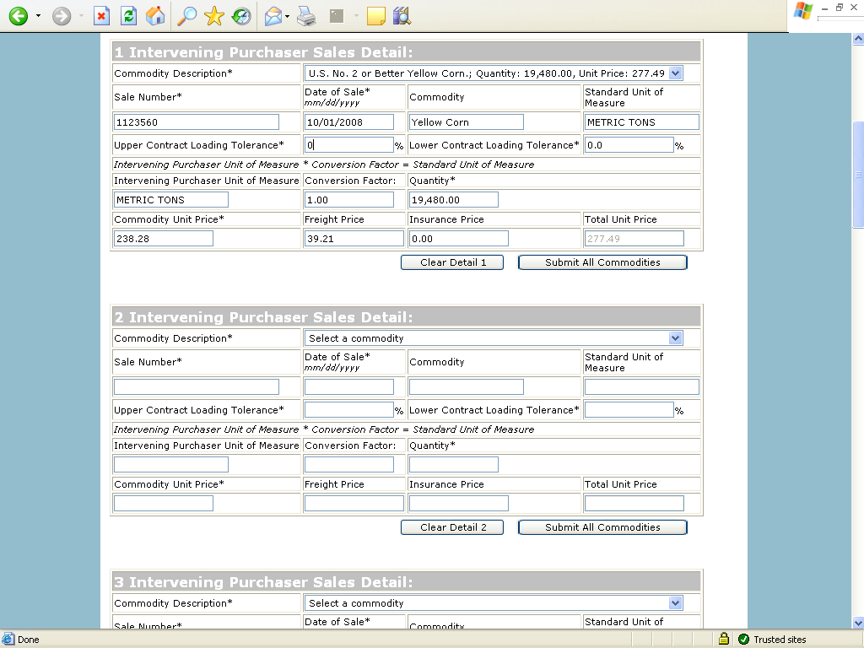
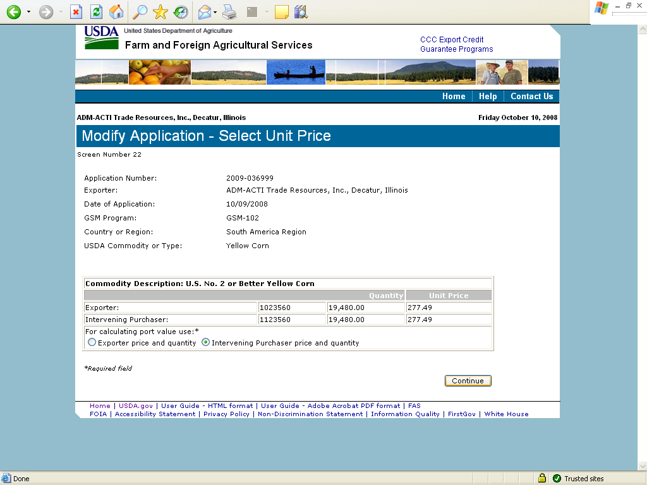
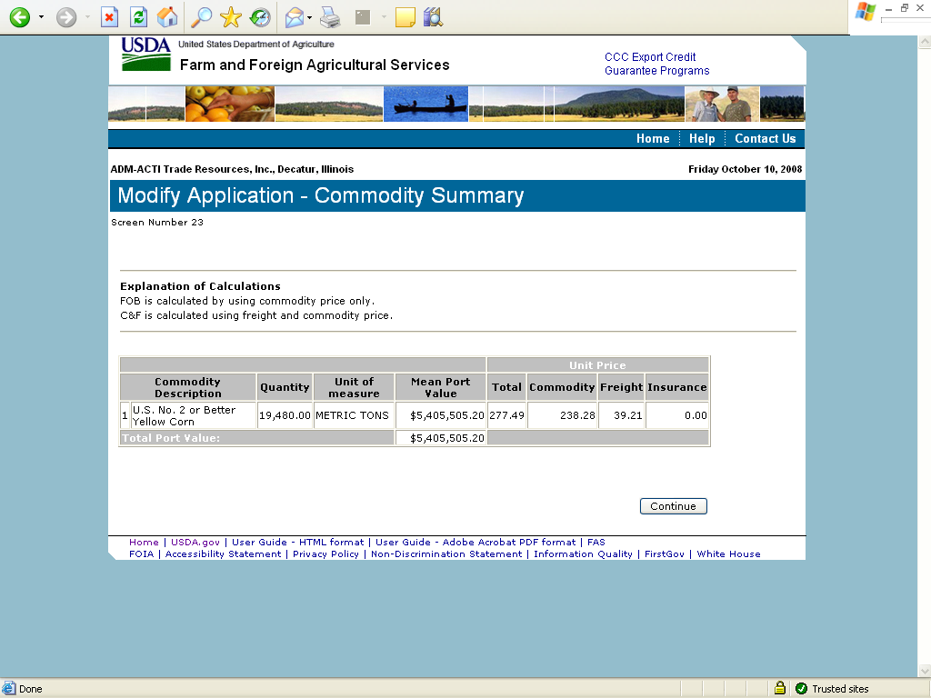
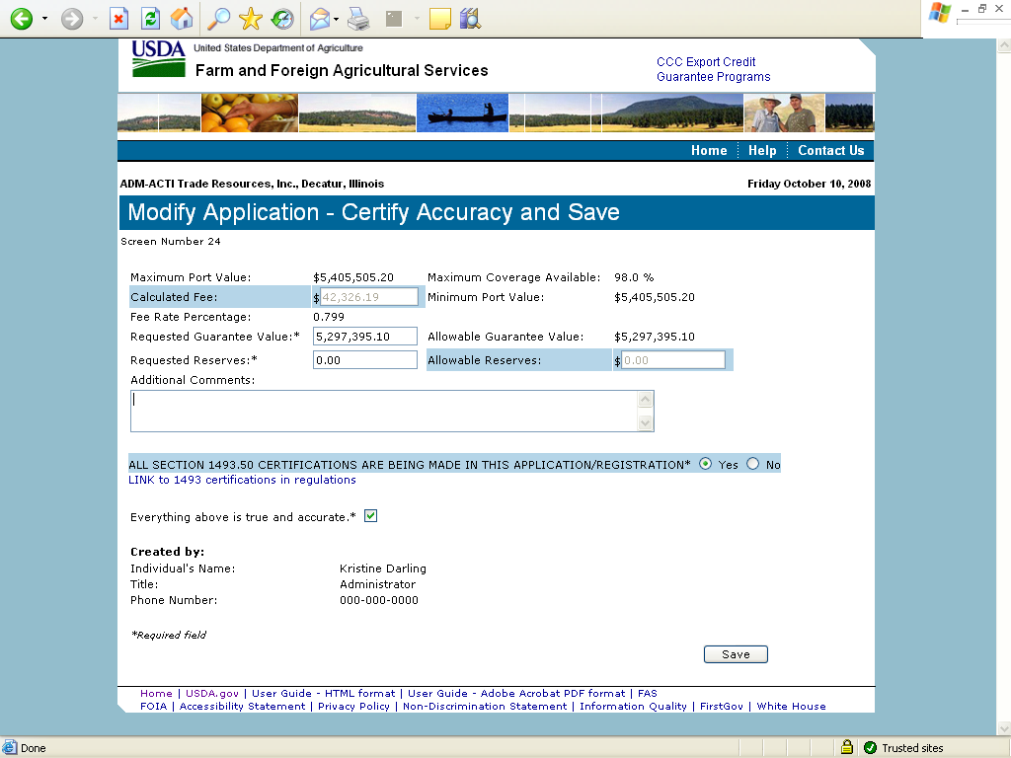

Form 3 – Modify Registration
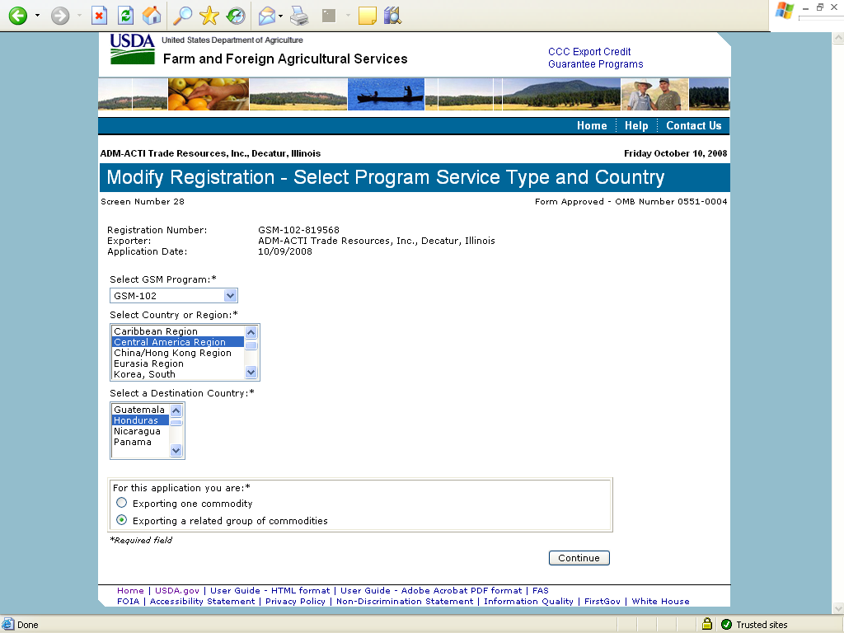
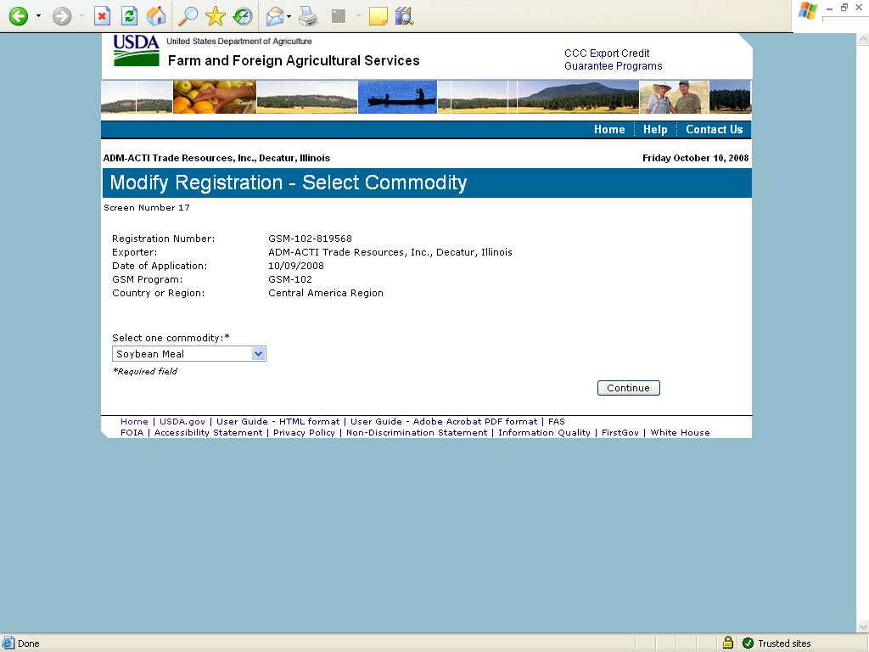
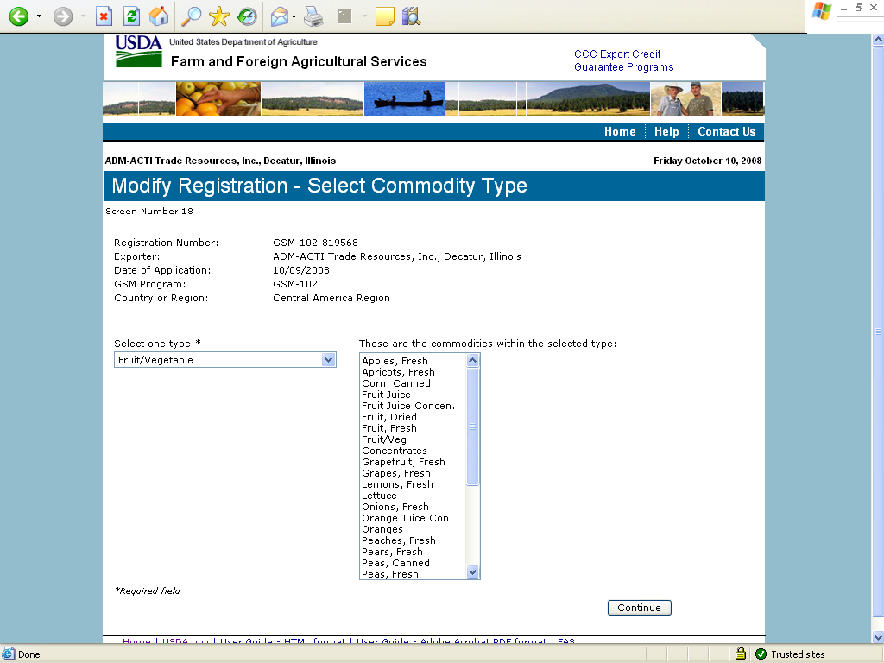
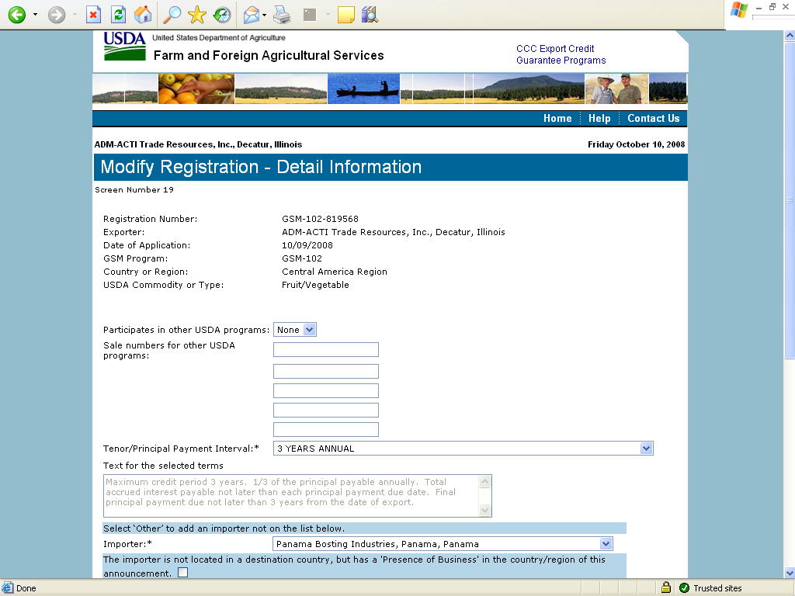
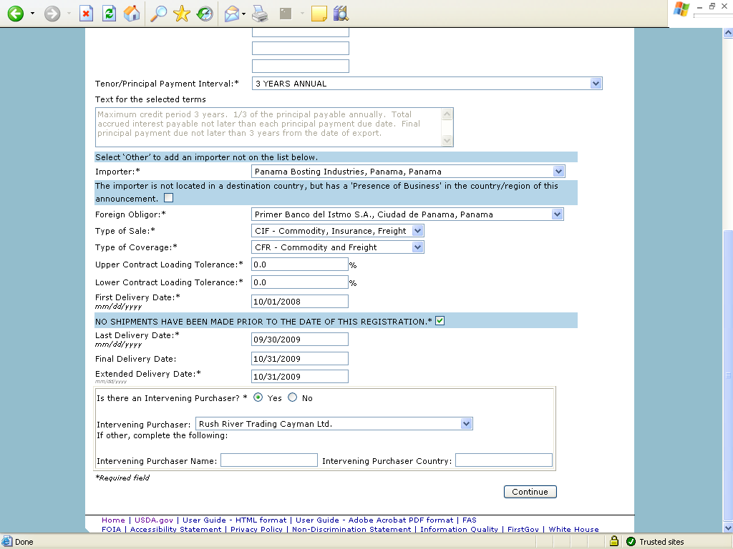
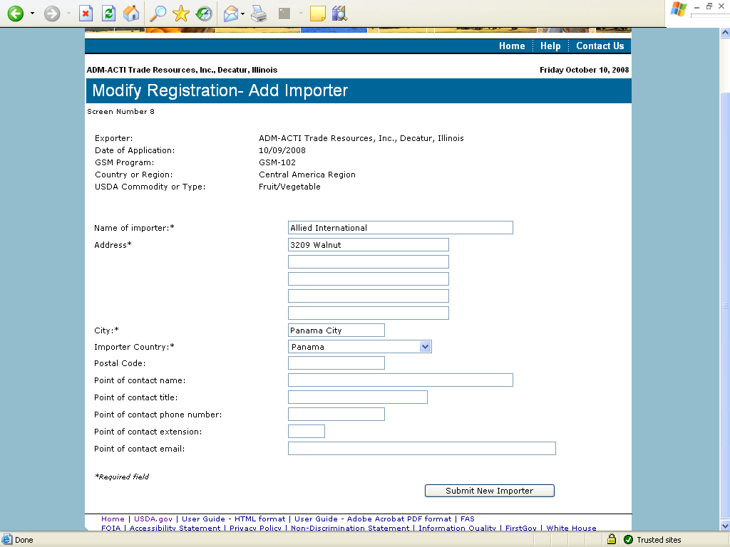
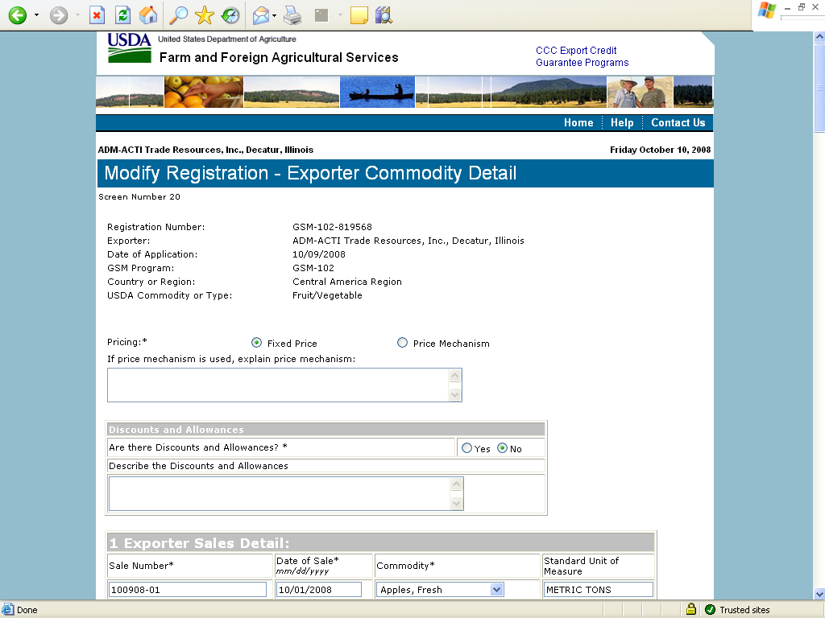

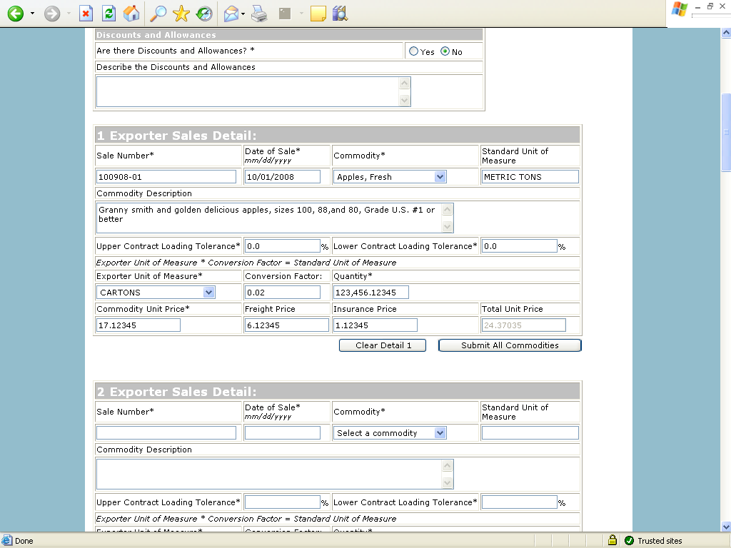
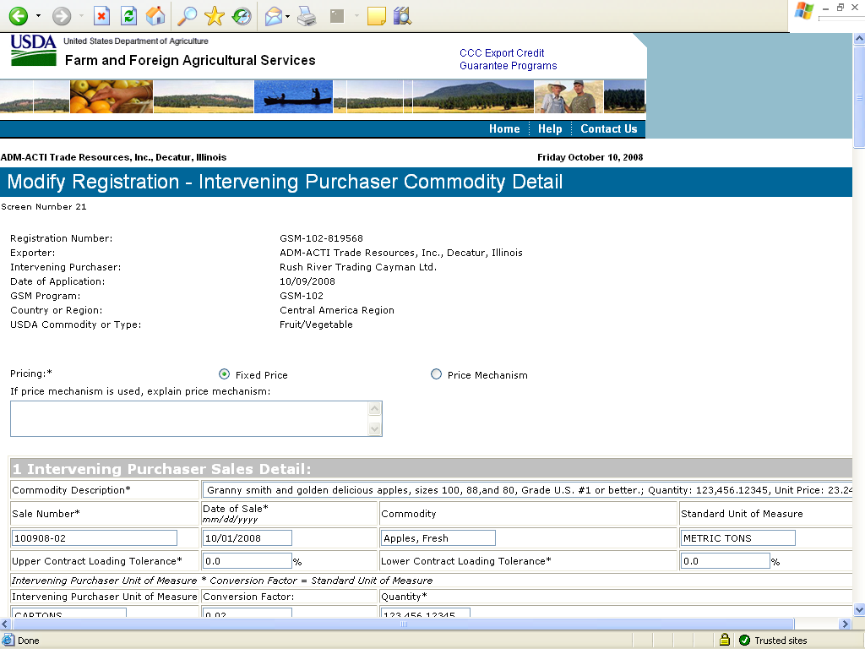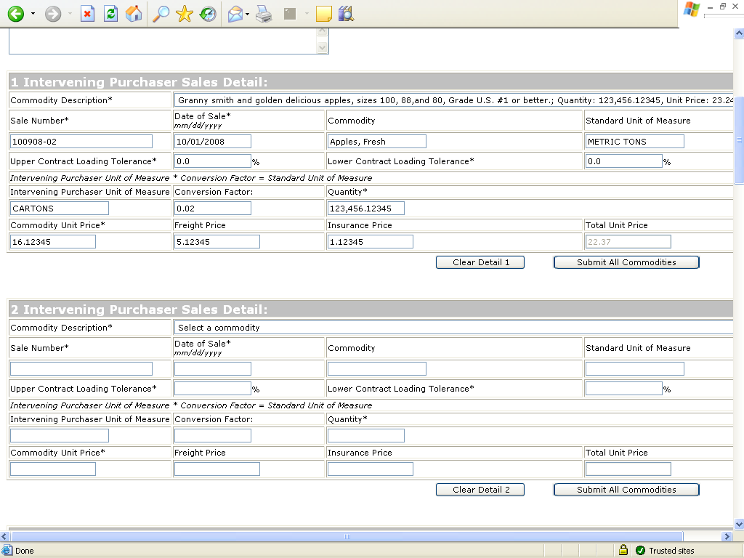
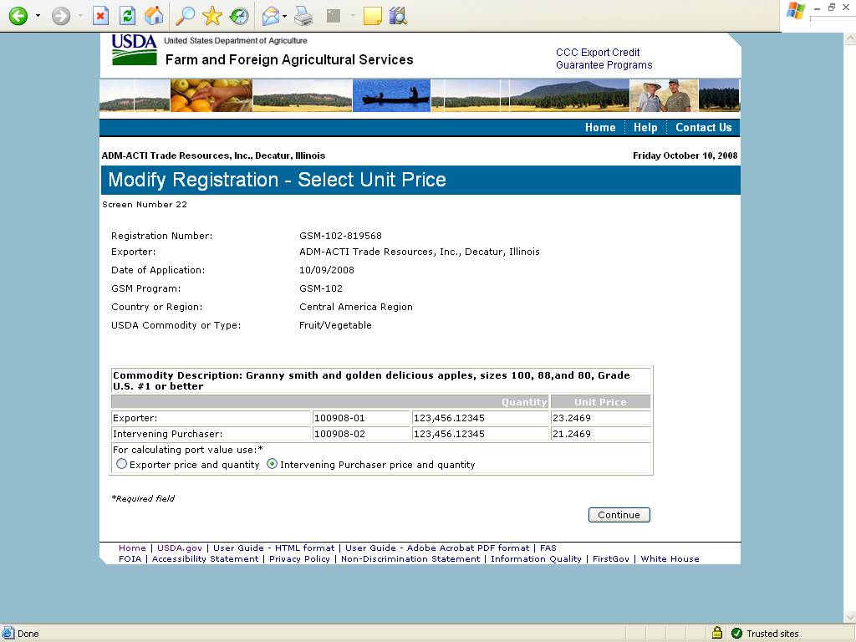
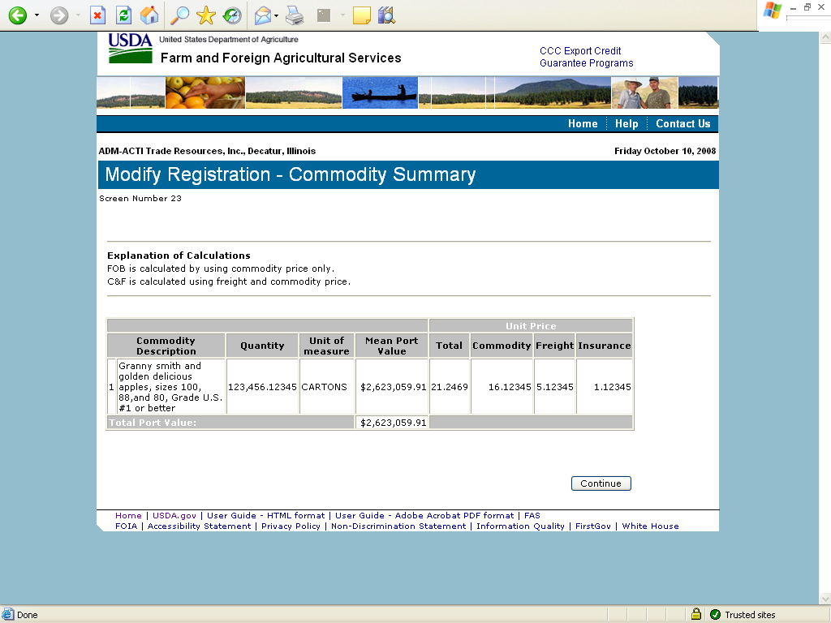
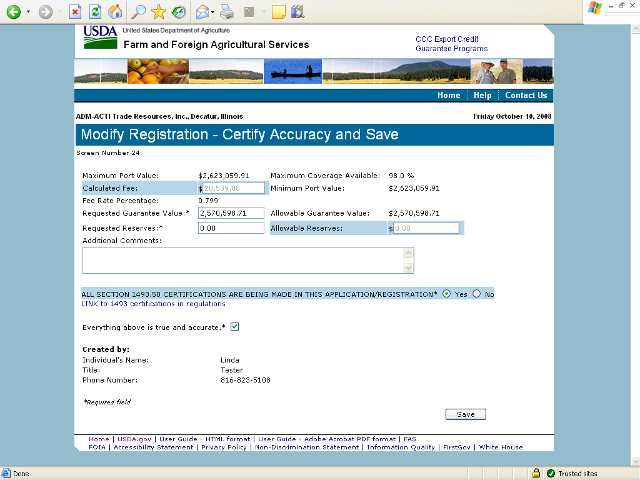
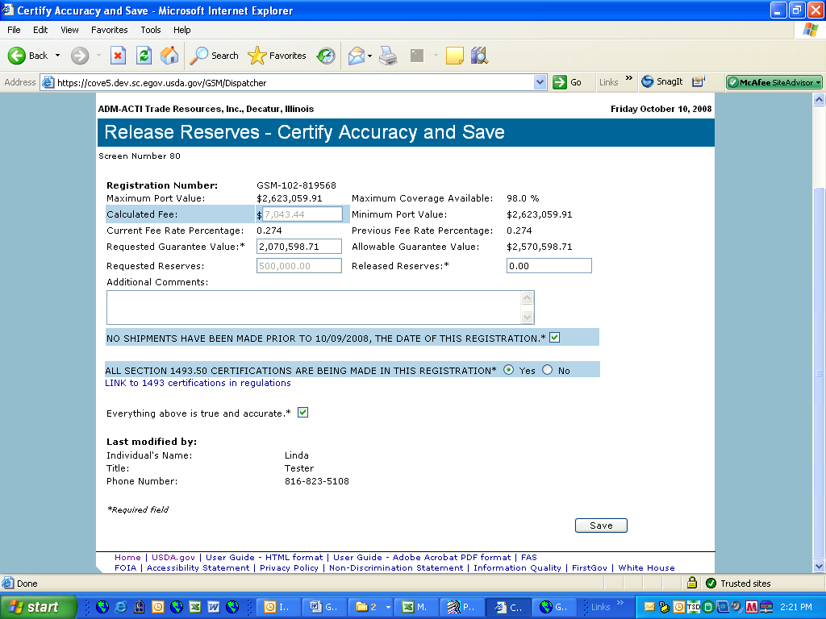

Form 4 – Assign Notice of Assignment
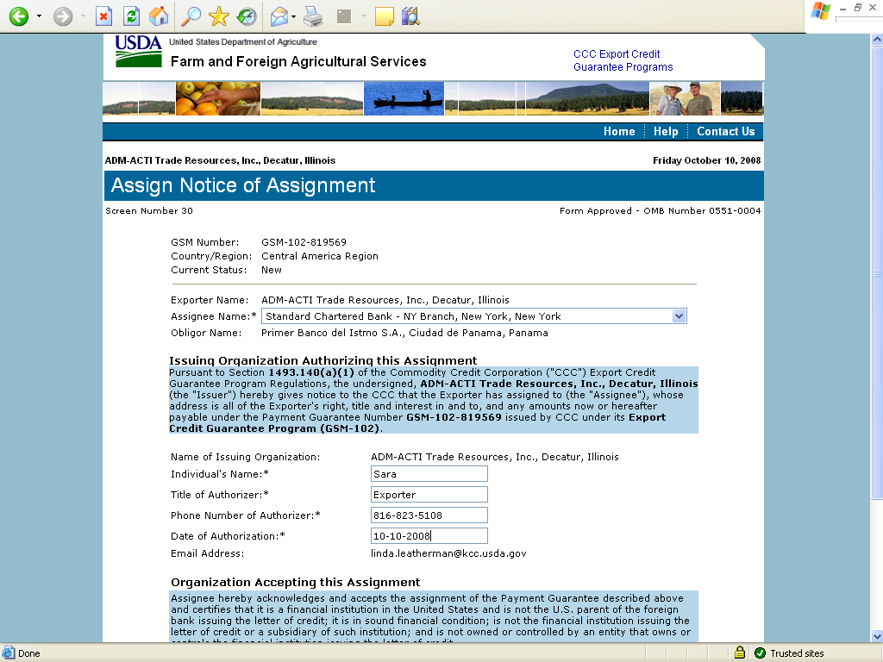
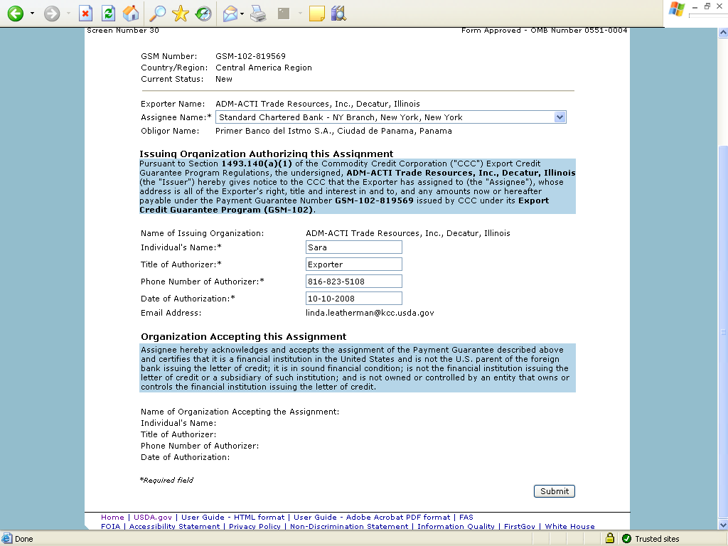

Form 5 – Withdraw Notice of Assignment
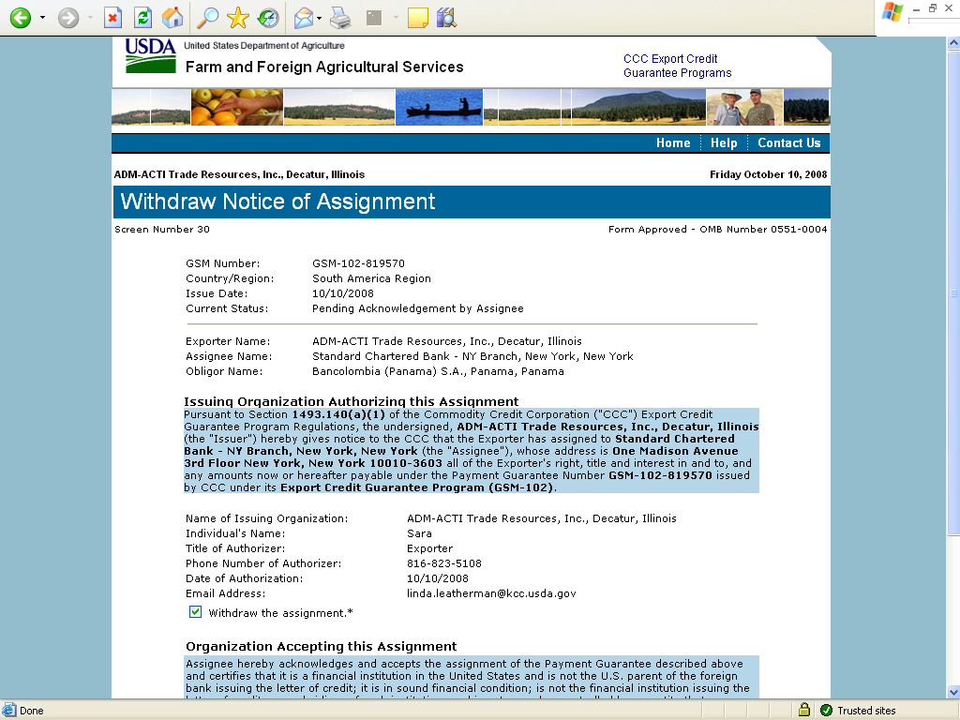
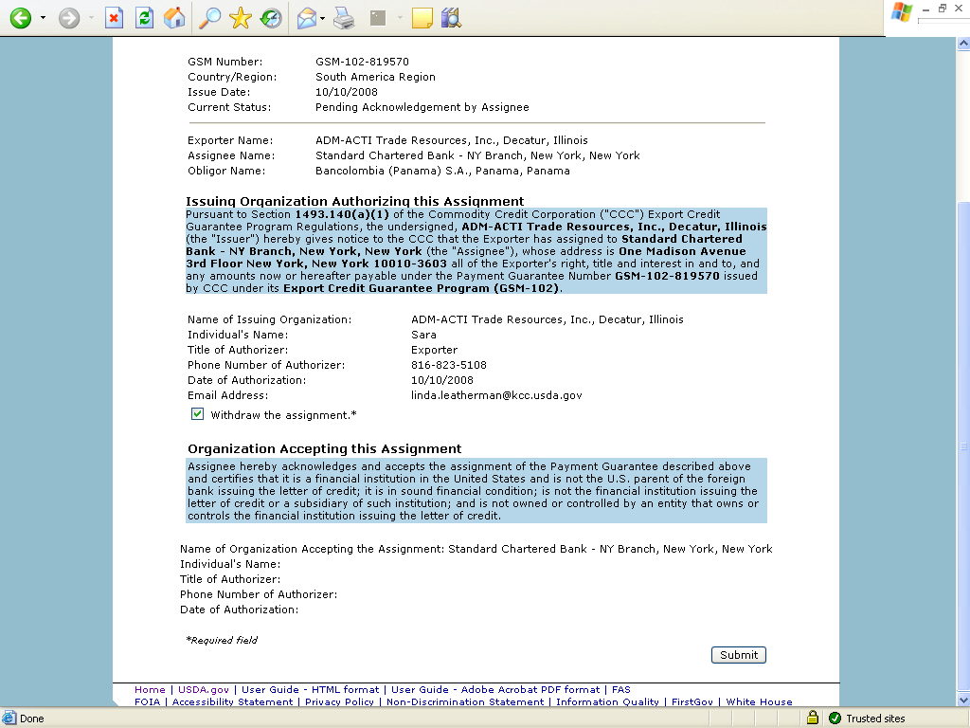

Form 6 – Accept Notice of Assignment
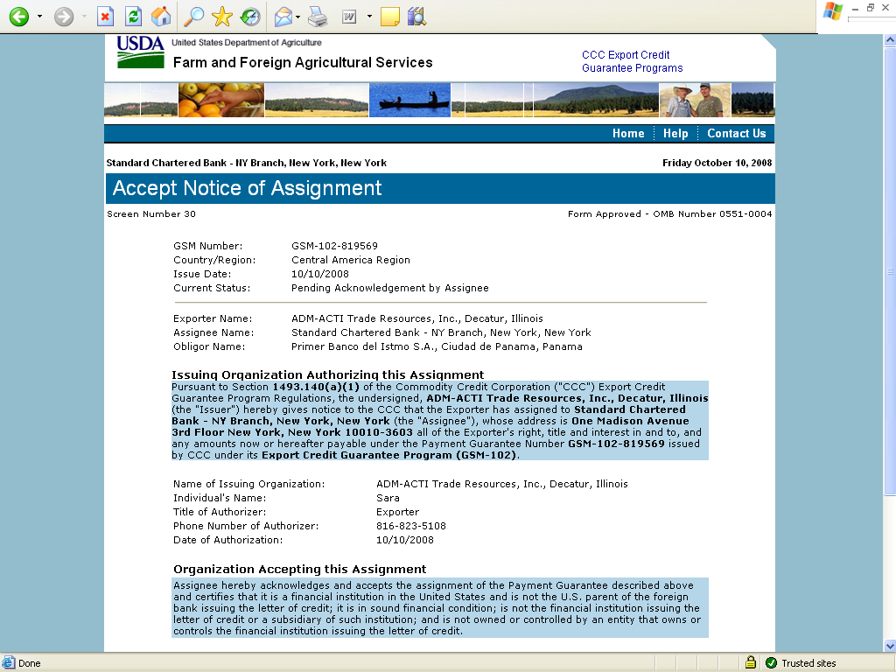
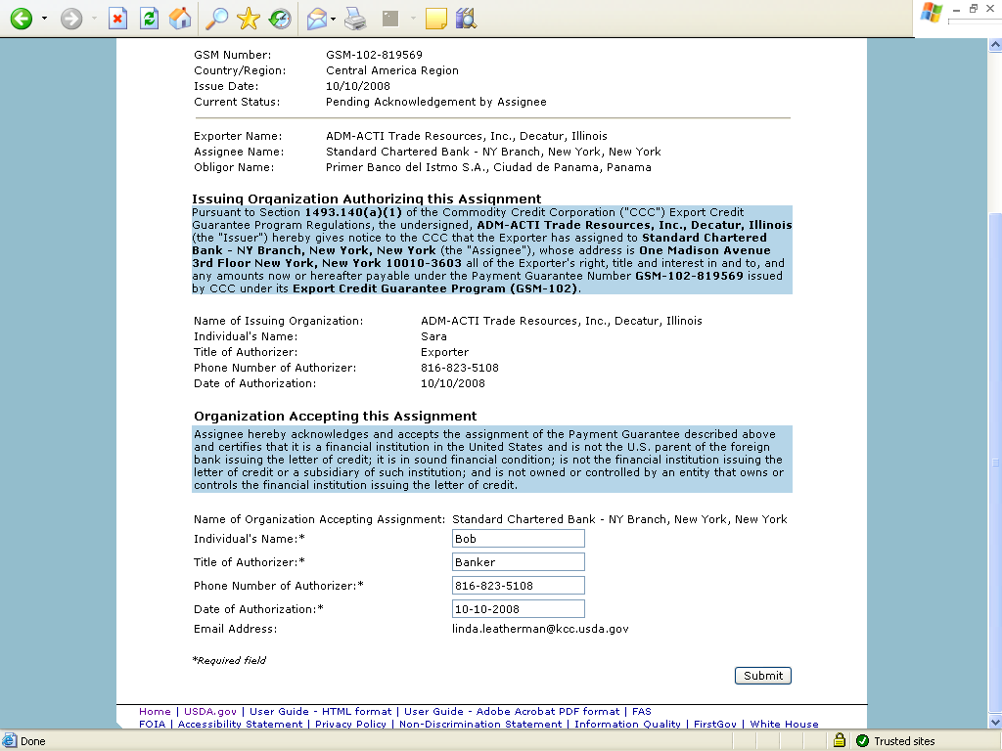

Form 7 – Reject Notice of Assignment
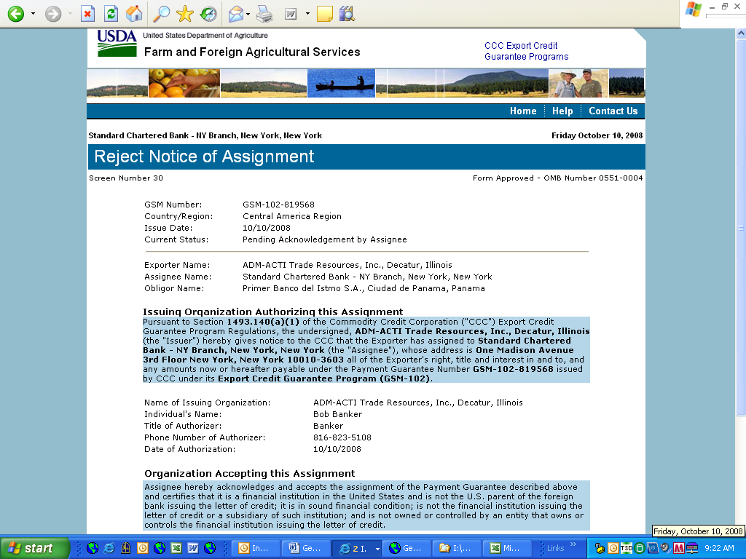
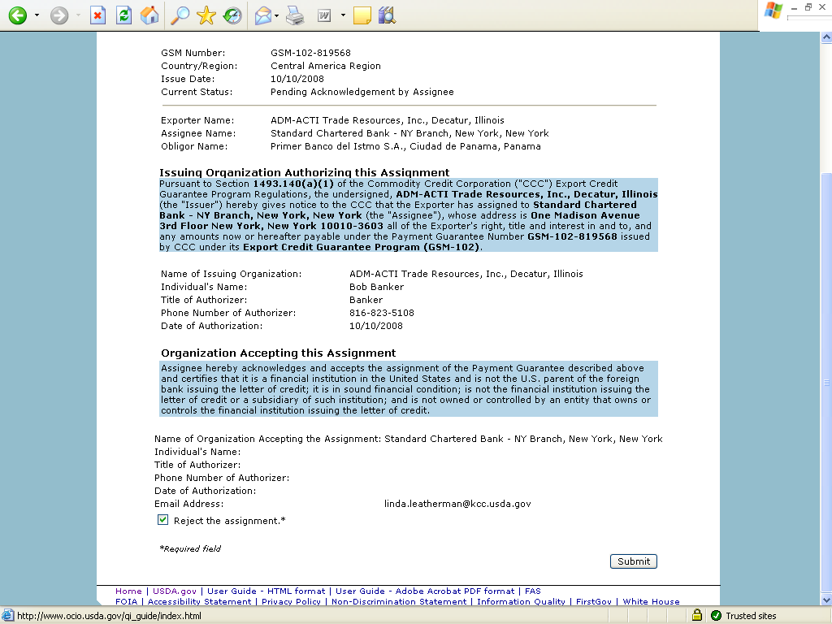

Form 8 – Reassign Notice of Assignment
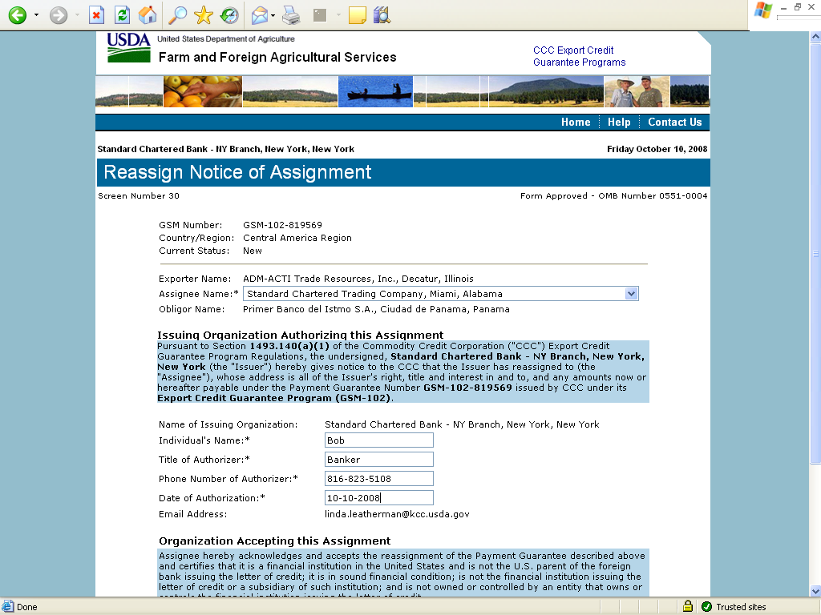
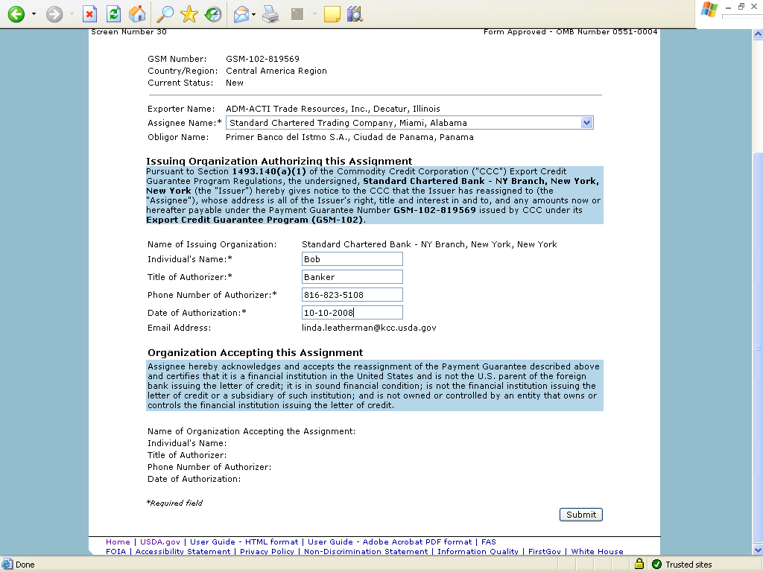

Form 9 – Modify Organization (Exporter)
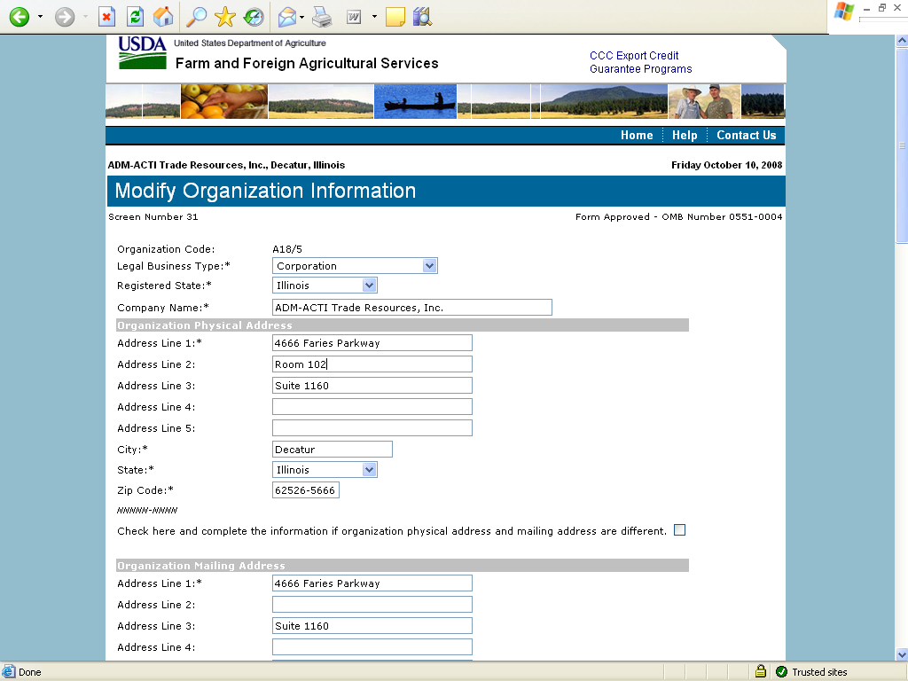
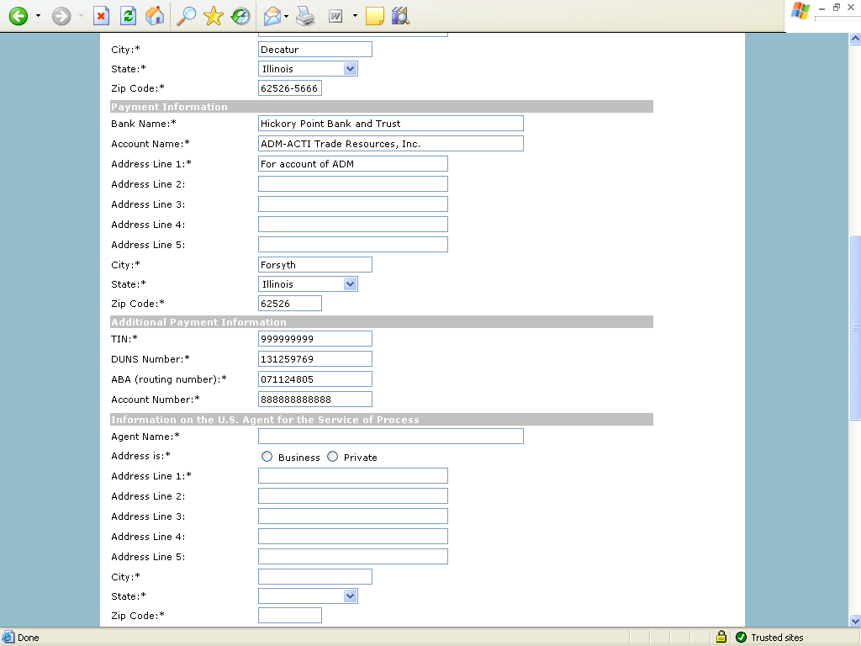
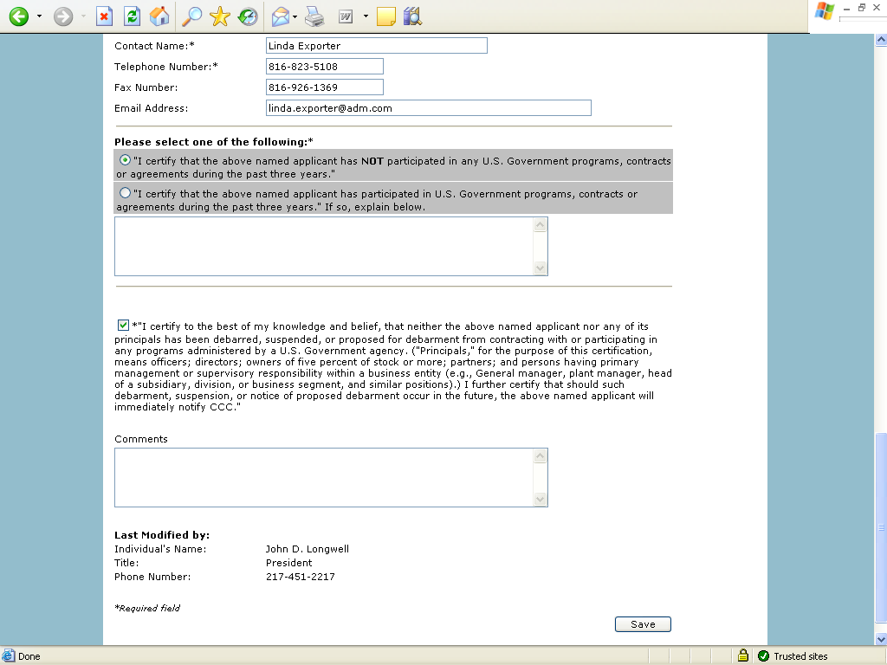

Form 10 – Modify Organization (US Bank)
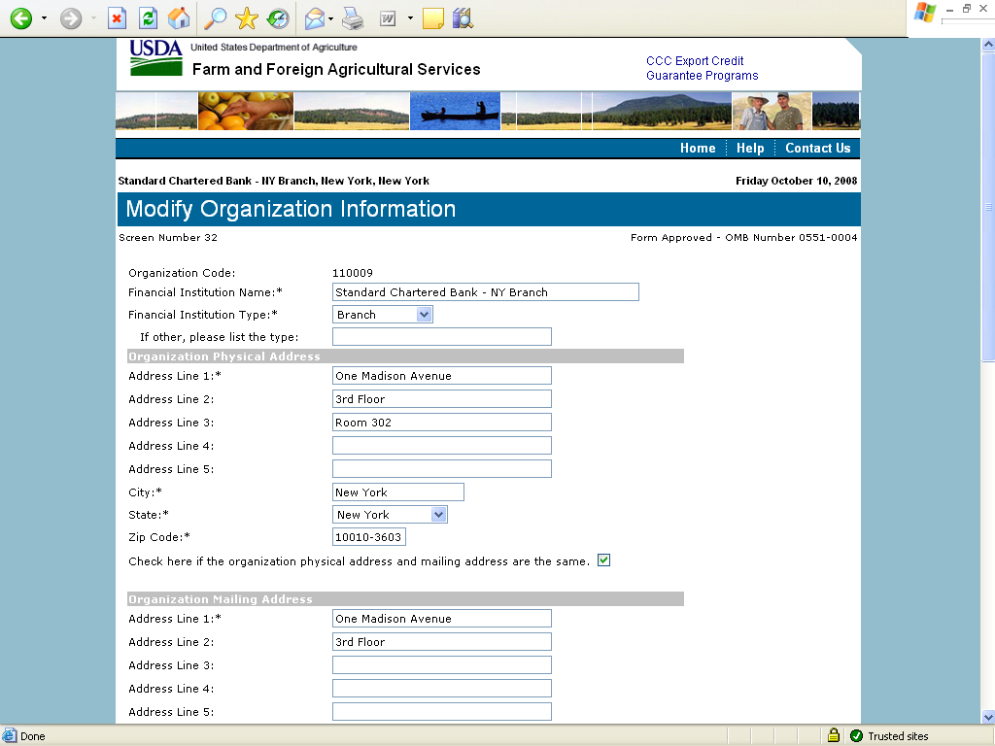
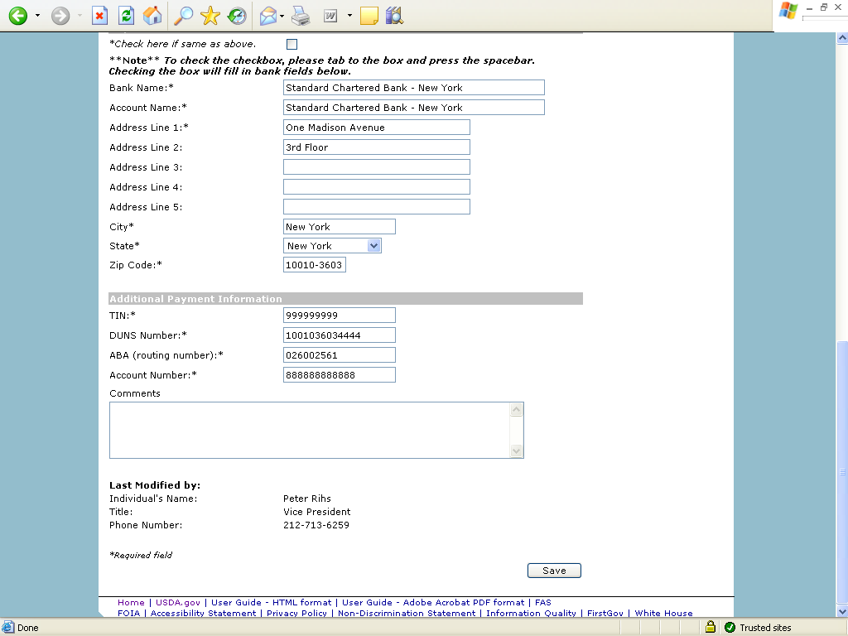

Form 11 – Create Point of Contact
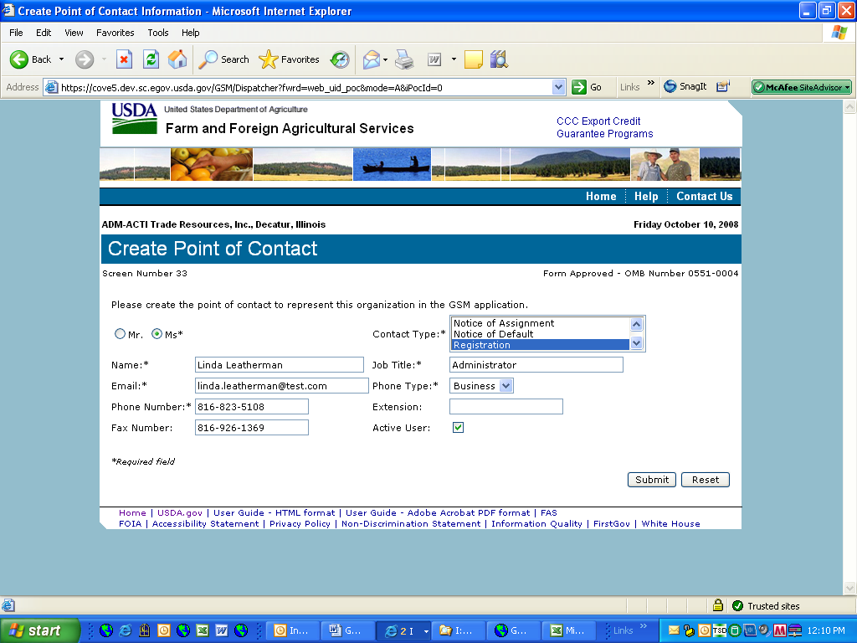

Form 12 – Modify Point of Contact
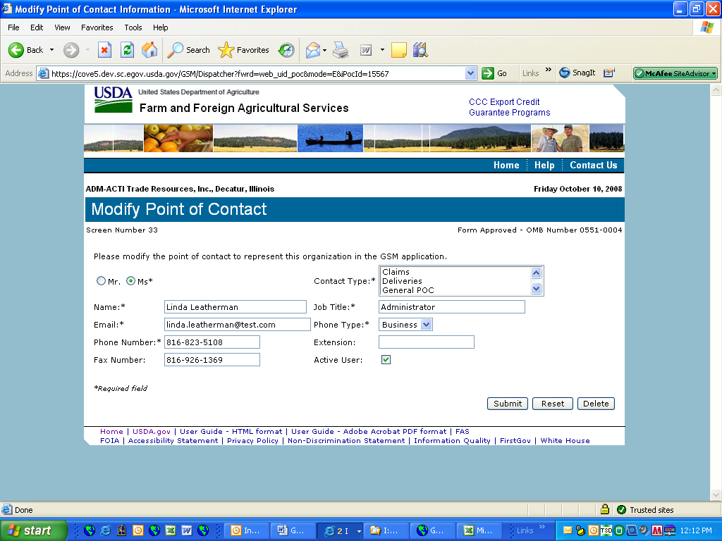

Form 13 – Create Delivery
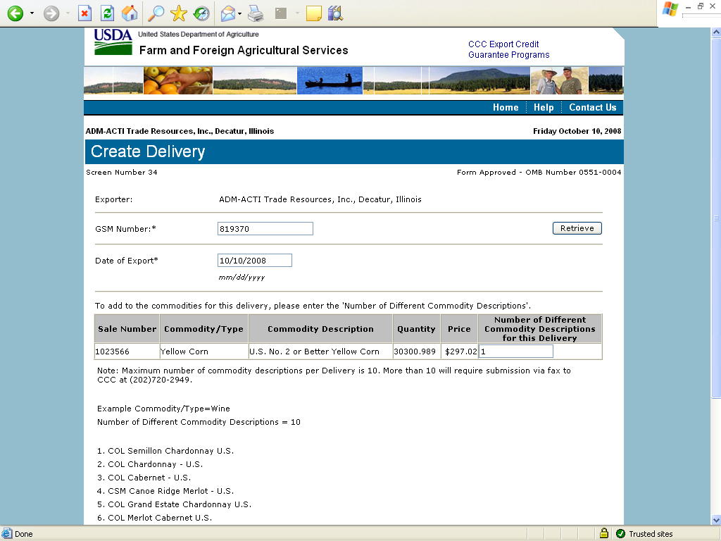
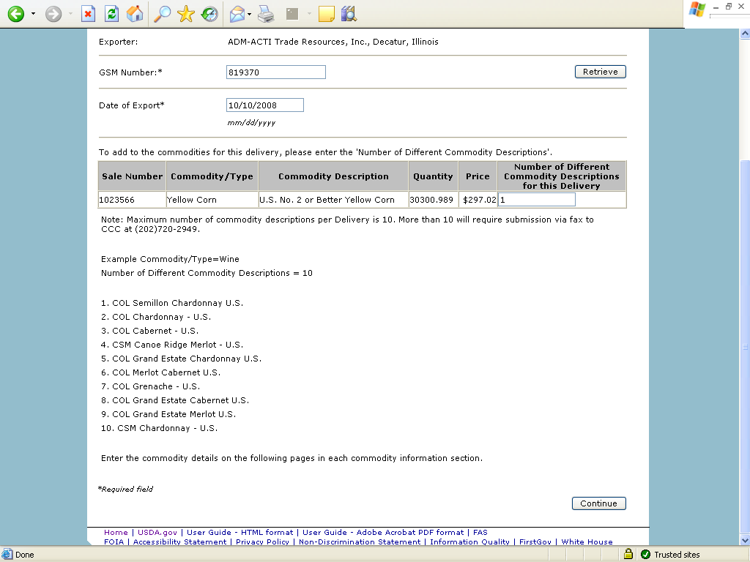
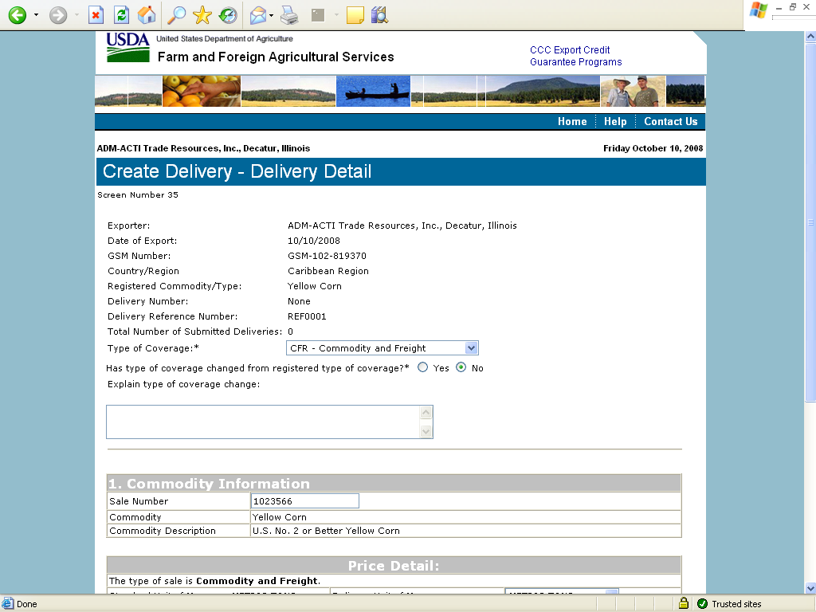
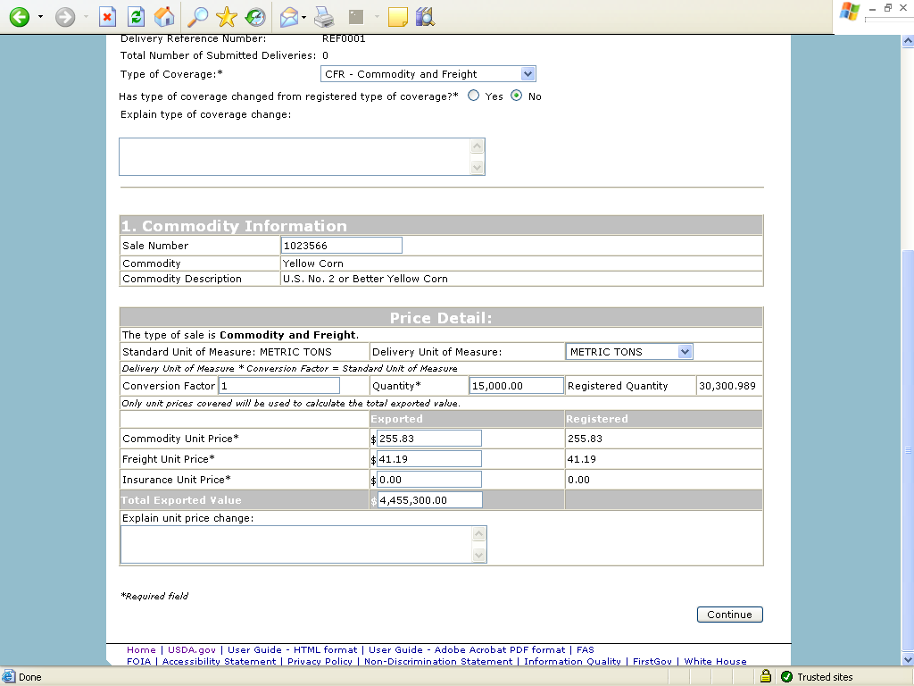
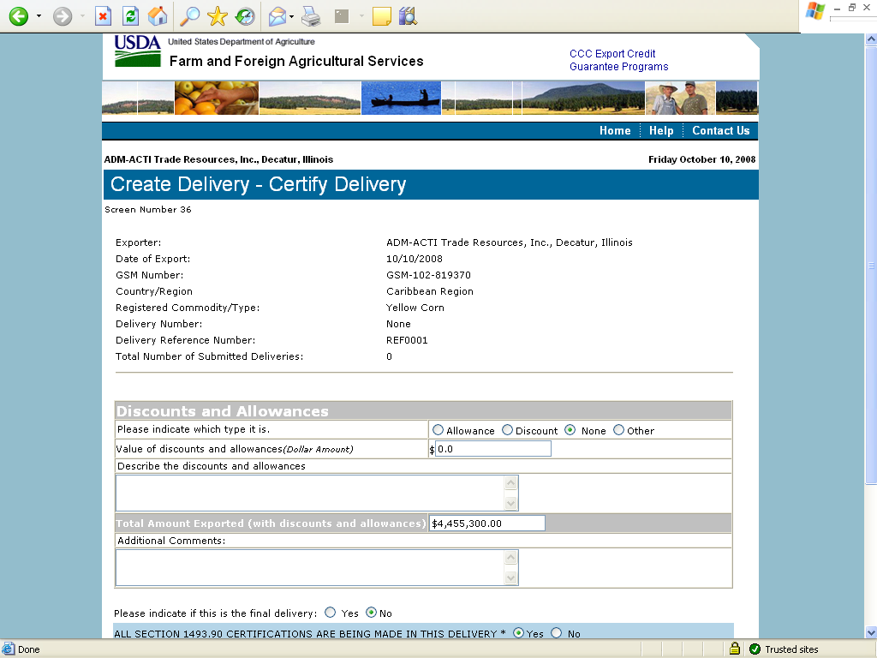
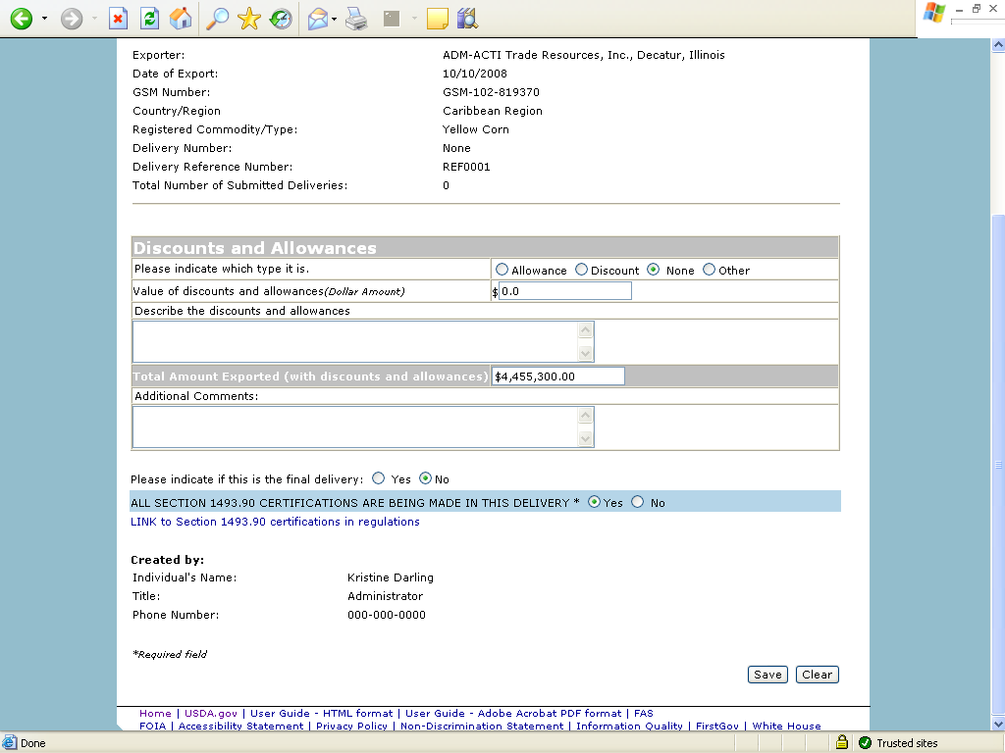

Form 14 – Withdraw Delivery
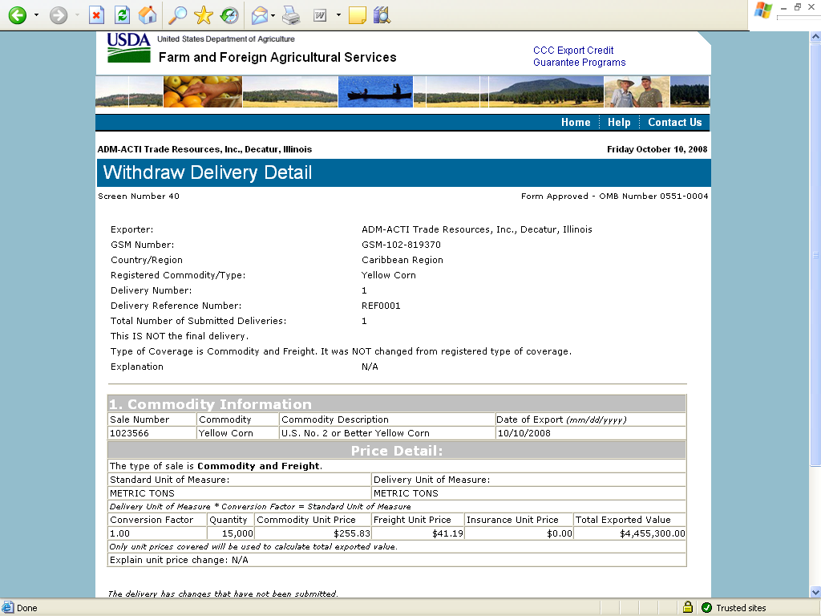
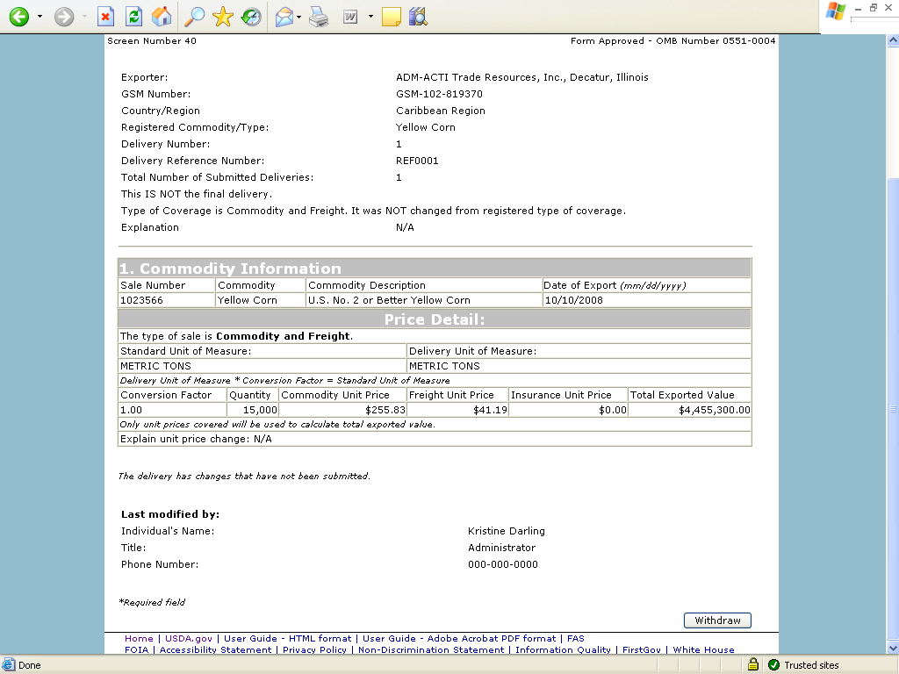

Form 20 - Modify Delivery
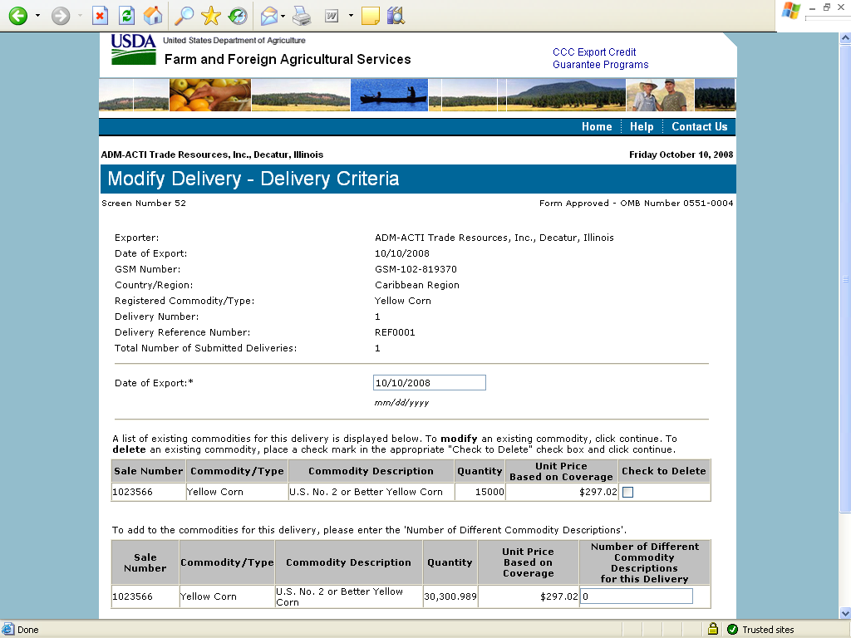
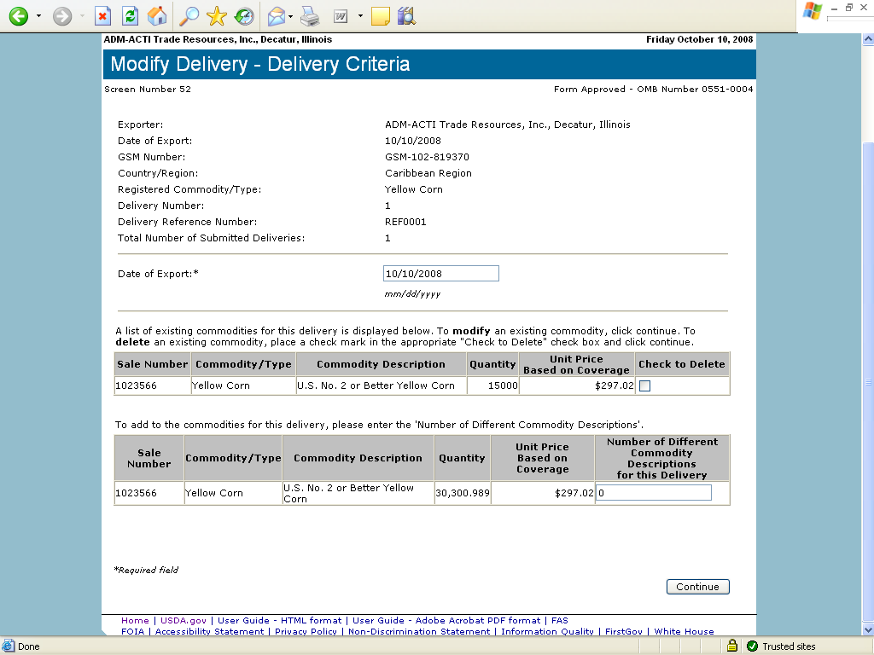
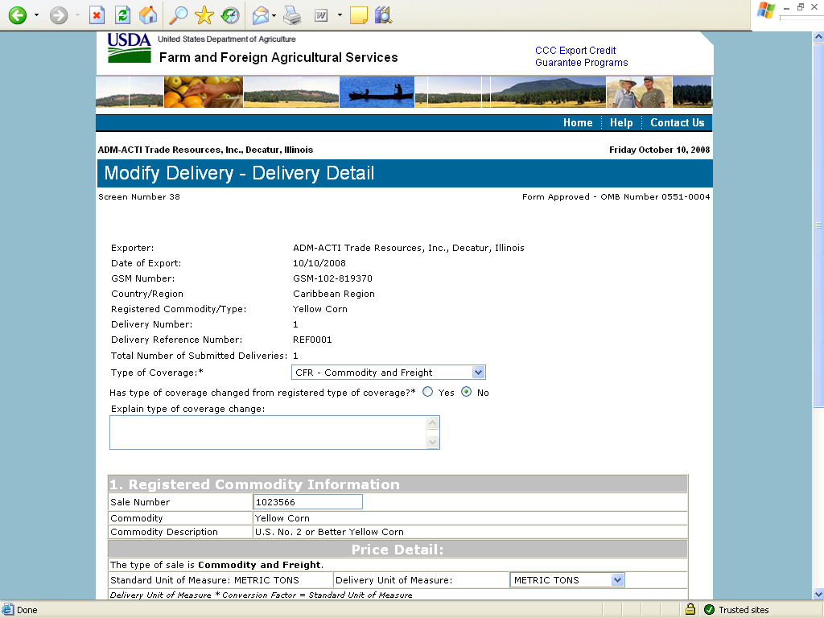
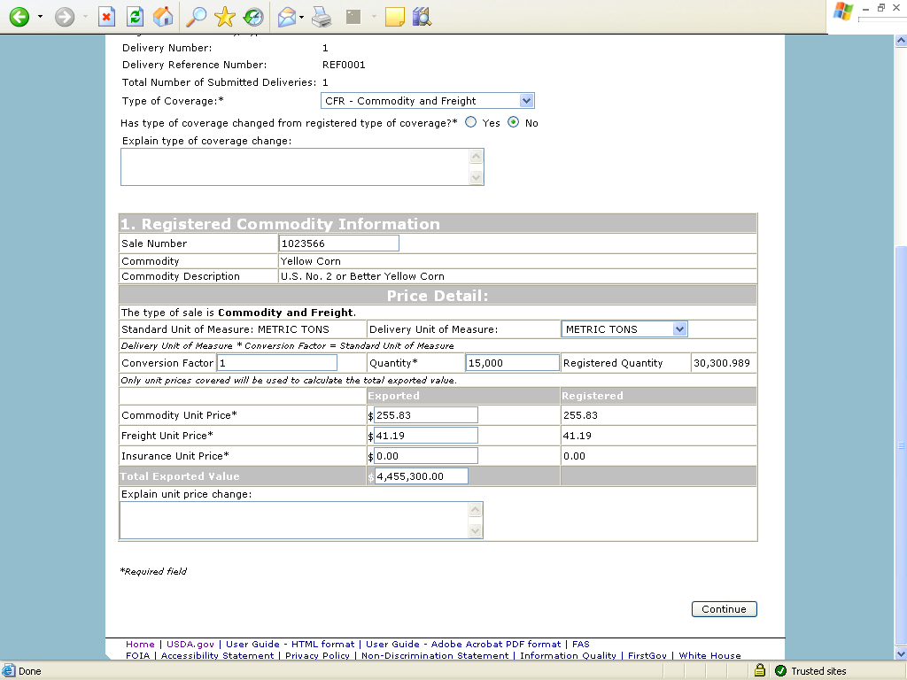
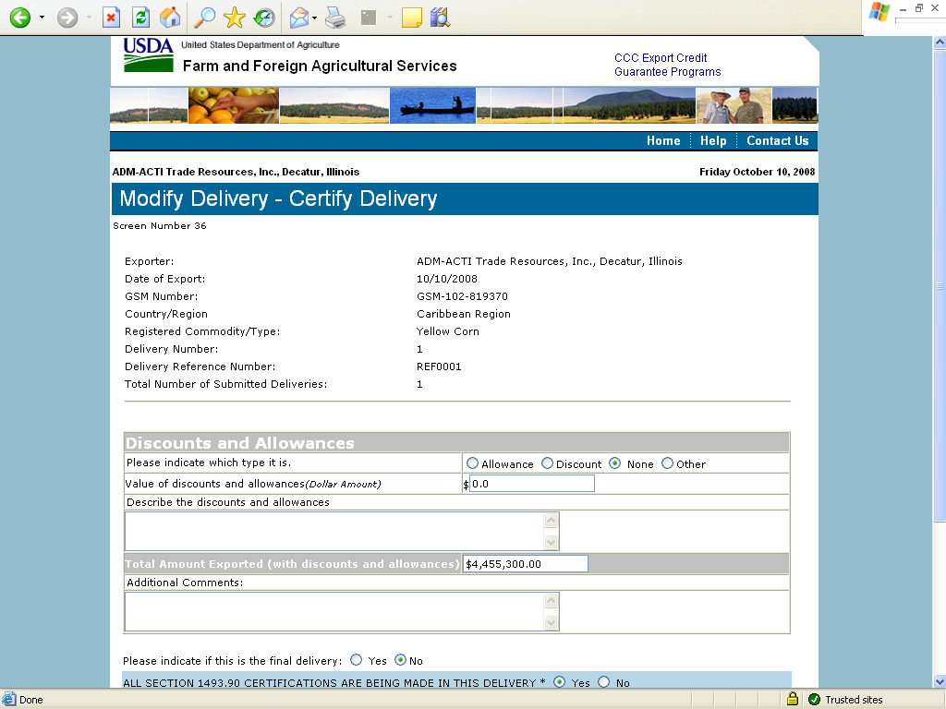
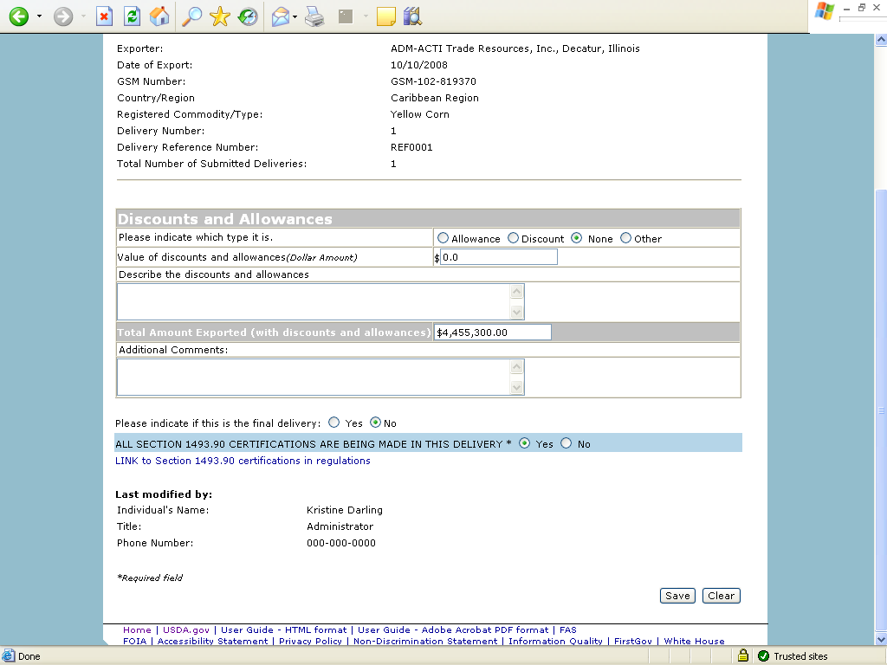

Form 21 - Register as an Internal Control Administrator
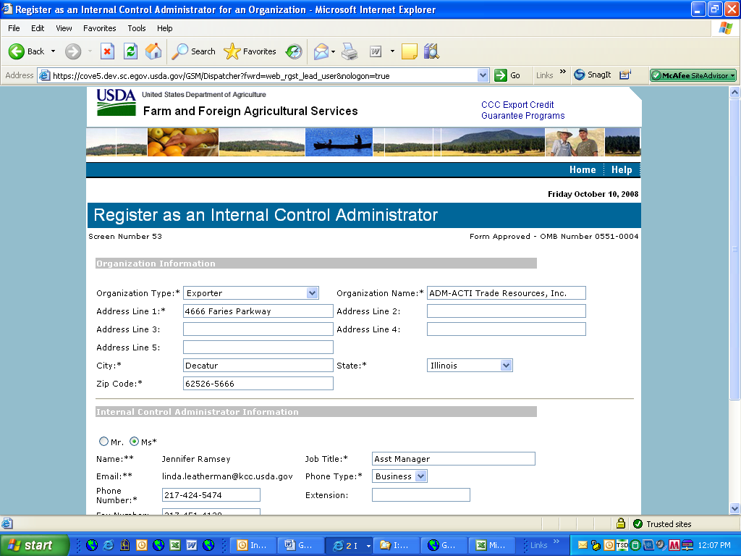
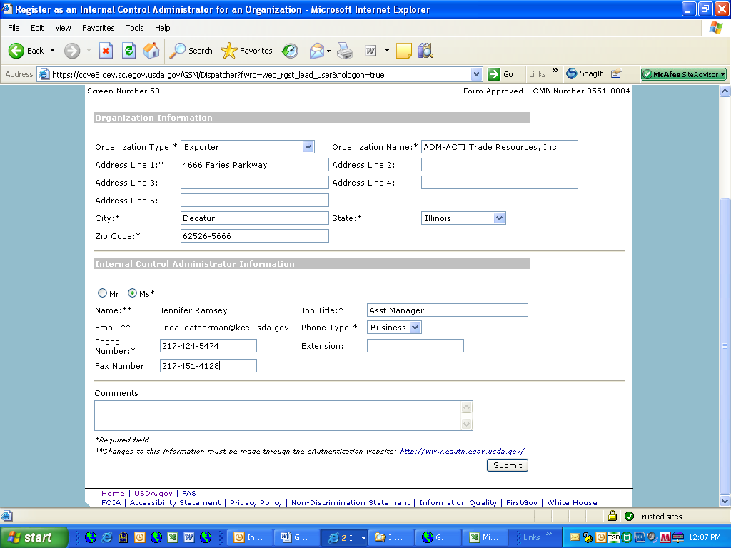

Form 22 – Apply for Participation in GSM System (US Bank)

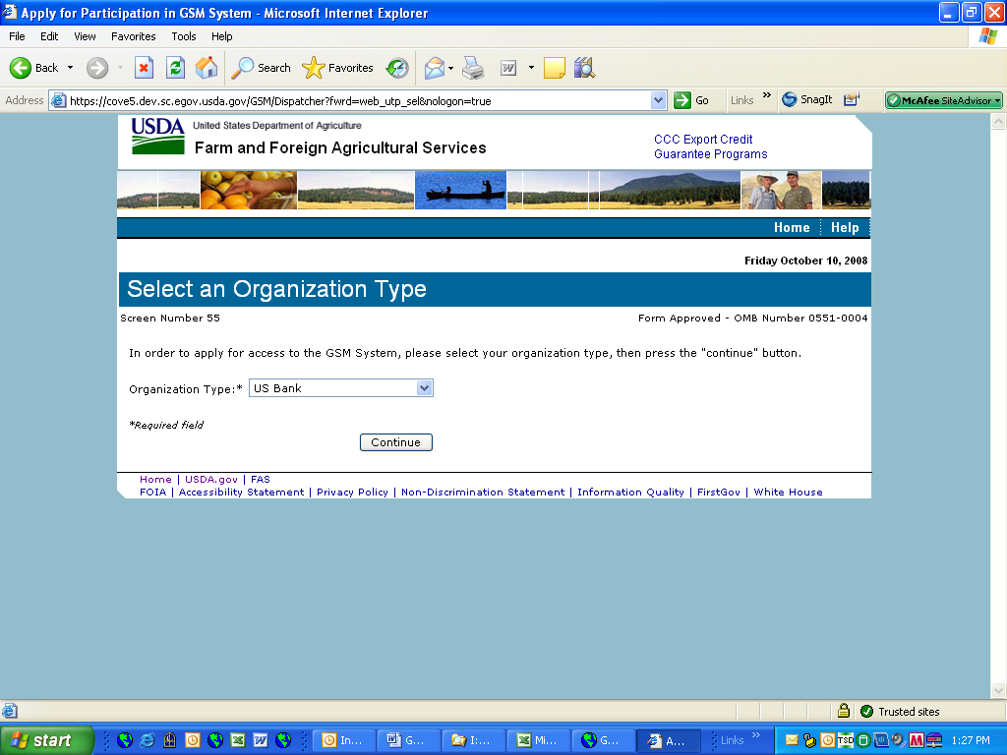
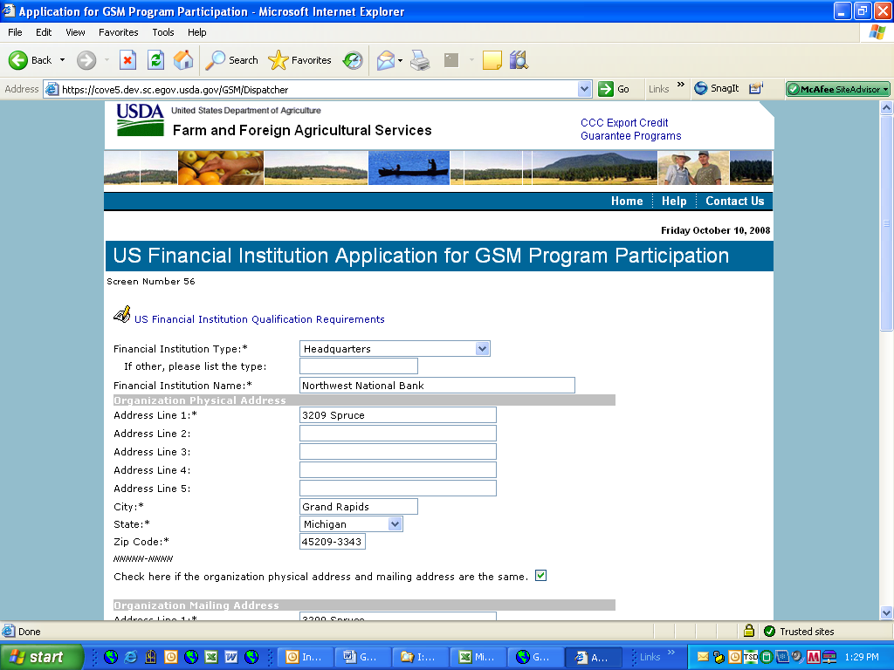
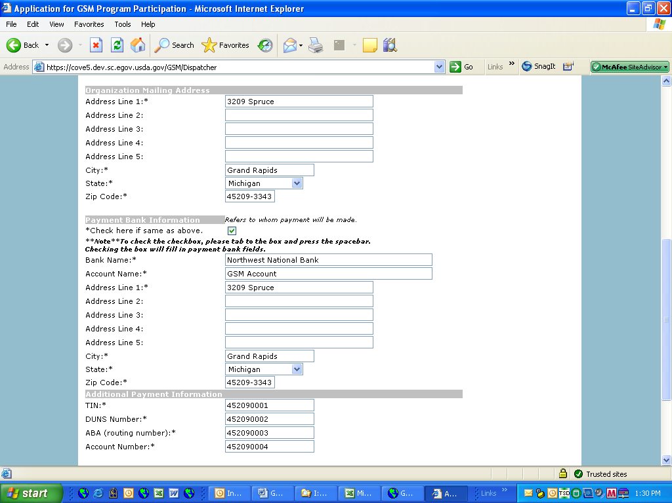
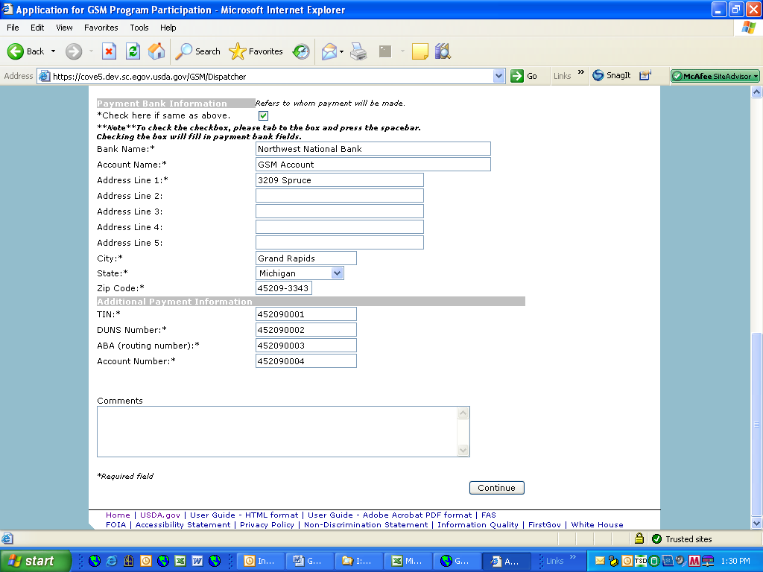
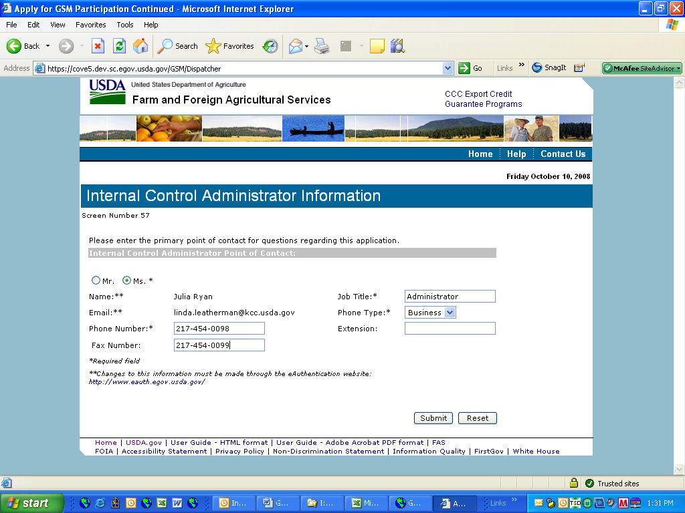

Form 23 – Apply for Participation in GSM System (Exporter)
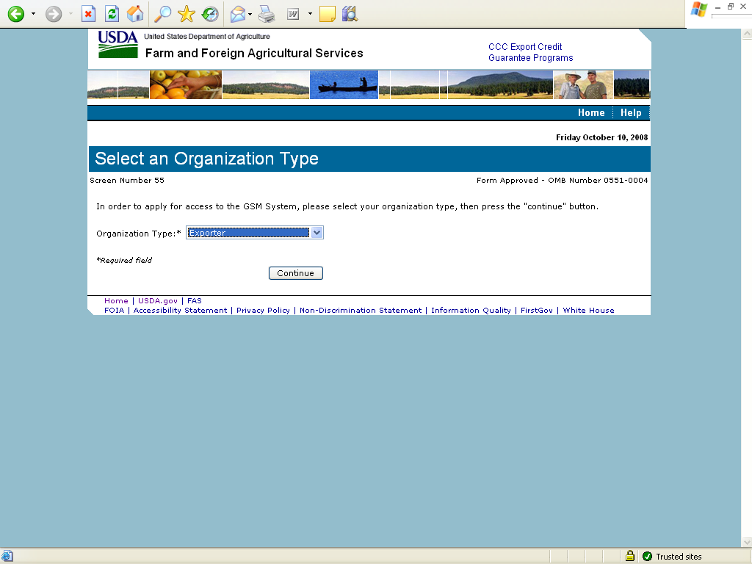
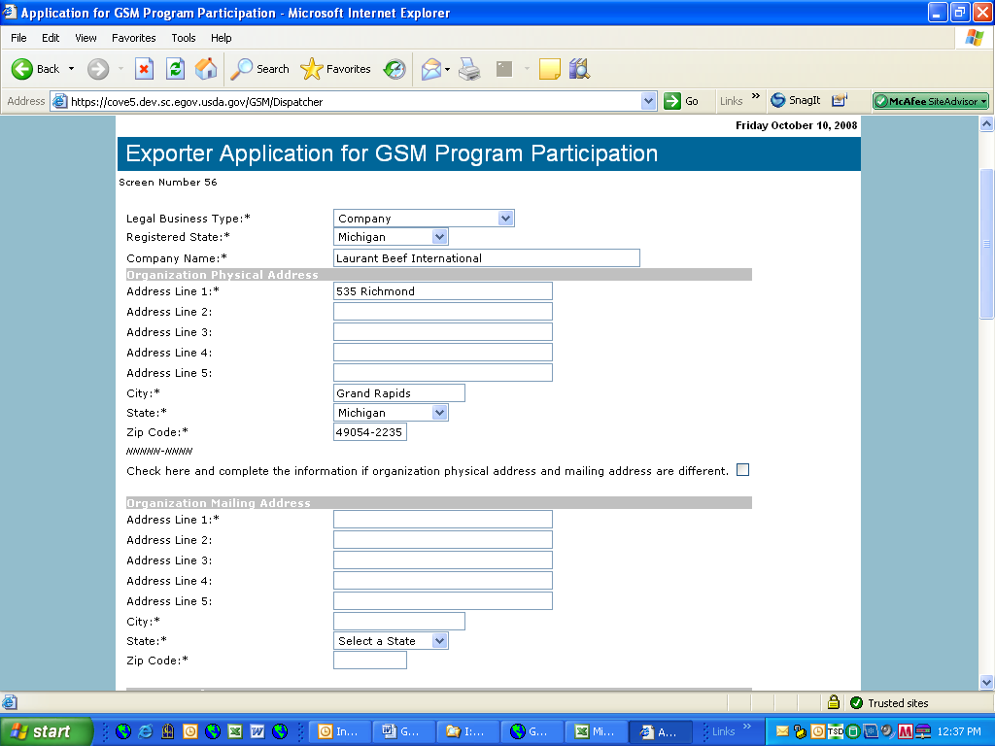
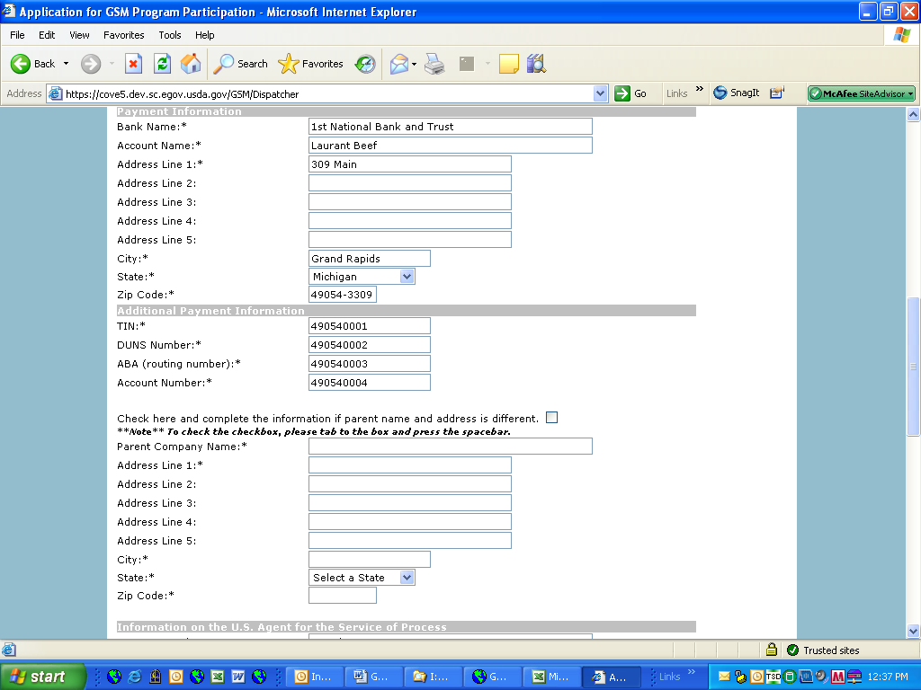
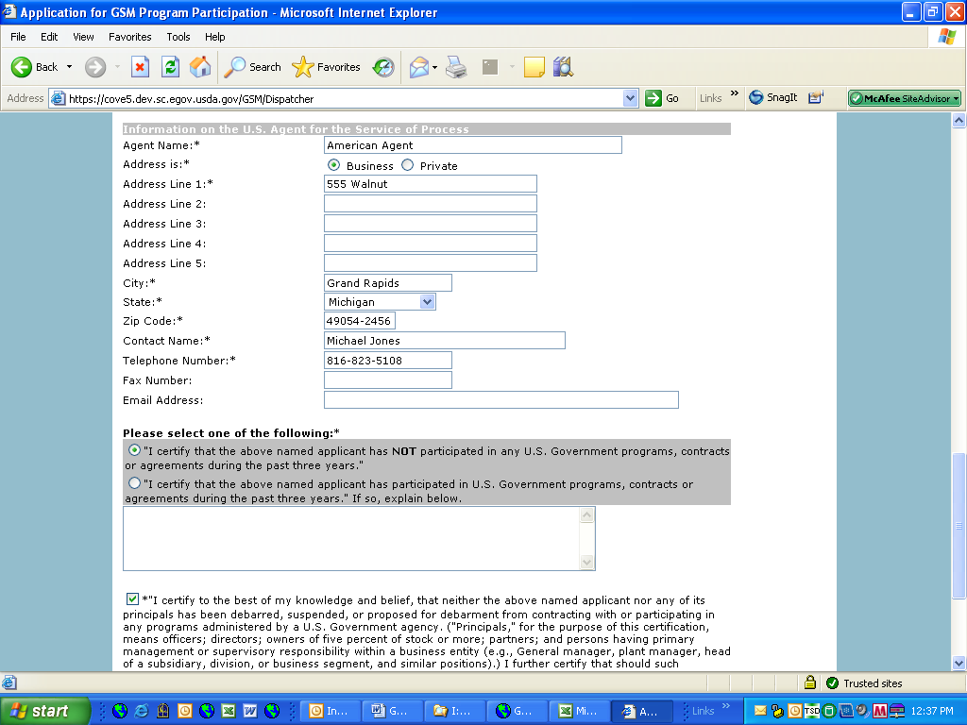
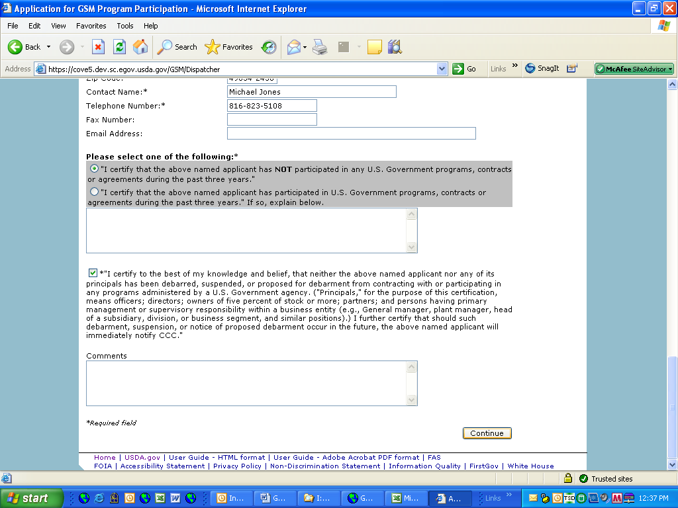
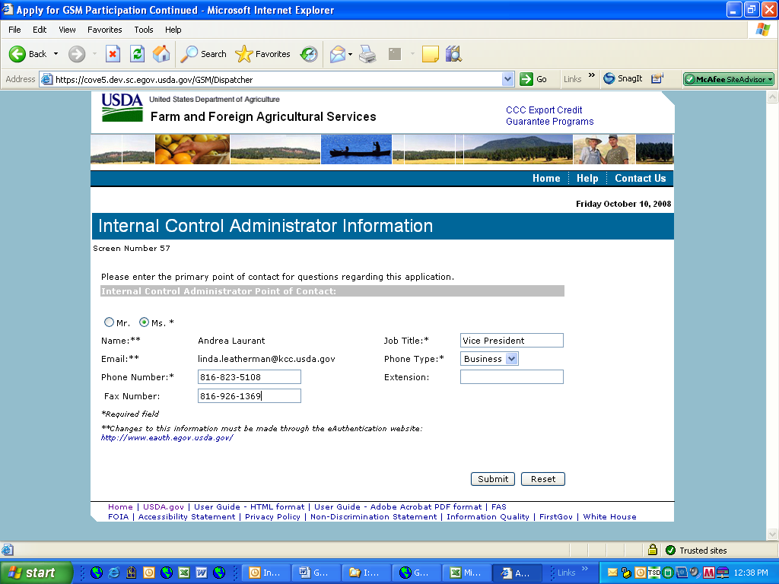

Form 24 – Copy a Submitted Application
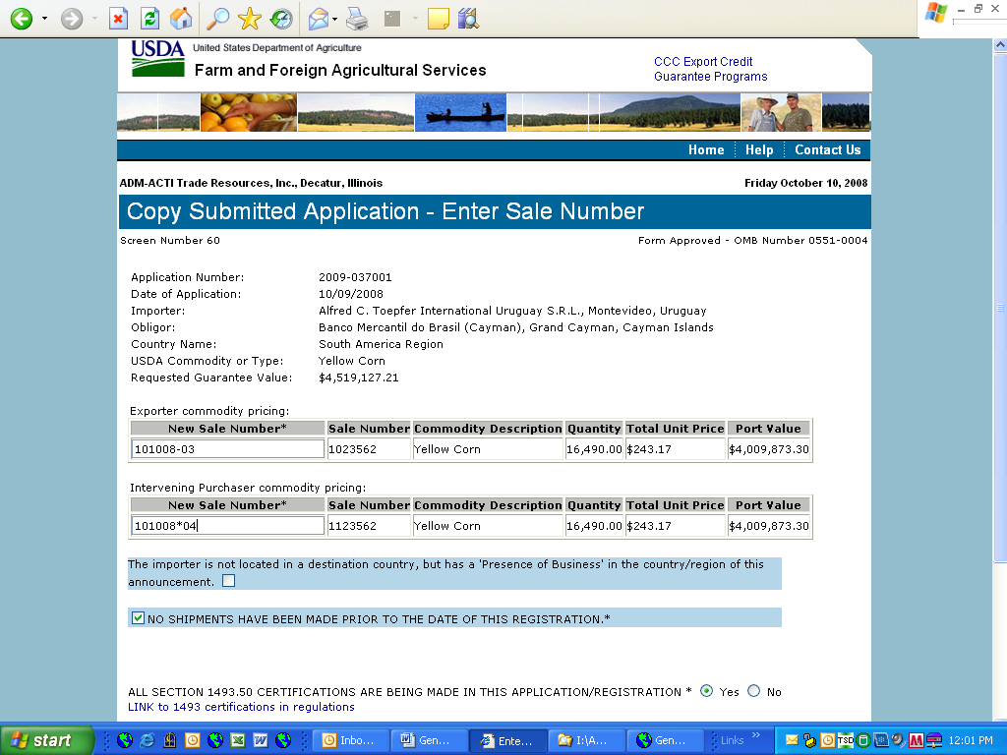
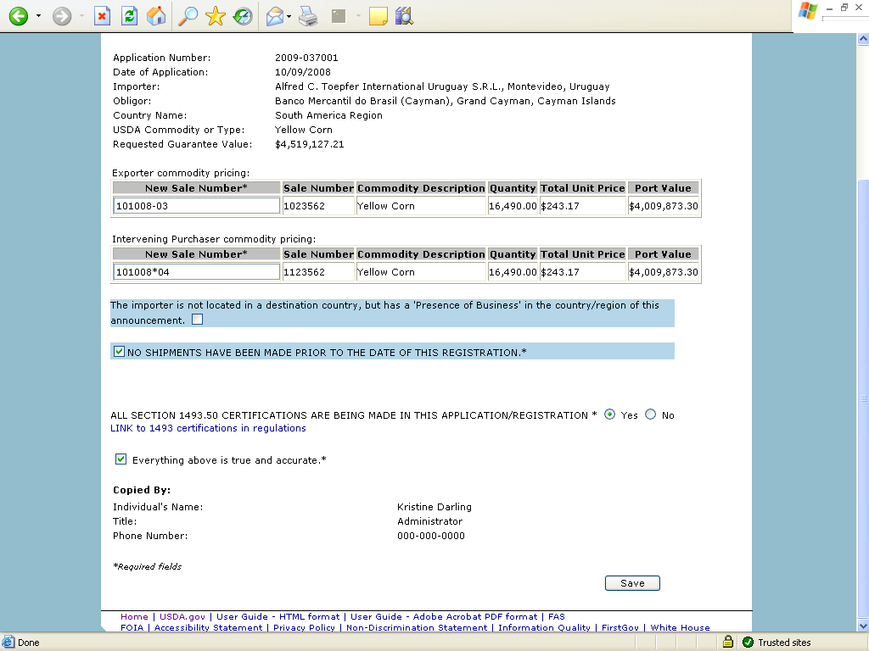

Form 25 – Assign Access
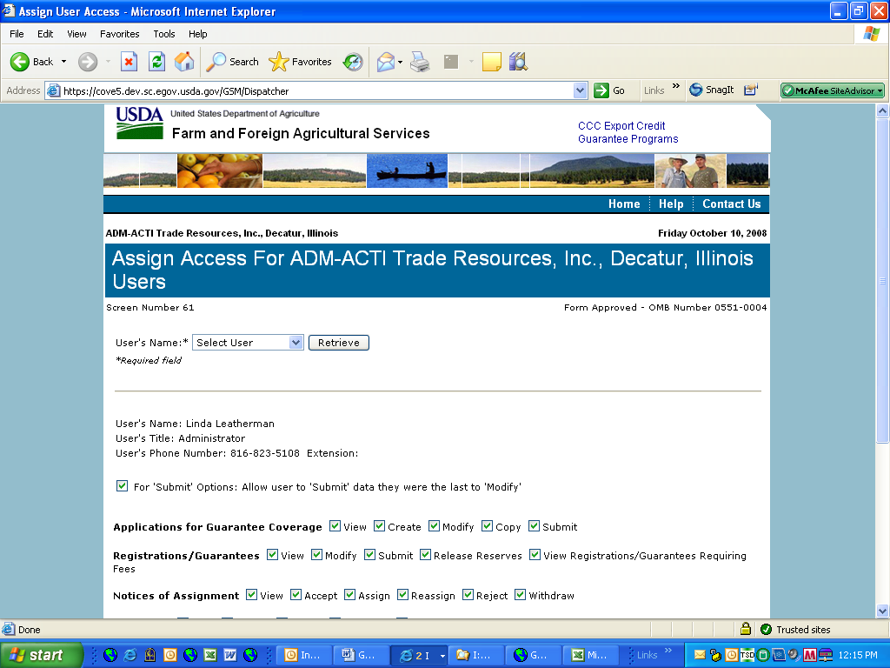
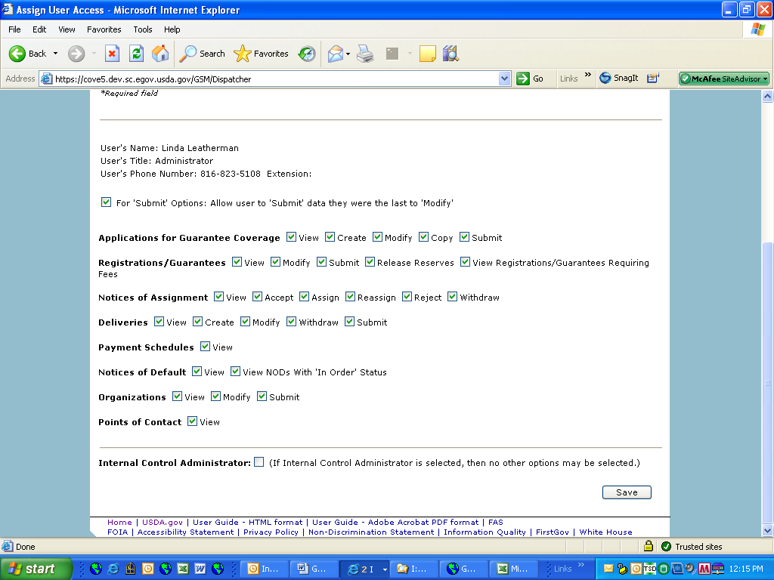

Form 26 – Submit Organization Information
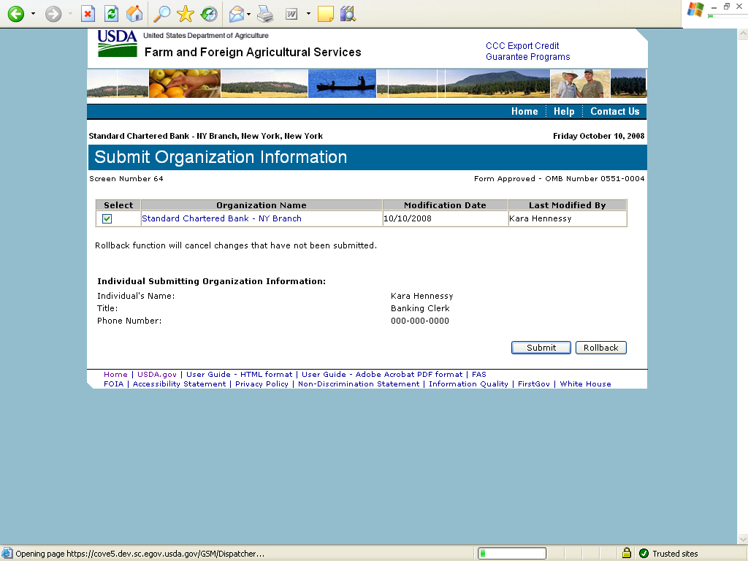

Form 27 – Submit Delivery
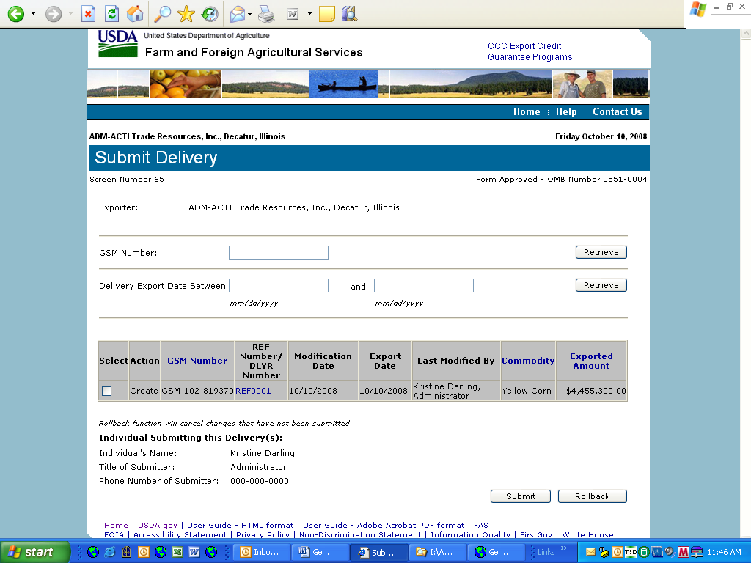

Form 30 – Submit Application(s)
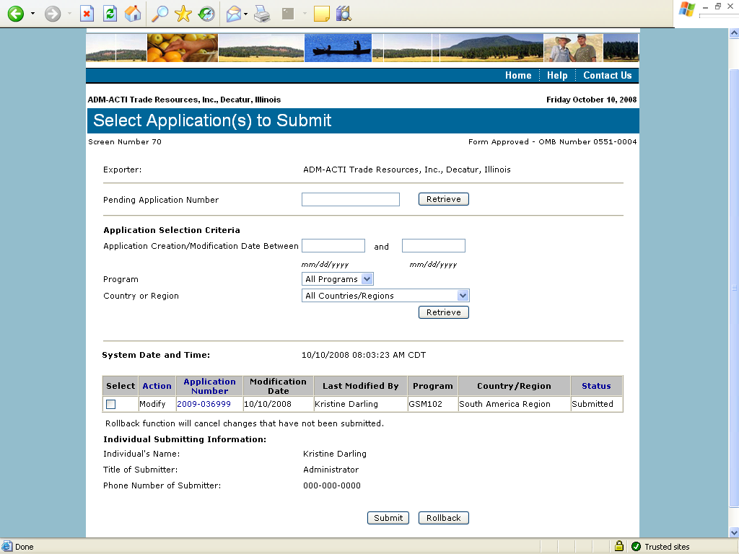

Form 31 – Submit Registration(s)
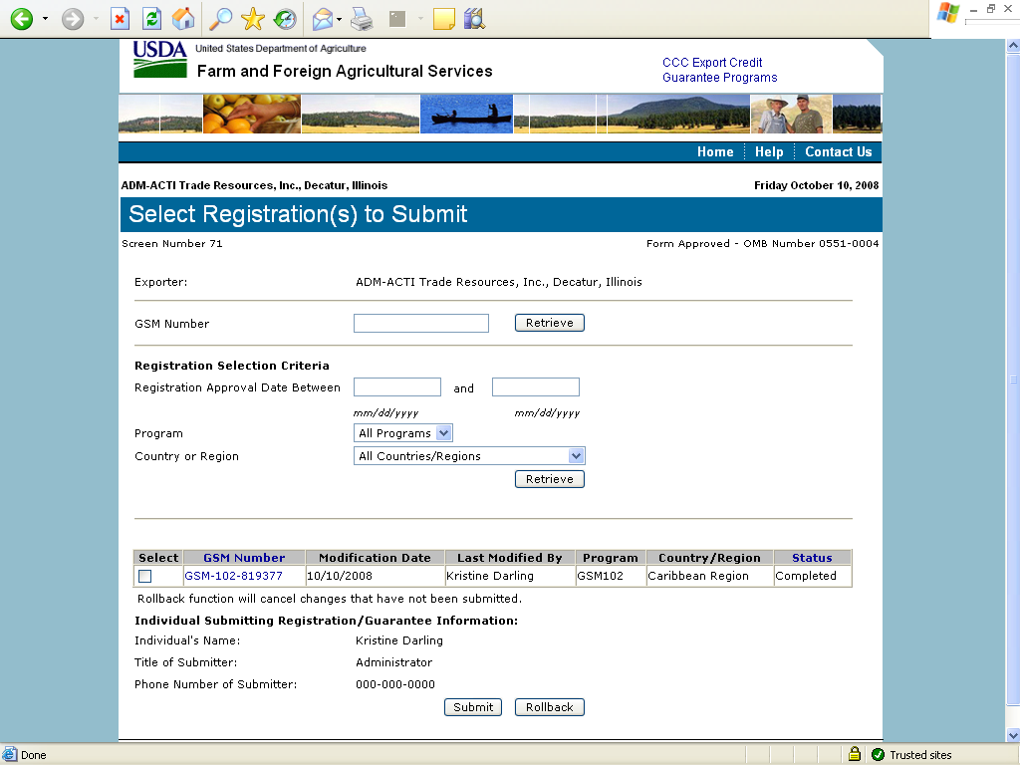

Form 33 – Request Web Access on Behalf of a Current Organization
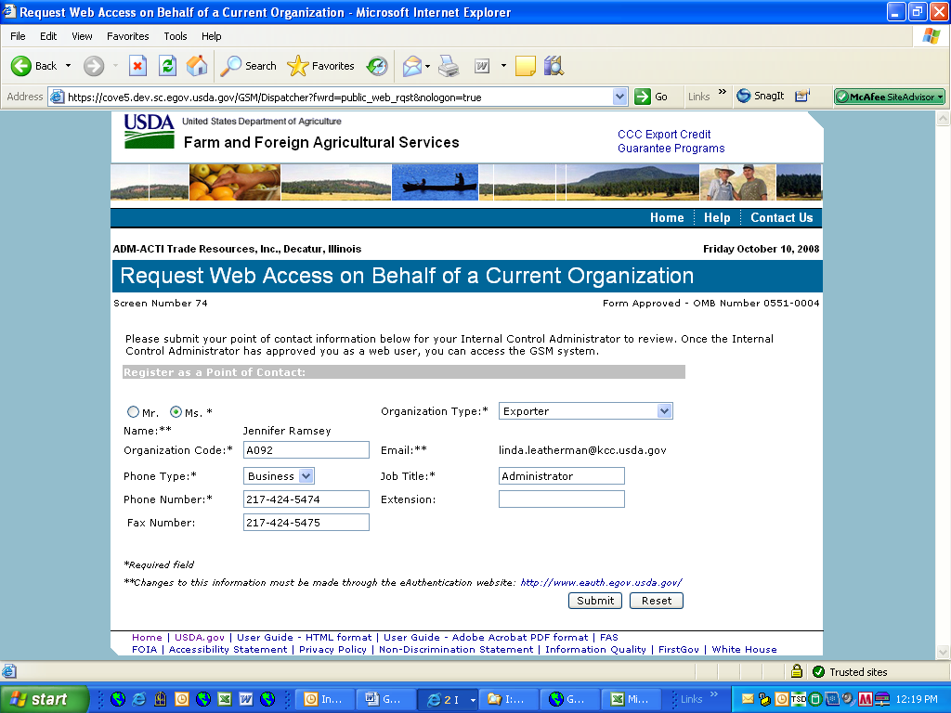

Form 34 – Edit Web User Associations
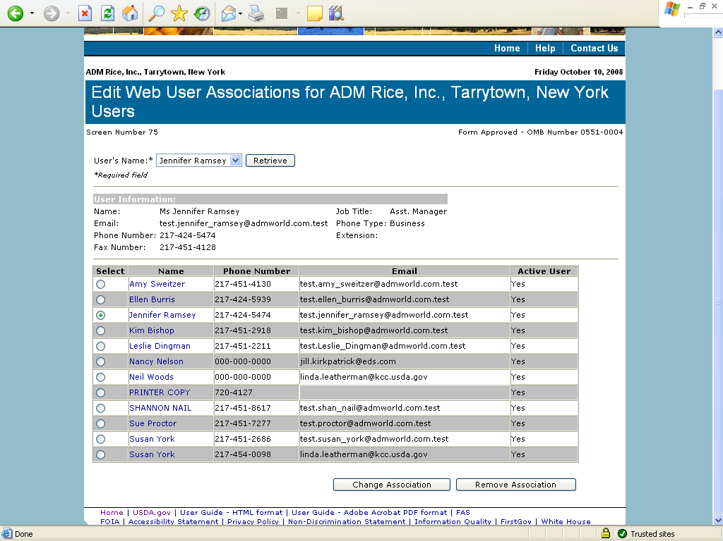

Form 35 – Review Web Access Request
