Attachment G.1. Draft Local Office Staff Group Interview Protocol (Pretest)
OMB No. 0584-[NEW]
Best Practices in Disaster Supplemental Nutrition Assistance Program (D-SNAP) Operations and Planning
May 5, 2021
Project Officer: Eric Sean Williams

Office of Policy Support
SNAP Research and Analysis Division
Food and Nutrition Service
U.S. Department of Agriculture
1320 Braddock Place
Alexandria, VA 22314
703.305.2640
eric.williams@fns.usda.gov

Draft Local Office Staff Group Interview Protocol
OMB Number: 0584-XXXX
Expiration Date: XX/XX/XXXX
My name is [name], and I’m a researcher at Insight Policy Research. As you may know, Insight is conducting a study for the U.S. Department of Agriculture’s Food and Nutrition Service (FNS) to identify and document Disaster Supplemental Nutrition Assistance Program (D-SNAP) best practices from across the country. This study will equip FNS and States with data demonstrating how to best plan for and implement D-SNAP programs across different disaster types, administrative contexts, and geographic settings.
My colleagues and I are currently visiting [State] and four other States to collect information from a wide range of stakeholders involved in planning and implementing a D-SNAP program. I want to start by thanking you for taking the time to speak with us today. Your perspective and insights will be very helpful to the study.
Your participation in this interview is voluntary, and your responses will be kept private, except as otherwise required by law. We will not share the information you provide with anyone outside the study team. You may refuse to answer any question, and you may stop the interview at any time.
We will take notes over the course of the interview and would like to record the conversation to help us remember the information we collect. The information you share with us today will be summarized and combined with information gathered from other people we interview. We will not link anything you say to your name in any reports or other project deliverables; however, the specific disasters and States we are studying will be identified.
I expect our conversation will take up to 2 hours. Do you have any questions for me about the project in general or what we will be discussing today?
Do I have your permission to record the conversation? You may stop the recording at any time.
[Confirm permission before recording starts.]
[Facilitator note: As relevant, repeat disaster-specific questions for multiple disasters or probe for differences between separate disaster implementations/operations.]
According to the Paperwork Reduction Act of 1995, an agency may not conduct or sponsor, and a person is not required to respond to, a collection of information unless it displays a valid OMB control number. The valid OMB control number for this information collection is 0584-xxxx. The time required to complete this information collection is estimated to average 3 hours per response, including the time for reviewing instructions, searching existing data sources, gathering and maintaining the data needed, and completing and reviewing the collection of information. Send comments regarding this burden estimate or any other aspect of this collection of information, including suggestions for reducing this burden, to the following address: U.S. Department of Agriculture, Food and Nutrition Services, Office of Policy Support, 1320 Braddock Place, Alexandria, VA 22314, ATTN: PRA (0584-xxxx). Do not return the completed form to this address.
- Background
I’d like to learn about your role and responsibilities at the [local] SNAP office.
- What is your current job title or position?
- How long have you been in this position?
- What are your primary responsibilities?
- What was your role in [selected D-SNAP(s)]?
  - [If needed for clarification] Were you [current position] during [selected D-SNAP(s)] or other D-SNAP(s)?
    - [If they were not in the position] Please describe your positions during [selected D-SNAP(s)] or other D-SNAP(s)?
- D-SNAP Planning and Needs Assessment
First, I would like to learn more about your office’s plans and preparations for D-SNAP.
- How familiar are you with your State’s D-SNAP plan?
  - What information does [State] typically include in the D-SNAP plan?
  - What types of disasters does [State] plan for?
- What, if any, training do you receive in preparation for D-SNAP?
  - What types of training do you receive? When? What does the training cover?
  - How often do these trainings occur?
  - How do you decide which staff will participate in the training(s)?
  - How useful do you find the training(s)?
  - How could the training(s) be improved?
- What training did you receive in preparation for [selected D-SNAP(s)] in particular? When? How?
- Are you involved in the D-SNAP needs assessment process? If so, please describe any roles you have in providing information for the needs assessment.
- D-SNAP Site Selection and Staffing
Let’s turn to site selection and staffing for the [selected D-SNAP(s)].
- What was (were) the site(s) for [selected D-SNAP(s)]?
  - [If D-SNAP site was the local office] What are some advantages and disadvantages of using the local office as the D-SNAP site?
- Tell me more about the selected site(s) for [selected D-SNAP(s)]:
  - What was the site like? [Request any signage, flow charts, or other diagrams of the site.]
  - How did you ensure there was power and internet connectivity at the site?
[Probe for: use of generators, internet set-up/capabilities]
  - How did you ensure crowd control at the site?
  - Did lingering damage from the disaster (e.g., road closures) affect the site at all? If so, how was the site affected?
  - Was the site an appropriate size? Why or why not? Who staffed the D-SNAP site?
    - Were local office staff personally affected by the disaster? If yes, how did that affect site staffing?
  - Were staff from other State agencies involved? If yes:
    - How many were involved?
    - How were merit staff and staff from other State agencies mobilized?
    - What were the roles of these staff?
  - Were temporary staff hired? If yes:
    - How many were hired?
    - Please describe the hiring process for these staff.
    - What were the roles of these staff?
- How were special populations (e.g., older individuals, people with disabilities or special needs) reached and served at the site? [Probe for: wheelchair accessibility, seating, adequate shelter from elements, wheelchair-accessible bathrooms, accessible communication materials]
- How did you ensure compliance with civil rights laws at this site? [If needed, probe for: assistance with language services, accommodations for older individuals or people with disabilities (e.g., building is wheelchair accessible, there is separate seating, etc.), adequate power, air conditioning, water, snacks, adequate number of bathrooms, including wheelchair-accessible bathrooms]
  - Did you experience any issues or problems with this site related to civil rights laws?
- What were the challenges associated with using this site for D-SNAP? How were those challenges addressed? [Probe for: too small, poor traffic flow, not enough seating, limited parking, poor crowd control]
- What aspects of the site made it a good D-SNAP site location? [Probe for: close to public transit, accessible for individuals with disabilities, near the disaster site, adequate size for serving applicants]
- Would you recommend using this site for a future D-SNAP? Why or why not?
- D-SNAP Application Processing
Next, let’s discuss the D-SNAP certification and issuance process. For this part of the discussion, we will map the steps on a whiteboard/large poster board to aid the group in visualizing the steps D-SNAP applicants go through when they arrive on site. [Facilitator note: Map the steps on a whiteboard or large poster. Repeat for multiple disasters. Refer to figure 1 for an example of the D-SNAP certification and issuance process.]
Figure 1. Example D-SNAP Certification and Issuance Process
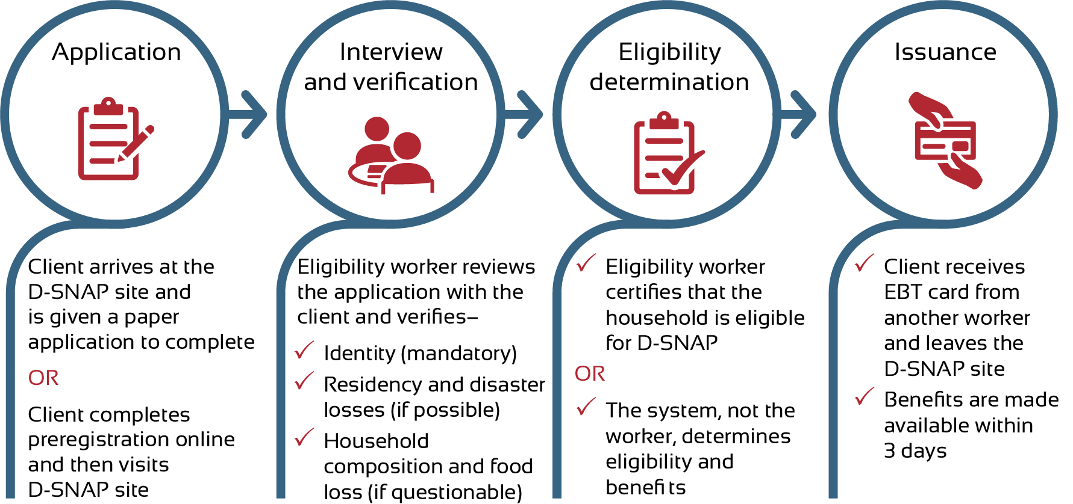
- Arrival and Application
- When a client arrives at the D-SNAP site, what happens first?
If the State uses paper applications distributed on site:
- How were applications distributed?
- Where did clients complete their D-SNAP applications?
- Who was available to assist clients with the application process?
- How did clients submit their applications? When? Where?
- After clients submitted their application, what came next?
If the State uses online preregistration:
- How did you locate the client’s preregistration information?
- What happened if the client’s information could not be found?
- How often did you encounter issues with online preregistration?
- What additional information did the caseworker request that was not included on the preregistration form?
- Interview and Verification
- Who conducted the interview?
- On average, how long did a client wait for an interview after arriving on site?
- Can you walk me through how you review the D-SNAP application with a client?
- What process was used for verification? [Probe for: documents requested, data matches conducted]
- How did you check for duplicate participation?
- How were you trained in the different eligibility criteria for D-SNAP as opposed to regular SNAP benefits?
- How did you ensure that as many clients as possible were interviewed on the same day?
- Eligibility Determinations
- Were eligibility workers able to use the State eligibility system to help determine D-SNAP eligibility?
  - If no:
    - Why were you unable to use your eligibility system?
    - What were the challenges associated with this approach? How were those challenges addressed?
    - What worked particularly well about this approach?
    - What extra program integrity measures did you have in place to ensure there were no duplicate certifications?
  - If yes:
    - What eligibility system(s) did your State use to conduct D-SNAP?
    - What were the challenges associated with this approach? How were those challenges addressed?
    - What worked particularly well about this approach?
- What was the average wait time between verification and eligibility determination?
- How often did you need to delay an eligibility determination because of a questionable application?
- Based on your experience serving both D-SNAP and SNAP clients, how do the characteristics of D-SNAP households for [selected D-SNAP(s)] compare with the characteristics SNAP households?
- Issuance
- Please describe your process for benefit issuance and reconciliation.
- How many EBT cards did your State supply to this D-SNAP site? Was that enough?
- Were there any challenges associated with card activation? If so, what were they?
- How did you store the cards?
- For current SNAP participants who received a supplement, was it issued automatically, or was an affidavit required? [Probe for the process for receiving a supplement]
- I understand D-SNAP benefits are issued within 72 hours of application. To your knowledge, was the timeframe met for all applications at your D-SNAP site (except in cases of delayed issuance for questionable applications)?
  - If no, what do you think prevented the timely disbursement of benefits? [Probe for: delays in data entry, lack of EBT cards]
- Process Reflection
- Thinking about the entire D-SNAP application process from start to finish, including site selection and staffing, what would you say worked particularly well for this site?
- What would you say was challenging or problematic with the D-SNAP application process? How, if at all, were these challenges addressed?
- D-SNAP Public Awareness Campaigns
Next, let’s discuss how your State and/or office informed the public about [selected D-SNAP(s)].
- Was your office involved in helping to inform the public about D-SNAP? If so, how?
- What did you hear from participants about how they heard about D-SNAP?
- In your opinion, was the public information campaign successful? Why or why not?
  - What would you do similarly if another disaster strikes?
  - What would you do differently?
- Program Integrity
Now let’s discuss D-SNAP program integrity measures and challenges.
- What are the key program integrity challenges for operating D-SNAP?
  - Which of these challenges did you encounter during [selected D-SNAP(s)]? How did you address them?
- [If not already answered] How did you maintain separation between eligibility and card issuance duties during D-SNAP? [Request any schematics of the site that show a separation between the two]
- What fraud prevention or program integrity methods did your office use? [Probe for: maps to verify residency in an affected area, income matches, or delaying benefits; separation of certification and issuance duties; checks for duplicate participation]
  - Which of these strategies would you say worked particularly well for ensuring program integrity? Why?
  - Would you do anything differently in a future D-SNAP? If so, what?
- Was your office involved with the postdisaster case review process? If so:
  - How did you select cases for review?
  - How were cases reviewed? By whom? When?
- What types of case errors did you commonly encounter?
  - What efforts were put into place to minimize these errors for future D-SNAPs?
- Closeout and Reporting
Next, let’s discuss D-SNAP closeout and reporting.
- What steps did you take to close out D-SNAP? Walk me through what is required to close out D-SNAP.
- Please describe the process for meeting D-SNAP reporting requirements.
  - Who was involved in reporting? To whom?
  - How frequently are reports submitted?
- How were the necessary data for reporting tracked before, during, and after D-SNAP?
- What challenges, if any, did you face in meeting the reporting requirements for [selected D-SNAP(s)]?
  - How were those challenges addressed?
- What worked particularly well for completing the required reports?
- Successes, Challenges, and Lessons Learned
Finally, I would like to discuss any further challenges, best practices, and lessons learned that we have not yet touched upon in our conversation.
- What would you say worked particularly well during [selected D-SNAP(s)]?
  - What do you think helped facilitate this? [Probe for: technology, role of partners, communication protocols, site selection or location, program integrity]
- What challenges did your office encounter in implementing [selected D-SNAP(s)]? [Probe for: technology, role of partners, communication protocols, site selection or location, program integrity]
  - How were these challenges addressed?
  - What would you do differently in future D-SNAPs?
- What are some key lessons that your office has learned from implementing [selected D-SNAP(s)]? [Probe for: technology, role of partners, communication protocols, site selection or location, program integrity, advance planning]
  - Were any changes made in your office’s approach to D-SNAP planning or operations as a result of these lessons learned? [Probe for: technology, role of partners, communication protocols, site selection or location, program integrity, advance planning]
- [If the State has responded to multiple types of disasters] How has your response and D-SNAP operations differed by the type of disaster (e.g., a tornado versus a hurricane, flooding versus a winter storm)?
- What impact do you think the additional D-SNAP benefits had on the economy in the disaster area and surrounding locations?
- Wrap-Up
Thank you for answering our questions. We have a few final questions before we conclude our discussion today.
- Is there anything else you would like to share about D-SNAP plan development, implementation, operations, or reporting?
- Is there anything we should have asked you about these topics but didn’t?
- May we follow up with you by email or phone if we have further questions?
That completes our questions for you. Thank you very much for speaking with us.

