Health Resources and Services Administration (HRSA)
Office of Planning, Analysis and Evaluation
Oral Health Awareness, Education, and Literacy Campaign

COGNITIVE INTERVIEW RECRUITMENT SCREENER – FOR PHASE 1 AND PHASE 2
15 TOTAL COGNITIVE INTERVIEWS (FOR EACH PHASE)

DEMOGRAPHIC BREAKS FOR EACH OF THE THREE SETS OF COGNITIVE INTERVIEWS
The final participant sample will reflect a mix of genders, ages, and races/ethnicities, as possible.
 | 3 Target Audiences  Categories | Audience 1  Families with young children | Audience 2 People with HIV | Audience 3  Adults ages 45 and older
*Recruit 1–2 participants from each of these 3 categories for each of the 3 target audiences. | Living in Rural Areas | 5 COGNITIVE INTERVIEWS  Recruit 5 Participants Total | 5 COGNITIVE INTERVIEWS  Recruit 5 Participants Total | 5 COGNITIVE INTERVIEWS  Recruit 5 Participants Total
HRSA
Health Center Patients
 | Living in Non-Rural Areas
*Participants may qualify for more than one category. For example, a person living with HIV could qualify as a HRSA patient and/or a person living in a rural area. In this example we would count the participant as ONE recruit for filling the rural quota and ONE recruit for filling the HRSA patient quota.

QUOTAS AND ELIGIBILITY
- Only individuals who score three or less on the Health Literacy Test (see page three in this document for the Health Literacy Test, “The Newest Vital Sign”) are eligible to participate in a cognitive interview. This Health Literacy Test must be administered in the initial online recruitment and screening process.

- Recruit 15 total participants: five participants for each of the three target audiences to each participate in a cognitive interview. Target audiences include (1) families with young children (parent/guardian of a child age 6 months through 3½ years), (2) people with HIV, and (3) adults ages 45 and older.

- One to two participants in each target audience must be categorized as living in a rural area [see response c in Q5].

- One to two participants in each target audience must be categorized as a HRSA health center patient [see response to Q6B].

- Participants who were overrecruited and dismissed from a prior focus group are eligible to participate in a cognitive interview.

Introduction
Hello, my name is _______________ and I’m calling from _________________about an upcoming project sponsored by the Health Resources and Services Administration, a federal government agency in the U.S. Department of Health and Human Services. We will be referring to it as “HRSA.” HRSA is the primary federal agency for improving health care to people who are geographically isolated and economically or medically vulnerable.

We want to talk with various individuals across the United States about mouth and teeth health. We want to get your feedback on some short materials, like brochures, to help consumers/patients know more about mouth and teeth health and to understand concerns consumers/patients like you might have on this topic. We will be conducting interviews to talk about how HRSA can better reach consumers/patients like you with important health information.

Each interview will last approximately 90 minutes. To maintain participants’ privacy, we will use first names only (no last names) during the discussion and your name or personal information will not be used in any project materials. During the discussion we will ask that you turn your video camera on so that you and the moderator can see one another and so that you can see information the moderator puts on the screen. We are very interested in your feedback to make sure the information in the materials is clear to consumers/patients like you.

In appreciation for your time, we will give you a monetary token of appreciation. To see if you qualify to participate, I need to ask you a few questions. These questions will take less than 10 minutes.

ADMINISTRATION OF THE FOLLOWING HEALTH LITERACY TEST, “THE NEWEST VITAL SIGN”, MUST BE ADMINISTERED IN THE INITIAL SCREENING PROCESS.
[***NOTE TO RECRUITERS: ONLY CONDUCT PHONE FOLLOW-UP, USING THE REST OF THIS SCREENER, AMONG THOSE WHO SCORED THREE OR LESS ON THIS TEST.***]

Please look at this nutrition label from the back of a container of a pint of ice cream. After you read it, answer the questions below about it.

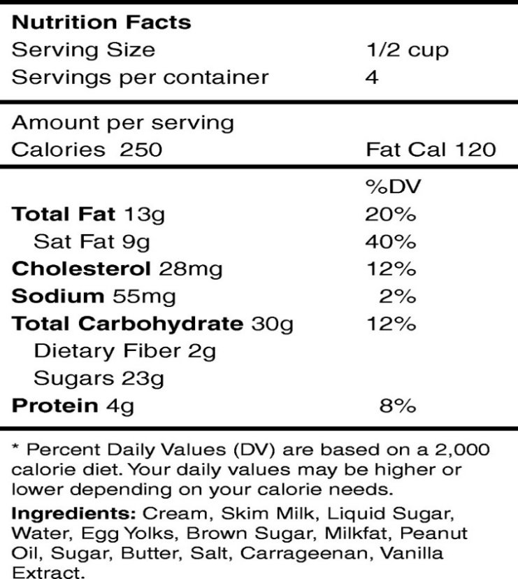

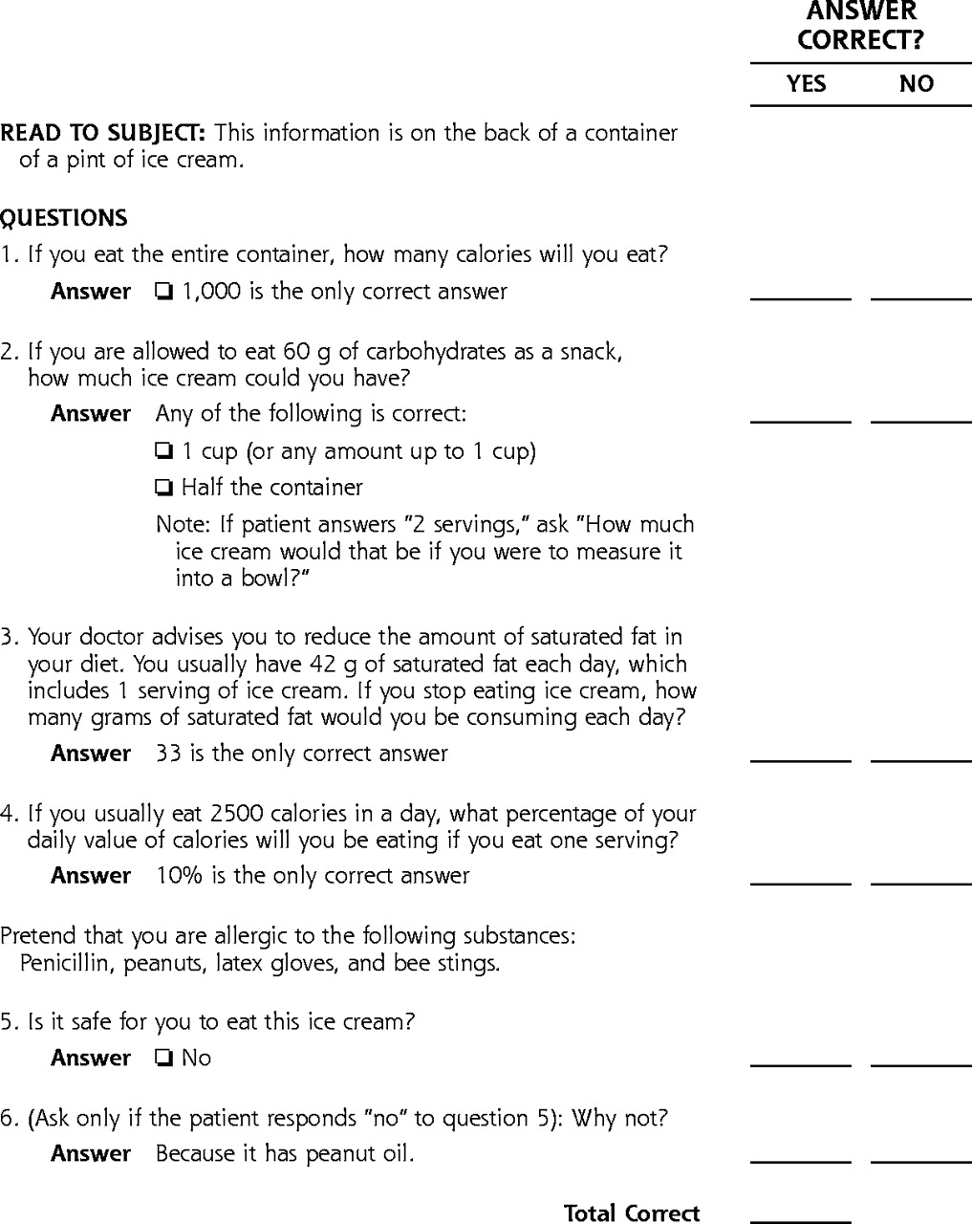

[NOTE TO RECRUITERS: ADMINISTER THE FOLLOWING QUESTIONS ONLY TO THOSE WHO SCORE THREE OR LESS ON THE HEALTH LITERACY TEST.]

Eligibility Questions
- Note for recruiters: Ask your typical articulation question (e.g., If you could have a dinner conversation with anyone, who would it be and why?). Check here if the potential participant speaks English fluently and articulates verbally well enough to participate in a meaningful discussion: _____Yes

- We will be conducting interviews online. To participate, you need to have access to one of the following: a desktop or laptop computer with a camera, a smartphone with a camera, or a tablet [tabletop or handheld computer device] with a camera. Which one(s) do you have? [CIRCLE ALL THAT APPLY.]
- Desktop/laptop computer with camera
- Smartphone with camera
- Tablet with camera
- None of these [THANK AND DISMISS.]

2A. [ASK ALL] Do you have internet access?
_____Yes _____No [THANK AND DISMISS.]

- How do you describe yourself?
- Male
- Female
- Self-identify as: __________________
[RECRUIT A MIX.]

- What is your current age________? [add actual age and check Corresponding category BELOW.]
- Under age 18 [THANK AND DISMISS.]
- 18–44
Those in categories c and d recruit for AUDIENCE 3 [“ADULTS”].
- 45–74
- 75–84
- 85 or older [THANK AND DISMISS.]
[RECRUIT b FOR AUDIENCES 1 AND 2.]

- Which of the following best describes the type of area you live in? [READ LIST.]
- Urban (city)
- Suburban
- Rural [RECRUIT 1–2 PARTICIPANTS PER TARGET AUDIENCE.]
- Small city or town
- American Indian/Alaska Native reservation [CLASSIFY AS RURAL.]
- Frontier [CLASSIFY AS RURAL.]
- Other. Please specify: ____________________
[RECRUIT A MIX.]

5A. In what state do you live? _____________________________________
a. Northeast: Connecticut, Massachusetts, Maine, New Hampshire, New Jersey, New York, Pennsylvania, Rhode Island, Vermont
b. South: Alabama, Arkansas, Delaware, District of Columbia, Florida, Georgia, Kentucky, Louisiana, Maryland, Mississippi, North Carolina, Oklahoma, South Carolina, Tennessee, Texas, Virginia, West Virginia
c. Midwest: Iowa, Illinois, Indiana, Kansas, Michigan, Minnesota, Missouri, North Dakota, Nebraska, Ohio, South Dakota, Wisconsin
d. West: Alaska, Arizona, California, Colorado, Hawaii, Idaho, Montana, New Mexico, Nevada, Oregon, Utah, Washington, Wyoming
[RECRUIT A MIX OF STATES/GEOGRAPHIC REGIONS, AS POSSIBLE.]

- Which of the following best describes the location where you most often get your health care? [CHECK ONE ONLY]. IF RESPONDENT DOESN’T KNOW, ASK FOR THE NAME OF THE PLACE AND VERIFY IN 6B.
- Office-based physician/doctor in private practice
- Hospital emergency room (emergency department)
- Urgent Care Center
- Community Health Center [VERIFY AS HRSA PATIENT IN 6B.]
- Public Health Department (i.e., city, county, state hospital/clinic) [VERIFY AS HRSA PATIENT IN 6B.]
- Other. Specify: ____________________ [VERIFY AS HRSA PATIENT IN 6B.]
6A. [ASK IF Q6 RESPONSE IS d, e, or f] What is the name of the place where you most often get your health care? May I also get the name of your city and state so I can write it in correctly?
Name of health care facility___________________________
City_______________ State_____________
BELOW IS THE VERIFICATION LINK. IF THE LOCATION PARTICIPANT USES IS FOUND ON THIS LINK, THE PARTICIPANT IS CLASSIFIED AS A HRSA PATIENT. RECRUIT 1–2 HRSA PATIENTS FOR EACH TARGET AUDIENCE.
6B. HRSA VERIFICATION LINK: https://findahealthcenter.hrsa.gov/
- Yes, HRSA patient [RECRUIT 1–2 PARTICIPANTS FOR EACH OF THE 3 TARGET AUDIENCES.]
- No
[NOTE: ONLY THOSE WITH A YES IN 6B CAN BE CATEGORIZED AS A HRSA PATIENT.]

- What kind of health insurance, if any, do you have now? [This question is not an eligibility question; this question is for descriptive and analysis purposes only.]
- Employer-provided insurance (a plan from your or your partner’s employer/work)
- Individually purchased insurance (a private, direct-purchased plan)
- Obamacare or the Affordable Care Act
- Parents’ insurance
- Student insurance plan
- Medicare
- Medicaid or some other form of public insurance
- Military health care
- I don’t know
- No to all/Uninsured

- Do you have dental insurance?
- Yes; What kind of dental insurance do you have?
  - Employer-provided insurance (a plan from your and your partner’s employer/work)
  - Individually purchased insurance (a private, direct-purchased plan)
  - Obamacare or the Affordable Care Act
  - Parents’ insurance
  - Student insurance plan
  - Medicare
  - Medicaid or some other form of public insurance
  - Military health care
  - I don’t know
  - No to all/Uninsured
- No
- Not sure

8A. [ASK ONLY IF AUDIENCE 3.] Which of the following best describes you?
- I have all or some of my adult teeth
- I do not have any of my adult teeth
[RECRUIT A MIX WITH MOST COMING FROM RESPONSE a.]

- Do you have any of the following health conditions?
- High blood pressure
- Diabetes
- HIV/AIDS
- How long ago were you diagnosed with HIV/AIDS? __ Years __ Months [CONTINUE RECRUITING FOR AUDIENCE 2. CATEGORIZE AS AUDIENCE 2 AND SKIP TO Q11.]

- [DO NOT ASK IF AUDIENCE 3.] Are you the parent or primary caregiver (caregiver of a child for at least 20 hours a week) to a child between 6 months and 3½ years of age?
- Yes, parent [GO TO 10A.]
- Yes, primary caregiver [GO TO 10A.]
- No [THANK AND DISMISS.]

10A. [IF YES in Q10 ASK.] Do you live in the same household as the child(ren)?
- Yes [RECRUIT FOR AUDIENCE 1: FAMILIES & CHILDREN.]
- No [THANK AND DISMISS.]

- Which of these best describes your ethnicity (choose one)?
- Hispanic or Latino
- Not Hispanic or Non-Latino

- Which of these best describes your race (choose one or more)?
- American Indian or Alaska Native
- Asian
- Black or African American
- Native Hawaiian or Other Pacific Islander
- White

RECRUITER: CHECK WHICH TARGET AUDIENCE THE PARTICPANT QUALIFIES FOR:
Audience 1 ______
Audience 2 ______
Audience 3 ______

Suggested language when terminating a call:
Thank you very much for your time today. We are required to recruit a wide variety of participants to help with this project. Unfortunately, we have filled participant slots with your background. However, we thank you for your interest in this project.

INVITATION
Thank you for answering my questions. We would like to invite you to participate in a 90-minute interview. If you agree and participate, we will send you a monetary token of appreciation for your time.

Are you interested and able to participate?
  - Yes [SCHEDULE ON Month/Day, 2020/2021, at x:xx a.m./p.m.–x:xx a.m./p.m. EASTERN TIME.]
  - No [THANK AND DISMISS.]

FOR SCHEDULED PARTICIPANTS
The interview has been scheduled on Month/Day, 2020/2021, from x:xx a.m./p.m.–x:xx a.m./p.m. Eastern time.

Before your scheduled interview, we will send you a confirmation text or email. The text or email will also include instructions on how to join the virtual interview. We will also contact you the day of the interview as a reminder.

For Children & Families Audience ONLY:
During the interview, the moderator will be asking for some parent-child role-playing, so we'd like to recommend that you arrive to the interview with a stuffed animal, doll, or pillow to take the role of a child.

If you wear reading glasses or use a hearing aid, please remember to bring those items to the interview. Some of our activities will involve reading.

If you must cancel, please let us know immediately, so we can find someone to take your place. My name is ___________ and you can reach me at _____________.

We ask that you log on at least 15 minutes before the start of the interview.

Thank you!
Public Burden Statement: An agency may not conduct or sponsor, and a person is not required to respond to, a collection of information unless it displays a currently valid OMB control number. The OMB control number for this project is 0915-0212 and expires 07/31/2021. This Information Collections Request is voluntary. Public reporting burden for this collection of information is estimated to average 1.5 hours per response, including the time for reviewing instructions and completing and reviewing the collection of information. Send comments regarding this burden estimate or any other aspect of this collection of information, including suggestions for reducing this burden, to HRSA Reports Clearance Officer, 5600 Fishers Lane, Room 14N136B, Rockville, Maryland, 20857.

