Form Approved OMB No. 0920-XXXX

Exp. Date xx/xx/20xx

**Instrument F**

**Experiment 1 and 2 Data Collection**

1. Experiment 1 – Mobile Robot

|  |  |
| --- | --- |
| **Variable** | **Conditions** |
| Robot Size | * Mobile base only (500 mm * Mobile base and 1-level cart (1000 mm) * Mobile base and 2-level cart (1500 mm) |
| Robot Speed | * 1.0 m/s * 1.5 m/s * 2.0 m/s |
| Robot Movement | * Straight lines (90 degree turns) * Curved lines |

Description: Start at the starting point, walk to the load point among the racks, pick a box from the rack, place it on the empty mobile robot, and then return to the starting point. Figure 1A and 1B show a top view of the test configurations. They will complete 1 loading task and will encounter robots with the selected height, moving speed, and movement path type while moving to the loading sections. One movement path condition will be tested for each configuration. Figure 1A will be used for the straight movement path condition and Figure 1B will be used for the curved movement path condition.

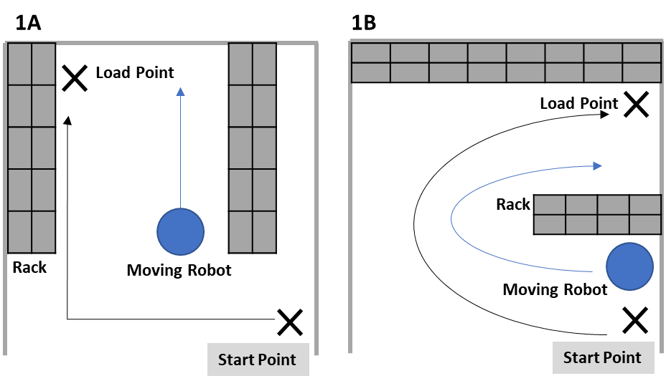

1. Experiment 2 – Collaborative Robot

|  |  |
| --- | --- |
| **Variable** | **Conditions** |
| Robot Size | * UR3 (arm reach 500 mm) * UR5 (arm reach 850 mm) * UR10 (arm reach 1300 mm) |
| Robot Speed | * 60 deg/s * 120 deg/s * 180 deg/s |
| Robot Movement | * 5 (base, shoulder, elbow, and 2 wrists) * 6 (base, shoulder, elbow, and 3 wrists) * 7 axes (base, shoulder, elbow, and 4 wrists). |

Description: A participant and a collaborative robot with different size, moving speed, and number of axes will be in opposite sides of a working station. There will be a total of 10 objects in two different shapes (square or round, five each) on the table, and a participant and robot will pick up the target objects and place on a tray in front of them. Objects will be dispersed at pre-selected locations within the working area to make arms of a participant and the virtual robot cross paths. The schematic in Figure 2 shows a top view of the virtual reality simulator layout.

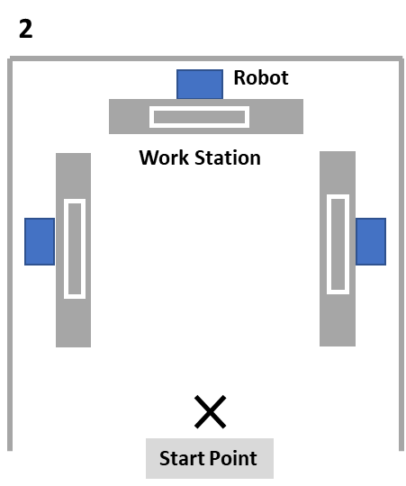

Public reporting burden of this collection of information is estimated to average 140 minutes per response, including the time for reviewing instructions, searching existing data sources, gathering and maintaining the data needed, and completing and reviewing the collection of information. An agency may not conduct or sponsor, and a person is not required to respond to a collection of information unless it displays a currently valid OMB control number. Send comments regarding this burden estimate or any other aspect of this collection of information, including suggestions for reducing this burden to CDC/ATSDR Information Collection Review Office, 1600 Clifton Road NE, MS D-74, Atlanta, Georgia 30333; ATTN: PRA (0920-XXXX).