Attachment 14k

<On official letterhead>

Name
Address
Date

Thank you for visiting the National Health and Nutrition Examination Survey (NHANES) mobile examination center.

Prior to entry to the examination center today you agreed to receive a screening test for the Coronavirus Disease 2019 (COVID-19). This test is intended to identify if you are currently infected. Infected persons may not have symptoms or know if they were exposed to COVID-19. By knowing a positive result, we can prevent further transmission of the virus.

Your rapid antigen test was found to be positive. At this time, you will not be able to continue at the NHANES mobile examination center today. If possible, we will follow up with you to schedule a visit for a later date.

Given your positive screening test, we strongly recommend that you
- immediately isolate from others as much as possible
- inform any close contacts
- monitor yourself for symptoms
- call your medical provider or local health department for further guidance

We are providing you with COVID-19 fact sheets on how to protect yourself and your family. Again, we strongly recommend that you follow up with your medical provider or your local health department about your positive screening test. You can contact your local health department at <insert local health department phone number>. The NHANES program cannot pay for further tests or treatment you may require.

For more information on COVID-19, please visit https://www.cdc.gov/coronavirus/2019-ncov.

If you have any questions, you may call me at our toll-free number, 1-800-452-6115, between 8:30 AM and 4:30 PM Eastern Time, Monday through Friday.

Sincerely yours,

Duong T Nguyen, DO
Chief Medical Officer

Enclosure

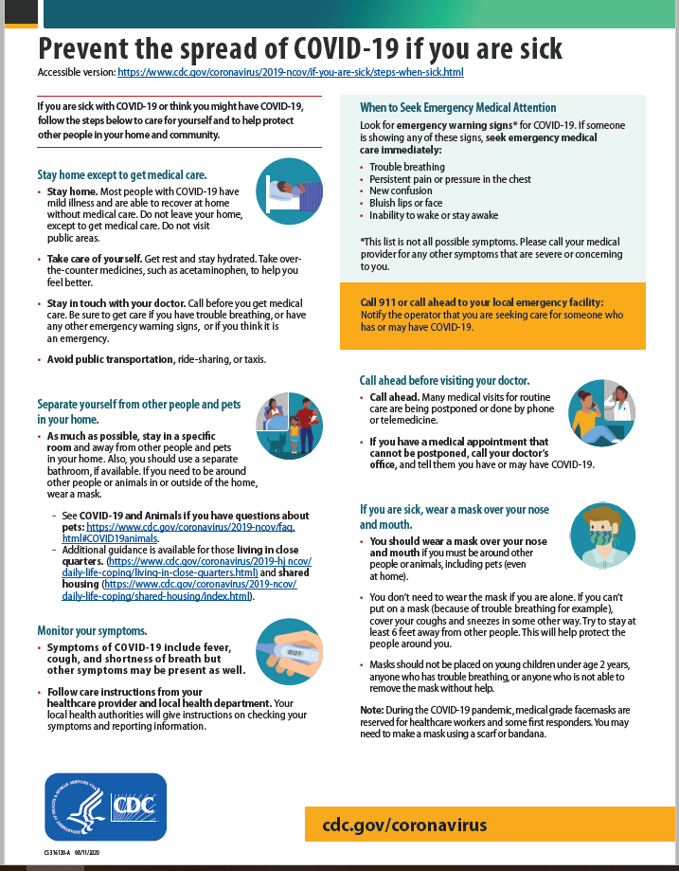

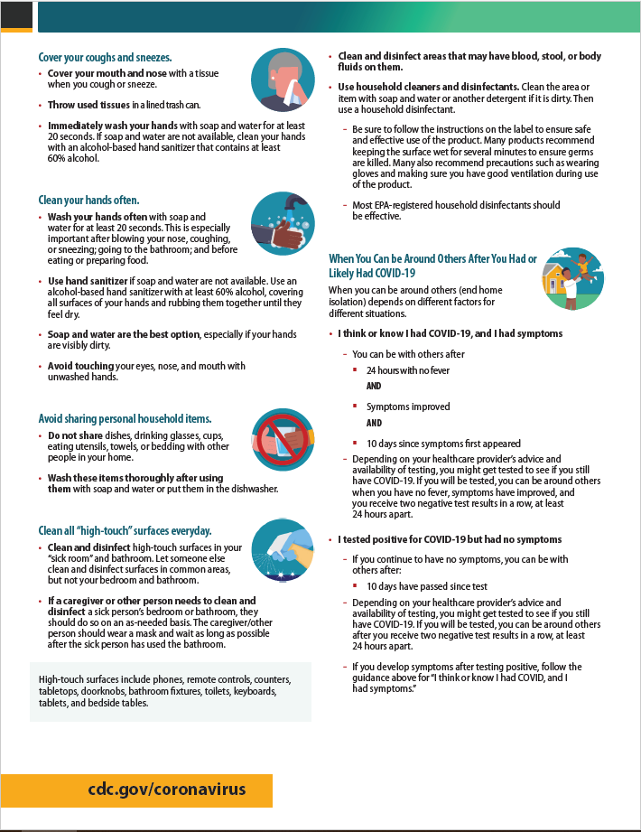

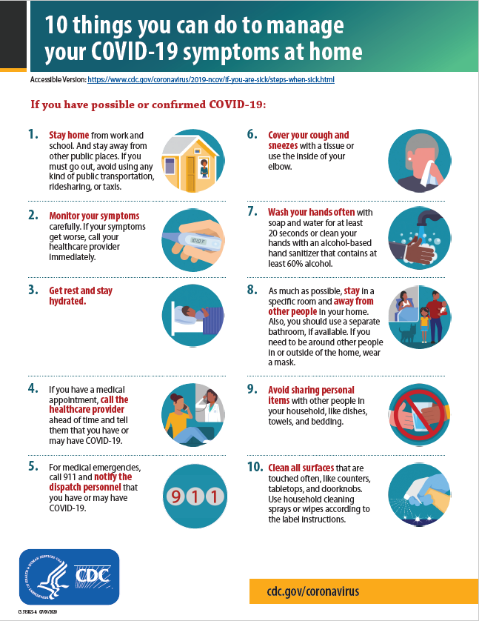

<On official letterhead>

Parent/Guardian
Sample person name
Address
Date

Dear Parent/Guardian,

Thank you for visiting the National Health and Nutrition Examination Survey (NHANES) mobile examination center with your child.

Prior to entry to the examination center today your child received a screening test for the Coronavirus Disease 2019 (COVID-19). This test is intended to identify if you are currently infected. Infected persons may not have symptoms or know if they were exposed to COVID-19. By knowing a positive result, we can prevent further transmission of the virus.

Your child’s rapid antigen test was found to be positive. At this time, your child will not be able to continue at the NHANES mobile examination center today. If possible, we will follow up with you to schedule a visit for a later date.

Given your child’s positive screening test, we strongly recommend that you
- immediately isolate them from others as much as possible
- inform their school and any close contacts
- monitor them for symptoms,
- call your medical provider or local health department for further guidance

We are providing you with COVID-19 fact sheets on how to protect yourself and your family. Again, we strongly recommend that you follow up with your child’s medical provider or your local health department about your child’s positive screening test. You can contact your local health department at <insert local health department phone number>. The NHANES program cannot pay for further tests or treatment you may require.

For more information on children and teenagers, please visit https://www.cdc.gov/coronavirus/2019-ncov/daily-life-coping/caring-for-children.html.

If you have any questions, you may call me at our toll-free number, 1-800-452-6115, between 8:30 AM and 4:30 PM Eastern Time, Monday through Friday.

Sincerely yours,

Duong T Nguyen, DO
Chief Medical Officer

Enclosure

