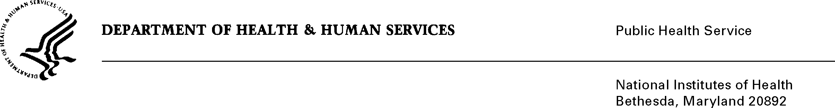

DATE: June 30, 2020

TO: Quinn Hirsch

Office of Management and Budget (OMB)

Reports Clearance Officer, DHHS

FROM: Mikia P. Currie

Chief, Project Clearance Branch

SUBJECT: Change Request to a Currently Approved Form

(OMB # 0925-0001, Expiration Date 2/28/2023)

This is a request for OMB to approve a non-substantial modification to the following forms:

* Attachment 15- eRA Commons Profile Data
  + Added Optional data element “Prior Name” (Prefix, First, Middle, Last, Suffix) if applicants would like to provide a prior name
* PHS6031 Payback Agreement
  + Removed old instructions and added updated and clarifying language throughout instructions

Your full consideration is appreciated.

**Attachments:**  **eRA Commons Profile Data and PHS 6031 Payback Agreement**