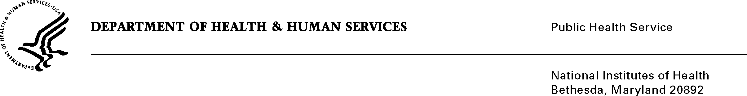

DATE: April 27, 2020

TO: Quinn Hirsch
Office of Management and Budget (OMB)
Reports Clearance Officer, DHHS

FROM: Mikia P. Currie
Chief, Project Clearance Branch

SUBJECT: Change Request to a Currently Approved Form
(OMB # 0925-0001, Expiration Date 2/28/2023)

This is a request for OMB to approve a non-substantial modification to Form PHS 6031 Payback Agreement of OMB # 0925-0001.

The change to PHS 6031 Payback Agreement:

- updated language under Payback Requirements section to provide clarifying guidance on the service requirement and how individuals may satisfy the obligation, (see red-line strikethrough attached)

Your full consideration is appreciated.

Attachment A: PHS 6031 Payback Agreement

