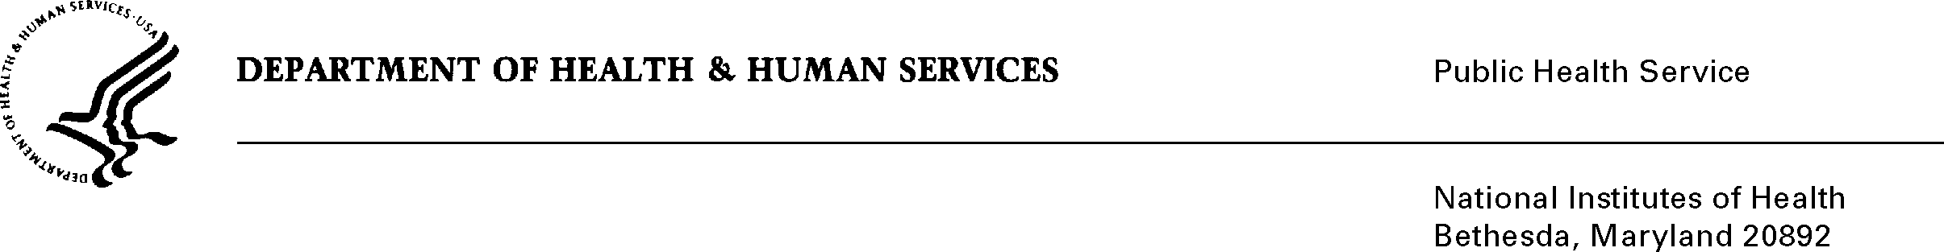

DATE: March 16, 2020

TO: Quinn Hirsch
Office of Management and Budget (OMB)
Reports Clearance Officer, DHHS

FROM: Mikia P. Currie
Chief, Project Clearance Branch

SUBJECT: Change Request to a Currently Approved Form
(OMB # 0925-0001 and 0925-0002, Expiration Date 2/28/2023)

This is a request for OMB to approve a non-substantial modification to the Training Data Tables as part of the NIH grant application packages. The changes are as follows:

(a) the instructions for xTRACT users in Table 4 and
(b) the description of underrepresented groups in the instructions for Tables 6 and 7. There were a few other changes:

- In the consolidated training tables: A correction to Table 8A, where an instruction inadvertently appeared in the wrong location in the version of the tables that was previously submitted to OMB
- In the undergraduate training tables: The same correction as above, as well as the modification to correct a column heading that was inadvertently reversed in Parts I and II.

You’ll find the various changes red-lined into the Consolidated Training Tables (Tables 4, 6, 7, and 8), the Undergraduate Training Tables (Table 8), and the Introduction to the Training Data Tables, attached. One of the reasons to list examples of underrepresented groups in the instructions for Tables 6 and 7 is to minimize burden on the part of applicants and provide information in the body of the table instructions, rather than referring them to information in a different location.

The change in the wording of the Introduction to the Data Tables was also intended to reduce applicant burden, by referring them directly to the Notice of NIH’s Interest in Diversity, rather than referring them to the Application Guide instructions, and from there referring them to the Grants Policy Statement

Attachment A: Consolidated Training Tables

Attachment B: Undergraduate Training Tables

Attachment C: Data Tables intro

Your full consideration is appreciated.

