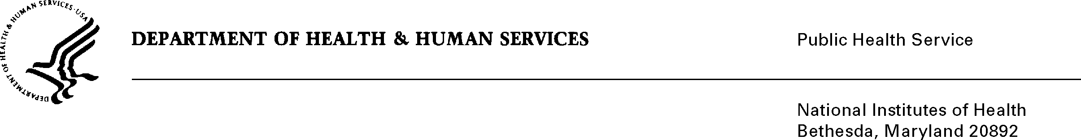

DATE: June 30, 2020

TO: Quinn Hirsch

Office of Management and Budget (OMB)

Reports Clearance Officer, DHHS

FROM: Mikia P. Currie

Chief, Project Clearance Branch

SUBJECT: Change Request to a Currently Approved Form

(OMB # 0925-0002, Expiration Date 2/28/2023)

This is a request for OMB to approve a non-substantial modification to the following form:

* PHS6031-1 Annual Payback Activities Certification (APAC)
  + Section I.4- Updated instructions
  + Section II.3- Removed Option A
  + Removed old instructions and added updated and clarifying language throughout instructions
  + Updated URL for form webpage

Your full consideration is appreciated.

**Attachments:**  **PHS6031 Annual Payback Activities Certification (APAC)**