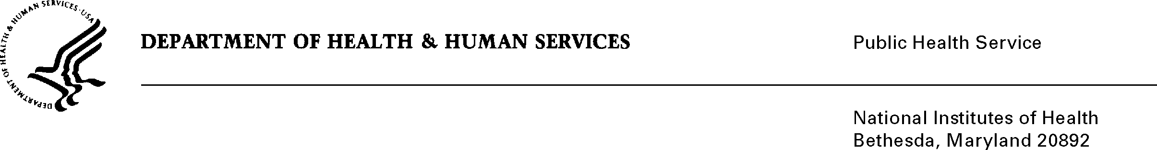

DATE: November 30, 2020

TO: Courtney Higgins

Office of Management and Budget (OMB)

Reports Clearance Officer, DHHS

FROM: Mikia P. Currie

Chief, Project Clearance Branch

SUBJECT: Change Request to a Currently Approved Form

(OMB # 0925-0001 and 0925-0002, Expiration Date 2/28/2023)

This is a request for OMB to approve a non-substantial modification to the Biographical Sketch Format Page and Other Support Format Page as part of the NIH grant application packages as previously referenced in the last revision cycle. The changes are as follows:

Biosketch Format Page (Fellowship and Non-Fellowship):

* Section B ‘Positions and Honors’ has been renamed ‘Positions, Scientific Appointments and Honors”
* The instructions for Section B clarify the types of positions and appointments to be included
* Section D has been updated to remove ‘Research Support’. This information is similar to data provided on the Other Support format page. Applicants may provide details on ongoing and recently completed projects that they wish to draw attention to in the personal statement.

Other Support Format Page:

* The Other Support Format Page has been re-organized to separate funded projects from in-kind contributions, to ensure clarity for applicants and recipients completing the form.
* The ‘Instructions for Selected Items’ have been removed from the Format Page itself, and have been placed into a separate instructions document, which provides additional details for providing the requested data elements, using existing policy requirements from the NIH Grants Policy Statement.

**Attachment A1:**  Biosketch Format Page Fellowship

**Attachment A2:**  Biosketch Format Page Non-Fellowship

Attachment B: Application Instructions - Biosketch

Attachment C: Other Support Format Page

Attachment D: Instructions for Completing Other Support

Your full consideration is appreciated.