Frequently Asked Questions about the
Medicare Current Beneficiary Survey

What is the Medicare Current Beneficiary Survey?
The Medicare Current Beneficiary Survey (MCBS) is an ongoing survey designed to learn more about the people who use Medicare and improve the Medicare program. The Centers for Medicare & Medicaid Services (CMS), part of the U.S. Department of Health and Human Services, oversees the Medicare program and sponsors this survey. MCBS data provide legislators, policy makers, and Congress with more information about how Medicare is used and how it affects beneficiaries like you.

Why is it important to participate in this survey?
The survey will help us understand how Medicare affects you, and what, if any, problems you have with it. The information you provide us will be used to make Medicare work better for you, both now and in the future. To conduct the survey, a professional interviewer will visit your home to ask questions about your health, your health care, and how much it costs.

Why have I been selected to participate?
As part of a randomly selected sample, you represent thousands of other Medicare beneficiaries. Your participation is important to accurately represent the experiences of all types of beneficiaries in the United States, regardless of health status. You cannot be replaced.

What types of questions will I be asked?
We will ask you questions about your recent experiences with Medicare, such as:
• Where do you usually go for health care?
• How do you usually schedule your health care appointments?
• How satisfied or dissatisfied are you with the out-of-pocket costs you paid for health care?
• How easy or difficult do you think the Medicare program is to understand?
• What are your suggestions or concerns about Medicare?

How long does it take?
Your first interview will last about an hour. We will also come back to interview you again next year. Subsequent interviews can take around 90 minutes, depending on your health status as well as your use of health care services.
Will helping with this survey affect my Medicare benefits in any way?
No, your benefits will not be affected in any way by your answers. Also, your benefits will not be affected by your decision to participate in this survey or not.
How do I know my answers will be kept private?
Your answers are protected under the Federal Privacy Act of 1974. The information you report is combined with information provided by many others and only used to describe Medicare beneficiaries as a group. No information that could identify you individually is publicly released.

How will I recognize the Medicare Current Beneficiary Survey Interviewer?
The interviewer is a representative from NORC at the University of Chicago who wears an official NORC ID badge with their picture, name, title, ID number and signature, as pictured below. On the back is a distinctive hologram and phone number to call to confirm the interviewer’s identity.
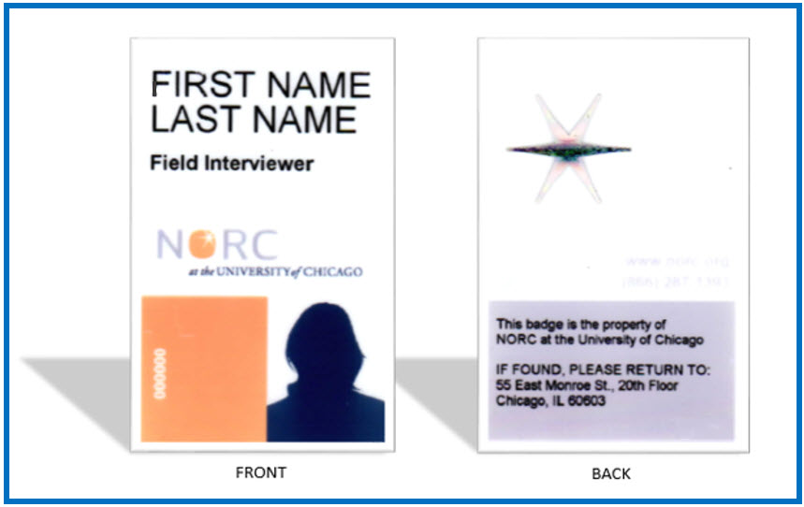

Image of NORC identification badge.
Why does the interviewer visit my home instead of calling?
Often, we do not have your phone number, so we cannot call ahead to schedule an appointment. The survey is completed in person because it is the most efficient and accurate way to conduct the interview. The survey can be completed wherever you feel most comfortable, whether that is in your home, a family member’s home, a coffee shop, or a library, and always at your convenience.

How can I make an appointment or get more information?
When the interviewer visits, you may schedule an appointment with her or him. You can even schedule an appointment in the evening or on a weekend. In the meantime, if you would like to learn more about the Medicare Current Beneficiary Survey, including recent reports and data:
Call us at 1-877-389-3429
Email us at mcbs@norc.org
Visit us at www.mcbs.norc.org &
www.cms.gov/MCBS

