For More Information  Call us toll-free at: 1-877-389-3429  Email us at: mcbs@norc.org  Visit us at: www.mcbs.norc.org or www.cms.gov/MCBS  [NORC and U.S. Department of Health and Human Services logo]  This survey is authorized by section 1875 (42 USC 139511) of the Social Security Act and is conducted by NORC at the University of Chicago for the U.S. Department of Health and Human Services.  OMB No. 0938–1275 | Expires 5/31/2021 | Medicare Current Beneficiary Survey Data Inform Key Policy Research  Some recent examples of findings from this important survey are:  Half of Medicare beneficiaries did not visit the dentist in the last year.  “Drilling Down on Dental Coverage and Costs for Medicare Beneficiaries” (Kaiser Family Foundation, 2019)  Most Medicare beneficiaries (81%) have some insurance coverage other than Medicare, including Medicaid, Medigap, and employer-sponsored insurance.  “Sources of Supplemental Coverage Among Medicare Beneficiaries in 2016” (Kaiser Family Foundation, 2018)  21% of Medicare beneficiaries age 65 and over have diabetes.  Beneficiaries with diabetes report poorer health and higher out-of-pocket costs than those without diabetes.  “Diabetes Occurrence, Costs, and Access to Care among Medicare Beneficiaries Aged 65 Years and Over” (Centers for Medicare and Medicaid Services, 2017)  You can find these publications and more information at www.mcbs.norc.org. | The  Medicare  Current  Beneficiary  Survey  (MCBS)  [Collage of MCBS Photos]
About the Medicare Current Beneficiary Survey  - The survey has been collecting information from Medicare beneficiaries about their health care since 1991.  - It is an important source of information about people who use Medicare and their experiences with health care.  - Over 100,000 people have participated in the survey since it began.  - The Centers for Medicare & Medicaid Services oversees the Medicare program and sponsors the survey.  Health care spending by Medicare beneficiaries was almost $1 billion in 2016; Medicare covered 63% of those costs.  Participating in the Survey  Each person contacted is scientifically chosen to represent thousands of other Medicare beneficiaries.  It is important to survey all selected beneficiaries to get an accurate picture of the Medicare population. Selected individuals cannot be replaced.  Together, survey participants represent the nation’s 58 million Medicare beneficiaries. | Conducting the Survey  A professional interviewer from the official survey contractor, NORC at the University of Chicago, visits each selected individual in person to conduct the survey.  The interviewer asks questions about the use of health care services, opinions about those services, and how much they cost.  Multiple surveys are conducted in order to document changes over time.  The initial survey lasts about an hour, while subsequent surveys last about ninety minutes.  94% of Medicare beneficiaries report being satisfied or very satisfied with the quality of their health care.  81% of Medicare beneficiaries report being satisfied or very satisfied with the cost of their health care.  [Graphic which displays this statistic]  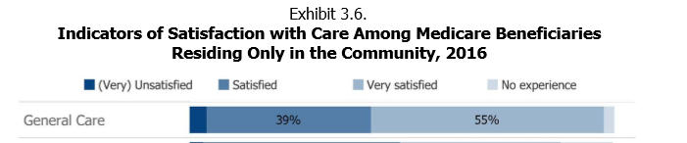 | Prescription Drugs were the largest single expenditure in 2016.  [Graphic which displays this statistic]  Our Commitment to Participants’ Rights and Privacy  Participation is voluntary and participants may skip any question they do not want to answer.  Medicare benefits will not be affected in any way by participants’ answers or their decision whether or not to participate.  All information participants provide will be kept private to the extent permitted by law under the Federal Privacy Act of 1974.  The information given will only be used to create summary tables and graphics for research purposes. No personal information is released publicly.

