Instrument 2. Identifying and contact information

According to the Paperwork Reduction Act of 1995, no persons are required to respond to a collection of information unless it displays a valid OMB control number. The valid OMB control number for this information collection is XXXX-XXXX. The time required to complete this information collection is estimated to average 25 minutes per response, including the time to review instructions, search existing data resources, gather the data needed, and complete and review the information collection. This includes the time it takes to complete the baseline survey. Send comments regarding this burden estimate to XXX. OMB expiration date xx/xx/xxxx.

**Identifying and Contact Information Data Collection** - **Screens in the Random Assignment, Participant Tracking Enrollment, and Reporting, or RAPTER®, system**

A1. Login screens

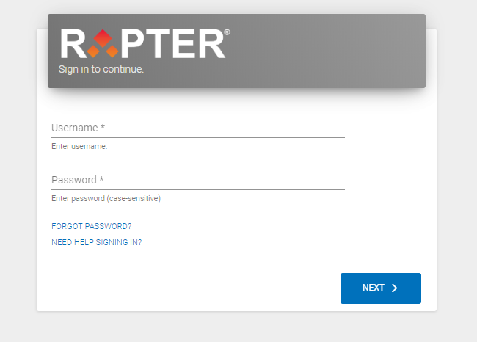

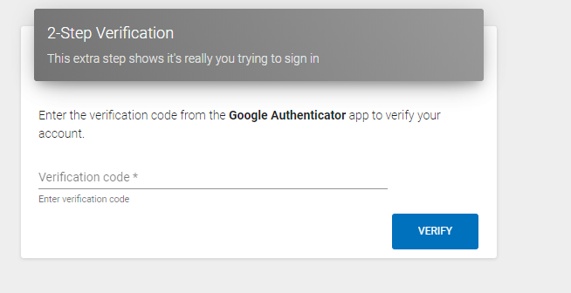

**Intake Screens**

B1. Study Eligibility

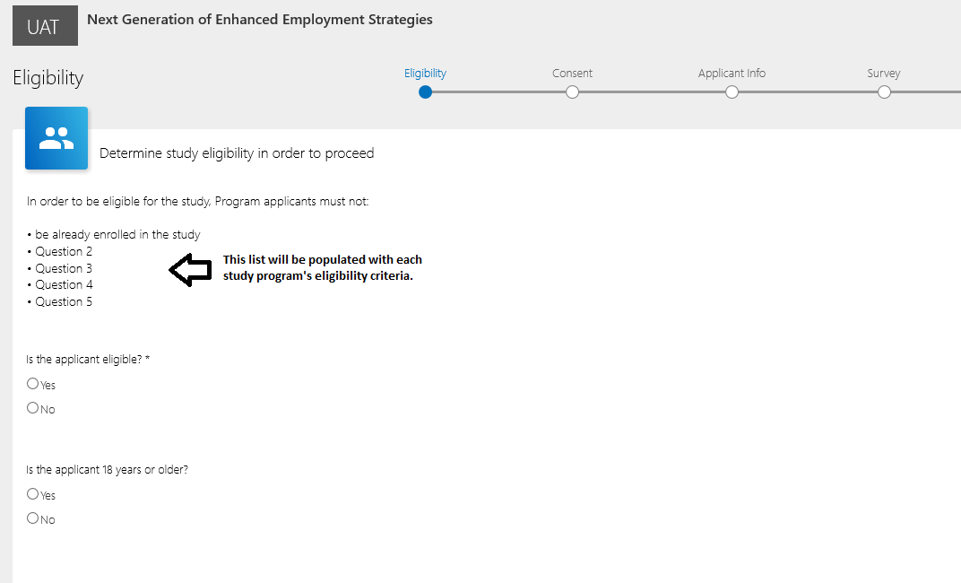

B2. Consent by Sample Member

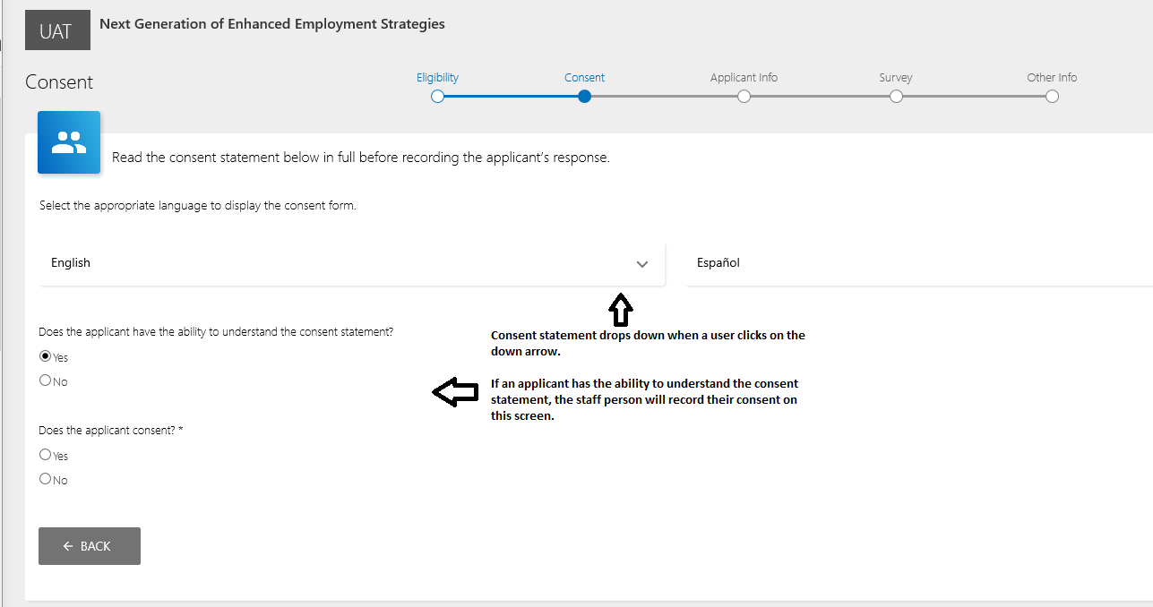

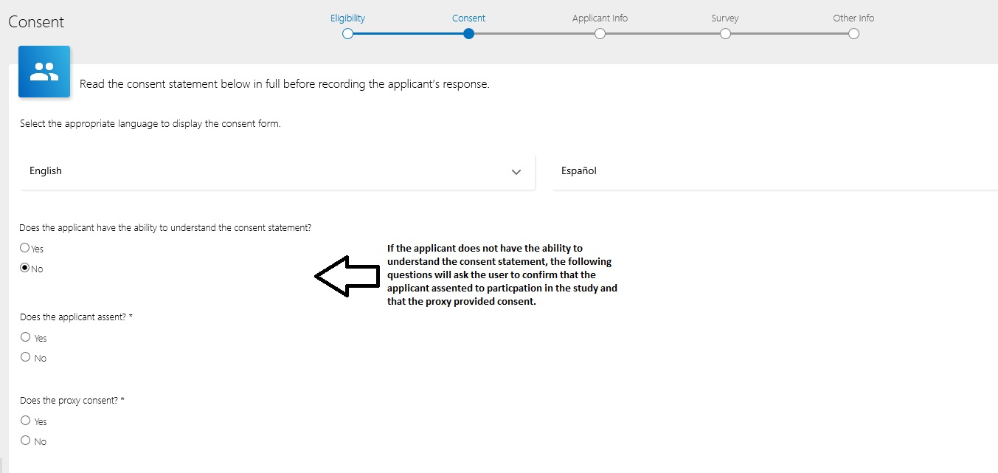

B3. Consent by parent/guardian

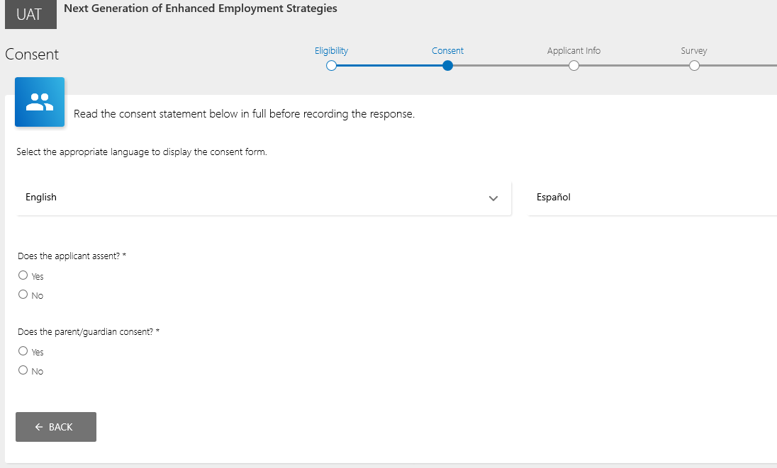

B4. Applicant information

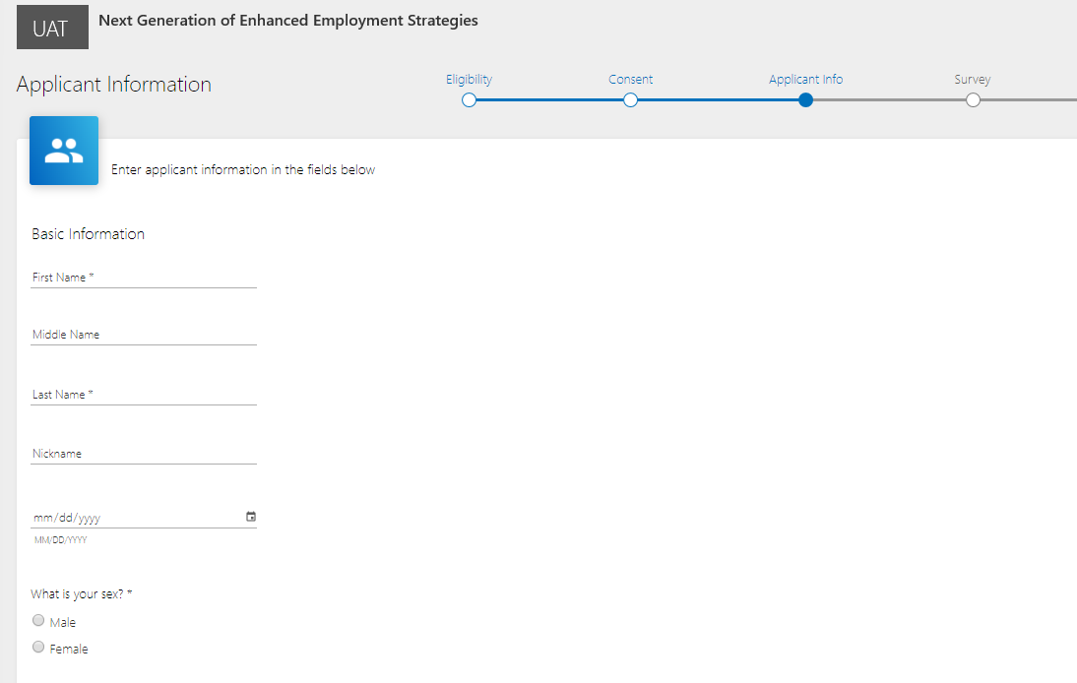

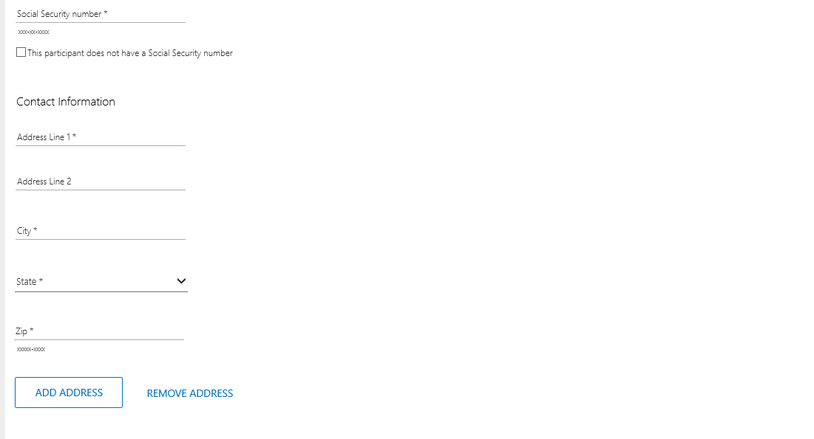



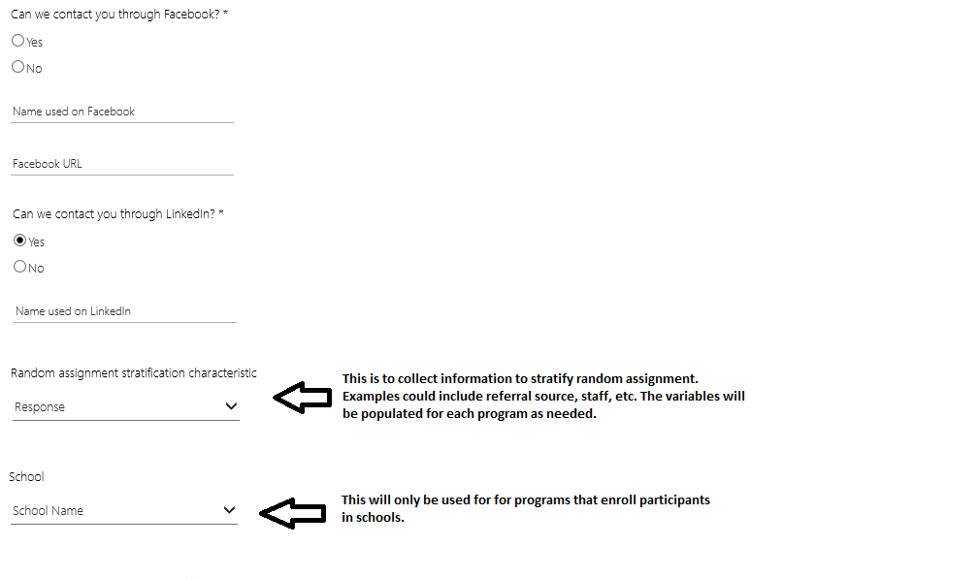

B5. Duplicate check

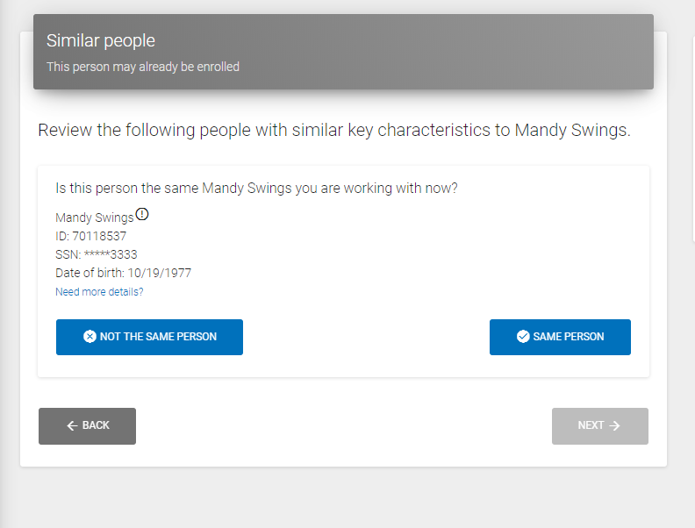

B6. Baseline

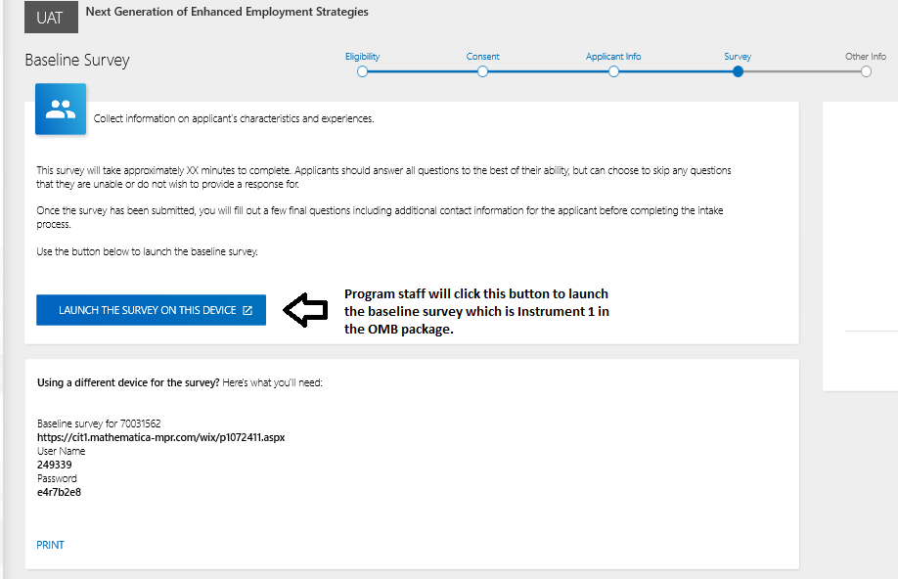

B7. Additional contacts screen

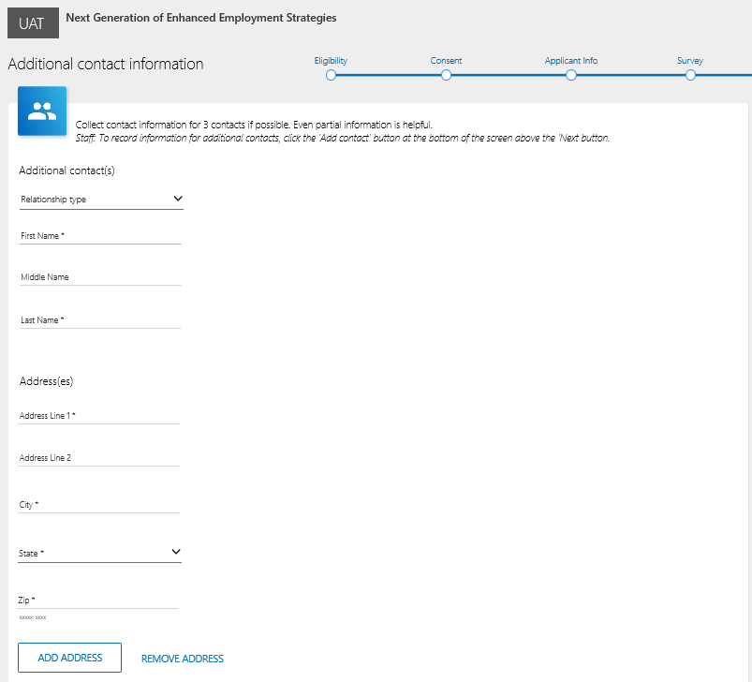



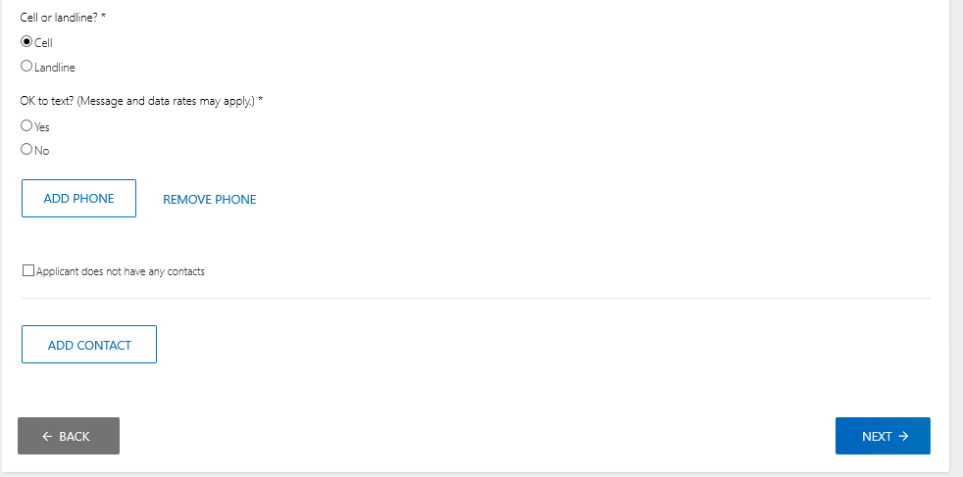

B8. Enrollment complete

