Low Income Home Energy Assistance Program (LIHEAP) Performance Measures

OMB Information Collection Request
0970 - 0449

Supporting Statement Part A - Justification
Updated December 2020

Submitted By:
Office of Community Services
Administration for Children and Families
U.S. Department of Health and Human Services

SUPPORTING STATEMENT A – JUSTIFICATION

Summary

Congress appropriated CARES Act (Public Law 116-136) funding for LIHEAP and allows the funding to be used in FY 2020 and FY 2021. Through this nonsubstantive change request, ACF seeks to change the Grantee Survey (Module I) to allow grantees to report CARES Act funds separately from non-CARES Act funds on their reports and to include lines reserved for future supplemental funding from Congress, if necessary. We also seek minor edits to Modules II and III, to update certain headings of the form to the appropriate years.

- Circumstances Making the Collection of Information Necessary

The Low Income Home Energy Assistance Program (LIHEAP) block grant (42 U.S.C. 8621) was established under Title XXVI of the Omnibus Budget Reconciliation Act of 1981, Public Law 97-35. The Office of Community Services (OCS) within the U.S. Department of Health and Human Services (HHS), Administration for Children and Families (ACF) administers LIHEAP at the Federal level.

The LIHEAP statute requires the program to report to Congress on program impacts annually, to develop performance goals, to ensure that benefits are targeted to those households with the greatest home energy need, and to assure that timely resources are available to households experiencing home energy crises. More specifically:

- Section 2610 of the LIHEAP Statute stipulates that the Secretary shall provide for the collection of certain data (Attachment 1). This section also requires the Secretary to submit to Congress each fiscal year a report on the data collected, on how States carry out certain requirements, on the impact of each State's program on recipient and eligible households, and on other relevant data.

- Section 2605(b) of the Low Income Home Energy Assistance Act of 1981 (42 U.S.C. §8624(b)) as amended by Sec. 311(b) of the Human Services Amendments of 1994 (Public Law 103-252) requires HHS to develop, in consultation with LIHEAP grantees, model performance goals that measure the success of each State’s LIHEAP activities.

- Section 2610(b)(2) of the Low Income Home Energy Assistance Act of 1981 (42 U.S.C. §8629(b)(2)) requires that HHS annually report to Congress on the impact LIHEAP is making on recipient and income-eligible households (see Attachment 1 for statutory language).

- Section 2605(b)(5) of the Low Income Home Energy Assistance Act of 1981 (42 U.S. C. §8624(b)(5)) requires LIHEAP grantees to provide, in a timely manner, that the highest level of energy assistance will be furnished to those households that have the lowest incomes and the highest energy costs or needs in relation to income, taking into account family size.

- Section 2604(c) of the Low Income Home Energy Assistance Act of 1981 (42 U.S. C. §8623(c)) requires that grantees reserve a reasonable amount of LIHEAP funds (based on data from prior years) until March 15 of each program year for energy crisis intervention. Furthermore, grantees are required to address home energy crises within expedited timeframes.

The LIHEAP Performance Data Form (LPDF) is an annual data collection effort conducted by the U.S. Office of Community Services (OCS) to collect information from state LIHEAP grantees and the District of Columbia to meet statutory requirements and program objectives. Data are collected in three distinct Modules:

- Module 1 (Grantee Survey) – This module collects information on the different purposes for which LIHEAP funding is used and the estimated average benefits furnished to clients for each type of assistance. This information has been collected by OCS and reported annually to Congress for over thirty years. These data collection efforts have furnished OCS with important information on how each grantee has chosen to implement the LIHEAP program to address the needs of low-income households in their jurisdiction. (Note: Data from this Module are included in the LIHEAP Annual Report to Congress (Attachment 3, Section I) and in the LIHEAP Data Warehouse available on the LIHEAP Performance Management Website.)

- Module 2 (LIHEAP Performance Measures) – This module collects information for four developmental performance measures: the Benefit Targeting Index for High Burden Households, the Burden Reduction Targeting Index for High Burden Households, the restoration of home energy service, and the prevention of loss of home energy service. These measures were approved for data collection by OMB in 2014 and mandatory data collection began for Fiscal Year 2016. (Note: Data from this Module are included in the annual LIHEAP Report to Congress and in the annual Congressional Budget Justification, and will be made available in the LIHEAP Data Warehouse.)

- Module 3 (Optional LIHEAP Performance Measures) – This module is optional and allows grantees to voluntarily collect and report supplementary information that compliments the required performance measures data. These optional data increase the individual grantee’s ability to use the Performance Data for LIHEAP program management.

Change Request Updates December 2020 – CARES Act Funds
Congress appropriated CARES Act (Public Law 116-136) funding for LIHEAP and allows the funding to be used in FY 2020 and FY 2021. The CARES Act overrode one important provision of the LIHEAP statute related to the obligation period and ability to carry forward funding. The provision allows LIHEAP grantees to obligate any portion of the supplemental LIHEAP funds in FY 2020 and/or FY 2021, contingent upon their own rules for obligating their own funds (45 CFR 96.30(a)). ACF notified LIHEAP grantees through the CARES Act LIHEAP Notice of Award letters that grantees must track and report the CARES Act funding separately from other LIHEAP funding sources.

In light of the current, national pandemic, ACF has revised this form to add lines specific to CARES Act funding. Additionally, the form has been revised to have lines reserved for future supplemental funding from Congress.

No other federal data collection efforts provide the fiscal data, other than carryover data collected on the LIHEAP Carryover and Reallotment Report (Carryover Report), that the Grantee Survey collects. Without the collection of these data, there is no way to report to Congress on State-specific and aggregated fiscal and performance measures data for the most recent fiscal year on the program.

OMB approved the renewal of the LPDF, under ICR Reference No. 201802-0970-007, on March 27, 2018. This current nonsubstantive change request will allow grantees to report CARES Act funds separately from non-CARES Act funds on their reports. We propose changes to Module I and minor edits to Modules II and III.

- Purpose and Use of the Information Collection

Below is a summary of the types of information that OCS is seeking authorization to continue to collect, the purpose in collecting these data, and how these data are used.

Module 1 (Grantee Survey)

OCS uses the mandatory Module 1 to collect and report on the States' annual estimates of their sources and uses of LIHEAP funding, LIHEAP average household benefits, and maximum annual income cutoffs for 4-person households for LIHEAP (Attachment 2).

The purpose of collecting the data for Module 1 is to obtain fiscal and benefits data from all 50 states and the District of Columbia. These data are used by OCS to analyze how grantees have chosen to implement the LIHEAP program to address the needs of low-income households and to report aggregated and state-specific fiscal data in the Secretary's annual LIHEAP Report to Congress (Attachment 3, Section I) and in the LIHEAP Data Warehouse. The data also are used to respond to inquiries from Congress, OMB, and the White House relating to budget and program decisions.

Module 2 (LIHEAP Performance Measures)

OCS uses the mandatory Module 2 to collect and report data for four developmental performance measures. The four performance measures are as follows:

- The benefit targeting index for high burden households receiving LIHEAP fuel assistance. This measure quantifies LIHEAP’s benefit targeting performance by measuring the extent to which the highest LIHEAP benefits are provided to households with the highest energy costs relative to household income.
- The burden reduction targeting index for high burden households receiving LIHEAP fuel assistance. This measure quantifies LIHEAP’s burden reduction targeting performance by measuring the extent to which households with the highest energy costs relative to income have a larger percentage of their energy bill paid with LIHEAP than households with average energy costs relative to income.
- The number of occurrences where LIHEAP benefits restored home energy services. This measure includes the number of occurrences where energy service was restored after disconnection, where fuel was delivered after the household ran out of fuel, and where inoperable home energy equipment was repaired or replaced.
- The number of occurrences where LIHEAP prevented the loss of home energy services. This measure includes the number of occurrences where a household had a past due or disconnect notice at the time of application and receipt of LIHEAP benefits, where assistance was provided to a household at imminent risk of running out of fuel, and where operable home energy equipment at imminent risk of failure was repaired or replaced.

The purpose of collecting the data for Module 2 is to obtain data from all 50 states and the District of Columbia that directly relates to the LIHEAP statutory mandate that LIHEAP assistance be targeted to those low income households with the highest home energy needs, i.e., vulnerable households and high-energy burden households. The four performance measures quantify how each LIHEAP program is targeting benefits to high energy burden and vulnerable households to help them maintain healthy, safe, and continuous use of home energy services, allowing for comparison over time and providing each grantee with information valuable for effective performance management and program implementation.

OCS uses the Performance Measures data to calculate aggregate performance data and report the results through the annual Congressional Justification budget process and in the annual LIHEAP Report to Congress. Once the data are published in the LIHEAP Report to Congress, grantees can compare their own results to the results for other states, as well as to regional and national summaries through the LIHEAP Data Warehouse.

Module 3 (Optional LIHEAP Performance Measures)

Module 3 is optional. OCS includes this module to allow grantees to report additional data that supplements the data reported for Module 2, including data on energy consumption, air conditioning use, and home energy service restoration and prevention of loss. Individual grantees use the information voluntarily reported in this module to help analyze and interpret their Performance Measures results.

Change Request Updates December 2020 – CARES Act Funds

OCS plans to use the additional data reported on this form for validating the Carryover Report and reporting on use of CARES Act funds. OCS has previously used the (non-CARES Act) data reported on this form for validating Carryover Report and for preparing the LIHEAP Annual Report to Congress. OCS must, on the Carryover Report, collect CARES Act and non-CARES Act data separately in order to calculate the amounts of funds that grantees (1) may carry over; and (2) must return to the government.
OCS added questions to this form that allow grantees to report non-CARES Act supplemental data. These questions serve the same purposes as the CARES Act questions. However, OCS will allow grantees to answer these questions only to the extent Congress passes a non-CARES Act supplemental in FFY 2021.

- Use of Improved Information Technology and Burden Reduction
Every effort will be made to minimize the burden of this data collection by providing grantees with resources for efficient data collection, data processing, and data reporting.

- Data Collection – OCS has provided grantees with multiple resources to assist with collecting the necessary data to complete the LIHEAP Performance Data Form, including a data collection guide, data collection templates, and training webinars reviewing data collection procedures. OCS also has furnished one-on-one training and technical assistance to numerous grantees and makes such assistance available annually.

- Data Processing – OCS has developed guidance documents to assist grantees with data processing. In addition, the ACF On-Line Data Collection System (OLDC) calculates some of the data fields, rather than requiring the grantee to do so.

- Data Reporting – The LIHEAP Performance Data Form is collected by OCS using the ACF On-Line Data Collection System (OLDC), which is a web-based reporting tool that grantees use to complete several LIHEAP reports. The OLDC tool assists grantees with completing the form by providing instructions, alerting grantees to possible errors, and allowing grantees to access prior versions of their report. OCS also provides extensive resources and training on data reporting with the intention of minimizing the burden associated with reporting accurate information. This includes detailed instructions on data reporting, webinars, a “Check before you submit” document, one-on-one technical assistance, and providing a summary of data reporting issues or questions following the review of each grantee’s submitted information.

Since 2010, the LIHEAP Performance Measures Work Group (PMIWG), consisting of state LIHEAP directors and HHS staff, has worked with OCS to develop resources and to encourage grantees to share information to assist with minimizing the burden of this data collection. Since the LIHEAP Performance Data Form was approved by OMB in 2014, a number of grantees have implemented or enhanced their existing data systems, client applications, client waivers, and vendor agreements to support collecting and reporting the required data.

- Efforts to Identify Duplication and Use of Similar Information
OCS investigation has revealed no duplicate sources of the state-level data elements required for the LIHEAP Performance Data Form.

For Module 1 (Grantee Survey), no similar data are available for all categories of sources and uses of federal LIHEAP funds. Without this collection effort, there would be no timely uniform data available to comply with requests from Congress, OMB, and the White House. Nor would information regarding the impact of program funds be available for the Department’s Annual LIHEAP Report to Congress (see Attachment 3, Section I), for hearings, and during the appropriations and oversight process.

For Module 2 (LIHEAP Performance Measures), similar data are available from two surveys published by the U.S. Energy Information Administration (EIA): the Residential Energy Consumption Survey (RECS) and the State Energy Consumption, Price, and Expenditure Estimates (SEDS). However, while these surveys provide similar information, neither survey provides adequate data for measuring LIHEAP performance:

- RECS – This survey collects utility consumption, energy expenditure, and energy insecurity data for a nationally representative sample of households. However, the RECS data has two limitations that make in inadequate for measuring LIHEAP performance. First, the RECS can only provide statistics for the nation, Census regions, and Census Division. Due to RECS sample design, state-level estimates are not available. Second, the RECS is conducted approximately every five years, limiting the timeliness of the data and prohibiting annual estimates. Due to these limitations, the RECS is not suitable for annual, state-level LIHEAP performance measurement.

- SEDS – This is an annual survey that furnishes information on energy consumption and energy expenditures for a number of different fuels at the state level. However, the SEDS data cannot furnish any information on the LIHEAP population and LIHEAP performance.

In summary, while both RECS and SEDS provide useful information that is used by OCS for a number of purposes, neither data source can furnish information on the annual performance of LIHEAP at the state-level.

- Impact on Small Businesses or Other Small Entities
There are three sources of the additional data sought–LIHEAP grantees, LIHEAP sub-grantees (i.e., local agencies), and energy vendors. LIHEAP sub-grantees are often small community-based organizations. Plus, some energy vendors are small businesses.

LIHEAP grantees consist solely of states, including the District of Columbia; certain territories; and certain Indian tribes and tribal organizations. Only the states and the District of Columbia complete the LPDF. None of those entities is a small business.

LIHEAP sub-grantees often consist of small, community-based organizations. Prior to FFY 2020, LIHEAP sub-grantees were expected, in their normal course of business, to track LIHEAP funds by federal fiscal year, source, and use. For FFY 2020, OCS required their primary grantees to track funds appropriated by the CARES Act and otherwise. OCS expects their primary grantees to flow down this requirement to the LIHEAP sub-grantees.

Certain energy vendors consist of small businesses. Prior to FFY 2020, LIHEAP grantees and LIHEAP sub-grantees required them to track LIHEAP funds by federal fiscal year, source, and use. For FFY 2020, OCS expects them also to track funds appropriated by the CARES Act and otherwise. However, OCS believes that this additional requirement will require no more than a minor adjustment to their existing tracking systems.

- Consequences of Collecting the Information Less Frequently
OCS uses these forms to collect this information annually, on a continuous basis. This information allows OCS and its grantees, as well as Congress and other decision-makers and stakeholders, to (1) understand how grantees use federal LIHEAP funds; (2) cross-validate the figures that appear on both forms; and (3) track the grantees’ usage of their funds.

Change Request Updates December 2020 – CARES Act Funds
The updates through this nonsubstantive change request will allow for understanding of how grantees use CARES Act and non-CARES Act funds. OCS plans to collect CARES Act information through the amended forms for FFY 2020 and FFY 2021. This will allow OCS, LIHEAP grantees, and other decision-makers and stakeholders to understand how grantees use CARES Act and non-CARES Act funds for LIHEAP. It will also allow OCS to validate the grantees’ reports of funds carried over and returned on the Carryover Report. The failure to collect this data will keep these parties from reporting on such usage and carrying out such validations.

- Special Circumstances Relating to the Guidelines of 5 CFR 1320.5
No special circumstances apply to this data collection.

- Comments in Response to the Federal Register Notice and Efforts to Consult Outside the Agency
A 60-day notice was published on pages 47211-47212 of the Federal Register on October 11, 2017 (see Attachment 4). OCS did not receive comments during this timeframe.

- Explanation of Any Payment or Gift to Respondents
No payments or gifts of any kind will be provided to respondents.

- Assurance of Confidentiality Provided to Respondents
We will protect the information to the extent allowed by Federal law.

- Justification for Sensitive Questions

No sensitive questions are asked in this data collection.

- Estimates of Annualized Burden Hours and Costs
The estimated burden hours associated with this data collection are shown in the table below:

Annual Respondent Burden and Cost Estimates for LIHEAP Performance Data Form

These estimates derive from those reported on the Supporting Statement of the last renewal request for this form. OCS developed the estimates for that statement by conducting in-depth interviews with a small number of grantees to learn more about the annual burden hours required to implement their data collection and reporting systems for this effort. OCS’ interviews found that, for Module 1, some grantees have fully developed reporting systems and that the time required each year to obtain the data and enter it into OLDC is less than 10 hours. Other grantees, particularly those where the fiscal office is separate from the LIHEAP program office face more challenges in preparing reports. Those grantees report that Module 1 takes them at least 40 hours. The average reported time for completion was 30 hours.

Change Request Updates December 2020 – CARES Act Funds
OCS adjusted the Supporting Statement of the last renewal request as follows to estimate the additional burden of reporting on CARES Act funds in Module 1:
- By adding 20 percent to the Average Hour Burden Per Response estimate of State Grantees; and
- By adding one Average Hour Burden Per Response for each energy vendor.

Both adjustments were off-handed estimates rather than estimates derived from OCS’ interviews.

OCS left the Average Hour Burden Per Response estimate for Module 2 and Module 3 unchanged from that which it derived from its interviews.

ANNUAL RESPONDENT BURDEN AND COST ESTIMATES FOR LIHEAP PERFORMANCE DATA FORM

 | Number of Respondents | Number of Responses Per Respondent | Average Hour Burden Per Response | Total Burden Hours
Module 1 (Grantee Survey)
State Grantees | 51 | 1 | 36 | 1,836
Energy Vendors (largest 5 electric, 5 natural gas, 10 fuel oil, and 10 propane vendors per state - average) | 1,530 | 1 | 1 | 1,530
Modules 2 and 3 (LIHEAP Performance Measures)
State Grantees—Part II | 51 | 1 | 150 | 7,650
Sub-Grantees (in states with sub-grantee managed systems) — Part II | 100 | 1 | 8 | 800
Energy Vendors (largest 5 electric, 5 natural gas, 10 fuel oil, and 10 propane vendors per state - average) — Part II | 1,530  (estimate) | 1 | 8.5 | 13,005
Total Annual Burden Hours |  |  |  | 24,821

- Estimates of Other Total Annual Cost Burden to Respondents and Record Keepers/Capital Costs
The data collection procedures should not require any new capital expenditures by grantees, sub-grantees, or energy vendors. The amended data collection procedures required for reporting CARES Act funds build on existing systems and so should not require any new capital expenditures by grantees, sub-grantees, or energy vendors.

- Annualized Cost to the Federal Government
Federal Government Staff tasks associated with the collection of these data include:

- Grantee Monitoring – Notifying grantees of the reporting requirement and conducting follow-up with grantees.
- Report Review – Reviewing submitted reports and working with grantees to furnish reliable data.
- Analysis and Reporting – Conducting analysis of the reported data and preparing tables to be submitted with targeted administrative reports (e.g., LIHEAP Report to Congress).

The table below furnishes information on the estimated Federal Staff hours and costs associated with each task:

Annual Federal Staff Hours and Costs

Task | Number of Hours | Rate | Total Cost
OLDC Form Development | 673 | $111.50/hour | $75,040
Grantee Monitoring | 42 | $111.50/hour | $4,683
Grantee Report Review | 66 | $111.50/hour | $7,359
Analysis and Reporting | 105 | $111.50/hour | $11,708
Subtotal: |  |  | $98,790

The table below furnishes information on the estimated Federal Contractor Staff hours and costs associated with each task:

Annual Federal Contractor Staff Hours and Costs

Task | Number of Hours | Average Rate | Total Cost
Grantee Report Review | 384 | $63.65 | $24,442
Analysis and Reporting | 216 | $63.65 | $13,748
Technical Assistance | 288 | $84.87 | $24,443
Subtotal: |  |  | $62,633

Total federal government costs are $161,423.

- Explanation for Program Changes or Adjustments
This request is for a non-substantive change to the collection approved by OMB under ICR Reference No. 201406-0970-003. It calls for grantees to report (1) CARES Act funds as a separate source; and (2) uses of all LIHEAP funds from the CARES Act and from other FFY 2020 sources separately. ACF needs this change to report on use of CARES Act funds and to validate the Carryover Report. We anticipate that the changes will increase the estimated time to respond from 30 to 36 hours for Module I.

- Plans for Tabulation and Publication and Project Time Schedule

The data from Module 1 of the LIHEAP Performance Data Form is included in the LIHEAP Report to Congress (see Attachment 3, Section I) to furnish Congress with information on how LIHEAP funds are used by grantees to deliver services to clients.

The data from Module 2 will be synthesized into the four performance measures described above and published in the annual LIHEAP Report to Congress. In addition, the raw data, as well as the synthesized performance measures will be made available to each grantee through the LIHEAP Data Warehouse. Each grantee will also be able to access their performance measures, the measures for other grantees, and national and regional summaries.
Activity | Weeks Following Report Submission Deadline
Completion of quality assurance testing on performance measures data (requires review of data inconsistencies and outliers with grantees) | 8 Weeks
Synthesis of data into performance measures indicators | 12 Weeks
Draft of statistical tables for inclusion in annual LIHEAP Report to Congress – text and appendices | 16 Weeks
Final statistical tables for inclusion in annual LIHEAP Report to Congress | 20 Weeks
Publication of annual LIHEAP Report to Congress* | --
Live launch of raw data and performance measures indicators on the LIHEAP Data Warehouse | 1 day post publication of Report to Congress
* Publication is dependent upon the Department’s clearance process of the annual LIHEAP Report to Congress.

The form will be due by grantees on February 16, 2021.

- Reason(s) Display of OMB Expiration Date is Inappropriate

Non-applicable.

- Exceptions to Certification for Paperwork Reduction Act Submissions

None.

B. Collection of Information Employing Statistical Methods

Statistical methods are not employed for collecting, analyzing, reporting data from Module 1 (Grantee Survey) as only total amounts and percent distributions are reported or tabulated.

One purpose of Module 2 (LIHEAP Performance Measures) is to calculate performance measures for individual states and the nation on the targeting of benefits and energy burden reduction to high burden households. As part of this process, grantees collect data on LIHEAP client energy expenditures from energy vendors. OCS worked with grantees to identify procedures that would furnish high quality data but also minimize reporting burden by targeting data collection to a subset of large energy vendors. Analysis of data by OCS found that the client-level variability in energy burden is mainly a function of client income, client energy usage, and fuel price. Fuel price variability is mainly a function of the fuel used (e.g., electricity, natural gas, fuel oil, or propane) rather that the company that supplied the fuel. (Delivered fuel markets, in particular, are very price sensitive.) For that reason, restricting the data collection to a subset of companies does not affect the data quality. (Note: Average expenditures for clients served by the largest companies were within 1% of the value of average expenditures for clients served by all companies.)

One reason to restrict the data collection to large companies is that those companies tend to high quality information systems and are more likely to have existing data exchange procedures with the grantee’s LIHEAP office and thereby can minimize reporting burden. Those grantees that request data from larger companies (including larger delivered fuel vendors) have found that automated procedures make reporting burden independent of sample size. For that reason, the vendors are able to report on all clients served by the program and thereby can furnish statistically robust data on the energy burden outcomes for clients.

For most grantees, the top 5 electric and gas companies serve 75% or more of LIHEAP clients using those fuels. For the small number of grantees that were reviewed by OCS, the top 10 fuel oil and LPG companies serve at least one-third of LIHEAP grantees using those fuels. For most grantees, those sample sizes are sufficient to furnish statistically robust estimates.

In a few jurisdictions (e.g., Tennessee and Nebraska), the electricity and/or natural gas markets are not so concentrated. In those jurisdictions, a large number of companies might need to be included in the reporting requirements to furnish robust estimates. However, those are balanced out by some small states that have only one
or two major electric and/or natural gas utilities.

Attachment 1

Section 2610 (42 USC 8629).
(a) The Secretary, after consultation with the Secretary of Energy,
shall provide for the collection of data, including--
(1) information concerning home energy consumption;
(2) the amount, cost and type of fuels used for households eligible
for assistance under this title;
(3) the type of fuel used by various income groups;
(4) the number and income levels of households assisted by this
title;
(5) the number of households which received such assistance and
include one or more individuals who are 60 years or older or disabled
or include young children; and
(6) any other information which the Secretary determines to be
reasonably necessary to carry out the provisions of this title.
Nothing in this subsection may be construed to require the Secretary to
collect data which has been collected and made available to the Secretary by
any other agency of the Federal Government.

(b) The Secretary shall, no later than June 30 of each fiscal year,
submit a report to the Congress containing a detailed compilation of the
data under subsection (a) with respect to the prior fiscal year, and a
report that describes for the prior fiscal year--
(1) the manner in which States carry out the requirements of
clauses (2), (5), (8), and (15) of section 2605(b); and
(2) the impact of each State's program on recipient and eligible
households.

(42 U.S.C. 8629)

Attachment 2

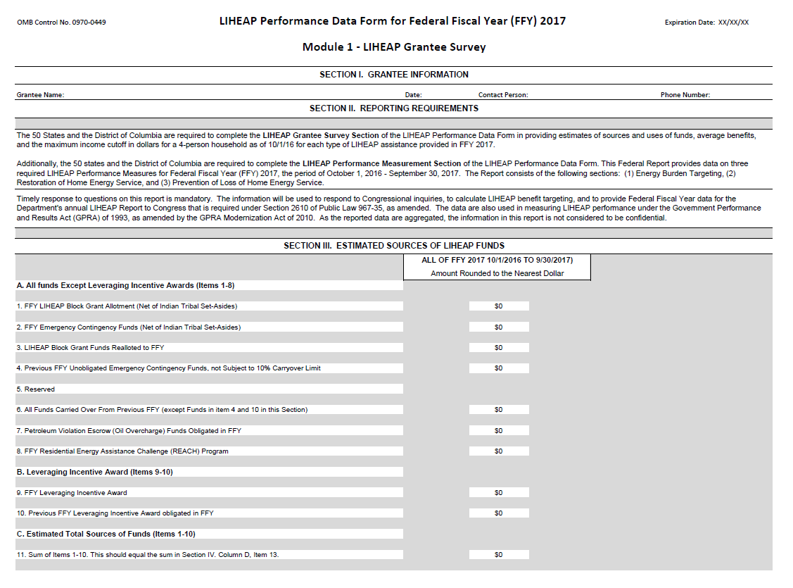

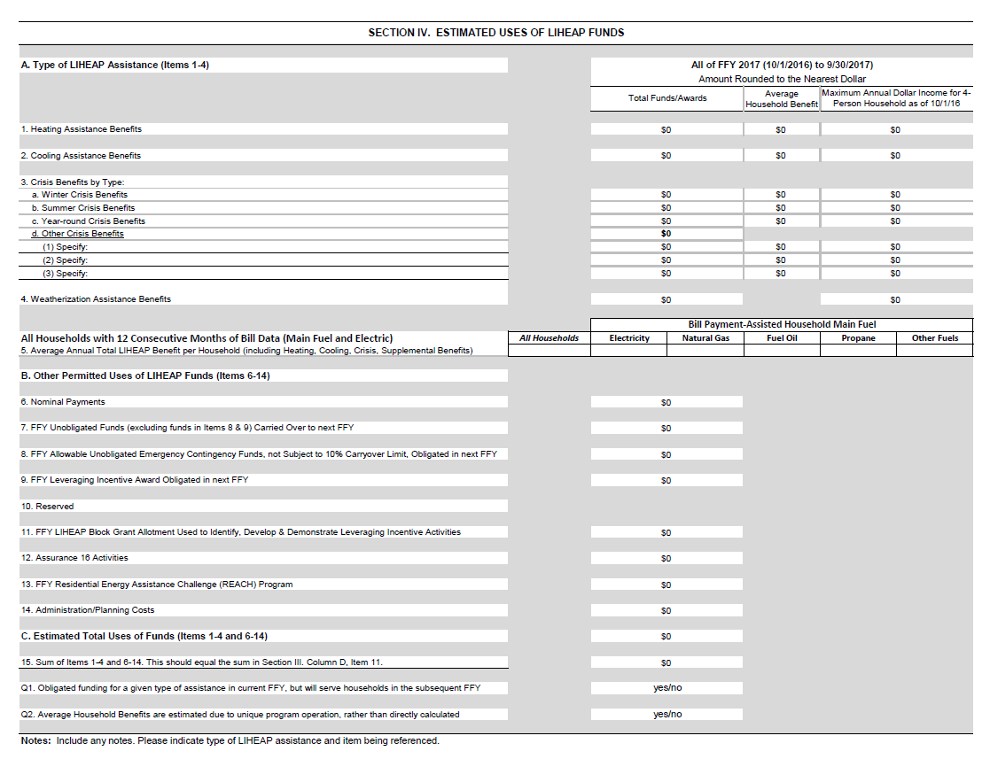

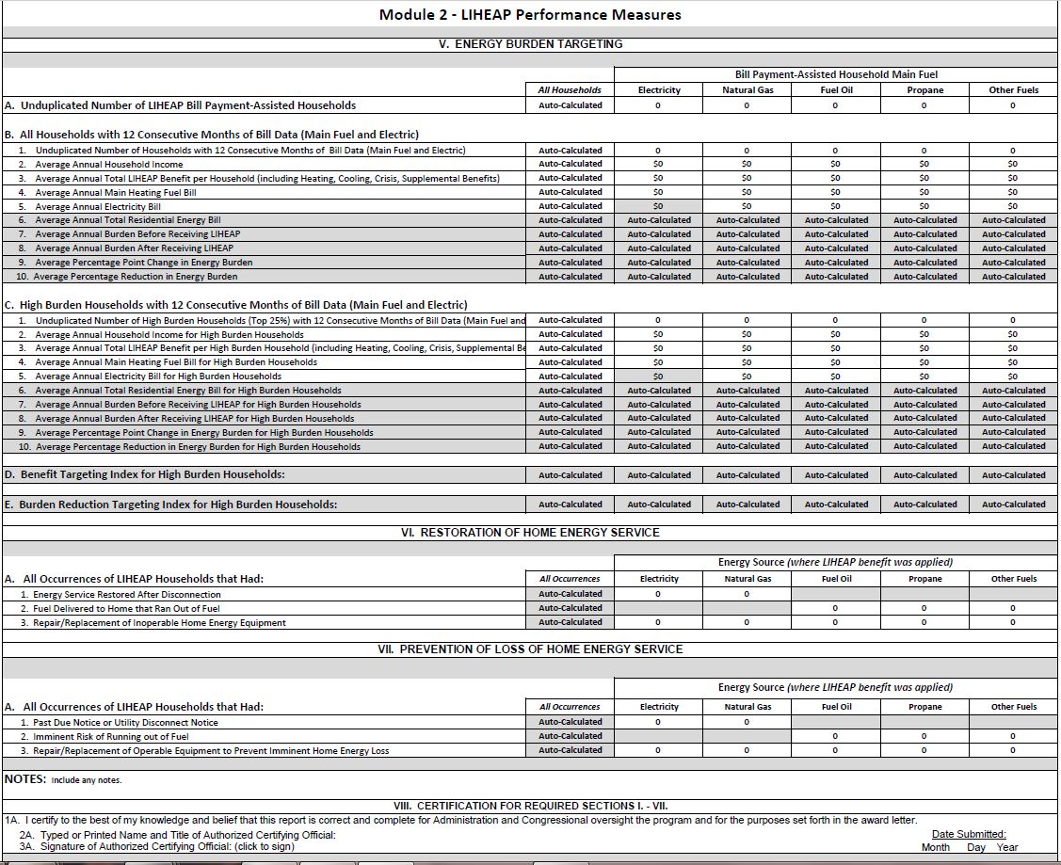

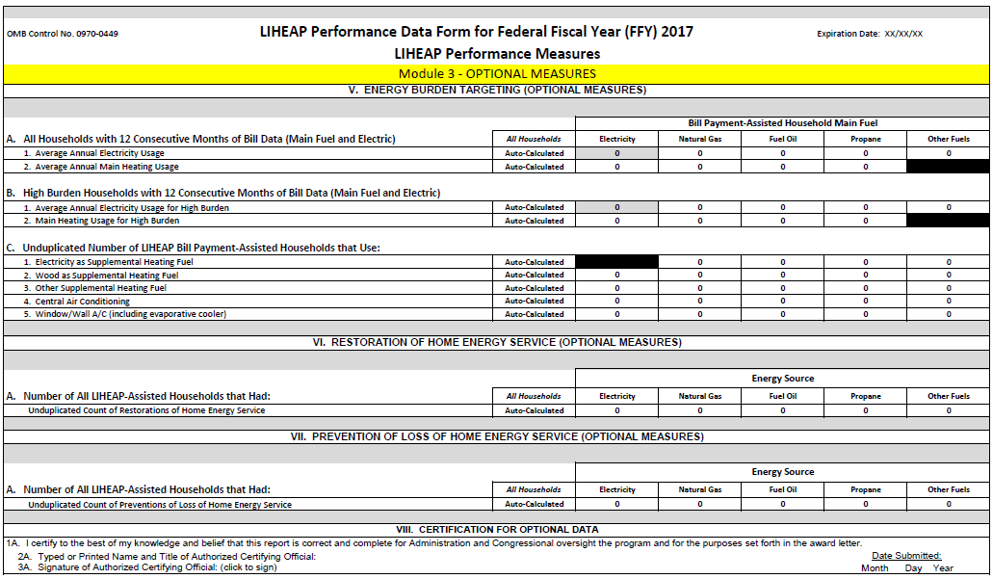

Attachment 3

See Section I of the 2014 Report to Congress, found here: https://www.acf.hhs.gov/sites/default/files/ocs/fy14_liheap_rtc_final.pdf

Attachment 4

Title: LIHEAP Performance Data Form for Federal Fiscal Year (FFY) XXXX.

OMB No.: 0970-0449.

Description: In response to the 2010 Government Accountability Office (GAO) report, Low Income Home Energy Assistance Program—Greater Fraud Prevention Controls are Needed (GAO-10-621), and in consideration of the recommendations issued by the Low Income Home Energy Assistance Program (LIHEAP) Performance Measures Implementation Work Group, the Office of Community Services (OCS) required the collection and reporting of the new performance measures by state LIHEAP grantees and the District of Columbia. Office of Management and Budget (OMB) approved the LIHEAP Performance Data Form (LPDF) in November 2014 (OMB Clearance No. 0970-0449) that expires on October 31, 2017. The LPDF provides for the collection of the following LIHEAP performance measures which are considered to be developmental as part of the LPDF:

- The benefit targeting index for high burden households receiving LIHEAP fuel assistance;
- The burden reduction targeting index for high burden households receiving LIHEAP fuel assistance;
- The number of households where LIHEAP prevented a potential home energy crisis; and
- The number of households where LIHEAP benefits restored home energy.

All State LIHEAP grantees and the District of Columbia are required to complete the LPDF data through the Administration for Children and Families' (ACF) web-based data collection and reporting system, the Online Data Collection (OLDC), which is available at: https://home.grantsolutions.gov/​home. The reporting requirements will be described through OLDC.

The previous OMB-approved LIHEAP Grantee Survey on sources and uses of LIHEAP funds was added in 2014 to the LPDF as an addition to the LIHEAP performance data. No substantive changes are being proposed for this data collection activity. A sample of the draft form is available for viewing here: https://www.acf.hhs.gov/​ocs/​resource/​funding-applications.

The form is divided into the following three modules to add clarity:

Module 1. LIHEAP Grantee Survey (Required Reporting)
Module 1 of the LPDF will continue to require the following data from each state for the federal fiscal year:
- Grantee information,
- sources and uses of LIHEAP funds,
- average LIHEAP household benefits, and
- maximum income cutoffs for 4-person households for each type of LIHEAP assistance provided by each grantee for the fiscal year.

Module 2. LIHEAP Performance Measures (Required Reporting)
Module 2 of the LPDF will continue to require the following data from each state for the federal fiscal year:

- Grantee information,
- energy burden targeting,
- restoration of home energy service, and
- prevention of loss of home energy.

Module 3. LIHEAP Performance Measures (Optional Reporting)
Module 3 of the LIHEAP LPDF will continue to voluntarily collect the following additional information from each interested grantee for the federal fiscal year:

- Average annual energy usage,
- Unduplicated number of households using supplemental heating fuel and air conditioning,
- Unduplicated number of households that had restoration of home energy service, and
- Unduplicated number of households that had prevention of loss of home energy.

Based on the data collected in the LPDF:

- ACF will provide reliable and complete LIHEAP fiscal and household data to Congress in the Department's annual LIHEAP Report to Congress.

- ACF will calculate LHEAP performance measures and report the results through the annual budget development process and in LIHEAP's annual Congressional Justification (CJ) under the Government Performance and Results Act of 1993.

- ACF and grantees will be informed about the impact LIHEAP has with respect to LIHEAP households' home energy burden (the proportion of their income spent towards their home heating and cooling bills), including information on the difference between the average recipient and high burden recipients, restoring home energy service, and preventing loss of home energy service.

- ACF will be able to respond to questions on sources and uses of LIHEAP funds from the Congress, Department, OMB, White House, and other interested parties in a timely manner.

- LIHEAP grantees will be able to compare their own results to the results for other states, as well as to regional and national results, through the Data Warehouse of the LIHEAP Performance Management Web site as they manage their programs.

Respondents: State Governments and the District of Columbia.

Annual Burden Estimates

The table below shows the estimated data collection and reporting burden for the LPDF as reported in 2014. These estimates are based on a small number of interviews conducted in 2014 with grantees, sub-grantees, and energy vendors. In support of this submission requesting comments, ACF is currently re-assessing the level of effort to collect and report the required data in order to develop updated burden estimates. The original 2014 estimates were based on grantee reporting capabilities at that time and included time and costs for initial system development. However, since most grantees have improved their reporting capabilities, many grantees have completed their system development, and ACF has furnished reporting resources and technical assistance to assist grantees, it is expected that the time and costs associated with reporting are lower than the original 2014 estimates show below.

Instrument | Number of respondents | Number of responses per respondent | Average burden hours per response | Total burden hours
Module 1: Grantee Survey
Grantees | 51 | 1 | 3.5 | 178.50
Module 2: Performance Measures
Grantees | 51 | 1 | 100 | 5,100
Sub-Grantees (in states with sub-grantee managed systems) | 200 (estimate) | 1 | 80 hours | 16,000
Large Energy Vendors (largest 5 electric, 5 gas, 10 fuel oil, and 10 propane vendors per state—average) | 1,530 (estimate) | 1 | 40 hours | 61,200
Small Energy Vendors (excluded except in special circumstances) | 200 | 1 | 10 | 2,000
Total Annual Burden Hours | 2,032 | 1 | Varies | 84,478

Estimated Total Annual Burden Hours: 168,956.50.

In compliance with the requirements of the Paperwork Reduction Act of 1995 (Pub. L. 104-13, 44 U.S.C. Chap 35), the is soliciting public comment on the specific aspects of the information collection described above. Copies of the proposed collection of information can be obtained and comments may be forwarded by writing to the Administration for Children and Families, Office of Planning, Research and Evaluation, 330 C Street SW., Washington, DC 20201. Attn: ACF Reports Clearance Officer. Email address: infocollection@acf.hhs.gov. All requests should be identified by the title of the information collection.

The Department specifically requests comments on: (a) Whether the proposed collection of information is necessary for the proper performance of the functions of the agency, including whether the information shall have practical utility; (b) the accuracy of the agency's estimate of the burden of the proposed collection of information; (c) the quality, utility, and clarity of the information to be collected; and (d) ways to minimize the burden of the collection of information on respondents, including through the use of automated collection techniques or other forms of information technology. Consideration will be given to comments and suggestions submitted within 60 days of this publication.

Mary Jones,
Reports Clearance Officer.

[FR Doc. 2017-21774 Filed 10-10-17; 8:45 am]

BILLING CODE 4184-80-P

Attachment 5

NOTICE OF OFFICE OF MANAGEMENT AND BUDGET ACTION

Department of Health and Human Services Administration for Children and Families

FOR CERTIFYING OFFICIAL: Franklin Baitman FOR CLEARANCE OFFICER: Darius Taylor
Date
10/24/2014

In accordance with the Paperwork Reduction Act, OMB has taken action on your request received 06/05/2014

ACTION REQUESTED: New collection (Request for a new OMB Control Number)

TYPE OF REVIEW REQUESTED: ICR REFERENCE NUMBER: AGENCY ICR TRACKING NUMBER:
Regular
201406-0970-003
OCS

TITLE: LIHEAP Performance Measures
LIST OF INFORMATION COLLECTIONS: See next page

OMB ACTION: Approved without change
OMB CONTROL NUMBER: 0970-0449
The agency is required to display the OMB Control Number and inform respondents of its legal significance in accordance with 5 CFR 1320.5(b).

EXPIRATION DATE: 10/31/2017
DISCONTINUE DATE:

BURDEN: | RESPONSES | HOURS | COSTS
Previous | 0 | 0 | 0
New | 2,032 | 84,479 | 5,000,000
Difference
Change due to New Statute | 0 | 0 | 0
Change due to Agency Discretion | 2,032 | 84,479 | 5,000,000
Change due to Agency Adjustment | 0 | 0 | 0
Change due to PRA Violation | 0 | 0 | 0
TERMS OF CLEARANCE:

OMB Authorizing Official: Dominic J. Mancini
Acting Deputy Administrator,
Office of Information and Regulatory Affairs

The FY 2016 Report to Congress is the first to contain performance measures data. This report is currently in the Department’s clearance process and is not yet published.
The LIHEAP program is intended to assist low-income households with their “home energy” costs. Home energy is energy used for home heating or cooling. This performance measure asks grantees to report on total residential energy bills because grantees and energy vendors do not have the statistical tools needed to estimate home energy usage. However, analysis of the 2009 RECS data shows that the correlation between households with high home energy costs and high residential energy costs averages 85%.

