Drug Enforcement Administration

Suspicious Orders Report System Online

User Manual
Version 1.2
September 17, 2020



Change Control Page
Revision | Date | Section | Description | Author
1.0 | 5-22-2019 | All | New documentation | Rowland Marcelo
1.1 | 11-7-2019 | All | Add Manage Users section and new upload and download capability. Make other edits as necessary. | Allen Rotz
1.2 | 9-17-2020 |  | Changes in process | Allen Rotz

Signature Page
Document Name: | Suspicious Orders Report System Online  User Manual
Publication Date: | May 22, 2019
Prepared by: | Rowland Marcelo, ASRC Federal Mission Services
Approval:
 | Anna Pacula, Section Chief  Diversion IT Section  Office of Information Systems |  | Date
Concurrence:
 | Bernard A. Carpenter, Deputy Chief  Diversion IT Section  Office of Information Systems |  | Date
Project Manager:
 | June E. Howard, Chief  Targeting and Analysis Unit  Pharmaceutical Investigations Section  Office of Diversion Control Operations |  | Date
Program Manager:
 | John P. Hegarty, Section Chief  Targeting & Special Projects Section (DOI) Office of Diversion Control Operations |  | Date

Preface
It is the reader’s responsibility to ensure they have the latest version of this document. Questions should be directed to the owner of this document or the project manager.
This document was developed by the Office of Information Systems, Diversion IT Section.
Approval
Approval of this document is contingent upon the review of and signatures by the project and program managers and by other government officials specified by the Signature Page.
Document Owner
Anna Pacula, Section Chief
Diversion IT Section
Office of Information Systems

(202) 307-3821
anna.pacula@usdoj.gov
Privacy Information
Unlimited Distribution
Copies may be made without contacting the owner of the document.

Table of Contents
1.0 Introduction 1
2.0 Registration/Login/Forgot Password/Change Password/Reports 2
2.1 Registration 2
2.1.1 Registering a single DEA Registration 6
2.1.2 Registering to report for Multiple DEA Registrations 9
2.2 Granting Access to SORS 16
2.3 Login/Main Menu 17
2.4 Forgotten Password 19
2.5 Change Password 20
2.6 Reports/Transactions 21
3.0 Transaction Filters 22
3.1 Dates 23
3.2 Column Heading Filters 25
3.3 Wild Cards 25
3.4 Column Arrows 25
3.5 Show Errors 25
4.0 Manage Individual Transactions 26
4.1 Add a Transaction 28
4.2 Edit a Transaction 29
4.3 Withdraw Transaction 31
5.0 Download Reports 32
5.1 Download to PDF 32
5.2 Download Text File 33
6.0 Upload Report Files 35
6.1 Download Error Report 40
6.2 View/Edit 41
6.3 Withdraw a Transaction 43
6.4 Report with Errors 44
6.5 Formatting of Transactions for SORS Online File Uploads 46
7.0 Additional Information 49
7.1 New NDCs 49
7.2 Central Reporter 52
8.0 Manage Users 54
8.1 Add User 55
8.2 Edit User 57
8.3 Adding a Not Enabled User 60
8.4 Enable Not Enabled User 61
8.5 Reset Password 64

Table of Figures
Figure 1: Login Screen 2
Figure 2 - Non-ARCOS SORS Registration Data Entry Form 3
Figure 3 – SORS Reporter Registration Introduction. 4
Figure 4 - ARCOS/SORS Online Registration Form 5
Figure 5 - Registration Form Complete 6
Figure 6 - Review Registration Information. 6
Figure 7 –Registration Complete, Check Your Email. 7
Figure 8 - Registration Approval Email 7
Figure 9 – Email with your username and temporary password. 8
Figure 10 – Registering to report for multiple DEA Registrations. 9
Figure 11 – A second DEA Registration added. 10
Figure 12 – Three additional DEA Registration Numbers 11
Figure 13 – Delete a DEA Registration for reporting. 12
Figure 14 – Deleted DEA Number no longer displays. 13
Figure 15- Review Registration Information. 14
Figure 16 - SORS Registration successfully saved. 14
Figure 17 - Verify your email address. 15
Figure 18 – Registration approval 15
Figure 19 - Login Page 17
Figure 20: SORS Main Menu for a SORS Reporter and the Admin Role. 18
Figure 21 - SORS Main Menu for the User Role 18
Figure 22 - Login Page 19
Figure 23 - SORS Password Recovery 20
Figure 24 - Reset Password Email 20
Figure 25 – Change Password Screen 21
Figure 26 - Password Changed 21
Figure 27 – SORS Main Menu 22
Figure 28 - Manage SORS Transactions Screen 23
Figure 29: Filter Dates 23
Figure 30: Calendar Tool 24
Figure 31: Column Search Field Example 25
Figure 32 – SORS Main Menu 26
Figure 33 - Manage SORS Transactions Page 27
Figure 34: Transaction Fields Display 28
Figure 35: Manage SORS Transactions Page 29
Figure 36: Report Available for Edits 30
Figure 37: Withdraw a Transaction 31
Figure 38 – Manage SORS Transactions Page 32
Figure 39 – Download to PDF popup 33
Figure 40 – Save PDF popup 33
Figure 41 – Download to Text File popup 33
Figure 42 – Save as Text File popup 34
Figure 43: Upload SORS Report Files Options on the Main Menu 35
Figure 44: Upload SORS Report 36
Figure 45: Choose File 36
Figure 46 – Validate File 37
Figure 47 - Submit File 38
Figure 48 - File Uploaded 39
Figure 49 - Manage SORS Transactions 41
Figure 50 - Edit Uploaded Transaction. 42
Figure 51 - Withdraw a Transaction 43
Figure 52 -SORS Report with errors (top) 44
Figure 53 - SORS Report with errors (bottom) 45
Figure 54: Add NDC Button 49
Figure 55: Add NDC Form 50
Figure 56: Navigate to PDF 50
Figure 57 – NDC Label Upload Help 51
Figure 58 – Format of a file uploaded in lieu of a NDC label. 51
Figure 59: NDC Confirmation 52
Figure 60: SORS Menu Options 52
Figure 61: Registrant Accounts for Central Reporter 53
Figure 62 - Main Menu for Admin Role 54
Figure 63 - Initial Manage Users Page 54
Figure 64 – New User Add/Edit User Form 55
Figure 65 - Example New Admin 56
Figure 66 - Review User Information 56
Figure 67 - New Admin User Displays 57
Figure 68 - Add/Edit User Form 58
Figure 69 - Review User Screen Displays New Last Name 58
Figure 70 - Successful update 59
Figure 71 - User Added as Not Active 60
Figure 72 – Not Enabled Login Problem 61
Figure 73 - User is Not Enabled 62
Figure 74 - Not Enabled User 62
Figure 75 - Yes Enabled Clicked 62
Figure 76 - Review User Screen for Enabled User 63
Figure 77 - User Displays as Enabled. 63
Figure 78 - Manage Users Page. 64
Figure 79 - Reset Password Popup 64
Figure 80 - Password Successfully Reset 65
Figure 81 - Login Page with Temporary Password. 65
Figure 82 - Change Password 66
Figure 83 - Main Menu with Banner 66

Introduction

Title 21, Code of Federal Regulations (21 CFR), Section 1301.74(b) requires registrants to report suspicious orders of controlled substances. Sellers shall inform DEA when an order(s) from a purchasing registrant is considered suspicious. Suspicious orders include orders of unusual size, orders deviating substantially from a normal pattern, and orders of unusual frequency.
The Suspicious Orders Report System (SORS) Online allows registrants to submit Suspicious Order Reports to DEA via the Internet. Reports of a single order transaction can be individually typed and transmitted to the DEA host webpage as explained in Section 4.1 Add a Transaction. Alternatively, text files containing multiple order transactions can be uploaded as explained in Section 6.0 Upload Reports. See Section 6.5 for the file format.
Registrants are able to make edits to submitted transaction records and withdraw transaction records from the database system. An explantion for the change is required, however. Users are able to download their submitted transaction records to PDF files or text string files. SORS Online’s filter allows users to search and locate their submitted records efficiently. SORS Online is login protected requiring users to enter a username and password. The system facilitates reporting by both Central SORS Reporters and individual SORS Reporters.
Please note DEA Registration numbers have been redacted.

Registration/Login/Forgot Password/Change Password/Reports
All of these functions are accessed from the Login Screen.
Click on https://app2.deadiversion.usdoj.gov/arcos-online to open the Login Screen shown below. If this link does not work, follow the instructions in the next paragraph below.

Alternatively, you can go to https://www.deadiversion.usdoj.gov , the DEA Diversion Homepage. Then hover over (do not click) the Registration tab to open a dropdown list and click on SORS. This opens the SORS Homepage which gives an explanation of reporting requirements as well as the clickable link Suspicious Orders Reports System (SORS) to open the Login Screen.

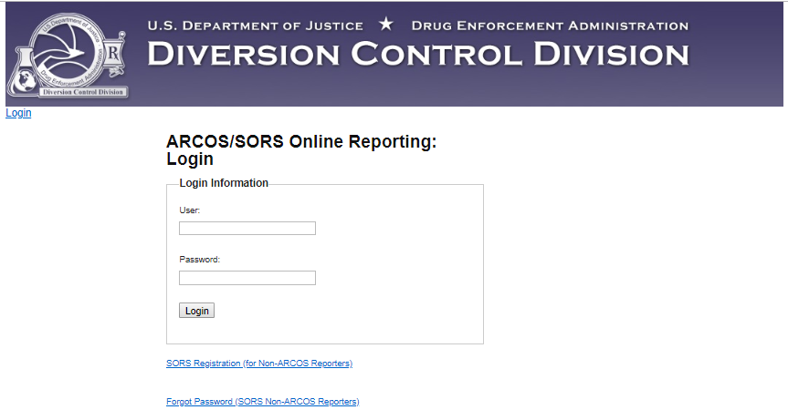
Figure 1: Login Screen
- Registration: If you are not an ARCOS Registrant and need to register for SORS, see
Section 2.1 Registration.
- Login: If you have a SORS registration, see Section 2.3 Login.
- Forgot Password: If you have forgotten your password, see
Section 2.4 Forgotten Password.
- Change Password: If you want to change your password, see Section 2.5 Change Password.
- Reports: If you want to manage or add a Report or a transaction, see
Section 2.6 Reposts/Transactions.

Registration
DEA registered individuals and organizations that are required to submit SORS Reports must register in SORS before submitting their first Report.

To register, click on the link SORS Registration (for Non-ARCOS Reporters) on the Login Screen (Figure 1). The data entry form below displays.

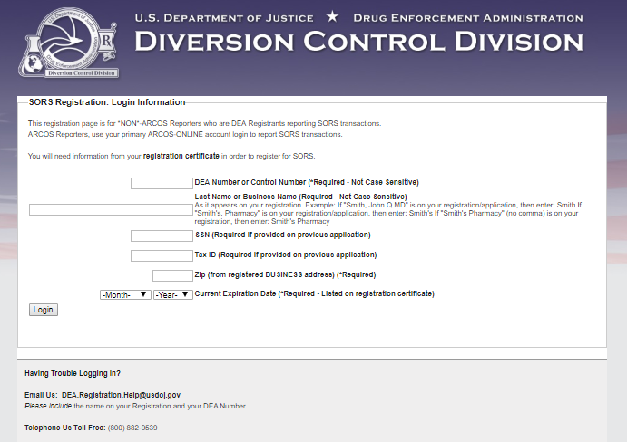
Figure 2 - Non-ARCOS SORS Registration Data Entry Form
Enter information as required. Click on Login. The figure below displays.

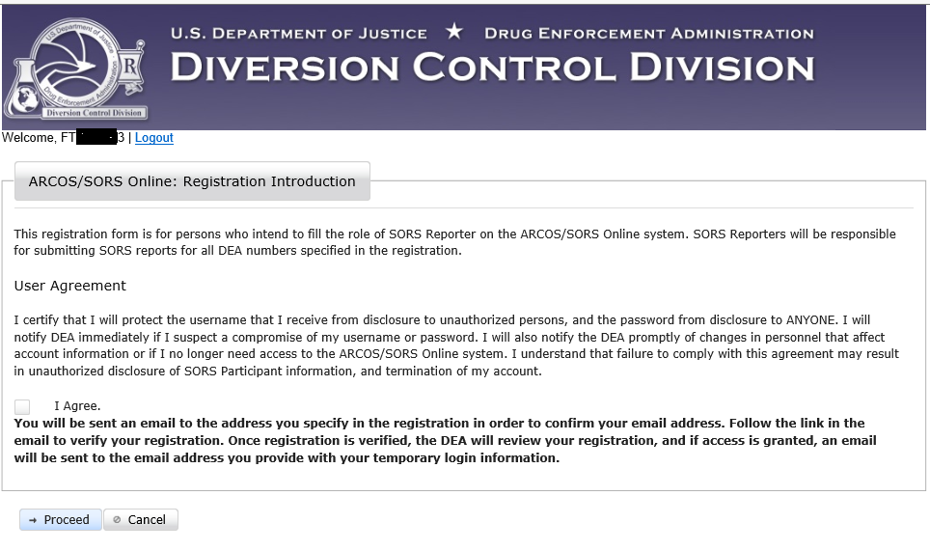
Figure 3 – SORS Reporter Registration Introduction.
Read this form and click in the checkbox to agree. Click on Proceed. The screen below displays.

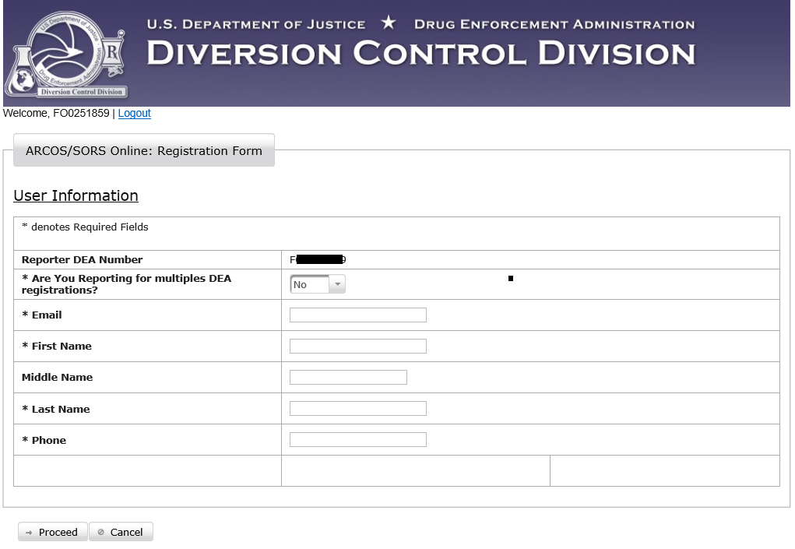
Figure 4 - ARCOS/SORS Online Registration Form
If you are registering to report for multiple DEA Registrations (i.e., a Central Reporter), click on the down arrow to display Yes. Go to Section 2.1.2
If you are registering to report for a single DEA Registration go to Section 2.1.1 below.

Registering a single DEA Registration
Enter the required information as shown in the example figure below.
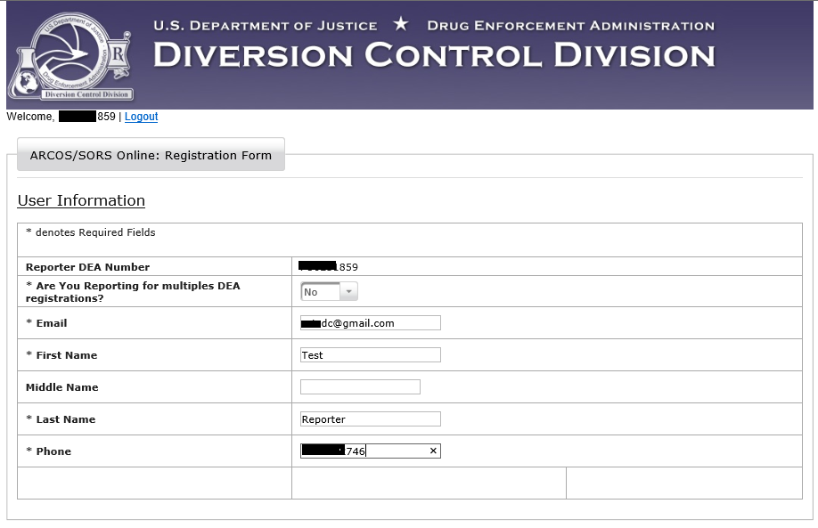
Figure 5 - Registration Form Complete
When the form is complete, click on Proceed. The screen below displays.
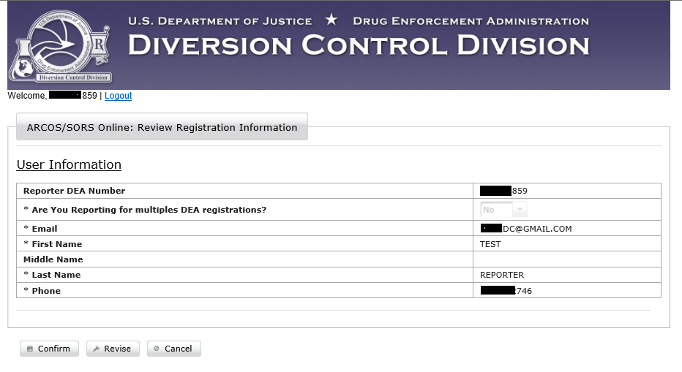
Figure 6 - Review Registration Information.
Review the information displayed. If everything is correct, click on Confirm. The screen below displays.
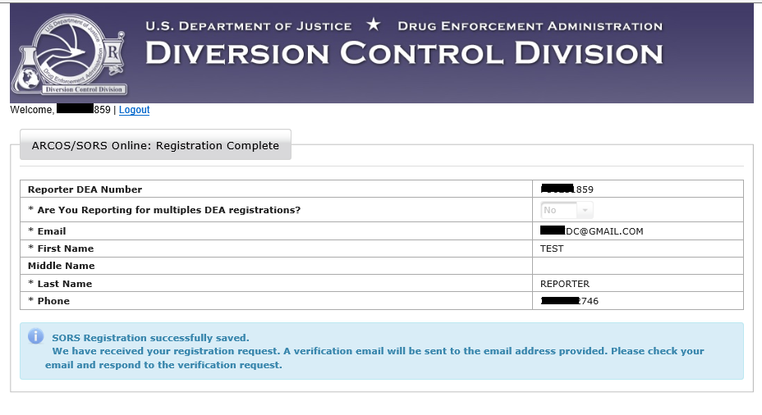
Figure 7 –Registration Complete, Check Your Email.
You will receive an email similar to the one below.
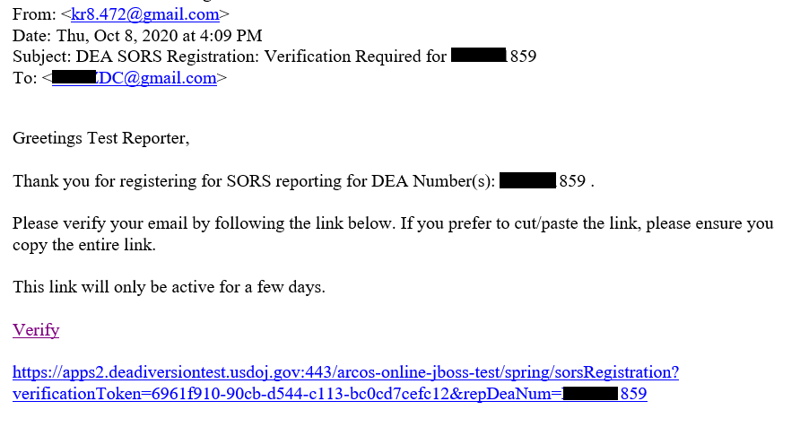
Figure 8 - Registration Approval Email
Click on the link to verify your email address. You will receive an email similar to the one below.
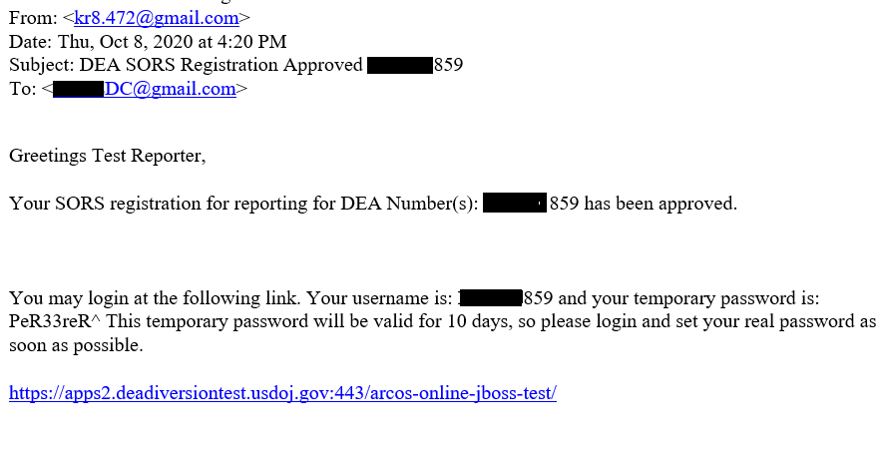
Figure 9 – Email with your username and temporary password.
The link will be different but similar. You should click on it to sign in with the temporary password and create a password to use each time you sign in.
This person is the SORS Reporter for this DEA Registration Number and that their Username will be the DEA Registration Number entered in Figure 5.
Note: This SORS Reporter may add otherindividual users to assist in the SORS Reporting function. See Section 8.1.1 Add User to Single Reporter.

Registering to report for Multiple DEA Registrations

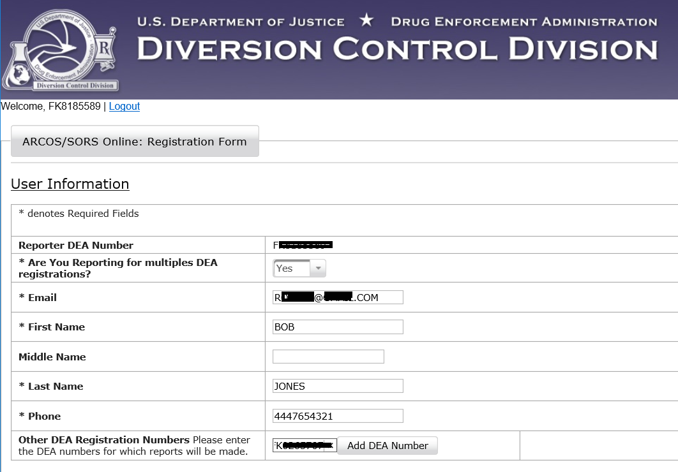
Figure 10 – Registering to report for multiple DEA Registrations.
Note: We will refer to a SORS Reporter that reports for multiple DEA Registrations as a Central Reporter.
With Yes displaying in the dropdown box, enter your email address, First Name, Last Name, Phone, number, and a DEA Registration Number for which you will also make Reports.
Click on Add DEA Number. Click on Proceed. A screen similar to the one below displays.
Note: The Add DEA Number data entry box is too small to display FK, the initial to letters of this DEA Number. In the screen below, only the F displays. The K and the remainder of this DEA Number is redacted.
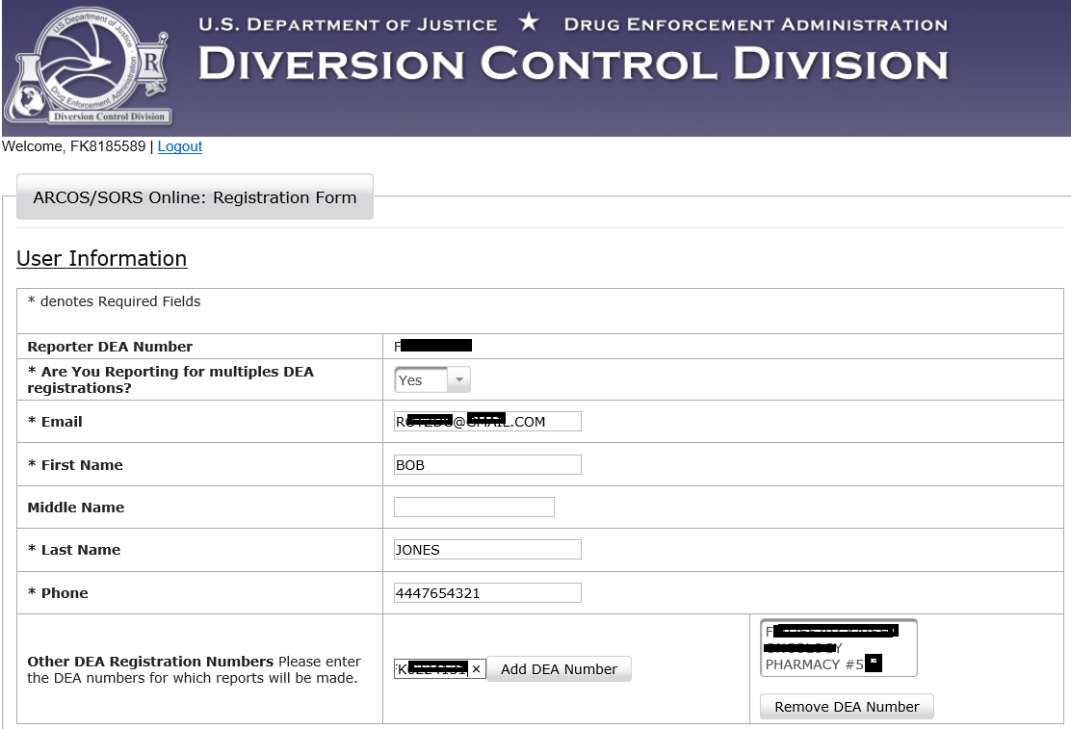
Figure 11 – A second DEA Registration added.
The second DEA Registration Number added in Figure 9 displays in the box at the bottom right of the screen above.
Add additional DEA Registrations Numbers to this SORS Reporter by repeating this procedure.
Enter the additional DEA Registration Numbers, one at a time, in the box to the left of
Add DEA Number.
Click on Add DEA Number for each one, and click on Proceed.
See the screen below.
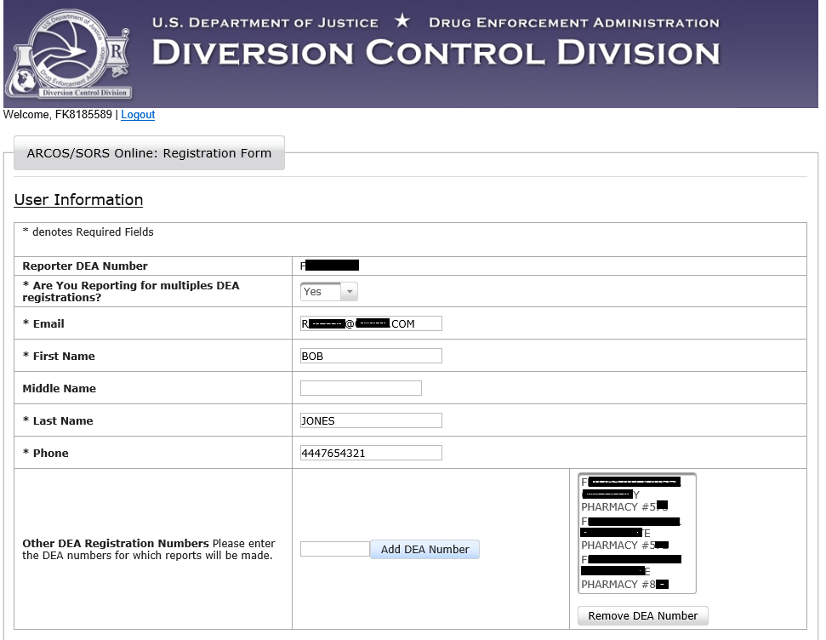
Figure 12 – Three additional DEA Registration Numbers
The screen above show the initial DEA Registration Number and three additional Registrations.
Note: If you need to remove one of the additional Registrations, click on it to highlight it. Then click on Remove DEA Number.
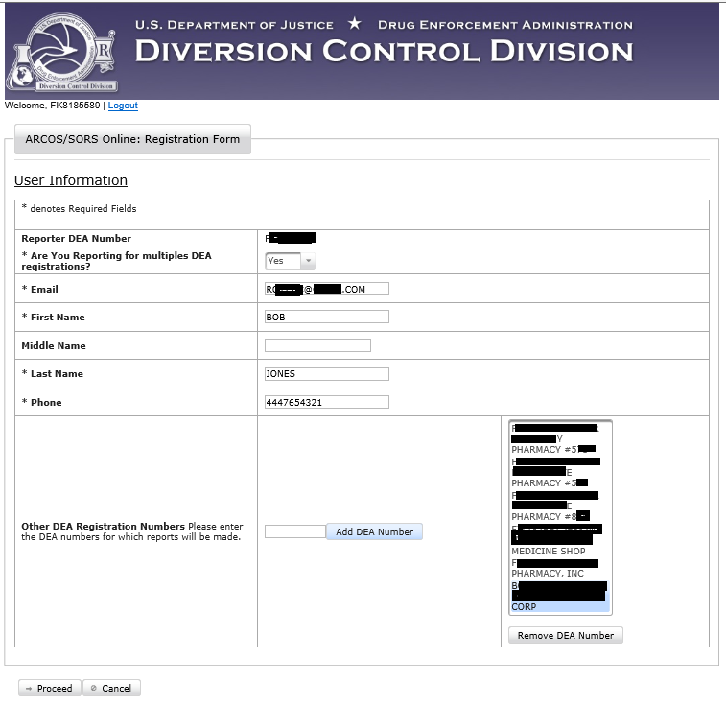
Figure 13 – Delete a DEA Registration for reporting.
The deleted DEA Registration no longer displays in the Addition DEA Number list.
See the figure below.
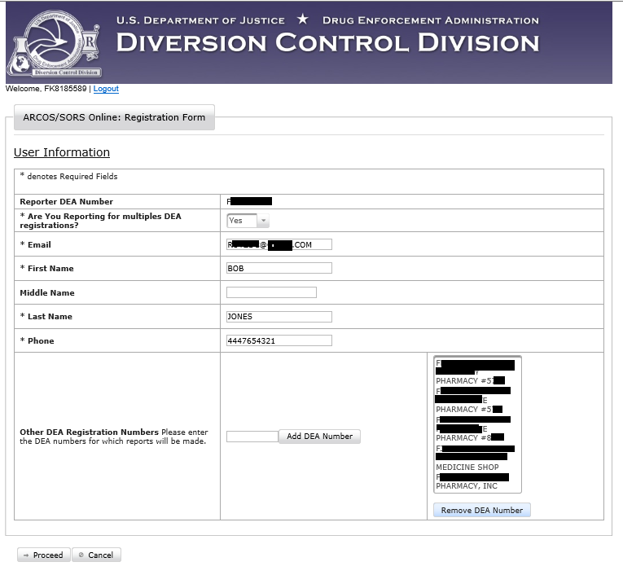
Figure 14 – Deleted DEA Number no longer displays.
If the screen displays all the Registrations you want to report for, click on Proceed.
A screen similar to the one below displays.
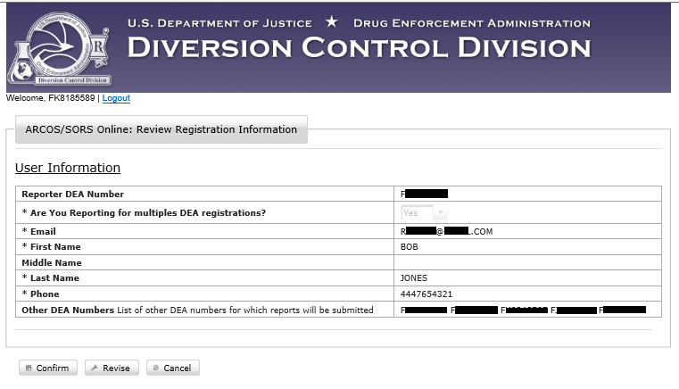
Figure 15- Review Registration Information.
Review the information displayed in the screen above.
If any information in the screen needs to be corrected, click on Revise. A screen similar to
Figure 12 displays to allow you to make corrections.
If everything is correct, click on Confirm. A screen similar to the one below will display.
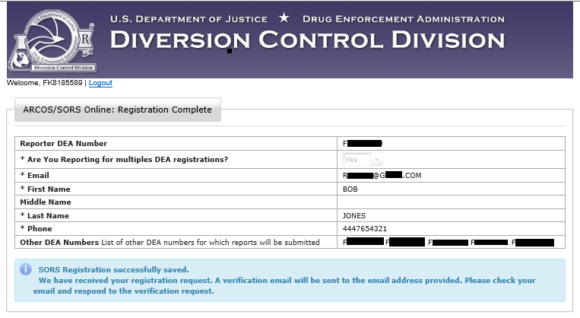
Figure 16 - SORS Registration successfully saved.

You will receive an email similar to the one below.
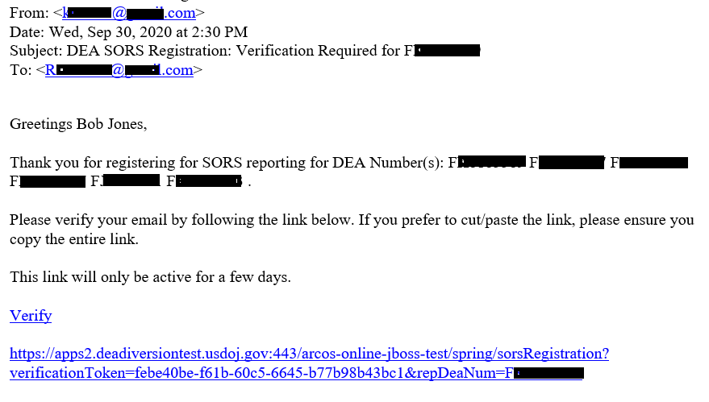
Figure 17 - Verify your email address.
Click on the link to verify your email address. The screen below displays.
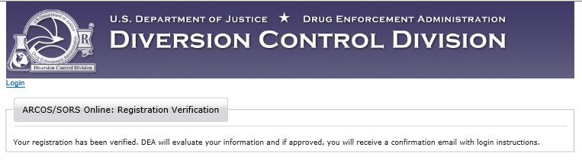
Figure 18 – Registration approval
Your registration will be evaluated. If approved you will receive an email similar to Figure 10 with login instructions including your username and temporary password
Note: This SORS Central Reporter may add individual users to assist in the SORS Reporting function. iSee Section 8.1.2 Add a User to a Central Reporter.

Users and Roles
SORS Reporters may add users to assist in the SORS Reporting Function at their organization.
All users will have either an Admin Role or a User Role. SORS Reporters will automatically have the Admin Role. When a SORS Reporters add users, they will assign each user an Admin Role or a User Role. See Section 8.1 for the procedure to add users.
An Admin can make Reports and add users at their organization. An Admin will assign these additional users an Admin Role or a User Role. Those with a User Role will only be able to make Reports.

Login/Main Menu
To open the Login Page, see Section 2.0
Figure 19 - Login Page
Enter your username and password. When you click on Login, the Main Menu will display below.
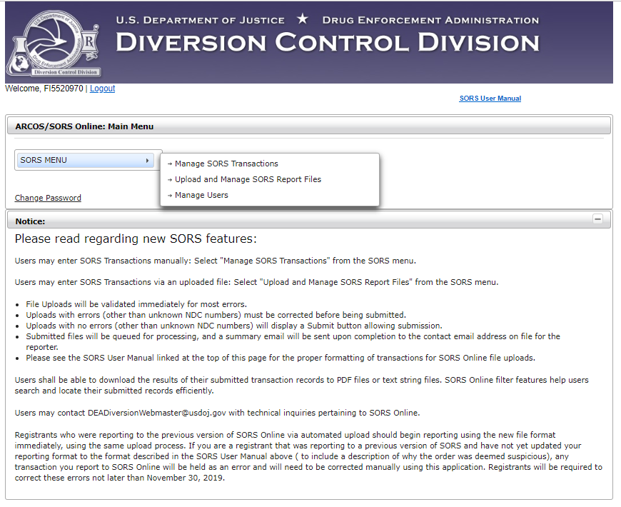
Figure 20: SORS Main Menu for a SORS Reporter and or a user assigned the Admin Role.
Note: The User Role will not have the Manage Users function on its Main Menu below.

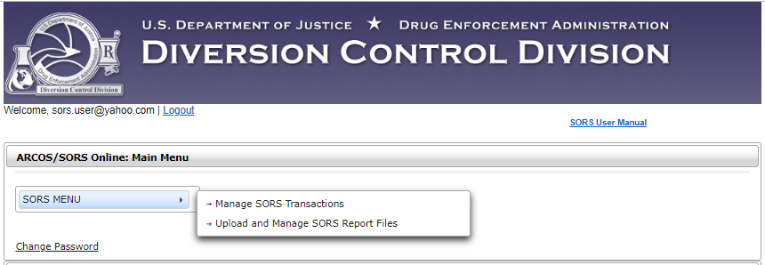
Figure 21 - SORS Main Menu for the User Role
- Click on Manage SORS Transactions, and the Manage SORS Transactions Screen will display. See Section 4.0 Manage Individual Transactions.
- Click on Upload and Manage SORS Report Files, and the Upload SORS Report Screen will display. See Section 6.0 Upload Report Files
- Click on Manage Users and the Manage Users Screen will display.
See Section 8.0 Manage Users.

Forgotten Password
If you have forgotten your password, click on the Forgot Password (SORS Non-ARCOS Reports) link on the Login page below.
Figure 22 - Login Page
The SORS Password Recovery Page displays below.
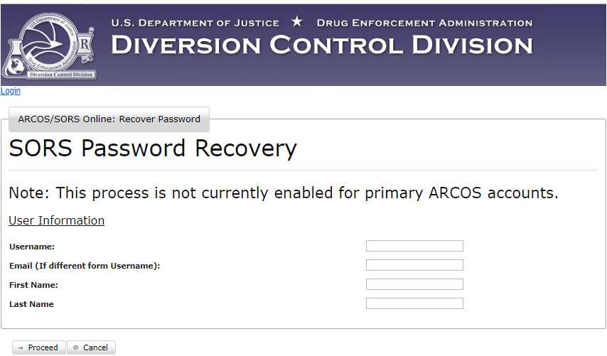
Figure 23 - SORS Password Recovery
Enter the required information. You will receive an email with the title: ARCOS/SORS Reset Password Notice. It will contain text with a link similar to the one below to reset your password.
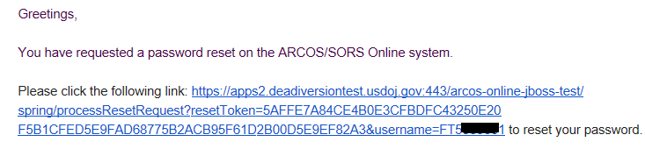
Figure 24 - Reset Password Email
Click on the link. A change password screen will display to allow you to set a new password.
Click on Proceed and a screen with a banner confirming successful password reset will display.

Change Password
On the Main Menu once you have logged in, click on the Change Password link. (Figure 20 or
Figure 21) The Change Password Screen displays below.
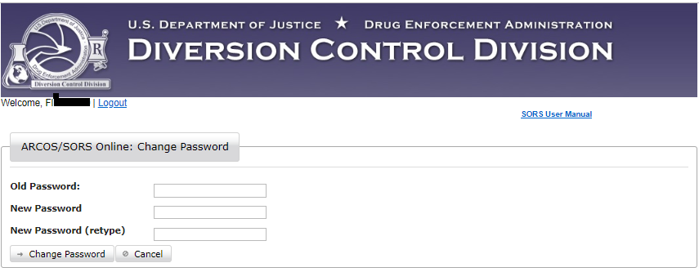
Figure 25 – Change Password Screen
Enter your old password and then the new password and retype it. Click on Change Password.
The screen below will display.
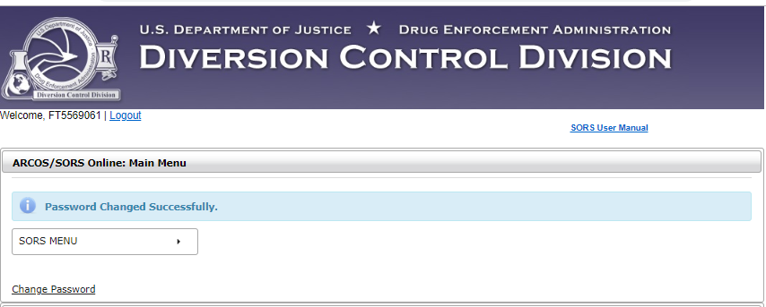
Figure 26 - Password Changed

Reports/Transactions

A transaction will contain information about the transfer of a single controlled substance between two DEA Registrants. See Section 4.0 Manage Individual Transactions
Section 4.1 explains how to report a transaction.
Section 4.2 explains how to amend a reported transaction.
Section 4.3 explains how to with withdraw a reported transaction.
Note: A reason is required when amending or withdrawing a transactiont.
A Report will contain the details of multiple transactions.

Transaction Filters
The SORS Online application has a filter capability to allow you to sort through a large volume of transaction records to efficiently find a specific record. This section details the different filtering options.

On the SORS Main Menu , click on Manage SORS Transactions.

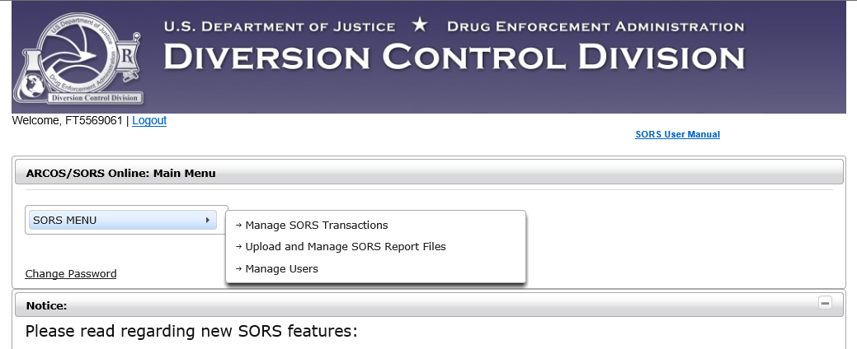
Figure 27 – SORS Main Menu

The Manage SORS Transaction Screen displays below.

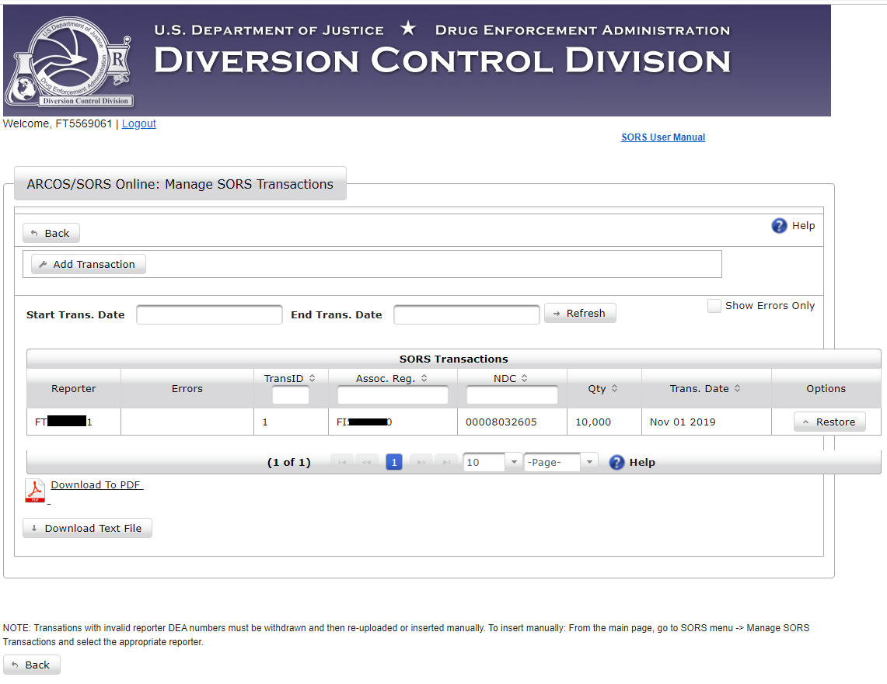
Figure 28 - Manage SORS Transactions Screen
The filtering capability is accessed on the Manage SORS Transactions Page above. The use of the filters is described below. Filtering operates the same for all users.

Note: Only those transactions reported by you (a SORS Reporter) or by users you added to the system (see Section 8.1 Add User) will display. In the above example, only one transaction has been reported.

Dates
Transaction information can be filtered by dates.
Figure 29: Filter Dates
- Click on the Start Trans. Date field. A calendar and time tool will display.
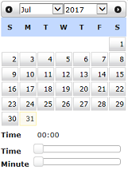
Figure 30: Calendar Tool
- Navigate to the start month using the dropdowns. Click on the start date. The date will populate the field. Repeat for the End Trans. Date field.

- If necessary for the start or end date, click on the Time bar, and scroll to adjust the hour filter to the specific time or time range to search.

- If necessary for the start or end date, click on the Minute bar, and scroll to adjust the minutes filter to the specific time or time range to search.

- Click on Refresh. Those transactions within the date/time range you entered will display, one transaction per row.

- If you enter a date in the Start Trans. Date field and leave the End Trans. Date field blank and click Refresh, all transactions from the Start Trans. Date to the most recent transaction will display.
- If you leave the Start Trans. Date field blank and enter a date in the End Trans. Date field and click Refresh, all transactions from the earliest transaction until the End Trans. Date will display.
- Clear both date fields, click on Refresh, and all entered transactions will display.

Column Heading Filters
The blank fields beneath a column heading is used to filter transaction records.
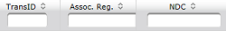
Type an NDC in its blank field, and all transaction records with that NDC will display on a screen similar to the one below.
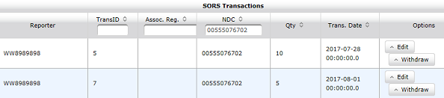
Figure 31: Column Search Field Example
Type an Assoc. Reg. number in its blank field, and all transaction records with that Assoc. Reg. number will display.
If you know the Transaction ID you can enter it in the TransID field. That transaction will display as a single line.
Note:

Wild Cards

Column Arrows
Click the (arrows symbol) within a column heading to rearrange the order of the data within the column. The first time you click on the lowest value in that column will appear at the top. Click on again and the highest value in that column will appear at the top. Additional clicking on the will toggle the display of information between the two states.

Show Errors
Transaction data that are uploaded may display errors. Errors can be filtered by clicking in the Show Errors Only checkbox. Only transactions with errors will display.

Manage Individual Transactions
On the SORS Main Menu, click on Manage SORS Transactions.

Figure 32 – SORS Main Menu

The Manage SORS Transaction Screen displays below.

All previously submitted transactions will display below or on following pages.
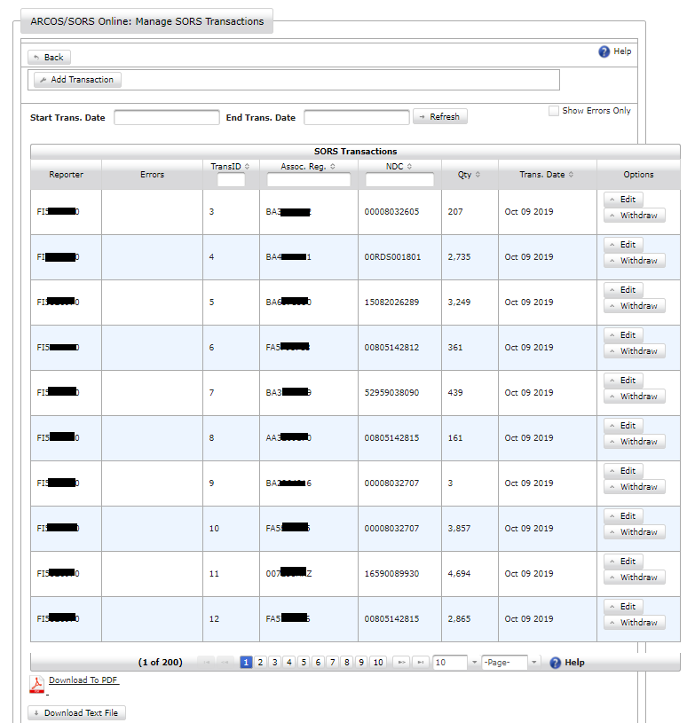
Figure 33 - Manage SORS Transactions Page
Each row displays the basic information of a transaction.

Note: Only those transactions reported by you (a SORS Reporter) or by users you added to the system (see Section 8.1 Add User) will display.

The Manage SORS Transaction Page allows you to access the following transaction activities:

- Add an individual transaction
- Edit an individual transaction
- Withdraw an individual transaction

Add a Transaction
On the SORS Main Menu (Figure 26), click on Manage SORS Transactions.

The Manage SORS Transaction Screen displays. (Figure 27 above)

Click on Add Transaction. Transaction fields will display.
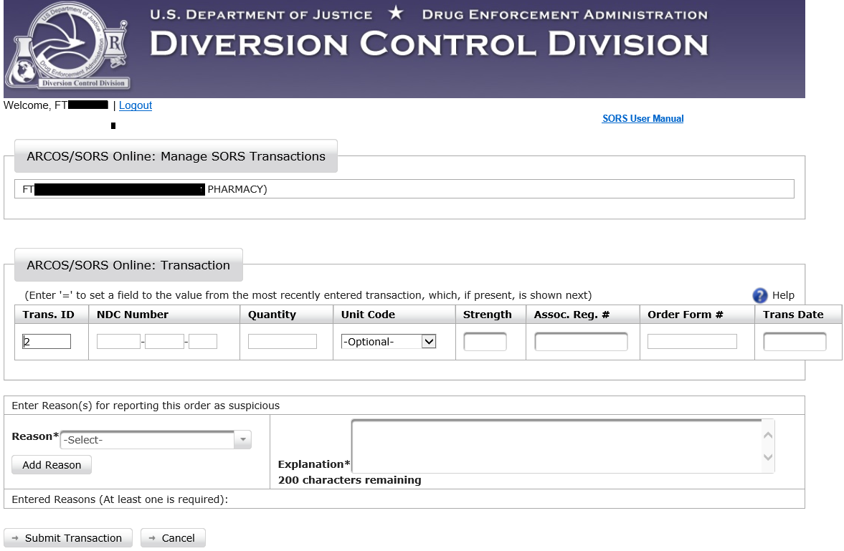
Figure 34: Transaction Fields Display
- Enter transaction information into the blank fields. If an NDC number is not in the system, you will see an option appear to add a temporary NDC number entry.
See Section 7.1 for more information about new NDCs.
Click the Help icon for additional guidance.
- Click on Submit Transaction. A confirmation message will display and the transaction will be added to the system.
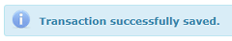
An alert with correction information will display if an adjustment(s) needs to be made to the data.
- Additional transactions may be added to the Report by clicking Add Transaction on the Manage SORS Transactions Page. (Figure 27)

- Click on Back to return to the Manage SORS Transactions page. The newly submitted transaction line item will display.
Note: When entering another transaction, the “=” symbol can be entered in a field(s) to repeat a value(s) from the previous transaction. Furthermore, entering “=” in the first (5-digit) field of the NDC Number will fill in the entire NDC number field.
Once a transaction is created (and hasn’t been withdrawn), it will remain in the system, available to be filtered and viewed. See Section 3.0, for filter information.

Edit a Transaction
On the SORS Main Menu (Figure 33), click on Manage SORS Transactions.

The Manage SORS Transaction Screen displays below.

SORS Online allows you to make edits to transactions.
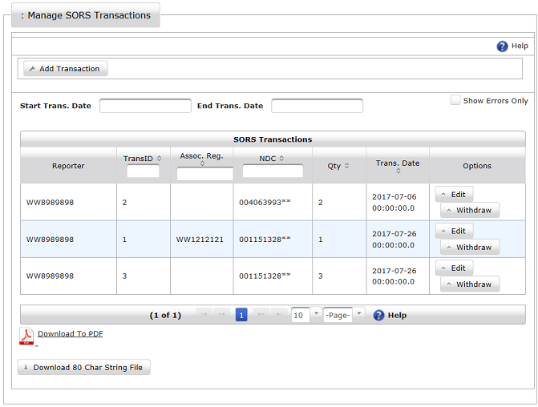
Figure 35: Manage SORS Transactions Page
Click on Edit above for the preferred transaction. The requested transaction page will display.

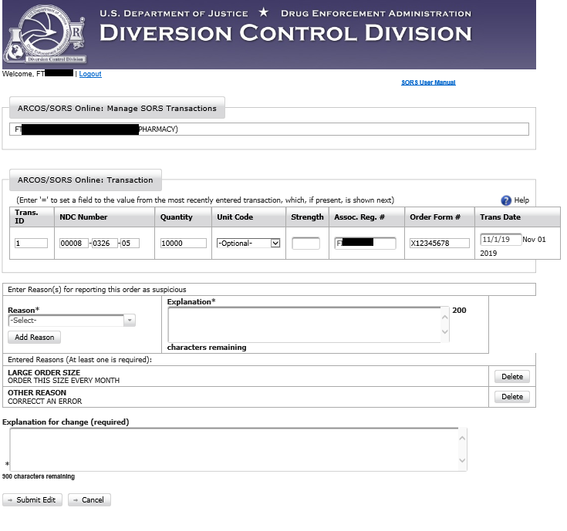
Figure 36: Report Available for Edits
- Make necessary edit(s) to the selected transaction.

- Provide an explanation for the change(s) in the available field. This is required.

- Click the Submit Edit button. A message will confirm the submission.

Withdraw Transaction
A Report transaction that was entered can be withdrawn from the Report.
On the SORS Main Menu (Figure 20 or Figure 21), click on Manage SORS Transactions.

The Manage SORS Transaction Screen displays. (Figure 35)

- On the SORS Transaction screen, click on Withdraw for the desired Report. The requested transaction page will display below.

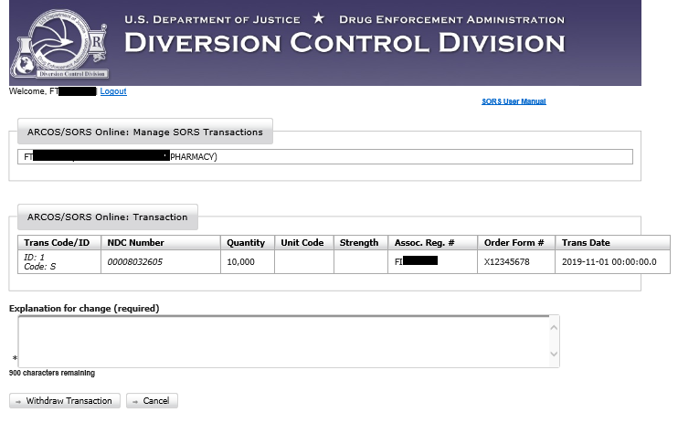
Figure 37: Withdraw a Transaction

- Enter the required explanation in the Explanation for change field . This is required.

- Click on Withdraw Transaction. The transaction will be withdrawn with the opportunity to be reinstated by clicking on Restore.

Download Reports
Figure 38 – Manage SORS Transactions Page

Download to PDF
Reports can be downloaded to PDF files.
- On the Manage SORS Transactions page (above), click on the Download To PDF link.

- The popup below displays at the bottom of your screen
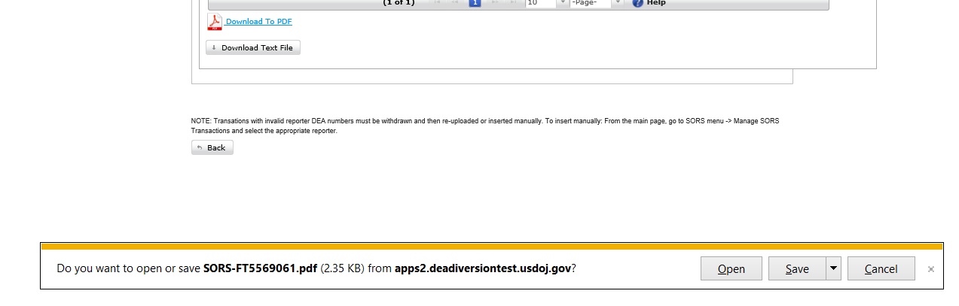
Figure 39 – Download to PDF popup
- Click on the down arrow next to Save.

- The popup below displays.
Figure 40 – Save PDF popup
- In the popup above, click on Save to save the file name shown to the download file or click on Save as to allow you to rename the file and or specify where the file is to be saved.

Download Text File
Reports can be downloaded to text files.
- On the Manage SORS Transactions page (Figure 32), click on Download Text File.
- The popup below displays at the bottom of your screen
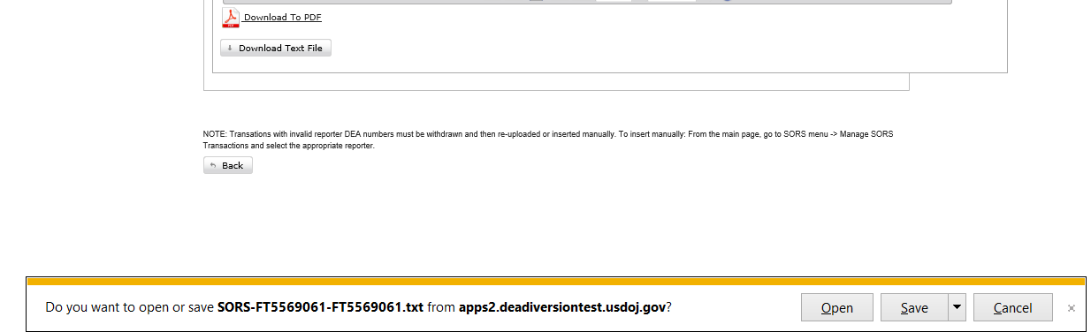
Figure 41 – Download to Text File popup
- Click on the down arrow next to Save.
- The popup below displays.

Figure 42 – Save as Text File popup
- In the popup above, click on Save to save the file name shown to the download file or click on Save as to allow you to rename the file and or specify where the file is to be saved.

Upload Report Files
Report Files contain information about multiple transactions.
The files must be .txt files and must follow the format explained in Section 6.5 below.
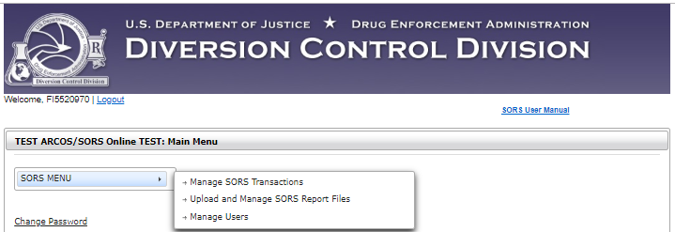
Figure 43: Upload SORS Report Files Options on the Main Menu
- Click on Upload and Manage SORS Report Files on the Main Menu. The Upload SORS Report page will display below.

Note: DEA Registration numbers are redacted.
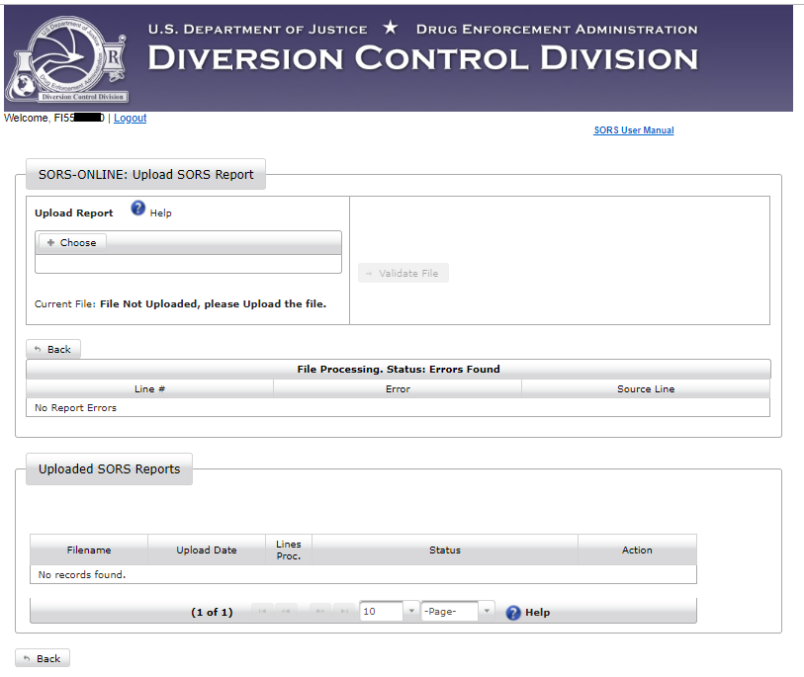
Figure 44: Upload SORS Report
- Click on Choose. A screen will open to allow you to navigate to the desired file.
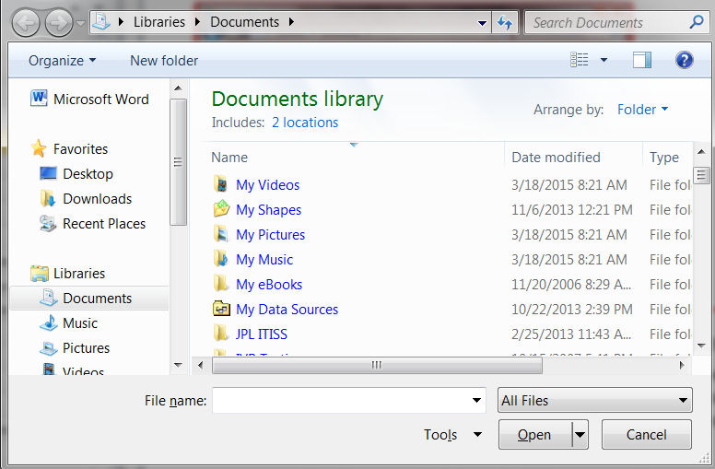
Figure 45: Choose File
- Click to select the file. The file name will display in the “File name” field.

- Click on Open. The system will upload the selected file. The name of the file will now display below Choose.
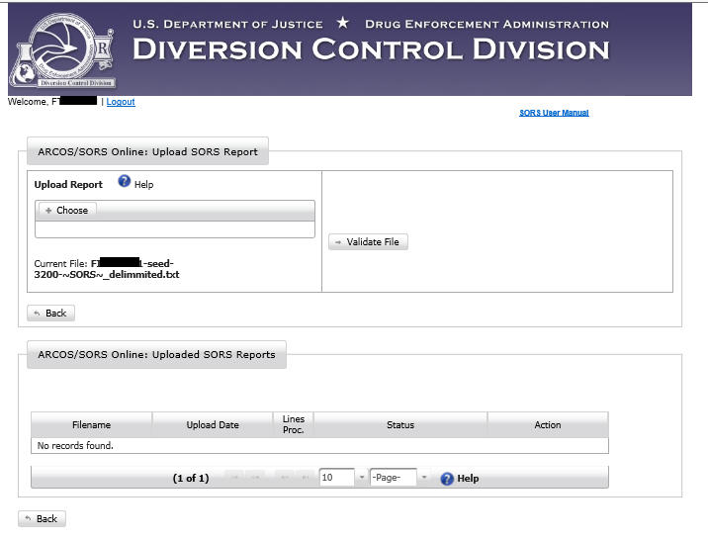
Figure 46 – Validate File
- The next step is to click on Validate File to check it for errors.
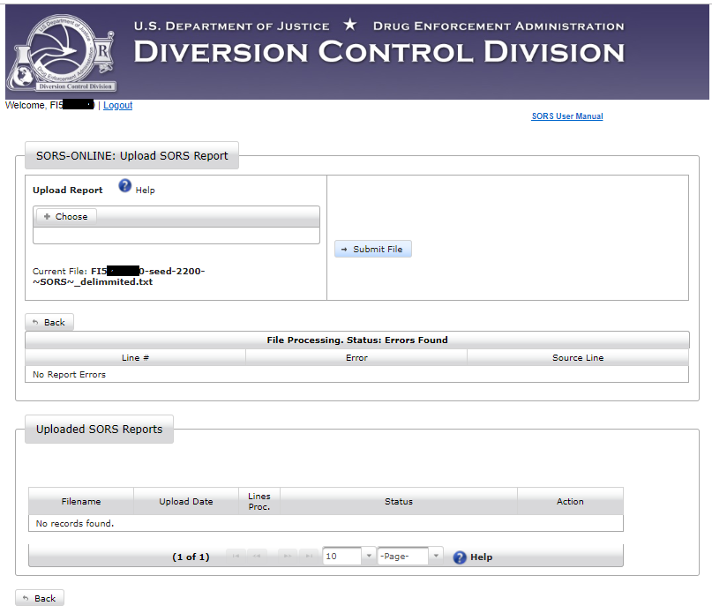
Figure 47 - Submit File
- If no errors are found, Validate File will change to Submit File. Click on this button to proceed. A screen similar to the one below will display.

Note: If there are errors, a screen similar to that in Section 6.4 below displays.
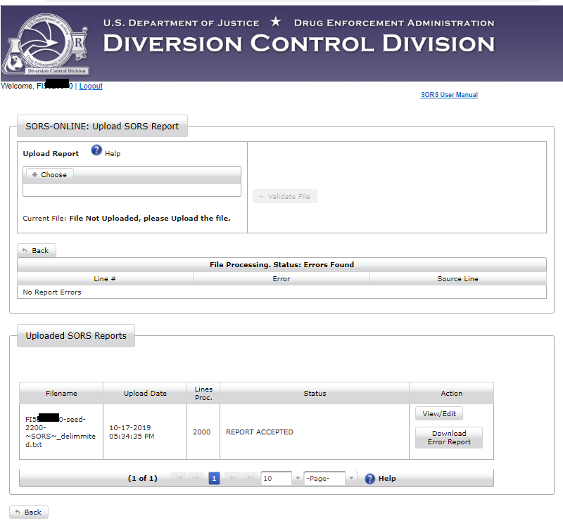
Figure 48 - File Uploaded

Download Error Report
Click on Download Error Report in the figure above. A text file similar to the one below will display. As there are no errors, in this case the Report acts as a transmittal receipt.

DATE: 10/24/19 DEPARTMENT OF JUSTICE
DRUG ENFORCEMENT ADMINISTRATION
SORS ERROR REPORT
SORS TRANSACTIONS PROCESSING
FI5XXXXX0
File: FI5XXXXX0-seed-2200-~SORS~_delimmited.txt
Uploaded: Thursday, October 17, 2019 - 5:34PM
TOTAL INPUT RECORDS = 2001
TOTAL ERROR RECORDS = 0
Input Data | Error Codes

View/Edit
Click on View/Edit in Figure 42. A screen similar to the one below displays.
Figure 49 - Manage SORS Transactions
The SORS Online application has a filter capability to allow you to sort through a large volume of transaction records to efficiently find a specific record. (See Section 3.0)

Click on the Edit button for a transaction. A screen similar to the one below displays.
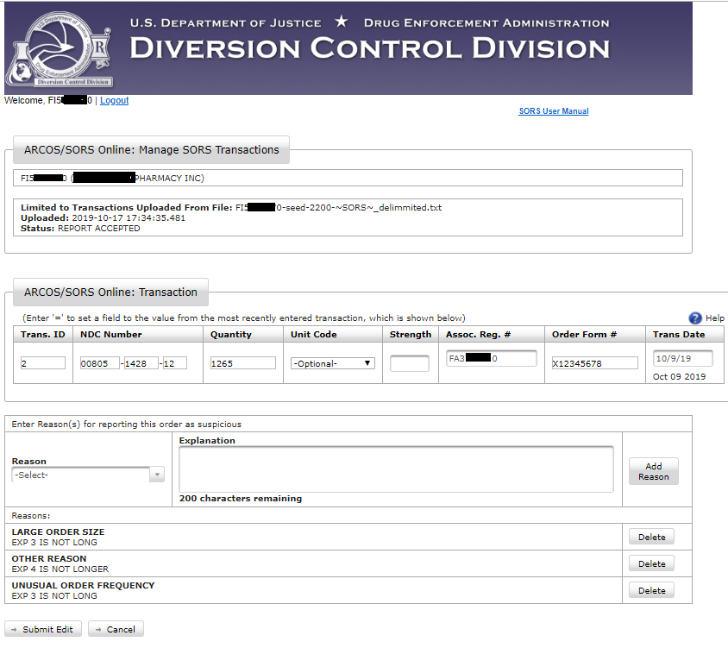
Figure 50 - Edit Uploaded Transaction.
Make the necessary edits. Then click on the Submit Edit button. The transaction will redisplay in a screen similar to Figure 49, but its location on the screen may change.

Withdraw a Transaction
Click on the Withdraw button in Figure 43 and the screen below displays.
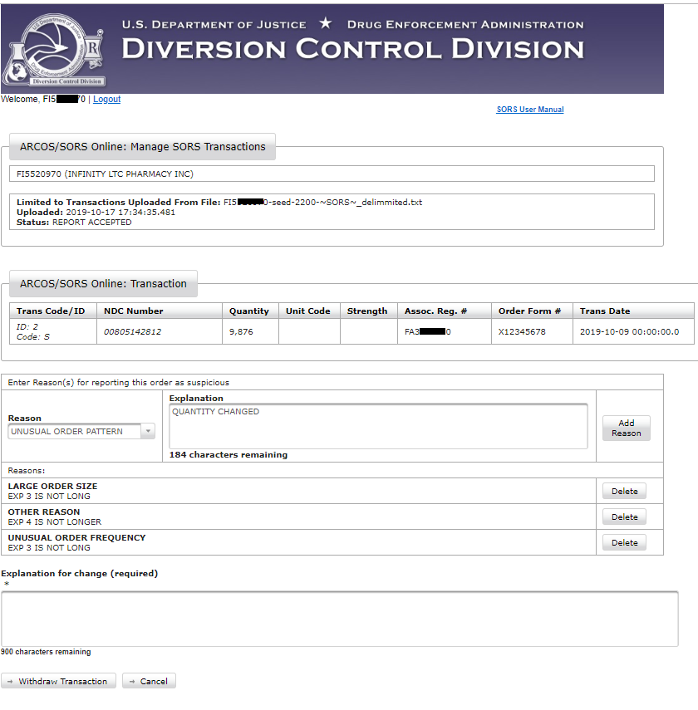
Figure 51 - Withdraw a Transaction
Carefully review the data displayed above to confirm this is the transaction you want to withdraw.
If you confirm the desired transaction, click on the Withdraw Transaction button.
Figure 49 will redisplay with the Edit and Withdraw buttons replaced with a Restore button. Again, the transaction my display on screen in a different location.

Report with Errors
If errors are detected when uploading a SORS Report file (see Section 6.0), a screen similar to the one below displays.
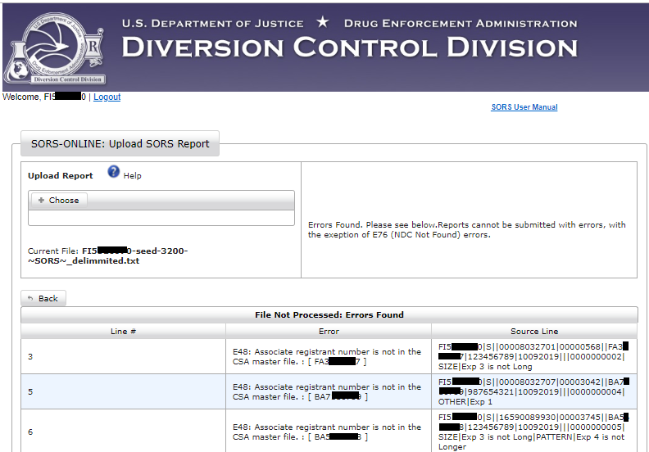
Figure 52 -SORS Report with errors (top)

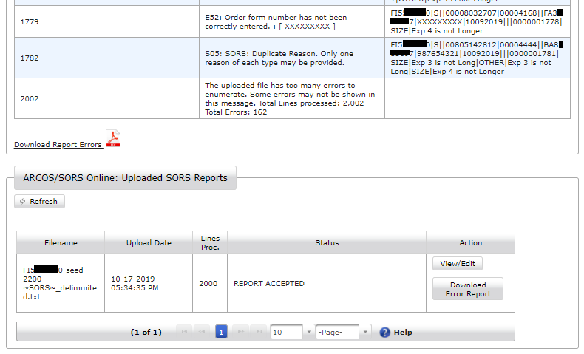
Figure 53 - SORS Report with errors (bottom)
Clicking the Download Error Report button will download a PDF of the screen above showing errors.

Formatting of Transactions for SORS Online File Uploads

SORS pipe delimited text file format with reasons
Filename:
Must contain “~SORS~” in the file name not including the double quotes
Header Format:
Column | Element | Example | Required | Notes
0 | Data Type | SORS | Y | Always SORS
1 | Reporter DEA No | AA1234567 | Y | Must be a reporter associated with the user uploading the file
2 | Report Date | 03212019 | Y | MMDDYYYY
Example
SORS|AA1234567|03212019
Transaction Format:
Column | Element | Example | Required | Notes
0 | Reporting Registrant DEA No | AA1234567 | Y
1 | Trans Code | S | Y | Always S
2 | Action Indicator |  |  | Always Empty
3 | NDC Number | 12345121234 | Y
4 | Quantity | 1256 | Y | Must be greater than 0, maximum 8 digits, no commas
5 | Unit Code | 1 |  | Arcos Allowed Unit Code, NDC dependent. Unit Codes below.
6 | Buyer DEA No | AA9876543 | Y
7 | DEA Order Form No | 123456789 | Y* | Required for schedule 1, 2, 2n drugs
8 | Transaction Date | 09272019 | Y | MMDDYYYY
9 | Correction Number | W1234567 |  | For correcting errors
10 | Strength | 1000 |  | Must be four digits, left pad with 0. Percentage. Implied decimal after third digit, e.g. 1000 = 100.0%, 0074 = 7.4%
11 | Transaction ID | 123456 |  | Maximum 10 digits
12 | First REASON Code | 1 | Y | Reason Codes are below. Must be a valid reason code
13 | First REASON Explanation | Explanation of why this order is suspicious for this reason code | Y | Explanation limited to 200 characters
14 | Second REASON Code | 3 |  | Optional
15 | Second REASON Explanation | Explanation of why this order is suspicious for this reason code | Y* | Required if reason code given  Explanation limited to 200 characters
16 | Third REASON Code | 4 |  | Optional
17 | Third REASON Explanation | Simple explanation of why this order is suspicious for reason code given | Y* | Required if reason code given  Explanation limited to 200 characters
18 | Fourth REASON Code | 2 |  | Optional
19 | Fourth REASON Explanation | Simple explanation of why this order is suspicious for reason code given | Y* | Required if reason code given  Explanation limited to 200 characters

Examples
AA1234567|S||52959038090|00002440||004978IEZ|X12345678|09272019|||0000000008|1|Explanation 1 goes here
FB0987644|S||52959038090|00001546||BA8220991|123456789|09272019|||0000000030|3|Explanation 1 |2|Explanation 2 |1|Explanation 3 |4|Explanation 4 goes here

Note: Unit and Reason Codes listed on next page.

Unit Codes
CODE | DESCRIPTION
1 | MICROGRAM
2 | MILLIGRAMS
3 | GRAMS
4 | KILOGRAMS
5 | MILLILITERS
6 | LITERS
D | DOZEN
K | THOUSANDS

Reason Codes
CODE | DESCRIPTION
1 | LARGE ORDER SIZE
2 | UNUSUAL ORDER FREQUENCY
3 | UNUSUAL ORDER PATTERN
4 | OTHER REASON

Additional Information

New NDCs
If you enter an NDC in a transaction that the system does not recognize, you will be prompted to have it added to the system as a temporary NDC. The temporary NDC will be verified by DEA. Although transactions with temporary NDC entries will be accepted, they will generate errors which must be corrected if the NDC has not been accepted by the ARCOS system at the time the Report is submitted.
The screenshot below displays the Add NDC button that appears when an NDC Number is entered and is not recognized by SORS Online.
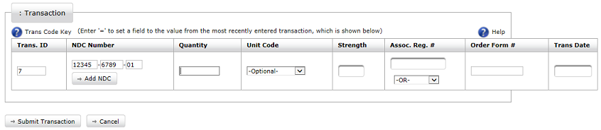
Figure 54: Add NDC Button
- Click Add NDC to request that the new NDC be added to the system. The Add NDC Form page will display below.

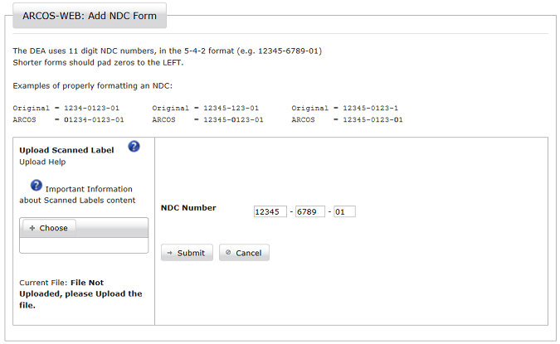
Figure 55: Add NDC Form
- A PDF of a scanned NDC label or a PDF that provides product information must be uploaded. Click the Choose button. A screen will open allowing you to navigate to the PDF.
Figure 56: Navigate to PDF
Figure 51 below displays guidance in uploading a PDF scanned label for the new NDC.
If a scan of the label for the new NDC is not possible, Figure 58 provides guidance of the alternative PDF.
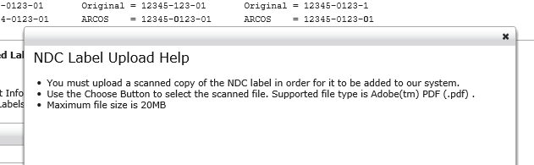
Figure 57 – NDC Label Upload Help

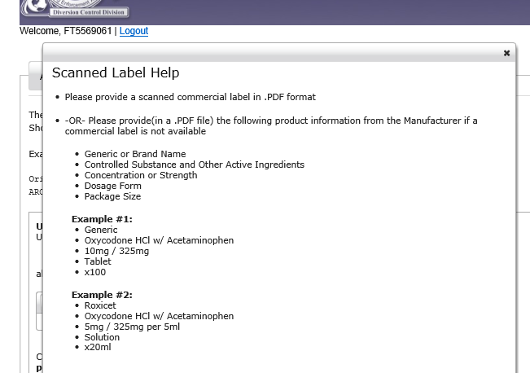
Figure 58 – Format of a file uploaded in lieu of a NDC label.
- Locate and click on the PDF file. .

- Click the Open button. A successful file upload message will display.
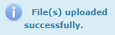

- Click Submit to send the drug information to DEA. A successful NDC entry message will display.
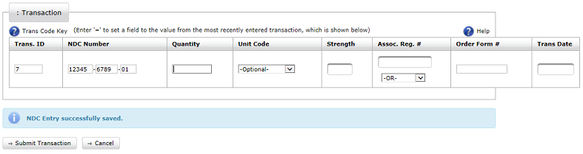
Figure 59: NDC Confirmation
- Complete the transaction fields and click the Submit Transaction button. See Section 4.1 for more information.

Central Reporter
Central Reporters that manage multiple registrant accounts can submit and manage transaction information through SORS Online. A Central Reporter account with SORS Online is required.
See Section 2.1.2.
- Log in to SORS Online as described in Section 2.3. The Main Menu page will display.

- Click the SORS Menu option. Two options will display.
Figure 60: SORS Menu Options
- Select Manage SORS Transactions. Each registrant account that the Central Reporter is responsible for will display.

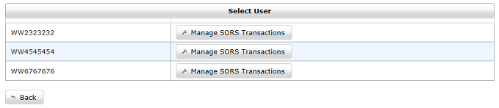
Figure 61: Registrant Accounts for Central Reporter
- Click Manage SORS Transactions of the preferred registrant. The transaction page for that registrant will display.

- At this point, the Central Reporter section within SORS Online operates like an individual registrant. Follow the previous sections of this User Manual for guidance as necessary.

Manage Users
This section is only applicable to SORS Reporters or those individuals having an Admin Role. All persons with the SORS Admin role can perform any of the functions described in this section..

Only a user with the SORS Admin Role will see Manage Users option on the Main Menu below
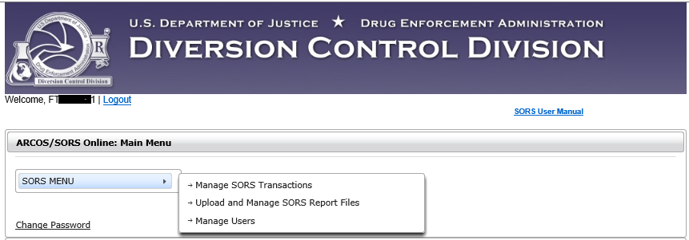
Figure 62 - Main Menu for Admin Role
Clicking Manage User on the Main Menu will display the Manage Users Page. The first time an organization registers for SORS, only the SORS Reporter, who registered in Section 2.1 will display in the Manage Users Page as shown below.
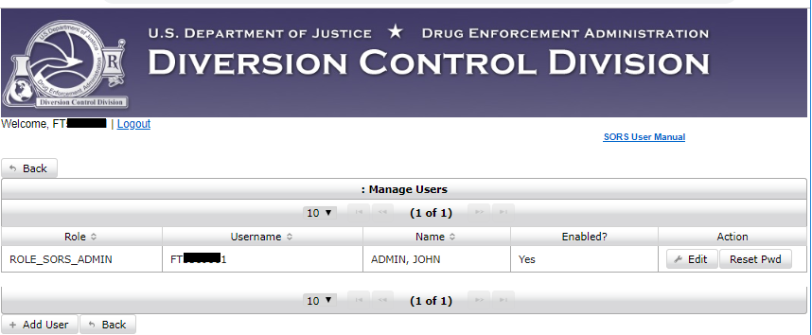
Figure 63 - Initial Manage Users Page

Add User
The SORS Reporter may add users to assist with making Reports for their organization.
To add a user, click on + Add User in the Manage Users Page above.
- If you report for a single registrant, go to Section 8.1.1 below.
- If you are a Central Reporter and report for multiple DEA Registrants,

Add User to Single Reporter
The blank form below displays.
Note: As shown below, the role of SORS User or SORS Admin is assigned on the Add/Edit User Form. Also, the term “Individual” may be used to describe an action applicable to both roles.
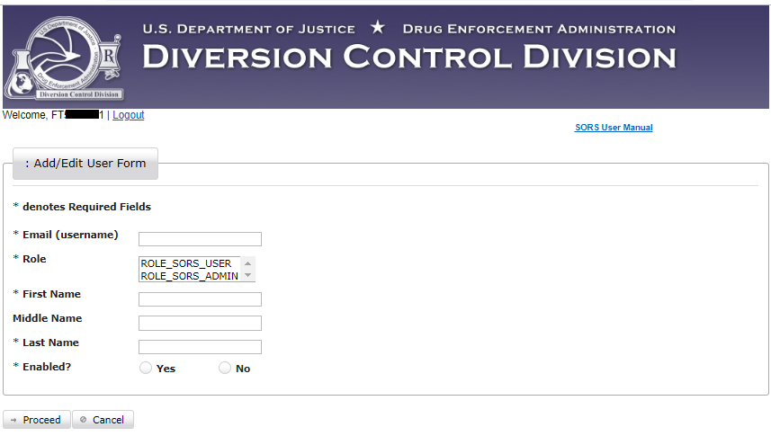
Figure 64 – New User Add/Edit User Form
In this form the Admin clicks on either ROLE_SORS_USER or ROLE-SORS_ADMIN to assign the role. Also, the Admin will click in the Yes radio button to enable the Individual. If the Admin clicks in the No ratio button, the Individual will not be enabled. See Section 8.3 Adding a Not Enabled User.
Below is an example of adding a new Admin User.
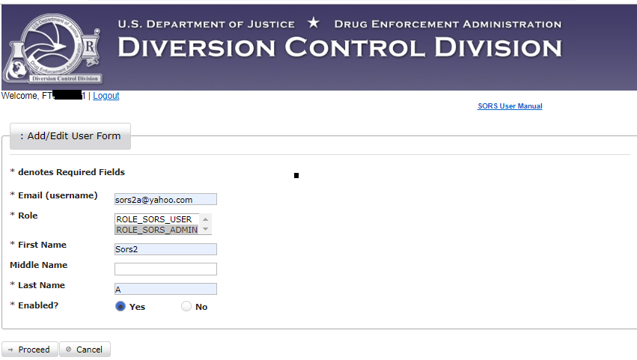
Figure 65 - Example New Admin
Having a second Admin user provides a backup capability if the other admin is not available.
Click on Proceed and the screen below displays.
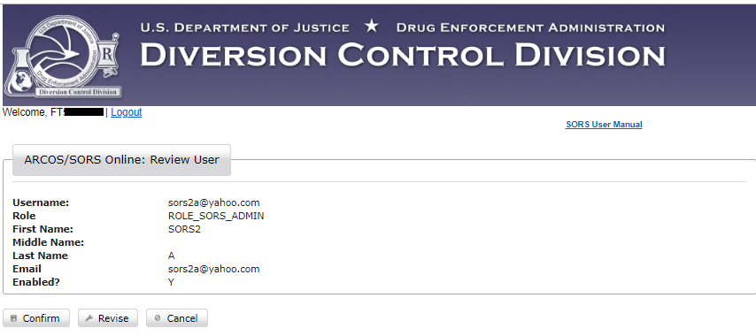
Figure 66 - Review User Information
Review the information displayed above. If everything is correct, click on Confirm. The screen below displays.
If anything above needs to be changed, click on Revise. A screen similar to Figure 46 to enable editing.
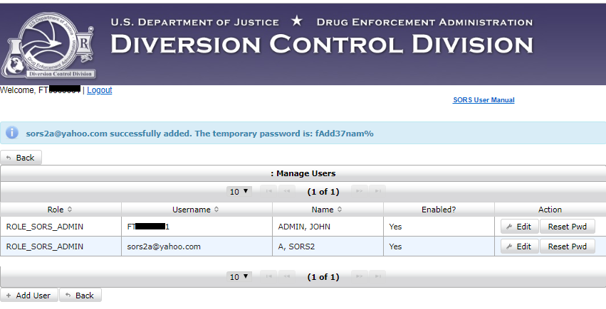
Figure 67 - New Admin User Displays

Add a User to a Central Reporter
Note that Central Report XXNNNN859 is registered to report for six additional DEA Registrants.
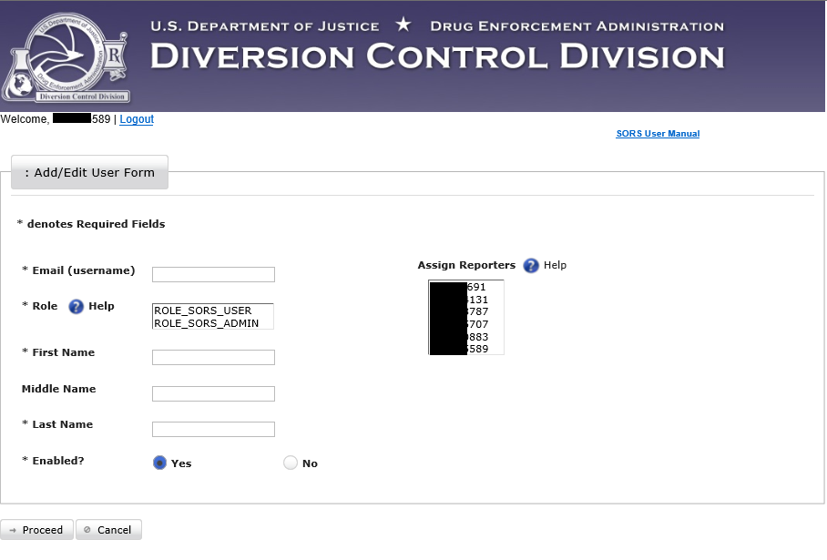
Figure 68 – Add/Edit User Form for Central Reporter XXNNNN859.

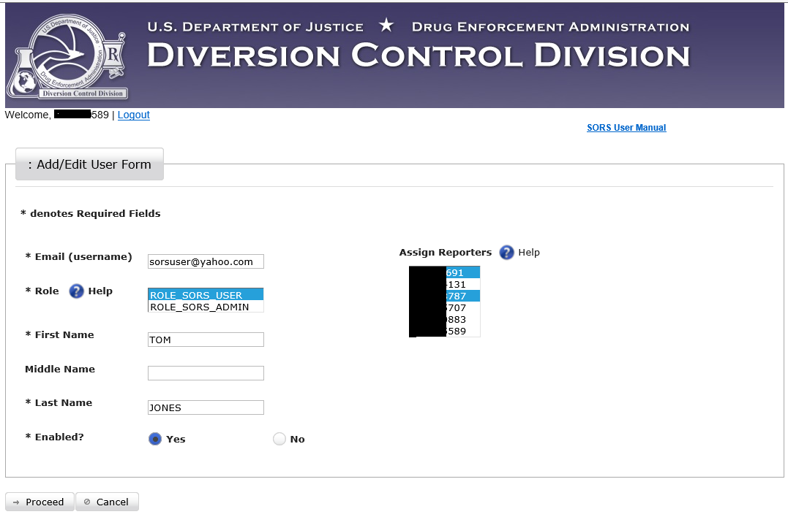
Figure 69 – Add user with authorization to report for two DEA Registrants
In this example, Central Report XXNNNN859 is adding the new user Tom Jones, with reporting authority limited to the two highlighted DEA Registrants. The new user is assigned the User Role. The new user could be assigned the Admin Role.
Click on Proceed. A screen similar to the one below displays.
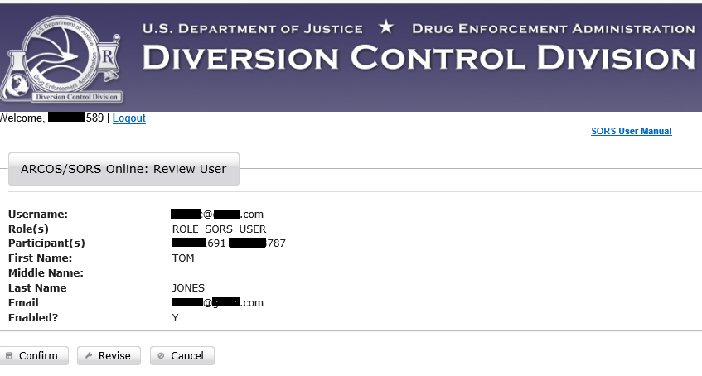
Figure 70 – Review User
Review the information displayed above. If accurate click on Confirm.
A screen similar to the one below displays.

Edit User
In this section, we use the edit function to correct an Admin user’s last name. A single letter last name, although registered, will not function properly.
Click on Edit for sors2a@yahoo.com
Figure 71 - Add/Edit User Form
In this example we use the Add/Edit User Form to edit the user. We correct/edit the last name from “A” to “Adm.” Then, click on Proceed.
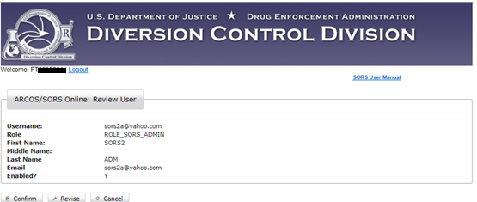
Figure 72 - Review User Screen Displays New Last Name
Click on Confirm to record the edit.
Note: The Username cannot be changed.
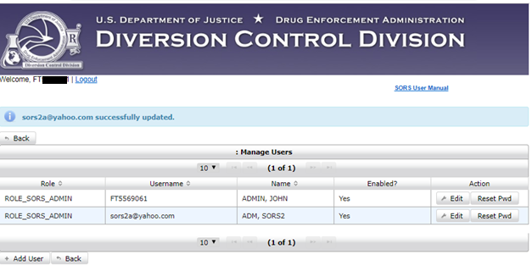
Figure 73 - Successful update
The above screen confirms the edit.

Adding a Not Enabled User
There are some issues when making add a user that is not enabled.
If you complete the process as in Section 8.2 to add a User (or Admin) you will get a screen similar to the one below.
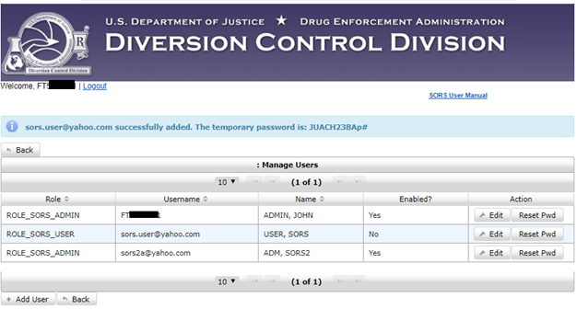
Figure 74 - User Added as Not Active
If you this User tries to login, the screen below will display.
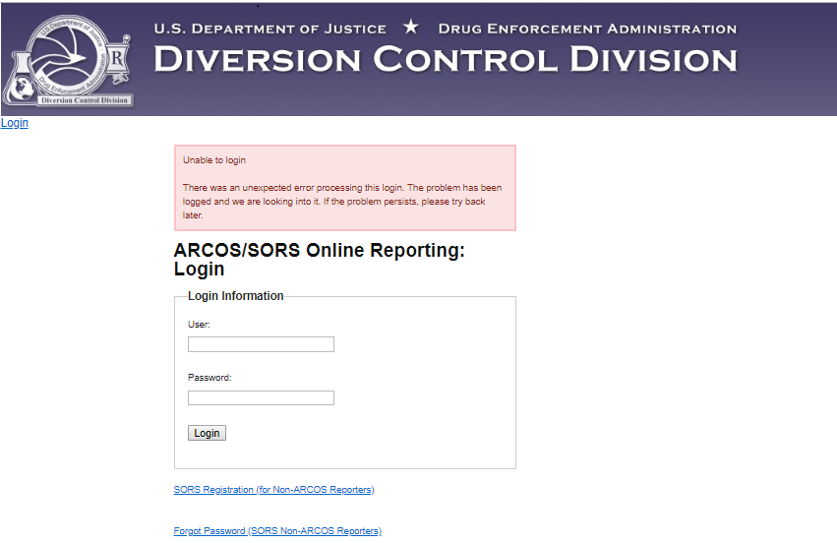
Figure 75 – Not Enabled Login Problem
The User (or Admin) must be enabled to get a password. See the next section below.

Enable Not Enabled User
Click on Edit for the Not Enabled User in the Manage Users Screen below.
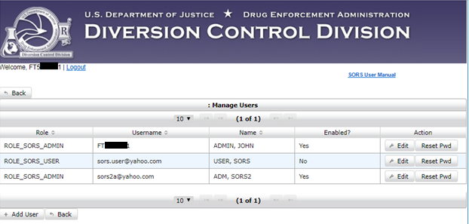
Figure 76 - User is Not Enabled
Click on Edit for the Not Enabled User in the Manage Users Screen above. The Add/Edit User Form for this user display.
Figure 77 - Not Enabled User
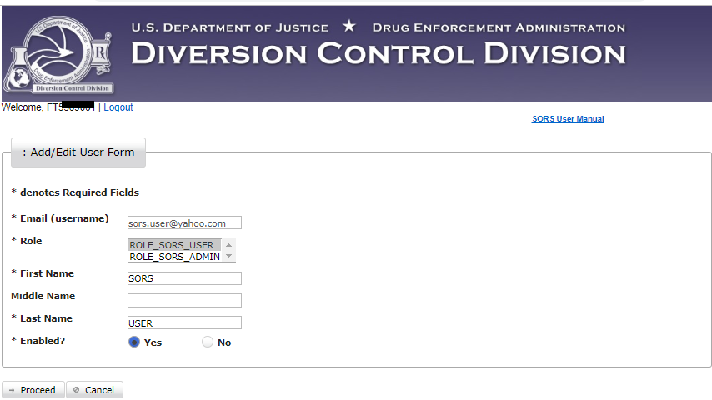
Figure 78 - Yes Enabled Clicked
Click in the Yes radio button so it displays as above. Click on Proceed. The screen below displays.
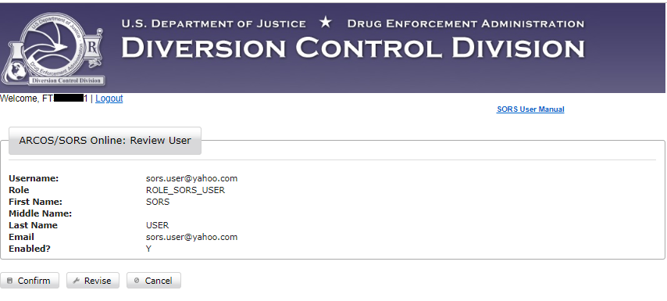
Figure 79 - Review User Screen for Enabled User
Click on Confirm to save the User as enabled. The Screen below displays.
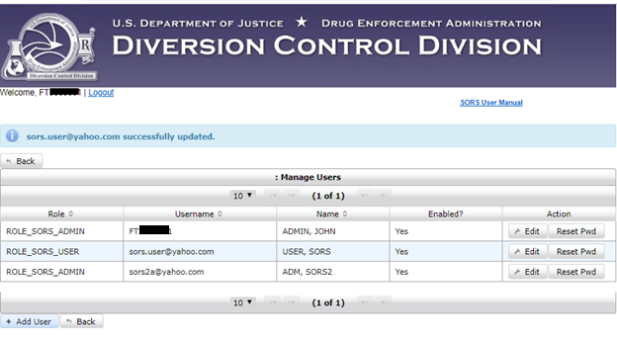
Figure 80 - User Displays as Enabled.
The previously not enabled User displays as enabled above.

Reset Password
An Admin can reset any user’s password. In this example we will reset the password of the user
sors.user@yahoo.com.
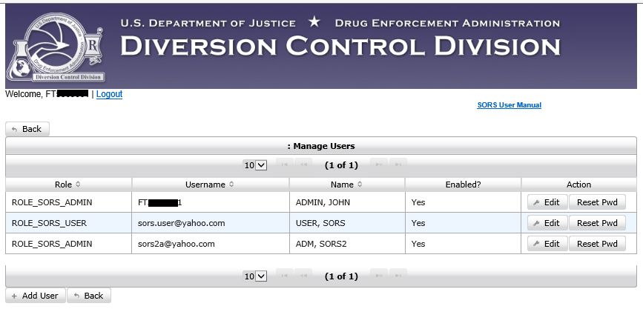
Figure 81 - Manage Users Page.
Click on Reset Pwd for this user. This popup displays.
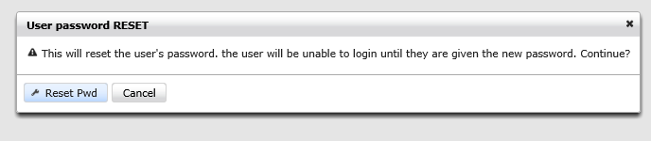
Figure 82 - Reset Password Popup
Click on Reset Pwd. Note the banner in the screen below.
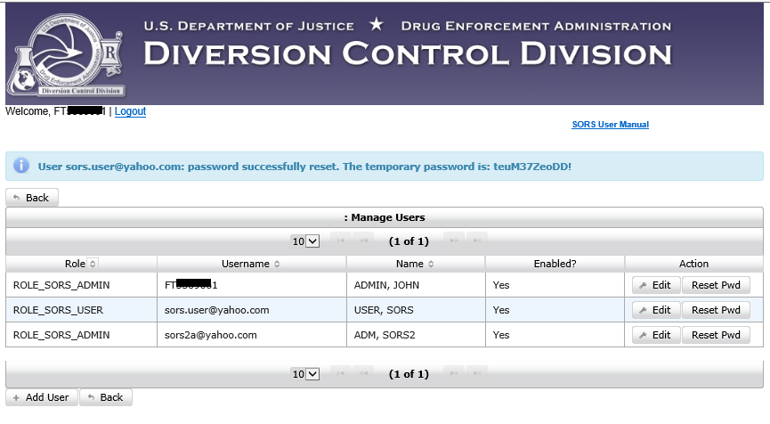
Figure 83 - Password Successfully Reset
Record the temporary password and give it to the affected user.
This user will open the Login Page and enter the username and temporary password as shown below.
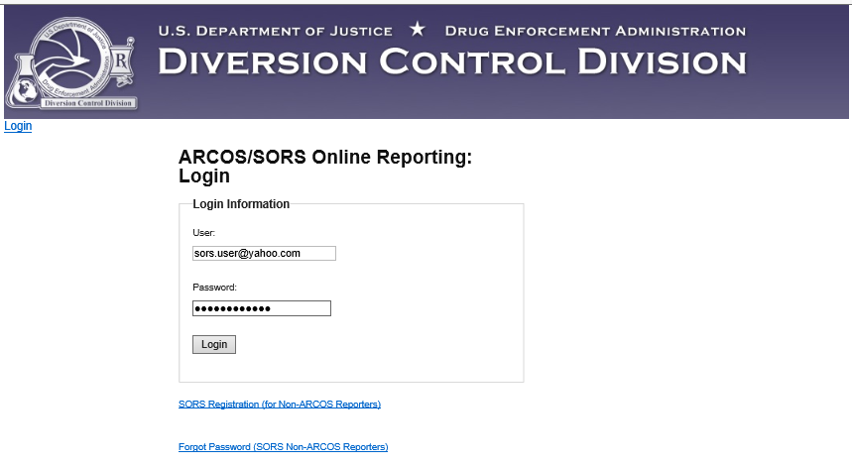
Figure 84 - Login Page with Temporary Password.
This user clicks on Login and the Change Password Page.
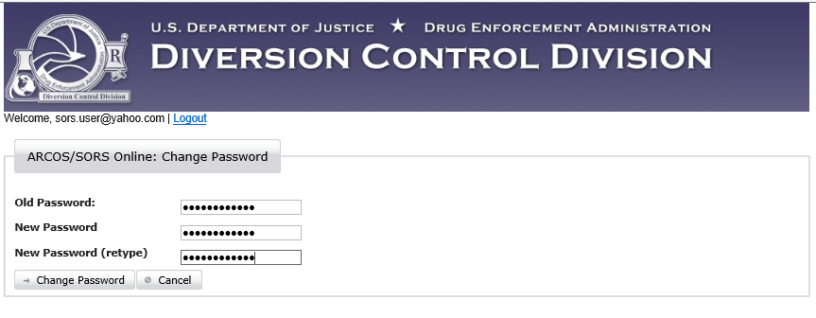
Figure 85 - Change Password
The user enters the old password, the new password, repeats the new password, and then click on Change Password.
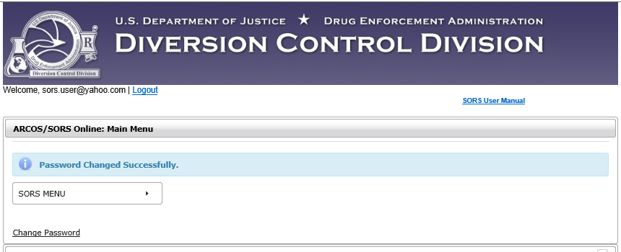
Figure 86 - Main Menu with Banner
The banner notes that the password was successfully changed.

