Questionnaire regarding Photo/DS-160 Confirmation Page
OMB Control No.: 1405-0193
EXPIRATION DATE: 4-30-2021
ESTIMATED BURDEN: 5 minutes
SV-2019-0002

The U.S. Embassy Tokyo, Visa Unit is responsible for issuing visas to qualified applicants. We are committed to delivering the best possible service to our customers. You are asked to complete this survey because you failed to bring the proper documents such as photo and/or DS-160 Confirmation page to your appointment, and that we are gathering this information to improve the clarity of the website. Please take a few minutes to complete this anonymous questionnaire.

Please check or fill in the following applicable items:

Q1: What sources did you use in determining the necessary documents for this application? Select multiple options if applicable.
- Embassy homepage (refer to flip side #1)
- US visa application page (refer to flip side #2)
- Embassy Twitter
- Checklist on an appointment letter
- Photo upload screen when filling in DS-160 visa application form (photograph requirements)
- Other: unofficial source such as word of mouth (please specify) ____________________________________________________________________________
Q2: The Consular office determined that your photograph failed to meet the Department of State requirements. Please explain why you were not able to submit a photo that met the requirements. (Only for those who apply)
- I did not know that there are photograph requirements
- I could not find the photograph requirements
- I could not understand the information explaining the photograph requirements
- I did not confirm that my photo met the photograph requirements
- I could not take a photograph that met the requirements
- I was aware of the requirements and thought my photo met the requirements
- Other ______________________________________________________________________
Q3: You did not submit a print out of your DS-160 confirmation page today. Please explain why you were not able to bring the DS-160 confirmation page to your appointment. (Only for those who apply)
- I did not know or understand that I was required to bring the confirmation page
- I thought I could bring an electronic copy instead of a physical copy of the confirmation page
- I could not print a copy of the confirmation page
- I lost my print-off of the confirmation page
- Other ______________________________________________________________________
Please provide any additional comments / suggestions regarding the embassy website below:

__________________________________________________________________________________
Thank you for your cooperation. Please submit this questionnaire at Window #1.
(1) Embassy homepage
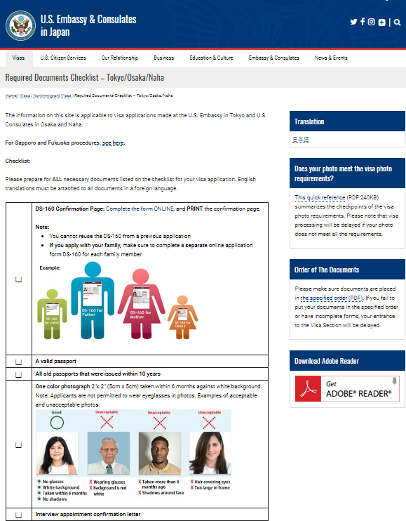
(2) US visa application page
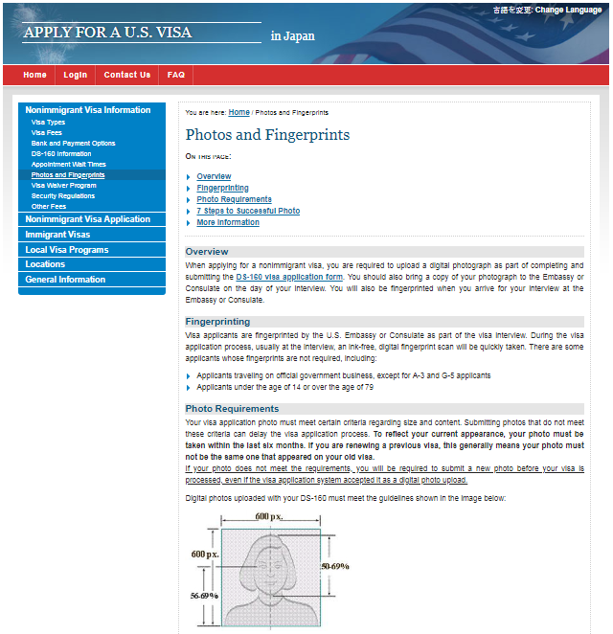
Public reporting burden for this collection of information is estimated to average 5 minutes per response, including time required for searching existing data sources, gathering the necessary documentation, providing the information and/or documents required, and reviewing the final collection. You do not have to supply this information unless this collection displays a currently valid OMB control number. If you have comments on the accuracy of this burden estimate and/or recommendations for reducing it, please send them to TokyoNIV@state.gov

