OMB Control No.: 1405-0193
EXPIRATION DATE: 4-30-2021
ESTIMATED BURDEN: 5 minutes
SV-2019-0001
Questionnaire regarding SEVIS fee payment

The U.S. Embassy Tokyo, Visa Unit is responsible for issuing visas to qualified applicants. We are committed to delivering the best possible service to our customers. You are asked to complete this survey because you were unprepared to pay the SEVIS fee at the expected time, and that we are gathering this information to improve the clarity of the website. Please take a few minutes to complete this anonymous questionnaire.

Please check or fill in the following applicable items:

Q1: Why did you not complete the SEVIS fee payment in advance of your visa application appointment? Select multiple options if applicable.
- I did not understand that the SEVIS fee is a separate and distinct payment from the visa processing application fee.
- I did not know that I had to pay any fee in advance of my visa application appointment.
- I thought I had successfully paid the fee.
- I thought a third party (such as an agency or program sponsor) was going to pay the fee.
- I forgot to pay.
- I could not afford to pay.
- I did not have a means by which to pay.
- I did not know how to pay.
- Other ______________________________________________________________________
Q2: What sources did you use in determining the necessary documents for this visa application? Select multiple options if applicable.
- Embassy homepage (refer to flip side #1)
- US visa application page (refer to flip side #2)
- Embassy Twitter
- Interview appointment confirmation form
- Other: unofficial source such as word of mouth (please specify) ___________________________________________________________________________
Q3: Was the website description of the SEVIS fee requirements easy to understand?
- Yes
- No
If you answered “No” to question 3, please briefly describe the reason(s) below:

__________________________________________________________________________________
Thank you for your cooperation. Please submit this questionnaire at Window #1.
(1) Embassy homepage
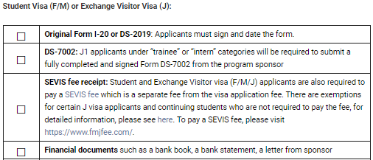
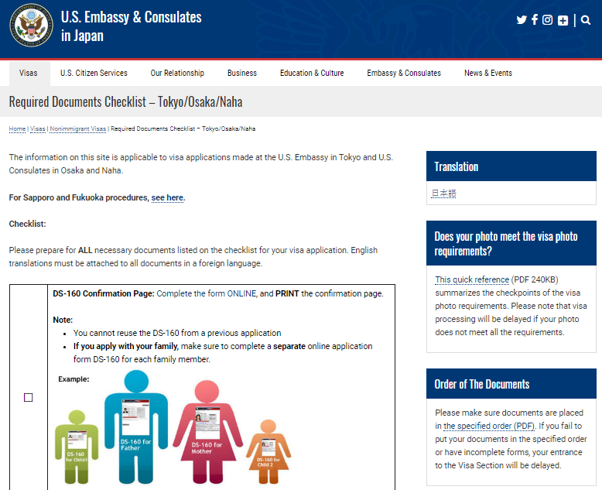

(2) US visa application page
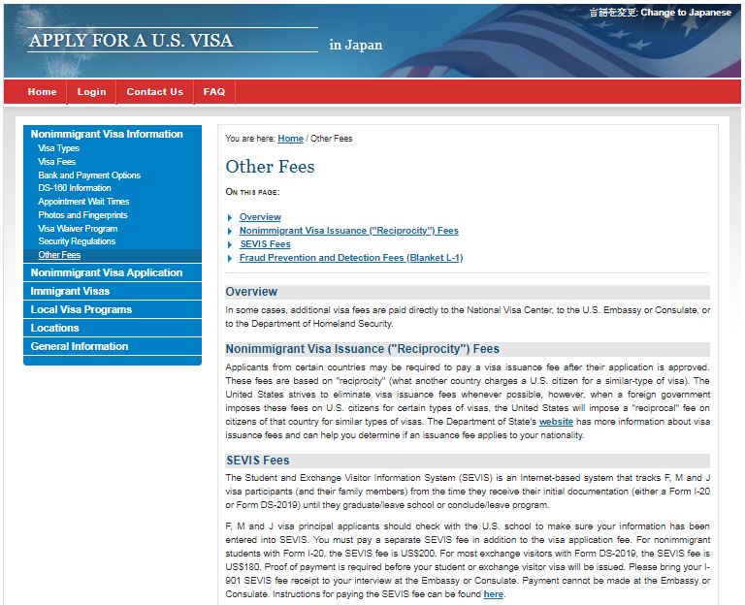
Public reporting burden for this collection of information is estimated to average 5 minutes per response, including time required for searching existing data sources, gathering the necessary documentation, providing the information and/or documents required, and reviewing the final collection. You do not have to supply this information unless this collection displays a currently valid OMB control number. If you have comments on the accuracy of this burden estimate and/or recommendations for reducing it, please send them to TokyoNIV@state.gov

