OMB Control Number: 2010-0042
Expiration Date: 3/31/2024
Form Number: 5800-0012

Burden Statement - This collection of information is approved by OMB under the Paperwork Reduction Act, 44 U.S.C. 3501 et seq. (OMB Control Number 2010-0042, Form Number 5800-0012, Expiration 3/31/2024). Responses to this collection of information are voluntary. An agency may not conduct or sponsor, and a person is not required to respond to, a collection of information unless it displays a currently valid OMB control number. The public reporting and recordkeeping burden for this collection of information is estimated to 10 minutes per response. Send comments on the Agency’s need for this information, the accuracy of the provided burden estimates and any suggested methods for minimizing respondent burden including through the use of automated collection techniques to the Director, Regulatory Support Division, U.S. Environmental Protection Agency (2821T), 1200 Pennsylvania Ave., NW, Washington, D.C. 20460. Include the OMB control number in any correspondence. Do not send the completed form to this address.

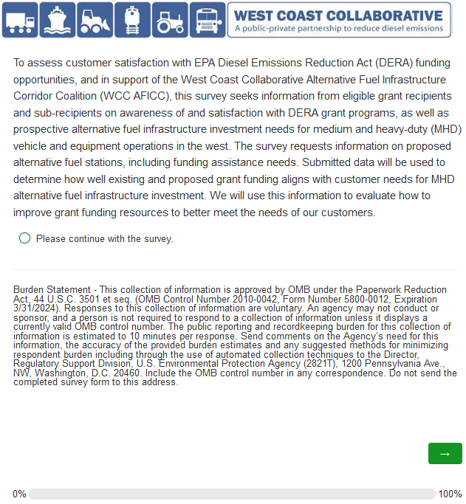
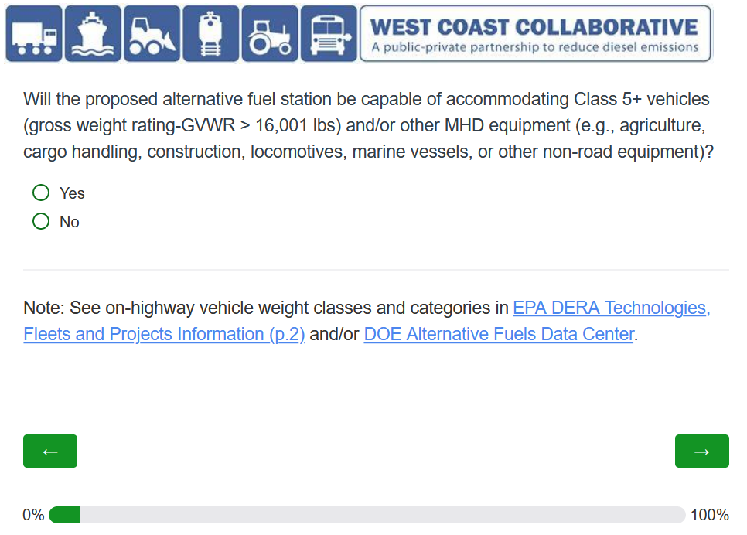

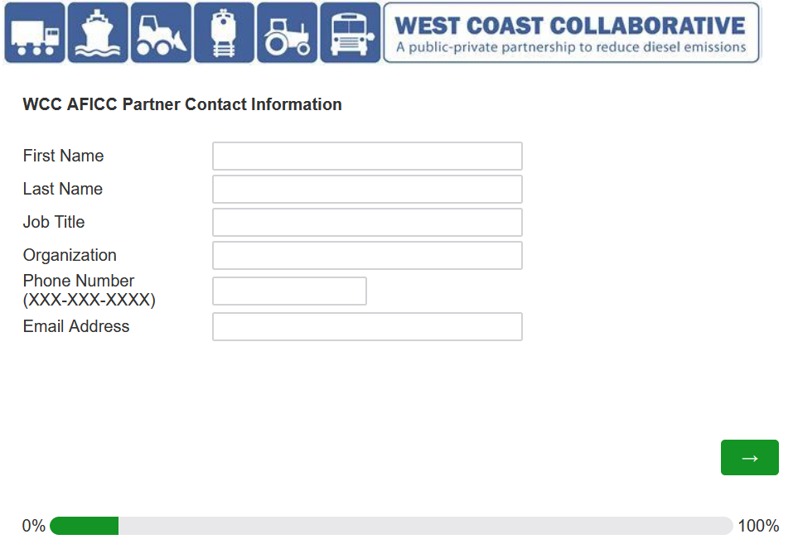

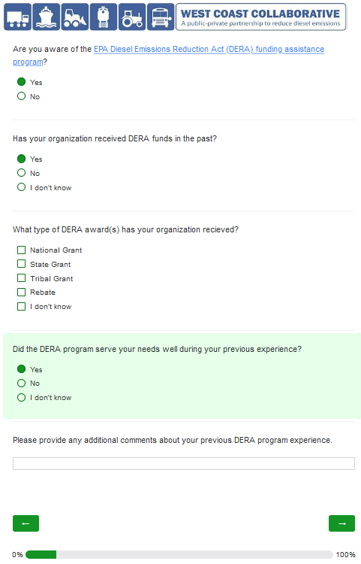
If “Yes” is selected on the second question listed above, then two additional questions drop down (see above).

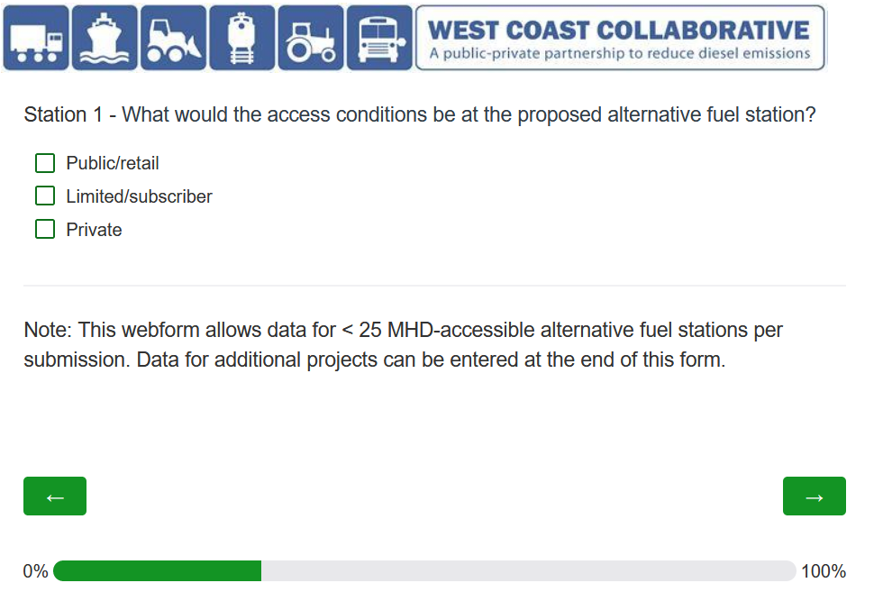

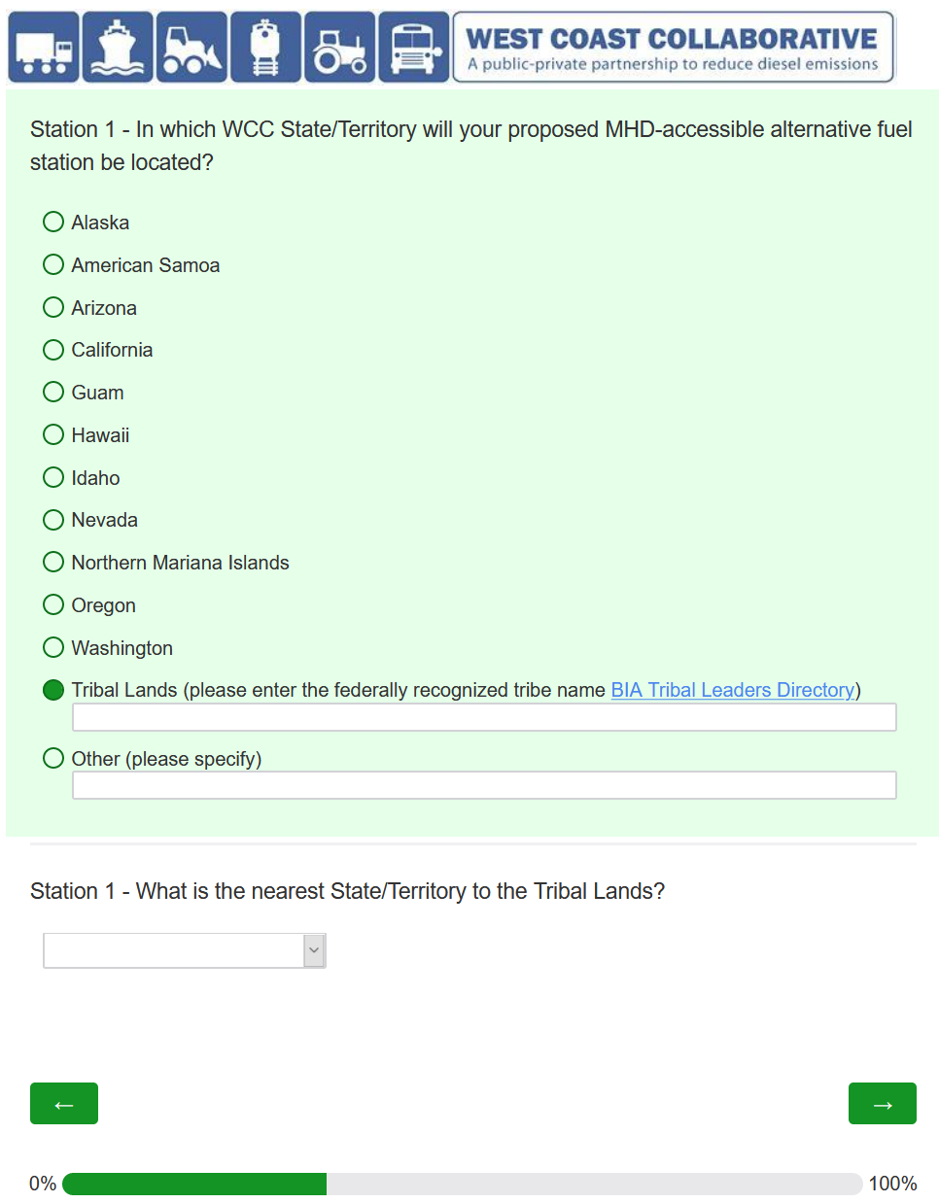
If “Tribal Lands” selected, then additional question drops down (see above).
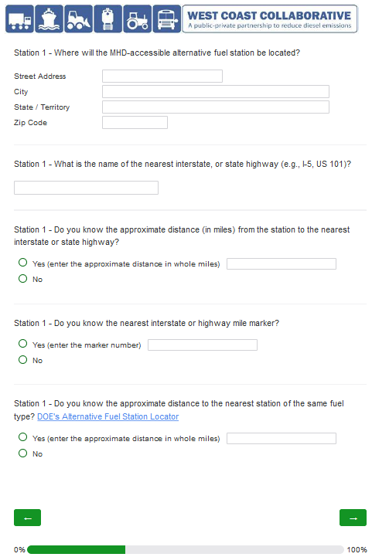
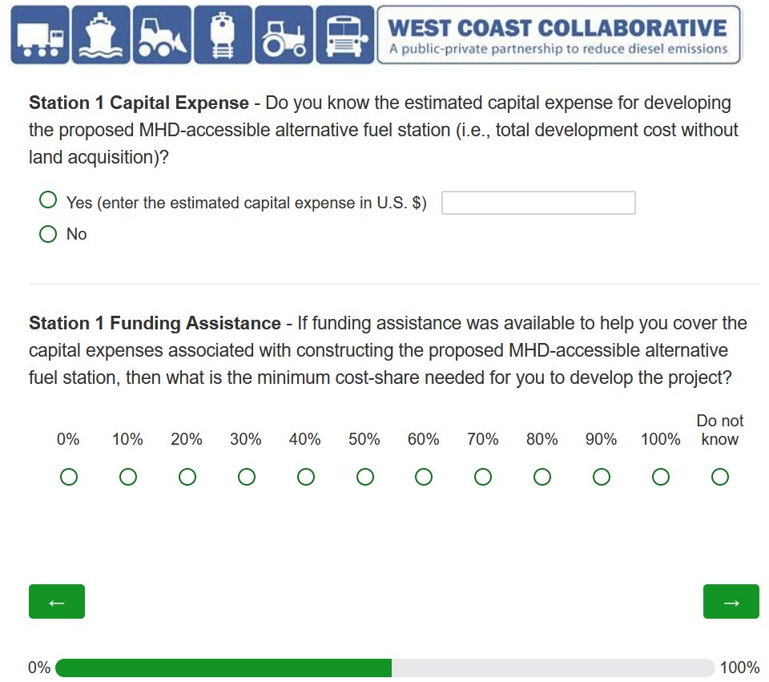
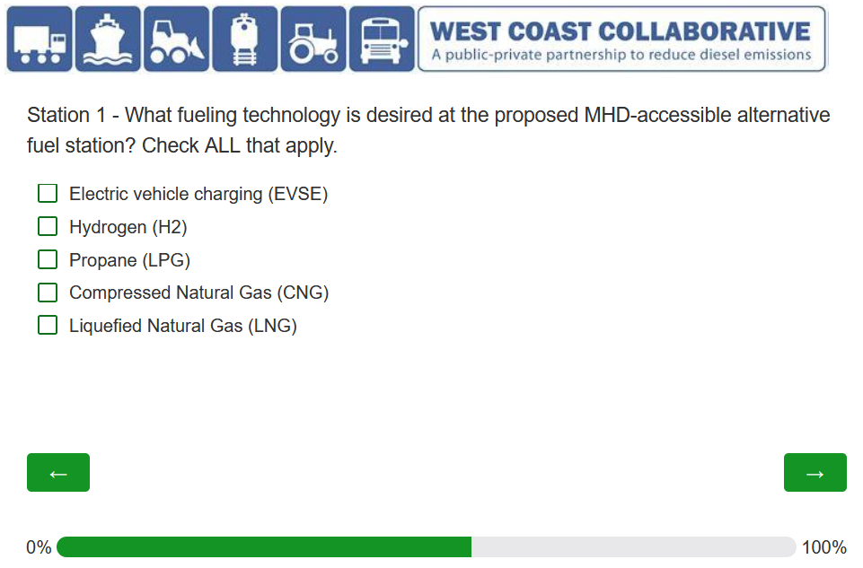
Following questions vary depending on fueling technology, or technologies selected here.

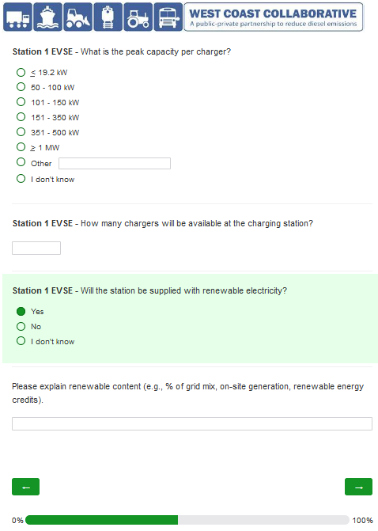
If “Yes” selected on third question, then optional text box drops down (see above).
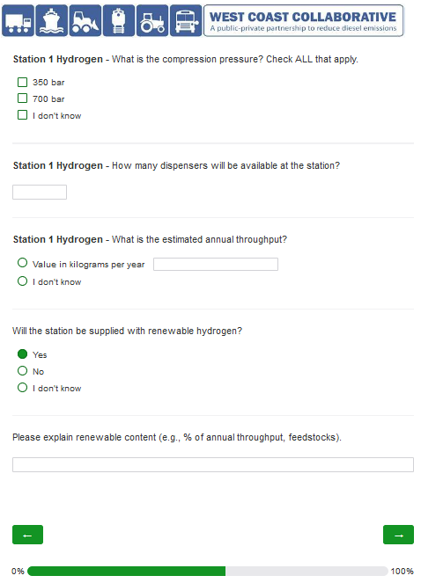
If “Yes” selected on third question, then optional text box drops down (see above).

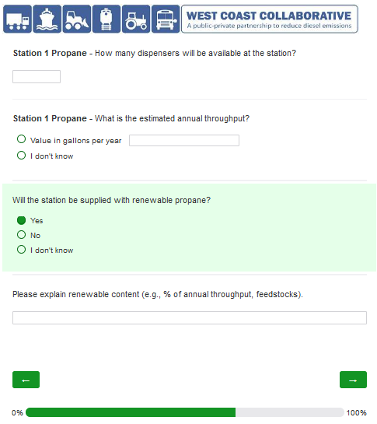
If “Yes” selected on third question, then optional text box drops down (see above).

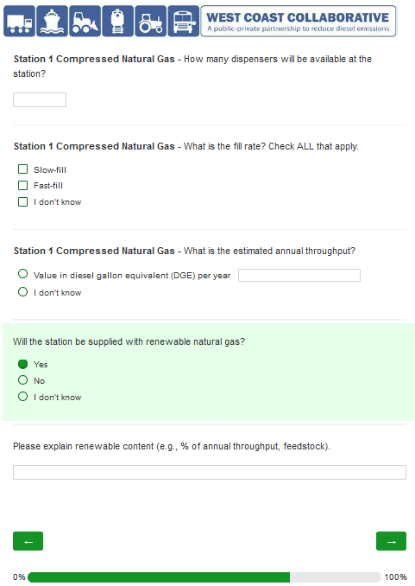
If “Yes” selected on forth question, then optional text box drops down (see above).
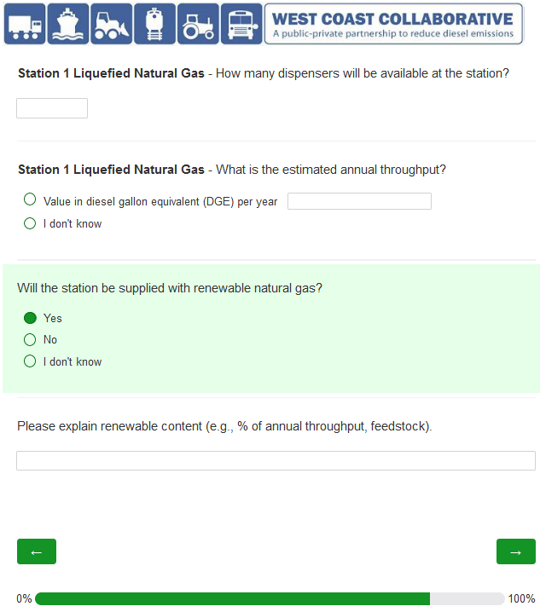
If “Yes” selected on third question, then optional text box drops down (see above).
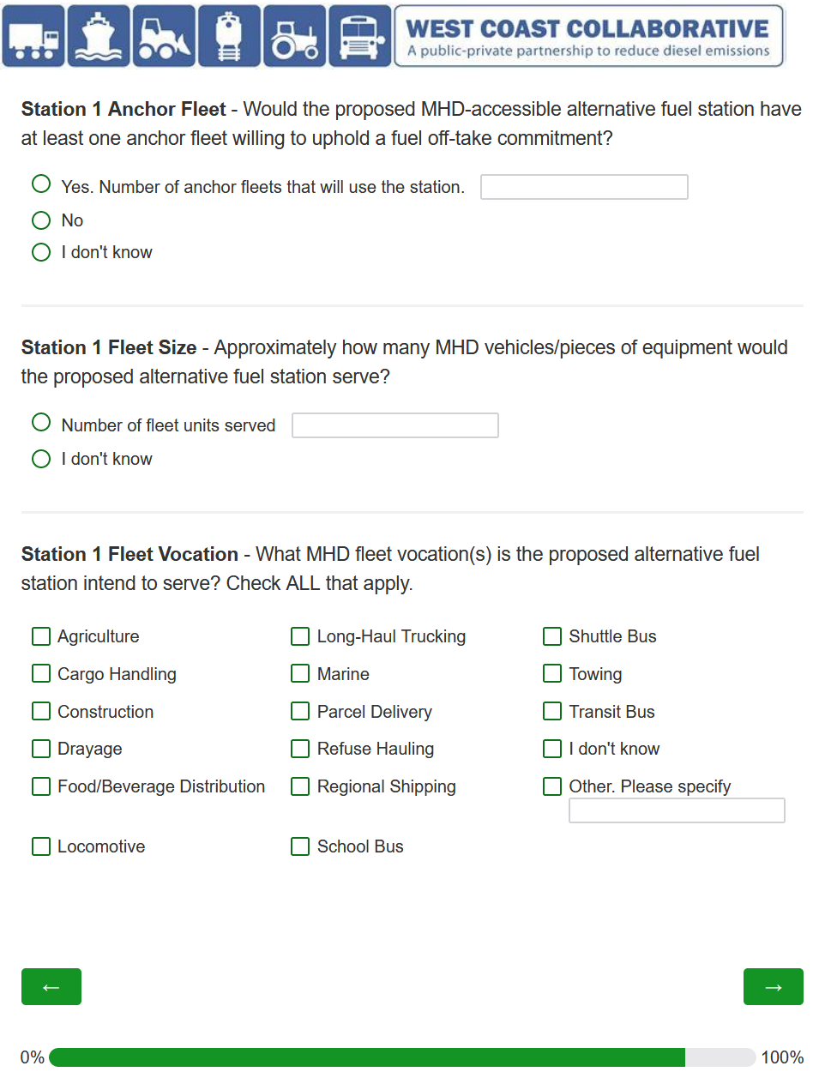
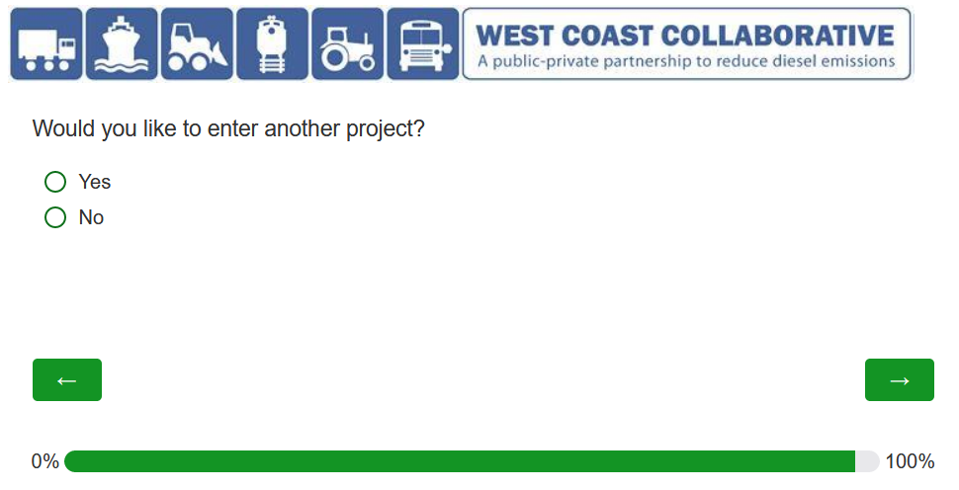
If “Yes” selected, then new data requested starting at p.7 above.
If “No” selected, then final page below.

