**Factory-Built Housing**

Factory-built housing systems are a potentially viable affordable housing option for low- and moderate-income Americans. Factory-built housing systems include modular units, panelized building systems, and manufactured homes.

**Modular homes[1]** (box-like modules with attached walls, floor, ceiling, wiring, plumbing, and interior fixtures) are 90 percent complete when they leave the factory and are assembled onsite (Geary, 2013; Deltec Homes, n.d.). Both panelized building systems and modular homes are subject to state and local building code requirements, like conventional homes that are built onsite (Geary, 2013; National Association of Home Builders [NAHB], n.d.).

**Figure 2 | Panelized Building Systems**

**Figure 1 | Modular Homes**

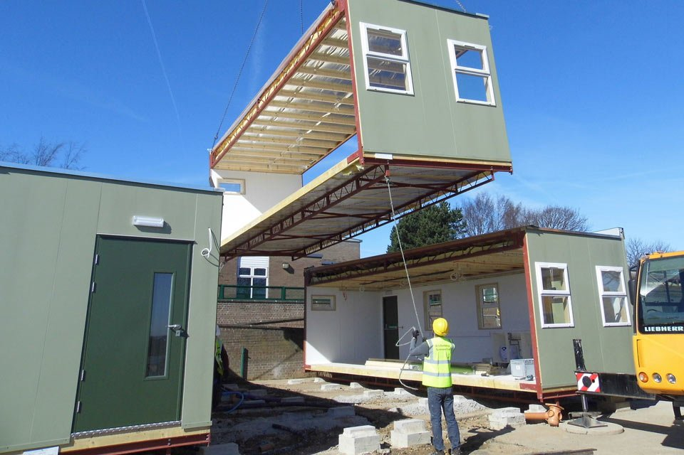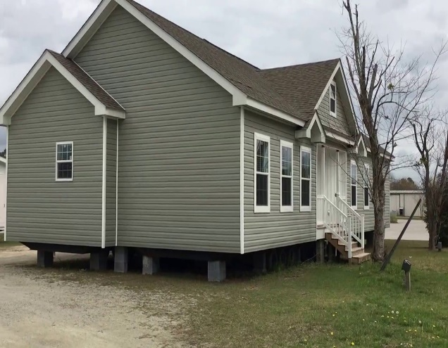

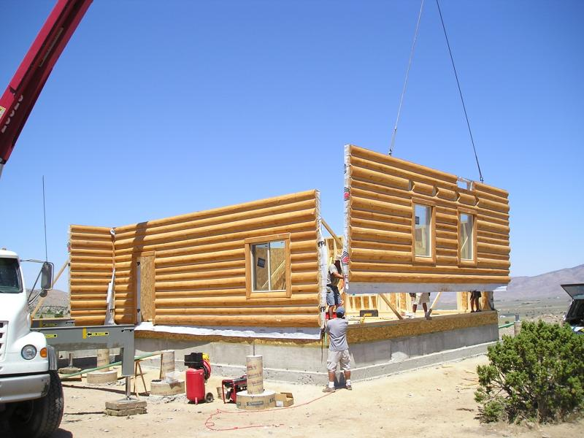**Panelized building systems[2]** refer to the structural components of a home, such as the walls, roof, and floors that are constructed in a factory and then assembled onsite (Deltec Homes, n.d.).

**Manufactured homes[3]** are built and assembled entirely in the factory and then delivered to the home site (Geary, 2013). Local building codes do not apply to manufactured homes. Manufactured homes must adhere to the federal construction standards established under the Manufactured Home Construction and Safety Standards (Manufactured Housing Institute [MHI], n.d.b) and enforced by the U.S. Department of Housing and Urban Development. These standards regulate all aspects of manufactured home construction, including design and construction strength, durability, and energy efficiency.

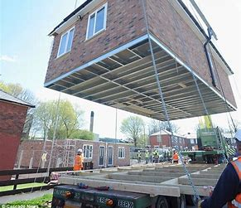

**Figure 3 | Manufactured Homes**

1. Source for figure 1 (left to right): (1) [**https://www.apacciooutlook.com/news/is-2020-the-year-of-modular-construction-nwid-7297.html**](https://www.apacciooutlook.com/news/is-2020-the-year-of-modular-construction-nwid-7297.html)(2) [**https://modularhomespic.blogspot.com/2018/11/greenfield-modular-homes-clayton-nc.html**](https://modularhomespic.blogspot.com/2018/11/greenfield-modular-homes-clayton-nc.html)
2. Source for figure 2: <https://www.grizzlylogbuilders.com/8_Steps_to_Build_your_Panelized_Home/page_874085.htm>
3. Source for figure 3: <https://aboutmanchester.co.uk/could-factory-built-homes-solve-the-housing-crisis/>