**DUE DATE REMINDER**

Recently, the U.S. Census Bureau and the Department of Housing and Urban Development mailed you a letter asking you to complete the **2018 Rental Housing Finance Survey.** If you have submitted your survey in the past few weeks, **thank you**. If you have not yet reported, please do so before the due date noted below. After the due date, a Field Representative from the Census Bureau will contact you to conduct a personal interview.

**Address:**

Please report online using the information below, and keep this letter for future reference:

**Website:**

**User ID:**

**Password:**

**Due Date:**

For assistance with completing this survey, visit us online at the website above or call our customer help line at 1-800-992-3530, Monday through Friday, 8:00 a.m. to 5:00 p.m. Pacific time.

**Thank you** in advance for your time and cooperation, and for helping the U.S. Census Bureau measure America’s people, places, and economy. Your response makes a difference.

Sincerely,

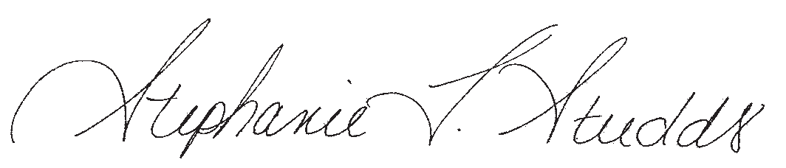

Stephanie L. Studds

Chief, Economic Indicators Division

U.S. Census Bureau