https://ness.nasa.gov/contractor

NESS for Contractors - Contracts

Section Navigation
- Purpose
- Procedure
- Result

Purpose
Next SectionTop
Contractors will no longer be submitting the NF1018 PDF form. Instead, contractors will log into NESS (NASA Form 1018 Electronic Submission System) for Contractors to input property data directly into the application. Use this procedure to request contract access or view a listing of your contracts in NESS for Contractors.
Trigger
Perform this procedure to obtain access to contracts or view contract information in NESS for Contractors.
Prerequisites
- A role in NESS for Contractors is required:
  - Guest accounts must be created for contractors without NASA identities. If you have not received your guest account credentials via email, please contact your Industrial Property Officer (IPO), who will create your guest account and/or re-send your credentials.
  - However, contractors with full NASA identities do not require guest accounts.
    - Full NASA identities must submit a NAMS request for the IT Asset "NF1018 Electronic Submission System (NESS)," requesting the role NESS Contractor.
    - If you are unable to access https://nams.nasa.gov to submit a NAMS request, please contact your Industrial Property Officer (IPO), who will submit a request on your behalf.
- If you are not assigned to any contracts, your screen will be blank. You must request access to specific contracts to view their data. If you can already see the data you require, you have been proactively assigned to the contract, and you do not have to request access.
Menu Path
Use the following menu path to begin this task:
- https://ness.nasa.gov/contractor Contracts Summary
Helpful Hints
- Contract data is view only. The R/O/C column in the field description table typically indicates whether the field is a process Requirement, Optional, or Conditional.

Procedure
Previous SectionNext SectionTop
1.Start the task from the NESS for Contractors home page at https://ness.nasa.gov/contractor.
Property Submissions is displayed by default.
NESS - NASA Form 1018 Electronic Submission System‬‬‬
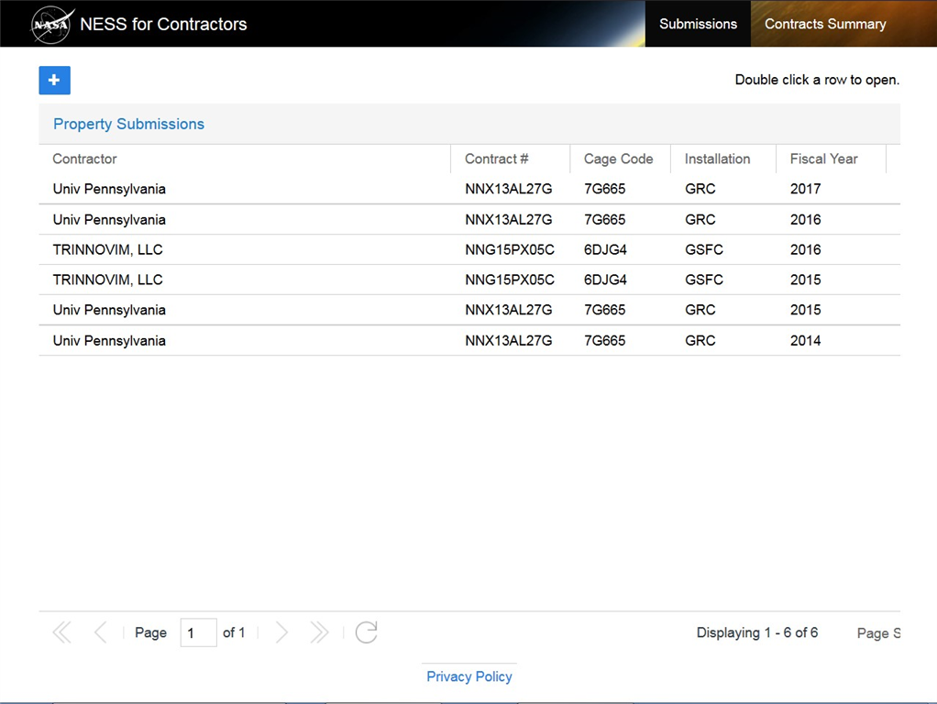
2.Click the Contracts Summary header link 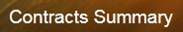 to display the Contract Summary screen.‬‬‬
NESS - NASA Form 1018 Electronic Submission System
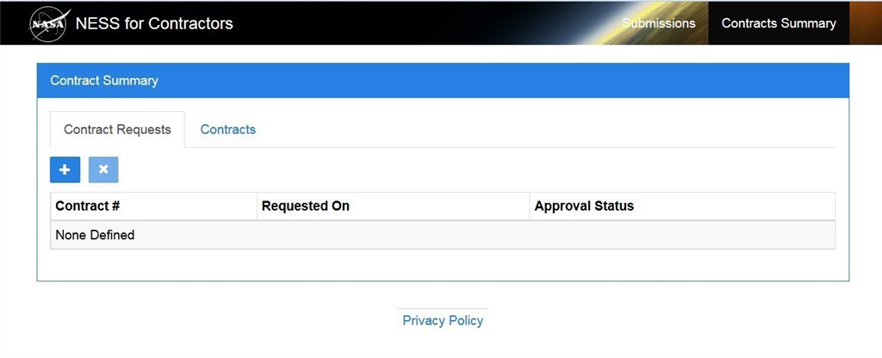
3.
Perform one of the following:
If You Need To | Then
Request access to a contract | Proceed to next Step 4
Display accessible contracts | Skip to Step 9
4.To request access to a contract, click the Add button on the Contract Requests tab. The Request Contract Access screen will display.
NESS - NASA Form 1018 Electronic Submission System‬‬‬
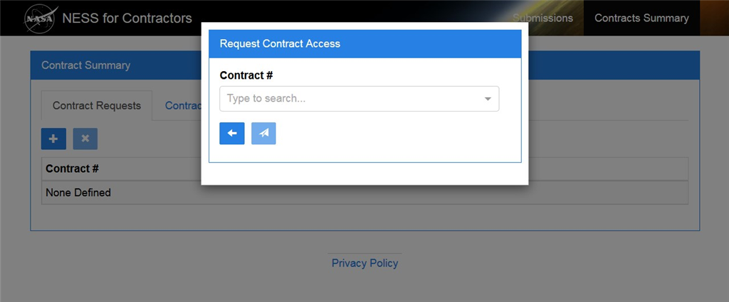
5.In the Contract # field, begin typing the contract number. Applicable search results will appear in the drop down menu.
Use vertical scroll as necessary to view all search results.
Be sure not to select a contract you already have access to. If you need to view a list of contracts you have access to, see Step 9.
NESS - NASA Form 1018 Electronic Submission System‬‬‬
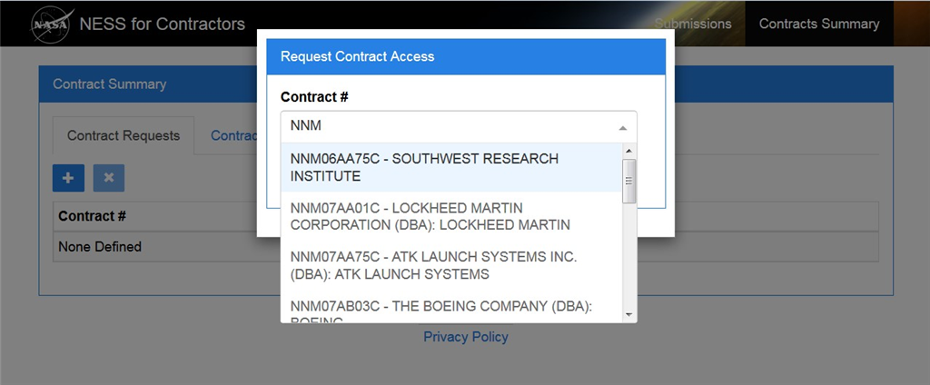
6.Select search results to add to the Contract # field. Click the up arrow to collapse the drop down menu when complete.
More than one contract number can be added to the request.
NESS - NASA Form 1018 Electronic Submission System‬‬‬
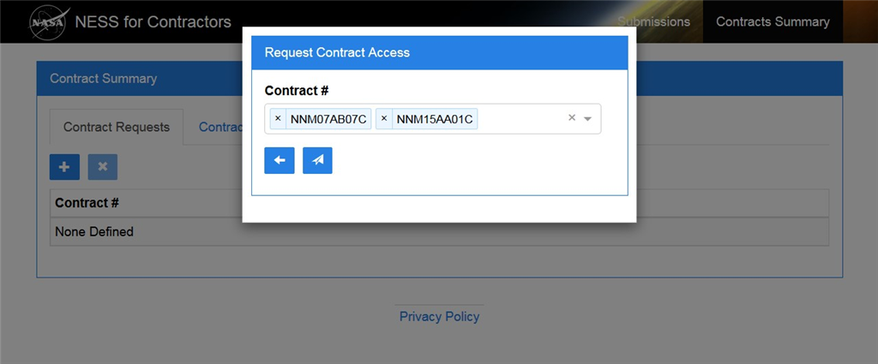
7.After selecting the appropriate contract(s), click the Submit button . Requests are displayed on the Contract Requests tab.
NESS - NASA Form 1018 Electronic Submission System‬‬‬
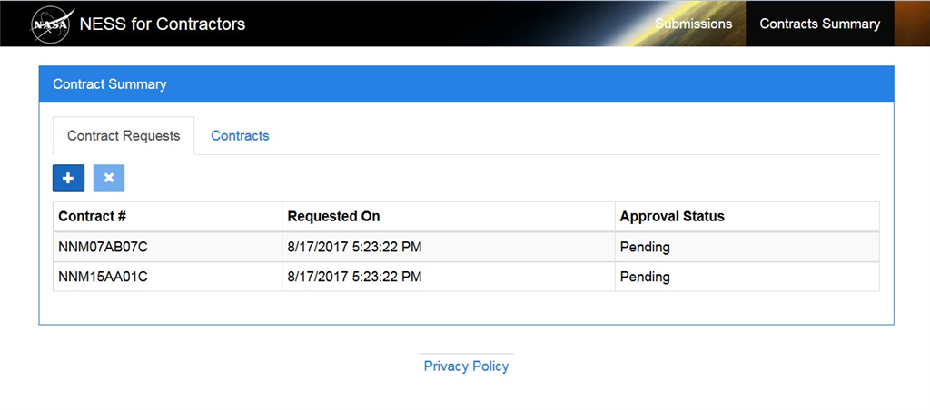
8.To cancel a request, first highlight the row to remove.
NESS - NASA Form 1018 Electronic Submission System‬‬‬
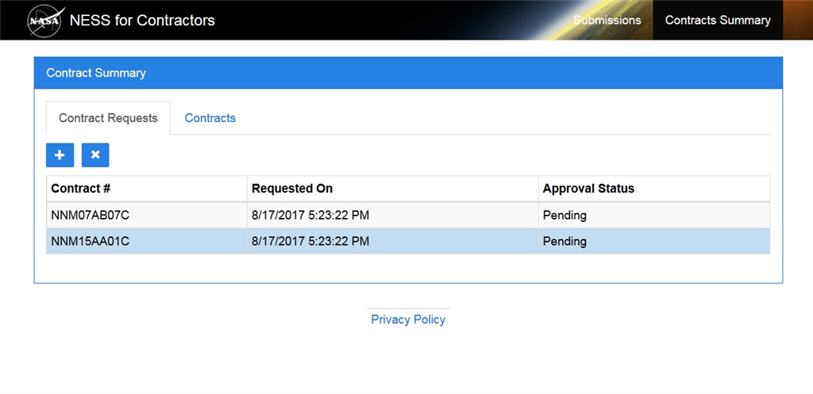
8.1.Click the Remove button 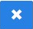.
NESS - NASA Form 1018 Electronic Submission System‬‬‬
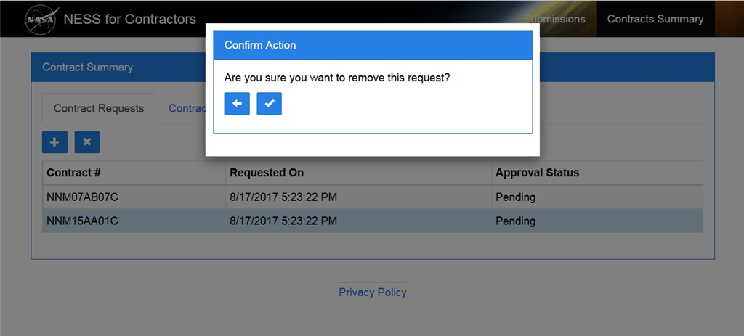
8.2.Then click the Okay button 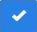 to confirm the request removal.
NESS - NASA Form 1018 Electronic Submission System‬‬‬
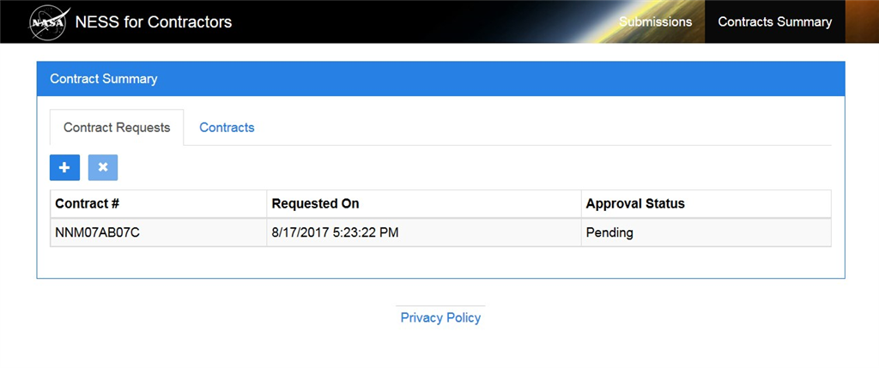
9.Click the Contracts tab to view a list of contracts you have access to.
NESS - NASA Form 1018 Electronic Submission System‬‬‬
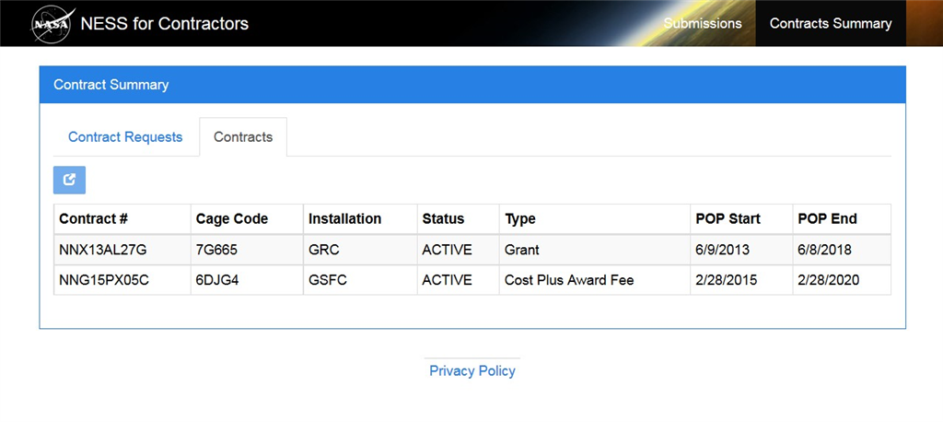
10.To view additional details about a contract, first highlight the row to view.
NESS - NASA Form 1018 Electronic Submission System‬‬‬
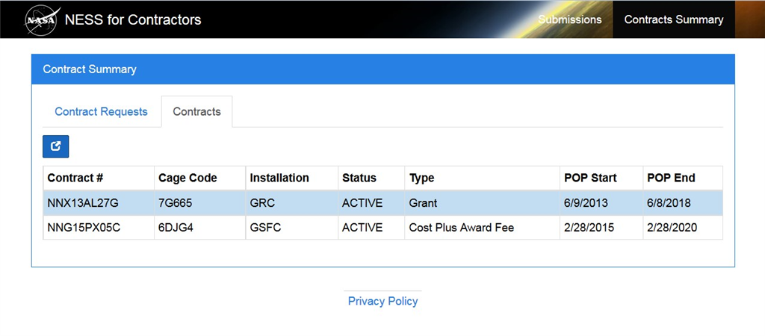
11.Then click the View button 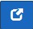. The Summary tab displays by default.
Review the read-only Summary tab fields using field definitions on next Step 12 as a guide.
NESS - NASA Form 1018 Electronic Submission System‬‬‬
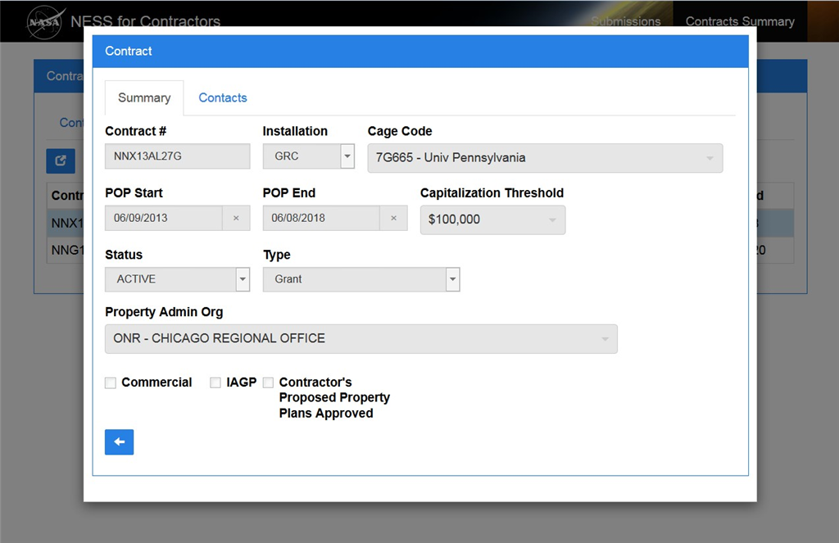
12.
As required, complete/review the following fields:

Field
R/O/C
Description

Contract #
Conditional
The Contract Number.

Example:
NNX13AL27G

Installation
Conditional
The NASA installation.

Example:
GRC

Cage Code
Conditional
The Commercial and Government Entity (CAGE) code.

Example:
7G665 - Univ Pennsylvania

POP Start
Conditional
The Period of Performance (POP) start date.

Example:
06/09/2013

POP End
Conditional
The Period of Performance (POP) end date.

Example:
06/08/2018

Capitalization Threshold
Conditional
Threshold for determining capital property.

Example:
$100,000

Status
Conditional
The status of the contract.

Example:
ACTIVE

Type
Conditional
The type of contract.

Example:
Grant

Property Admin Org
Conditional
The property administration organization.

Example:
ONR - CHICAGO REGIONAL OFFICE

Flags include:
- Commercial
- IAGP (Installation Accountable Government Property)
- Contractor's Proposed Property Plans Approved
NESS - NASA Form 1018 Electronic Submission System‬‬‬
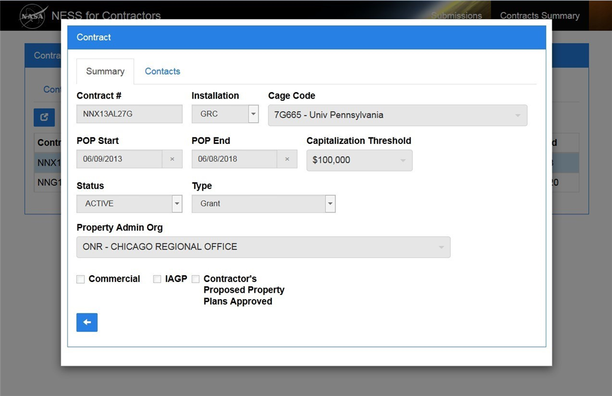
13.As required, click the Contacts tab to review contacts for the contract.
Use horizontal and vertical scroll as necessary.
NESS - NASA Form 1018 Electronic Submission System‬‬‬
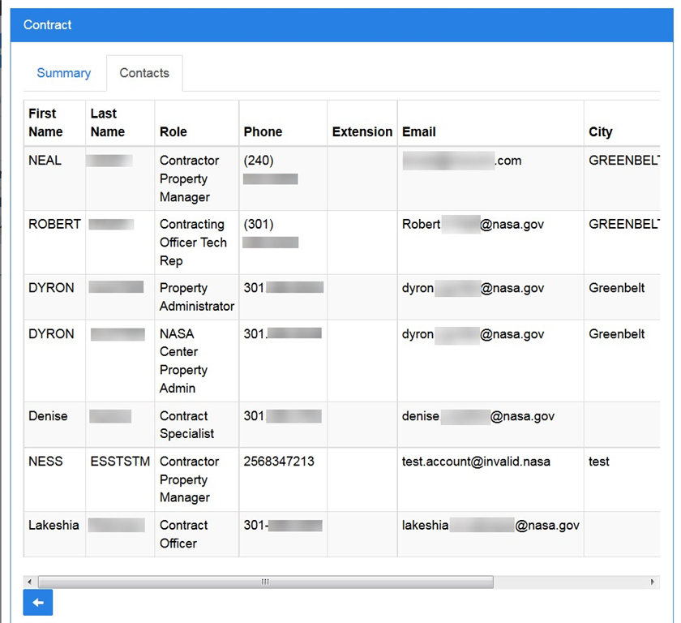
14.Click the Cancel button 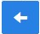 to return to the Contracts tab.‬‬‬
NESS - NASA Form 1018 Electronic Submission System‬‬‬
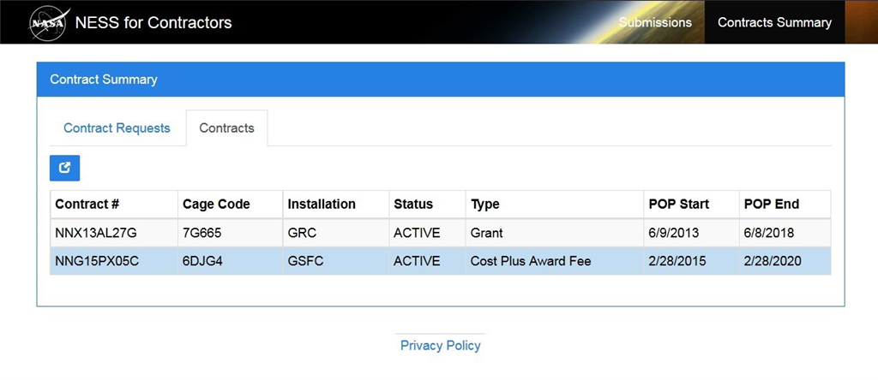
15.Click the NESS for Contractors link to return to the home page.

