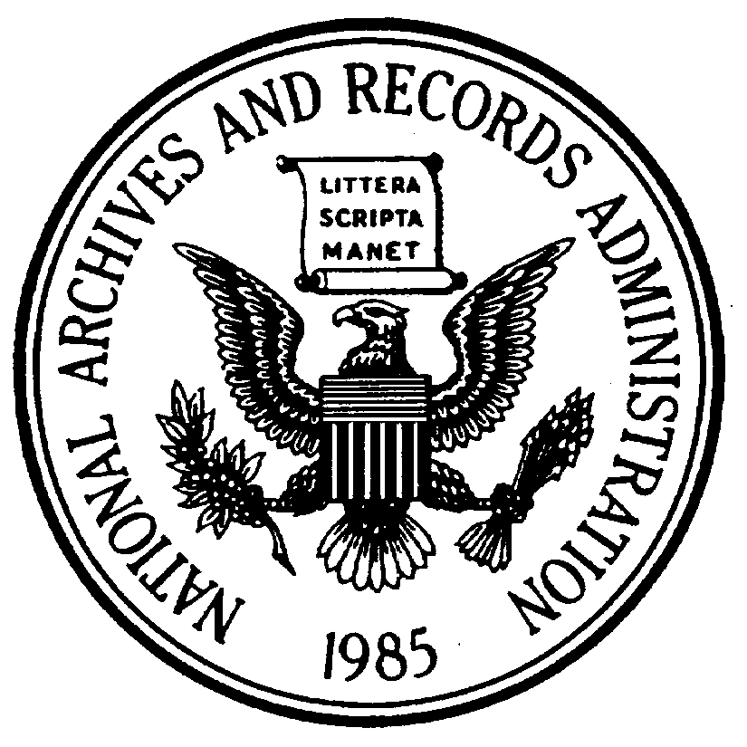
National Archives and Records Administration
700 Pennsylvania Avenue, NW
Washington, DC 20408-0001
Genealogy Fair Evaluation
Click here to enter a date.

We value your opinion. Please take a few minutes to complete this evaluation. Your comments help us maintain the quality of our services and help us plan future programs.

Please rate the following items: | Strongly  Agree | Agree | Disagree | Strongly  Disagree | No basis  to answer
I learned something that will help me
Handouts were useful
Presenter(s) were effective
The exhibitors provided relevant, useful information
Overall, I was satisfied with the fair

Which one of the following categories best describes you . . .

General public National Archives employee, student, volunteer, or docent
Researcher Other (please specify) ________________________________

How did you hear about the fair?

What topics would you like featured in future fairs?

How could this fair be improved?

(If more space is needed, continue on other side.)

If you would like to discuss this program, OR would like us to contact you regarding upcoming programs, please contact the Customer Services Division Know Your Records staff at KYR@nara.gov or 202-357-5333 or tell us how to get in touch with you.

Name & Address ______________________________________________________________

Email _______________________________________________________________________

PAPERWORK REDUCTION ACT PUBLIC BURDEN STATEMENT: You are not required to provide the information requested on a form that is subject to the Paperwork Reduction Act unless the form displays a valid OMB control number. Public burden reporting for this collection of information is estimated to be less than 5 minutes per response. Send comments regarding the burden estimate or any other aspect of the collection of information, including suggestions for reducing this burden, to National Archives and Records Administration (MP), 8601 Adelphi Rd, College Park, MD 20740-6001. DO NOT SEND COMPLETED FORMS TO THIS ADDRESS

