

2017

Cory Davis and Alexander L. Metcalf

Southwest Crown of the Continent Collaborative, University of Montana

1/1/2017

Seeley-Swan and Blackfoot Area National Forest Management Survey

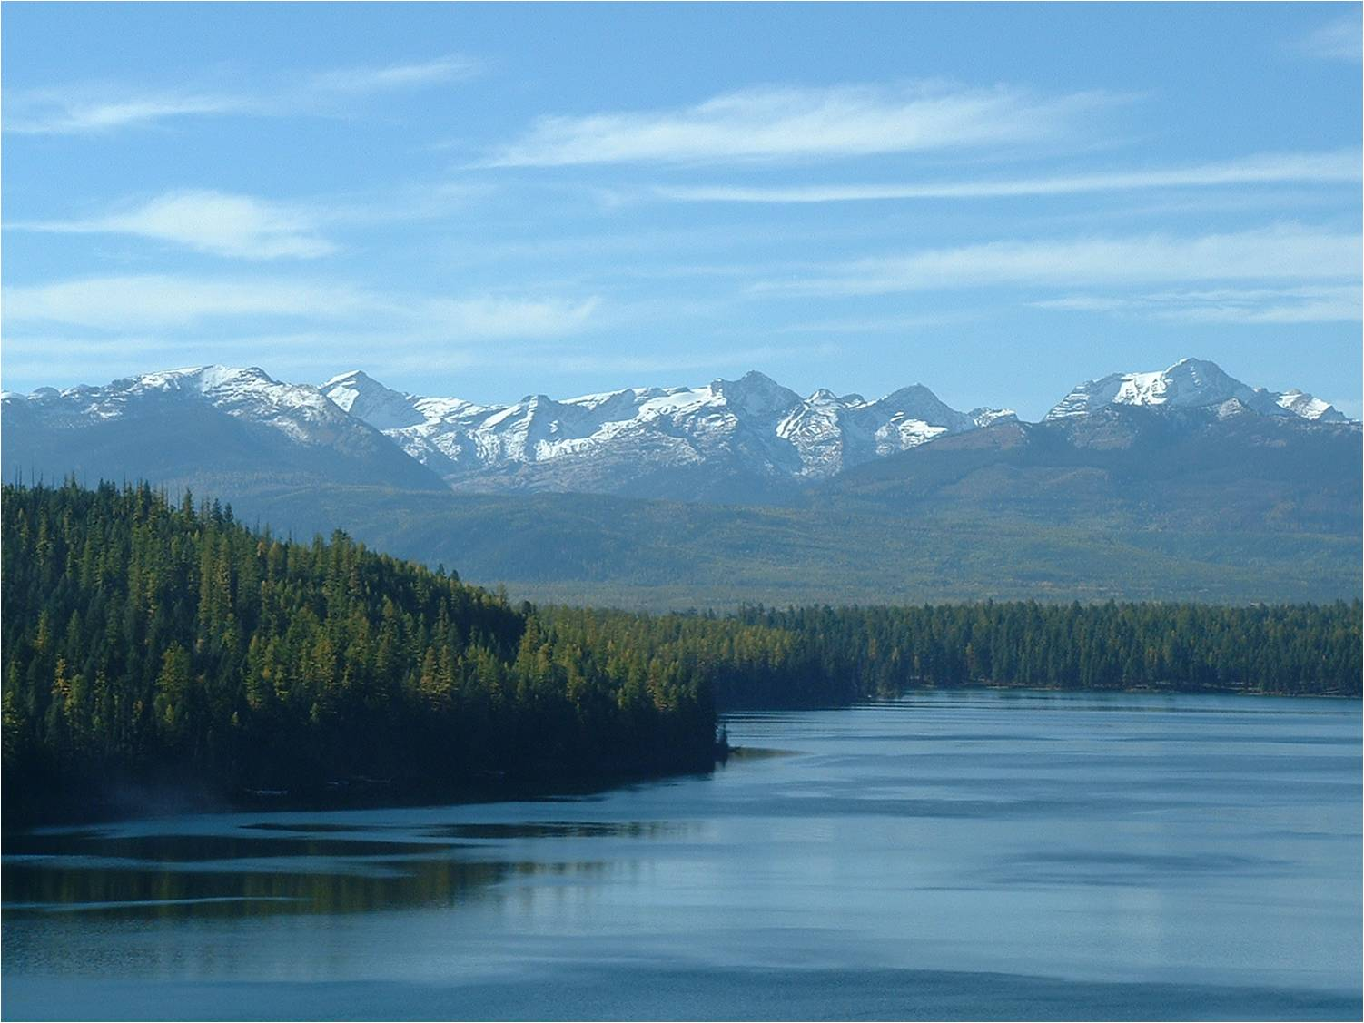

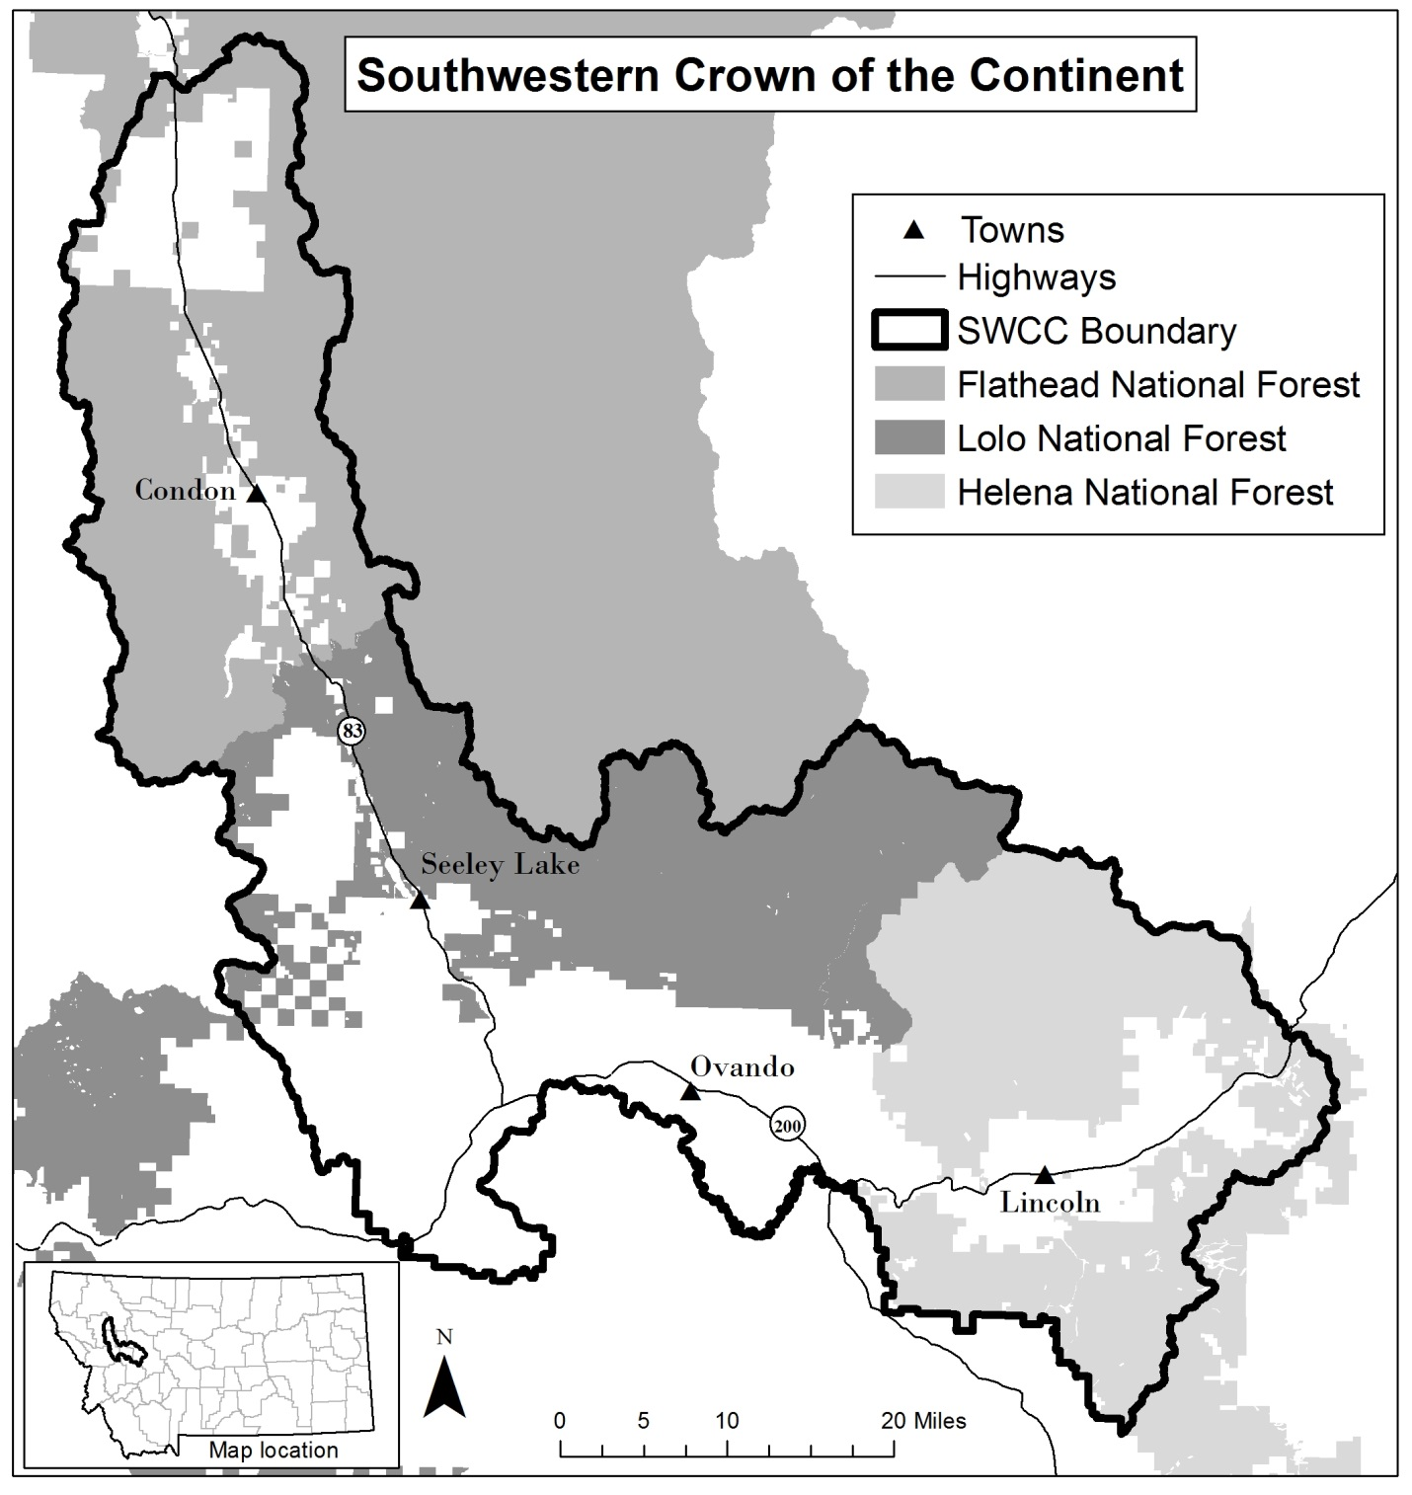**This survey mainly refers to the area inside the dark black line on the map below. The area is referred to as the “Southwest Crown of the Continent,” and includes the towns of Condon, Seeley Lake, Ovando, and Lincoln.**

**Please go to the next page and begin.**

# *According to the Paperwork Reduction Act of 1995, an agency may not conduct or sponsor, and a person is not required to respond to, a collection of information unless it displays a valid OMB control number. The valid OMB control number for this information collection is 0596-NEW. The time required to complete this information collection is estimated to average 20 minutes per response, including the time for reviewing instructions, searching existing data sources, gathering and maintaining the data needed, and completing and reviewing the collection of information.*

# start here

**We are interested in hearing from local residents about how National Forests in the area should be managed. Please answer the following questions about your views on National Forest use and management.**

**1. Have you participated in any of the following activities on National Forests in the last five (5) years? (Select all that apply)**

Hiking/walking

Downhill skiing

Fishing

Hunting

Cross-country skiing

Developed camping

Viewing wildlife

Relaxing

Snowmobiling

Driving for pleasure

Bicycling

Other (please specify):_______________________________

**2. From this list, what was your primary activity on National Forests in the last five (5) years?**

_______________________________________________________ (primary activity)

**3. If you had to pick one thing, what do you value most about the nearby National Forests?**

**_________________________________________________________________________________________________________**

# Forest Management Goals

**4. How important or unimportant are the following forest management goals?**

Mark one box (X) for each item below.

|  |  |  |  |  |  |
| --- | --- | --- | --- | --- | --- |
|  | Very Unimportant  (1) | Unimportant  (2) | Neither  (3) | Important  (4) | Very Important  (5) |
| **a. Maintaining quality habitat for native wildlife** |  |  |  |  |  |
| **b. Supporting healthy streams for native fish populations** |  |  |  |  |  |
| **c. Reintroducing fire as a natural forest process** |  |  |  |  |  |
| **d. Reducing occurrence of large wildfires** |  |  |  |  |  |
| **e. Reducing risk to communities from wildfires** |  |  |  |  |  |
| **f. Reducing risk to private property from wildfires** |  |  |  |  |  |
| **g. Reducing non-native, invasive weeds** |  |  |  |  |  |
| **h. Preserving old growth trees** |  |  |  |  |  |
| **i. Reducing non-native fish species** |  |  |  |  |  |
| **j. Allowing use of the forest to collect firewood, timber, or logs for personal use** |  |  |  |  |  |
| **k. Production of commercial timber products (e.g. lumber, pulp, pellets)** |  |  |  |  |  |
| **m. Supporting non-motorized access opportunities (e.g. hiking, camping, hunting, horse-riding)** |  |  |  |  |  |
| **n. Supporting motorized access opportunities (e.g. snowmobiles, OHV)** |  |  |  |  |  |

**5. How important or unimportant are the following goals for managing National Forest roads?** Mark one box (X) for each item below.

|  |  |  |  |  |  |
| --- | --- | --- | --- | --- | --- |
|  | Very Unimportant  (1) | Unimportant  (2) | Neither  (3) | Important  (4) | Very Important  (5) |
| **a. Reducing the impact of roads on wildlife habitat** |  |  |  |  |  |
| **b. Maintaining all roads that provide public access** |  |  |  |  |  |
| **c. Decreasing erosion from roads into streams/rivers** |  |  |  |  |  |
| **d. Maintaining road access for fire-fighting** |  |  |  |  |  |
| **e. Maintaining road access for timber harvesting** |  |  |  |  |  |

**6. Please tell us how much you agree or disagree with the following statements. Mark one box (X) for each item below.**

|  |  |  |  |  |  |
| --- | --- | --- | --- | --- | --- |
| **In the past five (5) years, National Forest managers in my area have done a good job…** | Strongly Disagree  (1) | Disagree  (2) | Neither  (3) | Agree  (4) | Strongly Agree  (5) |
| **a. Managing roads for recreational access** |  |  |  |  |  |
| **b. Managing roads for wildlife habitat** |  |  |  |  |  |
| **c. Managing for quality wildlife habitat** |  |  |  |  |  |
| **d. Managing for quality fish/aquatic habitats** |  |  |  |  |  |
| **e. Reducing non-native fish species** |  |  |  |  |  |
| **f. Managing for forest health** |  |  |  |  |  |
| **g. Reintroducing fire as a natural forest process** |  |  |  |  |  |
| **h. Reducing risks of large wildfires near communities** |  |  |  |  |  |
| **i. Reducing wildfire management costs** |  |  |  |  |  |
| **j. Supporting the forest products industry** |  |  |  |  |  |
| **k. Supporting the economic health of local communities** |  |  |  |  |  |
| **l. Providing quality recreation experiences** |  |  |  |  |  |
| **m. Managing for visual attractiveness** |  |  |  |  |  |
| **n. Controlling invasive weeds** |  |  |  |  |  |

# Current Forest Management

**7. In general, what do you think of the current number of roads in your National Forests?** Mark one box (X).

Far too few

Too few

Just right

Too many

Far too many

**8. In general, what do you think of the current amount of money spent on suppressing forest fires on your National Forests?** Mark one box (X).

Far too little

Too little

Just right

Too much

Far too much

**9. In general, what do you think of the current level of tree densities in your National Forests?** Mark one box (X).

Not dense enough

Dense enough

Too dense

Don’t know

# The Future of National Forests

**10. How strongly do you agree or disagree with the following statements about future National Forest management?**

Mark one box (X) for each item below.

|  |  |  |  |  |  |
| --- | --- | --- | --- | --- | --- |
| **I believe the National Forest lands around my community should …** | Strongly Disagree  (1) | Disagree  (2) | Neither  (3) | Agree  (4) | Strongly Agree  (5) |
| **a. Be kept wild (i.e., little human interference)** |  |  |  |  |  |
| **b. Provide opportunities for solitude** |  |  |  |  |  |
| **c. Support our economy through timber production** |  |  |  |  |  |
| **d. Support our economy through ranching/grazing** |  |  |  |  |  |
| **e. Support our economy through tourism** |  |  |  |  |  |
| **f. Provide opportunities for recreating in a challenging landscape** |  |  |  |  |  |

# Specific Forest MANAGEMENT Activities

**11. How strongly do you agree or disagree with the following statements about forestry activities that might take place on National Forests in your area?**

|  |  |  |  |  |  |
| --- | --- | --- | --- | --- | --- |
| Mark one box (X) for each item below. | Strongly Disagree  (1) | Disagree  (2) | Neither  (3) | Agree  (4) | Strongly Agree  (5) |
| **FORESTRY ACTIVITIES** | | | | | |
| **a. Removing some trees (thinning) reduces the severity of wildfires** |  |  |  |  |  |
| **b. Removing some trees (thinning) reduces long-term firefighting costs** |  |  |  |  |  |
| **c. I would like to see more forest thinning near communities** |  |  |  |  |  |
| **d. I would like to see more forest thinning in areas farther away from communities** |  |  |  |  |  |
| **e. Visual attractiveness should be considered when designing a thinning project** |  |  |  |  |  |
| **f. Clear cuts are an acceptable tool for forest management** |  |  |  |  |  |
| **g. Following fire or beetle kill, dead trees should be harvested** |  |  |  |  |  |
| **PRESCRIBED and WILDLAND FIRE** | | | | | |
| **h. Prescribed fires are an acceptable tool for fire prevention near communities** |  |  |  |  |  |
| **i. Prescribed fires are an acceptable tool for maintaining forest health in areas farther away from communities** |  |  |  |  |  |
| **j. Prescribed fires reduce long-term firefighting costs** |  |  |  |  |  |
| **k. Prescribed fires reduce the severity of wildfires** |  |  |  |  |  |
| **l. Some wildfires should be allowed to burn if they don’t threaten people’s lives or property** |  |  |  |  |  |
| **m. The smoke from prescribed burns is usually justified** |  |  |  |  |  |
| **WEED MANAGEMENT AND RECREATION** | | | | | |
| **n. Spraying herbicides on weeds along roads is acceptable as part of a weed management strategy** |  |  |  |  |  |
| **o. Aerial spraying of herbicides on weeds is acceptable as part of a weed management strategy** |  |  |  |  |  |
| **p. The Forest Service provides an adequate amount of recreation infrastructure (trails, campgrounds, etc.)** |  |  |  |  |  |

# Public Involvement

**12. Have you been involved in National Forest decision making processes using any of the following means?**

|  |  |  |  |
| --- | --- | --- | --- |
|  | Never  (1) | Sometimes  (2) | Frequently  (3) |
| **a. Attended public meetings** |  |  |  |
| **b. Talked to neighbors** |  |  |  |
| **c. Contacted elected officials** |  |  |  |
| **d. Wrote a letter to the editor** |  |  |  |
| **e. Submitted written comments on a project** |  |  |  |
| **f. Volunteered on a project** |  |  |  |
| **g. Joined a citizen advisory committee** |  |  |  |
| **h. Other (please specify):** | | | |

**13. How familiar are you with these programs and groups?**

|  |  |  |  |
| --- | --- | --- | --- |
| **How familiar are you with…** | Not familiar  (1) | Somewhat familiar  (2) | Very familiar  (3) |
| **a. The National Forest Service’s Collaborative Forest Landscape Restoration Program (CFLRP)** |  |  |  |
| **b. The Southwestern Crown Collaborative** |  |  |  |

**14. How strongly do you agree or disagree with the following statements?**

Mark one box (X) for each item below.

|  |  |  |  |  |  |
| --- | --- | --- | --- | --- | --- |
| **Over the past five (5) years…** | Strongly Disagree  (1) | Disagree  (2) | Neither  (3) | Agree  (4) | Strongly Agree  (5) |
| **a. I have had sufficient opportunity to comment on Forest Service management** |  |  |  |  |  |
| **b. There were ample opportunity for public input on Forest Service decisions** |  |  |  |  |  |
| **c. The local community has been involved in decisions about Forest Service management** |  |  |  |  |  |
| **e. Public comments were seriously considered by the Forest Service** |  |  |  |  |  |
| **f. Decisions were already made before the public had a chance to comment** |  |  |  |  |  |
| **g. Providing public comment felt meaningless** |  |  |  |  |  |
| **h. Final decisions balanced the concerns of most people** |  |  |  |  |  |

**15. How could the Forest Service better involve residents like you?** Write your response on the lines provided below.

**_________________________________________________________________________________________________________**

**_________________________________________________________________________________________________________**

**_________________________________________________________________________________________________________**

# Modes of Communication

**16. How useful, if at all, do you find the following modes of communication used by Forest Service managers?** Mark one box (X) for each item below.

|  |  |  |  |  |  |
| --- | --- | --- | --- | --- | --- |
|  | Not at all useful  (1) | Slightly useful  (2) | Moderately useful  (3) | Very useful  (4) | Extremely useful  (5) |
| **a. Personal, one-on-one interaction** |  |  |  |  |  |
| **b. Information booths at community events (e.g. farmer’s markets, festivals)** |  |  |  |  |  |
| **c. Large public meetings** |  |  |  |  |  |
| **d. Field trips with Forest Service** |  |  |  |  |  |
| **e. E-mails** |  |  |  |  |  |
| **f. Social media (e.g., Facebook, Twitter)** |  |  |  |  |  |
| **g. Official websites** |  |  |  |  |  |
| **h. Print material (e.g. letters, brochures)** |  |  |  |  |  |
| **i. Local print news outlets (e.g., Pathfinder, Blackfoot Valley Dispatch)** |  |  |  |  |  |
| **j. Regional print news outlets (e.g., Missoulian, Independent Record)** |  |  |  |  |  |
| **k. Through local non-profit organizations (e.g. Blackfoot Challenge, Clearwater Resource Council, Swan Valley Connections, Trout Unlimited, etc.)** |  |  |  |  |  |
| **l. Through meetings of local citizen groups (e.g., Southwestern Crown Collaborative, Lolo or Lincoln Restoration Committee)** |  |  |  |  |  |

**17. Are there any other ways you would like to receive communication from the Forest Service?** Write your response on the lines provided below.

**_________________________________________________________________________________________________________**

**_________________________________________________________________________________________________________**

**________________________________________________________________________________________________________**

# Environmental VIEWS

**18. How strongly do you agree or disagree with the following statements about the environment?** Mark one box (X) for each item below.

|  |  |  |  |  |  |
| --- | --- | --- | --- | --- | --- |
|  | Strongly Disagree  (1) | Disagree  (2) | Neither  (3) | Agree  (4) | Strongly Agree  (5) |
| **a. The primary value of forests is to generate income** |  |  |  |  |  |
| **b. The primary value of forests is as a resource for human livelihoods** |  |  |  |  |  |
| **c. Nature’s primary value is to provide products useful to people** |  |  |  |  |  |
| **d. Nature has as much right to exist as people** |  |  |  |  |  |
| **e. Wildlife, plants, and people have equal rights to live and develop** |  |  |  |  |  |
| **f. Forests have value, whether people are present or not** |  |  |  |  |  |

# Trust

**19. How strongly do you agree or disagree with the following statements about local Forest Service managers?** Mark one box (X) for each item below.

|  |  |  |  |  |  |
| --- | --- | --- | --- | --- | --- |
|  | Strongly Disagree  (1) | Disagree  (2) | Neither  (3) | Agree  (4) | Strongly Agree  (5) |
| **a. In general, Forest Service managers have similar goals for the forests as I do** |  |  |  |  |  |
| **b. Forest Service managers in my area are knowledgeable about forest management techniques** |  |  |  |  |  |
| **c. Forest Service managers in my area are sensitive to the local impacts of their decisions/actions** |  |  |  |  |  |
| **d. Forest Service managers in my area do a good job communicating with the public** |  |  |  |  |  |
| **e. My interactions with Forest Service managers in my area have been generally positive** |  |  |  |  |  |
| **f. I trust local Forest Service managers to make the proper decisions about forest management** |  |  |  |  |  |
| **g. I personally know and interact with local Forest Service employees** |  |  |  |  |  |

**20. How strongly do you agree or disagree with the following statements about interacting with people in general?** Mark one box (X) for each item below.

|  |  |  |  |  |  |
| --- | --- | --- | --- | --- | --- |
|  | Strongly Disagree  (1) | Disagree  (2) | Neither  (3) | Agree  (4) | Strongly Agree  (5) |
| **a. You can’t be too careful dealing with people** |  |  |  |  |  |
| **b. People are generally interested in their own welfare** |  |  |  |  |  |
| **c. One has to be alert or someone is likely to take advantage of you** |  |  |  |  |  |

# demographics

**21. How many years have you lived in the local community?** Write the number of years in the space provided below.

___ ___ years

**22. Do you live in the Southwest Crown (Swan, Blackfoot, and Clearwater Valleys) year-round or seasonally?**

Year-round Seasonally (I live outside this area for part of the year)

**23. In what year were you born?** Write the year of your birth in the space provided below.

**19**___ ___ year of your birth

**24. What is your gender?**  Mark one box (X).

Male Female

**25. What is the highest grade of school you have completed?** Mark one box (X).

Grade School

High School Graduate/ GED equivalent

Some College

College Graduate (e.g. Bachelor’s degree, Associate’s degree)

Post Graduate (e.g. Master’s degree or Ph.D)

**26. What was your 2015 household income before taxes?** Your best guess is ok. Mark one box (X).

Less than $10,000

$10,000 to $19,000

$20,000 to $39,999

$40,000 to $59,999

$60,000 to $79,999

$80,000 to $99,999

$100,000 to $119,000

$120,000 to $139,999

$140,000 or more

Don’t know

**27. How much of your income do you generate through the use of National Forest Lands (e.g., timber harvesting, non-timber forest products such as berries or firewood, outfitting, working for the Forest Service, photography, other recreation).**

None Very little Some About half Most Almost all All

(1) (2) (3) (4) (5) (6) (7)

**28. Thank you for completing this survey. If there are any other issues or input you would like to share, please include them in the space below or contact us directly.**

**_________________________________________________________________________________________________________**

**_________________________________________________________________________________________________________**

**_________________________________________________________________________________________________________**

**_________________________________________________________________________________________________________**

**_________________________________________________________________________________________________________**

**Thank you for taking this survey!**