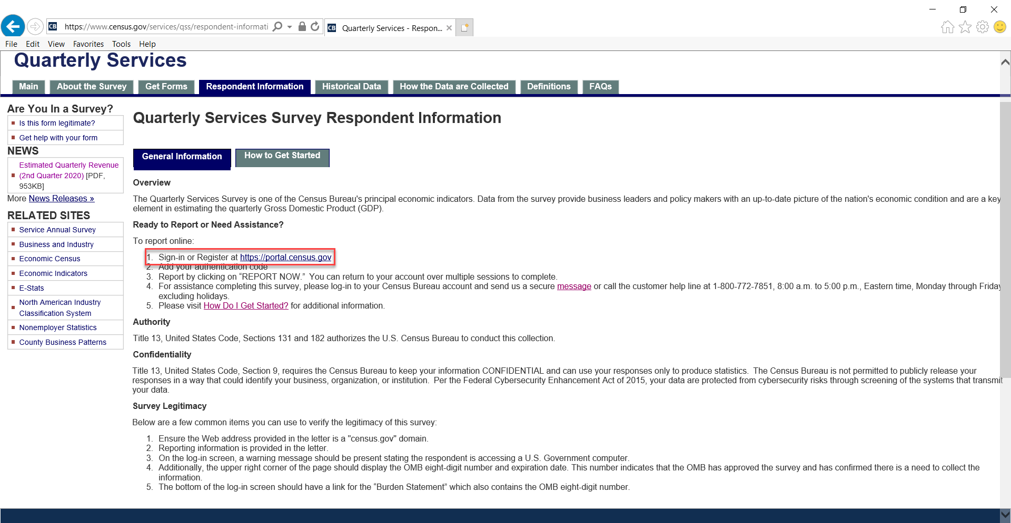
- Access to the respondent portal from the QSS website

- Respondent Portal
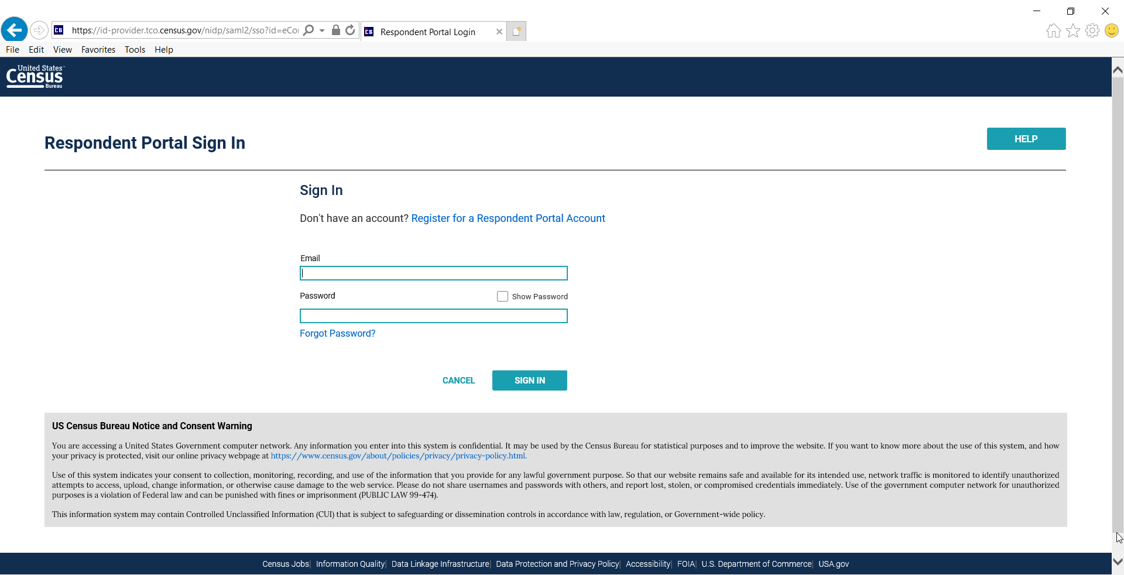

- Respondent adds new authentication code and then clicks “report now” to be routed to Centurion (data collection instrument)

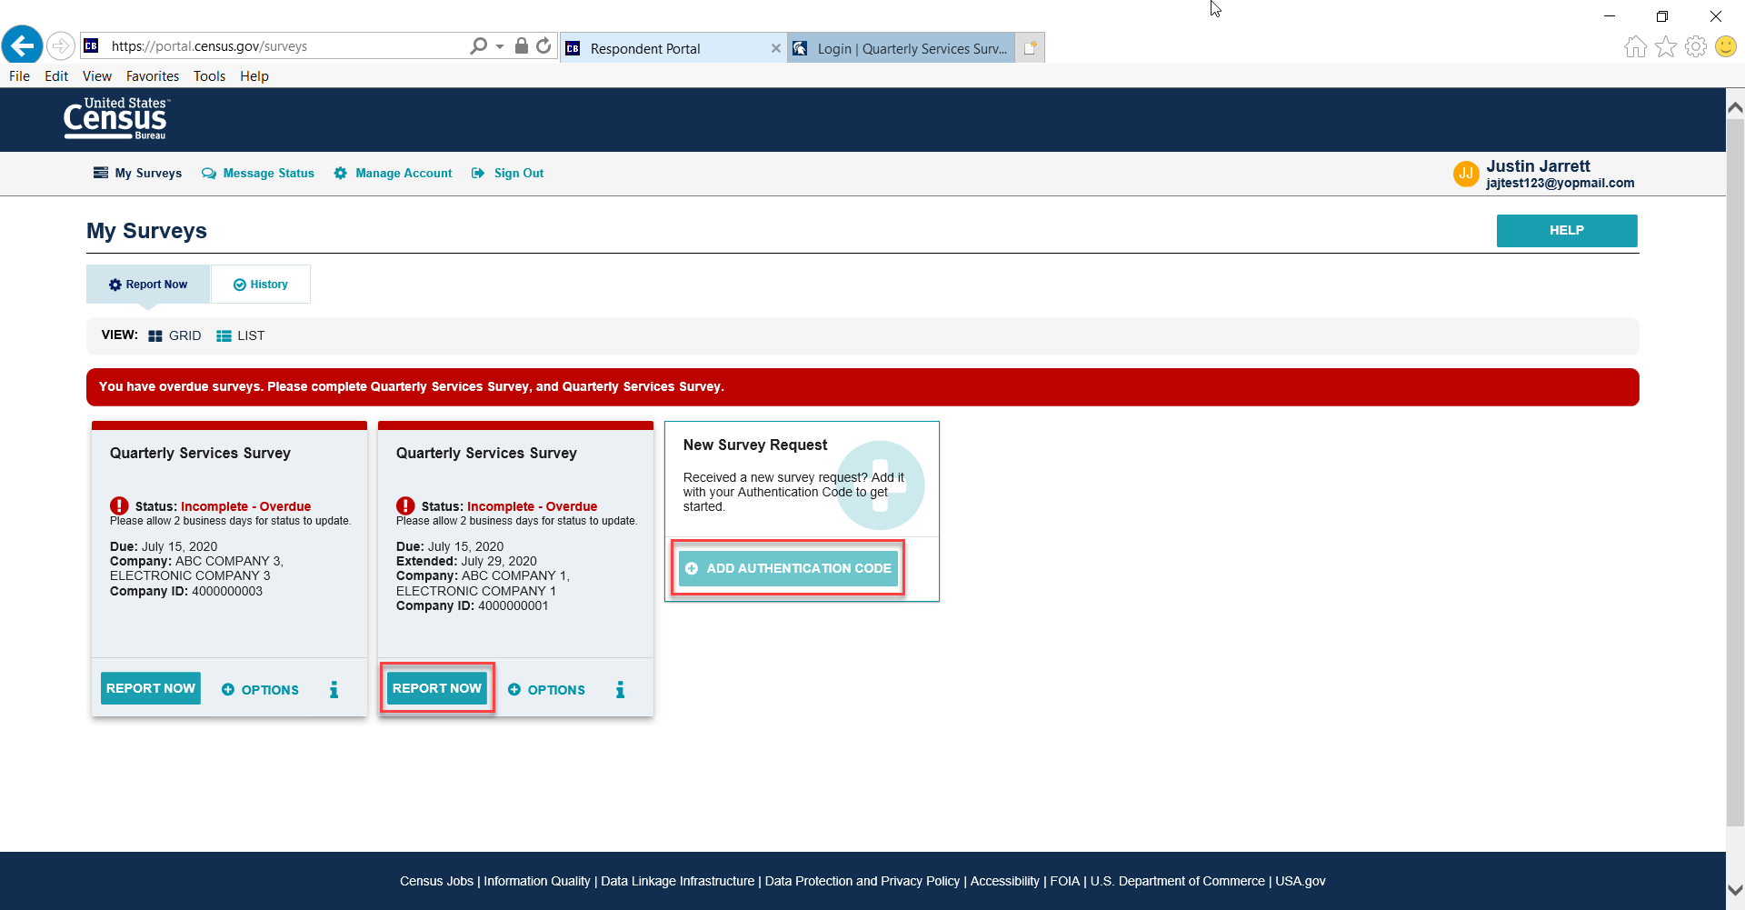

- Centurion Instrument – Entry Point
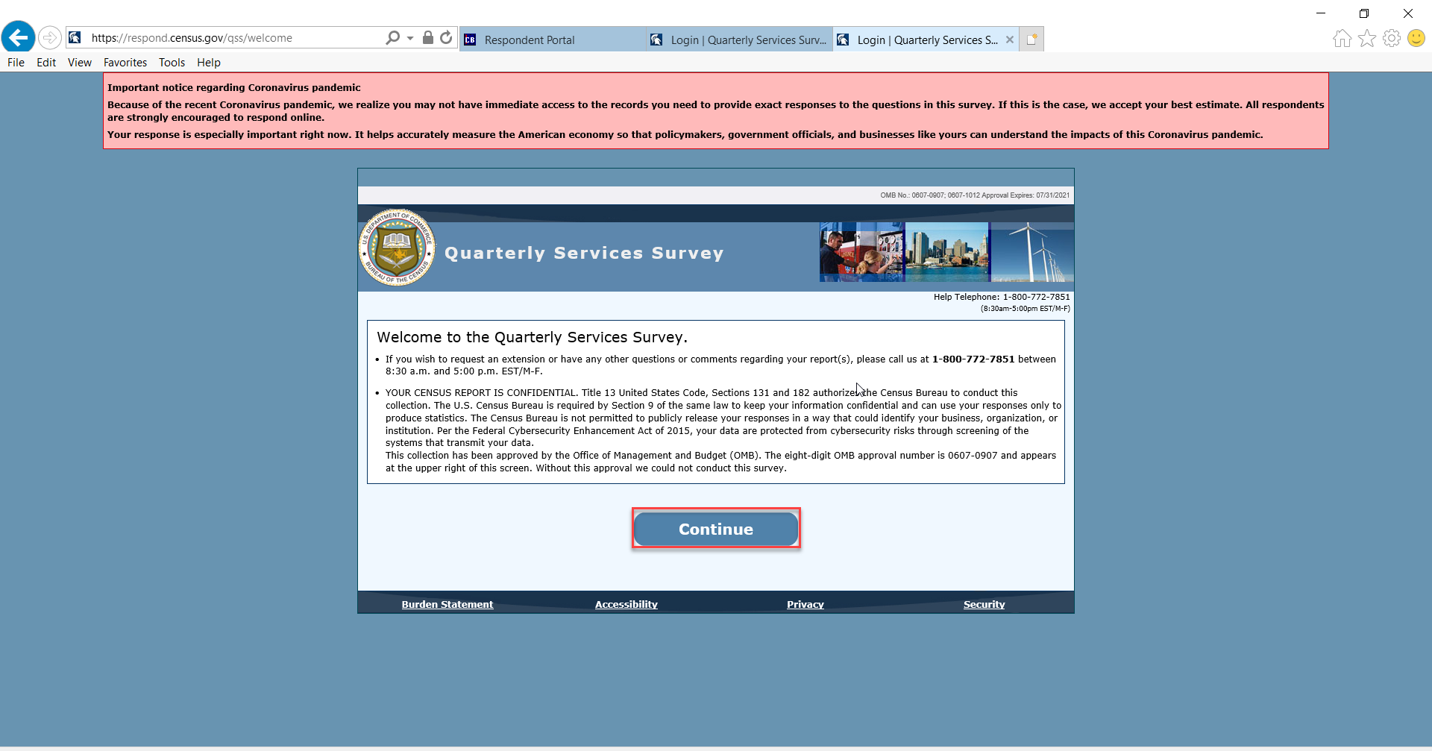

- Centurion – Main Menu
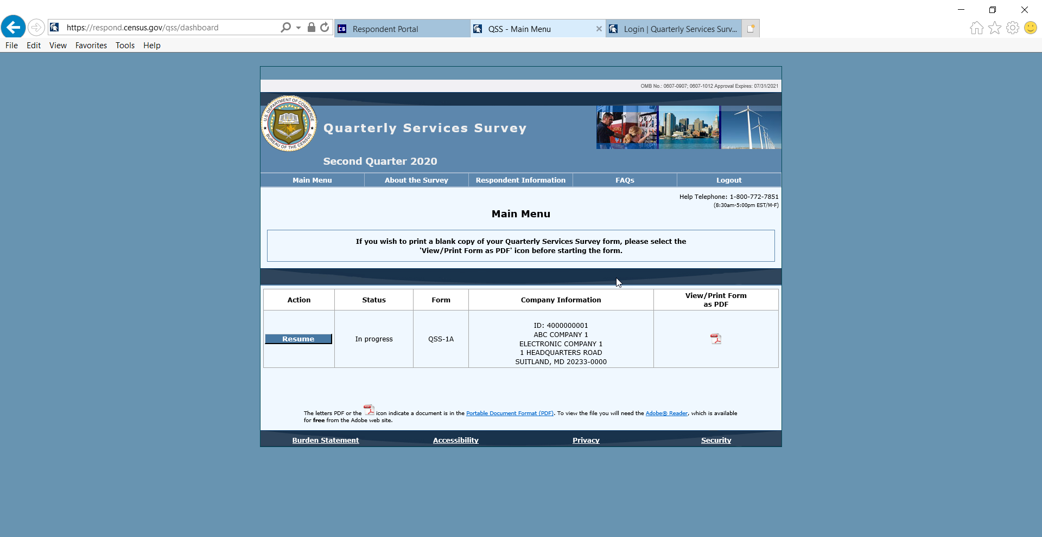

- Burden Statement
