Attachment C3: Fresh Empire Screener (Survey)
RIHSC No. 18-049CTP
OMB No. 0910-0810
Exp. Date: 10/31/2021

[THE FOLLOWING TEXT WILL BE PRESENTED BEFORE THE SCREENER]:

Fors Marsh Group (FMG), a research organization, is conducting a research study sponsored by the U.S. Food and Drug Administration (FDA). FMG will conduct an online survey with 800 teens ages 13-17 to get their opinions regarding a variety of tobacco-related facts intended to prevent tobacco use among youth. Participants in the study will receive a $10 gift card.

We would like to ask you to take a short screening survey to see if you qualify for this study. The screening survey asks questions about your tobacco-related behaviors as well as some general demographic questions which will only take about 5 minutes. Your answers to the questions will be kept private, meaning we won’t share them with anyone outside the research team. We will try our best to maintain the privacy of data collected. Still, a breach could occur by accident or as a result of hacking. Your participation is voluntary and you can stop at any time. There is no direct benefit to you for participating in the screening survey. If we determine that you are eligible, you will be invited to take the online survey.
If you have any questions about the study, you may contact the research team through Shane Mannis of FMG at (571) 858-3757 or pi@forsmarshgroup.com.

Do you consent to participate in this short screening survey?

- Yes, I agree to participate in this short screener GO TO SCREENER
- No, I do not want to participate in this short screener THANK AND TERMINATE

[TERMINATION TEXT]: “Thank you for interest in this study! We appreciate your time.”

[ONLY PARTICIPANTS WHO AGREE TO TAKE THE SCREENER WILL BE TAKEN TO THE QUESTIONS BELOW]

[ONLINE SCREENER]

[Unless otherwise noted, each item will be presented on a separate page, separated by a “NEXT” button.]

DEMOGRAPHICS AND TOBACCO USE

A1. How old are you?
12 years old or younger TERMINATE
13 years old
14 years old
15 years old
16 years old
17 years old
18 years old or older TERMINATE

[Programmer: ONLY ASK A1_a IF A1=“17”]
A1_a. Will you turn 18 by [study end date]?
Yes TERMINATE
No

[Tobacco use and openness to tobacco use questions will be grouped into sets by tobacco product. The order of the tobacco product sets will be randomized by participant.]

[Set 1, page 1: Cigarettes]

A2. Have you ever tried cigarette smoking, even one or two puffs?
Yes [CONTINUE TO A3]
No [SKIP TO A4]

[Set 1, page 2a: Cigarettes]

A3. About how many cigarettes have you smoked in your entire life? Your best guess is fine.
1 or more puffs but never a whole cigarette [CONTINUE TO A5]
1 cigarette [CONTINUE TO A5]
2 to 5 cigarettes [CONTINUE TO A5]
6 to 15 cigarettes (about 1/2 pack total) [CONTINUE TO A5]
16 to 25 cigarettes (about 1 pack total) [CONTINUE TO A5]
26 to 99 cigarettes (more than 1 pack, but less than 5 packs) [CONTINUE TO A5]
100 or more cigarettes (5 or more packs) [TERMINATE]

[Set 1, page 2b: Cigarettes]

A4. Do you think you will try a cigarette soon?
Definitely yes
Probably yes
Probably not
Definitely not

A5. Do you think you will smoke a cigarette at any time in the next year?
Definitely yes
Probably yes
Probably not
Definitely not

A6. If one of your friends were to offer you a cigarette, would you smoke it?
Definitely yes
Probably yes
Probably not
Definitely not

[CONTINUE TO NEXT RANDOMIZED TOBACCO PRODUCT SET]

[Set 2, page 1: Cigar products]

A7. Have you ever tried smoking cigars, cigarillos, or little cigars, such as Black and Milds, Swisher Sweets, Dutch Masters, White Owl, or Phillies Blunts, even one or two puffs?
Yes [CONTINUE TO A9]
No [CONTINUE TO A8]

[Set 2, page 2: Cigar products]

A8. Do you think you will try a cigar, cigarillo, or little cigar, such as Black and Milds, Swisher Sweets, Dutch Masters, White Owl, or Phillies Blunts, soon?
Definitely yes
Probably yes
Probably not
Definitely not

A9. Do you think you will smoke a cigar, cigarillo, or little cigar, such as Black and Milds, Swisher Sweets, Dutch Masters, White Owl, or Phillies Blunts, in the next year?
Definitely yes
Probably yes
Probably not
Definitely not

A10. If one of your friends were to offer you a cigar, cigarillo, or little cigar, such as Black and Milds, Swisher Sweets, Dutch Masters, White Owl, or Phillies Blunts, would you smoke it?
Definitely yes
Probably yes
Probably not
Definitely not

[CONTINUE TO NEXT RANDOMIZED TOBACCO PRODUCT SET]

[Set 3, page 1: Hookah]

A11. Have you ever tried smoking tobacco in a hookah or waterpipe, even one or two puffs?
Yes [CONTINUE TO A13]
No [CONTINUE TO A12]

[Set 3, page 2: Hookah]

A12. Do you think you will try smoking tobacco in a hookah or waterpipe soon?
Definitely yes
Probably yes
Probably not
Definitely not

A13. Do you think you will smoke tobacco in a hookah or waterpipe in the next year?
Definitely yes
Probably yes
Probably not
Definitely not

A14. If one of your friends were to offer you tobacco in a hookah or waterpipe, would you smoke it?
Definitely yes
Probably yes
Probably not
Definitely not
[CONTINUE TO NEXT RANDOMIZED TOBACCO PRODUCT SET]

[Set 4, page 1: E-Cigarettes]

A15. Have you ever tried vaping or smoking electronic cigarettes, e-cigarettes, vape pens, or hookah pens, such as Juul, Fin, NJOY, Blu, e-Go, or Vuse, even one or two puffs?
Yes [CONTINUE TO A17]
No [CONTINUE TO A16]

[Set 4, page 2: E-Cigarettes]

[RANDOMIZE ORDER]

A16. Do you think you will try a vape, an electronic cigarette, e-cigarette, vape pen, or hookah pen, such as Juul, Fin, NJOY, Blu, e-Go, or Vuse, soon?
Definitely yes
Probably yes
Probably not
Definitely not

A17. Do you think you will vape or smoke an electronic cigarette, e-cigarette, vape pen, or hookah pen, such as Juul, Fin, NJOY, Blu, e-Go, or Vuse, in the next year?
Definitely yes
Probably yes
Probably not
Definitely not

A18. If one of your friends were to offer you a vape or to smoke an electronic cigarette, e-cigarette, vape pen, or hookah pen, such as Juul, Fin, NJOY, Blu, e-Go, or Vuse, would you smoke it?
Definitely yes
Probably yes
Probably not
Definitely not

[Each of the following items will be presented on a separate page, separated by a “NEXT” button.]

A19. What is your sex?
Female
Male

A20. What is the 5-digit zip code where you CURRENTLY live?
___ ___ ___ ___ ___

A21. Are you Hispanic, Latino/a, or Spanish origin? (You can choose one answer or more than one answer)
No, not of Hispanic, Latino/a, or Spanish origin
Yes, Mexican, Mexican American, Chicano or Chicana
Yes, Puerto Rican
Yes, Cuban
Yes, another Hispanic, Latino/a, or Spanish origin

A22. What race or races do you consider yourself to be? (You can choose one answer or more than one answer)
American Indian or Alaska Native
Asian
Black or African American
Native Hawaiian or Other Pacific Islander
White
Other

MARKETING AND RESEARCH

B1. Do you or any member of your immediate family or a close friend work for...? (Select all that apply)
A market research company
A tobacco company (manufacturer or importer of tobacco products)
An advertising agency or public relations firm
The media (TV/radio/newspapers/magazines)
A healthcare professional (doctor, nurse, pharmacist, dietician, etc.)
None of these

B2. Have you ever received money or gift cards from a company for sharing your opinions about tobacco in a discussion group, interview or survey?
Yes, within the past 6 months
Yes, more than 6 months ago
No
I’m not sure

PICTURE SELECTION EXERCISE

B3. Rank the 3 people that would BEST FIT in your main group of friends by clicking on the pictures. The first picture you select by clicking on it will be the best fit overall.

B4. Rank the 3 people that would LEAST FIT in your main group of friends by clicking on the pictures. The first picture you select by clicking on it will be the least fit overall.
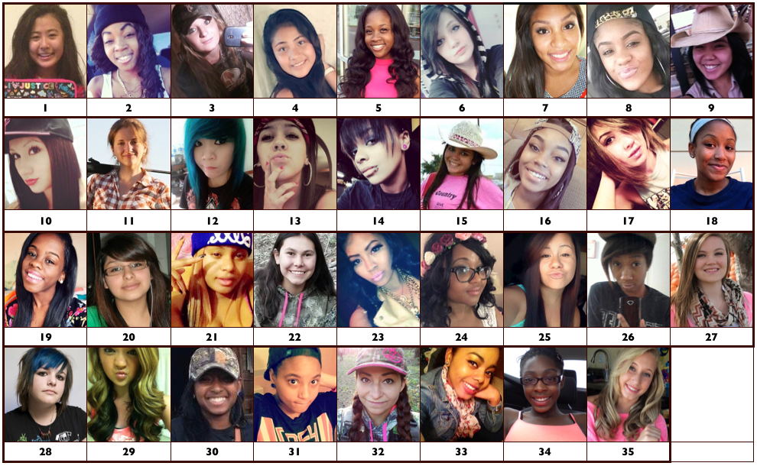

B5. Rank the 3 people that would BEST FIT in your main group of friends by clicking on the pictures. The first picture you select by clicking on it will be the best fit overall.

B6. Rank the 3 people that would LEAST FIT in your main group of friends by clicking on the pictures. The first picture you select by clicking on it will be the least fit overall.
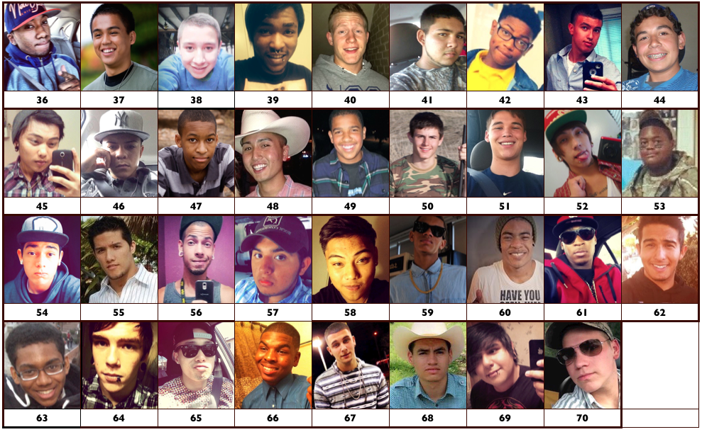

B7. People often hang out in different groups at school. For example, a lot of schools have a group of “jocks.” Some students gave the following list of groups. Please indicate how much you identify with each group by dragging the bar across the screen. Dragging the bar to 100 means you identify with this group very much and dragging the bar to 0 means you do not identify with this group at all.
[RANDOMIZE Programming note: Please have slider from 0–100 for each group]

 |  | 0——————100 | 9  Prefer not to answer
B7_1 | Hipsters | ₀——————₁₀₀ | ₉
B7_2 | Skaters | ₀——————₁₀₀ | ₉
B7_3 | Jocks | ₀——————₁₀₀ | ₉
B7_4 | Athletes | ₀——————₁₀₀ | ₉
B7_5 | Rockers | ₀——————₁₀₀ | ₉
B7_6 | Goth | ₀——————₁₀₀ | ₉
B7_7 | Emo | ₀——————₁₀₀ | ₉
B7_8 | Gangster | ₀——————₁₀₀ | ₉
B7_9 | Partyers | ₀——————₁₀₀ | ₉
B7_10 | Hip-hop | ₀——————₁₀₀ | ₉
B7_11 | Country | ₀——————₁₀₀ | ₉
B7_12 | Popular | ₀——————₁₀₀ | ₉
B7_13 | Mainstream | ₀——————₁₀₀ | ₉
B7_14 | Alternative | ₀——————₁₀₀ | ₉

EMAIL ADDRESS
C1. What is your email address? (To receive the main survey link): ______________
Please confirm the email address above: ___________

[IF EMAILS PROVIDED IN C1 DO NOT MATCH, PROVIDE ERROR MESSAGE]

[SCREEN OUT DISQUALIFYING YOUTH BEFORE PROCEEDING TO NEXT PAGE.]
[IF A1 = A OR G, DISQUALIFY]
[IF A1=”17 years old” AND A1_a=”Yes”, DISQUALIFY]
[IF A2 = A AND A3 = G, DISQUALIFY]
[IF A2 = B AND A4 = D AND A5 = D AND A7 = B AND A8 = D AND A9 = D AND A11 = B AND A12 = D AND A13 = D, DISQUALIFY]
[IF A20 IS NOT ZIP CODE WITHIN 48 CONTIGUOUS STATES OR DC, DISQUALIFY]
[IF B1 = B, DISQUALIFY]
[IF B2 = A, DISQUALIFY]
[IF HIP-HOP I-BASE SCORE < 4, DISQUALIFY]
[IF C1 MATCHES EMAIL ADDRESS ALREADY IN DATASET, DISQUALIFY]

[ELSE, QUALIFY]

[TEXT PRESENTED TO DISQUALIFIED PARTICIPANTS]: “Thank you for answering our questions! Unfortunately, you will not be invited to take part in the survey.”

[TEXT PRESENTED TO QUALIFIED PARTICIPANTS]: “Congrats! You qualify to complete the survey! We just need a little more info so we can send you the link in about 24 hours. You’ll receive a $10 gift card after you submit the survey.”

[TEXT BELOW WILL BE SHOWN ONLY TO PARTICIPANTS WHO QUALIFY]

CONTACT INFO PAGE
D1. If you would also like to receive the survey link by text message, please provide a phone number that we can text the link to.

Cell Phone Number: (__) ___ - ____
I do not have a cell phone number

[ANSWER REQUIRED TO PROCEED]

D2. Just one last thing. Before we can send you the full survey, we need to email a copy of our Opt-Out Form to your parent or guardian. This form explains what you will be doing, and provides them with a way to contact us only if they do NOT want you to complete the survey.

Parent or guardian’s email address: ___________________

As a reminder, we will not share your answers with anyone outside the study, including your parents.

[TEXT PRESENTED TO QUALIFIED PARTICIPANTS]: “Thank you! We will email you the link to the full survey in about 24 hours. After you submit the full survey, you will receive your $10 gift card. Don’t forget to check your SPAM if you do not see the survey link after 24 hours.”

Please note that you can only submit this survey once and receive one gift card. Fraudulent or duplicate surveys will not be eligible to receive a gift card.

Form Approved
OMB No. 0910-0810
Exp. Date: 10/31/2021
RIHSC #18-049CTP

Paperwork Reduction Act Statement: The public reporting burden for this information collection has been estimated to average 5 minutes per response to complete this survey (the time estimated to read and complete). Send comments regarding this burden estimate or any other aspects of this information collection, including suggestions for reducing burden, to PRAStaff@fda.hhs.gov.

