**OMB Control No. 0910-0810**

**Exp. Date: 10/31/2021**

**ATTACHMENT 1: PROMISING THEMES STUDY SCREENER**

**NOTE FOR INVESTIGATORS:** The Promising Themes Study is designed to identify beliefs or belief categories (themes) that can be used to prevent initiation or progression to established use, or promote quitting, among youth and young adults in relation to four product types: little cigars and cigarillos, vapes, smokeless tobacco, and cigarettes. This work is based on similar studies conducted by Bob Hornik and colleagues. To conduct the data analyses needed to inform future campaigns, surveys must include individuals with a range of substance use behaviors, including 1) current users, 2) non-current users who are susceptible or open to future use, and 3) non-current users who are closed to future use. This screener reflects that need. This screener may be tailored to focus on one, or a subset, of the product types included here.

**PROGRAMMER NOTE:** FORCE RESPONSES TO ALL SCREENER QUESTIONS.

**[SCNR_INTRO]**

Welcome to the Your Voice Now Survey!

The U.S. Food and Drug Administration (FDA) is developing education programs that will improve the health of youth and young adults.

​  
To inform these education programs, the FDA is conducting a survey in partnership with RTI International, a non-profit research organization. 

* You are being asked to answer a few questions to see if you are eligible for a study of approximately 1,500 youth and young adults in the United States.
* You may only complete this questionnaire **one time.**
* It will only take about **3 minutes**to see if you are eligible.
* If we determine you **are** **eligible**, you will have the opportunity to continue and complete **an additional online survey** for a $5 electronic gift card as a token of appreciation.
* You may only take that survey one time and you will onlyreceive one **$5 electronic gift card** if you complete it. If we find that you have completed the survey more than once, you may not receive a gift card. Once we complete this check, we will send you a **$5 electronic gift card** to the email address you provide. The gift card will be sent within 1-2 weeks.
* Your answers to the questions will be **kept private** to the fullest extent allowable by law and your participation is voluntary.

**ASK:** All respondents

**[SCNR_ASSENT]**

Do you agree to participate in this short survey?

1. Yes, I agree to participate in this short survey
2. No, I do not want to participate in this short survey

**ASK:** All respondents

**[EXIT_1]** [IF SCNR_ASSENT = 2]

Thank you for your time.

**ASK:** Ask respondents who do not provide assent

**[FB_TXT]** [IF SCNR_ASSENT = YES & RESPONDING FROM FACEBOOK]

RTI International, a non-profit research organization, is doing a survey to learn more about people like you. We (“RTI International”) want to make sure that the person who is taking the survey is who they say they are and does not take the survey more than once. Facebook will help us do this by making sure that you have a real Facebook account. This document will explain what kinds of information Facebook or RTI International may learn about you if you click on the “agree” button.

When you click on “agree,” you are allowing Facebook and RTI International to collect your email that you use to log in to Facebook and your unique Facebook user id number to make sure that you do not take the survey more than once. The information collected will help Facebook check that you have a real account. If you do not agree to allow Facebook and RTI International to collect this information, you should not take this survey. The information about you that we collect here may be added to other information we have about you.

We will protect the information we collect as much as possible. However, since this survey is online, there is still a chance that other people may see some information about you. This is a risk that is part of using the internet. We will do our best to make sure this does not happen.

This document (the Authorization Statement) only talks about the information that could be learned about you as part of the process that Facebook uses to make sure that you have a real Facebook account. Facebook will not share any other information about your account with us. It is possible that other people or organizations could also access this information about you.

**ASK:** Respondents who provide informed assent and are responding from Facebook

**[FB_AUTH]** [IF SCNR_ASSENT = YES & RESPONDING FROM FACEBOOK]

Please click the link to read the Authorization Statement to learn more about how Facebook and others may use the information that is collected. [Facebook Authorization Statement](https://chpstr.rti.org/privacy/fbprivacy.html)

1. I have read the Authorization Statement and agree to provide my Facebook information for such purposes.
2. I decline to provide my information for such purposes

**ASK:** All respondents

**[EXIT_2]** [IF FB_AUTH = 2]

Thank you for your time.

**ASK:** Respondents who do not agree to allow Facebook to collect information for account verification

**[IG_TXT]** [IF SCNR_ASSENT = YES & RESPONDING FROM INSTAGRAM]

RTI International, a non-profit research organization, is doing a survey to learn more about people like you. We (“RTI International”) want to make sure that the person who is taking the survey is who they say they are and does not take the survey more than once. Instagram will help us do this by making sure that you have a real Instagram account. This document will explain what kinds of information Instagram or RTI International may learn about you if you click on the “agree” button.

When you click on “agree,” you are allowing Instagram and RTI International to collect your email that you use to log in to Instagram and your unique Instagram user id number to make sure that you do not take the survey more than once. The information collected will help Instagram check that you have a real account. If you do not agree to allow Instagram and RTI International to collect this information, you should not take this survey. The information about you that we collect here may be added to other information we have about you.

We will protect the information we collect as much as possible. However, since this survey is online, there is still a chance that other people may see some information about you. This is a risk that is part of using the internet. We will do our best to make sure this does not happen.

This document (the Authorization Statement) only talks about the information that could be learned about you as part of the process that Instagram uses to make sure that you have a real Instagram account. Instagram will not share any other information about your account with us. It is possible that other people or organizations could also access this information about you.

**ASK:** Respondents who provide informed assent and are responding from Instagram

**[IG_AUTH]** [IF SCNR_ASSENT = YES & RESPONDING FROM INSTAGRAM]

Please click the link to read the Authorization Statement to learn more about how Instagram and others may use the information that is collected. [Instagram Authorization Statement](https://chpstr.rti.org/privacy/instprivacy.html)

1. I have read the Authorization Statement and agree to provide my Instagram information for such purposes.
2. I decline to provide my information for such purposes

**ASK:** All respondents

**[EXIT_3]** [IF IG_AUTH = 2]

Thank you for your time.

**ASK:** Respondents who do not agree to allow Instagram to collect information for account verification

**[LAND]** [IF R IS ON MOBILE DEVICE]

It looks like you are viewing this survey on a mobile device. This survey works best in landscape mode.Taking the survey on a mobile device might take longer.

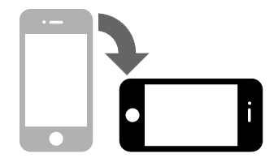

NEXT

**ASK:** All respondents who access the survey via a mobile device.

**[PRIV]**

Please make sure that you can answer the questions in private where no one can see your answers.

1. Next

**ASK:** All respondents

**[DRIV]**

Do not answer the questions while driving.

1. Next

**ASK:** All respondents

**[SCNR_INTRO2]** [IF FB_AUTH = 1 OR IG_AUTH = 1]

The first part of the survey asks a couple general questions about yourself.

**ASK:** Respondents who agree to FB or IG authorization

**[AGE]**

How old are you?

_____________years old [RANGE: 5-98]

99. Prefer not to answer

**ASK:** All respondents

**[GENDER]**

What sex were you assigned at birth, on your original birth certificate?

1. Male
2. Female
3. Refused
4. Don’t know

Do you currently describe yourself as male, female or transgender?

1. Male
2. Female
3. Transgender
4. None of these

Just to confirm, you were assigned {FILL} at birth and now you describe yourself as {FILL}. Is that correct?

1. Yes
2. No
3. Refused
4. Don’t know

**ASK:** All Respondents

**[HISPANIC]**

Are you of Hispanic, Latino/a, or Spanish origin? Select all that apply.

1. Yes

2. No

1. Prefer not to answer

**ASK:** All Respondents

**[RACE]**

What race or races do you consider yourself to be? Select all that apply.

1. American Indian or Alaska Native
2. Asian
3. Black or African American
4. Native Hawaiian or Other Pacific Islander
5. White
6. Prefer not to answer

**ASK:** All Respondents

**[LCC SURVEY SCREENER]**

**[LCC_EVERUSE]**

The next questions are about cigars, cigarillos, or little cigars such as Black & Mild, Swisher Sweets, Dutch Masters, Phillies Blunts, Prime Time, and Winchester.

Please do NOT include products with marijuana when answering these questions.

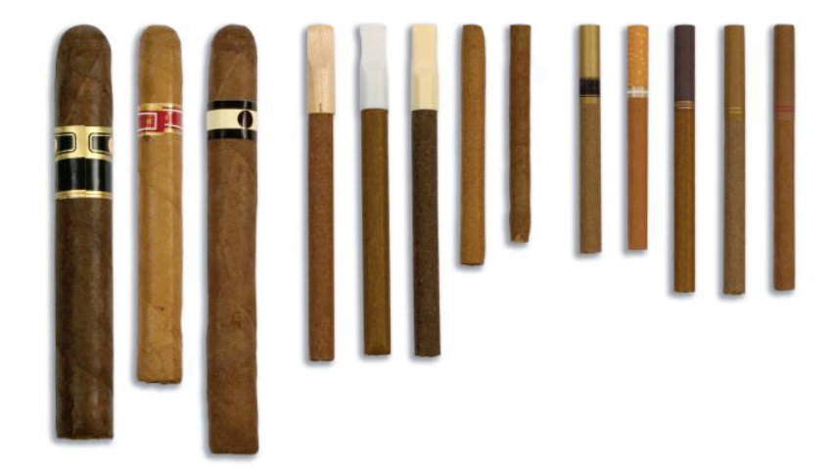

Have you ever smoked cigars, cigarillos, or little cigars even one time?

1. Yes
2. No
3. Prefer not to answer

**ASK:** All respondents.

**[LCC_CURRENTUSE]** [IF LCC_EVERUSE = 1 OR 99]

Please do NOT include products with marijuana when answering these questions.

During the past 30 days, on how many days did you smoke cigars, cigarillos, or little cigars?

_______ days [ALLOW 0-30 days]

99   Prefer not to answer

**ASK**: All respondents who indicate having ever used LCCs or PNTA

**[LCC_SUSCEPT]** [IF LCC_EVERUSE = 2 OR 99 OR LCC_CURRENTUSE = 0 OR 99]

Please do NOT include products with marijuana when answering these questions.

Thinking about the future…

|  |  |  |  |  |  |  |
| --- | --- | --- | --- | --- | --- | --- |
|  |  | **Definitely Yes** | **Probably Yes** | **Probably Not** | **Definitely Not** | **Prefer Not to Answer** |
| LCC_SUSCEPT_1 | Do you think you will smoke **cigars, cigarillos, or little cigars** soon? | 1 | 2 | 3 | 4 | 99 |
| LCC_SUSCEPT_1 | Do you think you will smoke **cigars, cigarillos, or little cigars** at any time in the next year? | 1 | 2 | 3 | 4 | 99 |
| LCC_SUSCEPT_1 | If one of your best friends were to offer you a **cigar, cigarillo, or little cigar**, would you smoke it? | 1 | 2 | 3 | 4 | 99 |

**ASK**: All respondents who indicate having never used LCCs or PNTA, OR who have not used LCCs in the past 30 days or PNTA

**[LCC_CURIOUS]** [IF LCC_EVERUSE = 2 OR 99]

Have you ever been curious about smoking a cigar, cigarillo, or little cigar?

1. Very curious
2. Somewhat curious
3. A little curious
4. Not at all curious

9 Prefer not to answer

**ASK:** Respondents who have never used LCCs or PNTA

**[VAPE SURVEY SCREENER]**

**[VAPE_EVERUSE]**

The next questions are about vaping products or vapes. You may also know them as JUUL, e-cigarettes, vape pens, Suorin, or mods. Some look like cigarettes, and others look like small boxes, pens, or pipes.

Please do NOT include vaping marijuana or THC when answering these questions.

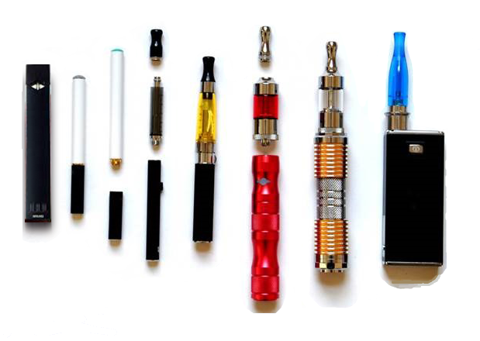

Have you ever tried vaping, even one time?

1. Yes
2. No
3. Prefer not to answer

**ASK:** All respondents

**[VAPE_CURRENTUSE]** [IF VAPE_EVERUSE = 1 OR 99]

Please do NOT include vaping marijuana when answering these questions.

During the past 30 days, on how many days did you vape?

_______ days [ALLOW 0-30 days]

99   Prefer not to answer

**ASK**: All respondents who indicate having ever vaped or PNTA

**[VAPE_SUSCEPT]** [IF VAPE_EVERUSE = 2 OR 99 OR VAPE_CURRENTUSE = 0 OR 99]

Please do NOT include vaping marijuana when answering these questions.

Thinking about the future…

|  |  |  |  |  |  |  |
| --- | --- | --- | --- | --- | --- | --- |
|  |  | **Definitely Yes** | **Probably Yes** | **Probably Not** | **Definitely Not** | **Prefer Not to Answer** |
| VAPE_SUSCEPT_1 | Do you think that you will **vape** soon? | 1 | 2 | 3 | 4 | 99 |
| VAPE _SUSCEPT_2 | Do you think you will **vape** at any time in the next year? | 1 | 2 | 3 | 4 | 99 |
| VAPE _SUSCEPT_3 | If one of your best friends were to offer you a **vape** would you use it? | 1 | 2 | 3 | 4 | 99 |

**ASK**: All respondents who indicate having never vaped or PNTA, OR who have not vaped in the past 30 days or PNTA

**[VAPE_CURIOUS]** [IF VAPE_EVERUSE = 2 OR 99]

Have you ever been curious about vaping?

1. Very curious
2. Somewhat curious
3. A little curious
4. Not at all curious

9 Prefer not to answer

**ASK:** Respondents who have never vaped or PNTA

**[SMOKELESS SURVEY SCREENER]**

**[SMOKELESS_EVERUSE]**

The next questions are about smokeless tobacco, such as dip, chewing tobacco, snuff, or snus. Common brands include [EDIT IF NECESSARY Copenhagen, Grizzly, Skoal, Camel Snus, Kodiak, and Longhorn].

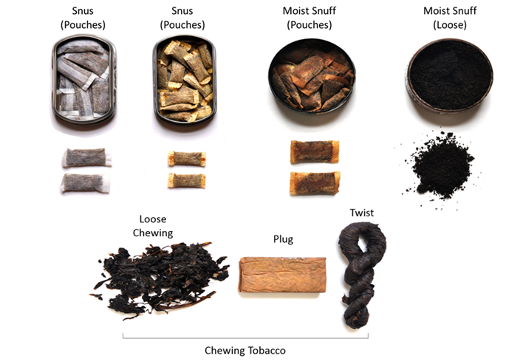

Have you ever used smokeless tobacco even just a small amount?

1. Yes
2. No
3. Prefer not to answer

**ASK:** All respondents.

**[SMOKELESS_CURRENTUSE]** [IF SMOKELESS_EVERUSE = 1 OR 99]

During the past 30 days, on how many days did you use smokeless tobacco?

_______ days [ALLOW 0-30 days]

99   Prefer not to answer

**[SMOKELESS _SUSCEPT]** [IF SMOKELESS_EVERUSE = 2 OR 99 OR SMOKELESS_CURRENTUSE = 0 OR 99]

Thinking about the future…

|  |  |  |  |  |  |  |
| --- | --- | --- | --- | --- | --- | --- |
|  |  | **Definitely Yes** | **Probably Yes** | **Probably Not** | **Definitely Not** | **Prefer Not to Answer** |
| SMKLS_SUSCEPT_1 | Do you think that you will use **smokeless tobacco** such as dip, chewing tobacco, snuff, or snus soon? | 1 | 2 | 3 | 4 | 99 |
| SMKLS _SUSCEPT_2 | Do you think you will use **smokeless tobacco** at any time in the next year? | 1 | 2 | 3 | 4 | 99 |
| SMKLS _SUSCEPT_3 | If one of your best friends were to offer you **smokeless tobacco**, would you use it? | 1 | 2 | 3 | 4 | 99 |

**ASK**: All respondents who indicate having never used smokeless or PNTA, OR who have not used smokeless in the past 30 days or PNTA

**[SMOKELESS_CURIOUS]** [IF SMOKELESS_EVERUSE = 2 OR 99]

Have you ever been curious about using **smokeless tobacco**?

1. Very curious
2. Somewhat curious
3. A little curious
4. Not at all curious

9 Prefer not to answer

**ASK:** Respondents who have never used smokeless or PNTA

**[CIGARETTE SURVEY SCREENER]**

The next questions are about cigarettes.

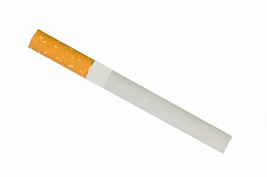

**[CIG_EVERUSE]**

Have you ever tried cigarette smoking, even one or two puffs?

1. Yes
2. No
3. Prefer not to answer

**ASK:** All respondents.

**[CIG_CURRENTUSE]** [IF CIG_EVERUSE = 1 OR 99]

During the past 30 days, on how many days did you smoke cigarettes?

_______ days [ALLOW 0-30 days]

99   Prefer not to answer

**[CIG_SUSCEPT]** [IF CIG_EVERUSE = 2 OR 99 OR CIG_CURRENTUSE = 0 OR 99]

Thinking about the future…

|  |  |  |  |  |  |  |
| --- | --- | --- | --- | --- | --- | --- |
|  |  | **Definitely Yes** | **Probably Yes** | **Probably Not** | **Definitely Not** | **Prefer Not to Answer** |
| CIG_SUSCEPT_1 | Do you think that you will smoke a **cigarette** soon? | 1 | 2 | 3 | 4 | 99 |
| CIG _SUSCEPT_2 | Do you think you will smoke a **cigarette** at any time in the next year? | 1 | 2 | 3 | 4 | 99 |
| CIG _SUSCEPT_3 | If one of your best friends were to offer you a **cigarette**, would you smoke it? | 1 | 2 | 3 | 4 | 99 |

**ASK**: All respondents who indicate having never smoked cigarettes or PNTA, OR who have not smoked cigarettes in the past 30 days or PNTA

**[CIG_CURIOUS]** [IF CIG_EVERUSE = 2 OR 99]

Have you ever been curious about smoking cigarettes?

1. Very curious
2. Somewhat curious
3. A little curious
4. Not at all curious

9 Prefer not to answer

**ASK:** Respondents who have never used cigarettes or PNTA

**[STATE]**

What state do you live in?

[PROGRAMMER note: INCLUDE DROP DOWN LIST OF 50 STATES & WASHINGTON DC. INCLUDE AN OPTION for ‘I don’t live in the United States’. SHOULD APPEAR FIRST IN DROP DOWN. INCLUDE AN OPTION FOR 99. Prefer not to answer. SHOULD APPEAR LAST IN DROP DOWN.]

ASK: All respondents

**[DOB]**

What is your date of birth?

Please use the following format (MM/DD/YYYY)

____/______/_______

99. Prefer not to answer

**ASK:** All respondents

**[EMAIL]**

Please enter your email address: _____________________ [OPEN TEXT]

99. Prefer not to answer

The email address you provide is used only for the purposes of this survey and will **not** be sold or shared.

**ASK:** All respondents

**[EMAIL_VER]** [IF EMAIL ≠ 99]

[PROGRAMMER NOTE: VERIFY EMAIL FORMAT AND THAT BOTH EMAIL ADDRESSES MATCH. Verify that this email was not used IN THE PAST 6 MONTHS.]

Please verify your email address: _____________________

99. Prefer not to answer

ASK: Respondents who provide an email address in EMAIL

[CHECKPOINT, INCLUDE IF:

* 15-24 years old based on age provided
* 15-24 years old BASED ON DOB
* STATE ≠ I DON’T LIVE IN THE US AND ≠ 99
* Age provided and age calculated by DOB must match
* Provided a valid email address (EMAIL ≠ 99 AND EMAIL_VER = 1)
* FOR EACH SURVEY We need a BALANCE of:
  + Currentusers: CURRENTUSE = >1 OR
  + NOT CURRENT/OPEN: (SUSCEPT A, B, OR C = 1 OR 3) OR (CURIOUS = 1-3)]
  + NOT CURRENT/CLOSED: (SUSCEPT A, B, AND C = 3) AND (CURIOUS = 4)]
* Dropping people with PNTA responses on the three key measures above

**[THANK_YOU]** [IF FAIL CHECKPOINT CRITERIA]

Thank you for taking the time to take our eligibility screener. Unfortunately, based on your responses, you do not qualify to participate in our survey.

[EXIT]

[ADD OMB INFORMATION HERE]

**ASK:** Participants who fail the inclusion criteria

**[CONTINUE]** [IF PASS CHECKPOINT CRITERIA]

You are invited to complete our web survey for a $5 electronic gift card. The survey will take about 20 minutes. Please click the “Next” button to continue and take the survey now.

1. Next

[ADD OMB INFORMATION HERE]

**ASK:** Respondents who pass the inclusion criteria

# PROMISING THEMES STUDY YOUTH AND YOUNG ADULT SURVEY

**[CONSENT]** [IF SCREENER AGE ≥ 18]

[ATTACHMENT X. PROMISING THEMES STUDY CONSENT FORM]

**ASK:** All respondents who are 18 years old or older

**[ASSENT]** [IF SCREENER AGE < 18]

[ATTACHMENT X. PROMISING THEMES STUDY ASSENT FORM]

**ASK:** All respondents who are 15 to 17 years old

**[CONSENTREF]** [IF CONSENT = 2 OR ASSENT = 2]

[PROGRAMMER: CODE AS REFUSAL]

Thank you for your time.

**ASK:** Respondents who refuse to provide consent or assent.

**Paperwork Reduction Act Statement:** **An agency may not conduct or sponsor, and a person is not required to respond to, a collection of information unless it displays a currently valid OMB control number. The public reporting burden for this information collection has been estimated to average 3 minutes per response to complete Recruitment and Screening (the time estimated to read, review, and complete). Send comments regarding this burden estimate or any other aspects of this information collection, including suggestions for reducing burden, to** [**PRAStaff@fda.hhs.gov.**](mailto:PRAStaff@fda.hhs.gov)