**ATTACHMENT 2: PROMISING THEMES SURVEY**

# SECTION A: BELIEFS

**[LCC ATTITUDE AND BELIEFS]**

[PROGRAM AT THE TOP OF EACH SCREEEN]

The next questions are about cigars, cigarillos, or little cigars such as Black & Mild, Swisher Sweets, Dutch Masters, Phillies Blunts, Prime Time, and Winchester.

Please do NOT include products with marijuana when answering these questions.

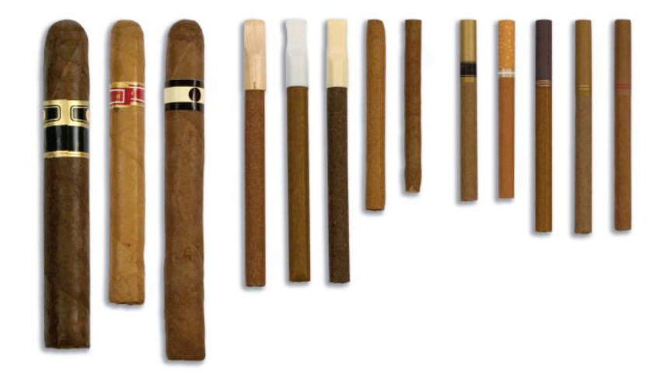

[PROGRAM AT THE TOP OF EACH SCREEEN] We want to hear what you think. There are no right or wrong answers.

**[ATTITUDE]**

Smoking cigars, cigarillos, and little cigars is…

|  |  |  |  |  |  |  |  |  |  |
| --- | --- | --- | --- | --- | --- | --- | --- | --- | --- |
| LCC_ATT_1 | Bad |  |  |  |  |  |  |  | Good |
| LCC_ATT_2 | Unenjoyable |  |  |  |  |  |  |  | Enjoyable |
| LCC_ATT_3 | Harmful |  |  |  |  |  |  |  | Not Harmful |
| LCC_ATT_4 | Dangerous |  |  |  |  |  |  |  | Not Dangerous |

[IF ANY ITEM IS LEFT UNANSWERED, THE ERROR MESSAGE SHOULD SAY “PLEASE PROVIDE AN ANSWER TO THIS QUESTION. IF YOU WOULD PREFER NOT TO ANSWER, PLEASE SELECT THE OPTION ‘PREFER NOT TO ANSWER.’” IN LOWERCASE LETTERS.]

**ASK:** All respondents.

**[THINK SERIES]**

[INVESTIGATOR NOTE: The placeholders below include individual belief items. Lee, et al. (2016) focused on identifying, not specific belief items, but sets of beliefs item, or “themes.” With this instrument, we can examine individual beliefs or sets of beliefs.]

The format for questions and response options in this section is:

**What do you think?**

Cigars, cigarillos, and little cigars contain toxic chemicals

1. Strongly Disagree
2. Disagree
3. Neutral
4. Agree
5. Strongly Agree

9 Prefer not to answer

LCC_THINK_1. Cigars, cigarillos, and little cigars contain toxic chemicals

LCC_THINK_2. Cigars, cigarillos, and little cigars can cause cancer

LCC_THINK_3. The nicotine in cigars, cigarillos, and little cigars is addictive

LCC_THINK_4. People who smoke cigarillos have toxins in their blood

LCC_THINK_5. Cigarillos contain carbon monoxide

LCC_THINK_6. Cigarillos are as dangerous as cigarettes

LCC_THINK_7. Even if you don’t inhale, you can get cancer from cigarillos

LCC_THINK_8. Cigarillo smoking causes premature death

LCC_THINK_9. Cigarillo smoking causes bladder cancer

LCC_THINK_10. Cigarillo smoking causes cancer of the mouth

LCC_THINK_11. Smoking little cigars can shorten your life

LCC_THINK_12. Smoking little cigars is smelly

[PLACEHOLDER FOR ADDITIONAL BELIEFS HERE]

**ASK:** All respondents.

**[FEEL SERIES]**

[ASK OF A RANDOM SUBSET OF ≈ 10% OF THE THINK SERIES]

The format for questions and response options in this section is:

**How does this make you feel?**

Cigars, cigarillos, and little cigars contain toxic chemicals

|  |  |  |  |  |  |  |  |  |  |
| --- | --- | --- | --- | --- | --- | --- | --- | --- | --- |
| LCC_FEEL_1a | Not Scared |  |  |  |  |  |  |  | Scared |
| LCC_FEEL_1b | Not Worried |  |  |  |  |  |  |  | Worried |
| LCC_FEEL_1c | Not Disgusted |  |  |  |  |  |  |  | Disgusted |

[PROGRAMMER NOTE: PROGRAM A “PREFER NOT TO ANSWER” OPTION FOR EACH]

LCC_FEEL_1. Cigars, cigarillos, and little cigars contain toxic chemicals

LCC_FEEL_2. Cigars, cigarillos, and little cigars can cause cancer

LCC_FEEL_3. The nicotine in cigars, cigarillos, and little cigars is addictive

LCC_FEEL_4. People who smoke cigarillos have toxins in their blood

LCC_FEEL_5. Cigarillos contain carbon monoxide

LCC_FEEL_6. Cigarillos are as dangerous as cigarettes

LCC_FEEL_7. Even if you don’t inhale, you can get cancer from cigarillos

LCC_FEEL_8. Cigarillo smoking causes premature death

LCC_FEEL_9. Cigarillo smoking causes bladder cancer

LCC_FEEL_10. Cigarillo smoking causes cancer of the mouth

LCC_FEEL_11. Smoking little cigars can shorten your life

LCC_FEEL_12. Smoking little cigars is smelly

[PLACEHOLDER FOR ADDITIONAL BELIEFS HERE]

**ASK:** All respondents.

**[PERCEIVED PERSONAL RISK SERIES]**

The format for questions and response options in this section is:

**We want you to think about yourself, and what might happen to you in the future.**

[STEM FOR CURRENT USER] **When I smoke cigars, cigarillos, or little cigars, I…**

[STEM FOR SUSCEPTIBLE AND CLOSED TO USE] **If I smoke cigars, cigarillos, or little cigars, I will…**

put toxic chemicals in my body

1. Definitely
2. Probably
3. I Don’t Know
4. Probably Not
5. Definitely Not

9 Prefer not to answer

LCC_PERSONAL_RISK_1. inhale toxic chemicals

LCC_PERSONAL_RISK_2. increase my risk for cancer

LCC_PERSONAL_RISK_3. risk getting addicted

LCC_PERSONAL_RISK_4. have toxins in my blood

LCC_PERSONAL_RISK_5. expose myself to carbon monoxide

LCC_PERSONAL_RISK_6. put myself in danger

LCC_PERSONAL_RISK_7. increase my risk for cancer, even if I don’t inhale

LCC_PERSONAL_RISK_8. increase my odds of a premature death

LCC_PERSONAL_RISK_9. increase my risk for bladder cancer

LCC_PERSONAL_RISK_10. increase my risk for cancer of the mouth

LCC_PERSONAL_RISK_11. shorten my life

LCC_PERSONAL_RISK_12. get smelly

[PLACEHOLDER FOR ADDITIONAL BELIEFS HERE]

**ASK:** All respondents.

**[IDENTIFYING BARRIERS TO CHANGE SERIES]**

The format for questions and response options in this section is:

**The next questions are about the reasons people smoke cigars, cigarillos, or little cigars. How important is each reason for you, as you think about whether to smoke cigars, cigarillos, or little cigars?**

Cigars, cigarillos, and little cigars… come in flavors I like

|  |  |  |  |  |  |  |  |  |  |
| --- | --- | --- | --- | --- | --- | --- | --- | --- | --- |
| LCC_IMP_1 | Not Important |  |  |  |  |  |  |  | Very Important |

[PROGRAMMER NOTE: PROGRAM A “PREFER NOT TO ANSWER” OPTION FOR EACH]

LCC_BARRIERS_1. come in flavors I like

LCC_ BARRIERS_2. help me feel relaxed

LCC_ BARRIERS_3. give me a good high

LCC_ BARRIERS_4. are cheaper than cigarettes

LCC_ BARRIERS_5. are safer than cigarettes

LCC_ BARRIERS_6. are more available than marijuana

LCC_ BARRIERS_7. boost or extend a high from marijuana

LCC_ BARRIERS_8. are legal products

LCC_ BARRIERS_9. are what my friends use

LCC_ BARRIERS_10. are something I do to spend time with friends

LCC_ BARRIERS_11. are shared among my friends

LCC_ BARRIERS_12. are what I’m used to

[PLACEHOLDER FOR ADDITIONAL BELIEFS HERE]

**ASK:** Respondents who report current use

**NORMATIVE BELIEFS SERIES**

The format for questions and response options in this section is:

**We want you to think about yourself, your peers, and your friends.**

[STEM FOR ALL RESPONDENTS]

1. Strongly Disagree
2. Disagree
3. Neutral
4. Agree
5. Strongly Agree

9 Prefer not to answer

LCC_NORM_1. Most of my close friends think it is OK for me to smoke LCCs.

LCC_NORM_2. It is OK for people my age to smoke LCCs.

LCC_NORM_3. Smoking LCCs is normal.

LCC_NORM_4. My school administration doesn’t care if I smoke LCCs.

LCC_NORM_5. Most people think it is OK to smoke LCCs.

LCC_NORM_6. My family is OK with me smoking LCCs.

LCC_NORM_7. Out of every 10 people your age, how many do you think smoke LCCs? (slider bar 1-10)

[PLACEHOLDER FOR ADDITIONAL BELIEFS HERE]

**ASK:** All respondents.

**PERCEIVED BEHAVIORAL CONTROL SERIES**

The format for questions and response options in this section is:

**How sure are you that, if you really wanted to, you could say no to cigars, cigarillos, or little cigars if…,**

[STEM FOR ALL RESPONDENTS]

1. Not at all sure
2. Slightly sure
3. Somewhat sure
4. Mostly sure
5. Completely sure

9 Prefer not to answer

LCC_PBC_1. You are at a party where most people are smoking them?

LCC_ PBC_2. A very close friend offers one?

LCC_ PBC_3. Someone you know offers one?

[PLACEHOLDER FOR ADDITIONAL BELIEFS HERE]

**ASK:** All respondents.

**[VAPE ATTITUDE AND BELIEFS]**

[PROGRAM AT THE TOP OF EACH SCREEEN]

The next questions are about vaping products or vapes. You may also know them as JUUL, e-cigarettes, vape pens, Suorin, or mods. Some look like cigarettes, and others look like small boxes, pens, or pipes.

Please do NOT include vaping marijuana or THC when answering these questions.

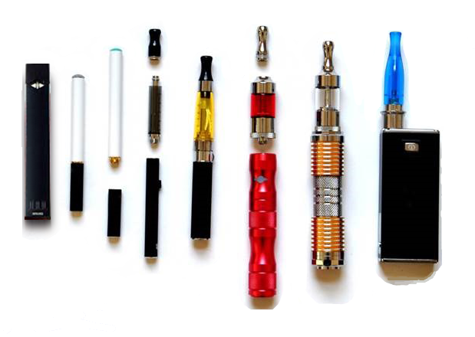

**[ATTITUDE]**

Vaping is…

|  |  |  |  |  |  |  |  |  |  |
| --- | --- | --- | --- | --- | --- | --- | --- | --- | --- |
| VAPE_ATT_1 | Bad |  |  |  |  |  |  |  | Good |
| VAPE_ATT_2 | Unenjoyable |  |  |  |  |  |  |  | Enjoyable |
| VAPE_ATT_3 | Harmful |  |  |  |  |  |  |  | Not Harmful |
| VAPE_ATT_4 | Dangerous |  |  |  |  |  |  |  | Not Dangerous |

[IF ANY ITEM IS LEFT UNANSWERED, THE ERROR MESSAGE SHOULD SAY “PLEASE PROVIDE AN ANSWER TO THIS QUESTION. IF YOU WOULD PREFER NOT TO ANSWER, PLEASE SELECT THE OPTION ‘PREFER NOT TO ANSWER.’” IN LOWERCASE LETTERS.]

**ASK:** All respondents.

**[THINK SERIES]**

The format for questions and response options in this section is:

**What do you think**?

Metal particles from vapes can get stuck in my lungs

1. Strongly Disagree
2. Disagree
3. Neutral
4. Agree
5. Strongly Agree

9 Prefer not to answer

VAPE_THINK_1.

VAPE_THINK_2.

VAPE_THINK_3.

VAPE_THINK_4.

VAPE_THINK_5.

VAPE_THINK_6.

VAPE_THINK_7.

VAPE_THINK_8.

VAPE_THINK_9.

VAPE_THINK_10.

VAPE_THINK_11.

VAPE_THINK_12.

[PLACEHOLDER FOR ADDITIONAL BELIEFS HERE]

**ASK:** All respondents.

**[FEEL SERIES]**

[ASK OF A RANDOM SUBSET OF ≈ 10% OF THE THINK SERIES]

The format for questions and response options in this section is:

**How does this make you feel**?

Metal particles from vapes can get stuck in my lungs

|  |  |  |  |  |  |  |  |  |  |
| --- | --- | --- | --- | --- | --- | --- | --- | --- | --- |
| VAPE_FEEL_1a | Not Scared |  |  |  |  |  |  |  | Scared |
| VAPE_FEEL_1b | Not Worried |  |  |  |  |  |  |  | Worried |
| VAPE_FEEL_1c | Not Disgusted |  |  |  |  |  |  |  | Disgusted |

VAPE_FEEL_1.

VAPE_FEEL_2.

VAPE_FEEL_3.

VAPE_FEEL_4.

VAPE_FEEL_5.

VAPE_FEEL_6.

VAPE_FEEL_7.

VAPE_FEEL_8.

VAPE_FEEL_9.

VAPE_FEEL_10.

VAPE_FEEL_11.

VAPE_FEEL_12.

[PLACEHOLDER FOR ADDITIONAL BELIEFS HERE]

**ASK:** All respondents.

**[PERCEIVED PERSONAL RISK SERIES]**

The format for questions and response options in this section is:

[STEM FOR CURRENT USER] **When I vape, I…**

[STEM FOR SUSCEPTIBLE AND CLOSED TO USE] **If I vape, I will…**

Get metal particles in my lungs

1. Definitely
2. Probably
3. I Don’t Know
4. Probably Not
5. Definitely Not

9 Prefer not to answer

VAPE_PERSONAL_RISK_1.

VAPE_PERSONAL_RISK_2.

VAPE_PERSONAL_RISK_3.

VAPE_PERSONAL_RISK_4.

VAPE_PERSONAL_RISK_5.

VAPE_PERSONAL_RISK_6.

VAPE_PERSONAL_RISK_7.

VAPE_PERSONAL_RISK_8.

VAPE_PERSONAL_RISK_9.

VAPE_PERSONAL_RISK_10.

VAPE_PERSONAL_RISK_11.

VAPE_PERSONAL_RISK_12.

[PLACEHOLDER FOR ADDITIONAL BELIEFS HERE]

**ASK:** All respondents.

**[IDENTIFYING BARRIERS TO CHANGE SERIES]**

The format for questions and response options in this section is:

**The next questions are about the reasons people use vapes. How important is each reason for you as you think about whether to vape?**

Vapes… are easy to hide

|  |  |  |  |  |  |  |  |  |  |
| --- | --- | --- | --- | --- | --- | --- | --- | --- | --- |
| LCC_IMP_1 | Not Important |  |  |  |  |  |  |  | Very Important |

[PROGRAMMER NOTE: PROGRAM A “PREFER NOT TO ANSWER” OPTION FOR EACH]

VAPE_BARRIERS_1.

VAPE_ BARRIERS_2.

VAPE_ BARRIERS_3.

VAPE_ BARRIERS_4.

VAPE_ BARRIERS_5.

VAPE_ BARRIERS_6.

VAPE_ BARRIERS_7.

VAPE_ BARRIERS_8.

VAPE_ BARRIERS_9.

VAPE_ BARRIERS_10.

VAPE_ BARRIERS_11.

VAPE_ BARRIERS_12.

[PLACEHOLDER FOR ADDITIONAL BELIEFS HERE]

**ASK:** Respondents who report current use

**NORMATIVE BELIEFS SERIES**

The format for questions and response options in this section is:

**We want you to think about yourself, your peers, and your friends.**

[STEM FOR ALL RESPONDENTS]

1. Strongly Disagree
2. Disagree
3. Neutral
4. Agree
5. Strongly Agree

9 Prefer not to answer

VAPE_NORM_1. Most of my close friends think it is OK for me to vape.

VAPE _NORM_2. It is OK for people my age to vape.

VAPE _NORM_3. Vaping is normal.

VAPE _NORM_4. My school administration doesn’t care if I vape.

VAPE _NORM_5. Most people think it is OK to vape.

VAPE _NORM_6. My family is OK with me vaping.

VAPE _NORM_7. Out of every 10 people your age, how many do you think vape? (slider bar 1-10)

[PLACEHOLDER FOR ADDITIONAL BELIEFS HERE]

**ASK:** All respondents.

**PERCEIVED BEHAVIORAL CONTROL SERIES**

The format for questions and response options in this section is:

**How sure are you that, if you really wanted to, you could say no to vaping if…,**

[STEM FOR ALL RESPONDENTS]

1. Not at all sure
2. Slightly sure
3. Somewhat sure
4. Mostly sure
5. Completely sure

9 Prefer not to answer

VAPE_PBC_1. You are at a party where most people are vaping?

VAPE _ PBC _2. A very close friend offers it?

VAPE _ PBC _3. Someone you know offers it?

[PLACEHOLDER FOR ADDITIONAL BELIEFS HERE]

**ASK:** All respondents.

**[SMOKELESS ATTITUDE AND BELIEFS]**

[PROGRAM AT THE TOP OF EACH SCREEEN]

The next questions are about smokeless tobacco, such as dip, chewing tobacco, snuff, or snus. Common brands include [EDIT IF NECESSARY Copenhagen, Grizzly, Skoal, Camel Snus, Kodiak, and Longhorn].

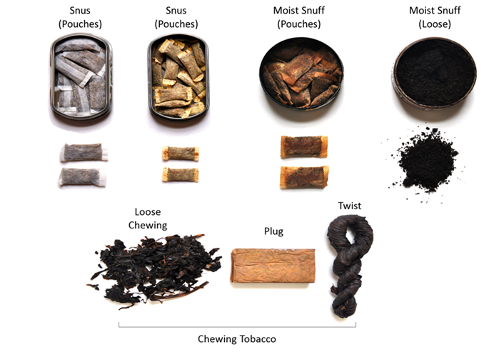

**[ATTITUDE]**

Using smokeless tobacco is…

|  |  |  |  |  |  |  |  |  |  |
| --- | --- | --- | --- | --- | --- | --- | --- | --- | --- |
| SMKLS_ATT_1 | Bad |  |  |  |  |  |  |  | Good |
| SMKLS _ATT_2 | Unenjoyable |  |  |  |  |  |  |  | Enjoyable |
| SMKLS _ATT_3 | Harmful |  |  |  |  |  |  |  | Not Harmful |
| SMKLS _ATT_4 | Dangerous |  |  |  |  |  |  |  | Not Dangerous |

[IF ANY ITEM IS LEFT UNANSWERED, THE ERROR MESSAGE SHOULD SAY “PLEASE PROVIDE AN ANSWER TO THIS QUESTION. IF YOU WOULD PREFER NOT TO ANSWER, PLEASE SELECT THE OPTION ‘PREFER NOT TO ANSWER.’” IN LOWERCASE LETTERS.]

**ASK:** All respondents.

**[THINK SERIES]**

[PROGRAM AT THE TOP OF EACH SCREEEN] We want to hear what you think. There are no right or wrong answers.

The format for questions and response options in this section is:

**What do you think**?

Smokeless tobacco can cause cancer

1. Strongly Disagree
2. Disagree
3. Neutral
4. Agree
5. Strongly Agree

9 Prefer not to answer

SMOKELESS_THINK_1.

SMOKELESS_THINK_2.

SMOKELESS_THINK_3.

SMOKELESS_THINK_4.

SMOKELESS_THINK_5.

SMOKELESS_THINK_6.

SMOKELESS_THINK_7.

SMOKELESS_THINK_8.

SMOKELESS_THINK_9.

SMOKELESS_THINK_10.

SMOKELESS_THINK_11.

SMOKELESS_THINK_12.

[PLACEHOLDER FOR ADDITIONAL BELIEFS HERE]

**ASK:** All respondents.

**[FEEL SERIES]**

[ASK OF A RANDOM SUBSET OF ≈ 10% OF THE THINK SERIES]

The format for questions and response options in this section is:

**How does this make you feel**?

Smokeless tobacco can cause cancer

|  |  |  |  |  |  |  |  |  |  |
| --- | --- | --- | --- | --- | --- | --- | --- | --- | --- |
| SMKLS _FEEL_1a | Not Scared |  |  |  |  |  |  |  | Scared |
| SMKLS _FEEL_1b | Not Worried |  |  |  |  |  |  |  | Worried |
| SMKLS _FEEL_1c | Not Disgusted |  |  |  |  |  |  |  | Disgusted |

SMOKELESS_FEEL_1.

SMOKELESS_FEEL_2.

SMOKELESS_FEEL_3.

SMOKELESS_FEEL_4.

SMOKELESS_FEEL_5.

SMOKELESS_FEEL_6.

SMOKELESS_FEEL_7.

SMOKELESS_FEEL_8.

SMOKELESS_FEEL_9.

SMOKELESS_FEEL_10.

SMOKELESS_FEEL_11.

SMOKELESS_FEEL_12.

[PLACEHOLDER FOR ADDITIONAL BELIEFS HERE]

**ASK:** All respondents.

**[PERCEIVED PERSONAL RISK SERIES]**

The format for questions and response options in this section is:

[STEM FOR CURRENT USER] **When I use smokeless tobacco, I…**

[STEM FOR SUSCEPTIBLE AND CLOSED TO USE] **If I use smokeless tobacco, I will…**

increase my risk for cancer

1. Definitely
2. Probably
3. I Don’t Know
4. Probably Not
5. Definitely Not

9 Prefer not to answer

SMOKELESS_PERSONAL_RISK_1.

SMOKELESS_PERSONAL_RISK_2.

SMOKELESS_PERSONAL_RISK_3.

SMOKELESS_PERSONAL_RISK_4.

SMOKELESS_PERSONAL_RISK_5.

SMOKELESS_PERSONAL_RISK_6.

SMOKELESS_PERSONAL_RISK_7.

SMOKELESS_PERSONAL_RISK_8.

SMOKELESS_PERSONAL_RISK_9.

SMOKELESS_PERSONAL_RISK_10.

SMOKELESS_PERSONAL_RISK_11.

SMOKELESS_PERSONAL_RISK_12.

[PLACEHOLDER FOR ADDITIONAL BELIEFS HERE]

**ASK:** All respondents.

**[IDENTIFYING BARRIERS TO CHANGE SERIES]**

The format for questions and response options in this section is:

**The next questions are about the reasons people use smokeless tobacco. How important is each reason for you as you think about whether to use smokeless tobacco?**

Smokeless tobacco… is safer than cigarettes

|  |  |  |  |  |  |  |  |  |  |
| --- | --- | --- | --- | --- | --- | --- | --- | --- | --- |
| LCC_IMP_1 | Not Important |  |  |  |  |  |  |  | Very Important |

[PROGRAMMER NOTE: PROGRAM A “PREFER NOT TO ANSWER” OPTION FOR EACH]

SMKLS_BARRIERS_1.

SMKLS_ BARRIERS_2.

SMKLS_ BARRIERS_3.

SMKLS_ BARRIERS_4.

SMKLS_ BARRIERS_5.

SMKLS_ BARRIERS_6.

SMKLS_ BARRIERS_7.

SMKLS_ BARRIERS_8.

SMKLS_ BARRIERS_9.

SMKLS_ BARRIERS_10.

SMKLS_ BARRIERS_11.

SMKLS_ BARRIERS_12.

[PLACEHOLDER FOR ADDITIONAL BELIEFS HERE]

**ASK:** Respondents who report current use

**NORMATIVE BELIEFS SERIES**

The format for questions and response options in this section is:

**We want you to think about yourself, your peers, and your friends.**

[STEM FOR ALL RESPONDENTS]

1. Strongly Disagree
2. Disagree
3. Neutral
4. Agree
5. Strongly Agree

9 Prefer not to answer

SMKLS _NORM_1. Most of my close friends think it is OK for me to use smokeless tobacco.

SMKLS _NORM_2. It is OK for people my age to use smokeless tobacco.

SMKLS _NORM_3. Using smokeless tobacco is normal.

SMKLS _NORM_4. My school administration doesn’t care if I use smokeless tobacco.

SMKLS _NORM_5. Most people think it is OK to use smokeless tobacco.

SMKLS _NORM_6. My family is OK with me using smokeless tobacco.

SMKLS _NORM_7. Out of every 10 people your age, how many do you think use smokeless tobacco? (slider bar 1-10)

[PLACEHOLDER FOR ADDITIONAL BELIEFS HERE]

**ASK:** All respondents.

**PERCEIVED BEHAVIORAL CONTROL SERIES**

The format for questions and response options in this section is:

**How sure are you that, if you really wanted to, you could say no to using smokeless tobacco if…,**

[STEM FOR ALL RESPONDENTS]

1. Not at all sure
2. Slightly sure
3. Somewhat sure
4. Mostly sure
5. Completely sure

9 Prefer not to answer

SMKLS _PBC_1. You are at a party where most people are using it?

SMKLS _ PBC _2. A very close friend offers it?

SMKLS _ PBC _3. Someone you know offers it?

[PLACEHOLDER FOR ADDITIONAL BELIEFS HERE]

**ASK:** All respondents.

**[CIGARETTE ATTITUDE AND BELIEFS]**

[PROGRAM AT THE TOP OF EACH SCREEEN]

The next questions are about cigarettes.

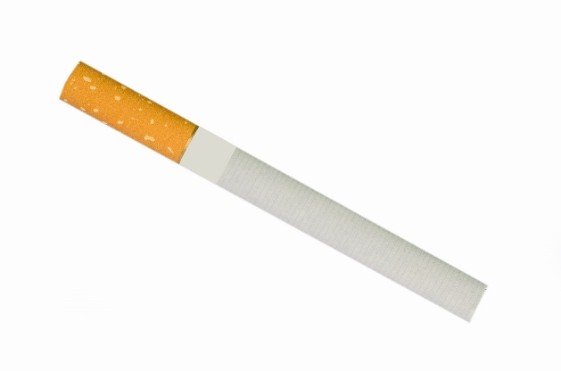

**[ATTITUDE]**

Smoking cigarettes is…

|  |  |  |  |  |  |  |  |  |  |
| --- | --- | --- | --- | --- | --- | --- | --- | --- | --- |
| CIGS_ATT_1 | Bad |  |  |  |  |  |  |  | Good |
| CIGS _ATT_2 | Unenjoyable |  |  |  |  |  |  |  | Enjoyable |
| CIGS _ATT_3 | Harmful |  |  |  |  |  |  |  | Not Harmful |
| CIGS _ATT_4 | Dangerous |  |  |  |  |  |  |  | Not Dangerous |

[IF ANY ITEM IS LEFT UNANSWERED, THE ERROR MESSAGE SHOULD SAY “PLEASE PROVIDE AN ANSWER TO THIS QUESTION. IF YOU WOULD PREFER NOT TO ANSWER, PLEASE SELECT THE OPTION ‘PREFER NOT TO ANSWER.’” IN LOWERCASE LETTERS.]

**ASK:** All respondents.

**[THINK SERIES]**

The format for questions and response options in this section is:

**What do you think**?

Cigarette smoking is addictive

1. Strongly Disagree
2. Disagree
3. Neutral
4. Agree
5. Strongly Agree

9 Prefer not to answer

CIGARETTE_THINK_1.

CIGARETTE_THINK_2.

CIGARETTE_THINK_3.

CIGARETTE_THINK_4.

CIGARETTE_THINK_5.

CIGARETTE_THINK_6.

CIGARETTE_THINK_7.

CIGARETTE_THINK_8.

CIGARETTE_THINK_9.

CIGARETTE_THINK_10.

CIGARETTE_THINK_11.

CIGARETTE_THINK_12.

[PLACEHOLDER FOR ADDITIONAL BELIEFS HERE]

**ASK:** All respondents.

**[FEEL SERIES]**

[ASK OF A RANDOM SUBSET OF ≈ 10% OF THE THINK SERIES]

The format for questions and response options in this section is:

**How does this make you feel**?

Cigarette smoking is addictive

|  |  |  |  |  |  |  |  |  |  |
| --- | --- | --- | --- | --- | --- | --- | --- | --- | --- |
| CIGS _FEEL_1a | Not Scared |  |  |  |  |  |  |  | Scared |
| CIGS_FEEL_1b | Not Worried |  |  |  |  |  |  |  | Worried |
| CIGS_FEEL_1c | Not Disgusted |  |  |  |  |  |  |  | Disgusted |

CIGARETTE_FEEL_1.

CIGARETTE_FEEL_2.

CIGARETTE_FEEL_3.

CIGARETTE_FEEL_4.

CIGARETTE_FEEL_5.

CIGARETTE_FEEL_6.

CIGARETTE_FEEL_7.

CIGARETTE_FEEL_8.

CIGARETTE_FEEL_9.

CIGARETTE_FEEL_10.

CIGARETTE_FEEL_11.

CIGARETTE_FEEL_12.

[PLACEHOLDER FOR ADDITIONAL BELIEFS HERE]

**ASK:** All respondents.

**[PERCEIVED PERSONAL RISK SERIES]**

The format for questions and response options in this section is:

[STEM FOR CURRENT USER] **When I smoke cigarettes, I…**

[STEM FOR SUSCEPTIBLE AND CLOSED TO USE] **If I smoke cigarettes, I will…**

risk getting addicted

1. Definitely
2. Probably
3. I Don’t Know
4. Probably Not
5. Definitely Not

9 Prefer not to answer

CIGARETTE_PERSONAL_RISK_1.

CIGARETTE_PERSONAL_RISK_2.

CIGARETTE_PERSONAL_RISK_3.

CIGARETTE_PERSONAL_RISK_4.

CIGARETTE_PERSONAL_RISK_5.

CIGARETTE_PERSONAL_RISK_6.

CIGARETTE_PERSONAL_RISK_7.

CIGARETTE_PERSONAL_RISK_8.

CIGARETTE_PERSONAL_RISK_9.

CIGARETTE_PERSONAL_RISK_10.

CIGARETTE_PERSONAL_RISK_11.

CIGARETTE_PERSONAL_RISK_12.

[PLACEHOLDER FOR ADDITIONAL BELIEFS HERE]

**ASK:** All respondents.

**[IDENTIFYING BARRIERS TO CHANGE SERIES]**

The format for questions and response options in this section is:

**The next questions are about the reasons people smoke cigarettes. How important is each reason for you as you think about whether to smoke cigarettes?**

Cigarettes… are easy to get

|  |  |  |  |  |  |  |  |  |  |  |
| --- | --- | --- | --- | --- | --- | --- | --- | --- | --- | --- |
| LCC_IMP_1 |  | Not Important |  |  |  |  |  |  |  | Very Important |

[PROGRAMMER NOTE: PROGRAM A “PREFER NOT TO ANSWER” OPTION FOR EACH]

CIG_BARRIERS_1.

CIG_ BARRIERS_2.

CIG_ BARRIERS_3.

CIG_ BARRIERS_4.

CIG_ BARRIERS_5.

CIG_ BARRIERS_6.

CIG_ BARRIERS_7.

CIG_ BARRIERS_8.

CIG_ BARRIERS_9.

CIG_ BARRIERS_10.

CIG_ BARRIERS_11.

CIG_ BARRIERS_12.

[PLACEHOLDER FOR ADDITIONAL BELIEFS HERE]

**ASK:** Respondents who report current use

**NORMATIVE BELIEFS SERIES**

The format for questions and response options in this section is:

**We want you to think about yourself, your peers, and your friends.**

[STEM FOR ALL RESPONDENTS]

1. Strongly Disagree
2. Disagree
3. Neutral
4. Agree
5. Strongly Agree

9 Prefer not to answer

CIG _NORM_1. Most of my close friends think it is OK for me to smoke cigarettes.

CIG _NORM_2. It is OK for people my age to smoke cigarettes.

CIG _NORM_3. Smoking cigarettes is normal.

CIG _NORM_4. My school administration doesn’t care if I smoke cigarettes.

CIG _NORM_5. Most people think it is OK to use smoke cigarettes.

CIG _NORM_6. My family is OK with me smoking cigarettes.

CIG _NORM_7. Out of every 10 people your age, how many do you think smoke cigarettes? (slider bar 1-10)

[PLACEHOLDER FOR ADDITIONAL BELIEFS HERE]

**ASK:** All respondents.

**PERCEIVED BEHAVIORAL CONTROL SERIES**

The format for questions and response options in this section is:

**How sure are you that, if you really wanted to, you could say no to smoking a cigarette if…,**

[STEM FOR ALL RESPONDENTS]

1. Not at all sure
2. Slightly sure
3. Somewhat sure
4. Mostly sure
5. Completely sure

9 Prefer not to answer

CIG _PBC_1. You are at a party where most people are smoking cigarettes?

CIG _ PBC _2. A very close friend offers one?

CIG _ PBC _3. Someone you know offers one?

[PLACEHOLDER FOR ADDITIONAL BELIEFS HERE]

**ASK:** All respondents.

# SECTION B: Behavior

**[LCC BEHAVIORS]**

[PROGRAMMER: FLOAT THE LLC DESCRIPTION FOR EACH QUESTION IN SECTION]

The next questions are about cigars, cigarillos, or little cigars such as Black & Mild, Swisher Sweets, Dutch Masters, Phillies Blunts, Prime Time, and Winchester.

Please do NOT include products with marijuana when answering these questions.



**[LCC_BEH_1]** [LCC_EVERUSE = 1]

How many times have you smoked cigars, cigarillos, or little cigars in your entire life?

1. 0 times
2. 1 time, even just a few puffs
3. 2 to 10 times
4. 11 to 20 times
5. 21 to 50 times
6. 51 to 99 times
7. 100 or more times
8. Prefer not to answer

**ASK:** Respondents who reported ever use in the screener.

**[LCC_BEH_2]** [LCC_BEH_1 = 1 or 9]

Have you ever smoked cigars, cigarillos, or little cigars even one time?

1. Yes 🡪 RETURN TO LCC_BEH_1
2. No
3. Prefer not to answer 🡪 RETURN TO LCC_BEH_1

**ASK:** Respondents who reported ever use in the screener, but then said “0 times” or PNTA in the survey. This item is a behavior check.

**[LCC_BEH_3]** [IF LCC_BEH_2 = 2]

Please do NOT include products with marijuana when answering these questions.

Thinking about the future…

|  |  |  |  |  |  |  |
| --- | --- | --- | --- | --- | --- | --- |
|  |  | **Definitely Yes** | **Probably Yes** | **Probably Not** | **Definitely Not** | **Prefer Not to Answer** |
| LCC_BEH_3a | Do you think you will smoke **cigars, cigarillos, or little cigars** soon? | 1 | 2 | 3 | 4 | 99 |
| LCC_BEH_3b | Do you think you will smoke **cigars, cigarillos, or little cigars** at any time in the next year? | 1 | 2 | 3 | 4 | 99 |
| LCC_BEH_3c | If one of your best friends were to offer you a **cigar, cigarillo, or little cigar**, would you smoke it? | 1 | 2 | 3 | 4 | 99 |

**ASK**: All respondents who indicate ever use in the screener, but then report never use in LCC_BEH_2. This item is a behavior check.

**[LCC_BEH_4]** [IF LCC_BEH_2 = 2]

Have you ever been curious about smoking a cigar, cigarillo, or little cigar?

1. Very curious
2. Somewhat curious
3. A little curious
4. Not at all curious

9 Prefer not to answer

**ASK**: All respondents who indicate ever use in the screener, but then report never use in LCC_BEH_2. This item is a behavior check.

**[LCC_BEH_5]** [LCC_BEH_1 = 2-7]

How old were you when you first smoked a cigar, cigarillo, or little cigar, even one or two puffs?

_____________years old [RANGE: 5-100]

9. Prefer not to answer

**ASK:** All respondents who report ever use.

[PROGRAMMER NOTE: If LCC_BEH_5 > AGE show error message and request correction.]

**[LCC_BEH_6]** [(LCC_EVERUSE = 1) AND (LCC_CURRENTUSE = 0)]

When did you last smoke a cigar, cigarillo, or little cigar?

1. Not during the past 30 days but sometime during the past 6 months
2. Not during the past 6 months but sometime in the past year
3. 1 to 4 years ago
4. 5 or more years ago
5. I don’t know
6. Prefer not to answer

**ASK:** All respondents who report ever use but not current use.

**[LCC_BEH_7]** [(LCC_CURRENTUSE > 0) OR (LCC_BEH_6 = 1)]

During the past 3 months, did you stop smoking cigars, cigarillos, or little cigars for one day or longer because you were trying to quit for good?

1. Yes
2. No
3. Prefer not to answer

**ASK:** Current users and people who have used during the past 6 months.

**[LCC_BEH_8]** [LCC_BEH_7 = 1 or 99]

How much do you want to stop smoking cigars, cigarillos, or little cigars?

1. Not at all
2. A little
3. Somewhat
4. A lot

9. Prefer not to answer

**ASK:** Current users who report having tried to quit in the past three months.

**[LCC_BEH_9]** [LCC_CURRENTUSE > 0]

Which type of cigar, cigarillo, or little cigar product do you usually smoke?

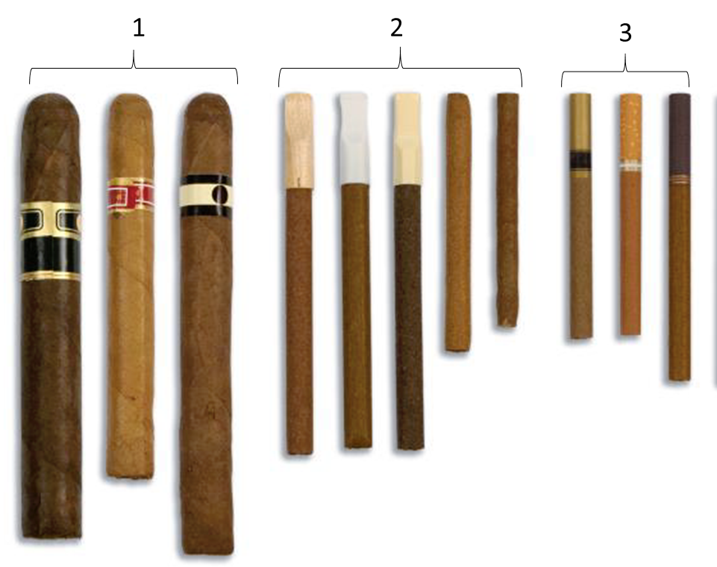

1. Traditional cigars (like Garcia y Vega, Macanudo, Romeo y Julieta, Arturo Fuente, or Cohiba)
2. Cigarillos (like Black & Mild, Swisher Sweets, Dutch Masters, Backwoods, Phillies Blunts, Zig Zag, White Owl, or Middleton’s)
3. Filtered cigars (like Cheyenne, Djarum, Talon, or 305s)
4. None of the above
5. I don’t know

9. Prefer not to answer

**ASK:** Respondents who report current use.

**[LCC_BEH_10]**

What **other** products have you used in the past 30 days?

Check all that apply.

1. Cigars, cigarillos, and little cigars [drop this response option in the LLC survey]
2. Vapes [drop this response option in the vape survey]
3. Smokeless tobacco [drop this response option in the smokeless survey]
4. Cigarettes [drop this response option in the cigarette survey]
5. THC/Marijuana
6. None of the above

9. Prefer not to answer

**ASK:** Respondents who reported current use

**[LCC_BEH_11]**

Have you recently switched from one tobacco or vaping product to another?

1. Yes
2. No

9. Prefer not to answer

**ASK:** Respondents who reported current use

**[LCC_BEH_12]** [CIG _BEH_11 = 1]

I recently switched…

|  |  |
| --- | --- |
| FROM | TO |
| 1. Cigars, cigarillos, and little cigars | 1. Cigars, cigarillos, and little cigars |
| 1. Vapes | 2. Vapes |
| 1. Smokeless tobacco | 3. Smokeless tobacco |
| 1. Cigarettes | 4. Cigarettes |
| 1. THC/Marijuana | 5. THC/Marijuana |

1. Prefer not to answer

**ASK:** Respondents who reported current use

**[LCC_BEH_13]**

Who do you trust for information on cigars, cigarillos, or little cigars? Check all that apply.

1. Friends
2. People on the Internet
3. Advertisers
4. Tobacco companies
5. Parents
6. Teachers/coaches
7. Government agencies
8. None of the above

9. Prefer not to answer

**ASK:** All respondents

**[VAPE BEHAVIORS]**

[PROGRAMMER: FLOAT THE VAPE DESCRIPTION FOR EACH QUESTION IN SECTION]

The next questions are about vaping products or vapes. You may also know them as JUUL, e-cigarettes, vape pens, Suorin, or mods. Some look like cigarettes, and others look like small boxes, pens, or pipes.

Please do NOT include vaping marijuana or THC when answering these questions.



**[VAPE_BEH_1]** [VAPE_EVERUSE = 1]

How many times have you vaped in your entire life?

1. 0 times
2. 1 time, even just a few puffs
3. 2 to 10 times
4. 11 to 20 times
5. 21 to 50 times
6. 51 to 99 times
7. 100 or more times

9. Prefer not to answer

**ASK:** Respondents who reported ever use in the screener.

**[VAPE_BEH_2]** [VAPE_BEH_1 = 1 or 9]

Have you ever vaped, even one time?

1. Yes 🡪 RETURN TO VAPE_BEH_1
2. No
3. Prefer not to answer 🡪 RETURN TO VAPE_BEH_1

**ASK:** Respondents who reported ever use in the screener, but then said “0 times” or PNTA in the survey. This item is a behavior check.

**[VAPE_BEH_3]** [IF VAPE_BEH_2 = 2]

Please do NOT include products with marijuana when answering these questions.

Thinking about the future…

|  |  |  |  |  |  |  |
| --- | --- | --- | --- | --- | --- | --- |
|  |  | **Definitely Yes** | **Probably Yes** | **Probably Not** | **Definitely Not** | **Prefer Not to Answer** |
| VAPE_BEH_3a | Do you think that you will **vape** soon? | 1 | 2 | 3 | 4 | 99 |
| VAPE _BEH_3b | Do you think you will **vape** at any time in the next year? | 1 | 2 | 3 | 4 | 99 |
| VAPE _BEH_3c | If one of your best friends were to offer you a **vape** would you use it? | 1 | 2 | 3 | 4 | 99 |

**ASK**: All respondents who indicate ever use in the screener, but then report never use in VAPE_BEH_2. This item is a behavior check.

**[VAPE_BEH_4]** [IF VAPE_BEH_2 = 2]

Have you ever been curious about vaping?

1. Very curious
2. Somewhat curious
3. A little curious
4. Not at all curious

9 Prefer not to answer

**ASK**: All respondents who indicate ever use in the screener, but then report never use in VAPE_BEH_2. This item is a behavior check.

**[VAPE_BEH_5]** [VAPE_BEH_1 = 2-7]

How old were you when you first vaped, even one or two puffs?

_____________years old [RANGE: 5-100]

99. Prefer not to answer

**ASK:** All respondents who report ever use.

[PROGRAMMER NOTE: If VAPE_BEH_5 > AGE show error message and request correction.]

**[VAPE_BEH_6]** [(VAPE_EVERUSE = 1) AND (VAPE_CURRENTUSE = 0)]

When did you last vape?

1. Not during the past 30 days but sometime during the past 6 months
2. Not during the past 6 months but sometime in the past year
3. 1 to 4 years ago
4. 5 or more years ago
5. I don’t know
6. Prefer not to answer

**ASK:** All respondents who report ever use but not current use.

**[VAPE_BEH_7]** [(VAPE_CURRENTUSE > 0) OR (VAPE_BEH_6 = 1)]

During the past 3 months, did you stop vaping for one day or longer because you were trying to quit for good?

1. Yes
2. No

9. Prefer not to answer

**ASK:** Current users and people who have used during the past 6 months.

**[VAPE_BEH_8]** [LCC_BEH_7 = 1 or 99]

How much do you want to stop vaping?

1. Not at all
2. A little
3. Somewhat
4. A lot

9. Prefer not to answer

**ASK:** Current users who report having tried to quit in the past three months.

**[VAPE_BEH_9]** [VAPE_CURRENTUSE > 0]

Which type of vape product do you usually use?



1. [FILL PRODUCTS HERE]
2. [FILL PRODUCTS HERE]
3. [FILL PRODUCTS HERE]
4. None of the above
5. I don’t know

9. Prefer not to answer

**ASK:** Respondents who report current use.

**[VAPE_BEH_10]** [VAPE_CURRENTUSE > 0]

What is in the vape product you usually use?

1. Nicotine
2. THC/marijuana
3. Nicotine and THC/marijuana together
4. Flavored vapor only (not nicotine or THC)
5. Don’t Know

9. Prefer not to answer

**ASK:** Respondents who report current use.

**[VAPE_BEH_11]**

What **other** products have you used in the past 30 days?

Check all that apply.

1. Cigars, cigarillos, and little cigars [drop this response option in the LLC survey]
2. Vapes [drop this response option in the vape survey]
3. Smokeless tobacco [drop this response option in the smokeless survey]
4. Cigarettes [drop this response option in the cigarette survey]
5. THC/Marijuana
6. None of the above

9. Prefer not to answer

**ASK:** Respondents who reported current use

**[VAPE_BEH_12]**

Have you recently switched from one tobacco or vaping product product to another?

1. Yes
2. No

9. Prefer not to answer

**ASK:** Respondents who reported current use

**[VAPE_BEH_13]** [CIG _BEH_12 = 1]

I recently switched…

|  |  |
| --- | --- |
| FROM | TO |
| 1. Cigars, cigarillos, and little cigars | 1. Cigars, cigarillos, and little cigars |
| 1. Vapes | 2. Vapes |
| 1. Smokeless tobacco | 3. Smokeless tobacco |
| 1. Cigarettes | 4. Cigarettes |
| 1. THC/Marijuana | 5. THC/Marijuana |

1. Prefer not to answer

**ASK:** Respondents who reported recently switching

**[VAPE_BEH_14]**

Who do you trust for information on vaping? Check all that apply.

1. Friends
2. People on the Internet
3. Advertisers
4. Vape companies
5. Parents
6. Teachers/coaches
7. Government agencies
8. None of the above

9. Prefer not to answer

**ASK:** All respondents

**[SMOKELESS BEHAVIORS]**

[PROGRAMMER: FLOAT THE SMOKELESS DESCRIPTION FOR EACH QUESTION IN SECTION]

The next questions are about smokeless tobacco, such as dip, chewing tobacco, snuff, or snus. Common brands include [EDIT IF NECESSARY Copenhagen, Grizzly, Skoal, Camel Snus, Kodiak, and Longhorn].



**[SMKLS_BEH_1]** [SMKLS_EVERUSE = 1]

How many times have you used smokeless tobacco in your entire life?

1. 0 times
2. 1 time, even just a few puffs
3. 2 to 10 times
4. 11 to 20 times
5. 21 to 50 times
6. 51 to 99 times
7. 100 or more times

9. Prefer not to answer

**ASK:** Respondents who reported ever use in the screener.

**[SMKLS_BEH_2]** [SMKLS_BEH_1 = 1 or 9]

Have you ever used smokeless tobacco, even one time?

1. Yes 🡪 RETURN TO SMKLS_BEH_1
2. No

9. Prefer not to answer 🡪 RETURN TO SMKLS_BEH_1

**ASK:** Respondents who reported ever use in the screener, but then said “0 times” or PNTA in the survey. This item is a behavior check.

**[SMKLS_BEH_3]** [IF SMKLS_BEH_2 = 2]

Thinking about the future…

|  |  |  |  |  |  |  |
| --- | --- | --- | --- | --- | --- | --- |
|  |  | **Definitely Yes** | **Probably Yes** | **Probably Not** | **Definitely Not** | **Prefer Not to Answer** |
| SMKLS_BEH_3a | Do you think that you will use **smokeless tobacco** such as dip, chewing tobacco, snuff, or snus soon? | 1 | 2 | 3 | 4 | 99 |
| SMKLS _BEH_3b | Do you think you will use **smokeless tobacco** at any time in the next year? | 1 | 2 | 3 | 4 | 99 |
| SMKLS _BEH_3c | If one of your best friends were to offer you **smokeless tobacco**, would you use it? | 1 | 2 | 3 | 4 | 99 |

**ASK**: All respondents who indicate ever use in the screener, but then report never use in SMKLS_BEH_2. This item is a behavior check.

**[SMKLS_BEH_4]** [IF SMKLS_BEH_2 = 2]

Have you ever been curious about using smokeless tobacco?

1. Very curious
2. Somewhat curious
3. A little curious
4. Not at all curious

9 Prefer not to answer

**ASK**: All respondents who indicate ever use in the screener, but then report never use in SMKLS_BEH_2. This item is a behavior check.

**[SMKLS_BEH_5]** [SMKLS_BEH_1 = 2-7]

How old were you when you first used smokeless tobacco?

_____________years old [RANGE: 5-100]

99. Prefer not to answer

**ASK:** All respondents who report ever use.

[PROGRAMMER NOTE: If SMKLS_BEH_5 > AGE show error message and request correction.]

**[SMKLS_BEH_6]** [(SMKLS_EVERUSE = 1) AND (SMKLS_CURRENTUSE = 0)]

When did you last use smokeless tobacco?

1. Not during the past 30 days but sometime during the past 6 months
2. Not during the past 6 months but sometime in the past year
3. 1 to 4 years ago
4. 5 or more years ago
5. I don’t know

9. Prefer not to answer

**ASK:** All respondents who report ever use but not current use.

**[SMKLS_BEH_7]** [(SMKLS_CURRENTUSE > 0) OR (SMKLS_BEH_6 = 1)]

During the past 3 months, did you stop using smokeless tobacco for one day or longer because you were trying to quit for good?

1. Yes
2. No

9. Prefer not to answer

**ASK:** Current users and people who have used during the past 6 months.

**[SMKLS_BEH_8]** [LCC_BEH_7 = 1 or 99]

How much do you want to stop using smokeless tobacco?

1. Not at all
2. A little
3. Somewhat
4. A lot

9. Prefer not to answer

**ASK:** Current users who report having tried to quit in the past three months.

**[SMKLS_BEH_9]** [SMKLS_CURRENTUSE > 0]

Which type of smokeless tobacco product do you usually use?



1. [FILL PRODUCTS HERE]
2. [FILL PRODUCTS HERE]
3. [FILL PRODUCTS HERE]
4. None of the above
5. I don’t know

9. Prefer not to answer

**[SMKLS_BEH_10]**

What **other** products have you used in the past 30 days?

Check all that apply.

1. Cigars, cigarillos, and little cigars [drop this response option in the LLC survey]
2. Vapes [drop this response option in the vape survey]
3. Smokeless tobacco [drop this response option in the smokeless survey]
4. Cigarettes [drop this response option in the cigarette survey]
5. THC/Marijuana
6. None of the above

9. Prefer not to answer

**ASK:** Respondents who reported current use

**[SMKLS_BEH_11]**

Have you recently switched from one tobacco or vaping product to another?

1. Yes
2. No

9. Prefer not to answer

**ASK:** Respondents who reported current use

**[SMKLS_BEH_12]** [CIG _BEH_11 = 1]

I recently switched…

|  |  |
| --- | --- |
| FROM | TO |
| 1. Cigars, cigarillos, and little cigars | 1. Cigars, cigarillos, and little cigars |
| 1. Vapes | 2. Vapes |
| 1. Smokeless tobacco | 3. Smokeless tobacco |
| 1. Cigarettes | 4. Cigarettes |
| 1. THC/Marijuana | 5. THC/Marijuana |

1. Prefer not to answer

**ASK:** Respondents who reported recently switching

**[SMKLS_BEH_13]**

Who do you trust for information on smokeless tobacco? Check all that apply.

1. Friends
2. People on the Internet
3. Advertisers
4. Vape companies
5. Parents
6. Teachers/coaches
7. Government agencies
8. None of the above

9. Prefer not to answer

**ASK:** All respondents

**[CIGARETTE BEHAVIORS]**

The next questions are about cigarette smoking.

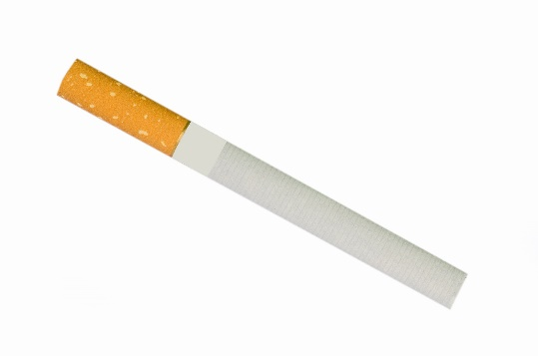

**[CIG_BEH_1]** [CIG_EVERUSE = 1]

How many times have you smoked cigarettes in your entire life?

1. 0 times
2. 1 time, even just a few puffs
3. 2 to 10 times
4. 11 to 20 times
5. 21 to 50 times
6. 51 to 99 times
7. 100 or more times

9. Prefer not to answer

**ASK:** Respondents who reported ever use in the screener.

**[CIG_BEH_2]** [CIG_BEH_1 = 1 or 9]

Have you ever smoked cigarettes, even one time?

1. Yes 🡪 RETURN TO CIG_BEH_1
2. No

9. Prefer not to answer 🡪 RETURN TO CIG_BEH_1

**ASK:** Respondents who reported ever use in the screener, but then said “0 times” or PNTA in the survey. This item is a behavior check.

**[CIG_BEH_3]** [IF CIG_BEH_2 = 2]

Thinking about the future…

|  |  |  |  |  |  |  |
| --- | --- | --- | --- | --- | --- | --- |
|  |  | **Definitely Yes** | **Probably Yes** | **Probably Not** | **Definitely Not** | **Prefer Not to Answer** |
| CIG_BEH_3a | Do you think that you will smoke a **cigarette** soon? | 1 | 2 | 3 | 4 | 99 |
| CIG_BEH_3b | Do you think you will smoke a **cigarette** at any time in the next year? | 1 | 2 | 3 | 4 | 99 |
| CIG_BEH_3c | If one of your best friends were to offer you a **cigarette**, would you smoke it? | 1 | 2 | 3 | 4 | 99 |

**ASK**: All respondents who indicate ever use in the screener, but then report never use in CIG_BEH_2. This item is a behavior check.

**[CIG_BEH_4]** [IF CIG_BEH_2 = 2]

Have you ever been curious about smoking cigarettes?

1. Very curious
2. Somewhat curious
3. A little curious
4. Not at all curious

9 Prefer not to answer

**ASK**: All respondents who indicate ever use in the screener, but then report never use in CIG_BEH_2. This item is a behavior check.

**[CIG_BEH_5]** [CIG_BEH_1 = 2-7]

How old were you when you first smoked a cigarette, even one or two puffs?

_____________years old [RANGE: 5-100]

99. Prefer not to answer

**ASK:** All respondents who report ever use.

[PROGRAMMER NOTE: If CIG_BEH_5 > AGE show error message and request correction.]

**[CIG_BEH_6]** [(CIG_EVERUSE = 1) AND (CIG_CURRENTUSE = 0)]

When did you last smoke a cigarette?

1. Not during the past 30 days but sometime during the past 6 months
2. Not during the past 6 months but sometime in the past year
3. 1 to 4 years ago
4. 5 or more years ago
5. I don’t know

9. Prefer not to answer

**ASK:** All respondents who report ever use but not current use.

**[CIG_BEH_7]** [(CIG_CURRENTUSE > 0) OR (CIG_BEH_6 = 1)]

During the past 3 months, did you stop smoking cigarettes for one day or longer because you were trying to quit for good?

1. Yes
2. No

9. Prefer not to answer

**ASK:** Current users and people who have used during the past 6 months.

**[CIG_BEH_8]** [CIG_BEH_7 = 1 or 99]

How much do you want to stop smoking cigarettes?

1. Not at all
2. A little
3. Somewhat
4. A lot

9. Prefer not to answer

**ASK:** Current users who report having tried to quit in the past three months.

**[CIG_BEH_9]**

What **other** products have you used in the past 30 days?

Check all that apply.

1. Cigars, cigarillos, and little cigars [drop this response option in the LLC survey]
2. Vapes [drop this response option in the vape survey]
3. Smokeless tobacco [drop this response option in the smokeless survey]
4. Cigarettes [drop this response option in the cigarette survey]
5. THC/Marijuana
6. None of the above

9. Prefer not to answer

**ASK:** Respondents who reported current use

**[CIG_BEH_10]**

Have you recently switched from one tobacco or vaping product to another?

1. Yes
2. No

9. Prefer not to answer

**ASK:** Respondents who reported current use

**[CIG_BEH_11]** **[CIG _BEH_10 = 1]**

I recently switched…

|  |  |
| --- | --- |
| FROM | TO |
| 1. Cigars, cigarillos, and little cigars | 1. Cigars, cigarillos, and little cigars |
| 1. Vapes | 2. Vapes |
| 1. Smokeless tobacco | 3. Smokeless tobacco |
| 1. Cigarettes | 4. Cigarettes |
| 1. THC/Marijuana | 5. THC/Marijuana |

1. Prefer not to answer

**ASK:** Respondents who reported recently switching

**[CIG_BEH_12]**

Who do you trust for information on vaping? Check all that apply.

1. Friends
2. People on the Internet
3. Advertisers
4. Vape companies
5. Parents
6. Teachers/coaches
7. Government agencies
8. None of the above

9. Prefer not to answer

**ASK:** All respondents

# SECTION D: ENVIRONMENT

**[ENV_1]**

Other than you, has anyone who lives with you used any of the following during the past 30 days?

For this next question, please **do not include products with marijuana/THC**.

Select all that apply.

1. Cigars, cigarillos, or little cigars
2. Vapes
3. Smokeless tobacco (chewing tobacco, snuff, or dip)
4. Cigarettes
5. Tobacco out of a water pipe (also called “hookah”)
6. Any other form of tobacco
7. No, no one who lives with me has used any form of tobacco during the past 30 days
8. Don’t know
9. Prefer not to answer

**ASK**: All respondents

**[ENV_2]**

Other than you, has anyone who lives with you used any of the following during the past 30 days?

For this next question, please **include products with marijuana/THC**.

Select all that apply.

1. Cigars, cigarillos, or little cigars
2. Vapes
3. Smokeless tobacco (chewing tobacco, snuff, or dip)
4. Cigarettes
5. Tobacco out of a water pipe (also called “hookah”)
6. Any other form of tobacco
7. No, no one who lives with me has used any form of tobacco during the past 30 days
8. Don’t know
9. Prefer not to answer

**ASK**: All respondents

**[ENV_3]**

Thinking about the people who are important to you, how would you describe their views on the vaping?

1. Very positive
2. Positive
3. Neither positive nor negative
4. Negative
5. Very negative

9. Prefer not to answer

**ASK:** All respondents.

The next section asks how you feel about your current relationship with your parents or guardians.

**[ENV_4]** [IF AGE = 15 – 17]

I am satisfied with the way my parents and I communicate with each other.

1. Strongly disagree
2. Disagree
3. Agree
4. Strongly agree
5. Prefer not to answer

**ASK**: Respondents ages 15 to 17

**[ENV_5]** [IF AGE = 15 – 17]

I try to do what my parents want me to do.

1. Strongly disagree
2. Disagree
3. Agree
4. Strongly agree
5. Prefer not to answer

**ASK**: Respondents ages 15 to 17

**[ENV_6]** [IF AGE = 15 – 17]

What my parents think of me is important.

1. Strongly disagree
2. Disagree
3. Agree
4. Strongly agree
5. Prefer not to answer

**ASK**: Respondents ages 15 to 17

**[ENV_7]** [IF AGE = 15 – 17]

How close do you feel to your parents?

1. Not very close
2. Somewhat close
3. Very close
4. Prefer not to answer

**ASK**: All respondents

**[ENV_7]** [IF AGE = 15 – 17]

To keep my friends, I’d even do things I don’t want to do.

1. Strongly disagree
2. Disagree
3. Agree
4. Strongly agree
5. Prefer not to answer

**ASK**: All respondents

**[ENV_8]**

Thinking about your mental health, which includes stress, depression, and anxiety, for how many days during the past 30 days was your mental health not good?

_____ Number of days [RANGE: 0-30]

98. Don’t know

99. Prefer not to answer

**ASK:** All respondents

# SECTION E: DEMOGRAPHICS AND CLOSING

**[EDUCATION]**

What is the highest grade or year of school you have completed?

**D_1.**

[IF AGE = 15-18: USE THE FOLLOWING RESPONSE OPTIONS]

1. Less than grade 7
2. Grade 8
3. Grade 9
4. Grade 10
5. Grade 11
6. Grade 12
7. Some college
8. Prefer not to answer

[IF AGE = 19-24: USE THE FOLLOWING RESPONSE OPTIONS]

1. Some high school or less

2. GED

3. High school diploma

4. Some college but no degree

5. Associate degree

6. Bachelor’s degree

7. Master’s degree or higher

1. Prefer not to answer

**ASK:** All respondents

**[EMPLOYMENT]** [IF AGE = 19-24]

**D_2.**

Which of the following best describes your current status? (Please select only one response, your main status now.)

1. Employed for wages
2. Self-employed
3. Out of work
4. Student
5. Unable to work
6. Prefer not to answer

**ASK:** All respondents

**[VERIFY]**

**D_3.**

Including this one, how many surveys about tobacco have you taken in the past six months?

__________ [RANGE: 1-10]

1. Prefer not to answer

**ASK**: All respondents

**[COMMNT]**

Thank you for completing the survey. Please enter any comments that you have about the survey.

**______________________** PROGRAMMER: PROGRAM OPEN ENDED ITEM WITH 2000 CHARACTER LIMIT. MAKE ITEM OPTIONAL.

1. Next

**ASK:** All respondents

**[THANKS]**

To thank you for completing the survey, you will receive an electronic gift card for $5. If you would like to decline receiving this payment, you can select “No” to continue to the next screen.

Would you like to receive this gift card?

1. Yes
2. No

**ASK**: All respondents

**[INCENT_EMAIL]** [IF THANKS=1]

Please provide the email address you would like to use to receive your gift card.

e-mail__________________________[ALLOW 50 CHARACTERS]

Confirm e-mail___________________[THIS FIELD MUST MATCH ABOVE]

**ASK:** Participants who indicate they would like to receive a gift card.

**[CLOSE]**

Thank you again for your participation. You may now close your browser or navigate away from this page.

Paperwork Reduction Act Statement: An agency may not conduct or sponsor, and a person is not required to respond to, a collection of information unless it displays a currently valid OMB control number. The public reporting burden for this information collection has been estimated to average 20 minutes per response to complete the Survey (the time estimated to read, review, and complete). Send comments regarding this burden estimate or any other aspects of this information collection, including suggestions for reducing burden, to [PRAStaff@fda.hhs.gov](mailto:PRAStaff@fda.hhs.gov).

**ASK:** All respondents