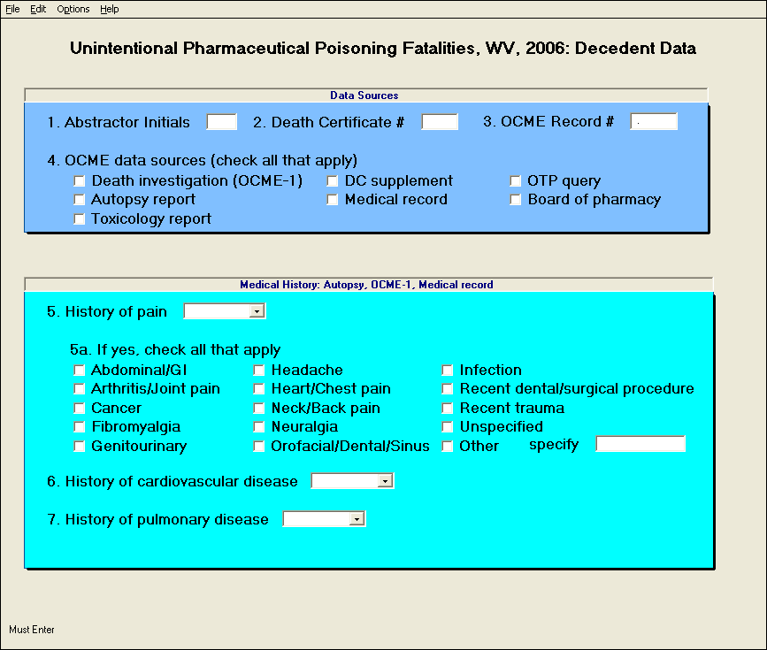

Note: response options for #5, #6, and #7 included yes or no/unknown.
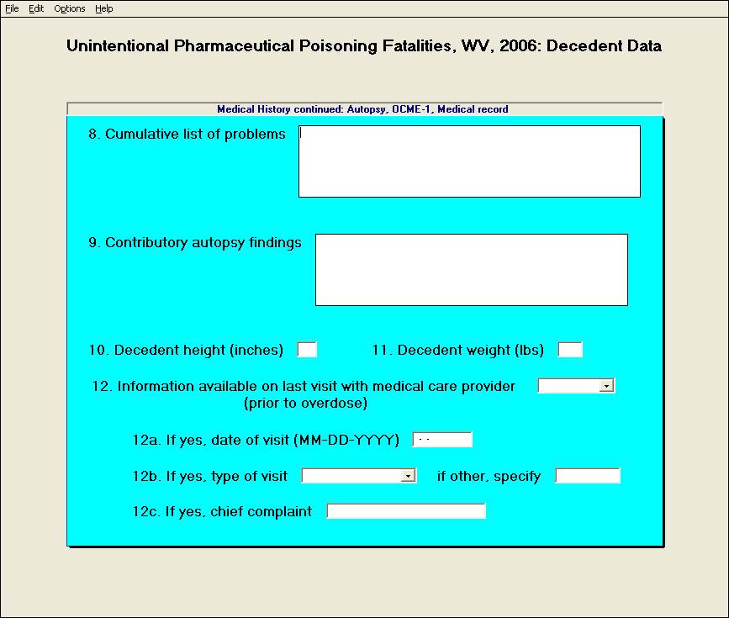

Note: response options for #12 included yes or no/unknown; response options for #12b included inpatient, emergency room, outpatient, drug treatment facility, other, or unknown.
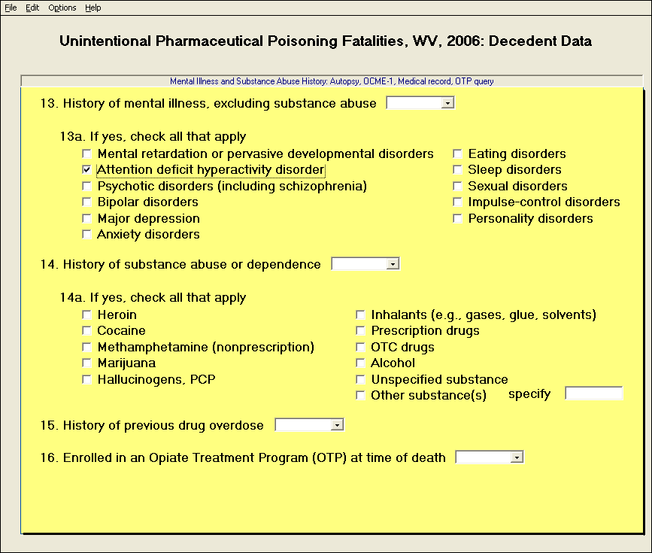

Note: response options for #13, #14, #15, and #16 included yes or no/unknown.

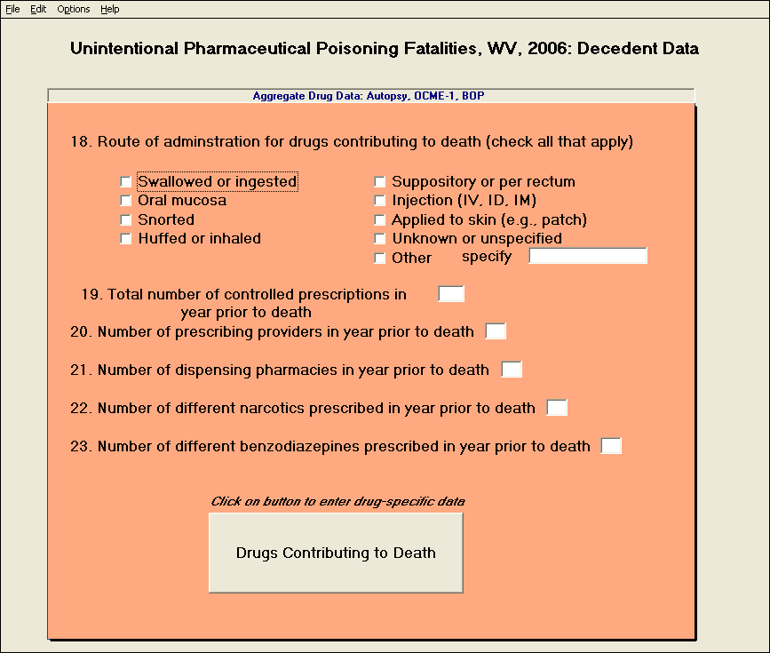

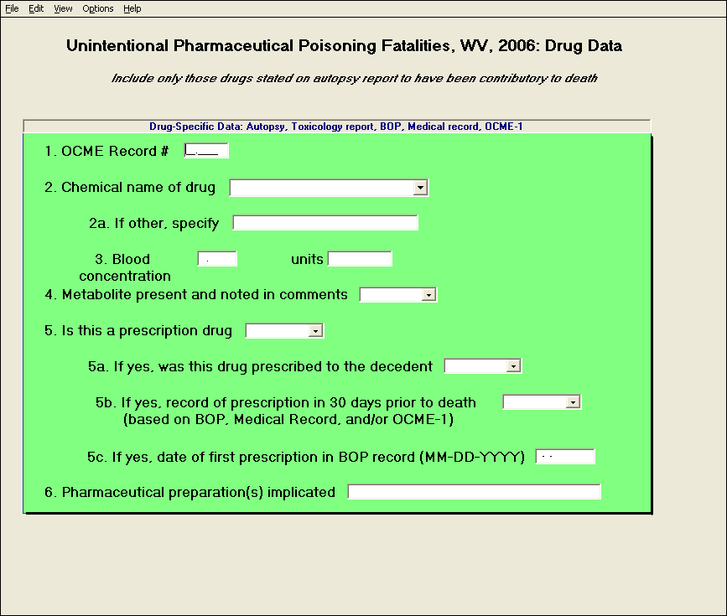

Note: response options for #2 included list of 100 drugs previously noted on death certificates as contributory to death or other; response options for #4, #5, #5a, and #5b included yes or no/unknown.

