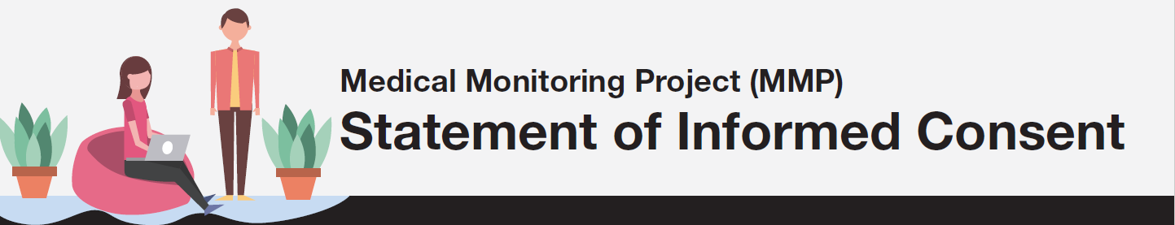We chose you for this project because you have HIV. Taking part in this project is up to you. You can choose to participate or not to participate. You don’t have to be in the project if you don’t want to be. If you decide to take part, you may leave the project at any time. There are no penalties or loss of benefits if you choose not to take part or to leave the project early. [If currently incarcerated: Taking part in this project will not affect your parole.]
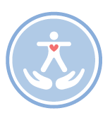Why we are doing this project
Your health department and the Centers for Disease Control and Prevention (CDC) are doing this project to learn more about people living with HIV, including the services they use and need. This information will help improve programs that keep people healthy and get them the help they need.

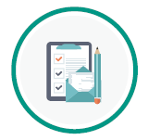What we will need from you
If you choose to be in this project, we will
- ask you questions
- look at your medical records

The questions
Answering the questions will take about 40 minutes. You don’t have to answer any question you don’t want to answer.

The questions ask about your
- medical past
- use of medical and social services
- sex practices
- use of drugs and alcohol
- reproductive history (if you are a woman)
- ability to work and take care of yourself

If we need more information, a staff member may contact you later.

We send the answers to CDC, but we don’t send them your name. Instead, we will assign a code number to your answers. We don’t send CDC any information that identifies you. We don’t send CDC any information that could trace back to you. Your answers are confidential. All project materials are kept in a locked cabinet or secure computer.

Your medical records
We will also look at your medical record to collect information about your HIV. This includes medicines you are taking, clinic visits, and lab test results. Again, we don’t send CDC any information that can identify you or that could trace back to you. A code number will link information from your medical records to your answers.
Supervisors will observe a small number of interviews and medical record reviews to give feedback to MMP staff on their work.

What you can expect from us
Privacy
We protect your privacy. All information you give us will be private and confidential.
Your records will be confidential as much as the law allows. We will group your answers with answers from other people who take part in this project so that no one will know your answers. We will send CDC information from this project, but we will not send any information that could identify you. Federal law protects the confidentiality of information kept at CDC.

Token of appreciation
You will receive $____ as a token of appreciation for taking part in the project if you answer the questions and let us review your medical records. If you later choose to leave the project, you may keep the money.
Things to consider
- There is no cost to you (other than your time and effort) for being in this project.
- If you like, we can give you information about how to avoid giving HIV to someone else.
- If you like, we can give you information about where to get medical and social services.
- There are no direct benefits from being in this project. However, the information you give us can help us improve services available to other people living with HIV.
- Some of the questions may make you feel uncomfortable or may be too personal. Remember: You don’t have to answer any questions you don’t wish to answer.

Questions?
About this project or your token of appreciation, please
- ask the person who asks you the interview questions
- call (local principal investigator) at (phone number)

About your rights and how the project works across the country, please contact
- (If applicable) The institutional review board (IRB) at (State/Local Health Department) at (phone number).
- (If applicable) (Local IRB contact) at (phone number).
- CDC at 1-404-639-6475. Please leave a brief message letting us know how to contact you. Say that you are calling in reference to the Medical Monitoring Project. Someone will return your call as soon as possible.

Participant’s Consent Statement
I agree to take part in the project described here. I have read the statement and understand the statement. The interviewer answered all of my questions. I understand that my participation is completely voluntary.

_________________________________ ___________________
Signature of Participant Date

__________________________________ ___________________
Signature of Interviewer Date

