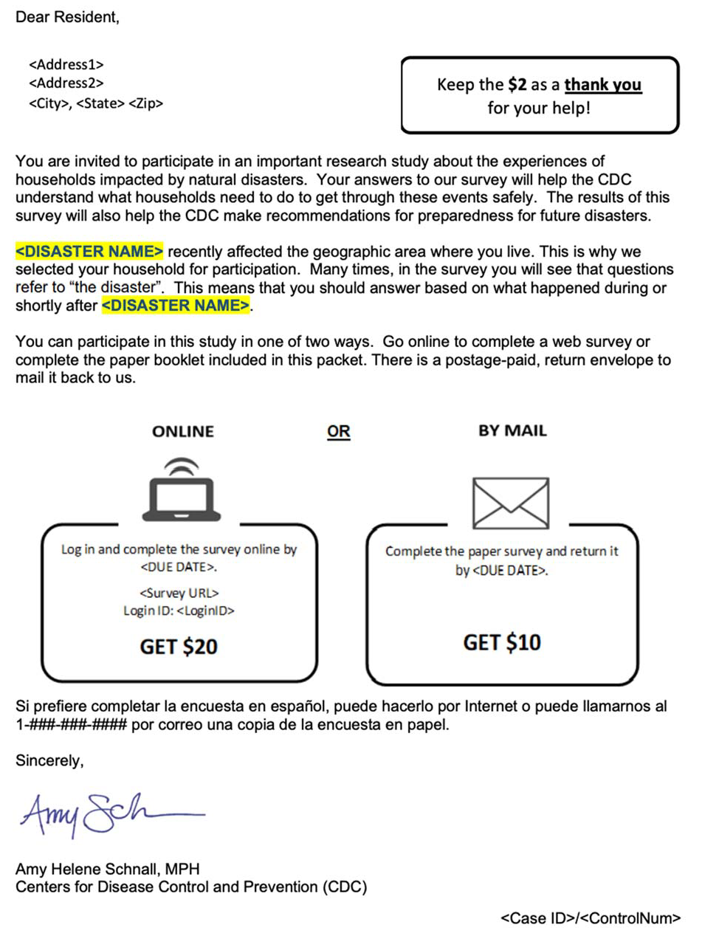
Attachment 4: Introductory Letter

50

