- Establishing Ticket Assignments and Ticket Use/Ticket Assignability
Ticket Portal:
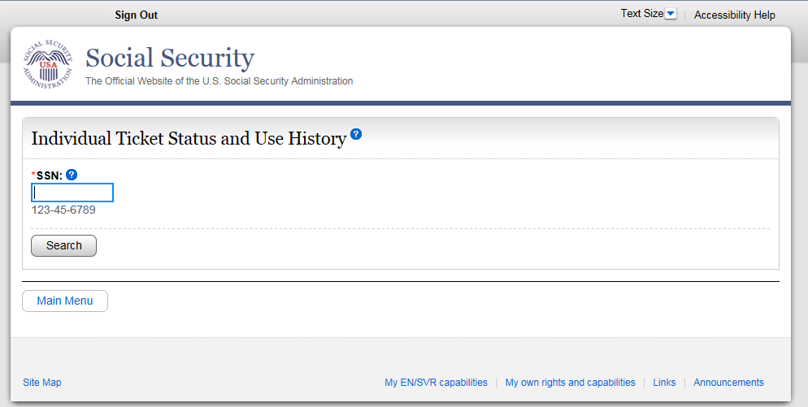
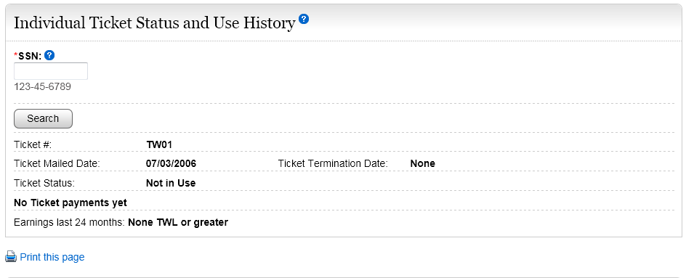
State agencies use Form SSA-1365 or the Ticket Portal
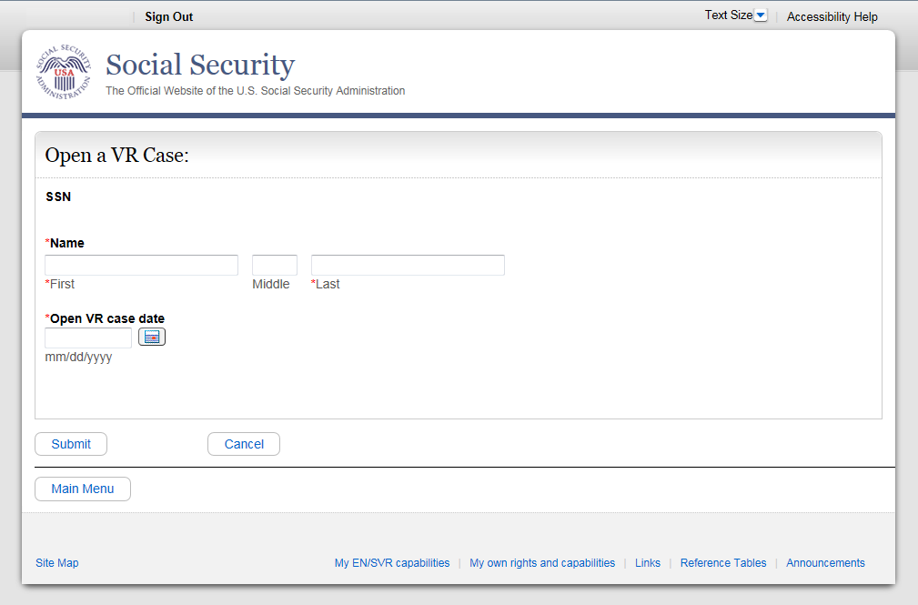
ENs in the private sector use the SSA-1370 or the Ticket Portal
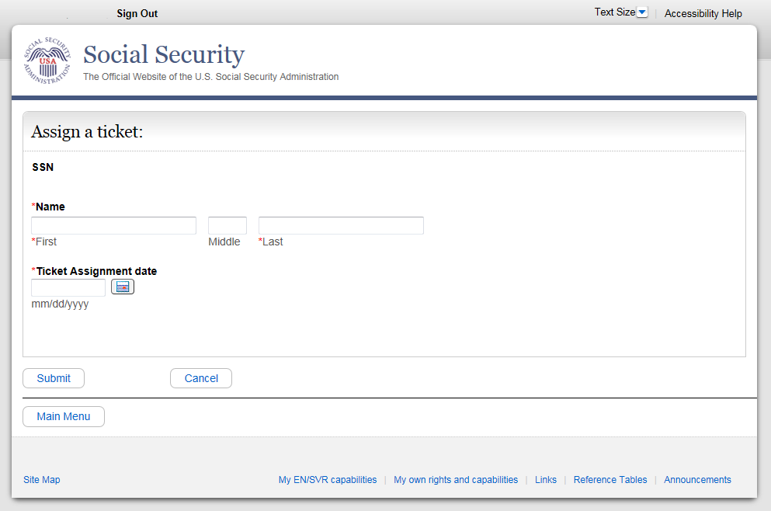
f. Requesting EN Payments

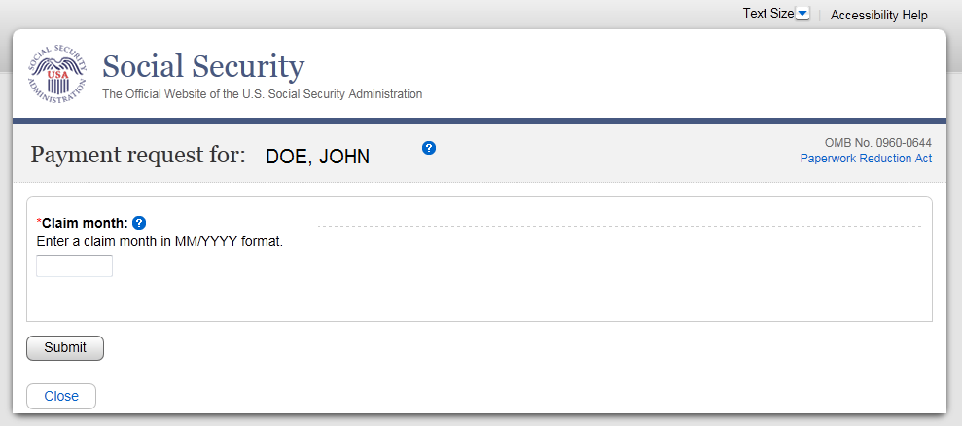
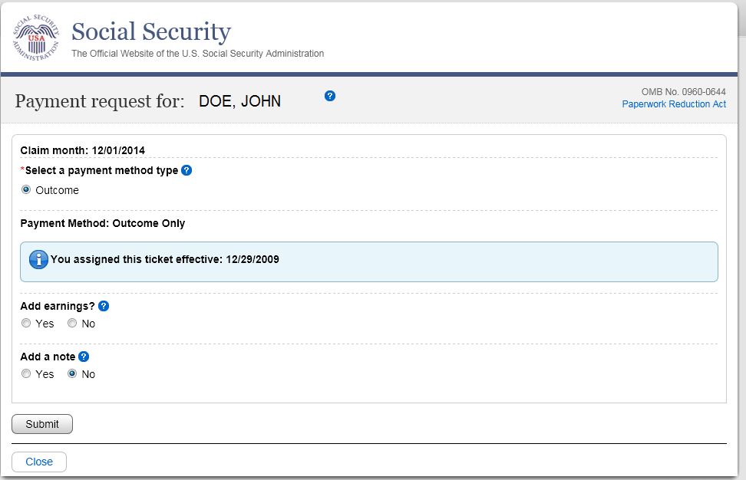

SSA will insert the following revised Privacy Act Statement into the form as soon as possible:
Privacy Act Statement
Collection and Use of Personal Information

Section 1148 of the Social Security Act, as amended, allows us to collect this information. Furnishing us this information is voluntary. However, failing to provide all or part of the information may prevent your successful participation in the program, including receipt of payment.

We will use the information to manage your participation in the Ticket to Work and Self-Sufficiency Program, including verification of eligibility of payment. We may also share your information for the following purposes, called routine uses:

- Disclosure to contractors and other Federal agencies, as necessary, for the purpose of assisting the Social Security Administration (SSA) in the efficient administration of its programs; and

- Information may be disclosed to state or employment networks having an approved business arrangement with SSA to perform vocational rehabilitation services for SSA disability beneficiaries and recipients.

In addition, we may share this information in accordance with the Privacy Act and other Federal laws. For example, where authorized, we may use and disclose this information in computer matching programs, in which our records are compared with other records to establish or verify a person’s eligibility for Federal benefit programs and for repayment of incorrect or delinquent debts under these programs.

A list of additional routine uses is available in our Privacy Act System of Records Notices (SORN) 60-0295, entitled Ticket-to-Work and Self-Sufficiency Program Payment Database, as published in the Federal Register (FR) on April 4, 2001, at 66 FR 17985 and 60-0300, entitled Ticket-to-Work Program Manager Management Information System, as published in the FR on June 15, 2001, at 66 FR 32656. Additional information, and a full listing of all of our SORNs, is available on our website at www.ssa.gov/privacy.

