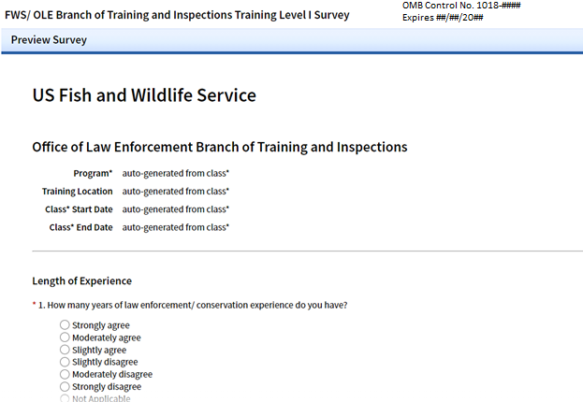

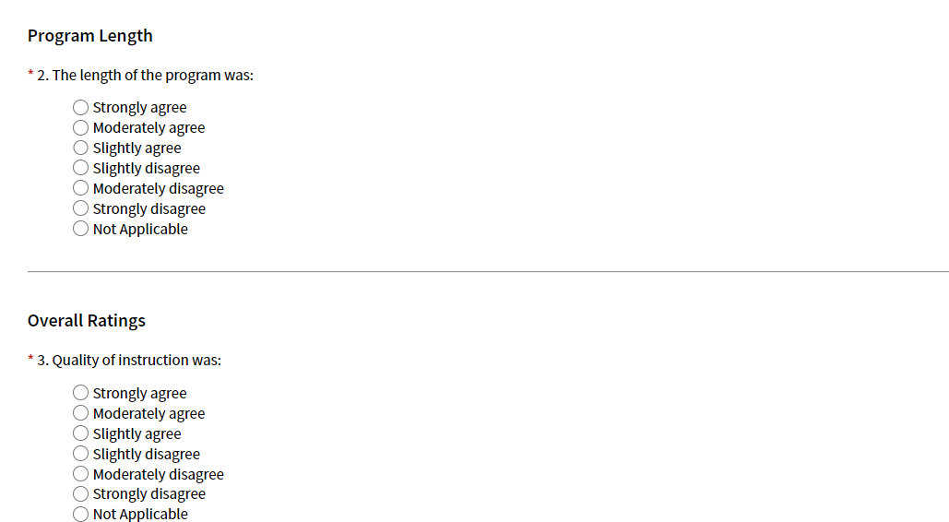

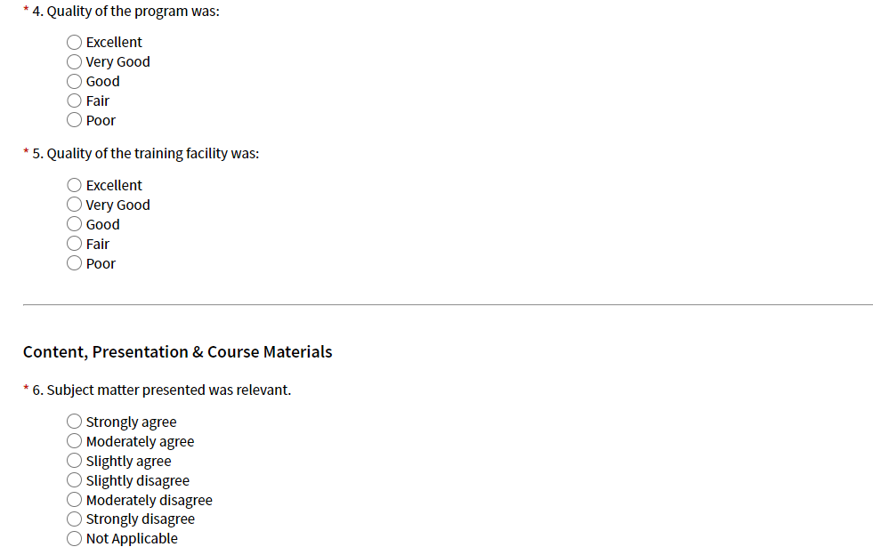

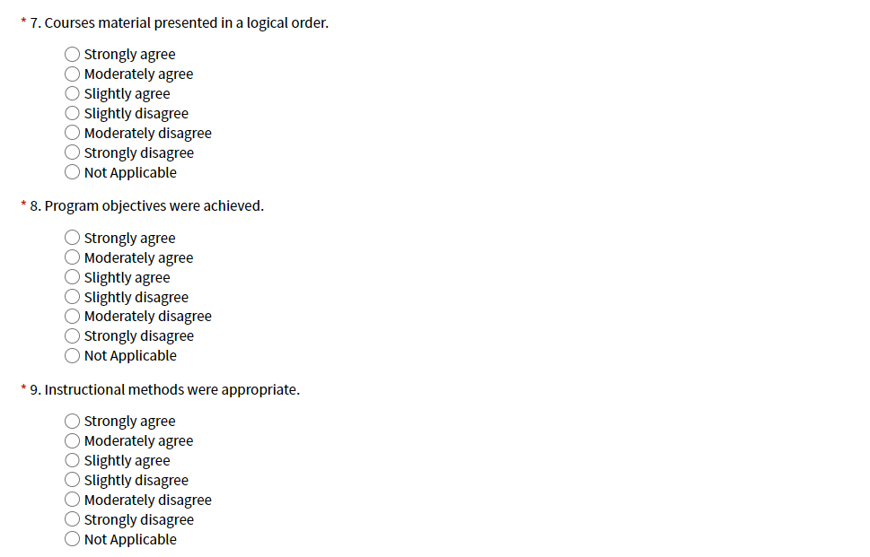

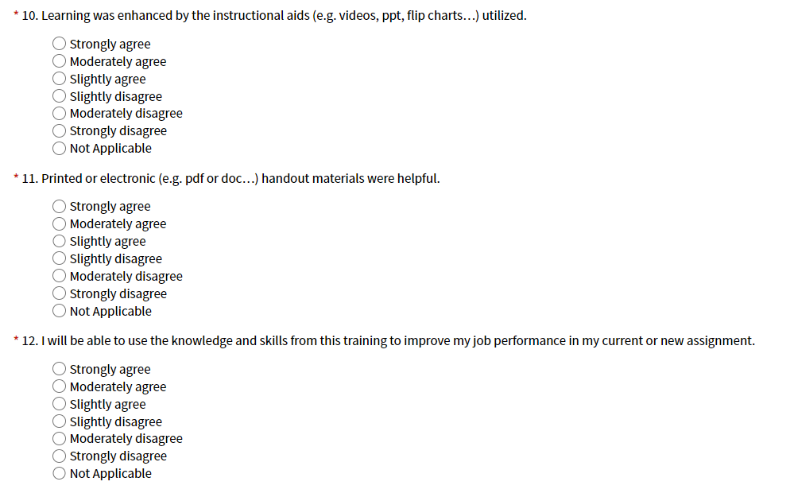

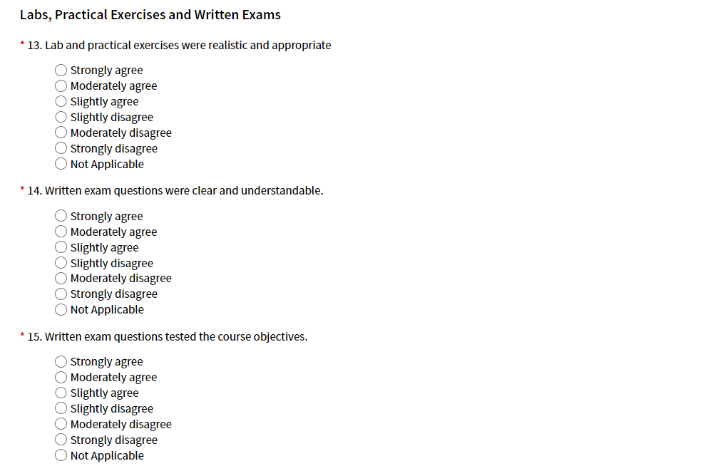

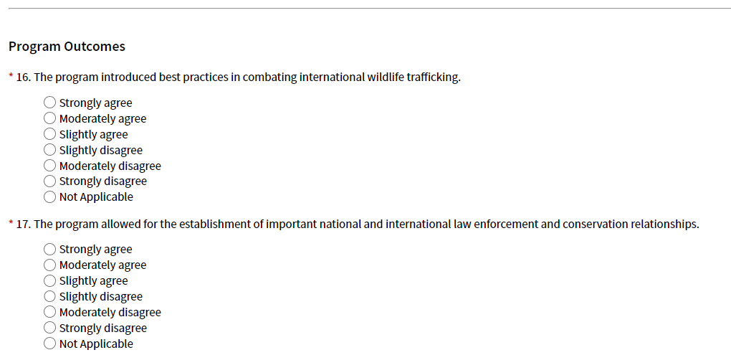

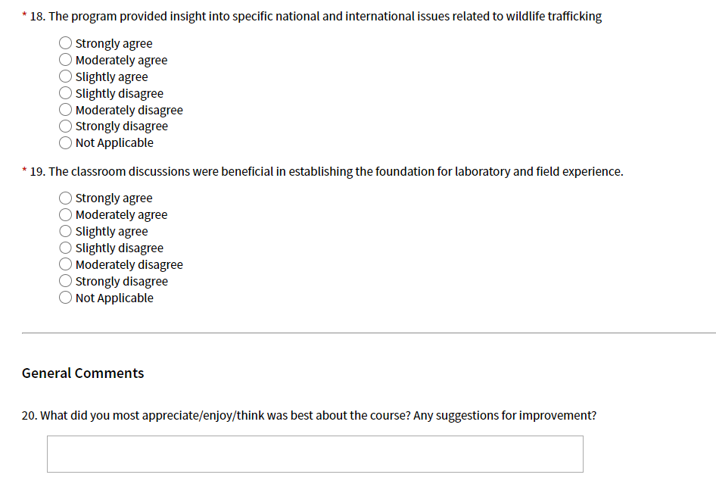

**NOTICES**

**PRIVACY ACT STATEMENT**

**Authority:** 5 U.S.C. 4101, et seq., Government Organization and Employee Training; Endangered Species Act (18 U.S.C. 1531-1543); Lacey Act (18 U.S.C. 42-44).

**Purpose:** To coordinate and conduct training for FWS special agents, wildlife inspectors, and administrative staff, as well as for State, Tribal, and foreign individuals responsible for wildlife and habitat protection.

**Routine Uses:** The information collected on this form may be shared in accordance with the Privacy Act of 1974 and the routine uses listed in the Department of Interior System of Records Notices INTERIOR/FWS-20, Investigative Case Files 64 FR 29055 (May 28, 1999); modification published 73 FR 31877 (June 4, 2008) and INTERIOR/DOI-10, Incident Management, Analysis and Reporting System (June 3, 2014) 79 FR 31974, and INTERIOR/DOI-16, Learning Management System, 70 FR 58230 (October 5, 2005); modification published at 73 FR 8342 (February 13, 2008) available at <https://www.doi.gov/privacy/doi-notices>.

**Disclosure:** Furnishing this information is voluntary; however, failure to provide all requested information may prevent you from being able to enroll or attend training.

**PAPERWORK REDUCTION ACT STATEMENT**

In accordance with the Paperwork Reduction Act (44 U.S.C. 3501), the U.S. Fish and Wildlife Service collects information necessary to coordinate and conduct training for FWS special agents, wildlife inspectors, and administrative staff, as well as for State, Tribal, and foreign individuals responsible for wildlife and habitat protection, and to respond to requests made under the Freedom of Information Act and the Privacy Act of 1974. Information requested in this form is purely voluntary. However, submission of requested information is required in order to process applications for permits authorized under the above laws. Failure to provide all requested information may be sufficient cause for the U.S. Fish and Wildlife Service to deny the request. According to the Paperwork Reduction Act of 1995, an agency may not conduct or sponsor and a person is not required to respond to a collection of information unless it displays a currently valid OMB control number. OMB has approved this collection of information and assigned Control No. 1018-####.

**ESTIMATED BURDEN STATEMENT**

We estimate public reporting for this collection of information to average 15 minutes, including time for reviewing instructions, gathering and maintaining data and completing and reviewing the form. Direct comments regarding the burden estimate or any other aspect of the form to the Service Information Clearance Officer, Fish and Wildlife Service, U.S. Department of the Interior, 5275 Leesburg Pike, MS: PRB (JAO/3W), Falls Church, VA 22041-3803, or via email at Info_Coll@fws.gov.