**Justification for Non-Material or Non-substantive Change to Currently-Approved Collection**

The 2020 Form 5500 and Form 5500-SF, Annual Return/Report of Employee Benefit Plan Instructions (Instructions) contain the following statement on page 5 thereof:

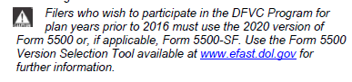

The Department of Labor (the Department) is submitting this non-material, non-substantive change request to its information collection approved under OMB Control Number 1210-0110 to change the reference to “2016” on page 5 of the Instructions to “2019.” The Department has uploaded a clean PDF and Word version (with tracked changes) of the Instructions into ROCIS reflecting the correction of this typo.