OPR home page
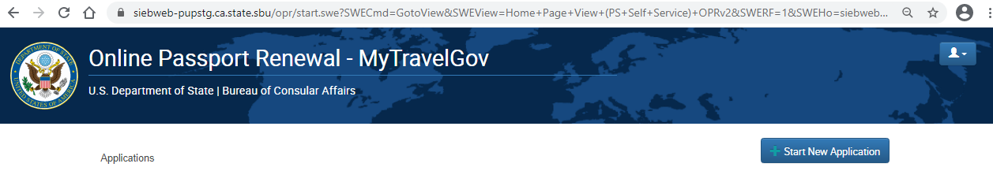

OPR initial eligibility questionnaire
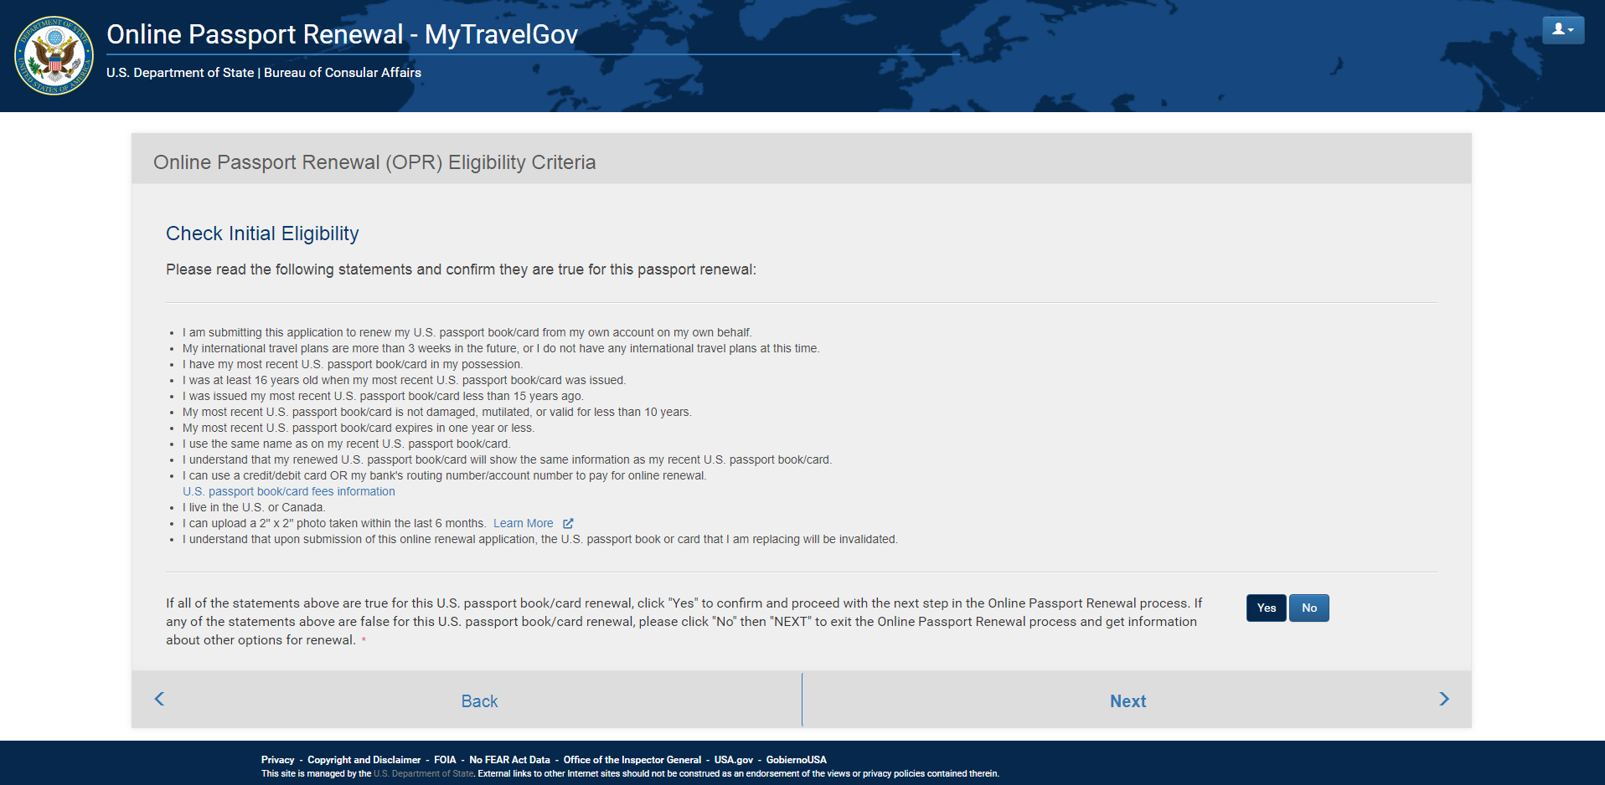

OPR Privacy Act screen
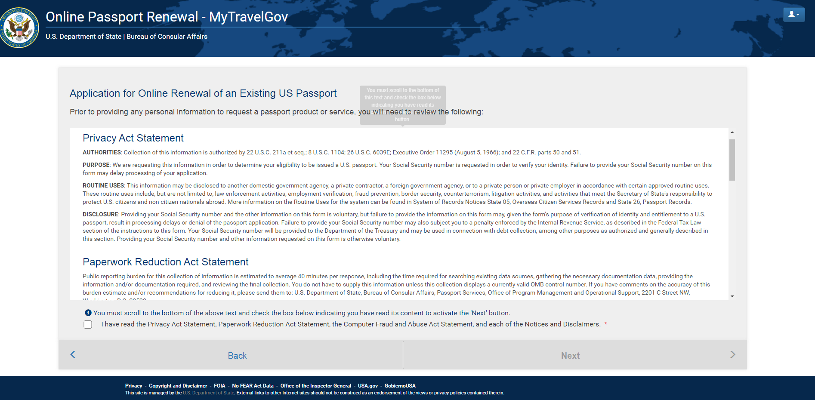
Note: when user scrolls down, user sees entire Paperwork Reduction Act verbiage:

OPR Product eligibility screen and OMB Number, Expiration Date and Estimated Burden Time
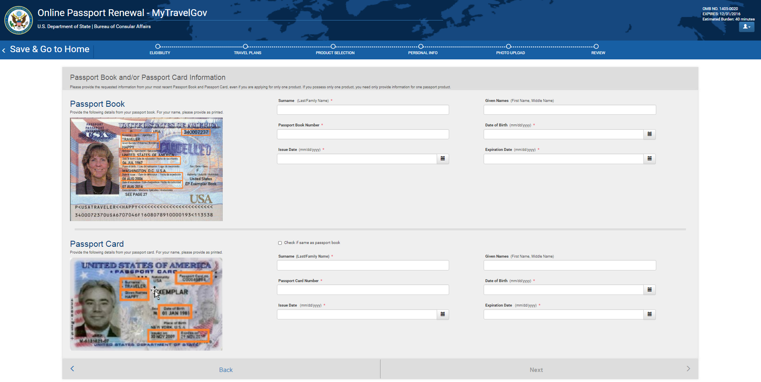

OPR Upcoming Travel Plans screen
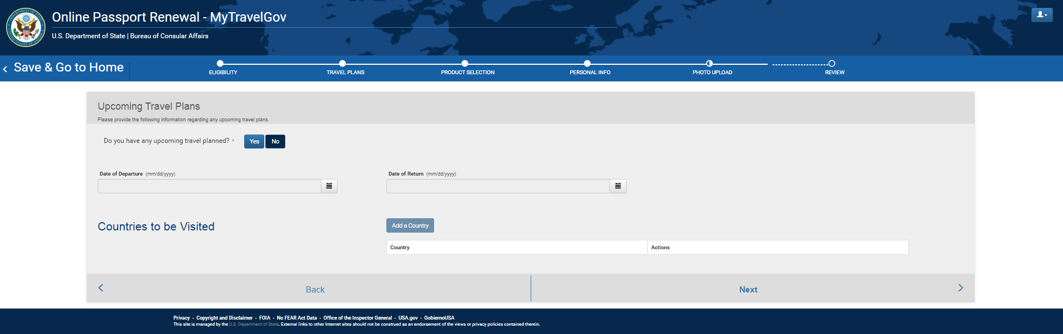

OPR Product Selection Screen
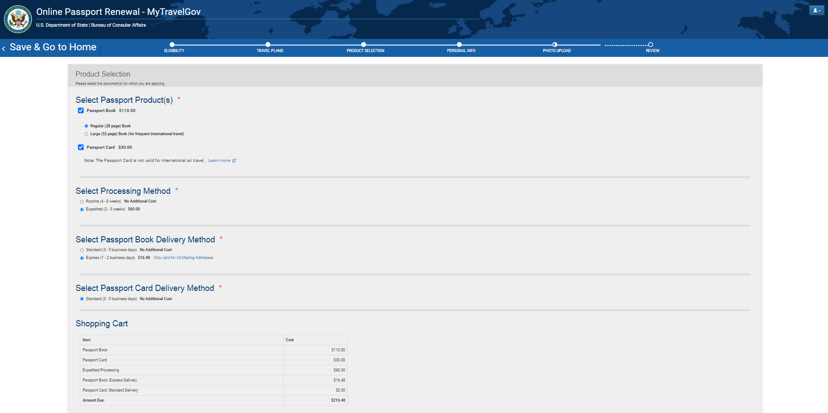

OPR Personal Information screen
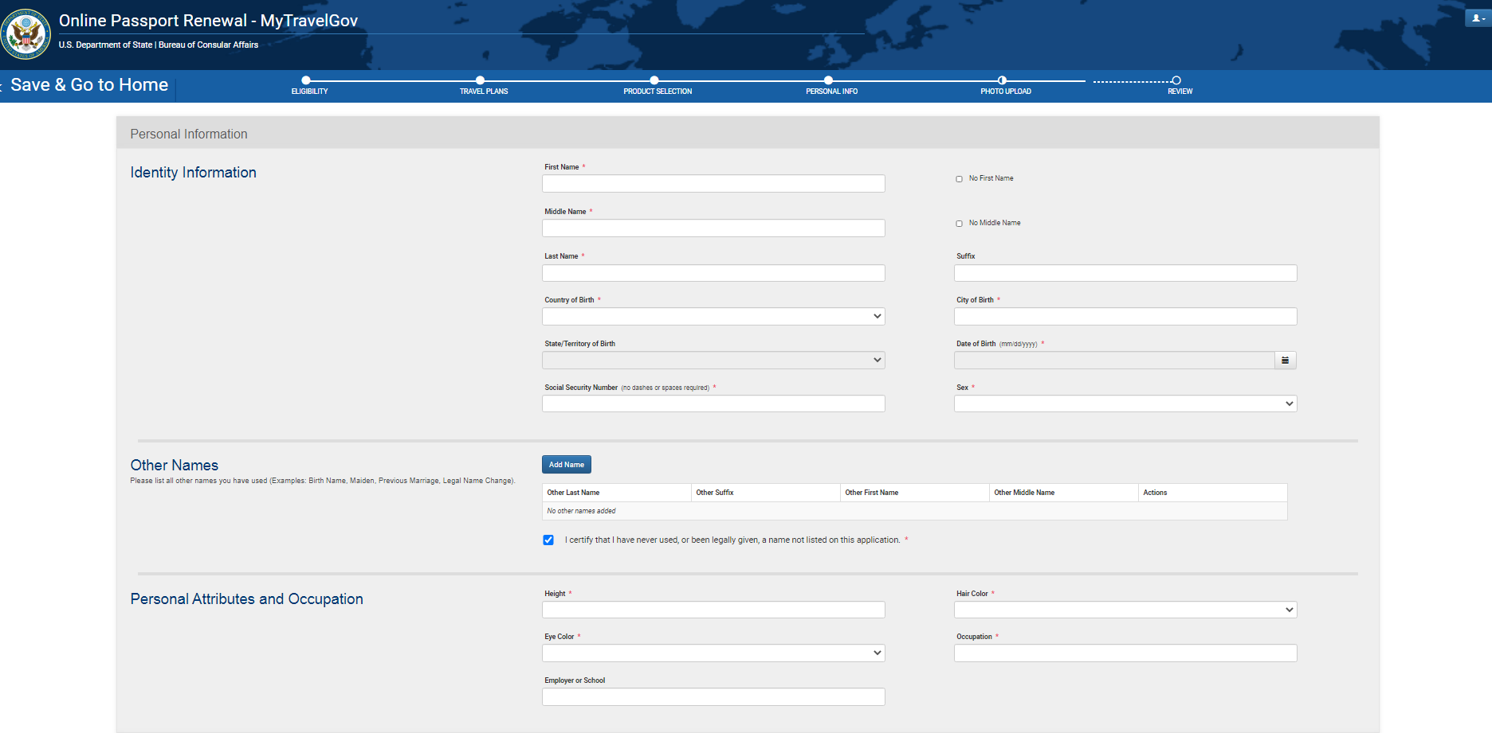

OPR Personal Information Screen (cont)
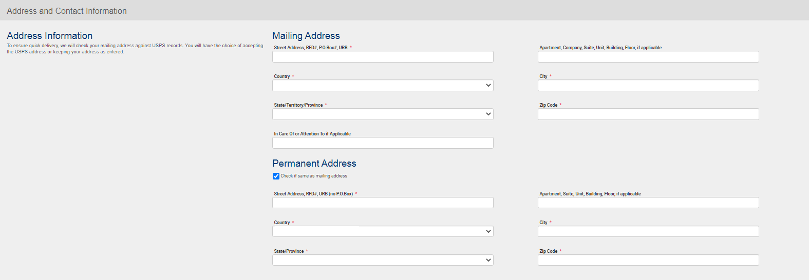

OPR Personal Information Screen (cont.)
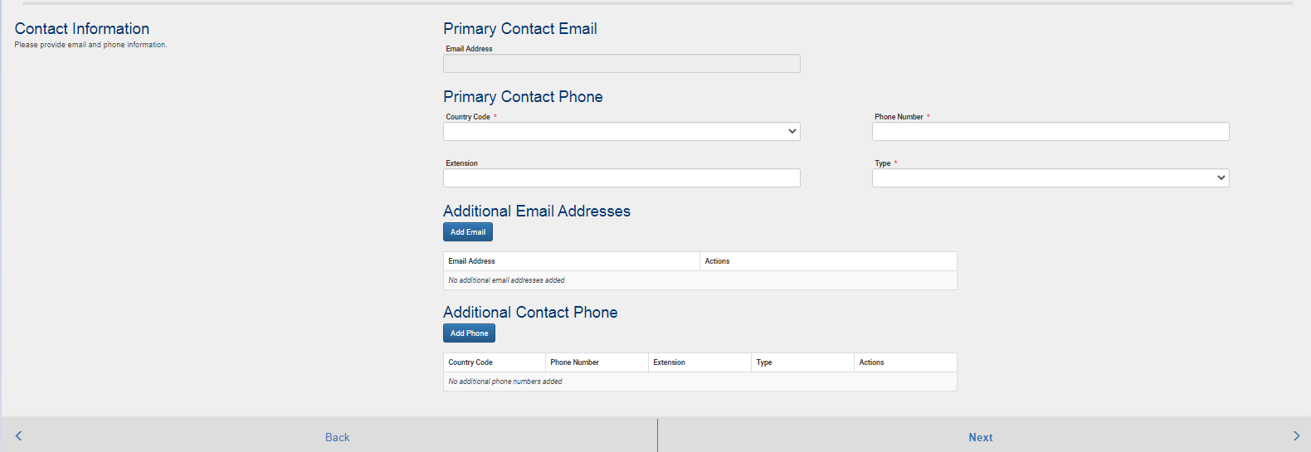

OPR Personal Information Screen (cont.)
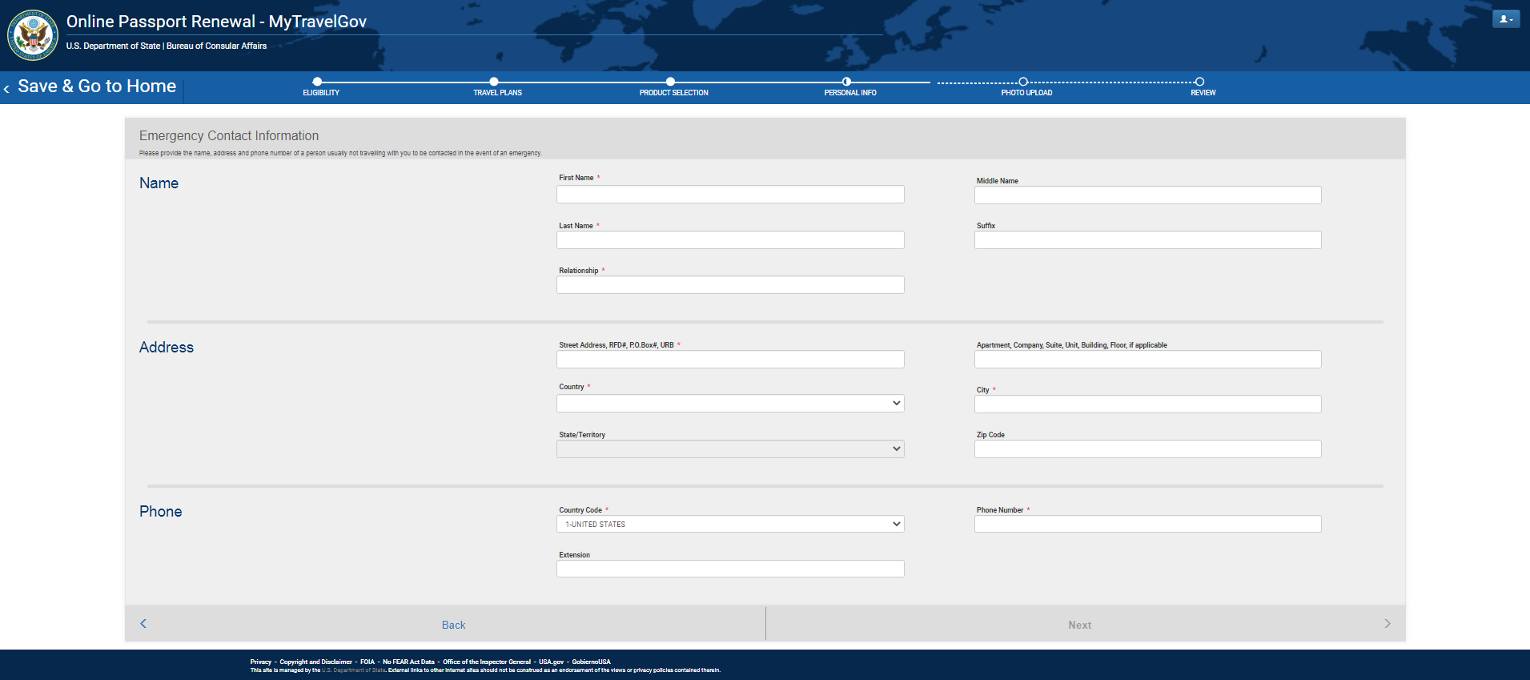

OPR Photo Upload Screen
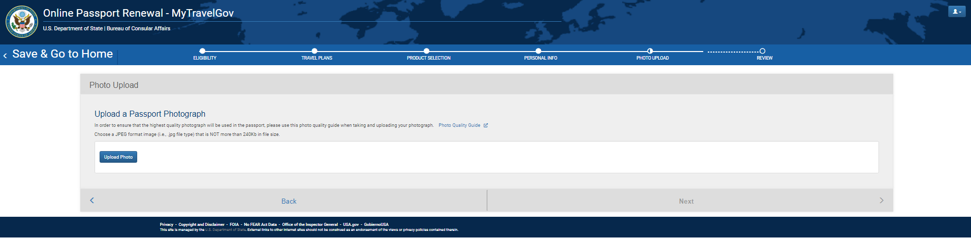

OPR Final Review screen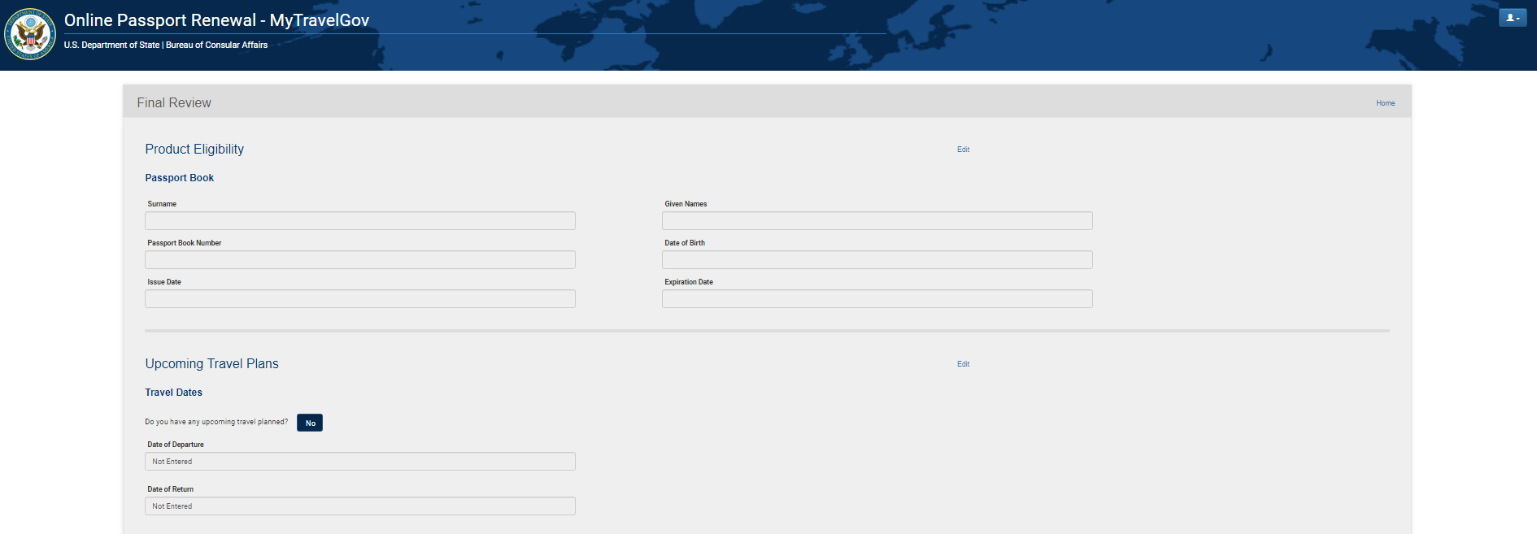

OPR Final Review screen (cont)
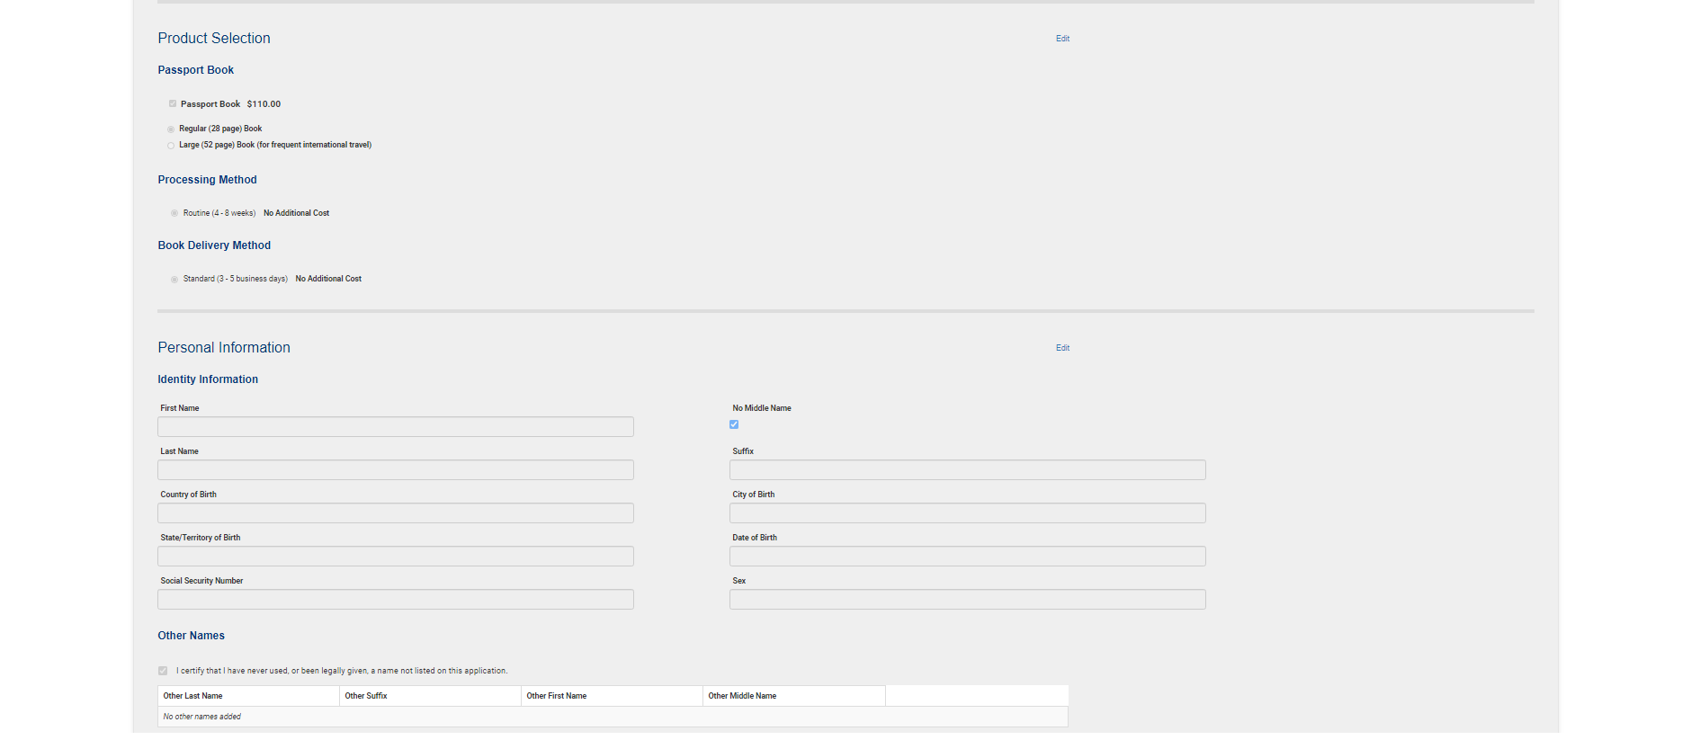

OPR Final Review screen (cont)
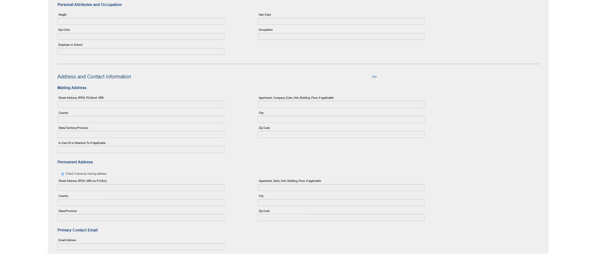

OPR Final Review screen (cont)
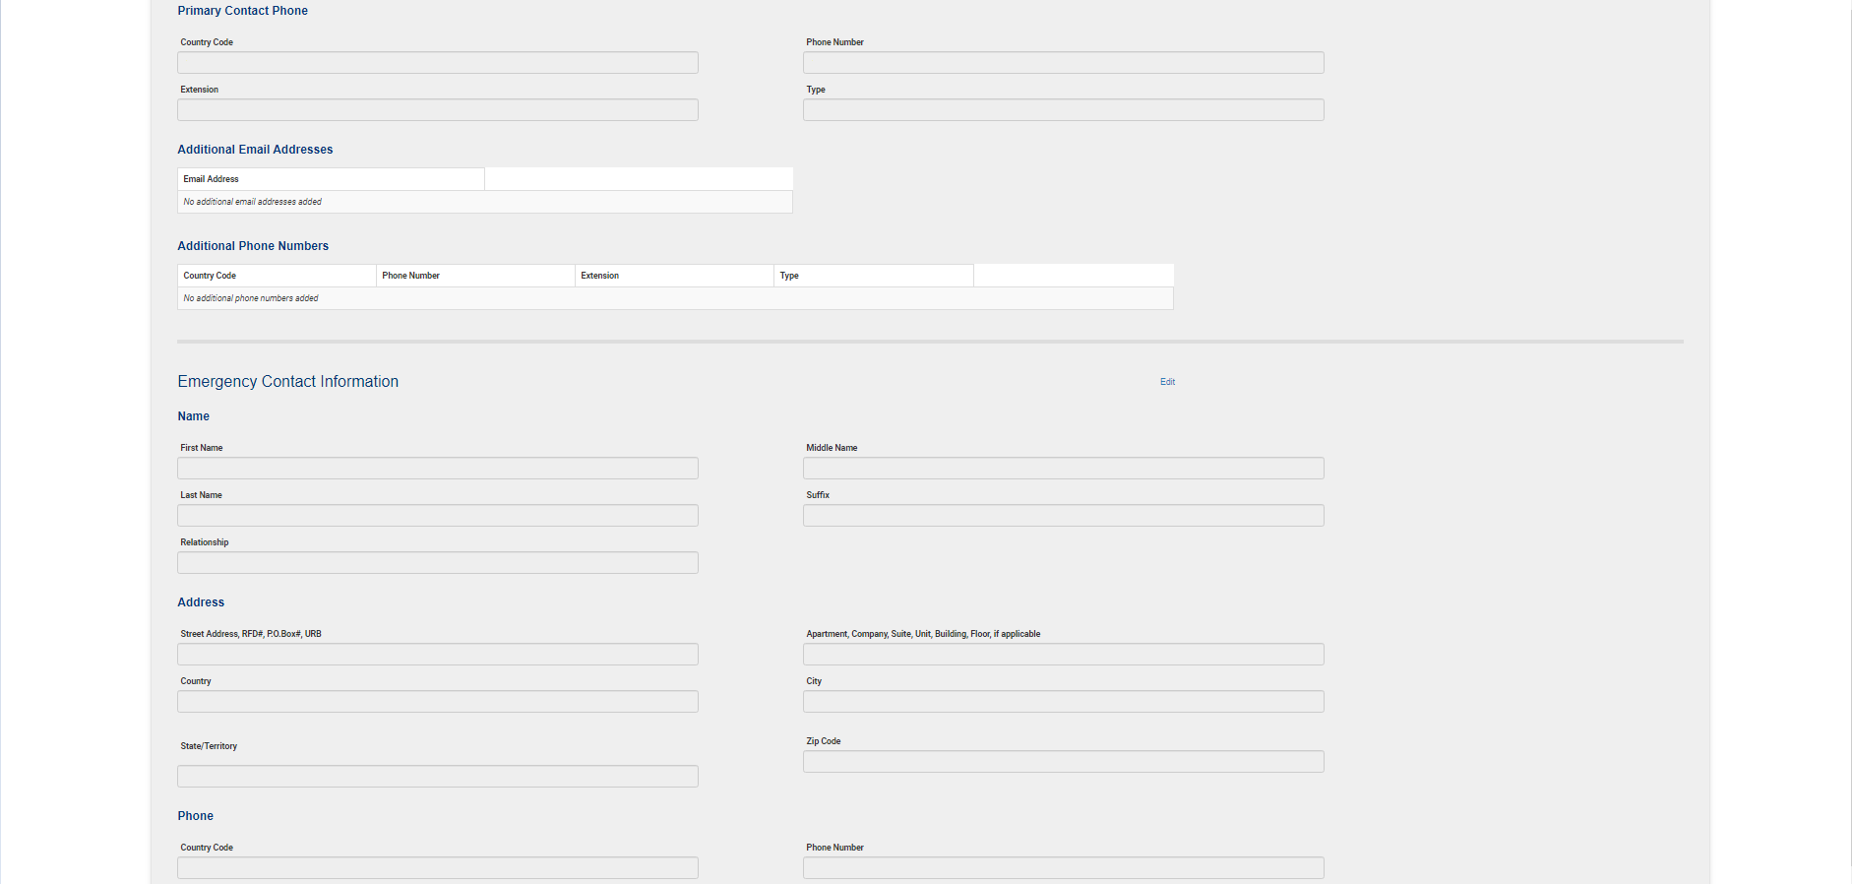

OPR Final Review screen (cont.)
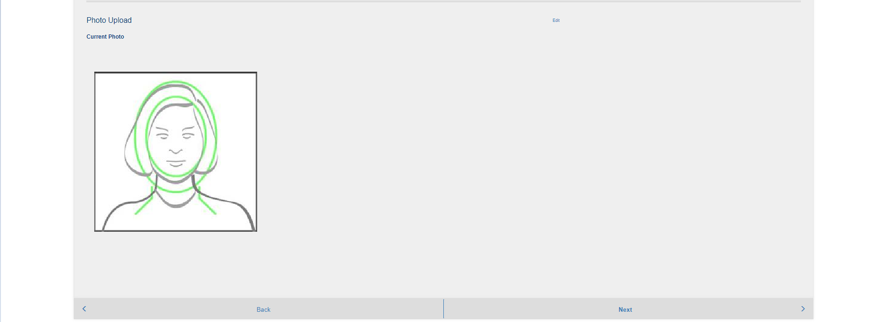

OPR signature / submission screen
