MSIX User Access Guide and Application
Department of Education

MSIX User Access

Guide and Application

MAY 2018
“MSIX is only available to Authorized UserS”
Table of Contents
MSIX Application Procedure Overview 3
MSIX Account Creation Hierarchy 4
1) Applicant Process 5
Obtain Application 5
Complete Application 6
Application Information 6
MSIX Account Information 7
Signature 7
Submit to Verifying Authority 9
2) Verifying Authority Process 10
Verify Applicant Identity and User Role 10
Complete Verifying Authority Portion of Application 10
Signature 11
Applicant Submits Application 12
3) Approving Authority Process 13
Review Complete Application 13
Signature 14
Next Steps 14
User Application for Access to MSIX 15

MSIX Application Procedure Overview
The MSIX Application Procedure is composed of three processes: Applicant, Verifying Authority, and Final Approving Authority. These processes are discussed in further detail in this guide to provide the steps for obtaining access to MSIX.
Roles in Application Procedure
The following key players participate in the Application Procedure:
- Applicant ⎯ the potential user requesting access to MSIX
- Verifying Authority ⎯ the Applicant’s direct supervisor or an individual that is above the direct supervisor in an official reporting structure who verifies the Applicant’s identification, attests to their need for an MSIX account, and confirms the Applicant has the right level of access
- Final Approving Authority ⎯ the State or Regional User Administrator who gives final approval and creates the Applicant’s account
Each of the roles plays a critical part in the application process. The “User Application for Access to MSIX” application form is also included at the end of this guide.
Application Procedure
The steps below outline the complete application process:
STEP 1: Applicant Information
- The Applicant completes the Applicant Information and signs the form (see page 15).
- The Applicant forwards the form to a Verifying Authority. This should be the Applicant’s direct supervisor or an individual that is above the direct supervisor in an official reporting structure. The Applicant must provide appropriate identification (such as state/district identification badge, passport, driver’s license, etc.) to verify their identity and evidence to support completion of a basic cyber security awareness training.

STEP 2: Identification Verification and Attestation
- The Verifying Authority completes his/her own information, reviews the entire application for completeness and accuracy, confirms the Applicant’s identification, attests to the Applicant’s need of an MSIX account, confirms completion of basic cyber security awareness training and confirms the right level of access.
- Upon completion, the Verifying Authority returns the form to the Applicant.

STEP 3: Forward Form to Approving Authority
- The Applicant locates his/her State/Regional Authority for final approval by going to the MSIX website: https://msix.ed.gov.
- The Applicant clicks on the link labeled ”Request An Account” to access the contact information for their state.
- The Applicant forwards the form to the State/Regional Authority for final approval.

STEP 4: State/Regional Authority Approval
- The State/Regional Authority reviews the Applicant and Verifying Authority portions of the application for completeness, completes his/her own information, signs the form, and files it in his/her local records.
- The State/Regional Authority creates an MSIX account for the Applicant.
- The Applicant receives two emails: one with his/her MSIX User Name and the other with his/her initial Password.

MSIX Account Creation Hierarchy
The figure below displays the account creation hierarchy within MSIX. The OME User Administrator is responsible for creation and maintenance of the State User Administrators.
The State User Administrators role differs depending on the use of the MSIX regional structure. If a state does not use the Regional User Administrator role, then the State User Administrator is responsible for the creation and maintenance of all additional roles.

1) Applicant Process

Obtain Application
Applications for access to MSIX can be obtained through the MSIX Sign In screen (https://msix.ed.gov). No login is required and the application form is downloadable from the Request an Account link.
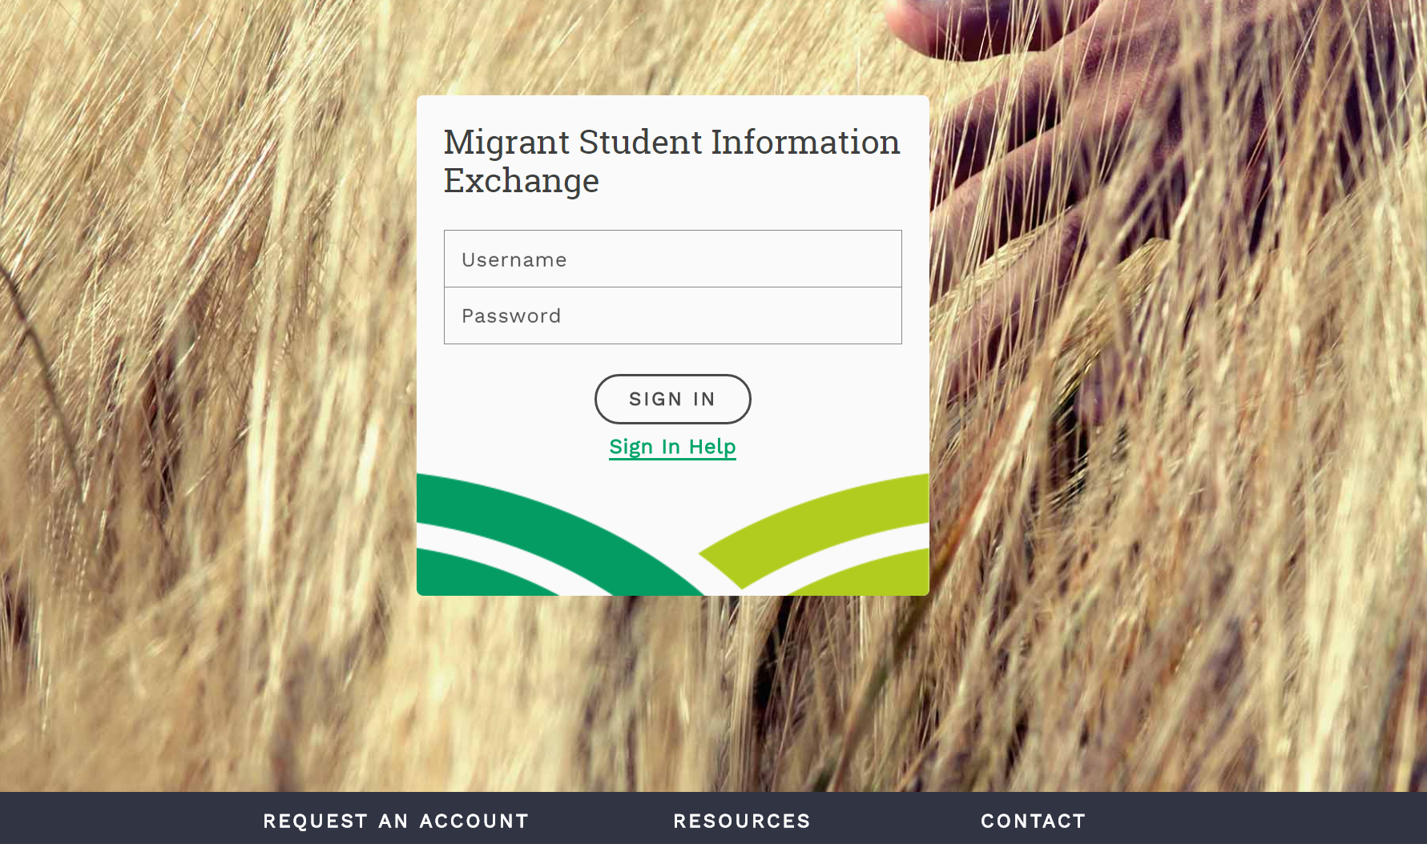
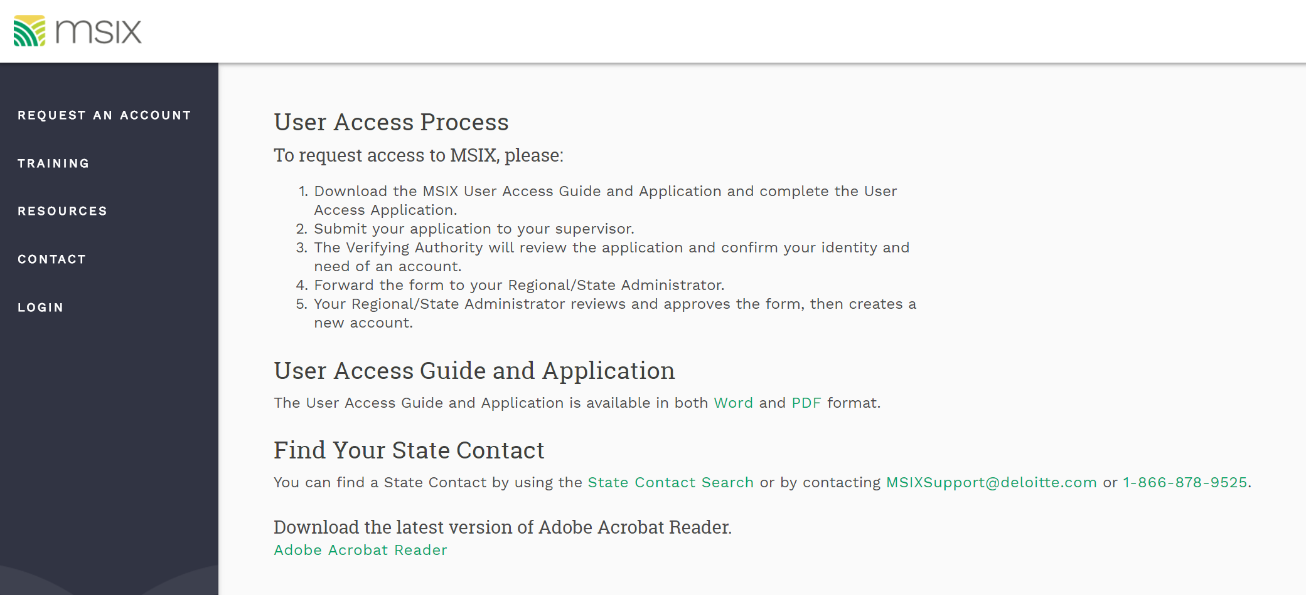

Complete Application
The form is a guideline created to help states with the user registration process. If this form is used, it must be completed in its entirety. The form below displays all of the fields to be completed by the applicant:
Applicant Information
- Complete the applicant information below and sign the form.
- Forward the form to a Verifying Authority. This should be your direct supervisor or an individual that is above the direct supervisor in an official reporting structure. Provide appropriate identification information and proof of cyber security training.
First Name |  |  | Last Name
Title |  |  | Cyber Security Training Date
Work Address | Street |  | City |  |  |  |  | State |  | Zip
Work Email |  |  |  |  | Work Telephone |  | XXX-XXX-XXXX  − − Ext.
Region  (if applicable) |  |  |  |  | School District (if applicable)

Intended Use
Purpose  (select one) | Migrant Education Program Participation, School Enrollment, Placement and Secondary Credit Accrual |  | US Dept of ED, OME Grant Management |  |  |  | Other: ___________________

MSIX Account Information
MSIX Role(s) | Primary User  Secondary User  State Regional Admin | State User Admin  Regional User Admin |  | State Data Admin  Regional Data Admin  District Data Admin  State Batch Submitter |  |  |  |  | OME User Admin Gov. Administrator  MSIX Privacy Act Admin

Signature

I certify that this information is accurate and complete to the best of my knowledge. I will only use MSIX in accordance with the MSIX Rules of Behavior.

Signature: _________________________________________________ Date: ______________________

Application Information
- First Name and Last Name ⎯ the legal name of the individual requesting access to MSIX
- Title ⎯ the applicant’s job title or description such as Teacher, Guidance Counselor, or Student Registrar
- Cyber Security Training Date – the date of most recently completed cyber security training, as required by the MSIX Rules of Behavior
- Work Address ⎯ the street, city, state and zip code of applicant’s workplace
- Work Email ⎯ the applicant’s workplace email address
- Work Telephone ⎯ the applicant’s workplace telephone number
The address, email, and telephone number provided on the application may be used to contact the applicant about MSIX matters.

MSIX Account Information
- Region and District ⎯ the region and district where the applicant works
Both fields are optional for roles that are not region or district specific; not all states have a regional structure.
- Intended Use – the reason for requesting access to MSIX. Requestors from State or Local Education Agencies are expected to select the first option. If selecting “Other,” a description of the intended use must be written into the form.
- MSIX Role ⎯ the desired MSIX user role(s) ⎯ see Table 1, “MSIX User Roles and Responsibilities.”
*Boxes shaded gray on the form are reserved for use by the US Department of Education.

Signature
- Signature ⎯ the applicant’s certification that the information provided is accurate and complete
- Date ⎯ the date the applicant signed the application
Once an MSIX user account has been created, the user should update their phone number and password using the My Account page in MSIX. Users must contact their State User Administrator to make any other changes to their account, such as changes to name, work address, or email address.
MSIX User Roles and Responsibilities
User Role | Description | Functions Allowed | Potential Users
State User Category
Primary | MSIX Primary Users can query student records in all states. This role can also initiate the merge and split process for student records in their state. | - Search, display, and print student records  - Export a student record to a file for load into a state system  - Email notification of a student arrival  - Initiate merge and split of student records  - Access to all district-level MSIX Reports | - Guidance Counselors  - MEP Data Entry Staff  - Recruiters  - Registrars  - Teachers
Secondary | MSIX Secondary Users can query student records in all states. | - Search, display, and print student records for students in all states  - Email notification of a student arrival  - Limited access to MSIX reports | - Guidance Counselors  - MEP Data Entry Staff  - Recruiters  - Registrars  - Teachers
State Regional Administrator | State Region Administrator establishes and maintains the regional structure and associated districts for states that choose to use regions. | - Enable and disable regional structure  - Create new regions  - Associate districts to regions  - Edit regions | - State identified
State Data Administrator | State Data Administrators can validate or reject near matches, merges and splits of student records. The role can initiate the merge and split process for student records in their state. This role can also resolve data quality issues and serve as the primary point of contact for escalation issues. | - Search, display, and print student records  - Export a student record to a file for load into a state system  - Email notification of a student arrival  - Initiate merge and split of student records  - Generate Data and Information Exchange Reports  - Initiate merge and split of student records  - Validate or reject record near matches, merges and splits  - Resolve data quality issues  - Respond to escalation requests  - State-level access to MSIX Reports | - State MEP Administrators  - MEP Data Entry Staff
Regional Data Administrator | Regional Data Administrators can validate or reject near matches, merges and splits of student records. The role can initiate the merge and split process for student records in their state. This role also serves as the secondary point of contact for escalation issues. | - Search, display, and print student records  - Export a student record to a file for load into a state system  - Email notification of a student arrival  - Initiate merge and split of student records  - Generate Data Reports  - Initiate merge and split of student records  - Validate or reject record near matches, merges and splits  - Resolve data quality issues  - Regional-level access to MSIX reports | - State MEP Administrators  - MEP Data Entry Staff
District Data Administrator | District Data Administrators can validate or reject near matches, merges and splits of student records. The role can also initiate the merge and split process for student records in their state. | - Search, display, and print student records  - Export a student record to a file for load into a state system  - Email notification of a student arrival  - Initiate merge and split of student records  - Initiate merge and split of student records  - Validate or reject record near matches, merges and splits  - Resolve data quality issues  - District-level access to MSIX reports | - State MEP Administrators  - MEP Data Entry Staff
State User Administrator | State User Administrators establish and manage user accounts for users in their state. | - Create user accounts  - Assign role(s)  - Update user account information  - Deactivate user accounts  - Reset passwords | - State identified
Regional User Administrator | Regional User Administrators establish and manage user accounts for users in their region. | - Create user accounts  - Assign role(s)  - Update user account information  - Deactivate user accounts  - Reset passwords | - State identified
State Batch Submitter | State Batch Submitter upload and transfer student files to MSIX for processing. *Contact MSIX Help Desk for file server access. | - Run data quality reports  - Upload and transfer student files to MSIX for processing | - State technical team
OME RESERVED ROLES
OME User Administrator | OME User Administrators establish and manage user accounts for all State User Administrators. | - Create / Deactivate user accounts  - Assign State User Administrators  - Update user account information  - Reset passwords | - US Dept of ED, OME identified personnel
Government Administrator | OME / Government Administrators can generate summary level standard and ad hoc queries on a State, Regional, or National level. | - Generate Reports | - US Dept of ED, OME identified personnel
MSIX Privacy Act Admin | Privacy Act Administrators can enter Statements provided by students and parents that formally dispute the data contained in a student's MSIX record. They can also query and view student records from all States. | - Search, display, and print student records  - Enter dispute Statements into a student's MSIX record | - US Dept of ED, OME identified personnel
Table 1 – MSIX User Roles and Responsibilities

Submit to Verifying Authority
The identity of MSIX Applicants should be verified and the type of MSIX access requested must be reviewed. The Applicant’s direct supervisor or an individual that is above the direct supervisor in an official reporting structure should perform the identity verification and application review. Further, they attest to the Applicant’s need for MSIX and confirm that the correct user roles have been requested. For example, an applicant who is a teacher should submit the application to his or her principal for identity verification and review, or an applicant who is a state MEP administrator should submit to his or her MEP Director for identity verification and review.
2) Verifying Authority Process

Verify Applicant Identity and User Role
When approving an application, the Verifying Authority should verify the user's identity (e.g., reviewing their State/District issued ID badge, driver's license, passport, etc.). As approver of system access, the Verifying Authority is responsible for verifying the Applicant’s identity. The Verifying Authority must review each field of the application for accuracy and completeness. The Verifying Authority will also verify that the Applicant’s MSIX role is appropriate for their job. The Verifying Authority is responsible for ensuring that the applicant has completed a basic cyber security awareness training course prior to gaining access. At a minimum, the new user must read and acknowledge the MSIX Rules of Behavior (August 2015 or most current as posted on MSIX).

Complete Verifying Authority Section
Upon successful verification of identity, the Verifying Authority will complete the Identification and Attestation portion on the second page of the application. Upon completion, they should retain a copy of the application for their local records.

Identification Verification and Attestation

As the Verifying Authority, you should be the Applicant’s direct supervisor or an individual that is above the direct supervisor in an official reporting structure.

Review the entire application for completeness and accuracy.

Complete the information below, confirm the Applicant’s identification, attest to his/her need of an MSIX account, confirm completion of basic cyber security training, and confirm that the Applicant has the right level of access.

Upon completion, file the form in your local records and return this form to the Applicant.
Verifying Authority  First Name |  |  | Verifying Authority  Last Name

Title
Work Email |  | Work Telephone |  | XXX-XXX-XXXX  − − Ext.
Organization |  | Applicant Identity Verification Method |  | State Driver’s License  State / District ID  Passport  Other: ________________
Account Effective Date (optional) |  | Account End Date  (optional)

Signature

I certify that: 1) I have verified the identity of the above applicant; 2) I have determined that he or she has a need for MSIX information; 3) I have confirmed that he or she completed basic cyber security training; and 4) the above-mentioned individual is requesting the appropriate MSIX role(s).

Signature: _________________________________________________ Date: ______________________

Identification Verification and Attestation
- Verifying Authority First Name and Verifying Authority Last Name ⎯ the legal name of the Verifying Authority reviewing the application
- Title ⎯ the official title or position of the Verifying Authority
- Work Email ⎯ the Verifying Authority’s work email address
- Work Telephone ⎯ the Verifying Authority’s workplace telephone number
The phone number may be used if the Verifying Authority needs to be contacted about MSIX matters.
- Organization ⎯ the organization or entity that employs the Verifying Authority
- Applicant Identity Verification Method ⎯ the type of ID or method used to verify the identity of the applicant
- Account Effective Date and Account End Date ⎯ optional fields that can be used to designate a known future start or end date for a user account
For instance, a future Account End Date may be entered for a seasonal employee that will no longer need access to MSIX after the summer months.

Signature
- Signature ⎯ the Verifying Authority’s certification that the information provided is accurate and complete
- Date ⎯ the date the applicant signed the application

Applicant Submits Application
Each state may have State User Administrators, Regional User Administrators, or both. The User Administrator will create an account in MSIX for the Applicant requesting access based on information provided in the application. The application should be delivered to the User Administrator’s office.
To find the contact information for a State or Regional User Administrator, click on the Request an Account link from the MSIX home page (msix.ed.gov), or contact the state’s Migrant Education Program office.
3) Approving Authority Process

Review Complete Application
The User Administrator will review the application received to verify that both the Applicant and Verifying Authority sections are complete. If any problems are identified during the review, the User Administrator will contact the Applicant and/or the Verifying Authority that reviewed the application.
Upon successfully completing the review, the User Administrator will create account(s) for the Applicant requesting access to MSIX based upon the information provided in their application.

State/Regional Authority Approval
- Review the Applicant and Verifying Authority portions of the application for completeness.
- Complete the information below, sign, and file the form in your local records.
- Create an MSIX account for the Applicant.

Approving Authority  First Name |  | Approving Authority  Last Name
Title |  |  |  | Role | Regional User Administrator  State User Administrator
Work Address | Street | City |  |  |  | State | Zip
Work Email |  |  | Work Telephone |  | XXX-XXX-XXXX  − − Ext.

Signature

I certify that this information is accurate and complete to the best of my knowledge and I hereby grant to the above-mentioned individual the MSIX role for which they have applied.

Signature: _________________________________________________ Date: _____________________

State/Regional Authority Approval
- Approving Authority First Name and Approving Authority Last Name ⎯ the legal name of the Approving Authority reviewing the application
- Title ⎯ the official title or position of the Approving Authority
- Role ⎯ the position of the Approving Authority representing either the regional or state level
- Work Address ⎯ the street, city, state and zip code of Approving Authority’s workplace
- Work Email ⎯ the Approving Authority’s work email address
- Work Telephone ⎯ the Approving Authority’s workplace telephone number
The phone number may be used if the Approving Authority needs to be contacted about MSIX matters.

Signature
- Signature ⎯ the Approving Authority’s certification that the information provided is accurate and complete
- Date ⎯ the date the applicant signed the application

Next Steps
Once the user account information is successfully entered into MSIX, the User Administrator will be taken to a confirmation page that indicates that the new account was successfully created. MSIX will generate an email notification to the new user, using the email address entered by the User Administrator, to notify them of their new MSIX Username and provide information about accessing MSIX. The User Administrator will be copied on this message as an additional confirmation that the account was created, and the new user notified. MSIX will generate a second separate email message to the new user only, containing the initial password for their new MSIX account. The new MSIX user will be required to reset this password when they first access MSIX.

User Application for Access to MSIX
STEP 1: Applicant Information
- The Applicant completes the Applicant Information and signs the form.
- The Applicant forwards the form to a Verifying Authority. This should be the Applicant’s direct supervisor or an individual that is above the direct supervisor in an official reporting structure. The Applicant must provide appropriate identification (such as state/district identification badge, passport, driver’s license, etc.) to verify their identity.

STEP 2: Identification Verification and Attestation
- The Verifying Authority completes his/her own information, reviews the entire application for completeness and accuracy, confirms the Applicant’s identification, attests to the Applicant’s need of an MSIX account, and confirms the right level of access.
- Upon completion, the Verifying Authority returns the form to the Applicant.

STEP 3: Forward Form to Approving Authority
- The Applicant locates his/her State/Regional Authority for final approval by going to the MSIX website: https://msix.ed.gov.
- The Applicant clicks on the link labeled ”Request An Account” to access the contact information for their state.
- The Applicant forwards the form to the State/Regional Authority for final approval.

STEP 4: State/Regional Authority Approval
- The State/Regional Authority reviews the Applicant and Verifying Authority portions of the application for completeness, completes his/her own information, signs the form, and files it in his/her local records.
- The State/Regional Authority creates an MSIX account for the Applicant.
- The Applicant receives two emails: one with his/her MSIX User Name and the other with his/her initial Password.

Applicant - Instructions to the Applicant
Applicant Information
- Complete the applicant information below and sign the form.
- Forward the form to a Verifying Authority. This should be your direct supervisor or an individual that is above the direct supervisor in an official reporting structure. Provide appropriate identification information and proof of cyber security training.
First Name |  |  | Last Name
Title |  |  | Cyber Security Training Date
Work Address | Street |  | City |  |  |  |  |  | State |  | Zip
Work Email |  |  |  |  | Work Telephone |  |  | XXX-XXX-XXXX  − − Ext.
Region  (if applicable) |  |  |  |  | School District (if applicable)

Intended Use
Purpose  (select one) | Migrant Education Program Participation, School Enrollment, Placement and Secondary Credit Accrual |  |  | US Dept of ED, OME Grant Management |  |  |  | Other: ___________________

MSIX Account Information
MSIX Role(s) | Primary User  Secondary User  State Regional Admin | State User Admin  Regional User Admin |  |  |  | State Data Admin  Regional Data Admin  District Data Admin  State Batch Submitter |  |  |  | OME User Admin  Gov. Administrator  MSIX Privacy Act Admin

Signature

I certify that this information is accurate and complete to the best of my knowledge. I will only use MSIX in accordance with the MSIX Rules of Behavior.

Signature: _________________________________________________ Date: ______________________

The Privacy Act of 1974 (5 U.S.C. § 552a)
Verifying Authority - Instructions to the Verifying Authority

Identification Verification and Attestation

As the Verifying Authority, you should be the Applicant’s direct supervisor or an individual that is above the direct supervisor in an official reporting structure.

Review the entire application for completeness and accuracy.

Complete the information below, confirm the Applicant’s identification, attest to his/her need of an MSIX account, confirm completion of basic cyber security training, and confirm that the Applicant has the right level of access.

Upon completion, file the form in your local records and return this form to the Applicant.

Verifying Authority  First Name |  | Verifying Authority  Last Name

Title
Work Email |  | Work Telephone | XXX-XXX-XXXX  − − Ext.
Organization |  | Applicant Identity Verification Method | State Driver’s License  State / District ID  Passport  Other: ________________
Account Effective Date (optional) |  | Account End Date  (optional)

Signature

I certify that: 1) I have verified the identity of the above applicant; 2) I have determined that he or she has a need for MSIX information; 3) I have confirmed that he or she completed basic cyber security training; and 4) the above-mentioned individual is requesting the appropriate MSIX role(s).

Signature: _________________________________________________ Date: ______________________

Final Approving Authority - Instructions to the Final Approving Authority

State/Regional Authority Approval
- Review the Applicant and Verifying Authority portions of the application for completeness.
- Complete the information below, sign, and file the form in your local records.
- Create an MSIX account for the Applicant.

Approving Authority  First Name |  | Approving Authority  Last Name
Title |  |  |  | Role | Regional User Administrator  State User Administrator
Work Address | Street | City |  |  |  | State | Zip
Work Email |  |  | Work Telephone |  | XXX-XXX-XXXX  − − Ext.

Signature

I certify that this information is accurate and complete to the best of my knowledge and I hereby grant to the above-mentioned individual the MSIX role for which they have applied.

Signature: _________________________________________________ Date: ______________________

The Privacy Act of 1974 (5 U.S.C. § 552a)

Privacy Act Statement
The U. S. Department of Education (Department) will use the information that you provide on the attached MSIX User Application Form to promote secure and appropriate access to the Migrant Student Information Exchange (MSIX) system. The Department owns the MSIX system, including the data stored therein, which has a significant value and is an integral part of the infrastructure that supports the Department’s mission, goals and critical operations. It is essential that information in the MSIX system is properly secured and protected against information security related threats and dangers. MSIX has incorporated access controls to protect it against inappropriate or undesired user access. The process of granting and controlling access begins with the completion of the MSIX User Application Form, and the granting of rights and privileges. The MSIX User Application Form serves an integral part of the Department’s system to identify and verify authorized users for access to MSIX, assign roles to authorized users of MSIX, tie actions taken within MSIX to a specific user, control access to MSIX and ensure authorized users only have access to MSIX that is needed to perform the actions required by their positions, prevent the inappropriate release of information in MSIX, and document that MSIX users understand the MSIX rules of behavior.

The Department requests the information on the attached Form under the authority provided by section 1308(b)(2) of the Elementary and Secondary Education Act (ESEA), as amended by the Every Student Succeeds Act(P.L. 114-95). Your disclosure of information is voluntary, but if you do not submit the requested information, either on this form or, in a State form, if applicable, that requests that you provide the same information, then you will not be granted access to use the MSIX system.

Without your consent, the Department may disclose information provided to entities under a published "routine use." Under such a routine use, we may disclose information to a third party contractor that we have hired to perform any function that requires disclosure of records in this system to employees of the contractor; to a researcher if an appropriate official of the Department determines that the individual or organization to which the disclosure would be made is qualified to carry out specific research related to functions or purposes of the MSIX system; to the U.S. Department of Justice (DOJ) or the Office of Management and Budget (OMB) if the Department concludes that disclosure is desirable or necessary to determine whether particular records are required to be disclosed under Freedom of Information Act or the Privacy Act; or to appropriate agencies, entities, and persons when (a) it is suspected or confirmed that the security or confidentiality of information in MSIX User Application Form has been compromised; (b) the Department has determined that as a result of the suspected or confirmed compromise, there is a risk of harm to economic or property interests, identity theft or fraud, or harm to the security or integrity of MSIX User Application Form or other systems or programs (whether maintained by the Department or by another agency or entity) that rely upon the compromised information; and, (c) the disclosure is made to such agencies, entities, and persons who are reasonably necessary to assist the Department in responding to the suspected or confirmed compromise and in helping the Department prevent, minimize, or remedy such harm.

If the federal government, the Department, or an employee of the Department is involved in litigation or alternative dispute resolution (ADR), we may send your information to the Department of Justice, a court or adjudicative body, or parties, counsel, representatives and witnesses, if the disclosure is relevant and necessary to the litigation or ADR. We may disclose your information to a member of Congress if you have asked for their assistance in addressing an issue related to your access to the MSIX. In addition, we may send your information to a foreign, federal, state, or local enforcement agency responsible for enforcing, investigating, or prosecuting violations of administrative, civil, or criminal law or regulation if your information is relevant to any enforcement, regulatory, investigative, or prosecutorial responsibility within the receiving entity’s jurisdiction. In the event that the information that you submit, alone or in connection with other information, indicates a violation or potential violation of any applicable statute, regulation, or order of a competent authority, the Department may disclose your information to the agency that has the responsibility for investigating or prosecuting the violation or enforcing or implementing the statute, regulation, or order. Finally, we may disclose your records to the DOJ to the extent necessary for obtaining DOJ advice on any matter relevant to an audit, inspection, or other inquiry related to the Migrant Education Program.
Paperwork Burden Statement

According to the Paperwork Reduction Act of 1995, no persons are required to respond to a collection of information unless such collection displays a valid OMB control number. The valid OMB control number for this collection is 1810-0686. Public reporting burden for this collection of information is estimated to average .5 hours per response, including time for data entry by the SEA or LEA MSIX User Administrator to enter the data into the MSIX system. The obligation to respond to this collection is required to obtain or retain benefit under Title I, Part C of ESSA (P.L. 114-95) Sec. 1304(b)(3) and Sec. 1308 (b)(2). No assurance of confidentiality is being provided. Send comments regarding the burden estimate or any other aspect of this collection of information, including suggestions for reducing this burden, to the U.S. Department of Education, 400 Maryland Ave., SW, Washington, DC 20210-4537 or email ICDocketMgr@ed.gov and reference the OMB Control Number 1810-0686. Note: Please do not submit the completed user application to this address.

