Trends in International Mathematics and Science Study (TIMSS 2023)

Field Test Sampling and Recruitment

OMB #1850-0695 v.16

Appendices A and B

Recruitment and Parent Permission Materials

Submitted by

National Center for Education Statistics

U.S. Department of Education

January 2021

Contents

Appendix A: Recruitment Materials 3

Appendix B: Notification Letters and Supporting Materials 80

**Appendix A**

**TIMSS 2023 Field Test Recruitment Materials**

Contents

Appendix A1 State TIMSS Field Test Letter (Option A - in-school) 5

Appendix A1a State TIMSS Field Test Letter (Option B - recruiting while schools are virtual) 6

Appendix A2 Endorsement Letter Template TIMSS Field Test 7

Appendix A3 Request for Letter of Support from Endorsing Organizations 8

Appendix A4a School District TIMSS Field Test Letter (Option A - in-school) 9

Appendix A4b School TIMSS Field Test Letter (Option A - in-school) 11

Appendix A4c TIMSS Field Test School Reminder Email – Grade 4 (Option A- in-school) 12

Appendix A4d TIMSS Field Test School Email – Grade 8 (Option A – in-school) 13

Appendix A5a District TIMSS Field Test Letter (Option B -recruiting while schools are virtual) 14

Appendix A5b School TIMSS Field Test Letter (Option B - recruiting while schools are virtual) 16

Appendix A5c TIMSS Field Test School Reminder Email – Grade 4 (Option B) 17

Appendix A5d TIMSS Field Test School Reminder Email – Grade 8 (Option B) 18

Appendix A6 School Web-Enabled Agreement Emails 19

Appendix A7 Teacher TIMSS Field Test Letter 21

Appendix A8 TIMSS 2023 Study Brochure Content: 8 ½ X 11in Tri-fold 22

Appendix A9 TIMSS 2023 Field Test FAQ (Option A - in-school) 25

Appendix A9a TIMSS 2023 Field Test FAQ (Option B - recruiting while schools are virtual) 27

Appendix A10 Summary of School Activities: TIMSS 2023 Field Test 29

Appendix A11 Email reminders to districts and schools 30

AppendixA12a Email to School Coordinator (SC) for TIMSS 2023 Field Test Registration 35

AppendixA12b TIMSS 2023 Field Test Registration and Provide School Information (PSI) Guide 37

AppendixA12c Automated Email for all TIMSS 2023 Field Test registrants 41

AppendixA12d Automated Email for TIMSS 2023 Field Test School Coordinator registrant 42

AppendixA13a TIMSS 2023 Field Test Login Page 43

AppendixA13b TIMSS 2023 Field Test Home Page 45

AppendixA13c TIMSS 2023 Field Test Provide School Information (PSI) Page 46

AppendixA13d TIMSS 2023 Field Test Prepare for Assessment Page 47

AppendixA14a TIMSS 2023 Field Test Student-Teacher Linkage Form (STLF) Email 49

AppendixA14b TIMSS 2023 Field Test Student Tracking Form (STF) Email 50

AppendixA14c Instructions for TIMSS 2023 Field Test Student Tracking Form (STF) 51

AppendixA14d Student-Teacher Linkage Form (STLF) Template (Grade 4 vs. Grade 8) 52

AppendixA14e TIMSS 2023 Field Test Documents Page 54

AppendixA14f TIMSS 2023 Field Test Important Websites and Contact Us Pages 55

AppendixA15a School Principal Questionnaire Login Card/Email 56

AppendixA15b Teacher Questionnaire Selection Email 57

AppendixA15c Teacher Questionnaire Reminder Email 58

AppendixA16 Online Questionnaire Login Screen Text 59

AppendixA17 Student Appointment Card for TIMSS 2023 Field Test: Grade 8 only 60

AppendixA18a Student Certificate of Completion 63

AppendixA18b School Certificate of Completion 64

Appendix A19 Email to School Coordinator to Submit Class and Student Lists – Grade 4 65

Appendix A19a Instructions for Submitting Class Lists – Grade 4 66

Appendix A19b Instructions for Submitting Student Lists – Grade 4 68

Appendix A20 Email to School Coordinator to Submit Class and Student Lists – Grade 8 72

Appendix A20a Instructions for Submitting Class Lists – Grade 8 73

Appendix A20b Instructions for Submitting Student Lists – Grade 8 75

Appendix A21 TIMSS 2023 Field Test COVID-19 Protocols 79

# Appendix A1 State TIMSS Field Test Letter (Option A - in-school)

<Title First Name Last Name> <Date>

<National Education Organization Official’s Title>

<National Education Organization>

<Address>

<City, State Zip>

Dear <Name>:

The United States is participating in an important international study: Trends in International Mathematics and Science Study 2023 (TIMSS). TIMSS is a cornerstone assessment for measuring U.S. student achievement in an international context. The continuation of U.S. participation allows for the study of past and current education policies that have shaped science and mathematics achievement over the past 28 years. This high quality, internationally comparative trend data provides key information to inform education policy discussions while identifying existing educational inequalities across socioeconomic, racial/ethnic, and gender lines.

Schools in your state have been selected to participate in the TIMSS 2023 field test which **will occur in the spring of 2022.**

*Use of TIMSS data can help identify how students are misunderstanding key math and science principles. Findings can be used to enhance curriculum of foundational items to improve student understanding nationally.*

**Please partner with us by learning more about TIMSS and encouraging participation of your states’ districts and schools that are selected to represent the U.S. in this study.** Your support can show how important this research is and increase participation and success of the study.

**Next steps:** Review the enclosed materials to learn more about TIMSS. Support TIMSS by providing a letter of support and sharing information about the study with your sampled districts and schools.

We are in contact with your state assessment director and NAEP State Coordinator to keep them informed about the TIMSS field test. You may contact RTI International project staff with questions at (XXX) XXX-XXX or <email address>. You may also contact TIMSS Project Officer Lydia Malley at the National Center for Educational Statistics at [lydia.malley@ed.gov](mailto:lydia.malley@ed.gov) or (202) 245-7266. We are confident that you will see the value and importance of this research and will want to partner with us to ensure that the United States has a representative sample of schools across the country.

Sincerely,

Peggy G. Carr, Ph.D.

Associate Commissioner, National Center for Education Statistics

cc: [State assessment director]

[NAEP State Coordinator]

Enclosures: TIMSS Brochure and Frequently Asked Questions (FAQs) sheet

In the United States TIMSS is sponsored by the National Center for Education Statistics (NCES). NCES is a division within the Institute of Education Sciences (IES), a part of the U.S. Department of Education. IES is the nation's leading source for rigorous, independent education research, evaluation and statistics.School and student participation are voluntary. Learn more about TIMSS by visiting: <https://nces.ed.gov/timss/>

*NCES is authorized to conduct this study under the Education Sciences Reform Act of 2002 (ESRA 2002, 20 U.S.C. §9543). All of the information provided by school staff and students may be used only for statistical purposes and may not be disclosed, or used, in identifiable form for any other purpose except as required by law (20 U.S.C. §9573 and 6 U.S.C. §151).*

# Appendix A1a State TIMSS Field Test Letter (Option B - recruiting while schools are virtual)

<Title First Name Last Name> <Date>

<National Education Organization Official’s Title>

<National Education Organization>

<Address>

<City, State Zip>

Dear <Name>:

The United States is participating in an important international study: Trends in International Mathematics and Science Study 2023 (TIMSS). TIMSS is a cornerstone assessment for measuring U.S. student achievement in an internationalcontext. The continuation of U.S. participation allows for the study of past and current education policies that have shaped science and mathematics achievement over the past 28 years. This high quality, internationally comparative trend data provides key information to inform education policy discussions while identifying existing educational inequalities across socioeconomic, racial/ethnic, and gender lines.

Schools in your state have been selected to participate in the TIMSS 2023 field test which **will occur in the spring of 2022**. We realize these are unprecedented times, and we are very aware of the strain the coronavirus pandemic has put on schools’ plans to deliver meaningful learning experiences to students while operating in a virtual environment. We are reaching out to you now with the expectation TIMSS will take place in on-campus classroom settings in spring 2022.

**Please partner with us by learning more about TIMSS and encouraging participation of your states’ districts and schools that are selected to represent the U.S. in this study.** Your support can show how important this research is and increase participation and success of the study.

**Next steps:**

* Review the enclosed materials to learn more about TIMSS.
* Support TIMSS by providing a letter of support and sharing information about the study with your sampled districts and schools.

We are in contact with your state assessment director and NAEP State Coordinator to keep them informed about the TIMSS field test. You may contact RTI International project staff with questions at (XXX) XXX-XXX or <email address>. You may also contact TIMSS Project Officer Lydia Malley at the National Center for Educational Statistics at [lydia.malley@ed.gov](mailto:lydia.malley@ed.gov) or (202) 245-7266. We are confident that you will see the value and importance of this research and will want to partner with us to ensure that the United States has a representative sample of schools across the country.

Sincerely,

Peggy G. Carr, Ph.D.

Associate Commissioner, National Center for Education Statistics

Enclosures: TIMSS Brochure and Frequently Asked Questions (FAQs) sheet

In the United States TIMSS is sponsored by the National Center for Education Statistics (NCES). NCES is a division within the Institute of Education Sciences (IES), a part of the U.S. Department of Education. IES is the nation's leading source for rigorous, independent education research, evaluation and statistics.School and student participation are voluntary. Learn more about TIMSS by visiting: <https://nces.ed.gov/timss/>.

*NCES is authorized to conduct this study under the Education Sciences Reform Act of 2002 (ESRA 2002, 20 U.S.C. §9543). All of the information provided by school staff and students may be used only for statistical purposes and may not be disclosed, or used, in identifiable form for any other purpose except as required by law (20 U.S.C. §9573 and 6 U.S.C. §151).*

# Appendix A2 Endorsement Letter Template TIMSS Field Test

State Department of Education/ National Education Organization Letterhead

[Date]

[Superintendent or Principal’s Name] [Executive Director/CEO Name]

[Title]

[School] [Organization Name]

[Address]

[City, State Zip]

Dear [School District and School Administrators] [Organization Members]:

On behalf of the [INSERT STATE EDUCATION AGENCY] [NATIONAL EDUCATION ORGANIZATION] we are pleased to support; **Trends in International Mathematics and Science Study 2023 (TIMSS)** being conducted by the National Center for Education Statistics (NCES) within the Institute of Education Sciences (IES) of the U.S. Department of Education (ED). We understand it is the NCES’ goal in conducting this study to provide valuable comparative information about the U.S. population’s educational performance, competencies, and skills in an international context.

This study compliments our [vision/mission/goal] of ______________________________________________ ________________________________________________________________________________________.

TIMSS assesses mathematics and science knowledge and skills at grades 4 and 8 and is designed to align broadly with curricula in the participating countries. The results, therefore, suggest the degree to which students have learned concepts and skills likely to have been taught in school. Data compiled and collected from TIMSS 2023 allows for evidence-based decisions to be made for the purposes of educational improvement.

Collection of these data is not possible without the participation of selected school districts and schools. By participating in the study, you are providing trend information about student achievement in mathematics and science relative to other countries, as well as indicators that show how this achievement relates to demographic and curricular, school, teacher, and student factors that provide the educational context for achievement.

We strongly encourage your participation in TIMSS 2023. [STATE ED AGENCY: **We are confident that schools in our state will understand the importance of this international study and will accept the invitation to participate if selected.] [**NATIONAL ED ORGANIZATION: **We are confident that our members and partners, and state and local education leadership will understand the importance of this national study and will accept the invitation to participate if selected.**

Should you have any questions, please call the TIMSS information number, (xxx) xxx-xxxx, or send an email to <email address>. You may also contact Lydia Malley at NCES at [lydia.malley@ed.gov](mailto:lydia.malley@ed.gov) (202) 245-7266 for more information.

Thank you for your dedication to education research and your help in making TIMSS 2023 a success.

Sincerely,

<Name>

Education Commissioner/Superintendent/Executive Director

State Education Agency/ Organization Name

*NCES is authorized to conduct this study under the Education Sciences Reform Act of 2002 (ESRA 2002, 20 U.S.C. §9543). All of the information provided by school staff and students may be used only for statistical purposes and may not be disclosed, or used, in identifiable form for any other purpose except as required by law (20 U.S.C. §9573 and 6 U.S.C. §151).*

# Appendix A3 Request for Letter of Support from Endorsing Organizations

Date

Dear Executive Director:

We are writing to request support from your organization for the **Trends in International Mathematics and Science Study 2023 (TIMSS**), which in the United States is conducted by the National Center for Education Statistics (NCES) within the Institute of Education Sciences (IES) of the U.S. Department of Education (ED).

TIMSS is a cornerstone assessment for measuring U.S. student achievement in an international context. The continuation of U.S. participation allows for the study of past and current education policies that have shaped science and mathematics achievement over the past 28 years. This high quality, internationally comparative trend data provides key information to inform education policy discussions while identifying existing educational inequalities across socioeconomic, racial/ethnic, and gender lines.

*Use of TIMSS data can help identify how students are misunderstanding key math and science principals. Findings can be used to enhance curriculum of foundational items to improve student understanding nationally.*

**We are hoping you will partner with us by learning more about TIMSS and encouraging participation of schools that are selected to represent the U.S. educational experience in this study.** Your support and a letter of endorsement can show how important this study is and increase participation and success of the study. Without school participation, the validity of national estimates is at risk.

**Next steps:** Support TIMSS by lending your logo and name, providing a letter of endorsement, and sharing information about the study with your members and partners.

*Results from TIMSS will give policymakers, researchers, and educators information they need to chart national progress against international standards and inform national discussions about international competitiveness.*

Should you have any questions please call the TIMSS information number, (xxx) xxx-xxxx, or send an email to <email address>. You may also contact Lydia Malley at NCES at [lydia.malley@ed.gov](mailto:lydia.malley@ed.gov) (202) 245-7266. We are confident that you will see the value and importance of this research and will want to partner with us to advance the quality of education for all our students.

Sincerely,

Peggy G. Carr, Ph.D.

Associate Commissioner, National Center for Education Statistics

Enclosures: TIMSS Brochure and Frequently Asked Questions (FAQs) sheet

*NCES is authorized to conduct this study under the Education Sciences Reform Act of 2002 (ESRA 2002, 20 U.S.C. §9543). All of the information provided by school staff and students may be used only for statistical purposes and may not be disclosed, or used, in identifiable form for any other purpose except as required by law (20 U.S.C. §9573 and 6 U.S.C. §151).*

# Appendix A4a School District TIMSS Field Test Letter (Option A - in-school)

[Date]

[DistrictName]

[Address]

[CitySTZip]

One time data collection point: spring 2022

On average, 1-2 classrooms per school will be selected.

Study will provide equipment and staff for student data collection.

**TIMSS fIELD TEST SNAPSHOT**

Dear <Superintendent>,

The United States is participating in an important international study: Trends in International Mathematics and Science Study 2023 (TIMSS). TIMSS is a cornerstone assessment for measuring U.S. student achievement in an international context. The continuation of U.S. participation allows for the study of past and current education policies that have shaped science and mathematics achievement over the past 28 years. This high quality, internationally comparative trend data provides key information to inform education policy discussions while identifying existing educational inequalities across socioeconomic, racial/ethnic, and gender lines.

One or more schools in your district <diocese> has been selected to participate in the TIMSS 2023 field test to occur in **spring 2022** **(see enclosure for school list)**. TIMSS is an important, and the longest running, international student assessment and measures trends in academic achievement at grades 4 and 8 in countries around the world, including the United States, since 1995.

**Benefits of TIMSS 2023 include:**

* Schools will receive <$200> <$800> or nonmonetary equivalent value
* If allowed, teachers will receive monetary compensation for completing a web-based survey
* Eligible district <diocese> and school staff may register for a no-cost interactive, webinar on timely topics such as social and emotional learning, project-based learning, or STEM.
* Participating students and staff also receive a service certificate from the U.S. Department of Education.

Within a few days study materials will be sent to selected schools in your district <diocese>, and our contractor RTI International will contact them to participate. [Name], your NAEP State Coordinator, may contact your staff with additional information.

If you have any questions, please do not hesitate to call (XXX)-XXX-XXXX or send an email to <email address>.

Sincerely,

[State CCSSO]

Enclosures: TIMSS Brochure, Frequently Asked Questions (FAQs) sheet, State Letter of Endorsement (if provided), List of Sampled Schools

In the United States TIMSS is sponsored by the National Center for Education Statistics (NCES). NCES is a division within the Institute of Education Sciences (IES), a part of the U.S. Department of Education. IES is the nation's leading source for rigorous, independent education research, evaluation and statistics.School and student participation are voluntary. Learn more about TIMSS by visiting: [https://nces.ed.gov/timss/](http://nces.ed.gov/surveys/timss).

*NCES is authorized to conduct this study under the Education Sciences Reform Act of 2002 (ESRA 2002, 20 U.S.C. §9543). All of the information provided by school staff and students may be used only for statistical purposes and may not be disclosed, or used, in identifiable form for any other purpose except as required by law (20 U.S.C. §9573 and 6 U.S.C. §151).*

**Please partner with us by encouraging participation of your schools that are selected to represent the U.S. in TIMSS.** **Your support can show the importance of this mission critical research.**

Within the next few days, a representative of RTI International will contact the following school or schools in your district <diocese> that have been selected for the field test.

|  |  |
| --- | --- |
| School name |  |
|  |  |
|  |  |
|  |  |

<IF APPLICABLE: We may also contact [LIST REPLACEMENT SCHOOLS HERE].>

|  |  |
| --- | --- |
| School name |  |
|  |  |
|  |  |
|  |  |

\***list of selected schools as enclosure\***

# Appendix A4b School TIMSS Field Test Letter (Option A - in-school)

Monetary incentive for school, school coordinator, and teachers (when allowed)

Token of appreciation and certificate of service for students

Interactive webinar for eligible district and school staff on timely topics such as social and emotional learning, project-based learning, or STEM.

**Benefits of Participation**

<Principal name> [Date]

<school name>

<address>

<city> <state> <zip>

Dear <Principal Name>,

The United States is participating in an important international study: Trends in International Mathematics and Science Study 2023 (TIMSS). TIMSS is a cornerstone assessment for measuring U.S. student achievement in an international context. The continuation of U.S. participation allows for the study of past and current education policies that have shaped science and mathematics achievement over the past 28 years. This high quality, internationally comparative trend data provides key information to inform education policy discussions while identifying existing educational inequalities across socioeconomic, racial/ethnic, and gender lines.

Your school has been selected to participate in the TIMSS 2023 field test to occur in **spring 2022**. Please put this assessment window date on your 2021-2022 school calendar. TIMSS measures trends in academic achievement at grades 4 and 8 in countries around the world. The purpose of the field test is to determine whether TIMSS questions are valid and fair for U.S. students and to help ensure that the TIMSS field operations will be effective for the main study in 2023. Students will take the assessment digitally on equipment supplied by the TIMSS 2023 Field Test Team.

To meet the rigorous standard of TIMSS data, each selected school needs to do their part and participate. Your district has been notified of your selection. Within the next few weeks, I will reach out to send you your school’s assessment date, answer any questions and obtain the name of your school coordinator (SC). Should there be a conflict on that date, a TIMSS representative will work with you to identify an alternate.

**Next Steps:**

* Review the enclosed study materials
* Write down the name and email address of your school coordinator (SC)
* You will receive a call in the next few days to discuss the study and provide the name of your SC
* If you prefer to contact us first, we can be reached at XXX-XXX-XXXX or <email address>

While it may never be the best time for research, we feel it is always important to find time for valuable research that can impact improvements in our nation’s educational outcomes. Thank you for your time and for supporting this important international study.

Sincerely,

[NAEP State Coordinator] or Peggy G. Carr, Ph.D., Associate Commissioner, National Center for Education Statistics

cc: [District Test Coordinator]

Enclosures: TIMSS Brochure, Frequently Asked Questions (FAQs) sheet, State Letter of Endorsement (if provided)

In the United States TIMSS is sponsored by the National Center for Education Statistics (NCES). NCES is a division within the Institute of Education Sciences (IES), a part of the U.S. Department of Education. IES is the nation's leading source for rigorous, independent education research, evaluation and statistics.School and student participation are voluntary. Learn more about TIMSS by visiting: [https://nces.ed.gov/timss/](http://nces.ed.gov/surveys/timss).

*NCES is authorized to conduct this study under the Education Sciences Reform Act of 2002 (ESRA 2002, 20 U.S.C. §9543). All of the information provided by school staff and students may be used only for statistical purposes and may not be disclosed, or used, in identifiable form for any other purpose except as required by law (20 U.S.C. §9573 and 6 U.S.C. §151).*

# Appendix A4c TIMSS Field Test School Reminder Email – Grade 4 (Option A- in-school)

Dear Principal:

Earlier this year, [NSC] from [SEA] communicated with you regarding your participation in the Trends in International Mathematics and Science Study (TIMSS) field test. TIMSS assesses mathematics and science knowledge and skills at grades 4 and 8 and is designed to align broadly with curricula in the participating countries. This is a friendly reminder that RTI International will be contacting you in the coming weeks to coordinate your school’s data collection logistics.

If you have already identified who will serve as your school coordinator (SC), and communicated the information to us, thank you very much. If you have not chosen someone to serve as the study SC, please identify someone in the next few days to work with us. You may send an email to <email address> with the name of your school and the SC’s name and contact information. RTI will do all that they can to minimize the burden on school staff and resources.

We realize these are unprecedented times, and we are very aware of the strain the coronavirus pandemic has put on schools’ plans to deliver meaningful learning experiences. We are reaching out to you now with the expectation that TIMSS will take place in on-campus classroom settings in spring 2022. We have multiple ways to conduct the student assessment in order to be responsive to each school’s unique instruction schedule.

Students in one or two of your 4th grade math classes will be selected to participate, with the TIMSS field test scheduled to take place on <**Date**>. If these dates are not convenient for your school, RTI will work with you to find an alternate date. Also, one school administrator and the math teacher(s) of the selected classroom(s) will be asked to complete a web-based questionnaire.

As a token of appreciation for participating in TIMSS, your school will receive <$200><$800>. Students who participate in TIMSS will receive a small gift as a token of appreciation. Your school’s TIMSS SC, (the staff person you designate to liaise with TIMSS project staff) will receive $100 for his or her time and effort coordinating TIMSS activities. Selected teachers will receive $25 for completing a brief questionnaire.

If you have any questions, please do not hesitate to contact the TIMSS Help Desk at xxx-xxx-xxxx or email: <email address>. Further information about TIMSS may be found by visiting the TIMSS website at [[https://nces.ed.gov/timss/](http://nces.ed.gov/surveys/timss).](https://surveys.nces.ed.gov/Pirls/)

Thank you for your time and for supporting this important international study.

Sincerely,

Debbie Herget

TIMSS 2023 Project Director, RTI International

*NCES is authorized to conduct this study under the Education Sciences Reform Act of 2002 (ESRA 2002, 20 U.S.C. §9543). All of the information provided by school staff and students may be used only for statistical purposes and may not be disclosed, or used, in identifiable form for any other purpose except as required by law (20 U.S.C. §9573 and 6 U.S.C. §151).*

# Appendix A4d TIMSS Field Test School Email – Grade 8 (Option A – in-school)

Dear Principal:

Earlier this year, [NSC] from [SEA] communicated with you regarding your participation in the Trends in International Mathematics and Science Study (TIMSS) field test. TIMSS assesses mathematics and science knowledge and skills at grades 4 and 8 and is designed to align broadly with curricula in the participating countries. This is a friendly reminder that RTI International will be contacting you in the coming weeks to coordinate your school’s data collection logistics.

If you have already identified who will serve as your school coordinator (SC), and communicated the information to us, thank you very much. If you have not chosen someone to serve as the study SC, please identify someone in the next few days to work with us. You may send an email to <email address> with the name of your school and the SC’s name and contact information. RTI will do all that they can to minimize the burden on school staff and resources.

We realize these are unprecedented times, and we are very aware of the strain the coronavirus pandemic has put on schools’ plans to deliver meaningful learning experiences. We are reaching out to you now with the expectation that TIMSS will take place in on-campus classroom settings in spring 2022. We have multiple ways to conduct the student assessment in order to be responsive to each school’s unique instruction schedule.

Students in one or two of your 8th grade math classes will be selected to participate, with the TIMSS field test scheduled to take place on <**Date**>. If these dates are not convenient for your school, RTI will work with you to find an alternate date. The math teacher(s) of the selected classroom(s) will be asked to complete a web-based questionnaire. TIMSS also needs a complete and current list of all of your school’s eighth-grade science teachers in order to link information about science teachers to the assessed students. One school administrator and science teachers of participating students will also be asked to complete online questionnaires.

As a token of appreciation for participating in TIMSS, your school will receive <$200><$800>. Students who participate in TIMSS will receive a small gift as a token of appreciation. Your school’s TIMSS SC, (the staff person you designate to liaise with TIMSS project staff) will receive $100 for his or her time and effort coordinating TIMSS activities. Selected teachers will receive $25 for completing a brief questionnaire.

If you have any questions, please do not hesitate to contact the TIMSS Help Desk at xxx-xxx-xxxx or email: <email address>. Further information about TIMSS may be found by visiting the TIMSS website at [[https://nces.ed.gov/timss/](http://nces.ed.gov/surveys/timss).](https://surveys.nces.ed.gov/Pirls/)

Thank you for your time and for supporting this important international study.

Sincerely,

Debbie Herget

TIMSS 2023 Project Director, RTI International

*NCES is authorized to conduct this study under the Education Sciences Reform Act of 2002 (ESRA 2002, 20 U.S.C. §9543). All of the information provided by school staff and students may be used only for statistical purposes and may not be disclosed, or used, in identifiable form for any other purpose except as required by law (20 U.S.C. §9573 and 6 U.S.C. §151).*

# Appendix A5a District TIMSS Field Test Letter (Option B -recruiting while schools are virtual)

**One-time data collection point: spring 2022**

**On average, 1-2 classrooms per school will be selected**

**Study will provide equipment and staff for student data collection**.

**TIMSS fIELD TEST SNAPSHOT**

<Title First Name Last Name> <Date>

<DistrictName>

<Address>

<CitySTZip>

Dear <Superintendent>,

The United States is participating in an important international study: Trends in International Mathematics and Science Study 2023 (TIMSS). TIMSS is a cornerstone assessment for measuring U.S. student achievement in an international context. The continuation of U.S. participation allows for the study of past and current education policies that have shaped science and mathematics achievement over the past 28 years. This high quality, internationally comparative trend data provides key information to inform education policy discussions while identifying existing educational inequalities across socioeconomic, racial/ethnic, and gender lines.

One or more schools in your district <diocese> has been selected to participate in the TIMSS 2023 field test to occur in **spring 2022** **(see enclosure for school list)**. TIMSS is an important, and the longest running, international student assessment and measures trends in academic achievement at grades 4 and 8 in countries around the world, including the United States, since 1995.

We realize these are unprecedented times, and we are very aware of the strain the coronavirus pandemic has put on schools’ plans to deliver meaningful learning experiences to students while operating in a virtual environment. We are reaching out to you now with the expectation that TIMSS will take place in on-campus classroom settings in spring 2022. We have multiple ways to conduct the student assessment in order to be responsive to each school’s unique instruction schedule.

**Benefits of TIMSS 2023 include:**

* Schools will receive <$200><$800> or nonmonetary equivalent value
* If allowed, teachers will receive monetary compensation for completing a web-based survey
* Eligible district <diocese> and school staff may register for a no-cost interactive, webinar on timely topics such as social and emotional learning, project-based learning, or STEM.
* Participating students and staff also receive a service certificate from the U.S. Department of Education.

Within a few days study materials will be sent to selected schools in your district <diocese>, and our contractor RTI International will contact them to participate. [Name], your NAEP State Coordinator, may contact your staff with additional information. If you have any questions, please do not hesitate to call (XXX)-XXX-XXXX or send an email to <email address>. You may also contact Lydia Malley at NCES at [lydia.malley@ed.gov](mailto:lydia.malley@ed.gov) or (202) 245-7266.

Sincerely,

[State CCSSO]

Enclosures: TIMSS Brochure, Frequently Asked Questions (FAQs) sheet, State Letter of Endorsement (if provided), List of Sampled Schools

In the United States TIMSS is sponsored by the National Center for Education Statistics (NCES). NCES is a division within the Institute of Education Sciences (IES), a part of the U.S. Department of Education. IES is the nation's leading source for rigorous, independent education research, evaluation and statistics.School and student participation are voluntary. Learn more about TIMSS by visiting: [https://nces.ed.gov/timss/](http://nces.ed.gov/surveys/timss).

*NCES is authorized to conduct this study under the Education Sciences Reform Act of 2002 (ESRA 2002, 20 U.S.C. §9543). All of the information provided by school staff and students may be used only for statistical purposes and may not be disclosed, or used, in identifiable form for any other purpose except as required by law (20 U.S.C. §9573 and 6 U.S.C. §151).*

**Please partner with us by encouraging participation of your schools that are selected to represent the U.S. in TIMSS.** **Your support can show the importance of this mission critical research.**

Within the next few days, a representative of RTI International will contact the following school or schools in your district <diocese> that have been selected for the field test.

|  |  |
| --- | --- |
| School name |  |
|  |  |
|  |  |
|  |  |

<IF APPLICABLE: We may also contact [LIST REPLACEMENT SCHOOLS HERE].>

|  |  |
| --- | --- |
| School name |  |
|  |  |
|  |  |
|  |  |

\***list of selected schools as enclosure\***

# Appendix A5b School TIMSS Field Test Letter (Option B - recruiting while schools are virtual)

Monetary incentive for school, school coordinator, and teachers (when allowed)

Token of appreciation and certificate of service for students

Interactive webinar for eligible district and school staff on timely topics such as social and emotional learning, project-based learning, or STEM.

**Benefits of Participation**

<Principal name> [Date]

<school name>

<address>

<city> <state> <zip>

Dear <Principal Name>,

The United States is participating in an important international study: Trends in International Mathematics and Science Study 2023 (TIMSS). TIMSS is a cornerstone assessment for measuring U.S. student achievement in an international context. The continuation of U.S. participation allows for the study of past and current education policies that have shaped science and mathematics achievement over the past 28 years. This high quality, internationally comparative trend data provides key information to inform education policy discussions while identifying existing educational inequalities across socioeconomic, racial/ethnic, and gender lines.

**Your school has been selected to participate in the TIMSS 2023 field test to occur in spring 2022**. TIMSS measures trends in academic achievement at grades 4 and 8 in countries around the world. The purpose of the field test is to determine whether TIMSS questions are valid and fair for U.S. students and to help ensure that the TIMSS field operations will be effective for the main study in 2023.

We realize these are unprecedented times, and we are very aware of the strain the coronavirus pandemic has put on schools’ plans to deliver meaningful learning experiences to students while operating in a virtual environment. We are reaching out to you now with the expectation that TIMSS will take place in on-campus classroom settings in spring 2022. We have multiple ways to conduct the student assessment in order to be responsive to each school’s unique instruction schedule.

To meet the rigorous standard of TIMSS data, each selected school needs to do their part and participate. Your district has been notified of your selection and we will reach out to you in the next few days to answer any questions and obtain the name of your school coordinator (SC) for the study.

**Next Steps:**

* Review the enclosed study materials
* Write down the name and email address of your school coordinator (SC)
* You will receive a call in the next few days to discuss the study and provide the name of your SC
* If you prefer to contact us first, we can be reached at XXX-XXX-XXXX or <email address>

While it may never be the best time for research, we feel it is always important to find time for valuable research that can impact improvements in our nation’s educational outcomes. Thank you for your time and for supporting this important international study.

Sincerely,

NAEP State Coordinator or Peggy G. Carr, Ph.D., Associate Commissioner, National Center for Education Statistics

cc: [District Test Coordinator]

Enclosures: TIMSS Brochure, Frequently Asked Questions (FAQs) sheet, State Letter of Endorsement (if provided)

In the United States TIMSS is sponsored by the National Center for Education Statistics (NCES). NCES is a division within the Institute of Education Sciences (IES), a part of the U.S. Department of Education. IES is the nation's leading source for rigorous, independent education research, evaluation and statistics.School and student participation are voluntary. Learn more about TIMSS by visiting: [https://nces.ed.gov/timss/](http://nces.ed.gov/surveys/timss).

*NCES is authorized to conduct this study under the Education Sciences Reform Act of 2002 (ESRA 2002, 20 U.S.C. §9543). All of the information provided by school staff and students may be used only for statistical purposes and may not be disclosed, or used, in identifiable form for any other purpose except as required by law (20 U.S.C. §9573 and 6 U.S.C. §151).*

# Appendix A5c TIMSS Field Test School Reminder Email – Grade 4 (Option B - recruiting while schools are virtual)

Dear Principal:

Earlier this year, [NSC] from [SEA] communicated with you regarding your participation in the Trends in International Mathematics and Science Study (TIMSS) field test. TIMSS assesses mathematics and science knowledge and skills at grades 4 and 8 and is designed to align broadly with curricula in the participating countries. This is a friendly reminder that RTI International will be contacting you in the coming weeks to coordinate your school’s data collection logistics.

If you have already identified who will serve as your school coordinator (SC), and communicated the information to us, thank you very much. If you have not chosen someone to serve as the study SC, please identify someone in the next few days to work with us. You may send an email to <email address> with the name of your school and the SC’s name and contact information. RTI will do all that they can to minimize the burden on school staff and resources.

We realize these are unprecedented times, and we are very aware of the strain the coronavirus pandemic has put on schools’ plans to deliver meaningful learning experiences to students while operating in a virtual environment. We are reaching out to you now with the expectation that TIMSS will take place in on-campus classroom settings in spring 2022. We have multiple ways to conduct the student assessment in order to be responsive to each school’s unique instruction schedule.

Students in one or two of your 4th grade math classes will be selected to participate, with the TIMSS field test scheduled to take place on <**Date**>. If these dates are not convenient for your school, RTI will work with you to find an alternate date. Also, one school administrator and the math teacher(s) of the selected classroom(s) will be asked to complete a web-based questionnaire.

As a token of appreciation for participating in TIMSS, your school will receive <$200><$800>. Students who participate in TIMSS will receive a small gift as a token of appreciation. Your school’s TIMSS SC, (the staff person you designate to liaise with TIMSS project staff) will receive $100 for his or her time and effort coordinating TIMSS activities. Selected teachers will receive $25 for completing a brief questionnaire.

If you have any questions, please do not hesitate to contact the TIMSS Help Desk at xxx-xxx-xxxx or email: <email address>. Further information about TIMSS may be found by visiting the TIMSS website at [[https://nces.ed.gov/timss/](http://nces.ed.gov/surveys/timss).](https://surveys.nces.ed.gov/Pirls/)

Thank you for your time and for supporting this important international study.

Sincerely,

Debbie Herget

TIMSS 2023 Project Director, RTI International

*NCES is authorized to conduct this study under the Education Sciences Reform Act of 2002 (ESRA 2002, 20 U.S.C. §9543). All of the information provided by school staff and students may be used only for statistical purposes and may not be disclosed, or used, in identifiable form for any other purpose except as required by law (20 U.S.C. §9573 and 6 U.S.C. §151).*

# Appendix A5d TIMSS Field Test School Reminder Email – Grade 8 (Option B - recruiting while schools are virtual)

Dear Principal:

Earlier this year, [NSC] from [SEA] communicated with you regarding your participation in the Trends in International Mathematics and Science Study (TIMSS) field test. TIMSS assesses mathematics and science knowledge and skills at grades 4 and 8 and is designed to align broadly with curricula in the participating countries. This is a friendly reminder that RTI International will be contacting you in the coming weeks to coordinate your school’s data collection logistics.

If you have already identified who will serve as your school coordinator (SC), and communicated the information to us, thank you very much. If you have not chosen someone to serve as the study SC, please identify someone in the next few days to work with us. You may send an email to <email address> with the name of your school and the SC’s name and contact information. RTI will do all that they can to minimize the burden on school staff and resources.

We realize these are unprecedented times, and we are very aware of the strain the coronavirus pandemic has put on schools’ plans to deliver meaningful learning experiences to students while operating in a virtual environment. We are reaching out to you now with the expectation that TIMSS will take place in on-campus classroom settings in spring 2022. We have multiple ways to conduct the student assessment in order to be responsive to each school’s unique instruction schedule.

Students in one or two of your 8th grade math classes will be selected to participate, with the TIMSS field test scheduled to take place on <**Date**>. If these dates are not convenient for your school, RTI will work with you to find an alternate date. The math teacher(s) of the selected classroom(s) will be asked to complete a web-based questionnaire. TIMSS also needs a complete and current list of all of your school’s eighth-grade science teachers in order to link information about science teachers to the assessed students. One school administrator and science teachers of participating students will also be asked to complete online questionnaires.

As a token of appreciation for participating in TIMSS, your school will receive <$200><$800>. Students who participate in TIMSS will receive a small gift as a token of appreciation. Your school’s TIMSS SC, (the staff person you designate to liaise with TIMSS project staff) will receive $100 for his or her time and effort coordinating TIMSS activities. Selected teachers will receive $25 for completing a brief questionnaire.

If you have any questions, please do not hesitate to contact the TIMSS Help Desk at xxx-xxx-xxxx or email: <email address>. Further information about TIMSS may be found by visiting the TIMSS website at [[https://nces.ed.gov/timss/](http://nces.ed.gov/surveys/timss).](https://surveys.nces.ed.gov/Pirls/)

Thank you for your time and for supporting this important international study.

Sincerely,

Debbie Herget

TIMSS 2023 Project Director, RTI International

*NCES is authorized to conduct this study under the Education Sciences Reform Act of 2002 (ESRA 2002, 20 U.S.C. §9543). All of the information provided by school staff and students may be used only for statistical purposes and may not be disclosed, or used, in identifiable form for any other purpose except as required by law (20 U.S.C. §9573 and 6 U.S.C. §151).*

# Appendix A6 School Web-Enabled Agreement Emails

**Web Enabled Agreement Email 1**

Dear Principal,

We hope this email finds you well! Your school was selected to participate in Trends in International Mathematics and Science Study (**TIMSS**) field test taking place in spring of 2022. We haven’t been able to reach you by phone and would like to learn the name of your selected school coordinator (SC). Please follow the link below to add your SC and we will follow up with them in the next few days.

Incentives are available for your school as a thank you for participating. If you have any questions, please give us a call at <phone> or <email>. We look forward to working with your students!

<Insert URL>

Sincerely,

TIMSS Field Test Team

**Web Enabled Agreement Email 2**

Dear Principal,

Did you know that the U.S. is one of approximately 65 countries participating in Trends in International Mathematics and Science Study (**TIMSS)**? Your school was selected for the field test taking place in spring 2022. The field test is essential to determine fairness in the assessment questions that will be used in the main study. Efforts in the field test help ensure that our nation’s achievement in grades 4 and 8 can be fairly reported.

Please follow the link below to reserve your space in the field test and designate your school coordinator (SC). Incentives are available to your school as a thank you. If you have any questions, please reach out to us at <phone> and <email>.

<Insert URL>

Thanks again,

TIMSS Field Test Team

**Web Enabled Agreement Email 3**

Dear Principal,

Trends in International Mathematics and Science Study **(TIMSS)** occurs only once every four years; our continual participation has opened a window onto the educational systems of other countries and revealed new possibilities for U.S. education. The participation of your school is *critical* in the field test taking place in spring 2022.

Please follow the link below to register your school in the TIMSS field test and designate your school coordinator (SC). Our team will reach out to your SC in the next few days; you may also contact us if you have any questions at <phone> or <email>. Thank you for your partnership!

<Insert URL>

With appreciation,

TIMSS Field Test Team

Source: <https://www.nap.edu/read/9605/chapter/3#10>

**Web Enabled Agreement Email 4**

Dear Principal,

Thank you for all that you do for students! We know how busy you are, so we are reaching out with a simplified way to communicate with the Trends in International Mathematics and Science (**TIMSS**) Study Team. As you know, your school was selected to represent the U.S. in the field test taking place in spring 2022. Please follow the link below to designate your school coordinator (SC).

We will contact your SC in the next few days; if you have any questions, we are available at <phone> or <email>. We look forward to working with your students!

<Insert URL>

With sincere thanks,

TIMSS Field Test Team

# Appendix A7 Teacher TIMSS Field Test Letter

<DATE>

Your login information:

Website: <insert URL>

Study ID: <ID>

Password: <Password>

<TEACHER NAME>

<SCHOOL NAME>

<ADDR1>

<ADDR2>

<CITY STATE ZIP>

Dear <TEACHER NAME>,

[School Name] is participating in the field test for the Trends in International Mathematics and Science Study 2023 (TIMSS), conducted by the National Center for Education Statistics (NCES), part of the U.S. Department of Education’s Institute of Education Sciences. The purpose of the field test is both to try out new questions and to help ensure that operational procedures will be effective in the 2023 main assessment. TIMSS is the longest ongoing international research study designed to measure trends in academic achievement in math and science at grades 4 and 8 in approximately 65 countries around the world.

You are receiving this invitation to participate because one or more of your <Fill 4th or 8th> grade classes has been selected. <As a token of our appreciation, you will receive [incentive] for answering questions about your background and selected students.> We are asking you to complete a 30-minute questionnaire to provide insight into school and classroom contexts for mathematics and/or science learning, your teaching experience and available resources and instructional practices at your school. Your participation is voluntary and very important to the success of this study.

To access the online questionnaire, use the web address and unique study ID and password provided at the top of this letter.

*Results from TIMSS will give policymakers, researchers, and educators information they need to chart national progress against international standards and inform national discussions about international competitiveness.*

Should you have any questions, please call (XXX) XXX-XXXX or email <email address>.

Your participation in the TIMSS 2022 field test will help us prepare for TIMSS 2023 and is very important to its success. We need to ensure that students in schools like yours are represented in our evaluation of assessment items and questionnaires. We thank you in advance for your cooperation in making this important research study a success.

Sincerely,

[NCES Commissioner]

Enclosures: TIMSS Study Brochure and Frequently Asked Questions

In the United States TIMSS is sponsored by the National Center for Education Statistics (NCES). NCES is a division within the Institute of Education Sciences (IES), a part of the U.S. Department of Education. IES is the nation's leading source for rigorous, independent education research, evaluation and statistics.School and student participation are voluntary. Learn more about TIMSS by visiting: [https://nces.ed.gov/timss/](http://nces.ed.gov/surveys/timss).

*NCES is authorized to conduct this study under the Education Sciences Reform Act of 2002 (ESRA 2002, 20 U.S.C. §9543). All of the information you provide may be used only for statistical purposes and may not be disclosed, or used, in identifiable form for any other purpose except as required by law (20 U.S.C. §9573 and 6 U.S.C. §151).*

# Appendix A8 TIMSS 2023 Study Brochure Content: 8 ½ X 11in Tri-fold

***Title page:***

<IES Logo>

Trends in International Mathematics and Science Study (TIMSS) 2023

***Inside panels:***

**What is TIMSS?**

The Trends in International Mathematics and Science Study (TIMSS) 2023 is an international assessment and research project designed to measure trends in mathematics and science achievement at the fourth- and eighth-grade levels as well as school and teacher practices related to instruction. Since 1995, TIMSS has been administered every 4 years. TIMSS 2023, the eighth study in the series, will involve students from approximately 65 countries, including the United States.

TIMSS is sponsored by the International Association for the Evaluation of Educational Achievement (IEA) and conducted in the United States by the National Center for Education Statistics (NCES), part of the U.S. Department of Education.

**Why is TIMSS important?**

TIMSS provides a unique opportunity to compare U.S. students’ math and science knowledge and skills at the fourth- and eighth-grade levels with that of their peers in countries around the world. TIMSS complements what we learn from national assessments by identifying the strengths and weaknesses of student performance relative to students around the world. The results inform national discussions about education as well as international competitiveness.

TIMSS provides valuable benchmark information on how U.S. students compare to students around the world, allows educators and policymakers to examine other educational systems for practices that could have application to the United States, and contributes to ongoing discussions of ways to improve the quality of education of all students.

**What type of assessment is TIMSS?**

The TIMSS mathematics and science assessment is developed through an international consensus building process involving input from U.S. and international experts in mathematics, science, and measurement. In a final step, the assessment is endorsed as suitable by all participating countries. The assessment contains a mix of questions: some require students to select appropriate responses, while others require that students solve problems and provide written answers. Examples of released TIMSS items are available at <http://nces.ed.gov/timss/educators.asp>. TIMSS 2023 will be a digitally-based assessment administered on supplied tablets.

**How does the United States compare internationally? Results from TIMSS 2019**

As the 2019 TIMSS results show, the United States had higher average scores than most participating countries in both mathematics and science at both the 4th and 8th grades. However, in 2019, the United States had relatively large score gaps between the top- and bottom-performing students in both TIMSS subjects and grades. In 8th-grade mathematics, only 1 of the 45 other education systems (Turkey) had a larger score gap between the top-performing (90th percentile) and bottom-performing (10th percentile) students than the United States. Moreover, except in grade 4 science, the U.S. score gaps increased from most prior administrations of TIMSS, related in part to drops in the 2019 performance of the bottom performers from the prior two administrations. Gender differences in the United States in 2019 were not consistent, and while boys outperformed girls at the 4th grade in both mathematics and science, there were no gender differences at the 8th grade in either subject.

Looking at changes over time in mathematics at both grades 4 and 8, U.S. average scores have increased over the long term—with higher average scores in 2019 than in 1995—but show no significant changes between 2015 and 2019. In science, U.S. average scores show no significant changes over the long term (from 1995 to 2019) or over the short term (from 2015 to 2019) at the 8th grade. However, at the 4th grade, the U.S. average score in science in 2019 has decreased since the last administration in 2015. The lack of change in 8th-graders’ average scores over the recent time period is related to the simultaneously rising scores of top performers and declining scores of bottom performers.

Additional TIMSS 2019 results can be found at https://nces.ed.gov/timss/results19.

***Back panels:***

**Other information collected by TIMSS**

TIMSS is more than an assessment of student knowledge in mathematics and science. TIMSS also considers the context in which learning occurs. Students, teachers, and schools are asked about a variety of aspects of the environments in which content is taught, learned, practiced, and applied. In this way, TIMSS provides each country with a rich source of information on the factors related to mathematics and science achievement.

**Participating education systems in TIMSS 2019**

**Countries**

|  |  |  |
| --- | --- | --- |
| **North and South America**  Canada  Chile  United States  **Europe**  Albania  Austria  Belgium (Flemish)  Bosnia and Herzegovina  Bulgaria  Croatia  Cyprus  Czech Republic  Denmark  England  Finland  France  Georgia  Germany  Hungary  Ireland  Italy  Latvia  Lithuania  Macedonia  Malta  Montenegro, Rep. of  The Netherlands  Norway  Northern Ireland-GBR  Poland  Portugal  Romania  Russian Federation  Serbia  Slovak Republic  Spain  Sweden  Turkey | **Asia and Middle East**  Armenia  Azerbaijan  Bahrain  Chinese Taipei  Egypt  Hong Kong SAR  Iran, Islamic Rep. of  Israel  Japan  Jordan  Kazakhstan  Korea, Rep. of  Kosovo  Kuwait  Lebanon  Malaysia  Oman  Pakistan  Philippines  Qatar  Saudi Arabia  Singapore  United Arab Emirates | **Africa**  Morocco  South Africa  **Australia and Oceania**  Australia  New Zealand |
| **Benchmarking participants** | | |
| Abu Dhabi, UAE  Dubai, UAE  Gauteng- ZAF  Source: https://nces.ed.gov/timss/participation.asp | Madrid-ESP  Moscow City-RUS  Western Cape-ZAF | Ontario, Canada  Quebec, Canada |

NCES is authorized to conduct TIMSS under the Education Sciences Reform Act of 2002 (ESRA 2002, 20 U.S.C. §9543). Information collected will help the U.S. Department of Education’s ongoing efforts to benchmark student achievement in the United States. Participation is voluntary. All of the information provided by school staff and students may be used only for statistical purposes and may not be disclosed, or used, in identifiable form for any other purpose except as required by law (20 U.S.C. §9573 and 6 U.S.C. §151). The U.S. Office of Management and Budget has approved the data collection under OMB#1850-0695. Individual responses will be combined with those from other participants to produce summary statistics and reports.

IES logo

For questions about TIMSS 2023, contact the TIMSS Information Hotline at 1-XXX-XXX-XXXX or email <email address>.

# Appendix A9 TIMSS 2023 Field Test FAQ (Option A - in-school)

**Trends in International Mathematics and Science Study**

**Frequently Asked Questions**

TIMSS 2023 field test will occur in the spring of 2022.

**What is TIMSS?**

The Trends in International Mathematics and Science Study (TIMSS) is an international assessment and research project designed to measure trends in mathematics and science achievement at the fourth- and eighth-grade levels as well as school and teacher practices related to instruction. Since 1995, TIMSS has been administered every 4 years. TIMSS 2023, the eighth study in the series, will involve students from approximately 65 countries, including the United States. TIMSS 2023 will be administered digitally.

**What is the field test for?**

Field tests are a critical part of the development of assessments like TIMSS. Field tests (small-scale, trial runs of an assessment) allow assessment developers to try out new questions to determine their performance when administered to students around the world. The results of the U.S. field test will help assessment developers to determine specific wording or content that may put U.S. students at a disadvantage relative to students in other countries. It will also allow the United States to fine tune operational procedures for the 2023 assessment.

**Why was my school selected for participation?**

Your school was randomly selected so that the overall U.S. field test sample will be representative of the overall U.S. school population. Field-testing on a diverse sample of students from a variety of schools, locations, and backgrounds ensures that the assessment wording and concepts are not regionally, culturally, or socially biased, and to evaluate performance among students with a variety of digital skills.

**Why should my school and students participate?**

TIMSS informs national discussions about education policy as well as international competitiveness. By participating, students ensure fairness in the questions that will be used in the main study in 2023. Field-testing the assessment questions will identify specific wording and content that could disadvantage U.S. students in the main study. Their participation helps ensure that students in schools like theirs are represented in our evaluation of assessment content. Students’ efforts in the field test help ensure that the achievement of our nation’s grade 4 and 8 students can be accurately and fairly reported.

**Will all our fourth- or eighth-grade students be asked to participate?**

It depends on the number of fourth- or eighth-grade classrooms in the school. In schools with only one or two such classrooms, all students will be asked to participate. In schools with more than two such classrooms, only students in two randomly selected classrooms will be asked to participate. In addition, some students with special needs or limited English proficiency may be excused from the assessment.

**Who conducts the TIMSS assessment?**

The National Center for Education Statistics (NCES), within the U.S. Department of Education, is authorized to conduct this study under the Education Sciences Reform Act of 2002 (ESRA 2002, 20 U.S.C. §9543), and approval of the U.S. Office of Management and Budget under OMB# 1850-0695. The entire assessment process will be administered on behalf of NCES by trained staff from RTI International, a research organization under contract with NCES.

**How are the school and teacher questionnaires administered?**

The teacher, school, and parent/guardian questionnaires are administered online from a secure website. Teacher questionnaires take about 30 minutes to complete, and ask teachers questions about their experience, available resources, and instructional practices. School questionnaires take about 20 minutes to complete and ask about school practices and resources.

**Do teachers need to help administer the assessment?**

No, RTI International field staff will visit the school on the day of the assessment, bringing with them all the materials required. These field staff will administer the assessments to students.

**Do schools need to provide computer equipment for the field test?**

No, RTI International field staff will bring all the equipment needed for the field test, including tablets and keyboards.

**When will the field test be conducted?**

The field test will be conducted in March and April 2022. RTI International will work with schools to identify an assessment date convenient for the school in that time period.

**Where will the field test be conducted?**

The assessment will be conducted in the schools that are selected to participate.

**How long does the field test take?**

The field test will take approximately 2 ½ hours to complete. This includes time for directions, the assessment, and a brief questionnaire that students complete about themselves.

**What will happen with the collected data?**

The field test data will be used to evaluate whether the assessment fairly and accurately measures students’ knowledge and skills in all participating countries. All of the information provided by school staff and students may be used only for statistical purposes and may not be disclosed, or used, in identifiable form for any other purpose except as required by law (20 U.S.C. §9573 and 6 U.S.C. §151). Reports of the findings from the field test will not identify participating districts, schools, students, parent/guardians, or individual staff. Individual responses will be combined with those of other participants to produce summary statistics and reports.

**Where can I find more information about TIMSS?**

Visit the TIMSS website at <http://nces.ed.gov/timss>.

For additional information about TIMSS 2023, contact the TIMSS U.S. home office at 1-(XXX)-XXX-XXXX or email <email address>

# Appendix A9a TIMSS 2023 Field Test FAQ (Option B - recruiting while schools are virtual)

Trends in International Mathematics and Science Study

**Frequently Asked Questions**

TIMSS 2023 field test will occur in the spring of 2022

**What is TIMSS?**

The Trends in International Mathematics and Science Study (TIMSS) is an international assessment and research project designed to measure trends in mathematics and science achievement at the fourth- and eighth-grade levels as well as school and teacher practices related to instruction. Since 1995, TIMSS has been administered every 4 years. TIMSS 2023, the eighth study in the series, will involve students from approximately 65 countries, including the United States. TIMSS 2023 will be administered digitally.

**What is the field test for?**

Field tests are a critical part of the development of assessments like TIMSS. Field tests (small-scale, trial runs of an assessment) allow assessment developers to try out new questions to determine their performance when administered to students around the world. The results of the U.S. field test will help assessment developers to determine specific wording or content that may put U.S. students at a disadvantage relative to students in other countries. It will also allow the United States to fine tune operational procedures for the 2023 assessment.

**Why was my school selected for participation?**

Your school was randomly selected so that the overall U.S. field test sample will be representative of the overall U.S. school population. Field-testing on a diverse sample of students from a variety of schools, locations, and backgrounds ensures that the assessment wording and concepts are not regionally, culturally, or socially biased, and to evaluate performance among students with a variety of digital skills.

**Why should my school and students participate?**

TIMSS informs national discussions about education policy as well as international competitiveness. By participating, students ensure fairness in the questions that will be used in the main study in 2023. Field-testing the assessment questions will identify specific wording and content that could disadvantage U.S. students in the main study. Their participation helps ensure that students in schools like theirs are represented in our evaluation of assessment content. Students’ efforts in the field test help ensure that the achievement of our nation’s grade 4 and 8 students can be accurately and fairly reported.

**Will all our fourth- or eighth-grade students be asked to participate?**

It depends on the number of fourth- or eighth-grade classrooms in the school. In schools with only one or two such classrooms, all students will be asked to participate. In schools with more than two such classrooms, only students in two randomly selected classrooms will be asked to participate. In addition, some students with special needs or limited English proficiency may be excused from the assessment.

**Who conducts the TIMSS assessment?**

The National Center for Education Statistics (NCES), within the U.S. Department of Education, is authorized to conduct this study under the Education Sciences Reform Act of 2002 (ESRA 2002, 20 U.S.C. §9543), and approval of the U.S. Office of Management and Budget under OMB# 1850-0695. The entire assessment process will be administered on behalf of NCES by trained staff from RTI International, a research organization under contract with NCES.

**How are the school and teacher questionnaires administered?**

The teacher, school, and parent/guardian questionnaires are administered online from a secure website. Teacher questionnaires take about 30 minutes to complete, and ask teachers questions about their experience, available resources, and instructional practices. School questionnaires take about 20 minutes to complete and ask about school practices and resources.

**Do teachers need to help administer the assessment?**

No, RTI International field staff will visit the school on the day of the assessment, bringing with them all the materials required. These field staff will administer the assessments to students.

**Do schools need to provide computer equipment for the field test?**

No, RTI International field staff will bring all the equipment needed for the field test, including tablets and keyboards.

**When will the field test be conducted?**

The field test will be conducted in March and April 2022. RTI International will work with schools to identify an assessment date convenient for the school in that time period.

**Where will the field test be conducted?**

The assessment will be conducted in the schools that are selected to participate. We have multiple ways to conduct the student assessment in order to be responsive to each school’s unique instruction schedule.

**How long does the field test take?**

The field test will take approximately 2 ½ hours to complete. This includes time for directions, the assessment, and a brief questionnaire that students complete about themselves.

**What will happen with the collected data?**

The field test data will be used to evaluate whether the assessment fairly and accurately measures students’ knowledge and skills in all participating countries. All of the information provided by school staff and students may be used only for statistical purposes and may not be disclosed, or used, in identifiable form for any other purpose except as required by law (20 U.S.C. §9573 and 6 U.S.C. §151). Reports of the findings from the field test will not identify participating districts, schools, students, parent/guardians, or individual staff. Individual responses will be combined with those of other participants to produce summary statistics and reports.

**Where can I find more information about TIMSS?**

Visit the TIMSS website at <http://nces.ed.gov/timss>.

For additional information about TIMSS 2023, contact the TIMSS U.S. home office at 1-(XXX)-XXX-XXXX or email <email address>

# Appendix A10 Summary of School Activities: TIMSS 2023 Field Test

|  |  |  |  |  |
| --- | --- | --- | --- | --- |
| **Summary of School Activities: TIMSS 2023 Field Test** | | | | |
|  | **May 2021- March 2022** | **January-February 2022**  **Prior to assessment day** | **March-April 2022**  **Assessment day** | **Benefits** |
| **Principal** | * Designate a school coordinator |  | * Support assessment day activities * Encourage students to participate and do their best on the assessment * Complete a brief web-based School Questionnaire on the characteristics of the school, its enrollment, resources, policies, and learning environment. Share the importance of participation in the study with school staff | * Represent other similar U.S. schools * Receive <$200> <$800> check for the school * Eligible staff may register for a no-cost webinar on timely topics project-based learning, social and emotional learning, or STEM |
| **School coordinator** | * Confirm an assessment date convenient for your school | * Arrange assessment day location * Confirm date and location with TIMSS assessment staff * Provide class lists and student lists through the TIMSS 2023 website portal * Notify teachers, selected students, and students’ parents of the study and benefit of participating * Work with study staff to identify students with special needs * Coordinate the principal’s completion of the school questionnaire and teacher’s completion of teacher questionnaires (online) * Collect parental consent forms where required and submit to TIMSS staff | * Confirm space for assessment is problem-free * Ensure all sampled students attend the assessment session * Meet with assessment staff and provide feedback about the assessment process | * If permitted, receive a $100 check or gift card for school supplies |
| **Selected Math & Science Teachers** |  | * Distribute parental permission forms and track permission status | * Complete a brief web-based survey on teacher classroom mathematics, science topics taught practices, use of technology, TIMSS | * If permitted, receive a $25 or gift card for school supplies |
| **Selected Students** |  |  | * Attend the assessment sessions, complete the assessment and student questionnaire | * Receive a small thank-you gift * Represent the United States in preparations for the international study |
| **RTI International assessment staff** | * Work with the school to set an assessment date * Help school coordinator with assessment details and logistics * Protect school and student information | * Call the school coordinator to discuss assessment day location and student participation * Select classroom sample and notify school of selected classes | * Administer student session from start to finish * Furnish all equipment * Administer a brief debriefing interview with the school coordinator at the end of the session * Maintain security of all materials | * Ensure quality and uniformity of data collected across the United States |

For additional information, go to <http://nces.ed.gov/timss>.

# Appendix A11 Email reminders to districts and schools

**District and School Engagement Email 1**

**Did you know** that changes in TIMSS evolve gradually? More than half the items are maintained in common from cycle to cycle to monitor trends in students’ achievement, but no items are kept for more than three assessments, so that the entire assessment is being refreshed continually[1]. Visit the **TIMSS** 2023 Frameworks <insert URL> to see what’s new.

Be sure to check current U.S. participation status for the **TIMSS** 2023 field test on the study website <insert URL>. We look forward to working with your students and will be in touch with you soon!

**TIMSS 2023 Field Test Team**

<phone>

<email>

<IES logo>

In the United States TIMSS is sponsored by the National Center for Education Statistics (NCES). NCES is a division within the Institute of Education Sciences (IES), a part of the U.S. Department of Education. IES is the nation's leading source for rigorous, independent education research, evaluation and statistics.School and student participation are voluntary. Learn more about TIMSS by visiting: [https://nces.ed.gov/timss/](http://nces.ed.gov/surveys/timss).

*NCES is authorized to conduct this study under the Education Sciences Reform Act of 2002 (ESRA 2002, 20 U.S.C. §9543). All of the information provided by school staff and students may be used only for statistical purposes and may not be disclosed, or used, in identifiable form for any other purpose except as required by law (20 U.S.C. §9573 and 6 U.S.C. §151).*

**District and School Engagement Email 2 (Grade 4)**

We are writing to say **THANK YOU!** By participating in research studies like Trends in International Mathematics and Science Study **(TIMSS**) you are contributing information that will help our country understand how students are learning to apply math and science. This knowledge will inform policymakers, researchers, and educators at all levels to improve outcomes for youth today and for years to come.

**Did you know**…

U.S. fourth-grade students have, on average, shown long-term improvement on the TIMSS mathematics assessments. At the fourth grade, U.S. students’ average mathematics scores was 17 points higher in 2019 than 1995 (initial administration) but was not significantly different from the score in 2015.[2]

Here are some math resources you may be interested in. Check out <https://ies.ed.gov/ncee/wwc/Math/> and <https://ies.ed.gov/ncee/wwc/Docs/ReferenceResources/RemoteMath_Elementary.pdf>

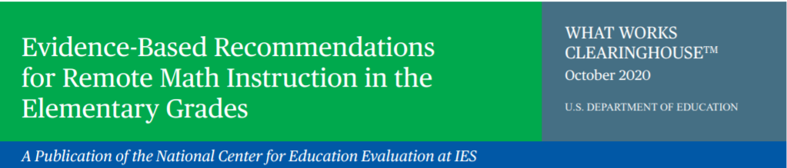

In the United States TIMSS is sponsored by the National Center for Education Statistics (NCES). NCES is a division within the Institute of Education Sciences (IES), a part of the U.S. Department of Education. IES is the nation's leading source for rigorous, independent education research, evaluation and statistics.School and student participation are voluntary. Learn more about TIMSS by visiting: [https://nces.ed.gov/timss/](http://nces.ed.gov/surveys/timss).

*NCES is authorized to conduct this study under the Education Sciences Reform Act of 2002 (ESRA 2002, 20 U.S.C. §9543). All of the information provided by school staff and students may be used only for statistical purposes and may not be disclosed, or used, in identifiable form for any other purpose except as required by law (20 U.S.C. §9573 and 6 U.S.C. §151).*

**District and School Engagement Email 3 (Grade 8)**

We are writing to say **THANK YOU!** By participating in research studies like Trends in International Mathematics and Science Study **(TIMSS**) you are contributing information that will help our country understand how students are learning to apply math and science. This knowledge will inform policymakers, researchers, and educators at all levels to improve outcomes for youth today and for years to come.

**Did you know**…

At the eighth grade, U.S. students’ average **TIMSS** mathematics score in 2019 was 23 points higher than in 1995, but was not significantly different from the score in 2015. Over 24 years, U.S. eighth-graders’ mathematics scores increased from 492 points in 1995 to 515 points in 2019[3].

Here are some math resources you may be interested in. Check out <https://ies.ed.gov/ncee/wwc/Math/> and <https://ies.ed.gov/ncee/wwc/Docs/ReferenceResources/RemoteMath_Secondary.pdf>.

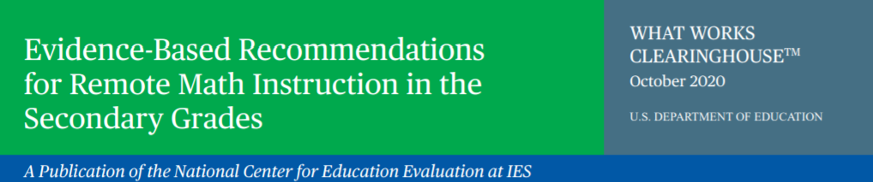

**TIMSS 2023 Field Test Team**

<phone>

<email>

<IES logo>

In the United States TIMSS is sponsored by the National Center for Education Statistics (NCES). NCES is a division within the Institute of Education Sciences (IES), a part of the U.S. Department of Education. IES is the nation's leading source for rigorous, independent education research, evaluation and statistics.School and student participation are voluntary. Learn more about TIMSS by visiting: [https://nces.ed.gov/timss/](http://nces.ed.gov/surveys/timss).

*NCES is authorized to conduct this study under the Education Sciences Reform Act of 2002 (ESRA 2002, 20 U.S.C. §9543). All of the information provided by school staff and students may be used only for statistical purposes and may not be disclosed, or used, in identifiable form for any other purpose except as required by law (20 U.S.C. §9573 and 6 U.S.C. §151).*

**District and School Engagement Email 4**

This is just a quick email to say THANK YOU! By participating in research like Trends in International Mathematics and Science Study (**TIMSS**) field test in the spring of 2022, you are helping to improve the condition of education for students today and years to come. To learn more about the current condition of education, check out the link below.

*Here is “The Condition of Education” 2020 report:*

[*https://nces.ed.gov/programs/coe/*](https://nces.ed.gov/programs/coe/)

[](https://nces.ed.gov/programs/coe/)

We look forward to talking to you again soon!

**TIMSS 2023 Field Test Team**

<phone>

<email>

<IES logo>

In the United States TIMSS is sponsored by the National Center for Education Statistics (NCES). NCES is a division within the Institute of Education Sciences (IES), a part of the U.S. Department of Education. IES is the nation's leading source for rigorous, independent education research, evaluation and statistics.School and student participation are voluntary. Learn more about TIMSS by visiting: [https://nces.ed.gov/timss/](http://nces.ed.gov/surveys/timss).

*NCES is authorized to conduct this study under the Education Sciences Reform Act of 2002 (ESRA 2002, 20 U.S.C. §9543). All of the information provided by school staff and students may be used only for statistical purposes and may not be disclosed, or used, in identifiable form for any other purpose except as required by law (20 U.S.C. §9573 and 6 U.S.C. §151).*

**District and School Engagement Email 5**

We are writing to say **THANK YOU**! By participating in international research like Trends in International Mathematics and Science (**TIMSS**), our country can continue to take part and learn about emerging issues in content and the contexts for learning.

Be sure to check current U.S. participation status for the **TIMSS** field test on the study website <insert URL>. We look forward to working with your students for the field test in spring of 2022.

Thank you for your time and contribution.

**TIMSS 2023 Field Test Team**

<phone>

<email>

<IES logo>

In the United States TIMSS is sponsored by the National Center for Education Statistics (NCES). NCES is a division within the Institute of Education Sciences (IES), a part of the U.S. Department of Education. IES is the nation's leading source for rigorous, independent education research, evaluation and statistics.School and student participation are voluntary. Learn more about TIMSS by visiting: [https://nces.ed.gov/timss/](http://nces.ed.gov/surveys/timss).

*NCES is authorized to conduct this study under the Education Sciences Reform Act of 2002 (ESRA 2002, 20 U.S.C. §9543). All of the information provided by school staff and students may be used only for statistical purposes and may not be disclosed, or used, in identifiable form for any other purpose except as required by law (20 U.S.C. §9573 and 6 U.S.C. §151).*

# AppendixA12a Email to School Coordinator (SC) for TIMSS 2023 Field Test Registration and to Provide School Information (PSI)

(red font for customization)

Dear <School Coordinator Name>,

We hope that this finds you well and enjoying another terrific school year! We are following up with you to remind you to put the *Trends in International Mathematics and Science Study (TIMSS) 2023* Field Test assessment date, [date], on your school calendar at [school name]. We appreciate your commitment to TIMSS, and we know your students will be excited and proud to represent U.S. students in this important international assessment. The TIMSS 2023 team looks forward to working with you to coordinate TIMSS in your school.

A sample of your grade [grade 4 or 8] classes will be taking TIMSS. In most schools, TIMSS will randomly select about two [math classes if grade 8] classes to participate in the assessment.

You will have a number of responsibilities critical to making TIMSS a success. Please review the attached *Summary of School Activities: TIMSS 2023* for an overview of these responsibilities. The TIMSS website <TIMSS URL> will assist you with these responsibilities and provide information about the assessment. You can refer to the attached *TIMSS Registration and Provide School Information (PSI) Guide* to assist you through the immediate next steps. Please register on TIMSS using this **registration ID**: [TIMSS school registration ID].

Once you have registered, please make sure to complete the questions on the **Provide School Information** page on the TIMSS website.

The timeline below provides an overview of these activities:

•  **Today** – Register on TIMSS and answer the questions on the TIMSS **Provide School Information** page.

•  **January** – Prepare and submit a list of classes on the Submit Class List. Once classes are submitted, TIMSS staff will inform you of the selected classes and will email you to submit the list of students in selected classes on the Student List page of TIMSS. The TIMSS 2023 team will contact you in January with directions for submitting the class and student lists.

• **January through March** –

* Receive a packet of TIMSS materials, including a TIMSS 2023 Parent FAQ, sample parent/guardian notification letters, and student appointment cards [student appt cards for grade 8 only]. These materials will also be available on the TIMSS website.
* Review lists of students and teachers.
* An assigned TIMSS representative will contact you to discuss assessment logistics and accommodations for students with disabilities or English language learners.
* Notify parents/guardians that their children have been selected for the assessment. A sample parent/guardian notification letter will be available on the TIMSS website for you to customize and print on your school letterhead.
* **One week before the assessment** – Distribute student appointment cards [student appt cards for grade 8 only] (mailed to you prior to assessment) and notify teachers in advance so they know when to release students and remind them to complete an online TIMSS Teacher Questionnaire, which should have been emailed to them by the TIMSS Team. Request that the school principal complete the TIMSS School Questionnaire as well.

Thank you in advance for your cooperation and effort in helping to coordinate this important assessment. If you have any questions, please feel free to contact the TIMSS information hotline at 1-(XXX)-XXX-XXXX or <email>. You may also get more information about this study by visiting the TIMSS website at <https://nces.ed.gov/timss/>.

Sincerely,

[NAEP State Coordinator]

Attachment: *Summary of School Activities: TIMSS 2023*

*TIMSS Registration and PSI Guide*

*NCES is authorized to conduct TIMSS under the Education Sciences Reform Act of 2002 (ESRA 2002, 20 U.S.C. §9543). All of the information provided by school staff and students may be used only for statistical purposes and may not be disclosed, or used, in identifiable form for any other purpose except as required by law (20 U.S.C. §9573 and 6 U.S.C. §151). The U.S. Office of Management and Budget has approved the data collection under OMB# 1850-0695. Individual responses will be combined with those from other participants to produce summary statistics and reports.*

# AppendixA12b TIMSS 2023 Field Test Registration and Provide School Information (PSI) Guide

**Registration + Username/Password**

In order to prepare for the TIMSS 2023 Field Test in grades 4 or 8, you must log in to the TIMSS website <TIMSS Website URL>. If you have never logged in to the website for the 2023 field test and cannot find the registration ID number provided to you by your state coordinator, please contact your state coordinator or the TIMSS hotline at <email address> / 1-XXX-XXX-XXXX.

1. Once you have your registration ID number, go to the <TIMSS Website URL> website and click “Please register.”
2. Enter your registration ID and click “Continue.”
3. Make sure to confirm the district and school name shown at the top of the page are correct. Then follow the instructions to enter your name and other contact info. If you will be handling most of the TIMSS tasks at your school, make sure to click “Are you the school coordinator for?”

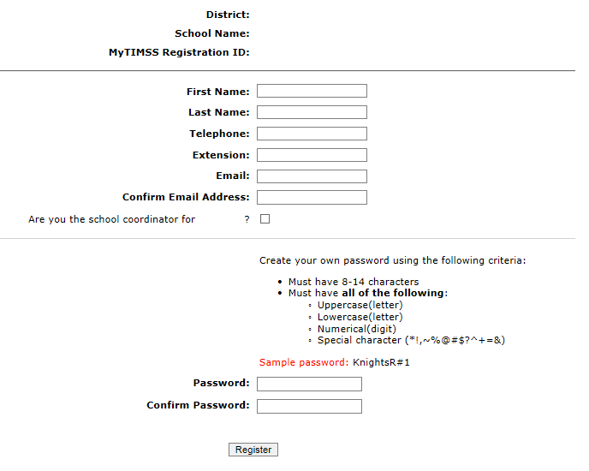

1. Then create a password that meets the password criteria and click **Register.**
2. Once created, your username will be emailed to you. Your username is **not** your email address.
3. If you check the “Are you the school coordinator for?” box, you will get an additional email with a Summary of upcoming activities.
4. When you first log in, you will see your school name, grade, and assessment date at the top banner. Please make sure those fields are accurate. If not, contact us at <email>.

**Site Home Page**

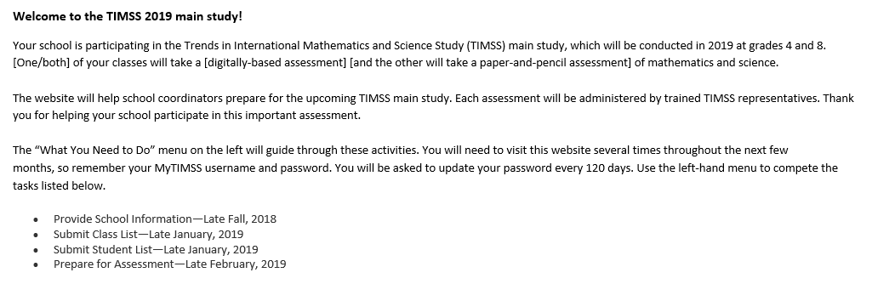

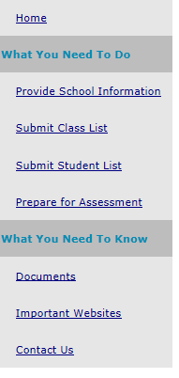

**Provide School Information (PSI)**

The first step in TIMSS is to complete the **Provide School Information** page. Click the **Provide School Information** link at the left-hand menu to access this page.

On the PSI page, the information on the left is the current information available for your school. Please make updates in the fields on the right if the current information on the left is blank or incorrect. Make sure to complete both the **“School Contact Information**” and **“School Characteristics”** sections. Then click Save.

Note: You will see this red text banner below until all required fields are filled out completely:



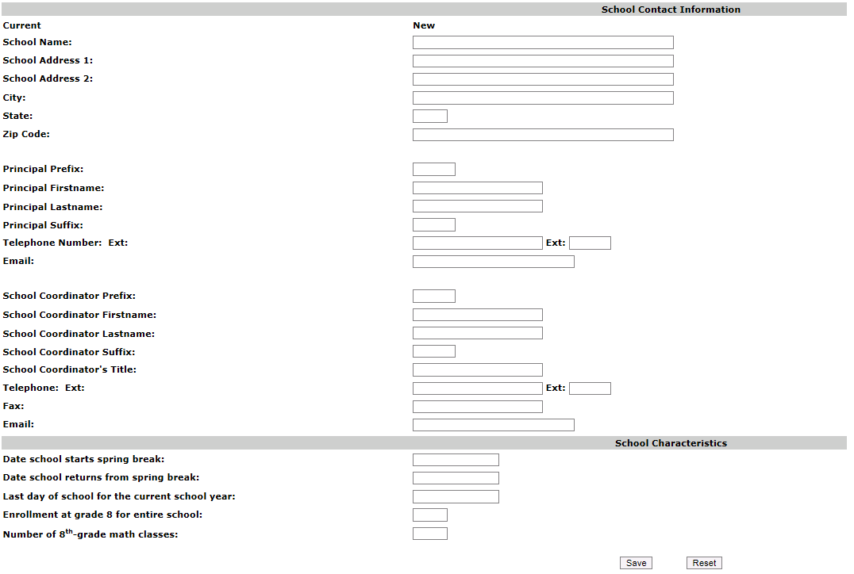

**If you are selected for grade 8, then the last two fields will ask about grade 8 (see pic above). For grade 8 schools, count all math classes **with at least one** 8th-grade student.

If you are selected for grade 4, then the last two fields will ask about grade 4. (see pic below).

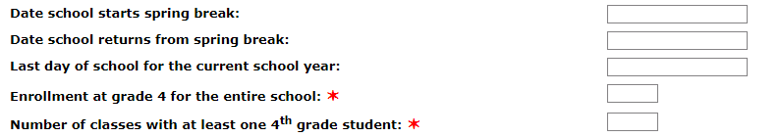

Once complete, you will see this blue text bar shown below at the top of the page.



In January 2022, we will email you instructions for submitting class and student lists.

Thank you for you school’s participation in TIMSS 2023 Field Test!

The TIMSS 2023 Field Test Team

xxx-xxx-xxxx

<email>

# AppendixA12c Automated Email for all TIMSS 2023 Field Test registrants

(Yellow highlight for merge data fields)

Thank you for creating a TIMSS account for the Trends in International Mathematics and Science Study:2023 (TIMSS) Field Test. To access TIMSS, go to <TIMSS Website URL> and enter your username and password.

**Username: [username]**

**Password information:** You created your own password upon registering. Use the **"Forgot Password"** links on TIMSS login page if needed. You will be prompted to change your password after 120 days.

TIMSS is a secure site that contains confidential information, so it is important to remember your username and password. If you choose to write down this information, store it in a secure place.

If you have questions or need help accessing the website, please contact the TIMSS hotline at <email> or at xxx-xxx-xxxx Monday through Friday between 9 a.m. and 5:00 p.m. ET.

Sincerely,

The TIMSS 2023 Field Test Team

*NCES is authorized to conduct TIMSS under the Education Sciences Reform Act of 2002 (ESRA 2002, 20 U.S.C. §9543). All of the information provided by school staff and students may be used only for statistical purposes and may not be disclosed, or used, in identifiable form for any other purpose except as required by law (20 U.S.C. §9573 and 6 U.S.C. §151). The U.S. Office of Management and Budget has approved the data collection under OMB# 1850-0695. Individual responses will be combined with those from other participants to produce summary statistics and reports.*

# AppendixA12d Automated Email for TIMSS 2023 Field Test School Coordinator registrant

(Yellow highlight for merge data fields; red font for customization)

Dear [school coordinator],  
  
Thank you for creating a TIMSS account for the Trends in International Mathematics and Science Study (TIMSS) Field Test on <TIMSS Website URL>. TIMSS is a secure website for sharing information and files related to your school’s participation in the TIMSS 2023 Field Test. The website’s **"What You Need to Do"** menu will guide you through the upcoming TIMSS Field Test activities.  
  
The first step is to complete the **Provide School Information** page. If you have not already done so, please go to <TIMSS Website URL>/ProvideSchoolInformation.aspx.   
  
In January, you will need to provide a complete and current list of **all of your school’s fourth-grade/eighth-grade mathematics classes** for the TIMSS team to randomly select two classes to participate in the TIMSS 2023 Field Test. You will then be asked to submit lists of **all students in the selected classes**. TIMSS also needs a list of **all of your school’s eighth-grade science teachers** and the courses they teach to assign teacher questionnaires that will be used to link information about science teachers to the assessed students. We will email you in early January with instructions about how to submit the class list, student list, and teacher list through <TIMSS Website URL>.   
  
Please see the **attached** Summary of School Activities for a complete list of activities associated with your school’s participation in the TIMSS 2023 Field Test.  
  
Thank you very much for participating in TIMSS, and for playing a key role in making the assessment a success in [school name]!  
  
Sincerely,  
  
The TIMSS 2023 Field Test Team  
  
*NCES is authorized to conduct TIMSS under the Education Sciences Reform Act of 2002 (ESRA 2002, 20 U.S.C. §9543). All of the information provided by school staff and students may be used only for statistical purposes and may not be disclosed, or used, in identifiable form for any other purpose except as required by law (20 U.S.C. §9573 and 6 U.S.C. §151). The U.S. Office of Management and Budget has approved the data collection under OMB# 1850-0695. Individual responses will be combined with those from other participants to produce summary statistics and reports.*

# AppendixA13a TIMSS 2023 Field Test Login Page

TIMSS USA LOGO

TIMSS 2023 Field Test

**Login**

TIMSS 2023 Field Test is a restricted-use website that contains information on the Trends in International Mathematics and Science Study (TIMSS).

**Existing User Login** First time visiting the TIMSS 2023 Field test site?

Schools can register now!

User Name: Please register

Password:

Forgot Password | Having trouble logging in?

Log In

The National Center for Education Statistics (NCES), within the U.S. Department of Education, conducts TIMSS in the United States as authorized by the Education Sciences Reform Act of 2002 (ESRA 2002, 20 U.S.C. §9543). All of the information you provide may be used only for statistical purposes and may not be disclosed, or used, in identifiable form for any other purpose except as required by law (20 U.S.C. §9573 and 6 U.S.C. §151).

According to the Paperwork Reduction Act of 1995, no persons are required to respond to a collection of information unless such collection displays a valid OMB control number. The valid OMB control number for this voluntary information collection is 1850-0695. The time required to complete this information collection and participate in study activities is estimated to average 240 minutes per school coordinator, including the time to review instructions, search existing data resources, gather the data needed, and complete and review the information collection. If you have any comments or concerns regarding the accuracy of the time estimate(s), suggestions for improving the form, or questions about the status of your individual submission of this form, write directly to: Trends in International Mathematics and Science Study (TIMSS), National Center for Education Statistics, Potomac Center Plaza (PCP), 550 12th St., SW, 4th floor, Washington, DC 20202.

OMB No. 1850-0695, Approval Expires xx/xx/xxxx.

**Notice: You are accessing a U.S. Government information system.**

This warning banner provides privacy and security notices consistent with applicable federal laws, directives, and other federal guidance for accessing this Government system, which includes all devices/storage media attached to this system. This system is provided for Government-authorized use only. Unauthorized or improper use of this system is prohibited and may result in disciplinary action and/or civil and criminal penalties.

(TIMSS 2023 Field Test Login page screenshot)

<TIMSS Website URL>

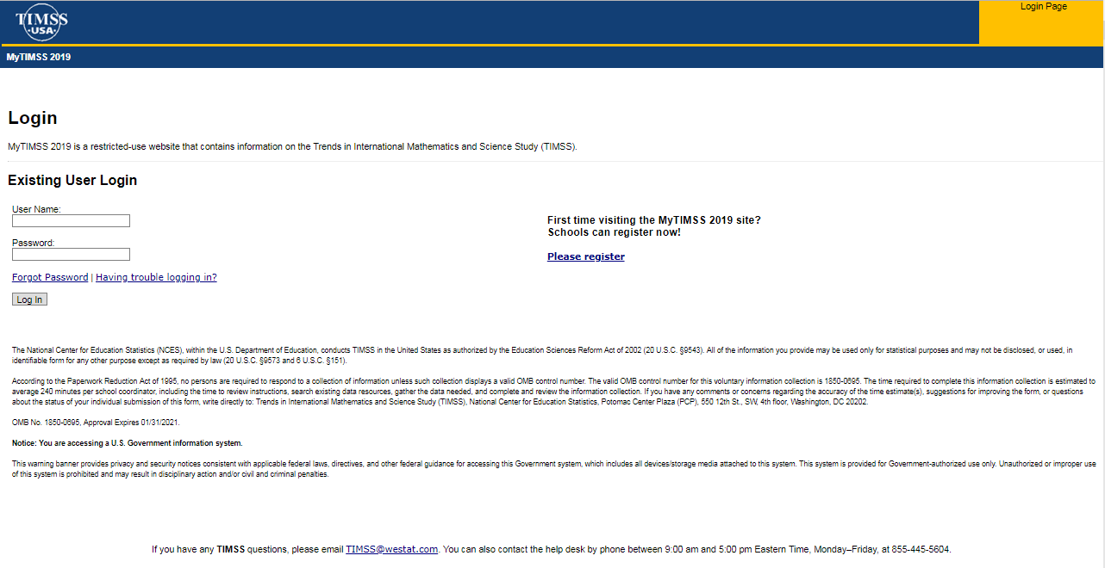

# AppendixA13b TIMSS 2023 Field Test Home Page

Welcome to the TIMSS 2023 Field Test!

Your school is participating in the Trends in International Mathematics and Science Study (TIMSS) Field Test, which will be conducted in 2023 at grades 4 and 8. [One/both] of your selected classes will take a digitally-based assessment of mathematics and science.

This website will help school coordinators prepare for the upcoming TIMSS Field Test. Each assessment will be administered by trained TIMSS representatives. Thank you for helping your school participate in this important assessment.

The "What You Need to Do" menu on the left will guide you through these activities. You will need to visit this website several times throughout the next few months, so remember your TIMSS username and password. You will be asked to update your password every 120 days. Use the left-hand menu to complete the tasks listed below.

* Provide School Information—Late Fall, 2021
* Submit Class List—Late January 2022
* Submit Student List—Late January 2022
* Prepare for Assessment—Mid-February 2022

(TIMSS Home Page screenshot)

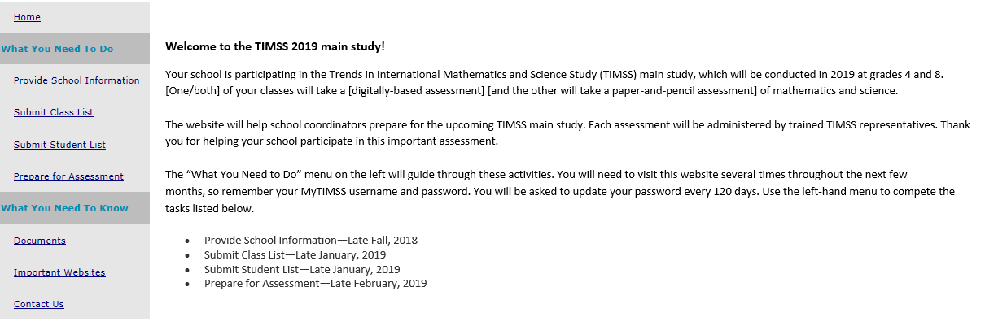

# AppendixA13c TIMSS 2023 Field Test Provide School Information (PSI) Page

(screenshot)

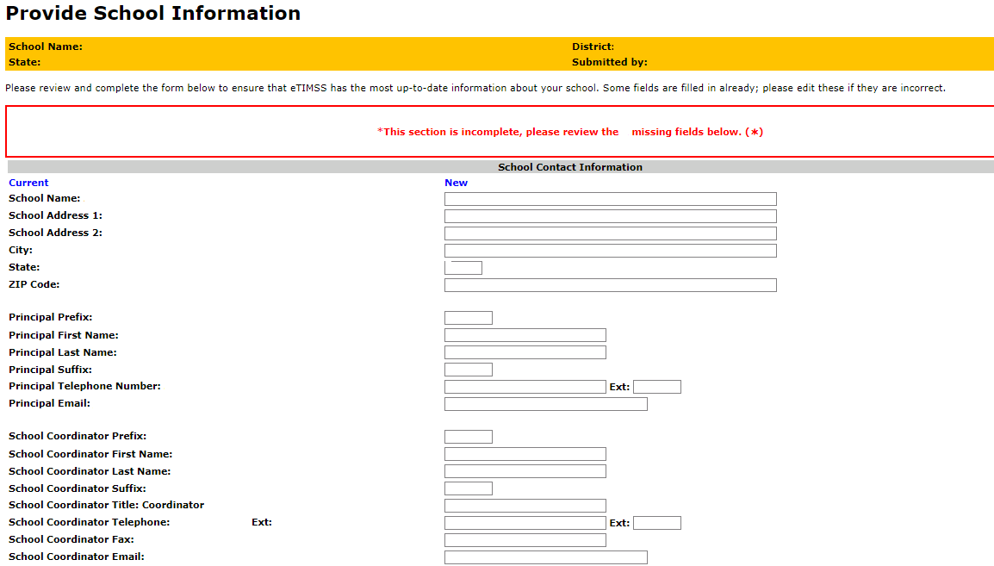

[Grade 4 schools]

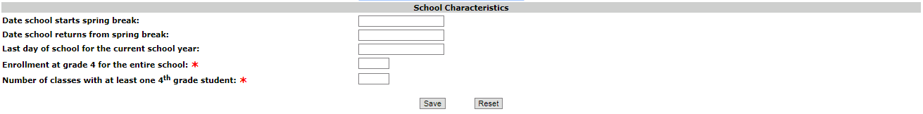

[Grade 8 schools]

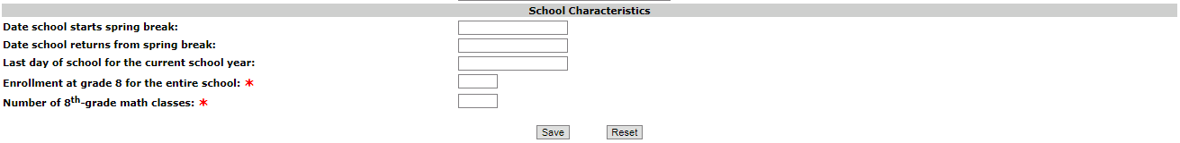

# AppendixA13d TIMSS 2023 Field Test Prepare for Assessment Page

(red font is customized depending on grade the school was selected for)

**Prepare For Assessment**

Thank you for providing information about all the fourth-grade classes / eighth-grade math classes in your school! After submitting both class and student lists, you will receive an email telling you that your sample of classes has been selected. Return to this webpage when you receive the email from <email>: “The list of students selected to participate in TIMSS is available in the Student-Teacher Linkage Form (STLF)”

**Student Tracking Linkage Form (download both if more than one link is shown)**

**Student-Teacher Linkage Forms (STLF)** – The forms list the selected students and their teachers. Please make sure students and teachers are linked correctly on the form. Instructions on how to access and review the forms were emailed to you and are in the Documents section on this website.

**Please note the following:**

If the students and teacher linkages appear fine in the STLF, no need to contact the TIMSS E-Filing Help Desk. Three business days later, please return to this page. Two new links will be shown here to download STF1 and STF2 (Student Tracking Forms). This is the form you can review to see if any student names, information, new enrollees, no longer enrolled students, should be updated. Your Test Administrator will contact you to discuss this. Do not contact the TIMSS E-Filing Help Desk unless there are major updates needed on this form. You can discuss the minor updates with your Test Administrator when they call you in the pre-assessment call.

**Student Tracking Form (download both if more than one link is shown)**

**Student Tracking Form (STF)–**The forms list the students who have been selected to participate in the assessment at your school. Instructions on how to access and review the forms are in the Documents section on this website. The STF will become available about a week after the STLF has been posted.

**Sample Parent Notification Letter and Facts for Parents about TIMSS**. You will receive a packet of TIMSS materials including a sample parent/guardian notification letter and a TIMSS Parent FAQ

A sample parent/guardian notification letter is in the Documents section for you to customize and print on your school letterhead. Please distribute the parent notification letter and the Parent FAQ (from our FedEx mailing to you) to the parents of the selected students prior to the assessment. Additionally, a Spanish version of the letter is available in the Documents page. You can also share the Parent FAQ link available here: https://nces.ed.gov/timss/parents/.

As your assessment date approaches, your Test Administrator will be contacting you to finalize the assessment day activities.

**Prepare for Assessment page** (screenshot)

(Grade 8 example below)

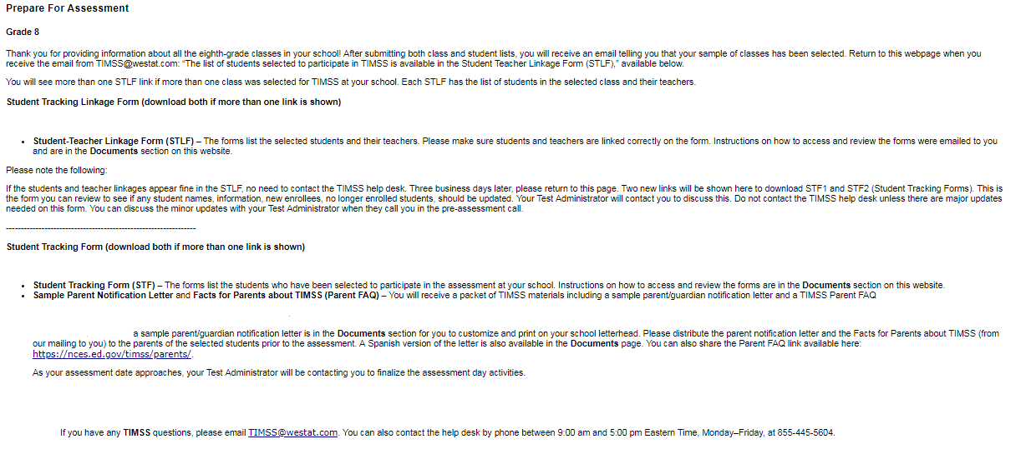

# AppendixA14a TIMSS 2023 Field Test Student-Teacher Linkage Form (STLF) Email

(yellow highlight for mail merge)

Dear [school coordinator],

The list of students selected to participate in TIMSS 2023 Field Test is available in the Student-Teacher Linkage Form (STLF)!

The **Student-Teacher Linkage Form (**STLF) lists the students who have been selected to participate in the assessment at your school. This list is based on the class and student information you submitted. To access the STLF, please login at <TIMSS Website URL>, then go to **Prepare for Assessment** and select **“Click here to download the STLF.”** In the two STLF excel files, there is a worksheet for each set of classes or students selected, so please make sure to review each STLF excel file. Most schools will have two excel files, one for each class.

For the Student-Teacher Linkage Form (STLF), you will only need to make sure the students on that list match the teachers to the selected students in the header of Column 6. If you see any errors, please contact the TIMSS E-Filing Help Desk at <email> or xxx-xxx-xxxx. Please do not email the list back to us.

In a week of the STLF posting, you will receive an email informing you that the final list of selected students and teachers are available. These lists, called the Student Tracking Forms (STF) will be posted on this same **Prepare for Assessment** page.

Thank you very much for participating in the TIMSS 2023 Field Test, and for submitting your school's class and student lists!

Sincerely,

The TIMSS 2023 Field Test Team

*NCES is authorized to conduct this study under the Education Sciences Reform Act of 2002 (ESRA 2002, 20 U.S.C. §9543). All of the information you provide may be used only for statistical purposes and may not be disclosed, or used, in identifiable form for any other purpose except as required by law (20 U.S.C. §9573 and 6 U.S.C. §151).*

# AppendixA14b TIMSS 2023 Field Test Student Tracking Form (STF) Email

(yellow highlight for mail merge; red for customization)

Dear [School Coordinator],

Thank you for providing information about all the fourth-grade/eighth-grade classes in your school! The list of students and teachers selected to participate in TIMSS 2023 Field Test is now available in the Student Tracking Forms (STF) available on the TIMSS website. Please see below for more details about the forms and parent notification.

* Student Tracking Form (STF) –The forms list the students who have been selected to participate in the assessment at your school. Instructions on how to access and review the forms are attached.
* Sample Parent Notification Letter and Facts for Parents about TIMSS 2023 Field Test (Parent FAQ) – A sample parent/guardian notification letter is attached for you to customize and print on your school letterhead. Please distribute the parent notification letter and the *Facts for Parents about TIMSS 2023 Field Test* to the parents of the selected students prior to the assessment. A Spanish version of the letter is available on the TIMSS site under **Documents.**
* FedEx Shipment
  + Within a week, a FedEx shipment of hard-copies of the *Facts for Parents* *about TIMSS 2023 Field Test (Parent FAQ)* will be delivered to you. You can also distribute them electronically or share the Parent FAQ link available here: <https://nces.ed.gov/timss/parents/>
  + Student Appointment/invitations cards to give to selected students will be sent to you as well.

As your assessment date approaches, your Test Administrator will be contacting you to finalize the assessment day activities and discuss accommodations, if necessary.

If you have any questions, please do not hesitate to call xxx-xxx-xxxx or send an email to <email>You may also get more information about this study by visiting the TIMSS website at <http://nces.ed.gov/timss>.

Thank you for your assistance with this study!

Sincerely,

The TIMSS 2023 Field Test Team

Attachments:

Sample Parent Notification Letter

Facts for Parents about TIMSS 2023 Field Test (Parent FAQ)

STF Instructions

*NCES is authorized to conduct this study under the Education Sciences Reform Act of 2002 (ESRA 2002, 20 U.S.C. §9543). All of the information you provide may be used only for statistical purposes and may not be disclosed, or used, in identifiable form for any other purpose except as required by law (20 U.S.C. §9573 and 6 U.S.C. §151).*

# AppendixA14c Instructions for TIMSS 2023 Field Test Student Tracking Form (STF)

**Reviewing the Student Tracking Form (STF)**

The two **Student Tracking Form** (STF) lists the students who have been selected to participate in the assessment at your school. This list is based on the student information you submitted. You can take notes on this form in preparation for the pre-assessment call in which the Test Administrator will ask you about any updates to this form over the phone. To access the STF, please login at www.<website URL>, then go to **Prepare for Assessment** and select **“Click here to download the STF.”** Student Appointment/invitations cards to give to selected students will be sent to you in a FedEx delivery.

As the first step in reviewing the Student Tracking Form, please verify the student information for accuracy after you open the excel file you just downloaded. See below for what should be reviewed. Please also make sure the school name and students match what you expect.

* Student’s name is listed in **Column 1**.
* Date of birth is listed in **Column 4.**
* Gender (using codes—1 for female and 2 for male) is listed in **Column 5**.
* Exclusion status in **Column 6.**
* Participation status in **Column 7.**

**Student Exclusions and Accommodations**

If a student is to be excluded from the assessment because he or she requires an accommodation, please make a note in column 6 using the codes at the bottom of the STF.

**Participation Status + Newly-enrolled or no-longer-enrolled students**

If many of the students listed in the STF are not enrolled in the school, please contact <email> ASAP, but you do not need to contact <email> if only 1 to 3 students are no longer enrolled or are newly enrolled. These new or no-longer-enrolled students can be discussed with your Test Administrator when they call you for the pre-assessment call (usually 1-2 weeks before assessment date). You can make a note on the form regarding these students in the first column in column 7 using the status codes shown at the bottom of the STF. You can also use status codes 1 through 4 to provide more information about a student.

**Updates and Questions**

If you have updates to the STF, please have the form ready for the pre-assessment call. You can also provide the hardcopy to the Test Administrator when they come to your school on assessment day. If you have any questions about completing this form, please address them with your Test Administrator when they contact you. For urgent questions on the STF, you can also contact the TIMSS E-Filing Help Desk <email>. The STF is just for you to take notes on in preparation for the pre-assessment call so you know parents of which students should be notified. Please do not send the STF back to us. You can however give it to the Test Administrator in person, if you would like, when they come on the assessment day.

# AppendixA14d Student-Teacher Linkage Form (STLF) Template (Grade 4 vs. Grade 8)

Grade 4 STLF

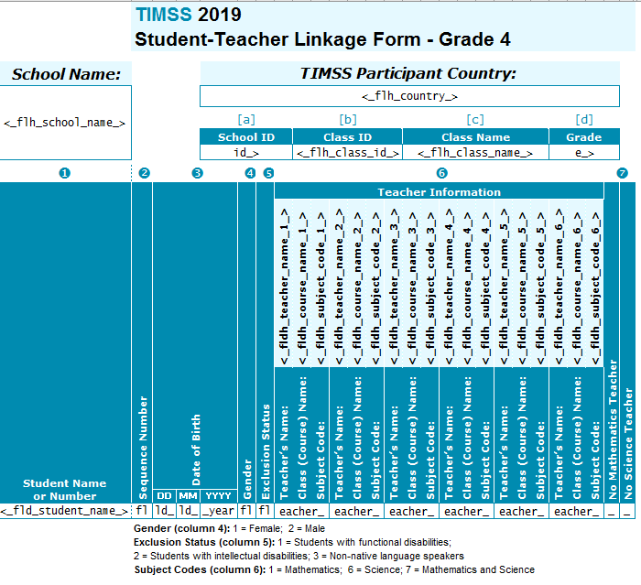

Grade 8 STLF

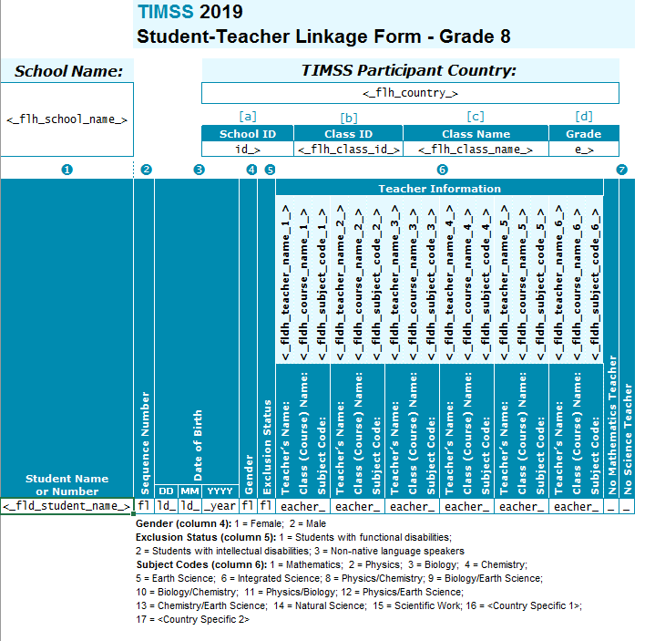

# AppendixA14e TIMSS 2023 Field Test Documents Page

Note: this screenshot will be replaced by an updated screenshot, reflecting the appropriate study year, in subsequent packages.

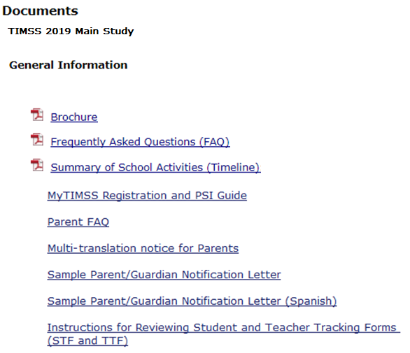

(Grade 4 example below)

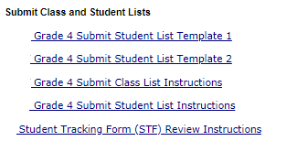

# AppendixA14f TIMSS 2023 Field Test Important Websites and Contact Us Pages

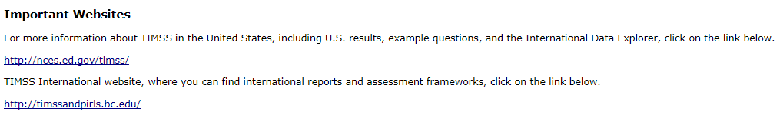

Contact us by phone: xxx-xxx-xxxx

Contact us by email: <email>

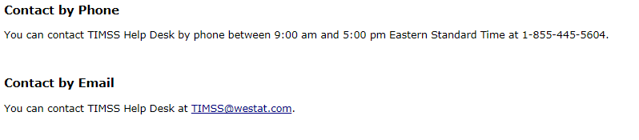

# AppendixA15a School Principal Questionnaire Login Card/Email

**Front of Card:**

Welcome to TIMSS 2023 Field Test!

Your school is participating in the Field Test for Trends in International Mathematics and Science Study (TIMSS) 2023. This online questionnaire seeks information about schools and provides important context to understanding the achievement of students taking the assessment.

Please go to the web address (URL) given below and log in to the online questionnaire with your “School ID” and “Password”, which are printed on the label attached below. Please contact the TIMSS hotline (<email>) if you have problems logging on.

The website link is: <TIMSS Website URL>

[Insert Label]

The online questionnaire does NOT require JavaScript or cookies to work. Responses are saved automatically as you go from question to question. The “Table of Contents” link on the bottom of each page provides an overview of all questions and whether you have completed them. You may leave the questionnaire at any time and log in again later. See notes on the back of this card.

OMB# 1850-0695 (expires XX/XX/XXXX).

**Back of Card:**

NOTES

* Please use the Previous and Next buttons to navigate backward and forward
* You may exit the questionnaire at any time and log in again later— all of your responses will be saved automatically.
* The Table of Contents provides an overview of all questions and shows whether you have completed all questions.
* To exit the Table of Contents, click on any question link or section header.
* If you would like a printed copy of the online questionnaire, click on the “Prepare Printer Version” link on the Table of Contents page.
* It is estimated that it will take approximately 30 minutes to complete the questionnaire.
* If you have problems accessing the online questionnaire or need assistance, please contact the TIMSS hotline at 1-xxx-xxx-xxxx or email <email>.

Thank you for the thought, time, and effort you have put into completing the questionnaire!

*NCES is authorized to conduct TIMSS under the Education Sciences Reform Act of 2002 (ESRA 2002, 20 U.S.C. §9543). All of the information provided by school staff and students may be used only for statistical purposes and may not be disclosed, or used, in identifiable form for any other purpose except as required by law (20 U.S.C. §9573 and 6 U.S.C. §151). The U.S. Office of Management and Budget has approved the data collection under OMB# 1850-0695. Individual responses will be combined with those from other participants to produce summary statistics and reports.*

# AppendixA15b Teacher Questionnaire Selection Email

Welcome to TIMSS 2023 Field Test!

Your school is participating in the Field Test for the Trends in International Mathematics and Science Study (TIMSS) 2023.  This online questionnaire seeks information about teachers’ academic and professional backgrounds, classroom resources, instructional practices, and attitudes toward teaching.

Please go to the web address (URL) given below and log in to the online questionnaire with your “User ID” and “Password”, which are below. Please contact the TIMSS hotline ([<email>](mailto:TIMSS@westat.com)) if you have problems logging on.  The website link is: [hyperlink]

**User ID:                [User ID]**

**Password:           [Password]**

**Subject code:     [Subject code]**

Responses are saved automatically as you go from question to question. The “Table of Contents” link on the bottom of each page provides an overview of all questions and whether you have completed them. You may leave the questionnaire at any time and log in again later. You must click “Finish” at the last page for us to receive your submission. See notes below.

NOTES

•        Please use the Previous and Next buttons to navigate backward and forward

•        You may exit the questionnaire at any time and log in again later— all of your responses will be saved automatically.

•        The Table of Contents provides an overview of all questions and shows whether you have completed all questions.

•        To exit the Table of Contents, click on any question link.

•        If you would like a printed copy of the online questionnaire, click on the “Prepare Printer Version” link on the Table of Contents page.

•        It is estimated that it will take approximately 30 minutes to complete the questionnaire.

•        You must click “Finish” at the last page for us to receive your submission.

•        If you have problems accessing the online questionnaire or need assistance, please contact the TIMSS hotline at 1-xxx-xxx-xxxx or email [<email>](mailto:TIMSS@westat.com).

•        If you would prefer to complete a paper questionnaire, please contact your TIMSS School Coordinator.

•        After you have completed the questionnaire and within a few days, you will receive a $20 Amazon gift card code from this email address as a token of appreciation for your participation.

Thank you for the thought, time, and effort you have put into completing the questionnaire!

Sincerely,

The U.S. TIMSS 2023 Field Test Team

*NCES is authorized to conduct TIMSS under the Education Sciences Reform Act of 2002 (ESRA 2002, 20 U.S.C. §9543). All of the information provided by school staff and students may be used only for statistical purposes and may not be disclosed, or used, in identifiable form for any other purpose except as required by law (20 U.S.C. §9573 and 6 U.S.C. §151). The U.S. Office of Management and Budget has approved the data collection under OMB# 1850-0695. Individual responses will be combined with those from other participants to produce summary statistics and reports.*

# AppendixA15c Teacher Questionnaire Reminder Email

Hello,

This is a gentle reminder to please complete the Trends in International Mathematics and Science Study (TIMSS) 2023 Field Test online teacher questionnaire. This online questionnaire seeks information about teachers’ academic and professional backgrounds, classroom resources, instructional practices, and attitudes toward teaching.

Please go to the web address (URL) given below and log in to the online questionnaire with your “User ID” and “Password”, which are below. Please contact the TIMSS Hotline ([<email>](mailto:TIMSS@westat.com)) if you have problems logging on.  The website link is: [hyperlink]

**User ID:                [User ID]**

**Password:           [Password]**

**Subject code:     [Subject code]**

Responses are saved automatically as you go from question to question. The “Table of Contents” link on the bottom of each page provides an overview of all questions and whether you have completed them. You may leave the questionnaire at any time and log in again later. You must click “Finish” at the last page for us to receive your submission. See notes below.

NOTES

•        Please use the Previous and Next buttons to navigate backward and forward

•        You may exit the questionnaire at any time and log in again later— all of your responses will be saved automatically.

•        The Table of Contents provides an overview of all questions and shows whether you have completed all questions.

•        To exit the Table of Contents, click on any question link.

•        If you would like a printed copy of the online questionnaire, click on the “Prepare Printer Version” link on the Table of Contents page.

•        It is estimated that it will take approximately 30 minutes to complete the questionnaire.

•        You must click “Finish” at the last page for us to receive your submission.

•        If you have problems accessing the online questionnaire or need assistance, please contact the TIMSS hotline at 1-xxx-xxx-xxxx or email [<email>](mailto:TIMSS@westat.com).

•        If you would prefer to complete a paper questionnaire, please contact your TIMSS School Coordinator.

•        After you have completed the questionnaire and within a few days, you will receive a $25 check or gift card for school supplies.

Thank you for the thought, time, and effort you have put into completing the questionnaire!

Sincerely,

The U.S. TIMSS 2023 Field Test Team

*NCES is authorized to conduct TIMSS under the Education Sciences Reform Act of 2002 (ESRA 2002, 20 U.S.C. §9543). All of the information provided by school staff and students may be used only for statistical purposes and may not be disclosed, or used, in identifiable form for any other purpose except as required by law (20 U.S.C. §9573 and 6 U.S.C. §151). The U.S. Office of Management and Budget has approved the data collection under OMB# 1850-0695. Individual responses will be combined with those from other participants to produce summary statistics and reports.*

# AppendixA16 Online Questionnaire Login Screen Text

(for the Principal, Teachers, and Students)

TIMSS 2023 Field Test - English (United States)

You are not logged in.

Welcome to the IEA - DPC SurveySystem

Online Questionnaires

Please enter your user ID and password (Checksum).

User ID:

Password:

The National Center for Education Statistics (NCES), within the U.S. Department of Education, conducts TIMSS in the United States as authorized by the Education Sciences Reform Act of 2002 (ESRA 2002, 20 U.S.C. §9543). All of the information you provide may be used only for statistical purposes and may not be disclosed, or used, in identifiable form for any other purpose except as required by law (20 U.S.C. §9573 and 6 U.S.C. §151).

According to the Paperwork Reduction Act of 1995, no persons are required to respond to a collection of information unless such collection displays a valid OMB control number. The valid OMB control number for this voluntary information collection is 1850-0695. The time required to complete this information collection is estimated to average 30 minutes per principal, 30 minutes per teacher, and 30 minutes per student, including the time to review instructions, search existing data resources, gather the data needed, and complete and review the information collection. If you have any comments or concerns regarding the accuracy of the time estimate(s), suggestions for improving the form, or questions about the status of your individual submission of this form, write directly to: Trends in International Mathematics and Science Study (TIMSS), National Center for Education Statistics, Potomac Center Plaza (PCP), 550 12th St., SW, 4th floor, Washington, DC 20202.

OMB No. 1850-0695, Approval Expires xx/xx/xxxx.

© IEA Online SurveySystem 2019 - Help

# AppendixA17 Student Appointment Card for TIMSS 2023 Field Test: Grade 8 only

**Front**

(IES Logo)

Welcome to the U.S. TIMSS 2023 Field Test Team!

___________________________________

(student name)

Congratulations, you have been selected to be part of a special group of students representing the United States in the TIMSS (Trends in International Mathematics and Science Study) 2023 Field Test.

See back for details.

**Back**

This spring, selected students from the United States will participate in the TIMSS 2023 Field Test.

Join us on....

TIMSS Date:

TIMSS Time:

TIMSS Location:

Please bring your own scientific or graphic calculator to the TIMSS 2023 Field Test.

During the assessment, you are not permitted to use devices that can connect to the Internet. Aside from the testing equipment, you cannot use a laptop or other portable computer, pocket organizer, device with a typewriter-style keyboard, electronic writing pad, pen input device, or a cell phone.

See front for details.

(IES logo)

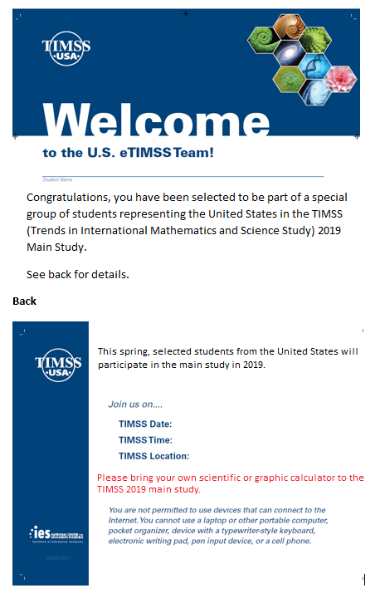

2023 field test.

field test in 2022.

Field Test.

2023

Student Login Card (label with login information will be affixed to the card)

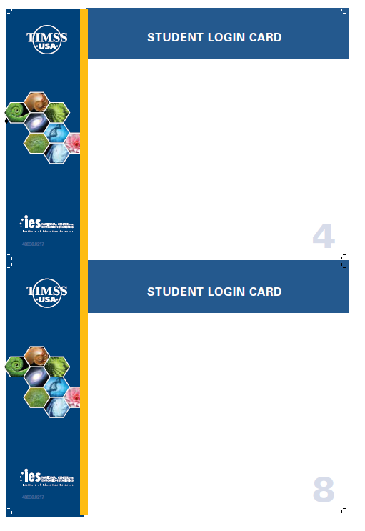

# AppendixA18a Student Certificate of Completion

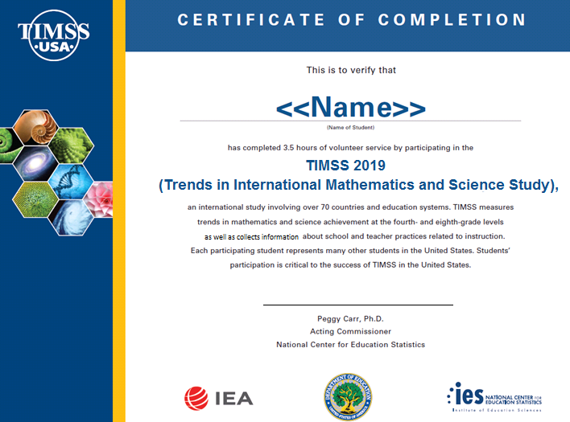

60

**TIMSS 2023**

# AppendixA18b School Certificate of Completion

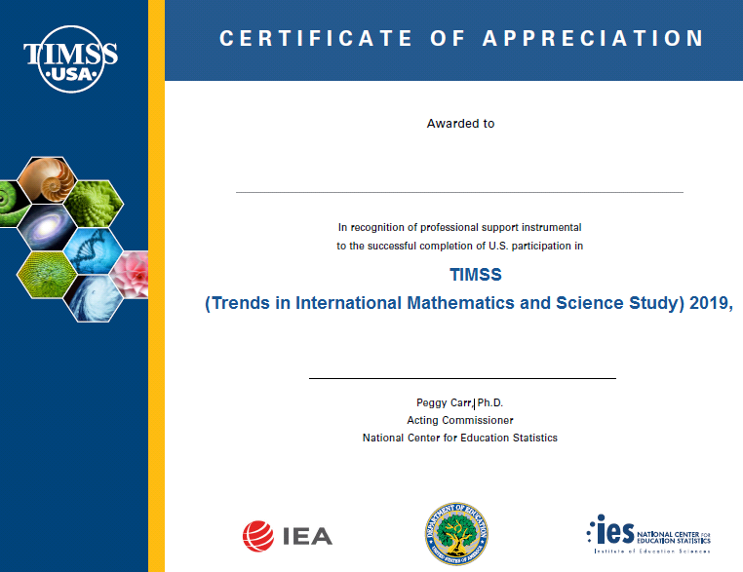

**2023.**

# Appendix A19 Email to School Coordinator to Submit Class and Student Lists – Grade 4

Dear [School Coordinator],

TIMSS needs a complete and current list of **all of your school’s fourth-grade classes** and **all the fourth-grade students in those classes** in order to randomly select classes to participate in the TIMSS 2023 Field Test.

Please go to <TIMSS web URL> to submit your class and student lists. If you have forgotten your login ID please contact the TIMSS helpdesk at [<email](mailto:timss@westat.com) address> or 1-xxx-xxx-xxxx. If you have forgotten your password, you can request a new password on the MyTIMSS login page.

After logging in, select **Submit Class List** to provide information about your fourth-grade classes. Once you have provided information about all fourth-grade classes, select **Submit Student List** to provide an electronic list of currently enrolled fourth-grade students in your school.

Instructions for **Submit Class List** and **Submit Student List** are attached. These tip sheets and Excel templates can also be found in the **Documents** section of <TIMSS URL>.

If you have any questions about submitting your list, please email or call the TIMSS Help Desk at [<email](mailto:TIMSSefile@westat.com) address> or 1-xxx-xxx-xxxx. ​

Please submit your student file by date mm/dd/yr**.** TIMSS will process your submission and select the sample of fourth-grade classes to be assessed. You will be informed of the classes selected within a few weeks of submitting your lists.

Thank you very much for participating in TIMSS, and for submitting your school's class and student lists!

Sincerely,

TIMSS 2023 Field Test Team

Attachments: Grade 4 Submit Class List Tip Sheet; Grade 4 Submit Student List Tip Sheet

*NCES is authorized to conduct this study under the Education Sciences Reform Act of 2002 (ESRA 2002, 20 U.S.C. §9543). All of the information you provide may be used only for statistical purposes and may not be disclosed, or used, in identifiable form for any other purpose except as required by law (20 U.S.C. §9573 and 6 U.S.C. §151).*

# Appendix A19a Instructions for Submitting Class Lists – Grade 4

**TIMSS 2023 Field Test: Instructions for Grade 4 Submit Class List**

TIMSS needs a complete and current list of all of your school’s fourth-grade classes in order to randomly select classes to be assessed. Typically, one or two classes are sampled in each school, and all students in the selected classes will be assessed.

On <web URL>, select **Submit Class List** from the navigation menu. Enter information for each fourth-grade class in the web form. After you have entered information for each class, click on the *Save* button, and another row will appear for you to enter information about another class.

Continue until you have entered information for all classes that contain fourth-grade students. Include the following information for each class:

• *Class Name*

• *Class Group or Track* (If applicable)

• *Number of Students*

• *Class Exclusion Status* (If applicable)

• *Name of Mathematics Teacher*

• *Name of Science Teacher*

When you have entered information for fourth-grade classes in your school, click on the *Finished* button.

**Example 1: Small school with the same Mathematics and Science Teacher for each class**

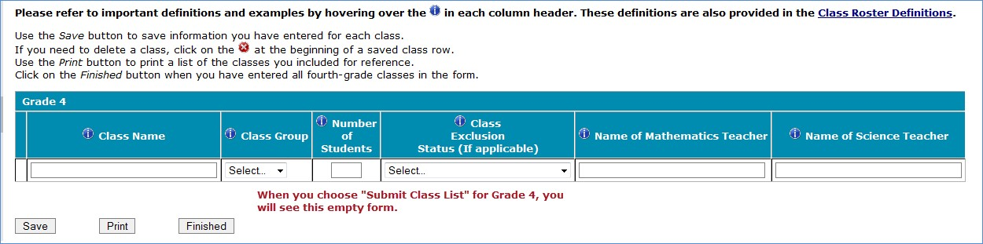

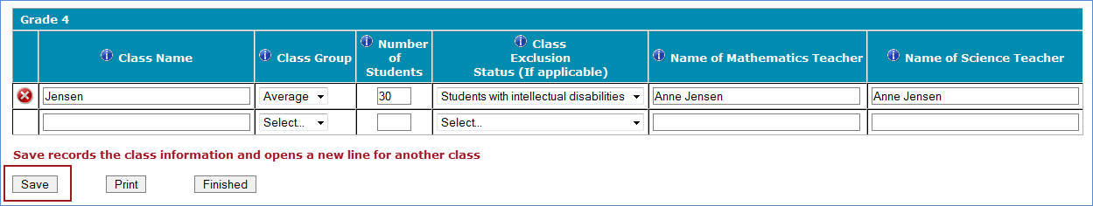

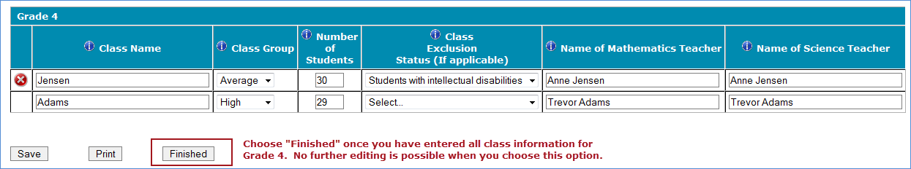

**Example 2: Larger school with multiple Grade 4 classes**

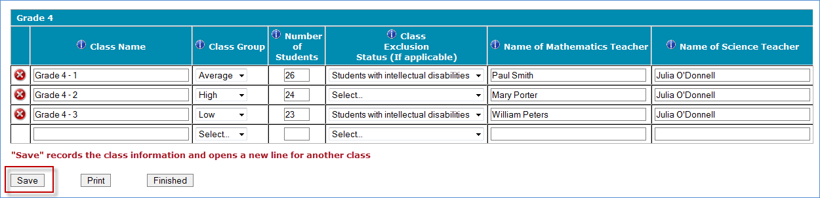

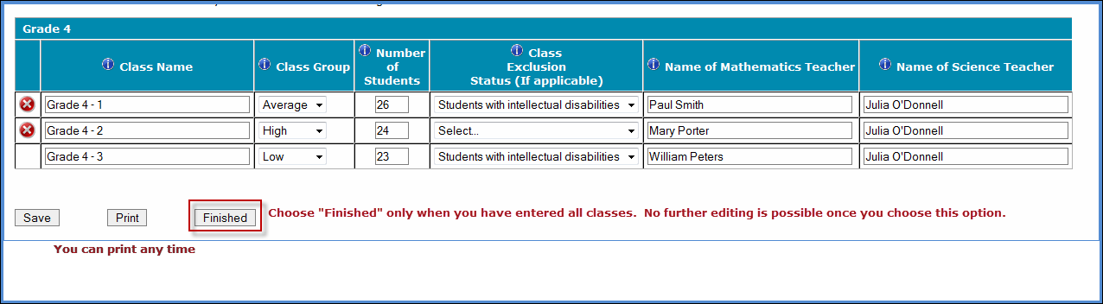

**Additional tips for submitting information about your fourth-grade classes:**

• Refer to the important definitions in the **Class Roster Definitions** document in the **Documents** section of<web URL>.

• Record the Class Name that is typically used by your school to refer to the class.

• For classes with students from more than one grade level, include in *Number of Students* only those students in grade 4. For example, if the class has 5 third-graders, 6 fourth-graders, and 4 fifth-graders, enter “6” as the *Number of Students* in this class.

• Use the most current enrollment information.

• Include all classes, even if they typically are excluded from your state testing program, or all students take alternate assessments. You can indicate information about the class in *Class Exclusion Status*.

• Name of mathematics teacher and name of science teacher may be the same.

• Print a list of the classes you included for your future reference using the *Print* button.

**If you need assistance, email <email address> or call 1-xxx-xxx-xxxx.**

# Appendix A19b Instructions for Submitting Student Lists – Grade 4

**TIMSS 2023 Field Test: Instructions for Grade 4 Submit Student List**

Along with the list of classes, TIMSS needs a complete and current list of **all students** in grade 4 in order to draw a random sample of classes (and therefore students) to participate in the assessment. Your student data electronic file must be submitted as a Microsoft Excel file.

You may use one of the **TIMSS Grade 4 Excel Templates** (located in **Documents** on [<web URL>](http://www.mytimss.com/) and described below) or you may provide an Excel file with the same information. If you cannot submit your student data with this information in an Excel file, please call or email the TIMSS Help Desk at [<email address>](mailto:%3cemail%20address%3e%20) or 1-xxx-xxx-xxxx.

**Step 1 – Compile Data in an Excel File**

Prepare an Excel file with the following data elements for all students in grade 4.

|  |  |
| --- | --- |
| **Data Element** | **Description** |
| Class | The fourth-grade class the student is enrolled in. Please use the  same class names you used in **Submit Class List.** |
| Teacher Name | Teacher of the above-named class |
| Student Name | The preferred format is First Name, Middle Name (or Initial), and  Last Name in separate columns. However, TIMSS will accept student names in one column. |
| Sex | Codes (numeric or text) for Male/Female |
| Date of Birth | The preferred format is Month of Birth and Year of Birth in  separate columns. However, TIMSS will accept Date of Birth in one column. |
| Student with a Disability  (SD) Status | School-defined codes for:  • Yes, IEP: Student has an Individualized Education Plan (IEP).  Students with 504 plans that need accommodations can be coded this value as well.  • No, not SD:  • Information unavailable at this time. |
| English Language  Learner (ELL) Status | School-defined codes for:  • Yes, ELL  • No, not ELL  • Information unavailable at this time. |

You may use one of the templates provided or create your own Excel file with these data for each student. It is preferred that you include column headers as the first row in your File, as in these templates. However, Files without column headers will be accepted.

*Template 1* has student name in three separate columns, and month of birth and year of birth in two separate columns.



*Template 2* has student name in one column, and date of birth in one column.



Tips for ensuring the File process goes smoothly:

• Use the template or provide column headers. Student information should begin on the second row. There should be no empty rows within the student data.

• Be sure to give your file a unique, descriptive name. Within Excel, click on *File*, then *Save As*,

and give your file a name such as “Your School Name Grade 4.xls.”

• The first row of data in your file will be read as the column header unless you indicate otherwise on the **Submit Student List** webpage. Each succeeding row will be considered a student record.

• There should be only one worksheet with data in the Excel file. If there are other worksheets, they must not contain any data.

**Step 2 – Upload Your Excel File**

Once your file is prepared and checked for accuracy and completeness, login to <web URL> and

select “Submit Student List” from the menu.

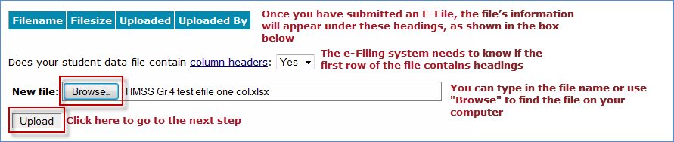

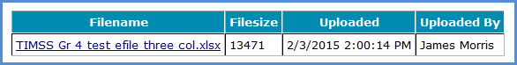

**Step 3 – Identify Your Columns**

We need to know what information is in each column of your student data file (E-File). If you provided column headers in your File (preferred), they are displayed in **Column Heading Is** in the table. If you did not provide column headers, **Column Heading Is** will contain numbers for each column in your submitted File. Click on the down arrows in **Your Column Contains** to select descriptions for each column header. If there is no appropriate description in the drop-down list, please select N/A.

Select *Next* after all columns have been identified.

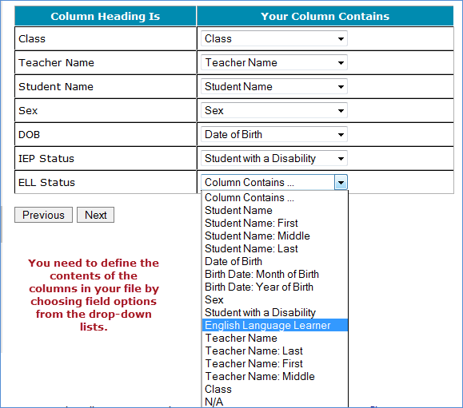

**Step 4 – Match Your Values to TIMSS Codes**

TIMSS also needs to know the values for some of the columns in your File. The tables contain the following information for each column:

• Your Values: The values in your File

• TIMSS Codes: Click on the down arrow and select the TIMSS Code that best matches Your Values

• Number: The number of students in your File with that value

• Percentage: The percentage in your File with that value

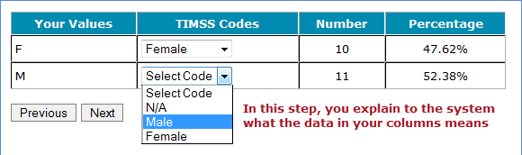

Use the *Previous* and *Next* buttons to navigate from column header to column header.

If there is an error in your data file, exit File, correct the problem in your Excel file, and upload the file again.

**Step 5 – Verify Your File**

The table in this section summarizes the information you have provided on your student list (File). Please review this summary and verify that the information is correct. *Total Enrollment* at the bottom of the table should match the number of students in your File, and the total number of students currently enrolled in grade 4.

Record whether the information is correct or incorrect by selecting the appropriate button at the bottom of the page. Then click the *Submit* button. If you select INCORRECT, you will need to correct your File and resubmit it.

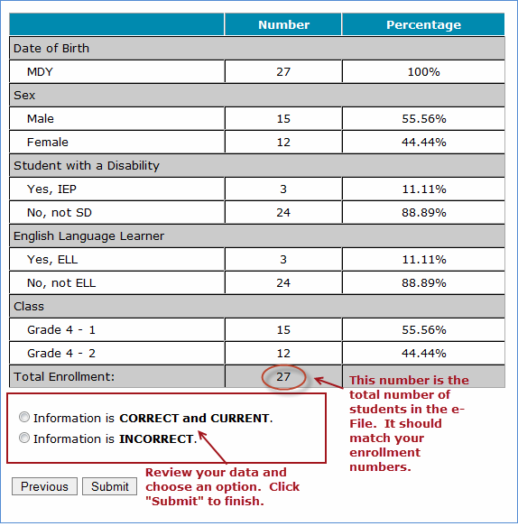

**If you need assistance, please contact the TIMSS Help Desk at**  [**<email address>**](mailto:%20%3cemail%20address%3e%20) **or 1-xxx-xxx-xxxx.**

# Appendix A20 Email to School Coordinator to Submit Class and Student Lists – Grade 8

Dear [School Coordinator],

TIMSS needs a complete and current list of **all of your school’s eighth-grade mathematics classes** and **all the eighth-grade students in those classes** in order to randomly select classes to participate in the TIMSS 2023 Field Test. TIMSS also needs a list of your school’s eighth-grade science teachers and the courses they teach in order to link information about science teachers to the assessed students.

Please go to <web URL> to submit your class and student lists. If you have forgotten your login ID please contact the TIMSS helpdesk at <email address> or 1-xxx-xxx-xxxx. If you have forgotten your password, you can request a new password on the TIMSS login page.

After logging in, select **Submit Class List** to provide information about your eighth-grade mathematics classes and science teachers. Once you have provided information about all eighth-grade mathematics classes and science teachers, select **Submit Student List** to provide an electronic list of currently enrolled eighth-grade students in your school.

Instructions for **Submit Class List** and **Submit Student List** are attached. These tip sheets and Excel templates can also be found in the **Documents** section of MyTIMSS. An optional webinar will be held on XXXXXXXX to review the Submit Class and Submit Student procedures. Registration information for the webinar will be sent to you in a separate mail. The webinar will be recorded for viewing at a later time as well.

If you have any questions about submitting your list, please email or call the TIMSS Help Desk at <email address> or 1-xxx-xxx-xxxx. ​

Please submit your student File by <date> **mm/dd/yr.** TIMSS will process your submission and select the sample of eighth-grade mathematics classes to be assessed. You will be informed of the classes selected within a few weeks of submitting your lists.

Thank you very much for participating in TIMSS, and for submitting your school's class and student lists!

Sincerely,

TIMSS 2023 Field Test Team

Attachments: Grade 8 Submit Class List Tip Sheet; Grade 8 Submit Student List Tip Sheet

*NCES is authorized to conduct this study under the Education Sciences Reform Act of 2002 (ESRA 2002, 20 U.S.C. §9543). All of the information you provide may be used only for statistical purposes and may not be disclosed, or used, in identifiable form for any other purpose except as required by law (20 U.S.C. §9573 and 6 U.S.C. §151).*

# Appendix A20a Instructions for Submitting Class Lists – Grade 8

**TIMSS 2023 Field Test: Instructions for Grade 8 Submit Class List**

TIMSS needs a complete and current list of all of your school’s eighth-grade mathematics classes in order to randomly select classes to be assessed. Typically, two classes are sampled in each school, and all students in the selected classes will be assessed.

**Step 1 – Enter information about all eighth-grade mathematics classes**

On<web URL>, select **Submit Class List** from the navigation menu. Enter information for each eighth-grade mathematics class in the web form. After you have entered information for each mathematics class, click on the *Save* button, and another row will appear for you to enter information about another mathematics class. Continue until you have entered information for all mathematics classes that contain eighth-grade students.

Include the following information for each class:

• *Class Name*

• *Class Group or Track* (If applicable)

• *Number of Students*

• *Class Exclusion Status* (If applicable)

• *Name of Mathematics Teacher*

**Example:**

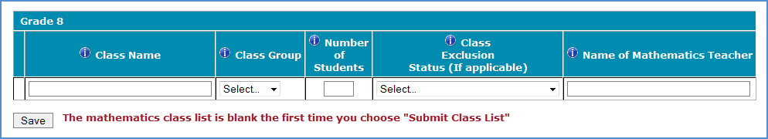

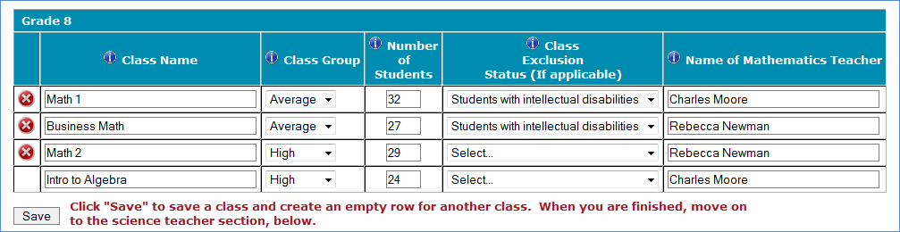

**Step 2 – Enter information about your eighth-grade science teachers**

TIMSS also needs a complete and current list of all of your school’s eighth-grade science teachers in order to link information about science teachers to the assessed students. Enter each teacher’s name and the course the teacher teaches (e.g. biology, integrated science) into the form. Click *Save* after entering each teacher. Continue until you have entered information about all science teachers who teach eighth-grade students.

**Example:**

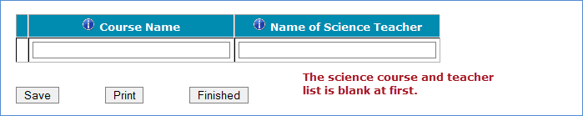

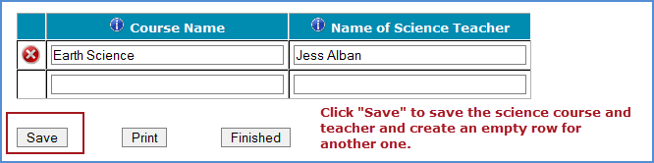

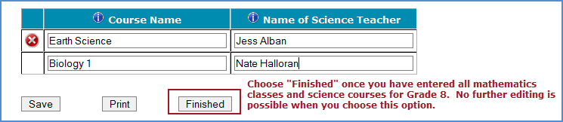

When you have entered information for eighth-grade mathematics classes, and eighth-grade science teachers, in your school, click on the *Finished* button.

**Additional tips for submitting information about your eighth-grade mathematics classes:**

• Refer to the important definitions in the **Class Roster Definitions** document in the **Documents** section of <web URL>.

• Record the Class Name that is typically used by your school to refer to the class.

• For math classes with students from more than one grade level, include in *Number of Students* only those students in grade 8. For example, if the class has 5 seventh-graders, 6 eighth- graders, and 4 ninth-graders, enter “6” as the *Number of Students* in this class.

• Use the most current enrollment information.

• Include all classes, even if they typically are excluded from your state testing program, or all students take alternate assessments. You can indicate information about the class in *Class Exclusion Status*.

• Examples of science courses include: general science, integrated science, biology, physical science. Use the course names that you use in your school.

• Print a list of the mathematics classes and science teachers you included for your future reference using the *Print* button.

**If you need assistance, email**  [**<email address>**](mailto:%20%3cemail%20address%3e%20) **or call 1-xxx-xxx-xxxx.**

# Appendix A20b Instructions for Submitting Student Lists – Grade 8

**TIMSS 2023 Field Test: Instructions for Grade 8 Submit Student List**

Along with the list of classes, TIMSS needs a complete and current list of **all students** in grade 8 in order to draw a random sample of mathematics classes (and therefore students) to participate in the assessment. Your student data electronic file (E-File) must be submitted as a Microsoft Excel file.

You may use one of the **TIMSS Grade 8 Excel Templates** (located in **Documents** on <web URL> and described below) or you may provide an Excel file with the same information. If you cannot submit your student data with this information in an Excel file, please call or email the TIMSS File Help Desk at [<email address>](mailto:%3cemail%20address%3e%20) or 1-xxx-xxx-xxxx.

**Step 1 – Compile Data in an Excel File**

Prepare an Excel file with the following data elements for all students in grade 8.

|  |  |
| --- | --- |
| **Data Element** | **Description** |
| Mathematics Class | The mathematics class the student is enrolled in. Please use the  same class names you used in **Submit Class List.** |
| Mathematics Teacher | Teacher of the above named mathematics class that the student is  taking |
| Science Teacher | Name of science teacher who teaches science to each student |
| Student Name | The preferred format is First Name, Middle Name (or Initial), and  Last Name in separate columns. However, TIMSS will accept student names in one column. |
| Sex | Codes (numeric or text) for Male/Female |
| Date of Birth | The preferred format is Month of Birth and Year of Birth in  separate columns. However, TIMSS will accept Date of Birth in one column. |
| Student with a Disability  (SD) Status | School-defined codes for:  • Yes, IEP: Student has an Individualized Education Plan (IEP).  Students with 504 plans that need accommodations can be  coded this value as well.  • No, not SD:  • Information unavailable at this time. |
| English Language  Learner (ELL) Status | School-defined codes for:  • Yes, ELL  • No, not ELL  • Information unavailable at this time. |

You may use one of the templates provided or create your own Excel file with these data for each student. It is preferred that you include column headers as the first row in your E-File, as in these templates. However, Files without column headers will be accepted.

*Template 1* has student name in three separate columns, and month of birth and year of birth in two separate columns.



*Template 2* has student name in one column, and date of birth in one column.



Tips for ensuring the File process goes smoothly:

• Use the template or provide column headers. Student information should begin on the second row. There should be no empty rows within the student data.

• Be sure to give your file a unique, descriptive name. Within Excel, click on *File*, then *Save As*,

and give your file a name such as “Your School Name Grade 8.xls.”

• The first row of data in your file will be read as the column header unless you indicate otherwise on the **Submit Student List** webpage. Each succeeding row will be considered a student record.

• There should be only one worksheet with data in the Excel file. If there are other worksheets, they must not contain any data.

**Step 2 – Upload Your Excel File**

Once your file is prepared and checked for accuracy and completeness, login to <web URL> and select “Submit Student List” from the left-hand menu.

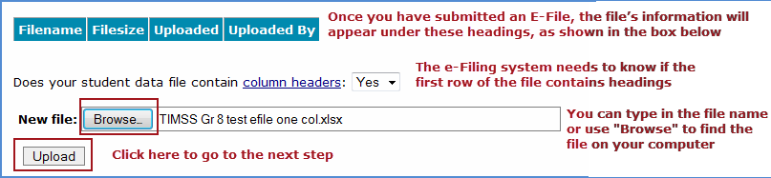

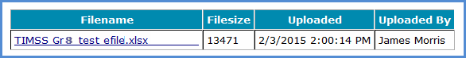

**Step 3 – Identify Your Columns**

We need to know what information is in each column of your student data file (E-File). If you provided column headers in your File (preferred), they are displayed in **Column Heading Is** in the table. If you did not provide column headers, **Column Heading Is** will contain numbers for each column in your submitted File. Click on the down arrows in **Your Column Contains** to select descriptions for each column header. If there is no appropriate description in the drop-down list, please select N/A.

Select *Next* after all columns have been identified.

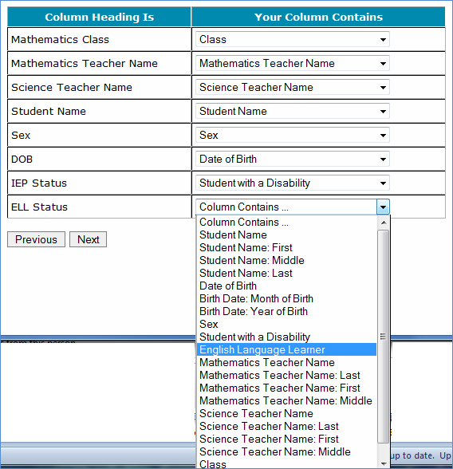

**Step 4 – Match Your Values to TIMSS Codes**

TIMSS also needs to know the values for some of the columns in your E-File. The tables contain the following information for each column:

• Your Values: The values in your File

• TIMSS Codes: Click on the down arrow and select the TIMSS Code that best matches Your Values

• Number: The number of students in your E-File with that value

• Percentage: The percentage in your E-File with that value



Use the *Previous* and *Next* buttons to navigate from column header to column header.

If there is an error in your data file, exit E-File, correct the problem in your Excel file, and upload the file again.

**Step 5 – Verify Your E-File**

The table in this section summarizes the information you have provided on your student list (File). Please review this summary and verify that the information is correct. *Total Enrollment* at the bottom of the table should match the number of students in your E-File, and the total number of students currently enrolled in grade 8.

Record whether the information is correct or incorrect by selecting the appropriate button at the bottom of the page. Then click the *Submit* button. If you select INCORRECT, you will need to correct your File and resubmit it.

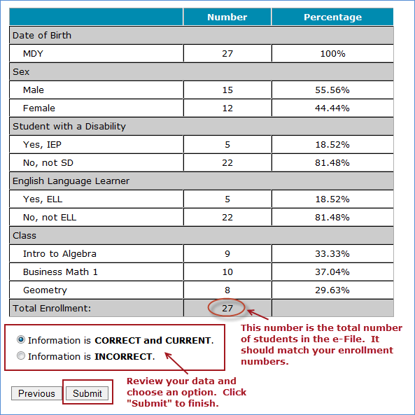

**If you need assistance, please contact the TIMSS File Help Desk at**  [**<email address>**](mailto:TIMSSefile@westat.com) **or 1-xxx-xxx-xxxx.**

# Appendix A21 TIMSS 2023 Field Test COVID-19 Protocols

(Notes: If needed at the time of data collection, protocols will be updated to reflect the most recent CDC guidelines and RTI Infectious Disease Response Teams guidance. Additionally, a graphically designed document will be created with these Protocols.)

TIMSS 2023 Field Test COVID-19 Protocols

* Provide Personal Protective Equipment (PPE)
  + TIMSS will provide field staff with PPE:
    - Disposable Masks
    - Disposable gloves
    - Hand Sanitizer
    - Sanitizing wipes & Spray
* Sanitizing and PPE Protocol
  + Multiple times during the assessment day, field staff will follow protocols to:
    - Sanitize testing equipment and equipment cases
    - Replace gloves and masks between assessment sessions
    - Used PPE will be discarded in TIMSS-supplies Trash bags and removed from the school by field staff
* Field Staff Covid-19 Protocol training
  + All field staff will be trained on Covid-19 protocols, including:
    - Donning and removing PPE
    - Proper disposal of used PPE
    - Social Distancing Requirements
    - Sanitizing equipment and equipment cases
    - Other school protocols
* Health Monitoring
  + Field staff will be expected to perform a Covid-19 Daily Checklist of their health and symptoms before reporting for work at a school.
    - Any field staff who do not successfully pass the daily health assessment will not report to school that day, and will be required to either:
      1. Test Negative for Covid-19 in accordance with CDC guidelines
      2. Be free of Covid-19 symptoms for a 14-day period before conducting any assessment in schools
      3. Provide Written documentation from their healthcare provider releasing their return to work
  + Before entering school buildings, field staff will take their temperature using a non-contact thermometer, and acknowledge that they are symptom free
* School Protocols
  + Field Staff will follow any and all school-specific required CDC protocols, which may include but not limited to the following:
    - Temperature checks and other symptom assessments by the school upon arrival at the school
    - Social distancing guidelines of staff and students
    - Additional school required PPE
    - Additional sanitizing requirements

## Appendix B: TIMSS 2023 Field Test Notification Letters and Supporting Materials

Contents

Appendix B1 TIMSS Field Test Sample Notification Letter – Grade 4 81

Appendix B2 TIMSS Field Test Sample Notification Letter – Grade 8 82

Appendix B3 TIMSS Field Test Sample Implicit Consent Letter – Grade 4 83

Appendix B4 TIMSS Field Test Sample Implicit Consent Letter – Grade 8 84

Appendix B5 TIMSS Implicit Consent Form – Grades 4 and 8 85

Appendix B6 TIMSS Field Test Sample Explicit Consent Letter – Grade 4 86

Appendix B7 TIMSS Field Test Sample Explicit Consent Letter – Grade 8 87

Appendix B8 TIMSS Explicit Consent Form – Grades 4 and 8 88

Appendix B9 TIMSS Facts for Parents About the Field Test – Grade 4 89

Appendix B10 TIMSS Facts for Parents About the Field Test – Grade 8 90

Appendix B11 Multi-translation Notice for Parents………………………………………………………………………….…..91

## Appendix B1 TIMSS 2023 Field Test Sample Notification Letter – Grade 4

SCHOOL LETTERHEAD

Dear Parent or Guardian,

Our school has accepted an invitation from the National Center for Education Statistics (NCES), part of the U.S. Department of Education, to participate in the **Trends in International Mathematics and Science Study (TIMSS)** field test. {Insert number} of our 4th-grade classes will take part. {This/One of these} is your child’s class.

**WHO**: Your child’s class is one of many 4th grade classes across the United States taking part in TIMSS. To have an accurate picture of what U.S. 4th graders can do in mathematics and science, it is important that each student selected take part in the study. I urge you to support this effort by encouraging your child to take part; however, participation in this study is entirely voluntary.

**WHAT**: Students will answer mathematics and science questions and complete a brief questionnaire about themselves. Previous experience suggests that students enjoy taking part, and participating students will receive a small gift.

**WHY**: TIMSS provides an accurate picture of what students can do in mathematics and science at grades 4 and 8 in the United States against countries around the world. Since 1995, TIMSS has measured worldwide trends in student knowledge of mathematics and science.

The enclosed summary sheet provides information about TIMSS, student participation, and gives a contact phone number and email address in case you have any questions.

Thank you for taking the time to learn about this important study.

Sincerely,

[School official]

*All of the information collected is safeguarded, as required by law. NCES is authorized to conduct this study under the Education Sciences Reform Act of 2002 (ESRA 2002, 20 U.S.C. §9543). All of the information provided by school staff and students may be used only for statistical purposes and may not be disclosed, or used, in identifiable form for any other purpose except as required by law (20 U.S.C. §9573 and 6 U.S.C. §151). Students and schools are never identified in any reports. All reported statistics refer to the United States as a whole.*

Enclosures: Facts for Parents about the TIMSS 2023 Field Test

## Appendix B2 TIMSS 2023 Field Test Sample Notification Letter – Grade 8

SCHOOL LETTERHEAD

Dear Parent or Guardian,

Our school has accepted an invitation from the National Center for Education Statistics (NCES), part of the U.S. Department of Education, to participate in the **Trends in International Mathematics and Science Study (TIMSS)** field test. {Insert number} of our 8th-grade classes will take part. {This/One of these} is your child’s class.

**WHO**: Your child’s class is one of many 8th grade classes across the United States taking part in TIMSS. To have an accurate picture of what U.S. 8th graders can do in mathematics and science, it is important that each student selected take part in the study. I urge you to support this effort by encouraging your child to take part; however, participation in this study is entirely voluntary.

**WHAT**: Students will answer mathematics and science questions and complete a brief questionnaire about themselves. Previous experience suggests that students enjoy taking part, and participating students will receive a small gift.

**WHY**: TIMSS provides an accurate picture of what students can do in mathematics and science at grades 4 and 8 in the United States against countries around the world. Since 1995, TIMSS has measured worldwide trends in student knowledge of mathematics and science.

The enclosed summary sheet provides information about TIMSS, student participation, and gives a contact phone number and email address in case you have any questions.

Thank you for taking the time to learn about this important study.

Sincerely,

[School official]

*All of the information collected is safeguarded, as required by law. NCES is authorized to conduct this study under the Education Sciences Reform Act of 2002 (ESRA 2002, 20 U.S.C. §9543). All of the information provided by school staff and students may be used only for statistical purposes and may not be disclosed, or used, in identifiable form for any other purpose except as required by law (20 U.S.C. §9573 and 6 U.S.C. §151). Students and schools are never identified in any reports. All reported statistics refer to the United States as a whole.*

Enclosures: Facts for Parents about the TIMSS 2023 Field Test

## Appendix B3 TIMSS 2023 Field Test Sample Implicit Consent Letter – Grade 4

SCHOOL LETTERHEAD

Dear Parent or Guardian,

Our school has accepted an invitation from the National Center for Education Statistics (NCES), part of the U.S. Department of Education, to participate in the **Trends in International Mathematics and Science Study (TIMSS)** field test. {Insert number} of our 4th-grade classes will take part. {This/One of these} is your child’s class.

**WHO**: Your child’s class is one of many 4th grade classes across the United States taking part in TIMSS. To have an accurate picture of what U.S. 4th graders can do in mathematics and science, it is important that each student selected take part in the study. I urge you to support this effort by encouraging your child to take part; however, participation in this study is entirely voluntary.

**WHAT**: Students will answer mathematics and science questions and complete a brief questionnaire about themselves. Previous experience suggests that students enjoy taking part, and participating students will receive a small gift.

**WHY**: TIMSS provides an accurate picture of what students can do in mathematics and science at grades 4 and 8 in the United States against countries around the world. Since 1995, TIMSS has measured worldwide trends in student knowledge of mathematics and science.

The enclosed summary sheet provides information about TIMSS, student participation, and gives a contact phone number and email address in case you have any questions. If you have any objection to your child joining in the TIMSS activities, please let us know by completing the attached consent form and returning it to the school.

Thank you for taking the time to learn about this important study.

Sincerely,

[School official]

*All of the information collected is safeguarded, as required by law. NCES is authorized to conduct this study under the Education Sciences Reform Act of 2002 (ESRA 2002, 20 U.S.C. §9543). All of the information provided by school staff and students may be used only for statistical purposes and may not be disclosed, or used, in identifiable form for any other purpose except as required by law (20 U.S.C. §9573 and 6 U.S.C. §151). Students and schools are never identified in any reports. All reported statistics refer to the United States as a whole.*

Enclosures: Facts for Parents about the TIMSS 2023 Field Test, Parent/Guardian Consent Form

## Appendix B4 TIMSS 2023 Field Test Sample Implicit Consent Letter – Grade 8

SCHOOL LETTERHEAD

Dear Parent or Guardian,

Our school has accepted an invitation from the National Center for Education Statistics (NCES), part of the U.S. Department of Education, to participate in the **Trends in International Mathematics and Science Study (TIMSS)** field test. {Insert number} of our 8th-grade classes will take part. {This/One of these} is your child’s class.

**WHO**: Your child’s class is one of many 8th grade classes across the United States taking part in TIMSS. To have an accurate picture of what U.S. 8th graders can do in mathematics and science, it is important that each student selected take part in the study. I urge you to support this effort by encouraging your child to take part; however, participation in this study is entirely voluntary.

**WHAT**: Students will answer mathematics and science questions and complete a brief questionnaire about themselves. Previous experience suggests that students enjoy taking part, and participating students will receive a small gift.

**WHY**: TIMSS provides an accurate picture of what students can do in mathematics and science at grades 4 and 8 in the United States against countries around the world. Since 1995, TIMSS has measured worldwide trends in student knowledge of mathematics and science.

The enclosed summary sheet provides information about TIMSS, student participation, and gives a contact phone number and email address in case you have any questions. If you have any objection to your child joining in the TIMSS activities, please let us know by completing the attached consent form and returning it to the school.

Thank you for taking the time to learn about this important study.

Sincerely,

[School official]

*All of the information collected is safeguarded, as required by law. NCES is authorized to conduct this study under the Education Sciences Reform Act of 2002 (ESRA 2002, 20 U.S.C. §9543). All of the information provided by school staff and students may be used only for statistical purposes and may not be disclosed, or used, in identifiable form for any other purpose except as required by law (20 U.S.C. §9573 and 6 U.S.C. §151). Students and schools are never identified in any reports. All reported statistics refer to the United States as a whole.*

Enclosures: Facts for Parents about the TIMSS 2023 Field Test, Parent/Guardian Consent Form

## Appendix B5 TIMSS Implicit Consent Form – Grades 4 and 8

**Trends in International Mathematics and Science Study (TIMSS)**

TIMSS 2023 Field Test

**Parent/Guardian Consent Form**

Your child has been asked to participate in a field test of an international study of student learning called the Trends in International Mathematics and Science Study (TIMSS). Each student who participates will receive a small gift. This assessment will be administered by a team of researchers from RTI International, who are operating under contract on behalf of the National Center for Education Statistics (NCES), with the U. S. Department of Education.

**If you grant permission for your child to participate in the TIMSS Field Test, you do not need to return this form.**

If you do not grant permission to your child’s participation in the TIMSS Field Test, please return this form to your child’s school as soon as possible.

No, I do not give permission for my child to participate in the TIMSS 2023 Field Test.

____________________________________________Date of signature: _____/_____/______

(Signature of parent or guardian)

Please Print:

Student name: __________________________________________

School name: ____________________________________________

Parent name: ____________________________________________

Parent telephone: ________________________________________

Parent email: _____________________________________________

FOR OFFICE USE ONLY:

Student ID: ________________________________________________

## Appendix B6 TIMSS 2023 Field Test Sample Explicit Consent Letter – Grade 4

SCHOOL LETTERHEAD

**Please read, sign, and return the attached consent form to your child’s school.**

Dear Parent or Guardian,

Our school has accepted an invitation from the National Center for Education Statistics (NCES), part of the U.S. Department of Education, to participate in the **Trends in International Mathematics and Science Study (TIMSS)** field test. {Insert number} of our 4th-grade classes will take part. {This/One of these} is your child’s class.

**WHO**: Your child’s class is one of many 4th grade classes across the United States taking part in TIMSS. To have an accurate picture of what U.S. 4th graders can do in mathematics and science, it is important that each student selected take part in the study. I urge you to support this effort by encouraging your child to take part; however, participation in this study is entirely voluntary.

**WHAT**: Students will answer mathematics and science questions and complete a brief questionnaire about themselves. Previous experience suggests that students enjoy taking part, and participating students will receive a small gift.

**WHY**: TIMSS provides an accurate picture of what students can do in mathematics and science at grades 4 and 8 in the United States against countries around the world. Since 1995, TIMSS has measured worldwide trends in student knowledge of mathematics and science.

The enclosed summary sheet provides information about TIMSS, student participation, and gives a contact phone number and email address in case you have any questions. **Before we can allow your child to join in the TIMSS activities, we must have your written consent. Please complete the attached form and return it to the school.**

Thank you for taking the time to learn about this important study and for returning the attached form.

Sincerely,

[School official]

*All of the information collected is safeguarded, as required by law. NCES is authorized to conduct this study under the Education Sciences Reform Act of 2002 (ESRA 2002, 20 U.S.C. §9543). All of the information provided by school staff and students may be used only for statistical purposes and may not be disclosed, or used, in identifiable form for any other purpose except as required by law (20 U.S.C. §9573 and 6 U.S.C. §151). Students and schools are never identified in any reports. All reported statistics refer to the United States as a whole.*

Enclosures: Facts for Parents about the TIMSS 2023 Field Test, Parent/Guardian Consent Form

## Appendix B7 TIMSS 2023 Field Test Sample Explicit Consent Letter – Grade 8

SCHOOL LETTERHEAD

**Please read, sign, and return the attached consent form to your child’s school.**

Dear Parent or Guardian,

Our school has accepted an invitation from the National Center for Education Statistics (NCES), part of the U.S. Department of Education, to participate in the **Trends in International Mathematics and Science Study (TIMSS)** field test. {Insert number} of our 8th-grade classes will take part. {This/One of these} is your child’s class.

**WHO**: Your child’s class is one of many 8th grade classes across the United States taking part in TIMSS. To have an accurate picture of what U.S. 8th graders can do in mathematics and science, it is important that each student selected take part in the study. I urge you to support this effort by encouraging your child to take part; however, participation in this study is entirely voluntary.

**WHAT**: Students will answer mathematics and science questions and complete a brief questionnaire about themselves. Previous experience suggests that students enjoy taking part, and participating students will receive a small gift.

**WHY**: TIMSS provides an accurate picture of what students can do in mathematics and science at grades 4 and 8 in the United States against countries around the world. Since 1995, TIMSS has measured worldwide trends in student knowledge of mathematics and science.

The enclosed summary sheet provides information about TIMSS, student participation, and gives a contact phone number and email address in case you have any questions. **Before we can allow your child to join in the TIMSS activities, we must have your written consent. Please complete the attached form and return it to the school.**

Thank you for taking the time to learn about this important study and for returning the attached form.

Sincerely,

[School official]

*All of the information collected is safeguarded, as required by law. NCES is authorized to conduct this study under the Education Sciences Reform Act of 2002 (ESRA 2002, 20 U.S.C. §9543). All of the information provided by school staff and students may be used only for statistical purposes and may not be disclosed, or used, in identifiable form for any other purpose except as required by law (20 U.S.C. §9573 and 6 U.S.C. §151). Students and schools are never identified in any reports. All reported statistics refer to the United States as a whole.*

Enclosures: Facts for Parents about the TIMSS 2023 Field Test, Parent/Guardian Consent Form

## Appendix B8 TIMSS 2023 Field Test Explicit Consent Form – Grades 4 and 8

**Trends in International Mathematics and Science Study (TIMSS)**

TIMSS 2023 Field Test

**Parent/Guardian Consent Form**

**Please read, sign, and return this consent form to your child’s school.**

Your child has been asked to participate in a field test of an international study of student learning called the Trends in International Mathematics and Science Study (TIMSS). Each student who participates will receive a small gift. This assessment will be administered by a team of researchers from RTI International, who are operating under contract on behalf of the National Center for Education Statistics (NCES), with the U. S. Department of Education.

PLEASE CHECK ONE:

Yes, I give permission for my child to participate in the TIMSS 2023 Field Test.

No, I do not give permission for my child to participate in the TIMSS 2023 Field Test.

PLEASE SIGN YOUR NAME BELOW:

_____________________________________________________ Date of signature: _____/_______/_______

(Signature of parent or guardian)

PLEASE PRINT:

Student name: _____________________________________________

School name: ______________________________________________

Parent name: ______________________________________________

Parent telephone: _________________________________________

Parent email: ______________________________________________

FOR OFFICE USE ONLY:

Student ID: ________________________________________________

## Appendix B9 TIMSS Facts for Parents About the TIMSS 2023 Field Test – Grade 4

**Facts for Parents**

**About the TIMSS 2023 Field Test**

Between March and April of this year, your child’s school will be one of about 35 nationwide taking part in a 4th-grade field test to prepare for TIMSS 2023.[4] Schools were selected randomly to represent the nation’s schools and, within each school, 4th-grade student classrooms were selected randomly to represent the nation’s 4th graders. Your child was among those students selected to take part in the TIMSS 2023 field test.

**What is TIMSS?**

TIMSS (Trends in International Mathematics and Science Study) is an international assessment that measures student learning in mathematics and science. Every four years since 1995, TIMSS documents worldwide trends in the knowledge of 4th graders. The National Center for Education Statistics (NCES), within the U.S. Department of Education, conducts TIMSS in the United States. Along with more than 65 other nations, the U.S. will take part in the 2023 TIMSS cycle as we did in 1995, 1999, 2003, 2007, 2011, 2015, and 2019.

**What is the purpose of the TIMSS 2023 Field Test?**

The TIMSS 2023 Field Test is testing 4th- and 8th-grade questions in electronic formats on tablet computers in approximately 70 schools in the United States in preparation for the 2023 international study. This field test will allow test developers to modify or delete questions that are not reliable or fair for students in the United States.

**What is involved?**

TIMSS staff will visit the school and administer the field test on tablet computers that they will bring to the school. The field test will take approximately 2 ½ hours. The assessment itself is 72 minutes with breaks between sections. Students will also be asked some questions about themselves and their educational experience. Participation in the study is voluntary.

**What are the benefits?**

The nation as a whole benefits from TIMSS by having a greater understanding of how the knowledge and skills of U.S. 4th graders compare with those of 4th graders in other countries. Our country benefits from the field test by ensuring that the questions used are fair and appropriate for U.S. students. Schools that participate in TIMSS will receive $200, and each student who participates will receive a small gift that we believe they will like.

**Who administers TIMSS?**

The entire assessment is administered by trained staff from RTI International, a research organization under contract to the U.S. Department of Education’s National Center for Education Statistics.

All of the information collected is safeguarded, as required by law. NCES is authorized to conduct this study under the Education Sciences Reform Act of 2002 (ESRA 2002, 20 U.S.C. §9543). All of the information provided by school staff and students may be used only for statistical purposes and may not be disclosed, or used, in identifiable form for any other purpose except as required by law (20 U.S.C. §9573 and 6 U.S.C. §151). Students and schools are never identified in any reports. All reported statistics refer to the United States as a whole.

**Where can I find out more about TIMSS?**

More information about TIMSS is available at the TIMSS website at <http://nces.ed.gov/timss> or <http://timss.bc.edu>. Or if you would like to contact a TIMSS staff member directly, please feel free to call the TIMSS hotline at XXX-XXX-XXXX or email us at<email address>.

## Appendix B10 TIMSS Facts for Parents About the TIMSS 2023 Field Test – Grade 8

**Facts for Parents**

**About the TIMSS 2023 Field Test**

Between March and April of this year, your child’s school will be one of about 35 nationwide taking part in an 8th-grade field test to prepare for TIMSS 2023[5]. Schools were selected randomly to represent the nation’s schools and, within each school, 8th-grade student classrooms were selected randomly to represent the nation’s 8th graders. Your child was among those students selected to take part in the TIMSS 2023 field test.

**What is TIMSS?**

TIMSS (Trends in International Mathematics and Science Study) is an international assessment that measures student learning in mathematics and science. Every four years since 1995, TIMSS documents worldwide trends in the knowledge of 8th graders. The National Center for Education Statistics (NCES), within the U.S. Department of Education, conducts TIMSS in the United States. Along with more than 65 other nations, the U.S. will take part in the 2023 TIMSS cycle as we did in 1995, 1999, 2003, 2007, 2011, 2015, and 2019.

**What is the purpose of the TIMSS 2023 Field Test?**

The TIMSS 2023 Field Test is piloting 4th and 8th grade questions in electronic format in approximately 70 schools in the United States in preparation for the 2023 international study (35 schools that include 4th grade and 35 that include 8th grade). This field test will allow test developers to modify or delete questions that are not reliable or fair for students in the United States.

**What is involved?**

TIMSS staff will visit the school and administer the field test on tablet computers that they will bring to the school. The field test will take approximately 2½ hours. The assessment itself is 90 minutes with breaks between sections. Students will also be asked some questions about themselves and their educational experience. Participation in the study is voluntary.

**What are the benefits?**

The nation as a whole benefits from TIMSS by having a greater understanding of how the knowledge and skills of U.S. 8th graders compare with those of 8th graders from other countries. Our country benefits from the field test by ensuring that the questions used are fair and appropriate for U.S. students. Schools that participate in TIMSS will receive $200, and each student who participates will receive a small gift that we believe they will like.

**Who administers TIMSS?**

The entire assessment is administered by trained staff from RTI International, a research organization under contract to the U.S. Department of Education’s National Center for Education Statistics.

All of the information collected is safeguarded, as required by law. NCES is authorized to conduct this study under the Education Sciences Reform Act of 2002 (ESRA 2002, 20 U.S.C. §9543). All of the information provided by school staff and students may be used only for statistical purposes and may not be disclosed, or used, in identifiable form for any other purpose except as required by law (20 U.S.C. §9573 and 6 U.S.C. §151). Students and schools are never identified in any reports. All reported statistics refer to the United States as a whole.

**Where can I find out more about TIMSS?**

More information about TIMSS is available at the TIMSS website at <http://nces.ed.gov/timss> or <http://timss.bc.edu>. Or if you would like to contact a TIMSS staff member directly, please feel free to call the TIMSS hotline at XXX-XXX-XXXX or email us at<email address>.

## AppendixB11 Multi-translation Notice for Parents

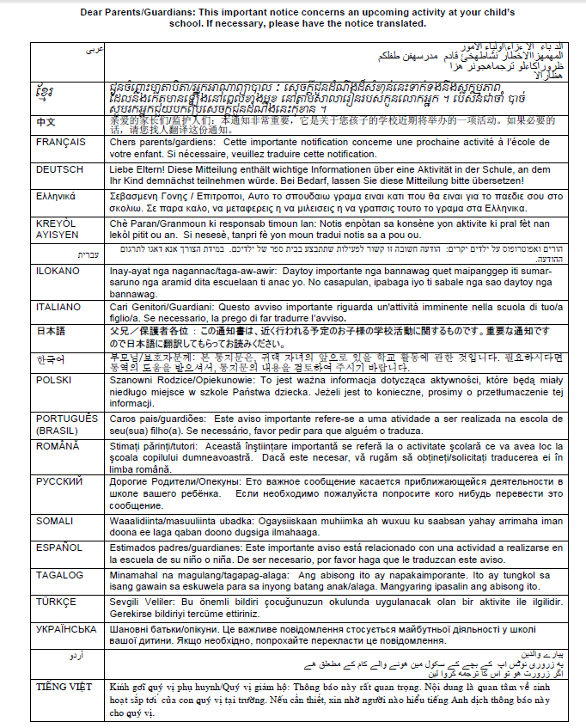

1. http://timssandpirls.bc.edu/timss2015/international-results/timss2015/wp-content/uploads/2016/T15-20-years-of-TIMSS.pdf
2. https://nces.ed.gov/timss/results19/index.asp#/math/trends
3. https://nces.ed.gov/timss/results19/index.asp#/math/trends
4. Another 35 schools nationwide will take part in the TIMSS 2023 Field Test at the 8th-grade level.
5. Another 35 schools nationwide will take part in the TIMSS 2023 Field Test at the 4th grade level.