# SUPPORTING STATEMENT ENVIRONMENTAL PROTECTION AGENCY

**National Emission Standards for Hazardous Air Pollutants: Generic Maximum Achievable Control Technology Standards Residual Risk and Technology Review for Carbon Black Production**

# IDENTIFICATION OF THE INFORMATION COLLECTION 1(a) Title of the Information Collection

National Emission Standards for Hazardous Air Pollutants: Generic Maximum Achievable Control Technology Standards Residual Risk and Technology Review for Carbon Black Production (40 CFR part 63, subpart YY), EPA ICR Number 2677.01 Office of Management and Budget (OMB) Control Number 2060-NEW.

# 1(b) Short Characterization/Abstract

This supporting statement addresses information collection activities that will be imposed by amendments to the National Emission Standards for Hazardous Air Pollutants (NESHAP) for the Carbon Black Production source category in the Generic Maximum Achievable Control Technology standards, 40 CFR part 63, subpart YY, referred to as the Carbon Black Production Maximum Achievable Control Technology (MACT) standards. The current Carbon Black Production MACT standards were promulgated on July 12, 2002 (67 FR 46257).

As part of the residual risk and technology reviews (RTR) for the NESHAP, the Environmental Protection Agency (EPA) is proposing amendments to correct and clarify regulatory provisions related to emissions during periods of startup, shutdown, and malfunction; add requirements for electronic reporting of performance test results and other compliance-related reports; include additional requirements for applicability/compliance performance testing; and add annual boiler tune up requirements for specified affected sources. This information collection request documents the recordkeeping and reporting requirements and burden imposed by these amendments.

In general, all NESHAP standards require initial notifications, performance tests, and periodic reports by the owners/operators of the affected facilities. These notifications, reports, and records are essential in determining compliance and are required of all affected facilities subject to NESHAP. This information collection request (ICR) includes the burden for all activities that will be conducted in the first three years following promulgation of the final amendments to the Carbon Black Production MACT standards only as they relate to the changes made as a result of the RTR and “other” actions under the proposal. These activities include reading the rule, conducting and documenting compliance applicability testing/calculations, and completing the recordkeeping and reporting requirements.

Any owner/operator subject to the provisions of this part shall maintain a file of these notifications, reports, and records, and retain the file for at least five years. All reports are sent to the delegated state or local authority. In the event there is no such delegated authority, the reports are sent directly to the EPA regional office. The use of the term "Designated Administrator" throughout this document refers to the U.S. EPA or a delegated authority such as a state agency. The term "Administrator" alone refers to the U.S. EPA Administrator.

Note that there are 15 currently operating carbon black production facilities, and it is assumed that no facilities would be constructed/modified within three years after promulgation of the rule. Therefore, over the next three years, it is estimated that 15 carbon black production facilities will be subject to this standard, and the total average labor, capital, and operations and maintenance costs imposed by the amendments will be approximately $180,000 per year for the first 3 years after the amendments are finalized with most costs being incurred in the first year (an estimated $430,000). The burden to the respondents from each facility is shown in Tables 1 through 4 in Attachment 1.

The total average annual cost to the Designated Administrator during the 3 years of the ICR is estimated to be approximately $10,000 per year after the amendments are finalized with most costs being incurred in the first year (an estimated $20,000). This burden includes labor costs for the Federal EPA and state and local authorities to implement the requirements in the NESHAP after the amendments are finalized. This burden is shown in Tables 5 through 8 of Attachment 2.

# Need for and Use of the Collection

**2(a) Need/Authority for the Collection**

The EPA is charged under CAA Section 112, as amended, to establish standards of performance for each category or subcategory of major sources and area sources of hazardous air pollutants (HAP). These standards are applicable to new or existing sources of HAP and require the maximum degree of emission reduction. In addition, CAA section 114(a) states that the Administrator may require any owner/operator subject to any requirement of this Act to:

(A) Establish and maintain such records; (B) make such reports; (C) install, use, and maintain such monitoring equipment, and use such audit procedures, or methods; (D) sample such emissions (in accordance with such procedures or methods, at such locations, at such intervals, during such periods, and in such manner as the Administrator shall prescribe); (E) keep records on control equipment parameters, production variables or other indirect data when direct monitoring of emissions is impractical; (F) submit compliance certifications in accordance with Section 114(a)(3); and (G) provide such other information as the Administrator may reasonably require.

In the Administrator's judgment, HAP emissions from carbon black production facilities cause or contribute to air pollution that may reasonably be anticipated to endanger public health or welfare. Therefore, NESHAP were promulgated for major sources in this source category at 40 CFR part 63, subpart YY.

Section 112 of the CAA establishes a two-stage regulatory process to develop standards for emissions of HAP from stationary sources. Generally, the first stage involves establishing technology-based standards and the second stage involves evaluating those standards that are based on MACT to determine whether additional standards are needed to address any remaining risk associated with HAP emissions. This second stage is commonly referred to as the “residual risk review.” In addition to the residual risk review, the CAA also requires the EPA to review standards set under CAA section 112 every 8 years and revise the standards as necessary taking into account any “developments in practices, processes, or control technologies.” This review is commonly referred to as the “technology review.” When the two reviews are combined into a single rulemaking, it is commonly referred to as the “risk and technology review.” As part of the RTR for the NESHAP, the EPA is proposing amendments to correct and clarify regulatory provisions related to emissions during periods of startup, shutdown, and malfunction; add requirements for electronic reporting of performance test results and other compliance-related reports; include additional requirements for applicability/compliance performance testing; and add annual boiler tune up requirements for specified affected sources.

**2(b) Practical Utility/Users of the Data**

The recordkeeping and reporting requirements in these standards ensure compliance with the applicable regulations which where promulgated in accordance with the Clean Air Act. The collected information is also used for targeting inspections and as evidence in legal proceedings.

Applicability assessment performance tests are required to determine if an affected facility is required to control emissions under the NESHAP and documentation is necessary to confirm/verify these determinations.

The notifications required in these standards are used to inform the Agency or Designated Administrator when a source is conducting applicability and compliance performance tests, and when a source is subject to the requirements of a regulation. In some cases, the Designated Administrator may choose to observe performance tests. The Designated Administrator may also use information to inform an inspection of the source to check if the pollution control devices are properly installed and operated, and the standards are being met.

The required semiannual (periodic) reports are used to determine periods of excess emissions, identify problems at the facility, verify operation/maintenance procedures and ongoing compliance with standards.

# Nonduplication, Consultations, and Other Collection Criteria

The requested recordkeeping and reporting will be required under 40 CFR part 63, subpart YY.

# 3(a) Nonduplication

If the subject standards have not been delegated, the information is sent directly to the appropriate EPA regional office. Otherwise, the information is sent directly to the delegated state or local agency. If a state or local agency has adopted its own similar standards to implement the Federal standards, a copy of the report submitted to the state or local agency can be sent to the Administrator in lieu of the report required by the Federal standards. Therefore, no duplication exists.

# 3(b) Public notice prior to ICR submission to OMB

A public notice and solicitation of public comment on this collection will be provided in the **Federal Register** notice of proposed rulemaking published for the National Emission Standards for Hazardous Air Pollutants: Generic Maximum Achievable Control Technology Standards Residual Risk and Technology Review for Carbon Black Production

# 3(c) Consultations

The public will be provided the opportunity to review and comment on the burden estimated in this Information Collection Request during the comment period for the proposed rulemaking.

The Agency has consulted industry experts and internal data sources to project the number of affected facilities and industry growth over the next three years. Industry trade association(s) and other interested parties were provided an opportunity to comment on the burden associated with these standards as they were being developed and that these same standards have been reviewed previously to determine the minimum information needed for compliance purposes. In developing this ICR, we consulted with internal experts at EPA’s Office of Air Quality and Planning Standards (OAQPS). OAQPS had previously contacted the International Carbon Black Association in developing a source count inventory.

# 3(d) Effects of Less Frequent Data Collection

Less frequent information collection would decrease the margin of assurance that facilities are continuing to meet the standards. Requirements for information gathering and recordkeeping are useful techniques to ensure that good operation and maintenance practices are applied and emission limitations are met. If the information required by these standards was collected less frequently, the proper operation and maintenance of control equipment and the possibility of detecting violations would be less likely.

# 3(e) General Guidelines

These reporting or recordkeeping requirements do not violate any of the regulations promulgated by OMB under 5 CFR part 1320, section 1320.5.

These Carbon Black Production MACT standards require the respondents to maintain all records, including reports and notifications for at least five years. The EPA believes that the five-year records retention requirement is consistent the Part 70 permit program and the five-year statute of limitations on which the permit program is based. The retention of records for five years allows EPA to establish the compliance history of a source, any pattern of non-compliance and to determine the appropriate level of enforcement action. The EPA has found that the most flagrant violators have violations extending beyond five years. In addition, EPA would be prevented from pursuing the violators due to the destruction or nonexistence of essential records.

# 3(f) Confidentiality

All information submitted to the Agency for which a claim of confidentiality is made will be safeguarded according to the Agency policies set forth in 40 CFR 2, subpart B –Confidentiality of Business Information (see 40 CFR 2; 41 FR 36902, September 1, 1976, amended by 43 FR 39999, September 28, 1978; 43 FR 42251, September 28, 1978; 44 FR 17674, March 23, 1979).

# 3(g) Sensitive Questions

The reporting or recordkeeping requirements in the standard do not include sensitive questions.

# THE RESPONDENTS AND THE INFORMATIONREQUESTED

# 4(a) Respondents/NAICS Codes

The respondents to the recordkeeping and reporting requirements are owners or operators of new or existing major source carbon black production facilities. This includes, but is not limited to, North American Industry Classification System (NAICS) Code 325182 (carbon black production) facilities/sources.

# 4(b) Information Requested

1. **Data Items**

In this ICR, all data that is recorded or reported is being proposed to be required by the Carbon Black Production MACT standards (40 CFR, part 63, subpart YY). The tables below reflect new requirements based on the proposed amendments only.

A source must make the following reports:

|  |  |
| --- | --- |
| **Notifications/Reports** | |
| Notification of Intention to Conduct Performance Test Dates | 40 CFR 63.999(a)(1). |
| Performance Test Results (including applicability assessments) | 40 CFR 63.1110(a)(1)(9) |
| Notification of Compliance Status Reports | 40 CFR 63.1110(d) |
| Periodic Reports | 40 CFR 63.1110(e) |

A source must keep the following records:

|  |  |
| --- | --- |
| **Recordkeeping** | |
| Each notification and report (related to proposed amendments) | 40 CFR 63.1109(a) (e.g., 40 CFR 63.1103(f)(3)(iii)(F), and 63.999(a)(1)) |
| Control applicability records | 40 CFR 63.1109(d) (e.g., 40 CFR 63.1103(iv)) |

Subsequent Performance Test Requirements (Every 5 Years (60 Months)

The proposed RTR amendments add the requirement to conduct performance tests every 5 years after the conduct of the initial performance test (or last performance test conducted to demonstrate compliance with the Carbon Black Production MACT standards) to ensure continued/ongoing compliance with the standards.

Electronic Reporting

As part of the proposed RTR amendments, respondents are required to use the EPA’s Electronic Reporting Tool (ERT) to develop performance test reports and submit them through the EPA’s Compliance and Emissions Data Reporting Interface (CEDRI). The ERT is an application rather than a form, and the requirement to use the ERT is applicable to numerous subparts. The splash screen of the ERT contains a link to the Paperwork Reduction Act (PRA) requirements, such as the OMB Control Number, expiration date, and burden estimate for this and other subparts. In this proposal, respondents would also be required to submit notifications and semiannual reports through the EPA’s CEDRI. The notification is an upload of their currently required notification in portable document format (PDF) file. The semiannual reports are to be created using Form 5900-484, the electronic template included with this Supporting Statement. The template is an Excel spreadsheet which can be partially completed and saved for subsequent semiannual reports to limit some of the repetitive data entry. It reflects the reporting elements required by the rule and does not impose additional reporting elements. The OMB Control Number is displayed on the Welcome page of the template, with a link to an online repository that contains the PRA requirements. For purposes of this ICR, it is assumed that there will be no additional burden associated with the proposed requirement for respondents to submit the notifications and reports electronically.

# Respondent Activities

|  |
| --- |
| **Respondent Activities** |
| Read instructions. |
| Adjust the existing ways to comply with any previously applicable instruction and requirements (e.g., due to removal of SSM-related changes). |
| Write and submit notifications/reports |
| Enter and maintain information required to be recorded based on proposed amendments (e.g., for boiler tune up reports). |

# THE INFORMATION COLLECTED -- AGENCY ACTIVITIES, COLLECTION METHODOLOGY, AND INFORMATION MANAGEMENT

**5(a) Agency Activities**

The EPA conducts the following activities in connection with the acquisition, analysis, storage, and distribution of the required information.

|  |
| --- |
| **Agency Activities** |
| Review notifications and reports required to be submitted by industry. |
| Prepare annual reports |
| Input, analyze, and maintain data in Enforcement and Compliance History Online (ECHO) and Integrated Compliance Information System (ICIS) |

# 5(b) Collection Methodology and Management

Initial compliance applicability test/performance test requirements/documentation is used by the Agency to discern a source’s applicability to/compliance with the emission standard. Data and records maintained by the respondents are tabulated and published for use in compliance and enforcement programs.

Data and records maintained by the respondents are tabulated and published for use in compliance and enforcement programs. The periodic reports are used for problem identification, as a check on source operation and maintenance, and for compliance determinations.

Information contained in the reports is reported by state and local governments in the ICIS-Air database, which is operated and maintained by EPA's Office of Compliance. ICIS-Air is EPA’s database for the collection, maintenance, and retrieval of compliance data for industrial and government-owned facilities. EPA uses ICIS-Air for tracking air pollution compliance and enforcement by local and state regulatory agencies, EPA regional offices and EPA headquarters. EPA and its delegated Authorities can edit, store, retrieve and analyze the data.

The records required by this regulation must be retained by the owner/operator for five

years.

# 5(c) Small Entity Flexibility

There are no small entities (*i.e*., small businesses) affected by this regulation.

# 5(d) Collection Schedule

Upon promulgation of the amendments, owners or operators of carbon black production facilities have up to a year to comply with most of the compliance testing/calculations, reporting and recordkeeping requirements associated with the amendments. For purposes of burden estimates, it is assumed that facilities will read the rule and perform the required applicability/compliance testing associated with process vents after the main unit filter (MUF) in year 1. For subsequent performance testing requirements (requirement to conduct every 5 years (60 months), it is assumed that 20 percent of existing facilities (3 facilities) will conduct performance tests every year in the first three years (starting in year 1). The specific frequency for each information collection activity within this request is shown in Tables 1 through 3 of Attachment 1.

# ESTIMATING THE BURDEN AND COST OF THE COLLECTION

Tables 1 through 4 of Attachment 1 present an itemization of the burden on the respondents subject to this NESHAP for the recordkeeping and reporting requirements in the first three years following promulgation of the amendments to the Carbon Black Production MACT standards. Tables 5 through 8 of Attachment 2 present a summary of the burden on the Federal EPA and state and local authorities in the first three years following promulgation of the amendments to the Carbon Black Production MACT standards.

The individual burdens are expressed under standardized headings. Where appropriate, specific tasks and major assumptions have been identified. Responses to this information collection are mandatory.

The agency may not conduct or sponsor, and a person is not required to respond to, a collection of information unless it displays a currently valid OMB Control Number.

# 6(a) Estimating Respondent Burden

The average annual burden to industry over the next three years from these recordkeeping and reporting requirements is estimated to be around 290 hours. The average annual recordkeeping hours are estimated at around 150 hours and the reporting requirement hours are estimated at around 140 hours, both of which are shown in Table 4 of Attachment 1. These hours are based on Agency knowledge and experience with the NESHAP program, and related ICRs.

# 6(b) Estimating Respondent Costs

The information collection activities for sources subject to these requirements are presented in Tables 1 through 4 of Attachment 1. The total cost for each respondent activity includes nonlabor costs, capital/startup costs, and operating and maintenance (O&M) costs.

# Estimating Labor Costs

This ICR uses the following labor rates:

Managerial $139.36 ($66.36 + 110%)

Technical $101.64 ($48.40 + 110%)

Clerical $47.57 ($22.65 + 110%)

These rates are from the United States Department of Labor, Bureau of Labor Statistics, May 2019, “National Industry-Specific Occupational Employment and Wage Estimates, Sectors 31, 32, and 33 – Manufacturing.” The rates are from column 8, mean hourly wage for “Management Occupations,” ”Architecture and Engineering Occupations,” and “Office and Administrative Support Occupations.”[1] The rates have been increased by 110 percent to account for the benefit packages available to those employed by private industry.

# Estimating Capital/Start-up and Operation and Maintenance Costs

In addition to the labor costs mentioned above, industry costs associated with the information collection activities in the proposed amendment to the carbon black MACT standards include capital/start-up costs and operation and maintenance costs associated with the cost to conduct/complete applicability/performance testing. For purposes of burden estimates, these tests are assumed to be conducted/completed by off-site contractors.

# Capital/Startup and Operation and Maintenance (O&M) Costs

Below are the estimated capital and startup costs associated with applicability and performance testing for the respondents that would be subject to the proposed changes to the Carbon Black Production MACT standards for the first three years after promulgation of the amendments.

|  |  |  |  |  |
| --- | --- | --- | --- | --- |
| (A)  Testing | (B)  Cost Per Test | (C)  Total Number of Respondents Over 3-Year Period | (D)  Total Cost (B X C) | Footnotes |
| **Periodic 5-Year Test** |  |  |  | a |
| Method 25A | $15,241 | 9 | $137,169 | b |
| **New Initial Performance Testing** |  |  |  | c |
| Method 25A | $21,350 | 15 | $320,250 | d |
| TOTAL |  | 24 | $457,419 |  |
| AVERAGE |  | 8 | $152,473 |  |

*Footnotes*:  
(a) Assumes 20% (3) of the total source category will annually perform the Periodic 5 -year test. Or 60% (9 facilities) in the 3 years of this ICR  
(b) The estimated cost of this test would be $15,241 and is required once every 5 years. We assumed that 20 percent of existing facilities (3 facilities) will need to perform these tests every year.

(c) The proposed rule requires all existing facilities (15 facilities) perform initial performance testing on vents downstream of the main unit filter (MUF) to determinate applicability within the first year of the promulgated amendments.

(d) The estimated cost of this test would be $21,350[2] but is only required once.

The total estimated capital and startup costs associated with applicability/performance testing for the respondents over the ICR 3-year period are $460,000, at an average estimated cost of $150,000 per year.

# 6(c) Estimating Agency Burden and Cost

The costs to the Agency are those costs associated with analysis of the reported information. The Agency’s overall compliance and enforcement program includes activities such as the examination of records maintained by the respondents, periodic inspection of sources of emissions (and attendance during the conduct of performance testing at a facility), and the publication and distribution of collected information.

The average annual Agency cost during the three years of the ICR based on proposed changes to the Carbon Black Production MACT standard is estimated to be about $10,000.

This cost is based on the average hourly labor rates as follows:

Managerial $66.62 (GS-13, Step 5, $41.64+ 60%) Technical $49.44 (GS-12, Step 1, $30.90+ 60%)

Clerical $26.75 (GS-6, Step 3, $16.72 + 60%)

These rates are from the Office of Personnel Management (OPM), 2019 General Schedule, which excludes locality rates of pay.[3] The rates have been increased by 60 percent to account for the benefit packages available to government employees. Details on the line item estimates used to calculate these burdens are presented in Tables 5 through 8 of Attachment 2.

# 6(d) Estimating the Respondent Universe and Total Burden and Costs

The total number of respondents is also referred to as the respondent universe. Based on research conducted for the RTR of the Carbon Black Production MACT standards, 15 facilities are currently operating and subject to the standards and no new sources are assumed in the first three years after promulgation of the proposed amendments. It is assumed that all of the facilities will begin complying within one year of promulgation of the proposed amendments and will be subject to recordkeeping and reporting requirements in each of the three years covered by this ICR.

# 6(e) Bottom Line Burden Hours and Cost Tables

* 1. **The Respondent Tally**

Over the first three years after finalizing the amendments, the total annual labor hours for respondents are estimated to be at 870 hours at a cost of approximately $540,000. The average annual labor hours over those three years is estimated to be 290 hours per year at a cost of approximately $180,000 per year. Furthermore, the total annual reporting and recordkeeping burden for this collection of information is estimated to average 9 hours per response. Details regarding these estimates may be found in Tables 1 through 4 of Attachment 1.

The total operation and maintenance costs associated with proposed additional applicability/performance test requirements assume that an off-site contractor will perform and prepare a report of their test results. These costs are estimated to total approximately $460,000 over the three-year period, at an estimated average cost of a little over $150,000 per year.

# The Agency Tally

The average annual burden over the first three years for the Agency is estimated to be 190 hours at a cost of approximately $10,000. The Agency burden hours and costs are presented in Tables 5 through 8 of Attachment 2.

# 6(f) Reasons for change in burden

The amendments to the NESHAP for Carbon Black Production (40 CFR, Part 63, Subpart YY) addressed in this ICR (1) revise provisions in the NESHAP (40 CFR Part 63, Subpart YY) to remove the SSM exemption and SSM plan and periodic report requirements; (2) require electronic submittal of performance test results; and (3) where applicable, adjustments for these amendments are reflected in Tables 1 and 2 of this ICR.

The burden estimate for reading and understanding the rule requirements was adjusted to reflect the time it would take industry to review the amended rule. Burden estimates were removed for developing SSM plans and submitting periodic SSM reports. We estimate that the burden associated with the separate recordkeeping requirements for periods of SSM that are being removed to be approximately the same as the burden associated with the recordkeeping requirements for deviations from rule requirements and, therefore, did not adjust burden for recordkeeping and semiannual compliance reporting.

In this proposal, pursuant to CAA section 112(d)(2) and (3),[4] the EPA is also proposing to broaden the applicability of the existing emission limit for process vents associated with the MUF to include all process vents. This would require facilities to conduct emissions testing on the additional process vents after the MUF, so that sources will be able to determine which vents have concentrations at or above the applicability threshold. In addition, the EPA is also proposing to add changes to require annual tune-up requirements for applicable process heaters/boilers. Lastly, we are proposing that owners or operators of carbon black production process vents subject to the rule conduct performance tests every 5 years to demonstrate continued compliance with the NESHAP. The respondent burden estimates for the proposed requirements include becoming familiar with and modifying operational plans according to the newly proposed requirements, observing a percentage of affected source performance/applicability tests, preparing associated notifications and reports, and conducting the associated recordkeeping requirements. The Delegated Administrator/Agency burden estimates for the proposed requirements include becoming familiar with the newly proposed requirements, reviewing the associated notifications and reports, and preparing annual compliance summary reports.

# 6(g) Burden Statement

The annual reporting and recordkeeping burden for this collection of information is estimated to be 9 hours per response. Burden means total time, effort, or financial resources expended by persons to generate, maintain, retain, or disclose or provide information to or for a Federal agency.

An agency may not conduct or sponsor, and a person is not required to respond to, a collection of information unless it displays a currently valid OMB control number. The OMB Control Numbers for EPA regulations are listed in 40 CFR part 9 and 48 CFR chapter 15.

To comment on the agency's need for this information, the accuracy of the provided burden estimates, and any suggested methods for minimizing respondent burden, including the use of automated collection techniques, the EPA has established a public docket for this ICR under Docket ID Number EPA-HQ-OAR-2020-0505. An electronic version of the public docket is available a[t http://www.regulations.gov/](http://www.regulations.gov/) which may be used to obtain a copy of the draft collection of information, submit or view public comments, access the index listing of the contents of the docket, and to access those documents in the public docket that are available electronically. When in the system, select “search,” then key in the docket ID number identified in this document. The documents are also available for public viewing at the Enforcement and Compliance Docket and Information Center in the EPA Docket Center (EPA/DC), EPA West, Room 3334, 1301 Constitution Ave., NW, Washington, DC. The EPA Docket Center Public Reading Room is open from 8:30 a.m. to 4:30 p.m., Monday through Friday, excluding legal holidays. The telephone number for the Reading Room is (202) 566-1744, and the telephone number for the docket center is (202) 566-1927. Also, you can send comments to the Office of Information and Regulatory Affairs, Office of Management and Budget, 725 17th Street, NW, Washington, DC 20503, Attention: Desk Officer for EPA. Please include the EPA Docket ID Number EPA-HQ-OAR-2020-0505 and OMB Control Number 2060-NEW in any correspondence.

# PART B OF THE SUPPORTING STATEMENT

This section is not applicable because statistical methods are not used in data collection associated with this regulation.

# ATTACHMENT 1

**TABLES 1, 2, 3, and 4**

Tables 1 - 3: Annual Respondent Burden and Cost of Recordkeeping and Reporting Requirements for the Carbon Black Production RTR – Years 1-3

Table 4: Summary of Annual Respondent Burden and Cost of Recordkeeping and Reporting Requirements for the Carbon Black Production RTR

**Table 1 - Annual Respondent Burden and Cost of Recordkeeping and Reporting Requirements for the Carbon Black Production RTR - Year 1**



**Table 2 - Annual Respondent Burden and Cost of Recordkeeping and Reporting Requirements for the Carbon Black Production RTR - Year 2**



**Table 3 - Annual Respondent Burden and Cost of Recordkeeping and Reporting Requirements for the Carbon Black Production RTR - Year 3**

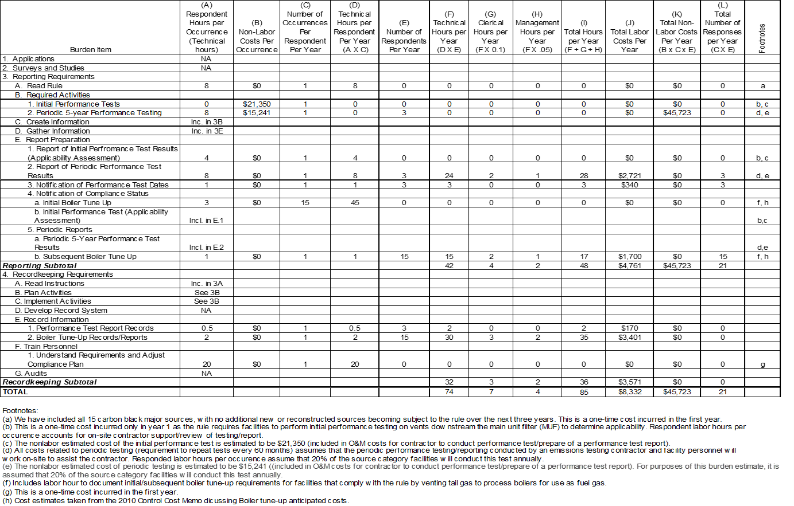

# Table 4 - Summary of Annual Respondent Burden and Cost of Recordkeeping and Reporting Requirements for the Carbon Black Production RTR



**ATTACHMENT 2**

# TABLES 5, 6, 7, and 8

Tables 5 - 7: Annual Agency Burden and Cost of Recordkeeping and Reporting Requirements for the Carbon Black Production RTR - Year 1-3

Table 8: Summary of Annual Agency Burden and Cost of Recordkeeping and Reporting Requirements for the Carbon Black Production RTR

**Table 5 - Annual Agency Burden and Cost of Recordkeeping and Reporting Requirements for the Carbon Black Production RTR - Year 1**

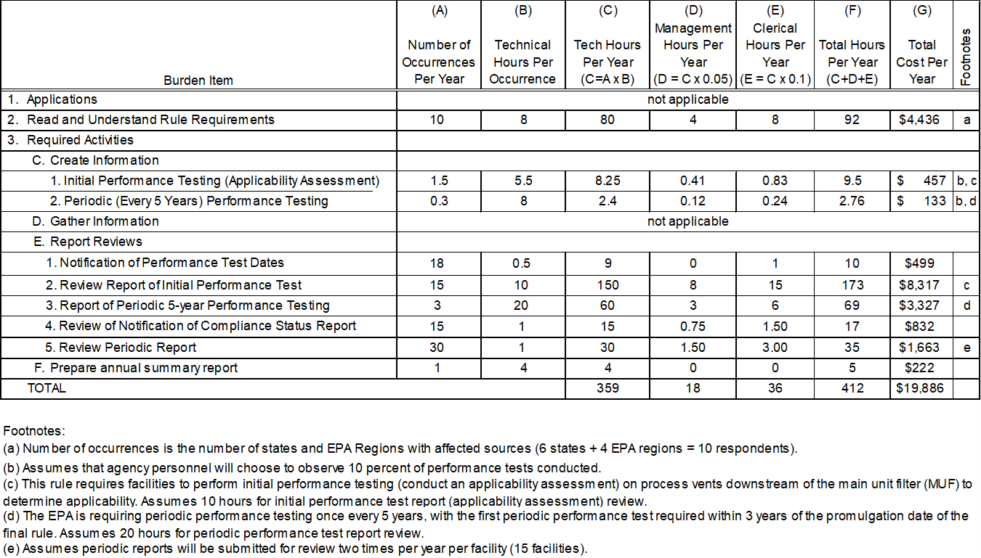

**Table 6 - Annual Agency Burden and Cost of Recordkeeping and Reporting Requirements for the Carbon Black Production RTR - Year 2**



**Table 7 - Annual Agency Burden and Cost of Recordkeeping and Reporting Requirements for the Carbon Black Production RTR - Year 3**



# Table 8 - Summary of Annual Agency Burden and Cost of Recordkeeping and Reporting Requirements for the Carbon Black Production RTR



1. <https://www.bls.gov/oes/current/naics4_3250A1.htm#11-0000>
2. Ibid.
3. <https://www.opm.gov/policy-data-oversight/pay-leave/salaries-wages/salary-tables/pdf/2019/GS_h.pdf>
4. The EPA has authority under CAA section 112(d)(2) and (3) to set MACT standards for previously unregulated HAP emissions. Moreover, the D.C. Circuit has held that the EPA has the obligation to address any previously unregulated HAP emissions as part of the 8-year review under CAA section 112(d)(6). See *LEAN v. EPA*, 955 F3d 1088, 1091 (D.C. Cir. 2020). The EPA also retains the discretion to revise a MACT standard under the authority of CAA section 112(d)(2) and (3) (see *Portland Cement Ass’n v. EPA*, 665 F.3d 177, 189 (D.C. Cir. 2011), such as when it identifies an error in the original standard. See also *Medical Waste Institute v. EPA*, 645 F. 3d 420, 426 (D.C. Cir. 2011) (upholding the EPA action establishing MACT floors, based on post-compliance data, when originally established floors were improperly established)).