Family Options Study Update
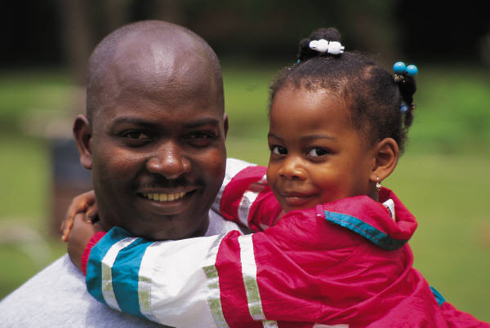 | 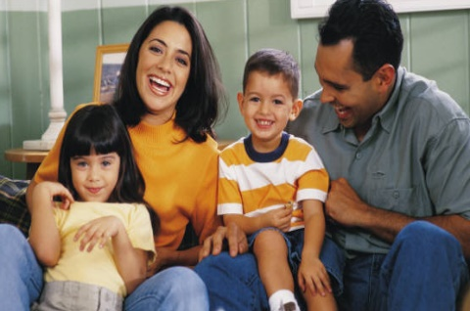
DATE «familyid»
Dear «r1» «r1a» «r1b»:
Hello again from the Family Options Study team! You became a participant in the Family Options Study in [RA MO/YR], when we interviewed you at «shelter» in «Site_Name_» as part of the study of housing and services interventions for families who experienced homelessness. The study is funded by the US Department of Housing and Urban Development (HUD). Abt Associates, a private research firm, is conducting the study. On behalf of HUD, the study team, and our local interviewers in each site we wish to thank you for your continued participation and cooperation in our study!
Below are some highlights about the study and the data collection efforts you have participated in over the past several years:
- You are one of 2,282 families that voluntarily enrolled in the Family Options Study between September 2010 and January 2012. You are part of a very special group of families and your opinions are important to create policies that help families experiencing homelessness.
- 12 different communities The Family Options Study took place in 12 communities across the United States.
- Two follow-up surveys complete Between September 2010 and December 2014 we conducted two follow-up surveys with study participants. We interviewed just about 1,800 study participants at each survey and collected data from more than 3,000 children. We also completed a check-in call with families back in 2017-2018. See results of this data collection at the links below.
- Looking Ahead In September 2021, HUD started a new phase of the study to continue interviewing you—the Family Options Study participants—to learn more about your experiences since you enrolled in the study. We will be calling all families in the study to complete a short 15-minute interview beginning in May 2022 and a longer interview in fall 2022.
- We need your help We would like to be able to interview you again to see how your life has changed since you first enrolled in the study. Your continued participation is voluntary, but your experiences are unique, and we want to be sure you are represented. Unfortunately, we can’t interview you if we can’t contact you. To help us contact you for the next interview we have enclosed a form that we would like you to review. Please check your address and telephone number on the following page. Please make the appropriate corrections in one of the following ways:
- Return the completed form to us by mail, using the enclosed envelope.
- Call us toll-free at 1-XXX-XXX-XXXX and make sure to use your personal PIN [FAMILYID].
- Visit [WEBLINK] and enter your username: [USERNAME] and PIN[FAMILYID].
Also, please provide us with the names, addresses, and telephone numbers of one person outside your household who would usually know where to reach you. We would call these friends or relatives only if we cannot locate you at your address. Once we receive your updated contact information, we will email you $15 in appreciation for your time.
If you have any questions, please feel free to contact us at 1-XXX-XXX-XXXX. Thank you in advance for your cooperation.
Sincerely yours,
Brenda Rodríguez, Senior Survey Project Director Lauren Dunton, Study Project Director
Abt Associates Abt Associates
Curious to learn more about what we have learned so far? See the reports here:
- First report: http://www.huduser.gov/portal/family_options_study.html
- Second report: https://www.huduser.gov/portal/sites/default/files/pdf/Family-Options-Study-Full-Report.pdf
- Long-term Tracking Project: https://www.huduser.gov/portal/sites/default/files/pdf/FamilyOptionsStudy-LongTerm.pdf

Please complete this form and return it in the postage-paid envelope provided, online or by phone.

Family Options Study Contact Form
PRIVACY ACT STATEMENT
Authority: Sec. 501, 502, Housing and Urban Development Act of 1970 (Pub.L. 91– 609), 12 U.S.C. 1701z–1, 1701z–2
Purpose: This information is being collected to locate the families that enrolled in the Family Options Study between September 2010 and January 2012 and to update their current contact information. The research team from Abt Associates will use the updated contact information to engage families at a later date to learn more about their experiences since they enrolled in the study.
Routine Use: Please refer to System of Record Notice.
Disclosure: Your participation in this information collection is voluntary and you can choose not to answer any question that is asked. Your responses will not affect your current or future receipt of housing assistance or other benefits.
SORN ID: PD&R/RRE.03 Homeless Families Impact Study Data Files https://www.govinfo.gov/content/pkg/FR-2014-02-26/pdf/2014-04202.pdf
Personal Information Verification
We have your NAME as: <name of record will be inserted here>
¨ This is correct This is not correct (print correct information below)
Enter Updated NAME: _____________________________________________________________________________________________
Last First M.I.
We have your ADDRESS as: <most recent address on record will be inserted here
¨ This is correct ¨ This is not correct (print correct information below)
Enter Updated ADDRESS: __________________________________________________________________________________________________
Street Address Apartment/Unit #
_______________________________________________________________________________________________________________
City State Zip Code
We have your MAILING ADDRESS as: <most recent mailing address on record will be inserted here>
¨ This is correct ¨ This is not correct (print correct information below)
Enter Updated MAIL ADDRESS: In care of: _____________________________________________________________________________________
________________________________________________________________________________________________________________________
Street Address Apartment/Unit # City State Zip Code
________________________________________________________________________________________________________________
City State Zip Code
We have your primary PHONE NUMBER as: <most recent phone number on record will be inserted here>
This is the best number to reach me This is not the best number to reach me (print correct information below)
Enter PHONE NUMBER:
Primary Phone Number: ( ) Alternate Phone Number: ( )
cell home work other cell home work other
Do we have permission to send text messages to you at this number?
Yes, you may contact me via text message to my cell phone No, you may not contact me via text message
(We may text you to confirm an appointment, to let you know that we are trying to reach you, or to request that you return your updated contact information form.)

We have your primary EMAIL as: <most recent email on record will be inserted here>
This is correct This is not correct (print correct information below)
Enter email: ______________________________________________________________
This is the email address we will use to email you a link to redeem your $15 gift certificate. If you do not have an email address or internet access, please check this box and a staff member will contact you.
What is your preferred method(s) of contact?
Call home number Call cell number Email Text Message Other
Secondary Contacts: Please list the name, address, and relationship to you of two people who will always know where to reach you. We will contact these people only if we can’t reach you in the future and will only tell them we are trying to contact you for a research study.
Person 1
Full Name:
 | First & Last |  |  | Relationship
Address:
 | Street Address & Apartment/Unit # City State |  |  |  |  | ZIP Code
Primary Phone: |  | ( ) | Email Address: |  | @

Person 2
Full Name:
 | First & Last |  |  | Relationship
Address:
 | Street Address & Apartment/Unit # City State |  |  |  |  | ZIP Code
Primary Phone: |  | ( ) | Email Address: |  | @

Adult Children Contact Information
Since the study began, we have collected information about the people (including children) who have lived with you. Since some are now adults, we would like to invite them to be part of the study. We need your help to reach them. For each person listed below, if you think they would be comfortable with you providing their contact information, please confirm the spelling of their name and provide contact information. If you are no longer in contact with them, please check the appropriate box. We plan to contact them beginning in fall 2022. At that time, we will explain the study more and they can choose whether to participate. You may want to let them know ahead of time about the study and our plan to contact them.
The first person is: <NAME1>. Is that spelling correct?
This is correct This is not correct (print correct information below) I am no longer in contact with <CHILD NAMEX>
Enter Updated NAME: __________________________________________________________________________________________
First M.I. Last Suffix
Enter ADDRESS:______________________________________________________________________________________________________
Street Address Apartment/Unit #
____________________________________________________________________________________________________________
City State Zip Code

Phone Number:( ) Email Address:__________________________________________

CID: < UNIQUE ID# >
The person is: <NAME2>. Is that spelling correct?
This is correct This is not correct (print correct information below) I am no longer in contact with <CHILD NAMEX>
Enter Updated NAME: _________________________________________________________________________________________
First M.I. Last Suffix
Enter ADDRESS:______________________________________________________________________________________________________
Street Address Apartment/Unit #
____________________________________________________________________________________________________________
City State Zip Code

Phone Number: ( )____________________ Email Address:_______________________________________________________

CID: < UNIQUE ID# >
The third person is: <NAME3>. Is that spelling correct?
This is correct This is not correct (print correct information below) I am no longer in contact with <CHILD NAMEX>
Enter Updated NAME: _________________________________________________________________________________________________
First M.I. Last Suffix
Enter ADDRESS:______________________________________________________________________________________________________
Street Address Apartment/Unit #
____________________________________________________________________________________________________________________
City State Zip Code

Phone Number:( ) Email Address:______________________________________________________________

CID: < UNIQUE ID# >
The fourth person is: <NAME4>. Is that spelling correct?>
This is correct This is not correct (print correct information below) I am no longer in contact with <CHILD NAMEX>
Enter Updated NAME: _______________________________________________________________________________________________
First M.I. Last Suffix
Enter ADDRESS:____________________________________________________________________________________________________
Street Address Apartment/Unit #
__________________________________________________________________________________________________________________
City State Zip Code

Phone Number:( )____________________ Email Address:______________________________________________________________

CID: < UNIQUE ID# >

PRA Burden Statement: Public Reporting Burden for this information collection is estimated to average 5 minutes per respondent, including time for reviewing instructions and completing the form. The Family Options Study is a multi-site random assignment experiment designed to study the impact of various housing and services interventions for homeless families in five key domains: housing stability, family preservation, adult well-being, child well-being, and self-sufficiency. The Family Options Study is a multi-site random assignment experiment designed to study the impact of various housing and services interventions for homeless families in five key domains: housing stability, family preservation, adult well-being, child well-being, and self-sufficiency. This information is being collected to locate the families that enrolled in the Family Options Study between September 2010 and January 2012 and to update their current contact information. Respondents are not required to respond. The information requested under this collection is protected and held confidential in accordance with 5 U.S.C. § 552a (Privacy Act of 1974) and OMB Circular No. A-130
Send comments regarding this burden estimate or any other aspect of this collection of information, including suggestions to reduce this burden, to Anna P. Guido, Reports Management Officer, QDAM, Department of Housing and Urban Development, 451 7th Street SW, Room 4176, Washington, DC 20410–5000. When providing comments, please refer to OMB Control No. 2528–0259. HUD may not conduct and sponsor, and a person is not required to respond to a collection of information unless the collection displays a valid OMB Control Number.

